GerminaQuant for R user manual

Flavio Lozano-Isla, Omar Benites Alfaro, Denise Garcia de Santana, Marli A. Ranal, Marcelo Francisco Pompelli

2017-04-05

# Introduction

**GerminaQuant for R** allows make the calculation of the germination variables incredibly easy in an interactive applications build in R (R Core Team, 2016), based in GerminaR and Shiny R package (Chang, Cheng, Allaire, Xie, & McPherson, 2017) . GerminaQuant app is reactive!. Outputs change instantly as users modify inputs. The principal features of the application allows to calculate the princiapal germination Variables, statistical analysis and easy way to plot the results.

# Evaluation of the seed germination process

The physiology and seed technology have provided valuable tools for the production of high quality seed and treatments and storage conditions (Marcos-Filho, 1998). In basic research, the seeds are studied exhaustively, and the approach of its biology is performed to fully exploit the dormancy and germination (Penfield & King, 2009). An important tool for indicate the performance of a seed lot is the precise quantification of germination through accurate analysis of the cumulative germination data (Joosen et al., 2010). Time, velocity, homogeneity, uncertainty and synchrony are measurements that inform the dynamics of the germination process. It is interesting not only for physiologists and seed technologists, but also for environmentalists, since it is possible to predict the degree of success of the species, based on the seed crop ability to redistribute germination over time, allowing the recruitment of part of the seedlings formed (Ranal & Santana, 2006).

# Germination variables

## Germinability ()

According to L. G. Labouriau (1983a), germinability is the percentage of seeds in which the germination process comes to the end in the experimental conditions by the intraseminal growth, resulting in the protrusion (or emergence) of a living embryo.

In percentage; expressed in the package as GRP. **Where:** : number of germinated seed in the time; : total number of seed in each experimental unit.

## Mean Germination Time () and Standard Deviation ()

The mean germination time was proposed by Haberlandt in 1875 (L. G. Labouriau, 1983a) and used by Czabator (1962) as mean length of incubation time (see Ranal & Santana (2006) for other details). It is calculated as the weighted mean of the germination time (hour, day or other time unit). The number of germinated seeds at the intervals established for the data collection is used as weight (Ranal & Santana, 2006).

In hour, day or other time unit; expressed in the program as MGT.

In the same time unit of the mean germination time; expressed in the program as SDG.

**Where:** : time from the start of the experiment to the observation (hour, day or other time unit); : number of germinated seeds in the time (not the accumulated number); : the last time of observation and : mean germination time.

## The germination variance of the germination time ().

The germination variance is expressed by:

In the square time unit of the meangermination time; expressed in the program as VGT. **Where:** : time from the start of the experiment to the observation (square time unit); : number of germinated seeds in the time (not the accumulated number); : the last time of observation and : mean germination time.

## Coefficient of variation of the germination time ().

In percentage; expressed in the program as CVG. **Where:** : standard deviation of the germination time and : mean germination time.

## Mean Germination Rate ()

The mean germination rate is defined as the reciprocal of the mean germination time, since the mean germination rate increases and decreases with , not with (L. G. Labouriau, 1983b).

Inverse of time unit; expressed in the program as MGR. **Where:** : : mean germination time.

## Germination speed coefficient ()

The germination speed coefficient which can be calculated by the formula:

In percentage; expressed in the program as GSP. **Where:** , number of seeds germinated in the time; , number of days from sowing.

## Uncertainty index ()

This measurement is an adaptation of the Shannon index and measures the degree of uncertainty associated to the distribution of the relative frequency of germination (L. Labouriau & Valadares, 1976). Low values indicate more synchronized germination (Ranal & Santana, 2006).

In bit; expressed in the package as UNC. **Where:** : relative frequency of germination; : number of seed germinated in the time, and : the last day of germination.

## Synchronyzation index ()

This index was proposed by Primack (1985) to assess the degree of overlapping of flowering among individuals in a population and Ranal & Santana (2006) adopted it for seed germination. The synchrony of germination of one seed with another assumed when the germination of all seeds occur at the same time and when at least two seeds can germinate, one at each time.

Adimensional measurement; expressed in the program as SYN. **Where:** : combination of germinated seeds in time, two together, and : number of germinated seed in the .

## Limits and units of the germination variables in GerminaQuant

Germination variables evaluated in GerminaQuant for R and limits according Ranal & Santana (2006) ; where: , number of seed germinated in time ; , the last day of the avaliation process for germination.

|  |  |  |  |
| --- | --- | --- | --- |
| Variables | Abbreviation | Limits | Units |
| Germinated seed number | GSN |  |  |
| Germinability | GNP |  |  |
| Mean germination time | MGT |  |  |
| Germination standard deviation | SDG |  |  |
| Germination variance | VGT |  |  |
| Coefficient of variation | CVG |  |  |
| Mean germination rate | MGR |  |  |
| Germination speed | SPG |  |  |
| Synchronyzation index | SYN |  |  |
| Uncertainty index | UNC |  |  |

# Germination field book

For correct analysis and fast data processing is important to take into account the data organization and the correct data collection of the germination process. In this section, we are going to explain how can you collect and organize your data.

For data example and layout, you can access and download GerminaQuant [spreadsheet](https://docs.google.com/spreadsheets/d/1QziIXGOwb8cl3GaARJq6Ez6aU7vND_UHKJnFcAKx0VI/edit#gid=667855537).

## Data Organization

The field book should have three essential parts.(1) The factor columns (red), according to the experimental design;(2) the seed number column, indicate the number of seeds sown in each experimental unit (green) and (3) the evaluation columns with the germination values (blue) (Figure @ref(fig:dtorg)). You can design your own field book with different names in the column according your experimental design.

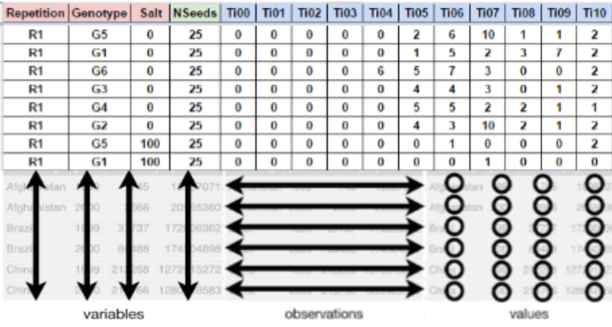

Layout for germination evaluation process. The factor column (red) are according the experimental design. The seed number column (green) for the number of seed sown and the evaluation columns (blue) for accounting the germination.

## Data Collection

The evaluation of the germination process is obtained of the count of the germination in each experimental unit and It can be evaluated in time lapse of hours, days or months in continuous interval of the same length always beginning with the time zero (ei. Ti00), until the end of the germination process or according to the researcher criteria.

# Germination analysis

After the data collection, the information can be processed using GerminaQuant App. The web application can be used in any device, connected to the internet, in an interactive way. The application is compound in tabs (Table @ref(tab:tabs)) that allow to make the analysis very easy.

Name and description of each tab of GerminaQuant to evaluate and analyze the germination process

|  |  |
| --- | --- |
| Tabs | Description |
| Presentation | Presentation of the aplication, principal characteristics and constributors |
| User Manual | User manual explain the meaning of each indice and how to collect and process your data |
| Fieldbook | Interface to upload the field book and choose the parameter for the germination analisys, GerminaQuant allows to upload tha data from google sheet or excel file |
| Germination | Calculate automatically the germination variables and export the data file. |
| Boxplot | Interface to explore your data and their distribution |
| Statistics | Interface to choose the variables according the experimental design for analysis of variance and summarise the information according the principal mean comparison test |
| Graphics | Graphic the mean comparison test for the variables selected in the statistical analisys and plot the information in customized bar or line plot. |
| InTime | Selecting the factor from your experiment, allows plotting the germination process in time. |
| Tools | Tool for calculte the osmotic potencial for any salt or PEG for germination experiments |

# GerminaQuant data processing

## Prepare you field book

For using the GerminaQuant is necessary that you have a data with germination values. You can use a following data as an example [data](https://docs.google.com/spreadsheets/d/1QziIXGOwb8cl3GaARJq6Ez6aU7vND_UHKJnFcAKx0VI/edit#gid=667855537). If you have a Google account you can clone the document and edit it online and download for your own analysis.

## Field book

When you have your field book, you can go [GerminaQuant for R](https://flavjack.shinyapps.io/germinaquant/) and go "Fieldbook" tab. Figure @ref(fig:impdt).

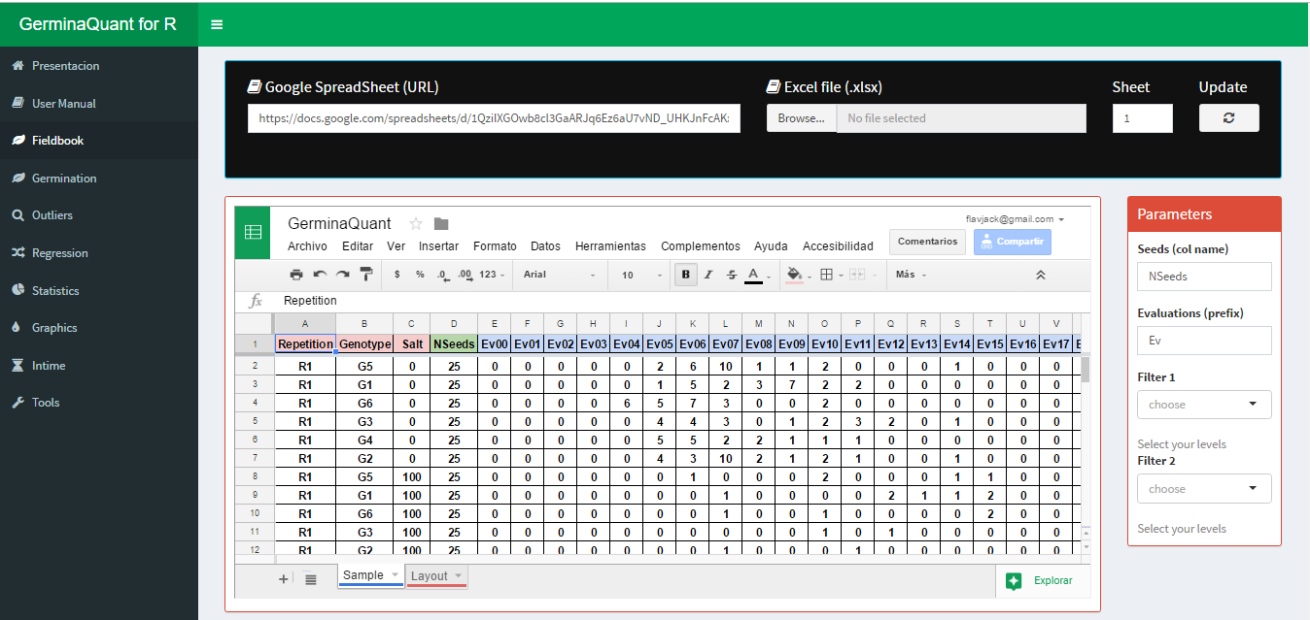

Fieldbook interface for import your data

You can paste a Google spread sheet URL or upload a local file in xlsx format. In "Seeds (col name)" you have to write the name of the column containing the information of the number of seed sown in each experimental unit, for "Evaluations (prefix)" you have to put the prefix of the names for the evaluated days from the germination time lapse.

## Germination

If the parameter in the "Fieldbook" tab are correct, in "Germination" tab will be performed and the values of the germination indices for each experimental unit will be shown. Table @ref(tab:varsum). GerminaQuant allows to copy or downloading the file in "csv" or "xlsx" format with the calculation of the germination variables. Figure @ref(fig:dwl)

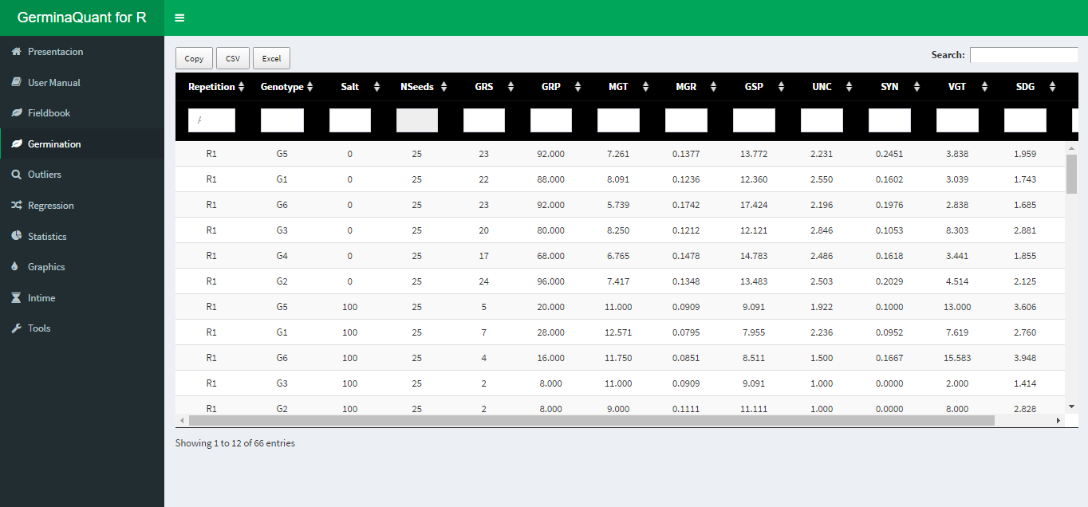

Dowload option for the calculated variables

## Statistical

The application can perform a factorial analysis according you experimental design (crd, crbd or lsd), and calculate the analysis of variance and the mean differences through Student Newman Keuls, Tukey or Duncan test according the chosen variable.

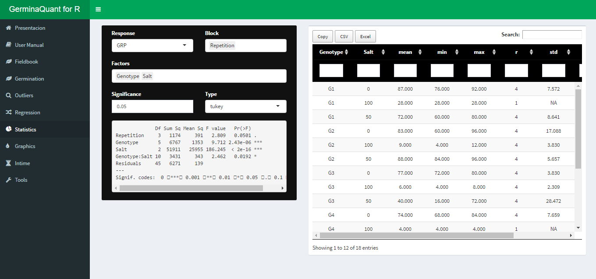

Statitical analysis with ANOVA and mean comparison test

## Graphics

Automatically after performed the statistical analysis the application will generate the graphs for the variable chosen with the mean comparison test. The interface allows customized bar or line plot and export in "tiff" format for publication quality.

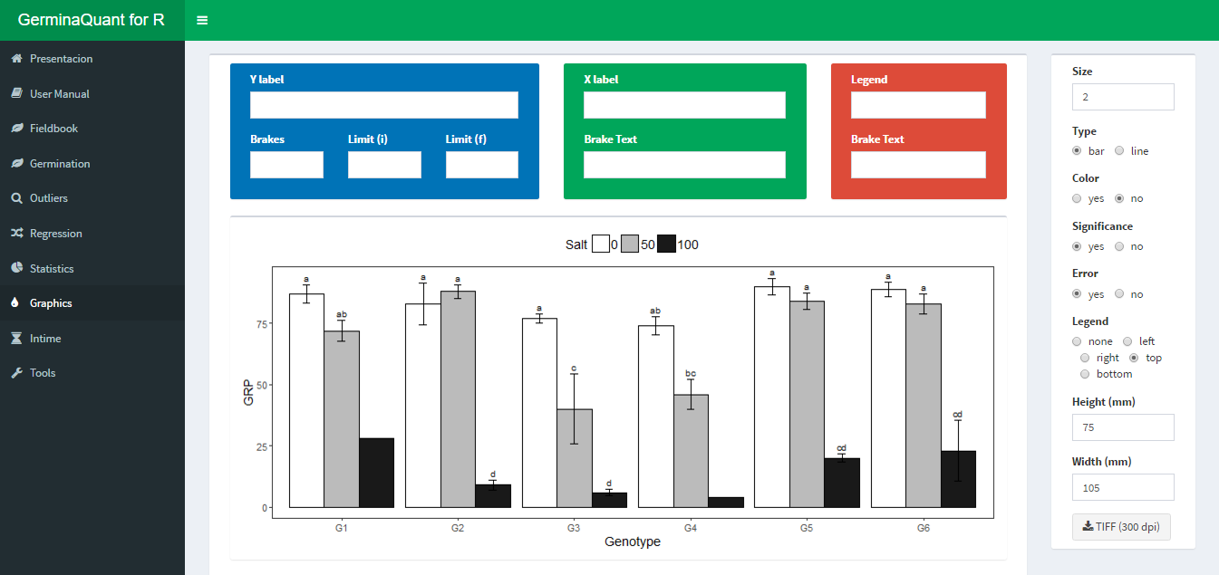

Customized interface for bar or line plot

## InTime

This Tab allows to visualize the germination process according the experimental factors. The interface allows customized the graphic. Figure @ref(fig:gtime)

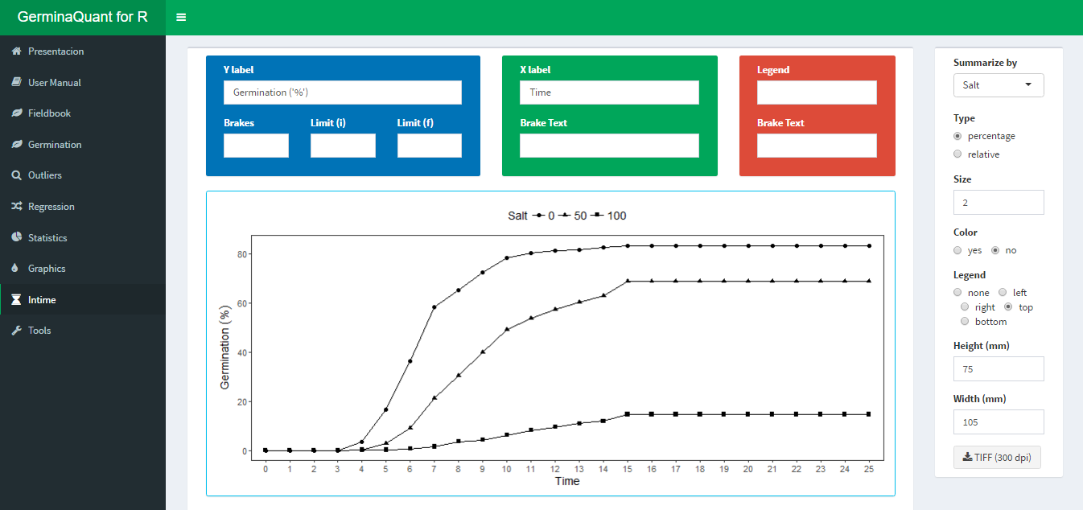

Germination in time plot

The application allows to plot two type of graphics, the first is the germination in percentage in time lapse and the second the relative germination that calculate the germination according the total number of germinated seeds.

Chang, W., Cheng, J., Allaire, J., Xie, Y., & McPherson, J. (2017). *Shiny: Web application framework for r*. Retrieved from <https://CRAN.R-project.org/package=shiny>

Czabator, F. J. (1962). Germination value: an index combining speed and completeness of pine seed germination. *Forest Science*, *8*(4), 386–396.

Joosen, R. V. L., Kodde, J., Willems, L. A. J., Ligterink, W., Plas, L. H. W. van der, & Hilhorst, H. W. (2010). germinator : a software package for high-throughput scoring and curve fitting of Arabidopsis seed germination. *The Plant Journal*, *62*(1), 148–159. doi:[10.1111/j.1365-313X.2009.04116.x](https://doi.org/10.1111/j.1365-313X.2009.04116.x)

Labouriau, L. G. (1983a). *A germinacâo das sementes* (p. 174). Washington.

Labouriau, L. G. (1983b). Uma nova linha de pesquisa na fisiologia da germinacao das sementes. *In Anais do XXXIV Congresso Nacional de Botanica*.

Labouriau, L., & Valadares, M. (1976). On the physiology of seed of calotropis procera. anais da academia brasileira de ciência. *Rio de Janeiro*, *42*(2), 235–264.

Marcos-Filho, J. (1998). New approaches to seed vigor testing. *Scientia Agricola*, *55*, 27–33. doi:[10.1590/S0103-90161998000500005](https://doi.org/10.1590/S0103-90161998000500005)

Penfield, S., & King, J. (2009). Towards a systems biology approach to understanding seed dormancy and germination. *Proceedings. Biological Sciences / The Royal Society*, *276*(1673). doi:[10.1098/rspb.2009.0592](https://doi.org/10.1098/rspb.2009.0592)

Primack, R. B. (1985). Patterns of flowering phenology in communities, populations, individuals, and single flowers. In *The population structure of vegetation* (pp. 571–593). Springer.

R Core Team. (2016). *R: A language and environment for statistical computing*. Vienna, Austria: R Foundation for Statistical Computing. Retrieved from <https://www.R-project.org/>

Ranal, M. A., & Santana, D. G. de. (2006). How and why to measure the germination process? *Revista Brasileira de Botânica*, *29*(1), 1–11. doi:[10.1590/S0100-84042006000100002](https://doi.org/10.1590/S0100-84042006000100002)