GerminaR and GerminaQuant .: user manual

Flavio Lozano-Isla $​^{1}$, Omar Benites Alfaro $​^{2}$, Denise Garcia de Santana $​^{3}$, Marli A. Ranal $​^{4}$, Marcelo Francisco Pompelli $​^{5}$

$​^{1}$ Universidade Federal Rural de Pernambuco, Brazil. email: [flavjack@gmail.com](mailto:flavjack@gmail.com)

Centro Internacional de la Papa (CIP), Peru. email: [obacc07@gmail.com](mailto:obacc07@gmail.com)

Universidade Federal de Uberlandia, Brazil. email: [denise.santana@ufu.br](mailto:denise.santana@ufu.br)

Universidade Federal de Uberlandia, Brazil. email: [ranal@ufu.br](mailto:ranal@ufu.br)

Universidade Federal de Pernambuco, Brazil. email: [mpompelli@gmail.com](mailto:mpompelli@gmail.com)

2020-03-02

# Introduction



**GerminaQuant for R** allows make the calculations for germination indices incredibly easy in an interactive web applications build in R (R Core Team, 2019), based in GerminaR (Lozano-Isla et al., 2019) and Shiny R package (Chang et al., 2019) . GerminaQuant app is reactive!. Outputs change instantly as users modify inputs. The principal features of the application allows to calculate the principal germination indices, statistical analysis and easy way to plot the results.

## Citation

Lozano-Isla, Flavio; Benites-Alfaro, Omar Eduardo; Pompelli, Marcelo Francisco (2019). GerminaR: An R package for germination analysis with the interactive web application “GerminaQuant for R.” Ecological Research, 34(2), 339–346. <https://doi.org/10.1111/1440-1703.1275>

## GerminaR CRAN

<https://CRAN.R-project.org/package=GerminaR>

## GerminaQuant app

Lozano-Isla, Flavio; Benites-Alfaro, Omar Eduardo; Pompelli, Marcelo Francisco (2016). GerminaQuant for R (Patent No. BR 51 2016 001327-3). <https://flavjack.shinyapps.io/germinaquant/>

# Seed germination process

The physiology and seed technology have provided valuable tools for the production of high quality seed and treatments and storage conditions (Marcos-Filho, 1998). In basic research, the seeds are studied exhaustively, and the approach of its biology is performed to fully exploit the dormancy and germination (Penfield & King, 2009). An important tool for indicate the performance of a seed lot is the precise quantification of germination through accurate analysis of the cumulative germination data (Joosen et al., 2009). Time, velocity, homogeneity, uncertainty and synchrony are measurements that inform the dynamics of the germination process. It is interesting not only for physiologists and seed technologists, but also for environmentalists, since it is possible to predict the degree of success of the species, based on the seed crop ability to redistribute germination over time, allowing the recruitment of part of the seedlings formed (Ranal & Santana, 2006).

# Germination field book

For a correct analysis and fast data processing is important to take into account the data organization and the proper record of the germination process. In this section we will explain how you should collect and organize your data.

## Prepare you field book

For using GerminaR and GerminaQuant is necessary that you have a dataset with germination values. You can use a following data as an example [*“prosopis”*](https://docs.google.com/spreadsheets/d/1QziIXGOwb8cl3GaARJq6Ez6aU7vND_UHKJnFcAKx0VI/edit#gid=667855537).

If you have a Google account you can made a copy of the document and edit it online or download in Excel format for your own analysis.

## Data Organization

The field book should have three essential parts.(1) The factor columns (red), according to the experimental design;(2) the seed number column, indicate the number of seeds sown in each experimental unit (green) and (3) the evaluation columns with the germination values (blue) (Figure 1). You can design your own field book with different names in the column according your experimental design.

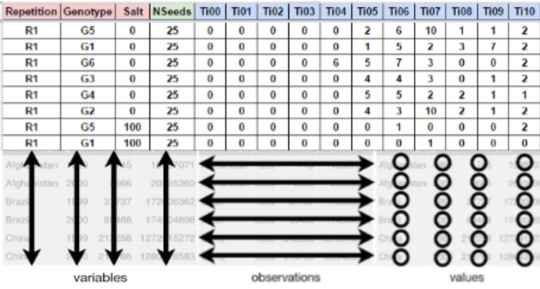

Figure 1: Layout for germination evaluation process. The factor column (red) are according the experimental design. The seed number column (green) for the number of seed sown and the evaluation columns (blue) for accounting the germination.

## Data Collection

The evaluation of the germination process is obtained of the count of the germination in each experimental unit and It can be evaluated in any time lapse (hours, days, months, etc) in continuous interval of the same length always beginning with the time zero (ei. Ti00), until the end of the germination process or according to the researcher criteria.

# Germination analysis

After the data collection, the information can be processed using GerminaR by the R console or using the GerminaQuant App. The web application can be used in any device in an interactive way. The application is compound for different tabs (Table 1) that allow to make the analysis very easy.

Table 1: Name and description of each tab of GerminaQuant to evaluate and analyze the germination process

|  |  |
| --- | --- |
| Tabs | Description |
| Presentation | Presentation of the application, principal characteristics and contributors |
| User Manual | User manual explain the meaning of each index and how to collect and process your data |
| Fieldbook | Interface to upload the field book and choose the parameter for the germination analysis, GerminaQuant allows to upload the data from google sheet or excel file |
| Germination | Calculate automatically the germination variables and export the data file. |
| Boxplot | Interface to explore your data and their distribution |
| Statistics | Interface to choose the variables according the experimental design for analysis of variance and summarize the information according the principal mean comparison test |
| Graphics | Graphic the mean comparison test for the variables selected in the statistical analysis and plot the information in customized bar or line plot. |
| InTime | Selecting the factor from your experiment, allows plotting the germination process in time. |
| Tools | Tool for calculate the osmotic potential for any salt or PEG for germination experiments |

# GerminaQuant data processing

## Field book

When you have your field book, you can access to the app [GerminaQuant for R](https://flavjack.shinyapps.io/germinaquant/) and go “Fieldbook” tab. Figure 2.

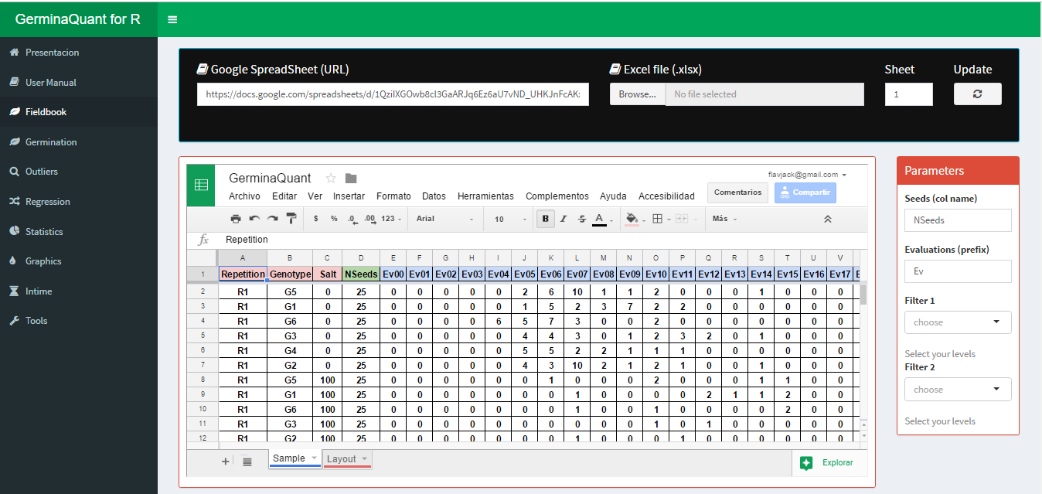

Figure 2: Fieldbook interface for import your data

You can paste a Google spread sheet URL or upload a local file in xlsx format. In “Seeds (col name)” you have to write the name of the column containing the information of the number of seed sown in each experimental unit, for “Evaluations (prefix)” you have to put the prefix of the names for the evaluated days from the germination time lapse.

## Germination

If the parameter in the “Fieldbook” tab are correct, in “Germination” tab will be performed and the values of the germination indices will be shown maintaining the experimental design. GerminaQuant allows to copy or downloading the information in “csv” or “xlsx” format. Figure 3

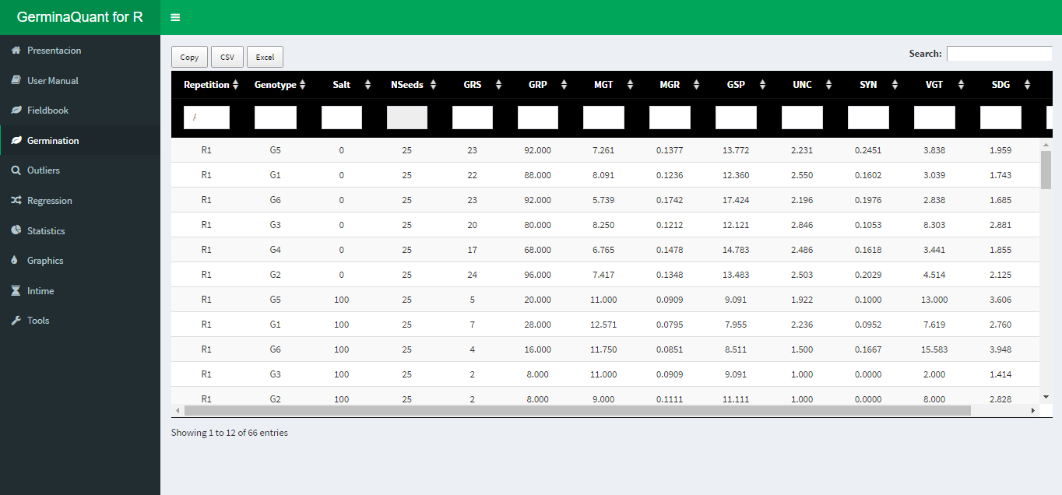

Figure 3: Dowload option for the calculated variables

## Statistical

The GerminaQuant application can perform analysis for experimental design in a Complete Randomize Design (CRD), Randomize Complete Block Design (RCBD), Latin Square Design (LSD) or factorial designs, allowing calculate the analysis of variance (AOV) and the mean differences through Student Newman Keuls (SNK), Tukey or Duncan test.

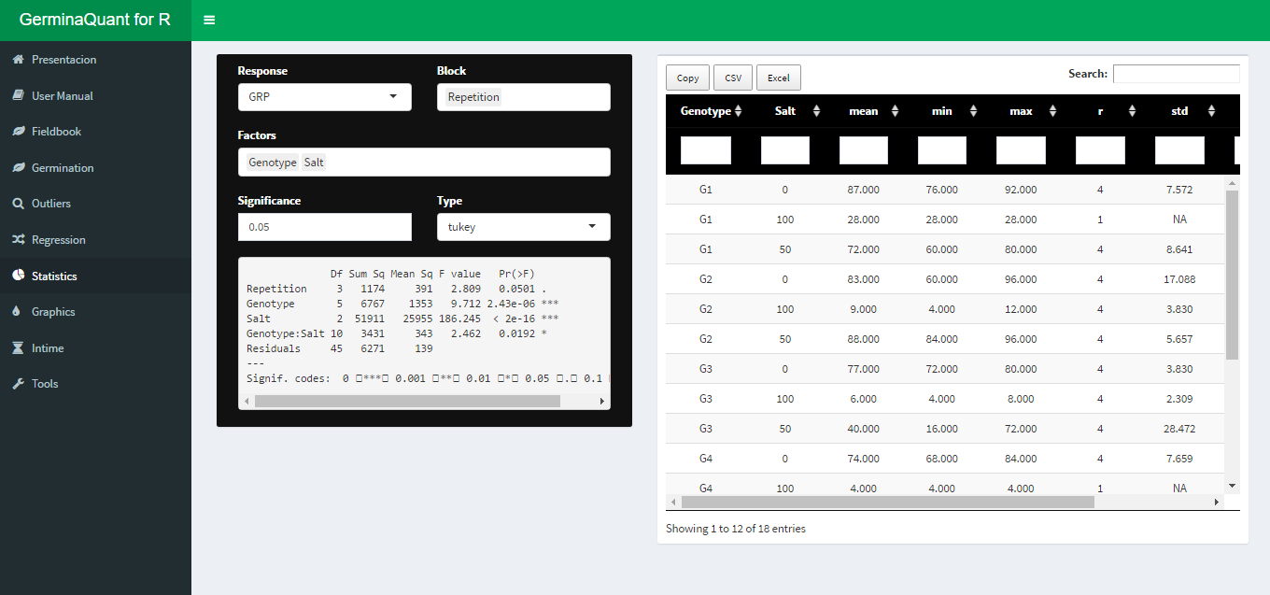

Figure 4: Statitical analysis with ANOVA and mean comparison test

## Graphics

Automatically after performed the statistical analysis the application will generate the graphs for the variable chosen with the mean comparison test. The app interface allows customized the graphics in a bar or line plot and export in “tiff” format for publication quality.

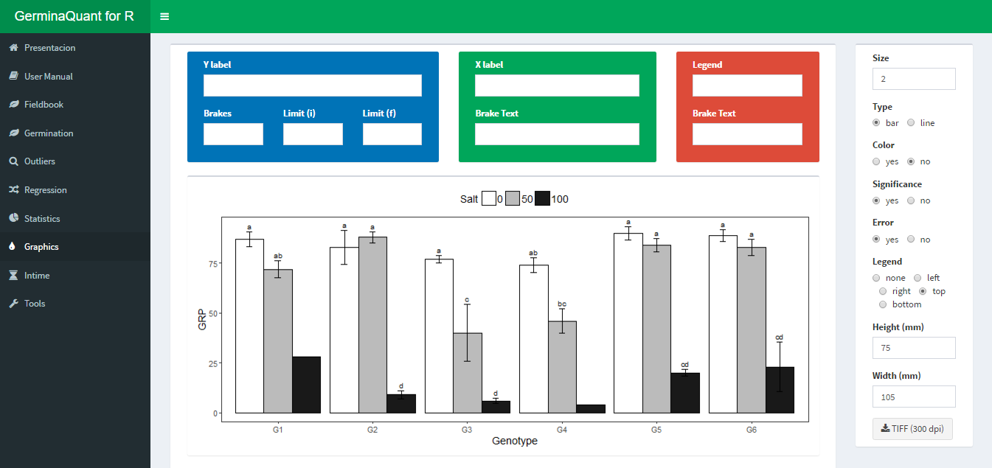

Figure 5: Customized interface for bar or line plot

## InTime

This Tab allows to visualize the germination process according one of the experimental factors. The app interface allows customized the graphic. Figure 6

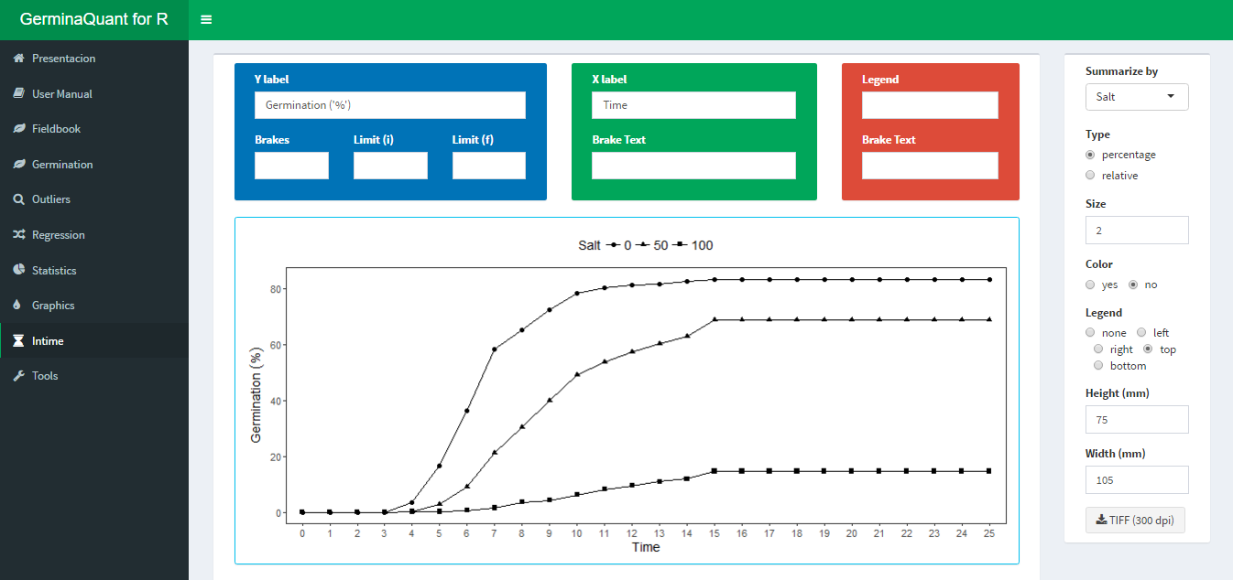

Figure 6: Germination in time plot

The application allows to plot two type of graphics, the first is the germination percentage in time lapse, and the second the relative germination that calculates the germination according the total number of germinated seeds.

# GerminaR: data analysis with code

Analysis for the germination experiment can follow a routine. The functions will de explain according to the data set included in the GerminaR package (“*prosopis*”).

1. Install and load the GerminaR package. Load the “*prosopis*” dataset on your session. In case of using another dataset, you can load your own data and proceed according to the following script:

# Install packages and dependencies  
packages <- c(  
 "devtools", # For install packages and complements from dev sources  
 "knitr", # Base of the bookdown template  
 "kableExtra", # Table notes!  
 "tidyverse", # Data manipulation  
 "googlesheets4", # Read/write google sheets files  
 "agricolae", # Agriculture data analysis  
 "GerminaR", # Germination analysis and line and bar easy plots  
 "cowplot", # For export and merge figures   
 "GerminaR"  
)  
  
installed_packages <- packages %in% rownames(installed.packages())  
if (any(installed_packages == FALSE)) {  
 install.packages(packages[!installed_packages])  
}  
invisible(lapply(packages, library, character.only = TRUE))  
rm(packages, installed_packages)  
  
# load data  
fb <- prosopis %>%   
 dplyr::mutate_at(vars(nacl, temp, rep), as.factor)  
  
# Prosopis data set  
fb %>% web_table(title = "Prosopis dataset loaded")

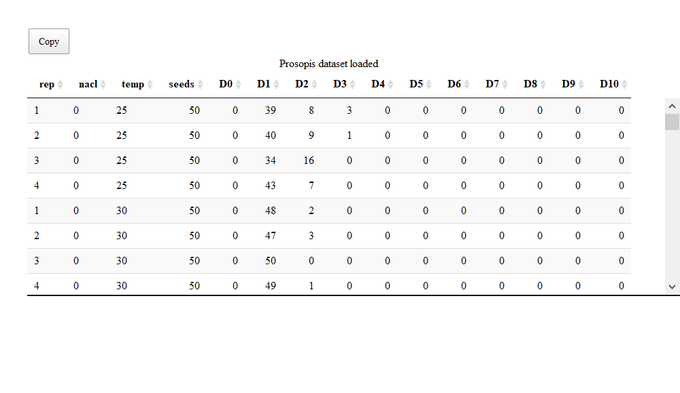

1. Calculate the germination indices and perform the ANOVA and the mean comparison tests. The user can generate the graphs, expressing their results, which can be either of bars or lines graphics.

# germination analysis (ten variables)  
gsm <- ger_summary(SeedN = "seeds", evalName = "D", data = fb)  
  
# Prosopis data set processed  
  
gsm %>% web_table(title = "Function *ger_summary* performe ten germination indices")

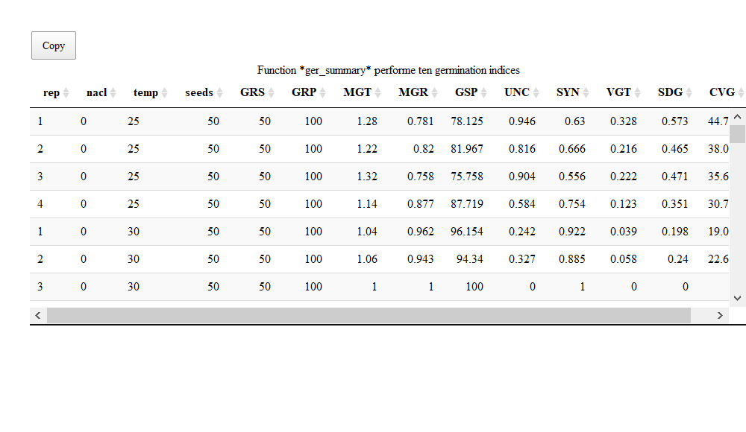

## Punctual analysis of germination

### Germination percentage

## Germination Percentage (GRP)  
# analysis of variance  
av <- aov(formula = GRP ~ nacl*temp + rep, data = gsm)  
# mean comparison test  
mc_grp <- ger_testcomp(aov = av, comp = c("temp", "nacl"), type = "snk")  
# data result  
mc_grp %>% web_table(title = "Germination percentage mean comparision")

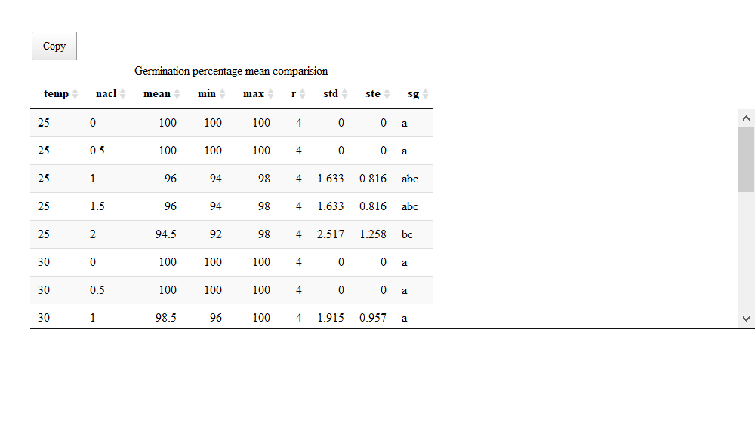

Figure 7: Germination experiment with *Prosopis juliflor* under different osmotic potentials and temperatures. Bar graph with germination percentage in a factorial analisys

# bar graphics for germination percentage  
grp <- fplot(data = mc_grp, type = "bar",   
 x = "temp", y = "mean", z = "nacl",   
 lmt = c(0,120), brk = 10,  
 ylab = "Germination ('%')",   
 xlab = "Temperature (ºC)",   
 lgl = "NaCl (MPa)", lgd = "top",   
 erb = T, color = F)  
  
grp

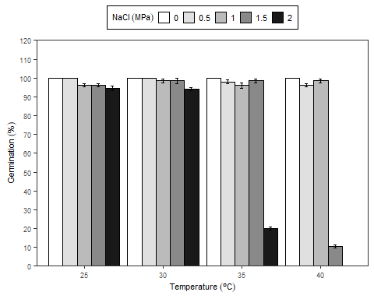

Figure 7: Germination experiment with *Prosopis juliflor* under different osmotic potentials and temperatures. Bar graph with germination percentage in a factorial analisys

### Mean germination time

## Mean Germination Time (MGT)  
# analysis of variance  
av <- aov(formula = MGT ~ nacl*temp + rep, data = gsm)  
# mean comparison test  
mc_mgt <- ger_testcomp(aov = av, comp = c("temp", "nacl"), type = "snk")  
# data result  
mc_mgt %>% web_table(title = "Mean germination time comparison")

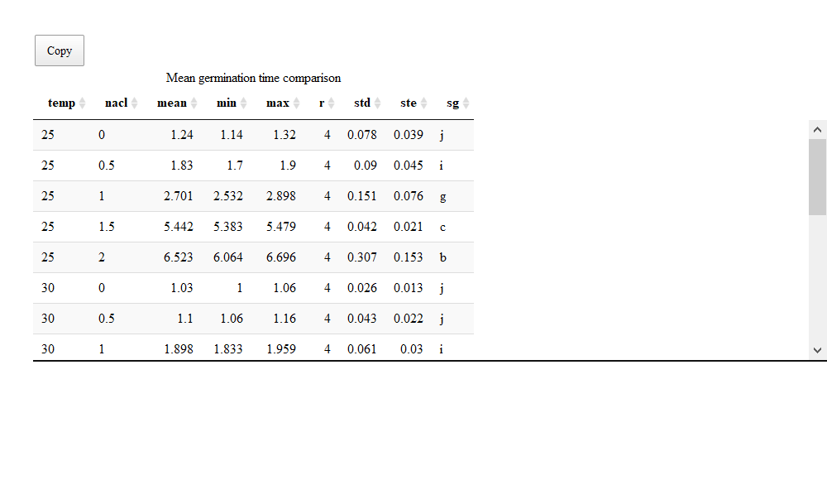

Figure 8: Germination experiment with *Prosopis juliflor* under different osmotic potentials and temperatures. Bar graph for mean germination time in a factorial analisys.

# bar graphics for mean germination time  
mgt <- fplot(data = mc_mgt, type = "bar",   
 x = "temp", y = "mean", z = "nacl",   
 lmt = c(0,9), brk = 1,  
 ylab = "Mean germination time (days)",   
 xlab = "Temperature (ºC)",   
 lgl = "NaCl (MPa)", lgd = "top",   
 sig = "sg", erb = T,   
 color = F, font = 1.2)  
  
mgt

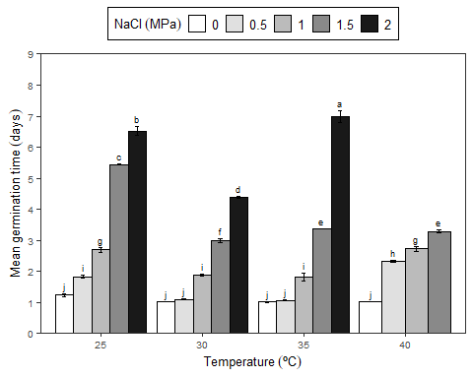

Figure 8: Germination experiment with *Prosopis juliflor* under different osmotic potentials and temperatures. Bar graph for mean germination time in a factorial analisys.

You can add at each plot different arguments as the standard error, significance of the mean test, color, labels and limits. The resulted graphics are performed for publications and allows to insert math expression in the titles.

## Cumulative analysis of germination

The cumulative analysis of the germination allows to observe the evolution of the germination process, being able to be expressed as the percentage of germination or with the relative germination.

### In time analysis for NaCl

# data frame with percentage or relative germination in time by NaCl  
git <- ger_intime(Factor = "nacl", SeedN = "seeds", evalName = "D", method = "percentage", data = fb)  
  
# graphic germination in time by NaCl  
nacl <- fplot(data = git, type = "line",   
 x = "evaluation", y = "mean", z = "nacl",   
 lmt = c(0,110), brk = 10,  
 ylab = "Germination ('%')",   
 xlab = "Day",   
 lgl = "NaCl (MPa)",   
 lgd = "top", color = F)  
nacl

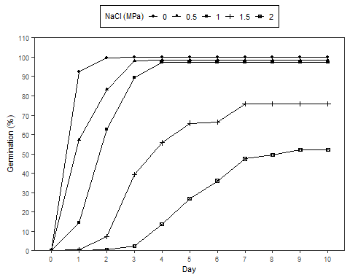

Figure 9: Germination experiment with *Prosopis juliflor* under different osmotic potentials and temperatures. Line graph from cumulative germination under different osmotic potentials.

### In time analysis for temperature

# data frame with percentage or relative germination in time by temperature  
git <- ger_intime(Factor = "temp", SeedN = "seeds", evalName = "D", method = "percentage", data = fb)  
  
# graphic germination in time by temperature  
temp <- fplot(data = git, type = "line",   
 x = "evaluation", y = "mean", z = "temp",   
 lmt = c(0,110), brk = 10,  
 ylab = "Germination ('%')",   
 xlab = "Day",   
 lgl = "Temperature ('°C')",   
 lgd = "top", color = F, font = 1.2)  
temp

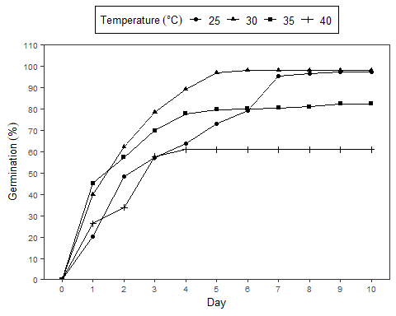

Figure 10: Germination experiment with *Prosopis juliflor* under different osmotic potentials and temperatures. Line graph from cumulative germination under different temperatures.

# References

Chang, W., Cheng, J., Allaire, J., Xie, Y., & McPherson, J. (2019). *Shiny: Web application framework for r*. <https://CRAN.R-project.org/package=shiny>

Joosen, R. V. L., Kodde, J., Willems, L. A. J., Ligterink, W., Plas, L. H. W. van der, & Hilhorst, H. W. M. (2009). Germinator: A software package for high-throughput scoring and curve fitting of *arabidopsis* seed germination. *The Plant Journal*, *62*(1), 148–159. <https://doi.org/10.1111/j.1365-313x.2009.04116.x>

Lozano-Isla, Flavio, Benites-Alfaro, Eduardo, O., Pompelli, & Francisco, M. (2019). GerminaR: An R package for germination analysis with the interactive web application “GerminaQuant for R”. *Ecological Research*, *34*(2), 339–346. <https://doi.org/10.1111/1440-1703.1275>

Marcos-Filho, J. (1998). New approaches to seed vigor testing. *Scientia Agricola*, *55*, 27–33. <https://doi.org/10.1590/S0103-90161998000500005>

Penfield, S., & King, J. (2009). Towards a systems biology approach to understanding seed dormancy and germination. *Proceedings of the Royal Society B: Biological Sciences*, *276*(1673), 3561–3569. <https://doi.org/10.1098/rspb.2009.0592>

Ranal, M. A., & Santana, D. G. de. (2006). How and why to measure the germination process? *Revista Brasileira de Botânica*, *29*(1), 1–11. <https://doi.org/10.1590/s0100-84042006000100002>

R Core Team. (2019). *R: A language and environment for statistical computing*. R Foundation for Statistical Computing. <https://www.R-project.org/>