Rticles: Scientific Documents with Bookdown R Package

www.quipo.org

Flavio Lozano-Isla , Jimmy Gomez

Agronomist, Co-founder quipo.org

Agronomist MSc, E-mail: [flavjack@gmail.com](mailto:flavjack@gmail.com)

# Abstract

Class aptent taciti sociosqu ad litora torquent per conubia nostra, per inceptos himenaeos. Curabitur sodales ligula in libero. Sed dignissim lacinia nunc. Curabitur tortor. Pellentesque nibh. Aenean quam. In scelerisque sem at dolor. Maecenas mattis. Sed convallis tristique sem. Proin ut ligula vel nunc egestas porttitor. Morbi lectus risus, iaculis vel, suscipit quis, luctus non, massa. Fusce ac turpis quis ligula lacinia aliquet. Mauris ipsum. Nulla metus metus, ullamcorper vel, tincidunt sed, euismod in, nibh. Quisque volutpat condimentum velit. Class aptent taciti sociosqu ad litora torquent per conubia nostra, per inceptos himenaeos. Nam nec ante. Sed lacinia, urna non tincidunt mattis, tortor neque adipiscing diam, a cursus ipsum ante quis turpis. *Nulla facilisi* Ut fringilla. **Suspendisse potenti** Nunc feugiat mi a tellus consequat imperdiet. Vestibulum sapien. Proin quam. Etiam ultrices. Suspendisse in justo eu magna luctus suscipit. Sed lectus. Integer euismod lacus luctus magna. Quisque cursus, metus vitae pharetra auctor, sem massa mattis sem, at interdum magna augue eget diam.

**Keywords:** Lorem, ipsum, dolor, sit amet, consectetur.

# Introduction

Lorem ipsum Lozano-Isla et al. (2018) dolor sit amet, consectetur adipiscing elit. Integer nec odio. Praesent libero. Sed cursus ante dapibus diam. Sed nisi. Nulla quis sem at nibh elementum imperdiet. Duis sagittis ipsum. Praesent mauris Fusce nec tellus sed augue semper porta. Mauris massa. Vestibulum lacinia arcu eget nulla Class aptent taciti sociosqu ad litora torquent per conubia nostra, per inceptos himenaeos. Curabitur sodales ligula in libero. Sed dignissim lacinia nunc (Maluszynski et al. 2009, Pompelli et al. 2012).

Curabitur tortor (Avenot et al. 2009, Zárate y Gianina 2017) Pellentesque nibh. Aenean quam. In scelerisque sem at dolor. Maecenas mattis. Sed convallis tristique sem. Proin ut ligula vel nunc egestas porttitor. Morbi lectus risus, iaculis vel, suscipit quis, luctus non, massa. Fusce ac turpis quis ligula lacinia aliquet. Mauris ipsum. Nulla metus metus, ullamcorper vel, tincidunt sed, euismod in, nibh. Quisque volutpat condimentum velit. Nulla facilisi. Ut fringilla. Suspendisse potenti. Nunc feugiat mi a tellus consequat imperdiet. Vestibulum sapien. Proin quam. Etiam ultrice. Suspendisse in justo eu magna luctus suscipit. Sed lectus. Integer euismod lacus luctus magna.

# Materials and Methods

The data was analyzed in the statistical software R (R Core Team 2019). The germination analysis and graphics was carried out with the package GerminaR (Lozano Isla et al. 2019). Each variable was submitted at analysis of variance (ANOVA) and the mean comparison test used was Student-Newman Keuls (P<0.05)(de Mendiburu 2019). For the multivariate analysis, the principal components analysis (PCA) and cluster hierarchical classification analysis (HCPC) will be used (Husson et al. 2019).

The vertical bars represent the means (±SE). The mean differences between the groups are represented by different capital letters and into the group different lowercase letters (SNK, p = 0.05) (Gutierrez et al. 2018).

More information about multivarite analysis in <http://factominer.free.fr/index.html>. Explanation for intepretation and analysis:

**PCA:** <https://www.youtube.com/watch?v=pks8m2ka7Pk&feature=youtu.be>

**HCPC:** <https://www.youtube.com/watch?v=4XrgWmN9erg>

## Data set

The data set used for this analysis is available in the following link: [DATA SET](https://docs.google.com/spreadsheets/d/1QziIXGOwb8cl3GaARJq6Ez6aU7vND_UHKJnFcAKx0VI/edit#gid=137089581)

## Nulla metus metus

Curabitur tortor. Pellentesque nibh. Aenean quam. In scelerisque sem at dolor. Maecenas mattis. Sed convallis tristique sem. Proin ut ligula vel nunc egestas porttitor. Morbi lectus risus, iaculis vel, suscipit quis, luctus non, massa. Fusce ac turpis quis ligula lacinia aliquet. Mauris ipsum. Nulla metus metus, ullamcorper vel, tincidunt sed, euismod in, nibh. Quisque volutpat condimentum velit. Class aptent taciti sociosqu ad litora torquent per conubia nostra, per inceptos himenaeos. Nam nec ante (Table 1).

# Results

## Sed convallis tristique sem

Lorem ipsum dolor sit amet, consectetur adipiscing elit. Integer nec odio. Praesent libero. Sed cursus ante dapibus diam. Sed nisi. Nulla quis sem at nibh elementum imperdiet. Duis sagittis ipsum. Praesent mauris. Fusce nec tellus sed augue semper porta. Mauris massa. Vestibulum lacinia arcu eget nulla. Class aptent taciti sociosqu ad litora torquent per conubia nostra, per inceptos himenaeos .

Curabitur sodales ligula in libero. Sed dignissim lacinia nunc. Curabitur tortor. Pellentesque nibh. Aenean quam. In scelerisque sem at dolor. Maecenas mattis. Sed convallis tristique sem. Proin ut ligula vel nunc egestas porttitor. Morbi lectus risus, iaculis vel, suscipit quis, luctus non, massa. Fusce ac turpis quis ligula lacinia aliquet. Mauris ipsum.

# load data  
  
library(GerminaR)   
  
fb <- prosopis %>%   
 dplyr::mutate_at(vars(rep, nacl, temp), as.character)  
  
# germination analysis  
  
gsm <- ger_summary(SeedN = "seeds", evalName = "D", data = fb)  
str(gsm)  
  
# analisys of variance  
  
av <- aov(formula = GRP ~ nacl*temp + rep, data = gsm)  
summary(av)  
  
# mean comparision test  
  
mc <- ger_testcomp(aov = av, comp = c("temp", "nacl"), type = "snk")

## Class aptent taciti

Nulla metus metus, ullamcorper vel, tincidunt sed, euismod in, nibh. Quisque volutpat condimentum velit. Class aptent taciti sociosqu ad litora torquent per conubia nostra, per inceptos himenaeos. Nam nec ante. Sed lacinia, urna non tincidunt mattis, tortor neque adipiscing diam, a cursus ipsum ante quis turpis. Nulla facilisi. Ut fringilla. Suspendisse potenti. Nunc feugiat mi a tellus consequat imperdiet. Vestibulum sapien. Proin quam. Etiam ultrices. Figure: 1.

# Discussion

Curabitur tortor León et al. (2018) and Dixit (2015), Pellentesque nibh. Aenean quam. In scelerisque sem at dolor. Maecenas mattis. Sed convallis tristique sem. Proin ut ligula vel nunc egestas porttitor. Morbi lectus risus, iaculis vel, suscipit quis, luctus non, massa. Fusce ac turpis quis ligula lacinia aliquet. Mauris ipsum. Nulla metus metus, ullamcorper vel, tincidunt sed, euismod in, nibh. Quisque volutpat condimentum velit. Class aptent taciti sociosqu ad litora torquent per conubia nostra, per inceptos himenaeos. Nam nec ante (Table 1).

Sed lacinia, urna non tincidunt mattis, tortor neque adipiscing diam, a cursus ipsum ante quis turpis. Nulla facilisi. Ut fringilla. Suspendisse potenti. Nunc feugiat mi a tellus consequat imperdiet. Vestibulum sapien. Proin quam. Etiam ultrices. Suspendisse in justo eu magna luctus suscipit. Sed lectus. Integer euismod lacus luctus magna. Quisque cursus, metus vitae pharetra auctor, sem massa mattis sem, at interdum magna augue eget diam. Vestibulum ante ipsum primis in faucibus orci luctus et ultrices posuere cubilia Curae; Morbi lacinia molestie dui. Praesent blandit dolor (Blum 2005).

# Conclusions

Class aptent taciti sociosqu ad litora torquent per conubia nostra, per inceptos himenaeos. Curabitur sodales ligula in libero. Sed dignissim lacinia nunc. Curabitur tortor. Pellentesque nibh. Aenean quam. In scelerisque sem at dolor. Maecenas mattis. Sed convallis tristique sem. Proin ut ligula vel nunc egestas porttitor. Morbi lectus risus, iaculis vel, suscipit quis, luctus non, massa. Fusce ac turpis quis ligula lacinia aliquet. Mauris ipsum. Nulla metus metus, ullamcorper vel, tincidunt sed, euismod in, nibh. Quisque volutpat condimentum velit. Class aptent taciti sociosqu ad litora torquent per conubia nostra, per inceptos himenaeos. Nam nec ante. Sed lacinia, urna non tincidunt mattis, tortor neque adipiscing diam, a cursus ipsum ante quis turpis. Nulla facilisi. Ut fringilla. Suspendisse potenti. Nunc feugiat mi a tellus consequat imperdiet.

# Acknowledgments

Donec lacus nunc, viverra nec, blandit vel, egestas et, augue. Vestibulum tincidunt malesuada tellus. Ut ultrices ultrices enim. Curabitur sit amet mauris. Morbi in dui quis est pulvinar ullamcorper. Nulla facilisi. Integer lacinia sollicitudin massa. Cras metus. Sed aliquet risus a tortor. Integer id quam. Morbi mi.

Table 1: Main functions in the GerminaR R package for seed germination variables and graphical analysis.

|  |  |
| --- | --- |
| Function | Description |
| ger_summary | Calculate ten germination indices maintaining the factors levels for analysis of variance |
| ger_intime | Calculates and displays cumulative germination data. |
| fplot | Function that allows to graphic the results in bar or line plot. |
| GerminaQuant | Runs the interactive application in offline mode for use on a personal computer. |
| prosopis | Dataset with germination experiment in *Prosopis juliflor* seeds under under different osmotic potentials and temperatures. |

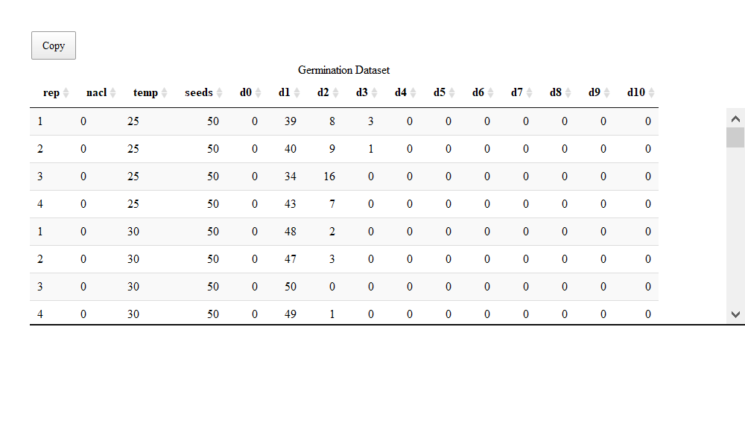

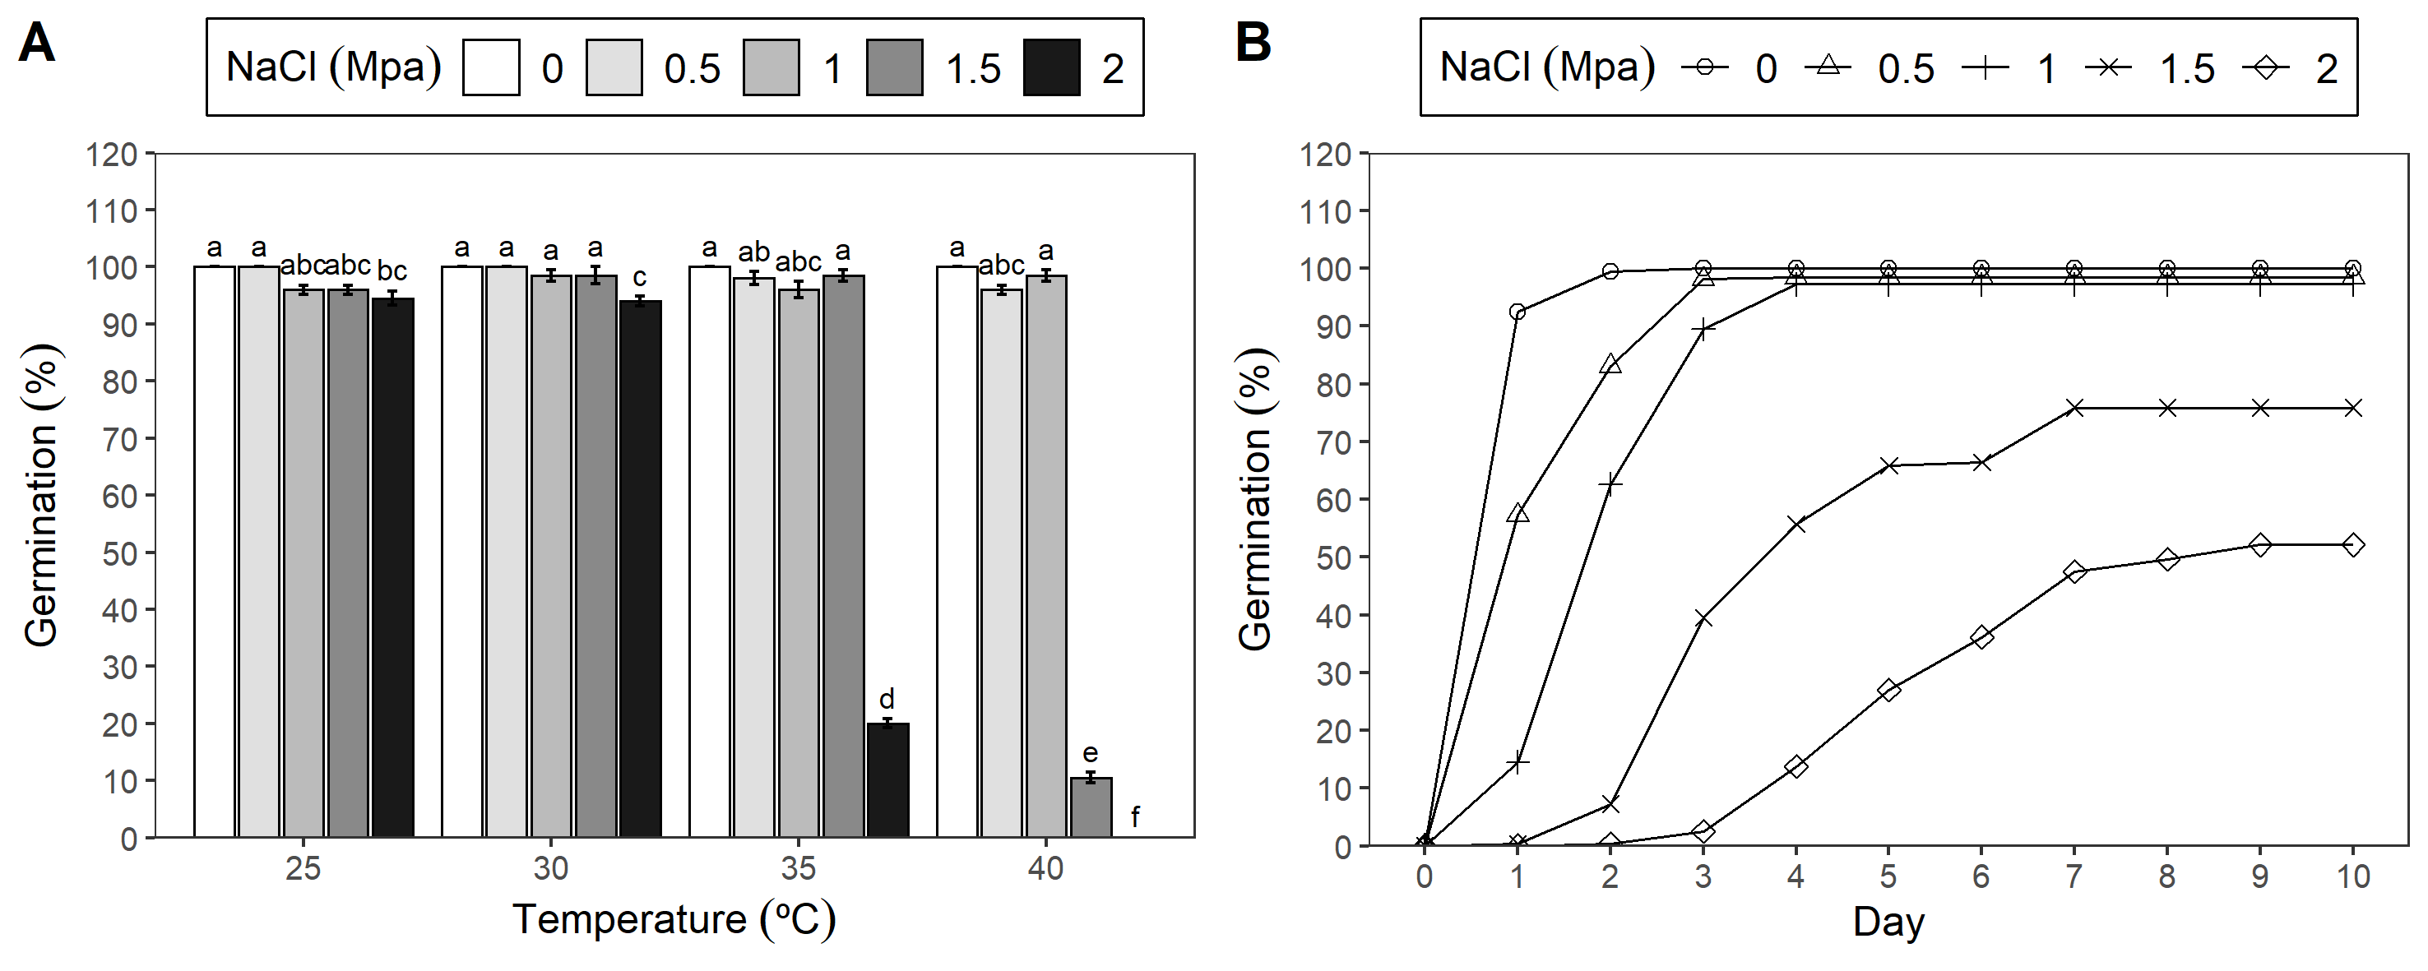

Figure 1: Germination experiment with *Prosopis juliflor* under different osmotic potentials and temperatures. A) Bar graph with germination percentage in a factorial analisys. B) Line graph from cumulative germination under different osmotic potentials.

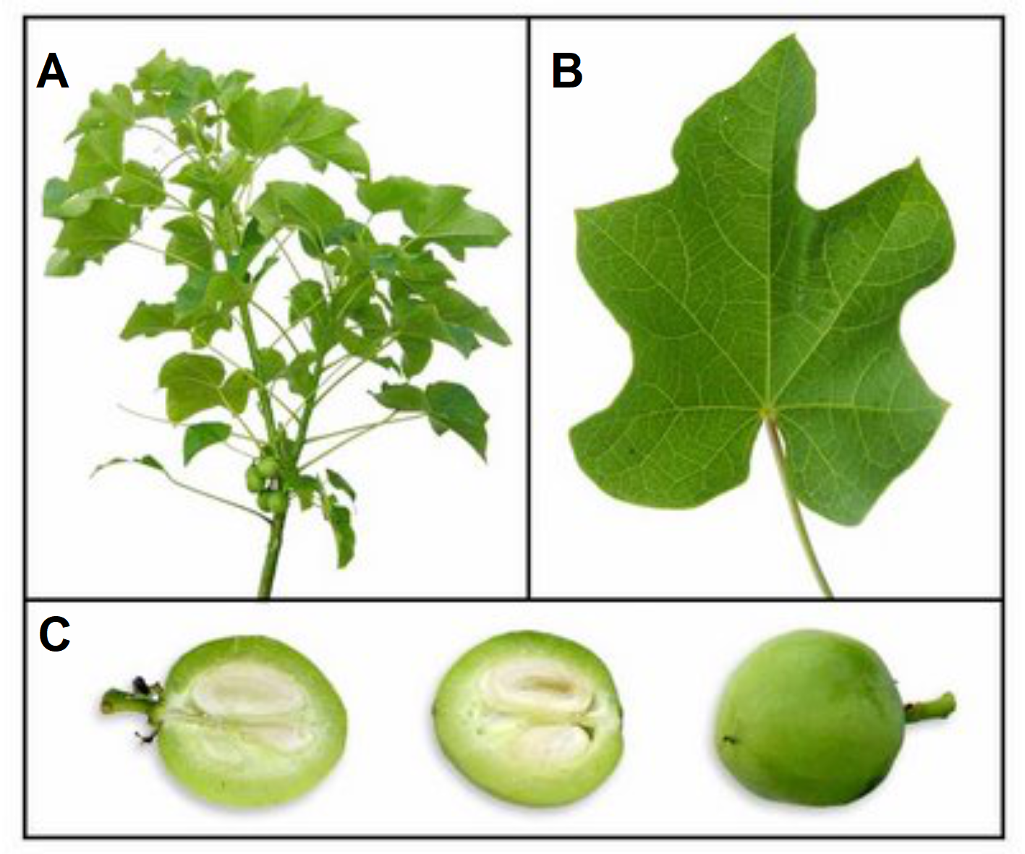

Figure 2: Plant of *Jatropha curcas*. A) Foliage, B) Leaf, C) Fruit.

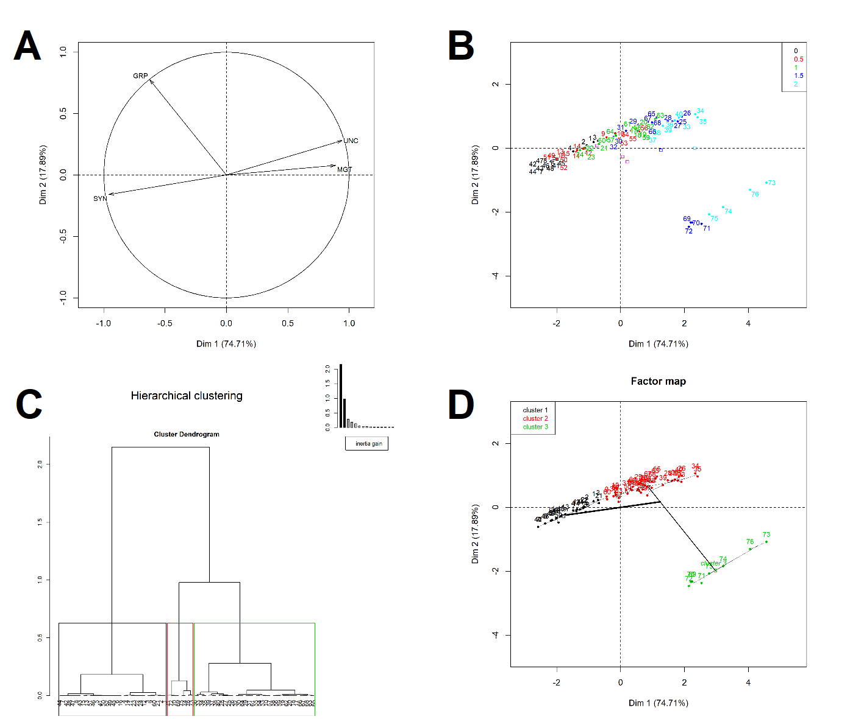

Figure 3: Multivariate Analysis: Principal component Analysis and Hierarchical Clustering Analysis.

# References

Avenot, H; Sellam, A; Michailides, T. 2009. Characterization of Mutations in the Membrane-Anchored Subunits AaSDHC and AaSDHD of Succinate Dehydrogenase from Alternaria Alternata Isolates Conferring Field Resistance to the Fungicide Boscalid. Plant Pathology 58(6):1134-1143. DOI: <https://doi.org/10.1111/j.1365-3059.2009.02154.x>.

Blum, A. 2005. Drought Resistance, Water-Use Efficiency, and Yield PotentialAre They Compatible, Dissonant, or Mutually Exclusive? Australian Journal of Agricultural Research 56(11):1159. DOI: <https://doi.org/10.1071/AR05069>.

de Mendiburu, F. 2019. Agricolae: Statistical Procedures for Agricultural Research (en línea). s.l., s.e. Disponible en <https://CRAN.R-project.org/package=agricolae>.

Dixit, A. 2015. Adaptación al cambio climático: aumento de la producción de quinua mediante técnicas nucleares..

Gutierrez, P; Vega, R; Garc’ıa, S; Casas, A. 2018. Contribution from Vermicompost to Trace Element Uptake in *Capsicum* *Baccatum* L. Var. *Pendulum* Grown under Organic Management at La Molina, Peru. Acta Horticulturae (1217):327-334. DOI: <https://doi.org/10.17660/ActaHortic.2018.1217.41>.

Husson, F; Josse, J; Le, S; Mazet, J. 2019. FactoMineR: Multivariate Exploratory Data Analysis and Data Mining (en línea). s.l., s.e. Disponible en <https://CRAN.R-project.org/package=FactoMineR>.

León, D; Gutierrez, P; Riojas, R; Casas, A. 2018. Nitrogen, Phosphorus and Potassium Levels in Asparagus Production. Acta Horticulturae (1223):81-87. DOI: <https://doi.org/10.17660/ActaHortic.2018.1223.12>.

Lozano Isla, F; Benites Alfaro, O; Pompelli, MF. 2019. GerminaR: Germination Indices and Graphics for Seed Germination in Ecophysiological Studies (en línea). s.l., s.e. Disponible en <https://flavjack.shinyapps.io/germinaquant/>.

Lozano-Isla, F; Campos, MLO; Endres, L; Bezerra-Neto, E; Pompelli, MF. 2018. Effects of Seed Storage Time and Salt Stress on the Germination of *Jatropha* *Curcas* L. Industrial Crops and Products 118:214-224. DOI: <https://doi.org/10.1016/j.indcrop.2018.03.052>.

Maluszynski, M; Szarejko, I; Bhatia, CR; Nichterlein, K; Lagoda, PJL. 2009. Methodologies for Generating Variability. Part 4: Mutation Techniques. Plant breeding and farmer participation:159-194.

Pompelli, MF; Antunes, WC; Ferreira, DTRG; Cavalcante, PGS; Wanderley-Filho, HCL; Endres, L. 2012. Allometric Models for Non-Destructive Leaf Area Estimation of *Jatropha* *Curcas*. Biomass and Bioenergy 36:77-85. DOI: <https://doi.org/10.1016/j.biombioe.2011.10.010>.

R Core Team. 2019. R: A Language and Environment for Statistical Computing (en línea). Vienna, Austria, R Foundation for Statistical Computing. Disponible en <https://www.R-project.org/>.

Zárate, C; Gianina, M. 2017. Respuesta de 100 Accesiones de Quinua a La Infección Natural de Mildiu (Peronospora Variabilis Gäum) En El Valle Del Mantaro..