Multivariate analysis reveals phenotypic groups among Peruvian maize races
Flavio Lozano-Isla^{1,2}, Pedro M. Rodriguez-Grados¹, Marly Guelac-Santillán¹, Luis Vargas-Cordova¹, Ricardo Sevilla³, Alexander Grobman³, Rodomiro Ortiz^{4,*} and Carlos I. Arbizu^{1,2,*}

¹ Centro de Investigación en Germoplasma Vegetal y Mejoramiento Genético de Plantas, Universidad Nacional Toribio Rodríguez de Mendoza de Amazonas (UNTRM), Amazonas 01001, Peru
² Facultad de Ingeniería y Ciencias Agrarias, Universidad Nacional Toribio Rodríguez de Mendoza de Amazonas (UNTRM), Amazonas 01001, Peru
³ Facultad de Agronomía, Universidad Nacional Agraria la Molina (UNALM). Lima 15024, Peru
⁴ Department of Plant Breeding, Swedish University of Agricultural Sciences (SLU), SE 23422 Lomma, Sweden
Corresponding author:
Rodomiro Ortiz (rodomiro.ortiz@slu.se); Carlos I. Arbizu (carlos.arbizu@untrm.edu.pe)

Abstract
Maize (Zea mays L.) in Peru exhibits extensive phenotypic diversity traditionally classified into races based on morphological traits, yet environmental variation complicates objective discrimination. Here we analyzed morphological data from 43 Peruvian maize races using principal component analysis and hierarchical clustering to identify key discriminant traits and phenotypic groups. Ten morphological variables related to plant architecture, tassel morphology, and ear characteristics explained 77.78% of phenotypic variation, enabling classification into four distinct phenotypic clusters. These clusters only partially corresponded with the historical racial classification, revealing phenotypic relationships not fully captured by traditional frameworks. Our findings demonstrate that multivariate statistical approaches provide an effective and objective method for characterizing Peruvian maize diversity, supporting improved germplasm conservation and utilization in breeding programs.

Keywords: amylaceous maize; Andean region; genetic diversity; germplasm conservation; maize races; morphological characterization; multivariate analysis; plant breeding

Introduction
Maize (Zea mays L.) is one of the most widely cultivated crops worldwide, playing a central role in global food systems due to its high productivity, broad adaptability, and diverse end uses (García-Lara and Serna-Saldivar, 2019). Global maize production reaches approximately 1,137 million tons annually, making it the most produced cereal crop, with applications spanning human consumption, animal feed, and industrial processing (Erenstein et al., 2022). Beyond its economic relevance, maize contributes significantly to food security, particularly in developing regions where it supports rural livelihoods and stabilizes food systems (Poole et al., 2021). Its global success is closely linked to its domestication in Mesoamerica around 9,000 years ago and its subsequent diversification, driven by extensive genetic variation and continuous selection processes (Kennett et al., 2020; Smith et al., 2022). In the context of increasing demand for food, feed, and bio-based products, maize remains a key component of agricultural systems, although challenges related to resource use, climate variability, and sustainability continue to influence its production (Grote et al., 2021; Kinnunen et al., 2020).

In Peru, maize represents a fundamental component of agricultural systems, with a cultivation history spanning several millennia. Archaeological evidence indicates its presence in the region between approximately 6700 and 3000 years BP, supporting early diversification across a wide range of ecological environments following its introduction from Mesoamerica (Grobman et al., 2012). This long-term cultivation has contributed to the development of substantial genetic diversity, with Peru recognized as one of the main centers of diversity for native maize races adapted to distinct agroecological conditions (Salvador-Reyes and Clerici, 2020). In the Andean region, maize is widely cultivated by smallholder farmers under variable environmental conditions, including drought and low temperatures (Zambrano et al., 2021). In addition to its role in agricultural production, maize remains a staple in local diets and is deeply integrated into traditional food systems. Native pigmented cultivars have also gained attention due to their content of bioactive compounds —naturally occurring substances such as anthocyanins and phenolics that may confer health benefits—and their potential use in functional foods, which are foods that provide additional health-promoting or disease-preventing properties beyond basic nutrition (Salvador-Reyes and Clerici, 2020). These characteristics position maize in Peru as both an agricultural resource and a key component of cultural and economic systems.

Morphological characterization has long been used to describe and differentiate maize germplasm, particularly in regions with high genetic diversity. This approach involves the evaluation of vegetative, reproductive, and kernel traits, including plant height, leaf architecture, ear morphology, kernel type, and grain color, which together reflect phenotypic variation among genotypes. Previous studies have demonstrated that these descriptors are effective for identifying diversity patterns and distinguishing maize accessions, especially in landrace-based systems (Kaushal et al., 2023; Patel et al., 2024). Kernel traits, such as size, density, and structural composition, provide additional information for classification and end-use quality, as they are influenced by both genetic factors and environmental conditions during development (Evers and Millar, 2002; Gwirtz and Garcia‐Casal, 2014). Considerable variation in morphological traits has been reported across maize populations, supporting their relevance for germplasm evaluation and breeding programs (Ashogbon, 2022). However, morphological descriptors may be influenced by environmental conditions, which can limit their ability to fully represent genetic relationships among maize races. Consequently, the integration of quantitative and multivariate approaches—such as statistical analyses that evaluate multiple traits simultaneously—has become necessary to improve the resolution and objectivity of classification systems.

The diversity of Peruvian maize has been documented in the foundational work of Grobman et al. (1961), which provided one of the earliest comprehensive classifications of maize races in the country. Their study described a high level of variation based on vegetative, tassel, ear, and kernel traits, including plant architecture, tassel structure, ear morphology, and grain characteristics. Based on these descriptors, Grobman et al. (1961) identified 49 maize races and organized them according to their evolutionary development into primitive, anciently derived, and more recent groups, as well as introduced, incipient, and imperfectly defined races. This classification reflects the complex processes of hybridization, selection, and geographical differentiation that have shaped maize diversity in Peru. Despite its continued relevance as a reference framework, this classification relies largely on qualitative descriptors—traits assessed by visual observation or categorical scoring—and incorporates limited quantitative integration, meaning that numerical measurements and statistical analyses are not extensively used. This may restrict its ability to capture fine-scale phenotypic differentiation among maize races under diverse environmental conditions.

In this context, there is a need for a precise and integrative reevaluation of morphological variability in Peruvian maize, particularly in highland environments where phenotypic expression may be strongly influenced by environmental heterogeneity. The objectives of this study were to (i) select discriminant morphological variables that most effectively distinguish among based on phenotypic variability, (ii) group maize races using multivariate analysis to identify clusters with intra-group similarity and inter-group differentiation, and (iii) compare the resulting groups with the racial classification proposed by Grobman, Salhuana, and Sevilla (1961) to assess their correspondence and divergence within the current classification framework.

By integrating quantitative approaches with classical morphological characterization, this study provides a more objective basis for understanding maize diversity in the Peruvian highlands. These findings contribute to improving germplasm classification and support more efficient use of genetic resources in breeding, conservation, and crop management programs within Andean maize systems.

Materials and Methods
Data construction and digitization
Morphological data were manually digitized from the race descriptions and quantitative data reported in Races of Maize in Peru: Their Origins, Evolution and Classification (Grobman et al., 1961). The resulting dataset was organized as a race × trait matrix, with each row representing a maize race and each column representing a morphological descriptor or associated race-level attribute. A total of 43 maize races were represented in the digitized matrix.

Quantitative values were transcribed as reported in the original source and were not recalculated from individual-level observations. Accordingly, each numerical entry represents the published race-level value available for a given morphological descriptor rather than a new estimate derived from individual plants or accessions. Missing information in the source was recorded as missing data rather than inferred or replaced during digitization. Because the historical dataset provides one set of morphological descriptors per race, the maize race was considered the unit of analysis. Consequently, the multivariate analyses characterize differences among historical race-level phenotypic profiles and do not quantify within-race phenotypic variation.

The digitized descriptors encompassed plant, leaf, tassel, ear, kernel, and internal ear characteristics. Trait names and measurement units were standardized for computational analysis while preserving the definitions and values reported in the original source. The complete digitized race × trait matrix is provided in Supplementary Table 1, while the descriptors retained after data-completeness filtering, including their units and descriptive statistics, are reported in Supplementary Table 2.

Table 1: Group and eco-geographical characterization of 43 Peruvian maize races (Zea mays L.) included in the study based on Grobman et al. (1961), including racial classification, regional distribution, representative locality of origin, and altitudinal adaptation range
Group | Race | Region | Locality | Altitude min (m) | Altitude max (m) | Altitudinal zone
Primitive | Confite Morocho | Sierra | Puno | 2800 | 3800 | Quechua–Suni
 | Confite Puntiagudo | Sierra | Puno | 3000 | 3800 | Suni
 | Kculli | Sierra | Cuzco | 2500 | 3500 | Quechua
 | Confite Puneño | Sierra | Puno | 3500 | 4000 | Suni–Puna
 | Enano | Sierra | Ayacucho | 2800 | 3500 | Quechua
Anciently derived | Huayleno | Sierra | Junín (Mantaro) | 2500 | 3200 | Quechua
 | Chullpi | Sierra | Cuzco | 2800 | 3600 | Quechua–Suni
 | Granada | Sierra | Junín | 2600 | 3400 | Quechua
 | Paro | Sierra | Junín | 2600 | 3300 | Quechua
 | Morocho | Sierra | Junín | 2400 | 3200 | Quechua
 | Huancavelicano | Sierra | Huancavelica | 3000 | 3800 | Suni
 | Mochero | Coast | La Libertad | 0 | 800 | Chala
 | Pagaladroga | Sierra | Ayacucho | 2600 | 3400 | Quechua
 | Chaparreño | Coast/Sierra | Lima | 500 | 2000 | Yunga
 | Rabo de Zorro | Sierra | Ayacucho | 2500 | 3300 | Quechua
 | Piricinco | Sierra | Ayacucho | 2500 | 3200 | Quechua
 | Ancashino | Sierra | Ancash | 2600 | 3400 | Quechua
 | Shajatu | Sierra | Cuzco | 2800 | 3500 | Quechua–Suni
 | Alazan | Sierra | Junín | 2500 | 3300 | Quechua
 | Sabanero | Sierra | Junín | 2400 | 3200 | Quechua
 | Uchuquilla | Sierra | Ayacucho | 2600 | 3400 | Quechua
 | Cuzco Cristalino Amarillo | Sierra | Cuzco | 2800 | 3400 | Quechua
 | Cuzco | Sierra | Cuzco | 2800 | 3400 | Quechua
 | Pisccorunto | Sierra | Cuzco | 2800 | 3500 | Quechua
Lately derived | Arequipeño | Coast | Arequipa | 0 | 1000 | Chala
 | Huachano | Coast | Lima (Huacho) | 0 | 800 | Chala
 | Chancayano | Coast | Lima (Chancay) | 0 | 800 | Chala
 | San Geronimo Huancavelicano | Sierra | Huancavelica | 2800 | 3600 | Quechua–Suni
 | Perla | Coast | Lima | 0 | 800 | Chala
 | Rienda | Coast/Sierra | Lima | 500 | 2000 | Yunga
 | Marañon | Selva alta | Amazonas | 400 | 1500 | Rupa-Rupa
 | Chimlos | Selva alta | Amazonas | 400 | 1500 | Rupa-Rupa
 | Cuzco Gigante | Sierra | Cuzco | 2800 | 3400 | Quechua
Introduced | Pardo | Coast | La Molina | 0 | 1000 | Chala
 | Aleman | Coast | La Molina | 0 | 1000 | Chala
 | Chuncho | Selva | Junín | 200 | 1000 | Rupa-Rupa
 | Arizona | Coast | La Molina | 0 | 1000 | Chala
Incipient | Jora | Sierra | Junín | 2500 | 3500 | Quechua
 | Coruca | Sierra | Junín | 2500 | 3300 | Quechua
 | Morocho Cajabambino | Sierra | Cajamarca | 2600 | 3400 | Quechua
 | Morado Canteño | Coast/Sierra | Lima (Cañete) | 500 | 2000 | Yunga
 | Sarco | Sierra | Ayacucho | 2600 | 3400 | Quechua
Imperfect | Perlilla | Coast | Lima | 0 | 500 | Chala

Data filtering and missing-value treatment
Data completeness was evaluated independently for each quantitative morphological descriptor across the 43 races. Completeness was calculated as the proportion of races with an observed, non-missing value for each descriptor. Variables with at least 80% observed data were retained, corresponding to a minimum of 35 observed race-level values per descriptor.

Application of this criterion retained 68 quantitative morphological descriptors for the initial multivariate analysis.

Remaining missing quantitative values were imputed using the arithmetic mean of the corresponding variable, as implemented by the PCA() function in the FactoMineR package. This procedure allowed all 43 race-level morphological profiles to be retained in the multivariate analysis rather than restricting the dataset to complete cases.

Principal component analysis and selection of informative traits
All statistical analyses were performed in R version 4.3.1 (R Core Team) using a Quarto workflow for computational reproducibility. Data manipulation and preprocessing were conducted using tidyverse (version 2.0.0), including dplyr (version 1.1.4) and tidyr (version 1.3.0). Multivariate analyses were performed using FactoMineR (version 2.8), and graphical representations were generated using factoextra, corrplot (version 0.92), and ggplot2 (version 3.4.4).

An initial principal component analysis (PCA) was performed using the 68 quantitative morphological descriptors retained after completeness filtering. Because the dataset included continuous measurements, counts, and dimensionless indices expressed on different numerical scales, variables were centered and scaled to unit variance (scale.unit = TRUE) before analysis. Historical racial groups and other categorical metadata were treated as supplementary qualitative variables and therefore did not contribute to the calculation of the principal components.

The squared cosine (cos²) was calculated for each quantitative variable to assess its quality of representation on the principal axes. Variables with cos² > 0.60 on at least one of the first two principal components (Dim.1 or Dim.2) were retained to construct a reduced morphological dataset. A second PCA was subsequently performed using the selected variables under the same centering and scaling procedure.

Phenotypic clustering and comparison with the historical classification
Hierarchical clustering on principal components (HCPC) was performed on the reduced PCA representation using the HCPC() function in FactoMineR. Cluster membership was determined exclusively from quantitative morphological similarity and independently of the historical racial classification.

The morphological characteristics of each cluster were evaluated using the quantitative-variable descriptions generated by HCPC. Cluster-specific means were compared with overall means using the v-test statistics implemented in FactoMineR, and variables significantly associated with each cluster (P < 0.05) were used to characterize its phenotypic profile.

Finally, the phenotypic clusters obtained from HCPC were compared descriptively with the six historical racial categories proposed by Grobman et al. (1961) using PCA ordination and the HCPC dendrogram. This comparison was used to assess the correspondence between quantitative morphological similarity and the historical racial framework. Because the analysis was based on one summarized morphological profile per race, the resulting clusters represent relationships among race-level phenotypic profiles and do not quantify within-race variation among plants, accessions, populations, or environments.

Results

Discriminant morphological traits in Peruvian maize races
After applying the ≥80% data-completeness criterion, 68 quantitative morphological descriptors were retained for multivariate analysis across the 43 Peruvian maize races. These descriptors represented a broad range of plant, leaf, tassel, ear, cob, kernel, and internal ear characteristics.

Principal component analysis (PCA) of the 68 retained descriptors showed that PC1 and PC2 explained 23.04% and 21.51% of the total variance, respectively, accounting jointly for 44.55% (Figure 1a). Although these two components provided the principal two-dimensional representation of morphological differentiation among races, more than half of the total variance was distributed across subsequent components, indicating that the phenotypic structure of Peruvian maize was multidimensional.

PC1 was mainly associated with vegetative and tassel-related traits, including plant height, ear height, leaf length, leaf width, tassel length, tassel branching space, and the number of primary tassel branches. In contrast, PC2 was more strongly associated with ear-related characteristics, particularly basal ear diameter, internal ear diameter, cup width, and the cob–rachis index. These patterns indicate that vegetative/tassel morphology and ear architecture represented contrasting dimensions of variation in the first two PCA axes.

Assessment of the quality of variable representation using squared cosine values (cos²) identified nine morphological descriptors with cos² > 0.60 on at least one of the first two principal components. These comprised leaf length, leaf width, tassel length, tassel branching space, number of primary tassel branches, basal ear diameter, internal ear diameter, cup width, and the cob–rachis index. These descriptors were subsequently used to construct a reduced morphological dataset focused on traits strongly represented along the first two principal dimensions.

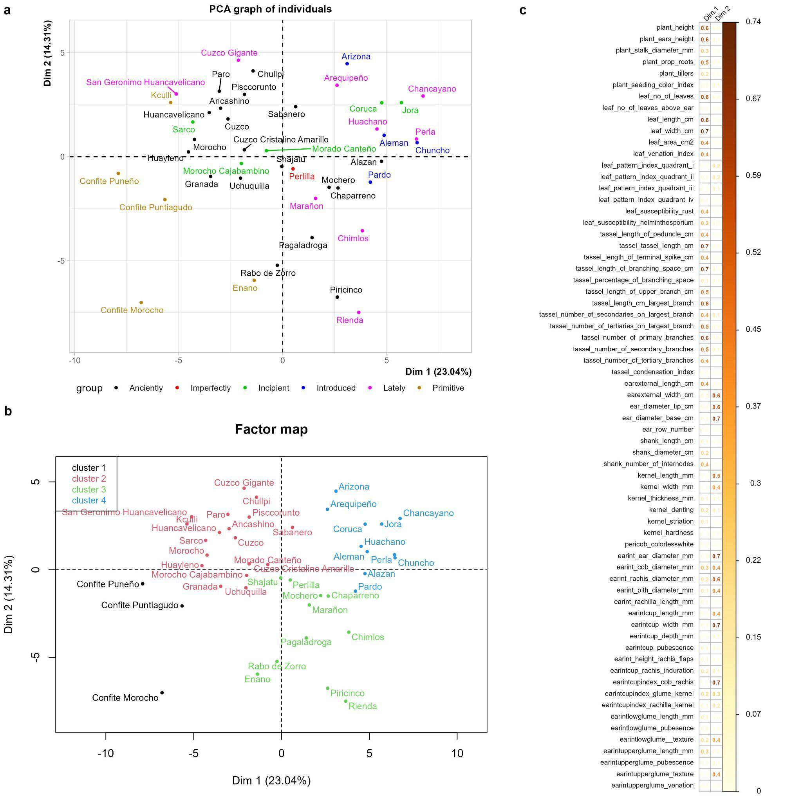
Figure 1: Multivariate structure of morphological variation among 43 Peruvian maize races (Zea mays L.) based in 68 quantitative morphological descriptors. (a) Principal component analysis (PCA) of race-level morphological profiles colored according to the historical racial categories proposed by Grobman et al. (1961); (b) hierarchical clustering on principal components projected onto the first two PCA dimensions; and (c) quality of variable representation (cos²) on PC1 and PC2. Historical racial categories were treated as supplementary qualitative information and did not contribute to PCA axis construction (n = 43).

Phenotypic clustering structure of maize races
A second PCA was performed using the nine morphological descriptors selected according to their cos² values. Within this reduced trait set, PC1 accounted for 43.92% and PC2 for 33.86% of the variance, jointly representing 77.78% (Figure 2a). Because these descriptors were selected specifically for their strong representation on the first two dimensions of the initial PCA, the higher cumulative percentage in the reduced analysis was expected and should not be interpreted as an increase in explained variance relative to the 68-descriptor PCA. Instead, the reduced analysis provided a compact two-dimensional summary of variation within the selected trait set.

In the reduced PCA, PC1 was primarily associated with vegetative architecture and tassel morphology, including leaf length, leaf width, tassel length, tassel branching space, and number of primary tassel branches. PC2 was more strongly associated with ear morphology, particularly basal ear diameter, internal ear diameter, cup width, and the cob–rachis index. Thus, the reduced ordination emphasized the principal morphological contrasts represented by the selected vegetative, tassel, and ear traits.

Hierarchical clustering on principal components (HCPC) separated the 43 race-level morphological profiles into four phenotypic clusters (Figure 2b). Cluster 1 comprised five races—Confite Morocho, Confite Puntiagudo, Confite Puneño, Huayleno, and Morocho—and was characterized by comparatively lower mean values for several vegetative, tassel, and ear dimensions, including leaf length and width, tassel length, number of primary tassel branches, tassel branching space, and ear dimensions.

Cluster 2 comprised 15 races and was characterized mainly by comparatively larger ear dimensions together with intermediate vegetative and tassel characteristics. Higher mean basal ear diameter and ear diameter, together with a comparatively lower cob–rachis index, differentiated this group from the remaining clusters.

Cluster 3 comprised 10 races and was characterized by comparatively longer tassels and greater tassel branching space, together with lower mean ear diameter and cup width. The cob–rachis index showed comparatively high values in this cluster, indicating a distinctive internal ear morphological profile.

Cluster 4 comprised 13 races and displayed comparatively high mean values for several vegetative and reproductive descriptors, including leaf length, leaf width, tassel length, tassel branching space, number of primary tassel branches, and selected ear dimensions. Complete membership of the four phenotypic clusters should be provided in a supplementary table so that individual race assignments can be verified directly.

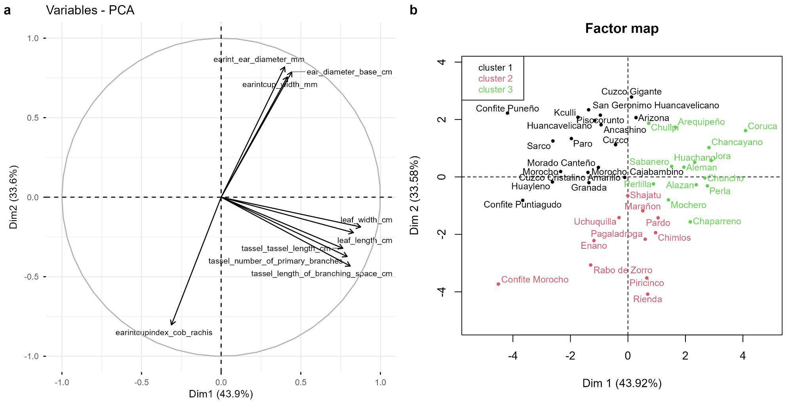
Figure 2: Multivariate analysis of 43 Peruvian maize races (Zea mays L.) based on nine morphological descriptors selected according to their quality of representation (cos² > 0.60) on the first two dimensions of the initial PCA. (a) Principal component analysis of the reduced trait set and (b) hierarchical clustering on principal components showing the four phenotypic clusters (n = 43).

Comparison with the racial classification of Grobman, Salhuana, and Sevilla (1961)
The four phenotypic clusters obtained through HCPC were compared with the six historical racial categories proposed by Grobman et al. (1961). Projection of the historical categories onto PCA space showed substantial overlap among categories, with races from different historical groups occupying similar regions of the multivariate space (Figure 3a). Likewise, races assigned to the same historical category were distributed across different branches of the HCPC dendrogram (Figure 3b).

These patterns indicate that morphological similarity among the analyzed races was not completely aligned with the historical racial classification. Several phenotypic clusters contained races assigned to different historical categories, while individual historical categories were represented in more than one phenotypic cluster. Therefore, the quantitative multivariate structure captured relationships among race-level morphological profiles that were only partially reflected by the classical evolutionary classification.

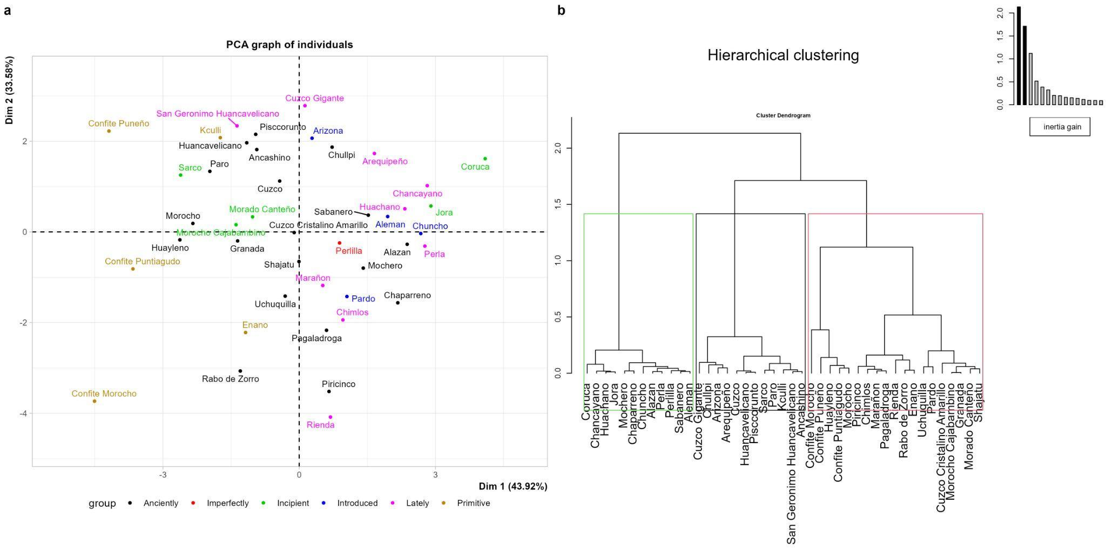
Figure 3: Comparison between multivariate phenotypic structure and the historical racial classification of 43 Peruvian maize races (Zea mays L.). (a) PCA ordination of race-level morphological profiles colored according to the historical racial categories proposed by Grobman et al. (1961), and (b) HCPC dendrogram showing morphological relationships among races. Historical racial categories were used only for comparison and did not contribute to PCA or HCPC construction (n = 43). 41)

Discussion

Morphological structure of Peruvian maize diversity
The present study demonstrates that the phenotypic diversity of Peruvian maize races can be effectively summarized through a relatively small set of quantitative morphological descriptors. From the 69 variables retained after the completeness filtering, ten traits associated primarily with plant architecture, tassel morphology, and ear structure showed the highest representation in the first two principal components. The PCA based on these ten variables accounted for 77.78% of the total phenotypic variation, compared with only 44.55% when the complete set of 69 variables was considered. This marked increase in explained variation indicates that the selected descriptors capture the major morphological gradients present among the 43 races and provides evidence that a large and historically accumulated descriptor set can be reduced without substantially losing the principal structure of phenotypic differentiation.

The predominance of plant architecture, tassel characteristics, and ear morphology in explaining phenotypic differentiation is consistent with the broader literature on maize landraces. A recent systematic review of phenotypic diversity in maize landraces identified plant architecture, flowering traits, and ear and kernel characteristics as recurrent contributors to differentiation among landraces across contrasting environments. These traits are particularly relevant because they integrate developmental patterns associated with adaptation, reproductive biology, farmer selection, and local production systems (Nanyangwe et al., 2026). Similar patterns have also been reported in maize diversity studies in which a relatively limited number of agro-morphological traits provided strong discrimination among landraces. For example, multivariate analyses of Himalayan maize landraces identified ear length, ear diameter, kernel weight, kernel number, and flowering behavior as major contributors to phenotypic differentiation (Sharma et al., 2015).

In the present study, PC1 was dominated by vegetative and tassel-related characteristics, including leaf length, leaf width, tassel length, tassel branching space, and number of primary tassel branches, whereas PC2 was mainly associated with ear architecture, including ear diameter, internal ear diameter, cup width, and the cob–rachis index. This separation suggests that vegetative/reproductive architecture and ear structure represent partially independent dimensions of phenotypic differentiation in Peruvian maize. Rather than reflecting a single morphological gradient, the diversity of these races therefore appears to result from combinations of traits that may have been shaped by different selection pressures and developmental processes.

The importance of these traits is also biologically plausible in the context of Andean maize. Peruvian maize has been cultivated across highly heterogeneous environments for millennia, and archaeological evidence demonstrates a long history of maize cultivation and diversification in Peru (Grobman et al., 2012). The resulting landraces have been maintained under contrasting agroecological conditions, ranging from lowland environments to high-elevation systems, providing opportunities for local selection and differentiation. Consequently, morphological traits related to plant architecture and reproductive structures may reflect both genetic differentiation and environmentally mediated phenotypic plasticity. This distinction is particularly important when interpreting morphological classifications of landraces.

Reduction of morphological descriptors improves the resolution of phenotypic differentiation
An important methodological finding of this study is that dimensionality reduction substantially improved the representation of phenotypic variation. The initial PCA based on 69 variables explained less than half of the total variation in the first two axes, whereas the analysis restricted to the ten variables with cos² > 0.6 explained 77.78%. This result should not be interpreted simply as evidence that the remaining descriptors are biologically unimportant. Rather, it indicates that many variables provide redundant information or contribute relatively little to the major axes of variation captured by the first two components.

The identification of a reduced descriptor set is particularly relevant for germplasm characterization because morphological evaluations can involve large numbers of traits, increasing labor requirements, data incompleteness, and analytical complexity. The systematic evidence available for maize landraces indicates considerable heterogeneity in the number and type of descriptors used among studies and emphasizes the need for standardized and informative phenotyping strategies (Nanyangwe et al., 2026). In this context, the ten variables identified here provide a potential core descriptor set for preliminary phenotypic screening of Peruvian maize races.

Nevertheless, these variables should not necessarily be regarded as a universal replacement for comprehensive characterization. Morphological descriptors that contribute little to the first two PCs may still contain information associated with specific agronomic, nutritional, adaptive, or taxonomic attributes. Therefore, the principal value of the reduced set is its capacity to summarize the dominant structure of morphological variation efficiently rather than to eliminate the need for complete characterization when conservation or breeding decisions require more detailed information.

Phenotypic clusters reveal relationships that extend beyond the historical racial classification
The HCPC analysis separated the 43 races into four phenotypic groups with contrasting combinations of vegetative, tassel, and ear characteristics. Cluster 1 represented the most compact morphological phenotype, whereas Cluster 4 showed the greatest vegetative and reproductive development. Clusters 2 and 3 occupied intermediate but clearly differentiated positions, primarily because of contrasting ear and tassel characteristics. Importantly, these clusters did not correspond strictly to the six historical categories proposed by Grobman et al. (1961).

The partial correspondence between the multivariate clusters and the historical classification is one of the most relevant findings of this study. The classical classification of Peruvian maize was developed from extensive morphological observations and incorporated evolutionary and geographical considerations, resulting in categories such as primitive, anciently derived, lately derived, introduced, incipient, and imperfectly defined races (Grobman et al., 1961). The present analysis does not invalidate this framework; instead, it demonstrates that evolutionary classification and phenotypic similarity represent different analytical dimensions.

The overlap among historical categories in the PCA space and the presence of races from different historical groups within the same HCPC cluster indicate that phenotypic similarity is not completely structured according to the historical evolutionary categories. Conversely, races assigned to the same historical category may occupy different phenotypic clusters. Such patterns are expected in a highly diverse, open-pollinated crop such as maize, where gene flow, farmer-mediated seed exchange, recurrent selection, and adaptation to local environments can generate complex combinations of morphological traits.

This interpretation is consistent with recent molecular evidence from Peruvian maize. García-Mendoza et al. (2025), using genotyping-by-sequencing in landraces from Cajamarca and Huancavelica, detected substantial genetic diversity and found that genetic relationships were not strongly determined by geographic origin. Their results emphasize that the structure of Peruvian maize diversity cannot necessarily be inferred from geography or traditional categories alone. This is important for interpreting the present results because morphological similarity among races should not automatically be interpreted as evidence of close genetic relatedness.

Likewise, studies of maize landraces in other regions have shown that morphological and molecular diversity can capture complementary aspects of population structure. For example, analyses combining morphological and molecular information have demonstrated that phenotypically differentiated landraces may share genetic backgrounds, whereas populations with relatively similar phenotypes can maintain substantial molecular differentiation (Alicandri et al. 2025). This reflects the complex relationship between genotype, phenotype, environment, and selection in maize landraces.

Environmental effects and the interpretation of morphological diversity
The interpretation of morphological differentiation requires particular caution because morphological traits are products of both genetic and environmental influences. This issue is especially relevant for Peruvian maize because the races considered in the historical classification are associated with markedly different ecological and altitudinal environments. The dataset analyzed here includes races originating from environments extending from coastal zones to highland and upper Amazonian systems, with substantial differences in altitude and ecological conditions. Hence, the phenotypic clusters identified in this study should be considered phenotypic similarity groups rather than genetic populations. The observed differences may reflect combinations of genetic differentiation, local adaptation, phenotypic plasticity, and historical selection. This distinction is supported by recent evidence showing that environmental effects and genotype × environment interactions can strongly influence the expression of morphological traits in maize landraces. A global synthesis of 50 studies found that flowering time, plant architecture, and ear and kernel traits frequently contribute to landrace differentiation, but also emphasized that phenotypic expression reflects the combined effects of genotype, environment, and genotype × environment interactions (Nanyangwe et al., 2026).

This consideration may also explain why some races traditionally grouped according to evolutionary history exhibit similar phenotypic profiles. If similar agroecological pressures repeatedly favor comparable plant architectures or ear characteristics, phenotypic convergence may occur even when populations are not closely related genetically. Conversely, different environmental conditions or farmer preferences may produce divergent phenotypes within historically related groups. Thus, the four clusters identified here can be interpreted as major phenotypic configurations that have emerged from the interaction between inherited variation and environmental selection rather than as direct representations of evolutionary lineages.

Implications for conservation and maize breeding
The identification of a reduced set of informative descriptors and four major phenotypic groups has practical implications for the conservation and utilization of Peruvian maize germplasm. Native maize populations constitute an important reservoir of diversity for breeding because they contain variation associated with adaptation to heterogeneous environments and traditional production systems. Their value is particularly relevant in the context of climate variability, where locally adapted germplasm may provide traits useful for improving resilience and stability.

The identification of contrasting morphological profiles may provide a basis for prioritizing germplasm for subsequent evaluation. For example, races characterized by distinctive ear architecture could be prioritized for research targeting grain characteristics and end-use quality, whereas races exhibiting contrasting plant architecture could be evaluated for adaptation, biomass-related traits, lodging resistance, or suitability to production systems. However, such applications require subsequent replicated field evaluations because the current analysis was designed to characterize morphological structure rather than estimate trait heritability or agronomic performance.

The potential breeding value of maize landraces is increasingly recognized through genomic approaches. European maize landraces, for example, have been shown to harbor extensive allelic diversity and substantial genetic variation for quantitative traits, demonstrating that landrace diversity can be converted into usable breeding material when appropriately characterized and evaluated across environments (Takou et al. 2025). Similarly, recent SNP-based analyses of Peruvian maize have confirmed high genetic diversity within Andean germplasm, reinforcing the importance of maintaining and characterizing these resources (García-Mendoza et al. 2025).

Accordingly, the present study provides a phenotypic framework that can serve as a basis for future integration with genomic information. Combining the ten discriminant morphological descriptors identified here with genome-wide SNP data would allow researchers to determine whether the major phenotypic groups correspond to genetic structure, identify traits associated with particular genomic regions, and distinguish environmentally induced phenotypic differentiation from genetically controlled variation. Such an integrative strategy would substantially improve the resolution of Peruvian maize diversity and strengthen the identification of germplasm with potential value for breeding.

Historical classification and quantitative phenotyping should be considered complementary
The results support a complementary rather than replacement-based relationship between classical racial classification and quantitative multivariate analysis. The racial system developed by Grobman et al. (1961) remains an important historical and biological reference because it integrates extensive observations of morphology, geography, evolutionary interpretation, and ethnobotanical context. However, the present study demonstrates that statistical analysis of quantitative descriptors can reveal relationships that are difficult to recognize through categorical classification alone.

This distinction is particularly important for the conservation of maize diversity. A classification system based exclusively on phenotypic clusters could overlook historically important races that possess unique characteristics but are placed within broader morphological groups. Conversely, a purely historical classification may obscure quantitative similarities among races that could be useful for germplasm management and comparative evaluation. Therefore, the most informative strategy is to maintain the historical racial identity while incorporating quantitative phenotypic descriptors as an additional layer of characterization.

The four clusters identified here should consequently be interpreted as a phenotypic organization of the existing racial diversity, rather than as a new racial classification. This distinction avoids overinterpretation and provides a more robust framework for subsequent genomic and multi-environment studies.

Limitations and future research
Several limitations should be considered when interpreting these findings. First, the morphological database was derived from the comprehensive historical characterization of Grobman et al. (1961), meaning that the present study represents a secondary analysis of previously collected phenotypic information rather than a contemporary multi-environment experiment. Consequently, the analysis cannot independently partition genetic effects from environmental effects. Second, the reduction of 130 descriptors to 69 variables according to data completeness, followed by selection of ten variables based on cos², was intended to maximize the representation of the dominant phenotypic structure but may exclude traits that are biologically relevant but weakly represented in the first two principal components.

Future research should therefore validate the four phenotypic groups using contemporary replicated field trials across contrasting Peruvian environments. Such experiments should incorporate genotype × environment analyses and estimates of heritability for the most informative traits. In parallel, genome-wide genotyping would allow the relationship between morphological and genetic structure to be formally tested. This is particularly relevant given recent evidence of high genetic diversity among Peruvian maize landraces and the apparent weakness of geographic origin as a sole predictor of genetic structure (García-Mendoza et al., 2025).

Overall, the present findings indicate that the phenotypic diversity of Peruvian maize is structured along multiple morphological dimensions and cannot be fully represented by the historical racial categories alone. The identification of 10 informative descriptors and four phenotypically coherent groups provides a more parsimonious representation of this diversity and may serve as a basis for future integration of morphological, ecological, and genomic information. Rather than challenging the historical classification, the results demonstrate the value of combining classical taxonomy with quantitative phenotyping and, ultimately, genomic approaches to improve the conservation and utilization of Peru's xceptionally diverse maize genetic resources.

Conclusion
This study demonstrated that multivariate statistical analyses provide an effective framework for characterizing the phenotypic diversity of Peruvian maize races. From an initial set of 69 retained morphological variables, ten informative descriptors associated with plant architecture, tassel morphology, and ear characteristics were identified as the variables that best represented the principal dimensions of phenotypic variation.
The selected variables efficiently summarized morphological diversity and enabled the identification of four well-defined phenotypic groups. Although these groups showed partial agreement with the historical racial classification proposed by Grobman et al. (1961), they also revealed phenotypic relationships that were not fully reflected by the traditional classification, highlighting the value of quantitative multivariate approaches for evaluating morphological similarity among races.

Rather than replacing the classical racial classification, the multivariate approach complements it by providing an objective statistical framework for describing phenotypic diversity. The integration of informative morphological descriptors with multivariate analyses represents a valuable strategy for germplasm characterization and offers practical applications for the conservation, management, and utilization of native Peruvian maize in breeding programs. Future studies integrating phenotypic and genomic information will further improve our understanding of the evolutionary relationships and diversity of Peruvian maize races.

References
Alicandri, E., De Santis, D., Modesti, M., Ferri, S., Paolacci, A.R., Rea, R, and Ciaffi, M. (2025). Genetic and Phenotypic Diversity and Evaluation of Total Phenolics and Antioxidant Properties of Garlic Landraces from Lazio Region (Central Italy): "Aglio Rosso di Proceno" and "Aglio Rosso di Castelliri". Plants (Basel), 14(8), 1189. doi: 10.3390/plants14081189.
Ashogbon, A. O. (2022). Chemistry of maize components. In Maize (pp. 39–76). CRC Press. https://www.taylorfrancis.com/chapters/edit/10.1201/9781003245230-2/chemistry-maize-components-adeleke-omodunbi-ashogbon
Erenstein, O., Jaleta, M., Sonder, K., Mottaleb, K., and Prasanna, B. M. (2022). Global maize production, consumption and trade: Trends and R&D implications. Food Security, 14(5), 1295–1319. https://doi.org/10.1007/s12571-022-01288-7
Evers, T., and Millar, S. (2002). Cereal Grain Structure and Development: Some Implications for Quality. Journal of Cereal Science, 36(3), 261–284. https://doi.org/10.1006/jcrs.2002.0435
García-Mendoza, P.J., Saldaña, C.L., Pérez-Almeida, I.B., Prieto-Rosales, G.P., Medina-Castro, D.E., Taramona-Ruíz, L.A., and Arbizu, C.A. (2025). Genetic diversity and population structure of maize landraces from Huancavelica and Cajamarca provinces of Peru using SNP markers. Plant Genetic Resources: Characterization and Utilization, 23(4),262-270. doi:10.1017/S1479262125000024
García-Lara, S., and Serna-Saldivar, S. O. (2019). Corn History and Culture. In Corn (pp. 1–18). Elsevier. https://doi.org/10.1016/B978-0-12-811971-6.00001-2
Grobman, A., Bonavia, D., Dillehay, T. D., Piperno, D. R., Iriarte, J., and Holst, I. (2012). Preceramic maize from Paredones and Huaca Prieta, Peru. Proceedings of the National Academy of Sciences, 109(5), 1755–1759. https://doi.org/10.1073/pnas.1120270109
Grobman, A., Salhuana, W., Sevilla, R., and Mangelsdorf, P. C. (1961). Races of maize in Peru; their origins, evolution and classification. https://www.cabidigitallibrary.org/doi/full/10.5555/19631604469
Grote, U., Fasse, A., Nguyen, T. T., and Erenstein, O. (2021). Food Security and the Dynamics of Wheat and Maize Value Chains in Africa and Asia. Frontiers in Sustainable Food Systems, 4, 617009. https://doi.org/10.3389/fsufs.2020.617009
Gwirtz, J. A., and Garcia‐Casal, M. N. (2014). Processing maize flour and corn meal food products. Annals of the New York Academy of Sciences, 1312(1), 66–75. https://doi.org/10.1111/nyas.12299
Kaur, R., and Singh, A. (2022). Coloured maize and its unique features. In Maize (pp. 247–284). CRC Press. https://www.taylorfrancis.com/chapters/edit/10.1201/9781003245230-8/coloured-maize-unique-features-ramandeep-kaur-urvashi-ramandeep-kaur-arashdeep-singh
Kaushal, M., Sharma, R., Vaidya, D., Gupta, A., Saini, H. K., Anand, A., Thakur, C., Verma, A., Thakur, M., Priyanka, and Kc, D. (2023). Maize: An underexploited golden cereal crop. Cereal Research Communications, 51(1), 3–14. https://doi.org/10.1007/s42976-022-00280-3
Kennett, D. J., Prufer, K. M., Culleton, B. J., George, R. J., Robinson, M., Trask, W. R., Buckley, G. M., Moes, E., Kate, E. J., Harper, T. K., O’Donnell, L., Ray, E. E., Hill, E. C., Alsgaard, A., Merriman, C., Meredith, C., Edgar, H. J. H., Awe, J. J., and Gutierrez, S. M. (2020). Early isotopic evidence for maize as a staple grain in the Americas. Science Advances, 6(23), eaba3245. https://doi.org/10.1126/sciadv.aba3245
Kinnunen, P., Guillaume, J. H. A., Taka, M., D’Odorico, P., Siebert, S., Puma, M. J., Jalava, M., and Kummu, M. (2020). Local food crop production can fulfil demand for less than one-third of the population. Nature Food, 1(4), 229–237. https://doi.org/10.1038/s43016-020-0060-7
Nanyangwe, S., Ndeve, A. D., Fato, P., Munisse, P., Oladiran, K. P., Lhamine, C. F., & Kipkoech, M. C. (2026). Phenotypic diversity in maize landraces: A systematic review of global patterns, methodological approaches, and implications for breeding. Genes, 17(4), 413. https://doi.org/10.3390/genes17040413
Patel, R., Memon, J., Kumar, S., Patel, D. A., Sakure, A. A., Patel, M. B., Das, A., Karjagi, C. G., Patel, S., Patel, U., and Roychowdhury, R. (2024). Genetic Diversity and Population Structure of Maize (Zea mays L.) Inbred Lines in Association with Phenotypic and Grain Qualitative Traits Using SSR Genotyping. Plants, 13(6), 823. https://doi.org/10.3390/plants13060823
Poole, N., Donovan, J., and Erenstein, O. (2021). Viewpoint: Agri-nutrition research: Revisiting the contribution of maize and wheat to human nutrition and health. Food Policy, 100, 101976. https://doi.org/10.1016/j.foodpol.2020.101976
Salvador-Reyes, R., and Clerici, M. T. P. S. (2020). Peruvian Andean maize: General characteristics, nutritional properties, bioactive compounds, and culinary uses. Food Research International, 130, 108934. https://doi.org/10.1016/j.foodres.2019.108934
Sharma, L., Prasanna, B. M., & Ramesh, B. (2010). Analysis of phenotypic and microsatellite-based diversity of maize landraces in India, especially from the North East Himalayan region. Genetica, 138(6), 619–631. https://doi.org/10.1007/s10709-010-9436-1
Smith, J. S., Trevisan, W., McCunn, A., and Huffman, W. E. (2022). Global dependence on Corn Belt Dent maize germplasm: Challenges and opportunities. Crop Science, 62(6), 2039–2066. https://doi.org/10.1002/csc2.20802
Takou, M., Schulz, K., and Stetter, M.G. (2025). Local Selection Shaped the Diversity of European Maize Landraces. Molecular Ecology, 34(24),e17720. doi: 10.1111/mec.17720.
Zambrano, J. L., Yánez, C. F., and Sangoquiza, C. A. (2021). Maize Breeding in the Highlands of Ecuador, Peru, and Bolivia: A Review. Agronomy, 11(2), 212. https://doi.org/10.3390/agronomy11020212

