Below is a drafted feature of your project based on your original submission. Thank you for submitting your project to Maintainers in Academia and for your contribution to open source. Please feel free to make any light edits or updates, especially where details may have changed. You’re also welcome to add links, images, or screenshots if helpful. In the email, you’ll also find a few optional questions on AI and evolving workflows, feel free to respond if you’d like to contribute.

Maintainer: Flavio Lozano-Isla (Professor)
Institution: Universidad Nacional Toribio Rodriguez de Mendozas (UNTRM)
Department/Faculty: Agronomy Faculty

Project:
- Name: inti: Tools and Statistical Procedures in Plant Science
- Repository: https://github.com/Flavjack/inti
- Website: https://inkaverse.com/
- Logo:
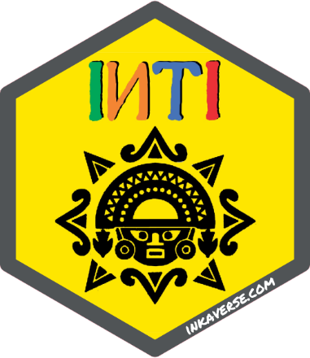

Profiles:
- GitHub: https://github.com/Flavjack

- LinkedIn: https://www.linkedin.com/in/flozanoisla/
- Google Scholar: https://scholar.google.es/citations?user=ltiG4dMAAAAJ&hl

The interview
What is inti: Tools and Statistical Procedures in Plant Science, and what does it help people do?
The inti package is part of the inkaverse project, which was developed for support with tools and statistical procedures for plant science and experimental design. Its main goal is to support researchers throughout the full workflow, from experimental planning and data collection with tarpuy(), to data analysis and visualisation with yupana(), and technical writing. The project aims to make scientific analysis more accessible, reproducible, and efficient for students, researchers, and professionals.
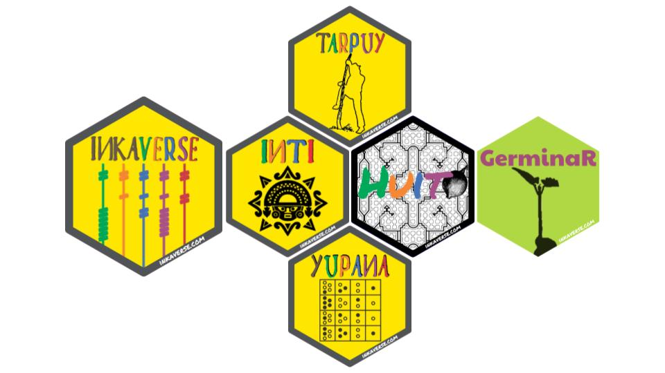
Figure 1. The Inkaverse Project: An Integrated Package of Statistical Tools and Experimental Design Applications for Plant Science Research.
What inspired you to start this project?
During my PhD, I spent a significant amount of time analysing and organising data from field experiments. This experience inspired me to create a project that supports young scientists in learning statistics and plant science. I wanted to shorten their learning curve by providing an interactive approach that introduces them to the R programming language and helps them transition into data analysis and scientific programming.
How does this project connect to your academic work?
This project aligns with my academic work in teaching, capacity development, and research in plant sciences. As a university professor and researcher, I develop and teach courses related to plant breeding, crop physiology, and data analysis. My teaching emphasises interactive and applied learning to equip students with the skills needed to conduct rigorous scientific research.
Who contributes to the project?
I initially developed the project in collaboration with a colleague from my first professional experience and a university friend. The early phase combined practical field experience with academic insights.
Currently, the project is maintained and further developed by me alongside a group of students. As an open-source initiative, it also benefits from contributions, feedback, and recommendations from the scientific community.
How are students involved in the project?
Students are primarily involved through testing, identifying bugs, and providing feedback. After receiving training in data analysis and programming, they also contribute to coding and implementing new pipelines. This hands-on experience strengthens their skills while supporting the project’s continuous development.
How is the project used in teaching or coursework?
The project is integrated into the Programming and Data Analysis course within the Faculty of Engineering and Agricultural Sciences (FICA) at the Universidad Nacional Toribio Rodríguez de Mendoza. Students use the software for hands-on coding, data analysis, and implementing pipelines, including analysing data for their research and thesis projects.

What impact has this project had on your students?
Participating in this project has significantly improved my students’ data analysis and decision-making skills. Many students now apply these skills in roles within private companies.
The project has also supported their academic progress by reducing the time required to prepare theses, dissertations, and scientific publications, equipping them with practical tools for both academic and professional success.
What impact has the project had beyond the classroom or research?
The project has had a notable real-world impact by improving the analytical skills and employability of students and their future careers. Many participants have transitioned into private-sector roles where they apply what they have learned.
Beyond academia, the project has fostered a community of practice, encouraging continuous learning and innovation in agricultural data analysis and supporting evidence-based decision-making in real-world contexts.
What does it take to maintain the project?
The project is currently maintained as part of my academic and research activities, alongside contributions from students and the community. It is also supported by GitHub Sponsors and training services provided to private companies. These resources help sustain its development and respond to the evolving needs of the agricultural data analysis community.
What have been the biggest challenges in maintaining the project, especially in an academic setting?
One of the biggest challenges is balancing the project development with teaching responsibilities, research commitments, and student supervision. However, this limitation has been partially mitigated through the active involvement of students, who contribute to the maintenance, continuous development, updating, and refinement of the software, thereby fostering a collaborative and sustainable development framework within the academic context.
How do you ensure the project remains sustainable over time?
To ensure sustainability, the project has been integrated into coursework, where students contribute through coding and testing. Additional support comes from research grants, GitHub Sponsors, and training services. The open-source model also encourages ongoing community contributions.
How do you engage with your community?
We create and share free educational content, including videos and training sessions, to support the community in learning data analysis techniques.
The software is available as an R package on CRAN, ensuring easy access for users worldwide. We also published all the software under open-source license, encouraging adoption, feedback, and contributions of the community.
Have you taken part in any open source programs or events?
Not yet, but we are interested in participating in open-source programs and events in the future.
What would you love to achieve by showcasing your project?
I would love to highlight the project’s impact on capacity development in agricultural data analysis and programming. Showcasing it would increase visibility, attract collaborators, and encourage contributions from scientific, academic, and industry communities. It would also promote accessible tools that simplify research and support scientific innovation.
Is there anything else you’d like to share about your project or open source journey?
As an agronomist, I began my journey without a background in programming. Over time, I recognised the importance of programming and open-source software in research, which shaped my focus on accessible learning for students from non-programming backgrounds.
I now prioritise teaching basic programming skills in agricultural sciences to expand career opportunities and support data-driven research.
In addition, I maintain other educational R packages such as GerminaR and huito, which support plant science data analysis and promote accessible, reproducible research practices.

Optional: AI, Workflows & Maintaining Your Project
Do you use AI tools in your day to day work on this project? If so, how?
Artificial intelligence tools are systematically integrated into the daily workflow to enhance, refine, and accelerate both the development and deployment of the software components associated with this educational project. Their application spans code optimization, debugging, documentation generation, and the automation of repetitive tasks, thereby increasing overall efficiency and reducing development time. Furthermore, many contemporary programming environments and platforms incorporate built-in AI functionalities within their interfaces, which facilitates more intuitive coding processes, improves usability, and streamline implementation across different stages of the software lifecycle.
Do you implement AI into your classroom or coursework (if applicable)? If so, what does that look like in practice?
Yes, artificial intelligence is actively integrated into both classroom instruction and coursework as a complementary tool to support learning processes. In practice, AI-based tools are used to assist students in understanding programming concepts, identifying and correcting coding errors, and exploring alternative solutions in real time. This approach facilitates a more interactive and adaptive learning environment, where students can receive immediate feedback and guidance.
The incorporation of AI significantly accelerates the acquisition of programming skills by reducing the learning curve associated with complex concepts and debugging processes. As a result, students can maintain engagement and motivation, minimizing frustration commonly associated with early stages of programming training, and fostering a more efficient and sustained learning experience.
Has AI changed how you maintain or manage your project?
The integration of artificial intelligence has significantly transformed how the project is maintained and managed. AI-assisted programming tools have streamlined development workflows, enabled more efficient maintenance processes and facilitating continuous improvement of the software. These tools support automated error detection, code optimization, and refactoring, which enhances code quality and robustness.

Have you experimented with AI driven or automated workflows in your project? What has that looked like?
Yes, AI workflows are integrated to support code generation and automate documentation, particularly for R functions. This accelerates development, improves code quality, and enhances reproducibility and collaboration within the project.
Have you explored GitHub Agentic Workflows? What has your experience been?
Not yet.
If you use GitHub Agentic Workflows, do you prefer to create, debug, and modify them through an agent, or by manually editing the markdown file?
I didn’t use GitHub Agentic Workflows.
How do you see your contributors using AI when working on your project?
Contributors primarily use artificial intelligence as a support tool for programming tasks, particularly for debugging and error detection in code. In practice, AI assists them in identifying issues more efficiently, suggesting improvements, and exploring alternative coding solutions. At the same time, this interaction contributes to the progressive enhancement of their programming skills, as it provides immediate feedback and reinforces learning through guided problem-solving.
What concerns or challenges, if any, do you have about the use of AI in your project or field?
Although artificial intelligence represents a substantial advancement in supporting programming tasks, one of the main challenges lies in its dependency on prior user expertise. In practice, the effective use of AI-generated code still requires a solid understanding of programming fundamentals, as the outputs are not always error-free and often demand critical evaluation and correction. Consequently, without sufficient technical knowledge, there is a risk of misinterpreting suggestions or propagating errors, which highlights the continued importance of foundational skills for the reliable and responsible use of AI in the project.

How has your approach to maintaining this project evolved over time?
The approach to maintaining the project has progressively evolved toward a more collaborative and community model. Initially centered on individual development, it has transitioned to actively engaging students in the continuous improvement of the package through feedback, support, and practical contributions. Furthermore, the open-access nature of the project has enabled external users to participate in refining the codebase, proposing enhancements, and identifying issues.
How do you see AI shaping the future of your project or field?
Artificial intelligence is expected to play a transformative role in shaping the future of the project by enhancing both the development process and user interaction. In the context of software engineering, AI tools will continue to improve code generation, optimization, and validation, thereby increasing development efficiency and code quality. At the same time, AI is likely to be progressively integrated into the software itself, enabling more dynamic and intelligent interaction with users through adaptive interfaces and automated assistance.

