Nested Association Mapping (NAM) Reveals Genetic Architecture of Agronomic Traits in Quinoa
Flavio Lozano-Isla^{1,2*}; Milagros Ninoska Munoz-Salas³, Mireia Vidal-Villarejo¹; Bettina I.G. Haussmann^{1,4}; Angel Mujica Sanchez⁵; Karl Schmid^{1,6*}
1 Institute of Plant Breeding Seed Science, and Population Genetics, University of Hohenheim, DE
2 Present affiliation: Instituto de Investigación para el Desarrollo Sustentable de Ceja de Selva (INDES-CES), Universidad Nacional Toribio Rodríguez de Mendoza de Amazonas, Chachapoyas, PE.
3 Department of Earth and Environment, Institute of Environment, Florida International University, Miami, FL 33199, US
4 Present affiliation: German Institute for Tropical and Subtropical Agriculture (DITSL GmbH), Witzenhausen, DE
5 Programa de Mejoramiento Genético de Cultivos Andinos, Facultad de Ciencias Agrarias, Universidad Nacional del Altiplano, Puno, PE
6 Cluster of Excellence GreenRobust, University of Hohenheim, DE
*Corresponding author.
Flavio Lozano-Isla <flavio.lozano@untrm.edu.pe>
Karl Schmid <karl.schmid@uni-hohenheim.de>

ORCID IDs:
Author | ORCID | email
Flavio Lozano-Isla | 0000-0002-0714-669X | flavio.lozano@untrm.edu.pe
Milagros Ninoska Munoz-Salas | 0009-0001-7278-5690 | mmuno126@fiu.edu
Mireia Vidal-Villarejo | 0000-0002-7507-0930 | mireia.vidal@uni-hohenheim.de
Bettina I.G. Haussmann | 0000-0002-2360-6799 | bettina.haussmann@uni-hohenheim.de
Angel Mujica Sanchez | 0000-0002-7013-8780 | amujica@unap.edu.pe
Karl Schmid | 0000-0001-5129-895X | karl.schmid@uni-hohenheim.de

STATEMENTS AND DECLARATIONS
Funding
This study was supported by a capacity development grant from KWS SAAT SE & Co. KGaA awarded to the Universidad Nacional del Altiplano, Puno, and the University of Hohenheim. The Article Processing Charge (APC) were funded by the Vice-Rectorate for Research of the Universidad Nacional Toribio Rodríguez de Mendoza de Amazonas (UNTRM).
Data and code availability
The datasets generated and/or analyzed during the current study are publicly available. Raw sequencing data have been deposited in the European Nucleotide Archive (ENA) under BioProject accession PRJEB114395 (https://www.ebi.ac.uk/ena/browser/view/PRJEB114395). The complete dataset and reproducible analysis scripts are available in the GitHub repository (https://github.com/Flavjack/quinoa-genetics). Supplementary File 1 contains all datasets and analysis workflows used in this study.
Author contributions
BIGH and KS conceived the study. FLI and AMS performed material preparation, data collection and investigation. FLI and MVV curated the data. Methodology was developed by FLI, MNMS and MVV, and formal analysis was performed by FLI. Software was implemented by FLI and MVV. Visualization was prepared by FLI and MNMS. BIGH and KS acquired funding, and AMS provided project administration and resources. BIGH and KS supervised the study. FLI and MNMS wrote the first draft, and all authors contributed to review and editing. All authors read and approved the final manuscript.
Acknowledgments
The authors thank the Andean Crops Genebank of the Universidad Nacional del Altiplano (UNAP), Puno, Peru, for supplying the genetic materials used in this research.
Competing interests
The authors declare no competing financial or non-financial interests.

ABSTRACT
Quinoa (Chenopodium quinoa Willd.) is a stress tolerant pseudocereal recognized for its nutritional value and adaptation to marginal environments. However, breeding progress for yield and resilient cultivars remains constrained by limited knowledge of the genetic architecture of agronomic traits. To address this gap, two nested association mapping (NAM) populations were developed using the recurrent parents Salcedo INIA, a high-yielding cultivar, and Kancolla, a traditional highland landrace, crossed with four diverse founder cultivars from the Peruvian Altiplano. Previously collected multi-environment phenotypic data from 125 recombinant inbred lines were integrated with low coverage whole-genome resequencing, from which 6,054 high quality SNP markers were retained in 118 individuals for genomic analyses. Population structure analyses showed differentiation between Salcedo and Kancolla families, with limited differentiation among families. Genome-wide association analysis identified 29 significant SNPs involving 21 unique SNPs across eight agronomic traits, including flowering time, physiological maturity, plant height, panicle morphology, and yield. Candidate genes analysis identified 38 genes located within genomic regions surrounding significant SNPs. Genomic prediction showed trait and population dependent performance, with accuracies ranging from −0.11 to 0.79 and the highest values observed for phenological and selected panicle traits. This study establishes a NAM resource for quinoa and provides genomic insights that can support genetic dissection and efficient selection for adaptation and productivity in Andean breeding programs.
Keywords: andean crops; genetic diversity; genomic prediction; GWAS; plant breeding

INTRODUCTION
Quinoa (Chenopodium quinoa Willd.) is increasingly recognized as a nutritionally rich and stress-tolerant pseudocereal [1,2]. Its grains contain a balanced profile of essential amino acids, polyunsaturated fatty acids, dietary fiber, vitamins, and minerals. They are also gluten-free and have a low glycaemic index, which are attributes that make them suitable for functional foods and specialized diets [3]. In addition to these nutritional properties, quinoa exhibits tolerance to multiple abiotic stresses, including drought, salinity, frost, and low-fertility soils, enabling cultivation in environments where traditional crops are less productive [4–8]. This combination of resilience and nutritional quality positions quinoa as a strategic crop under a climate change scenario.
Global expansion of quinoa cultivation has accelerated since the International Year of Quinoa in 2013, with experimental and commercial cultivation now reported in more than 120 countries [9]. Although Peru and Bolivia remain the principal producers and exporters, significant expansion has occurred in North America, Europe, Africa, and Asia [9,10]. This global expansion has created opportunities to diversify food systems while also posing challenges associated with yield instability, market fluctuations, and increasing demands on genetic resources [10,11]. The conservation and targeted use of this genetic diversity are essential for developing new cultivars with greater yield stability and climate resilience.
Recent advances in genomics have shown the potential of improving quinoa cultivars by breeding for traits like resistance against downy mildew [12,13], early maturity and higher productivity [14], and resilience against abiotic stresses [15,16]. In addition, high-throughput phenotyping pipelines enable the systematic capture of the extensive phenotypic variation present among quinoa genetic resources [17]. Building on these advances, efforts toward QTL mapping, such as those by Maldonado-Taipe et al. [14], have provided a foundation for integrating the diversity of genetic resources into breeding programmes. Genome-wide association study (GWAS) and bulk segregant analysis (BSA) approaches have identified genomic regions linked to downy mildew resistance and candidate defense-related genes, including a major resistance locus on chromosome 4 [13,18]. Similarly, the construction of the first genetic linkage maps has provided a basic framework for trait mapping but lacks the power to capture the allelic diversity present in quinoa germplasm [19]. In contrast, nested association mapping (NAM), a multi-parent population design in which a common parent is crossed with multiple diverse founders, combines the high mapping resolution of genome-wide association studies with the power of linkage analysis [20]. This approach has proven effective in other crops [21–23] enabling precise dissection of quantitative traits and facilitating marker deployment in breeding by integrating the statistical resolution of linkage mapping with the allelic diversity of multi-parent populations.
This study explores the potential of NAM populations for dissecting complex agronomic and adaptive traits in quinoa. The integration of widely used cultivars in the Peruvian highlands, such as Salcedo INIA and Kancolla provide a foundation for including causal genetic variation for these traits in a NAM population design. We focus on the genetic analysis of NAM populations developed from crosses between Salcedo INIA, Kancolla, and diverse founder lines. Our objectives were (i) to assess the genetic structure and diversity of the NAM families, (ii) to identify QTLs associated with agronomic and yield-related traits through joint linkage–association analyses using previously published multi-environment phenotypic data collected in the Peruvian highlands, and (iii) to evaluate the predictive performance of genomic selection models. These populations represent a foundational genomic resource for quinoa improvement, providing a pathway to integrate genetic diversity into breeding pipelines for quinoa.

MATERIALS AND METHODS
The phenotypic dataset used in the present study was re-used the multi-environment phenotypic data reported by Lozano-Isla et al. [24]. In the present study, these published phenotypic data were integrated with a low-coverage whole-genome resequencing SNP markers to perform population structure analyses, genome-wide association mapping, candidate gene identification, and genomic prediction.

Plant material and population development
In a previous study on quinoa breeding [24], we developed six segregating populations derived from biparental crosses of traditional Peruvian cultivars to establish two nested association mapping (NAM) populations. A structured multi-parental design was implemented using two contrasting recurrent parents: Salcedo INIA (SAL) and Kancolla (KAN). The SAL-based panel was generated by crossing Salcedo INIA with three founder lines – Huariponcho (SAL × HUA), Pandela Rosada (SAL × PAN), and Negra Collana (SAL × NCO) – while the KAN-based panel comprised crosses between Kancolla and Huariponcho (HUA × KAN), Pasankalla (PAS × KAN), and Negra Collana (NCO × KAN). The F₁ progenies were advanced through five generations of selfing using a bulk method to increase homozygosity, producing 96 recombinant inbred lines (RILs) per cross. From these, 25 lines per population were selected and subsequently evaluated from the F₇ to F₉ generations in multi-location field trials across the Peruvian highlands to assess agronomic performance, yield stability, and adaptation under contrasting environmental conditions (Figure 1).

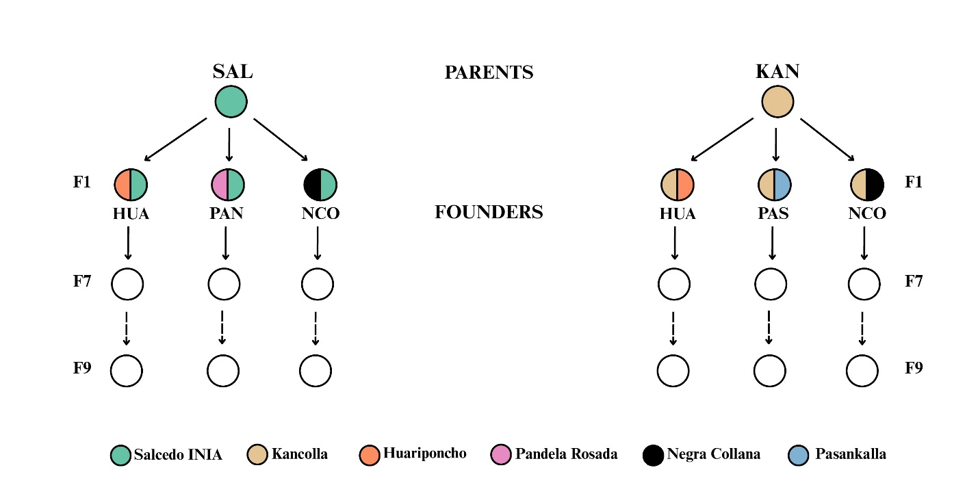
Figure 1: Breeding scheme for nested association mapping (NAM) using two populations developed for a quinoa breeding program in the Peruvian highlands. Two recurrent parents were used: Salcedo INIA (SAL) and Kancolla (KAN). SAL was crossed with Huariponcho (SALxHUA), Pandela Rosada (SALxPAN), and Negra Collana (SALxNCO), while KAN was crossed with Huariponcho (HUAxKAN), Pasankalla (PASxKAN), and Negra Collana (NCOxKAN).
Parental lines were selected based on agronomic performance, phenotypic divergence, and adaptation to Andean highland environments [24]. Salcedo INIA is a widely used cultivar characterized by high yield potential and resistance to frost and powdery mildew [25], and has also been studied for its postharvest physical properties and grain quality at different altitudes [26]. In contrast, Kancolla is a traditional landrace noted for its cold and hail tolerance and elevated saponin content [27]. It was identified as a resilient genotype in field trials in the Andean highland and in stressful environments such as saline soils and arid conditions of the Sahara desert [24,28]. The founder lines Huariponcho, Pandela Rosada, Pasancalla, and Negra Collana were chosen to maximize allelic diversity, capture adaptive variation, and enhance recombination within each NAM panel.

Phenotypic evaluation
Phenotypic data used in the present study were obtained from Lozano-Isla et al. [24]. The study generated BLUEs and BLUPs from multi-environment trials using mixed linear models. In the present study, the published BLUE values were used as phenotypic information. Field trials conducted at two experimental sites in the highlands of the province of Puno, Peru, near Lake Titicaca and approximately 40 km apart: Camacani (3,825 m a.s.l.) and Illpa (3,820 m a.s.l.). Phenological and agronomic traits were measured at three developmental stages: flowering (BBCH stage 69), physiological maturity (BBCH stage 89), and harvest (BBCH stage 99), according to the BBCH scale adapted for quinoa [29]. Standard descriptors developed by Biodiversity International [30] were employed to record traits, including days to 50% flowering (days), days to physiological maturity (days), plant height (cm), stem diameter (cm), panicle length (cm), panicle width (cm), grain yield per plant (g) and yield per plot (g/5 m2). Grain yield per plant was estimated using two subsamples of 10 randomly selected plants per experimental unit to ensure representative sampling. Panicle width × length (cm2) was included as a trait due to its correlation with yield [24].
Phenotypic data were subjected to quality control, including outlier detection and residual diagnostic analyses to verify model assumptions. Following the recommendations of Kozak and Piepho [31], residual plots were used to assess normality and homogeneity of variance. These procedures were performed and reported in our previous study [24], from which the BLUE estimates used in the present work were obtained.

Genotyping and sequence processing
DNA extraction and sequencing
Young leaves were sampled from three-month-old field-grown plants at Camacani. For each line, pooled tissue from two plants was dried in silica gel and shipped to the University of Hohenheim (Germany) for DNA extraction using the AX Gravity DNA kit (A&A Biotechnology, Poland). DNA integrity was assessed by agarose gel electrophoresis, and concentration was quantified using Qubit fluorometry (Qubit™ 4 Fluorometer, Thermo Fisher Scientific, USA). Whole-genome sequencing was conducted at Novogene (Beijing, China) using the Illumina NovaSeq S4 platform, generating 2 × 150 bp paired-end reads.
Read processing, variant calling, and SNP filtering
Raw sequencing reads from the 235 retained samples were processed using Trim Galore v0.6.7 [32] with parameters --paired and -q 30 to remove adapter sequences and low-quality bases. High quality reads were aligned to the quinoa reference genome (QQ74; CoGe ID 60716) using BWA-MEM v0.7.17 [33]. Resulting BAM files were sorted and indexed with SAMtools v1.8 [34], and duplicate reads were removed using Picard tools. Variant calling was performed using BCFtools v1.11 [35].
An initial filtering step was applied to remove variants with more than 80% missing genotypes (F_MISSING > 0.8). The resulting variant dataset was subsequently imported into the snpR R package [36] for population genomic filtering. SNPs were retained when the minor allele frequency (MAF) was ≥0.05, each locus was genotyped in at least 50% of individuals (min_ind = 0.50), and each individual was genotyped at ≥50% of loci (min_loci = 0.50). MAF filtering was performed within cross (maf_facets = “cross”), following the recommendations of Hemstrom et al. [37]. Non polymorphic loci were removed during filtering.

Population structure and genetic diversity
Population structure and genetic diversity were assessed using the snpR R package [36]. Genotype data were imported from the filtered VCF file as an snpRdata object and annotated with population and cross metadata. Principal component analysis (PCA) was performed using plot_clusters() with population and cross information as facets to visualize genetic differentiation among NAM lines. Population structure was inferred using sparse non-negative matrix factorization (sNMF) implemented in plot_structure(), testing values of K from 2 to 10 with 20 replicate runs per K. The optimal number of ancestral clusters was determined based on the minimum mean cross entropy criterion. A final ancestry plot was generated at the selected K value. Genetic diversity was quantified using observed heterozygosity (Ho), expected heterozygosity (He), the inbreeding coefficient (FIS), and the proportion of polymorphic loci using calc_ho(), calc_he(), calc_fis(), and calc_prop_poly(), respectively. Population differentiation among the six NAM crosses was estimated using pairwise Weir and Cockerham’s FST implemented in calc_pairwise_fst() and visualized as a heatmap.

Genome-wide association study
Genome-wide association studies (GWAS) were conducted to identify SNP–trait associations underlying yield-related traits in the quinoa NAM populations. To maximize statistical robustness and reduce spurious associations, multiple complementary statistical models were implemented in the rMVP R package [38]. The framework was selected because it is memory-efficient, visualization-enhanced, and parallel-accelerated, allowing efficient variance component estimation and large-scale computation. The fixed and random model circulating probability unification (FarmCPU) was used in the analysis [39]. This model combines fixed and random effects while correcting for population structure and kinship, thereby increasing statistical power across loci of varying effect sizes. To control for confounding, the first principal components derived from genome-wide SNP data were included as fixed covariates, while a kinship matrix was incorporated as a random effect. Significance thresholds were determined using Bonferroni threshold for the p-value where $α_{Bonferroni}=m/α; m=0.05$ and $α$ is the number of SNPs (Supplementary File 1). This multi-model and multi threshold strategy ensured both sensitivity in detecting true associations and stringency in minimizing false positives. The phenotypic data for the analysis was performed using the BLUEs calculated in the MLT in the second stage from Lozano-Isla et al [24] according to Holland & Piepho [40].

Identification of candidate genes associated with significant SNPs
Candidate genes associated with significant SNPs identified in the physical positions of genome-wide significant SNPs detected in the GWAS analyses. The quinoa QQ74 genome annotation was obtained as a GFF3 file (CoGe Genome ID 60716; https://genomevolution.org/coge/GenomeInfo.pl?gid=60716) [41]. Gene functions were extracted from the annotation and processed using the GenomicRanges package [42]. For each significant SNP, a genomic window extending ±100 kb around the SNP position was defined. Genomic overlaps between SNP windows and annotated genes were identified using findOverlaps() (Supplementary File 1). Gene identifiers, genomic coordinates, and annotation information were extracted for each overlapping feature, and genes lacking annotation information were excluded from the final candidate gene dataset.

Genomic prediction
Genomic prediction was implemented using the genomic best linear unbiased prediction (GBLUP) framework, which is widely used in plant breeding due to its reliability, scalability, and interpretability [43]. Marker effects were modeled across the genome using ridge regression BLUP (rrBLUP) [44], allowing the estimation of genomic estimated breeding values (GEBVs) under the assumption of predominantly additive genetic effects. This linear mixed model framework has been widely adopted in genomic selection because it captures a substantial portion of the genetic variance while remaining computationally efficient in high-dimensional datasets [45].
To assess predictive ability, cross-validation (CV) was used. In each replicate, 60% of the lines were randomly assigned to the training set for model fitting, while the remaining 40% were allocated to the validation set for prediction. To strengthen the robustness and reproducibility of accuracy estimates, this cross-validation procedure was repeated across 300 resampled prediction sets, each consisting of five independent CV iterations. This resampling strategy has been recommended in recent genomic prediction studies to ensure stable and unbiased evaluations of predictive performance [43].
Prediction accuracy was quantified with the Pearson correlation between observed phenotypes and genomic estimated breeding values (GEBVs) in the validation set, complemented by the normalized root mean square error (NRMSE) to account for scaling effects [46]. The Pearson correlation (r), which ranges from −1 to 1, measures the ability of the model to correctly rank genotypes according to their genetic merit, with values closer to 1 indicating higher predictive ability [47]. In contrast, the NRMSE quantifies the magnitude of prediction error relative to the scale of the trait, where values closer to cero indicate greater predictive precision [48].

RESULTS

Genetic structure and diversity
To assess the structure and differentiation of each NAM population, principal component analysis (PCA) and population structure analyses were performed, and the fixation index (Fst) was estimated to quantify the degree of population differentiation between both NAM populations (Figure 2). Additionally, diversity indices were calculated for each population, including proportion of polymorphic loci, observed heterozygosity (Ho), expected heterozygosity (He), and the inbreeding coefficient (FIS).
Low-coverage whole-genome sequencing of 348 lines generated a total of 361.95 Gb of raw data. Quality control at the sample level identified 113 samples with sequencing output below 50 Mb, which were excluded from further analyses. The remaining 235 samples yielded an average of 1.54 Gb per sample, corresponding to approximately 1.06× coverage of the 1.45 Gb quinoa genome [41] (Supplementary Figure 1). After filtering using BCFtools, 61,528 SNPs were retained for downstream genotype filtering. Subsequent filtering with the snpR R package retained 6,054 high quality SNPs across 118 individuals, which were used for subsequent genetic analyses (Supplementary Figure 2).
Principal component analysis (PCA) revealed clear genetic differentiation between the two NAM populations derived from the parental varieties Kancolla (KAN) and Salcedo INIA (SAL) (Figure 2 a). The first principal component (PC1), explaining 13.84% of the total variance, separated individuals according to parental origin, with KAN-derived genotypes clustering on the left and SAL-derived genotypes on the right. In contrast, the second principal component (PC2), accounting for 3.05% of the variance, did not reveal a clear pattern of differentiation between groups.
To characterize genetic structure and patterns of admixture among biparental families derived from KAN and SAL parental lines, the number of ancestral clusters (K) was inferred using sparse non-negative matrix factorization (sNMF). The number clusters for population structure was inferred for K = 2–10 (Supplementary Figure 3), which identified a stable structure at K = 3 based on the minimum mean cross entropy criterion (Figure 2 b). Across K values, a primary subdivision aligned with parental background (KAN vs. SAL) was consistently recovered, with cross-specific admixture superimposed on this axis. At K = 3, KAN-derived families (NCO×KAN, HUA×KAN, PAS×KAN) were assigned predominantly to Cluster 2 (blue), with PAS×KAN showing the highest homogeneity, HUA×KAN displaying intermediate admixture, and NCO×KAN exhibiting the greatest admixture, including contributions from Clusters 1 and 3, and the largest overlap with SAL-derived groups. Conversely, SAL-derived families (SAL×PAN, SAL×HUA, SAL×NCO) showed high membership to Cluster 3 (yellow), with SAL×PAN being the least admixed and only modest contributions from Cluster 2 across SAL crosses. Cluster 1 contributed minimally overall.
Pairwise fixation index (FST) estimates indicated low genetic differentiation within each parental group and moderate differentiation between groups (Figure 2 c). Both Kancolla (KAN)- and Salcedo INIA (SAL)-derived families showed minimal internal structuring with FST-values among KAN-NAM families ranging from 0.004 to 0.014 SAL-NAM from 0.003 to 0.005 whereas consistent differentiation was observed in pairwise comparisons between KAN- and SAL-derived families, with an average of 0.15 reflecting a stronger separation by parental origin, and confirming the PCA.

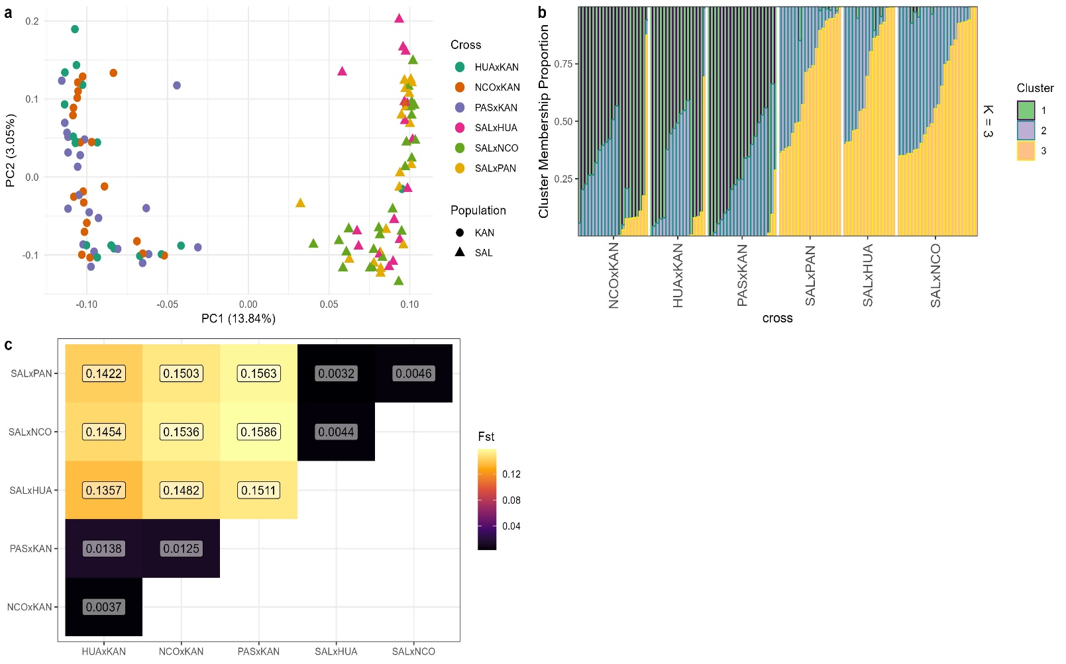
Figure 2: Genetic differentiation of quinoa NAM sub populations. (a) Principal component analysis (PCA) based on genome-wide SNPs. (b) Ancestry estimation for population structure using sparse non-negative matrix factorization (sNMF) at K = 3. (c) Pairwise fixation index (FST) heatmap among NAM subpopulations. For population structure each vertical bar represents an individual, and colors indicate cluster-membership proportions; individuals are grouped by cross: Negra Collana × Kancolla (NCO×KAN), Huariponcho × Kancolla (HUA×KAN), Pasankalla × Kancolla (PAS×KAN), Salcedo INIA × Pandela Rosada (SAL×PAN), Salcedo INIA × Huariponcho (SAL×HUA), and Salcedo INIA × Negra Collana (SAL×NCO).

Genetic diversity indices for the quinoa NAM populations are summarized in Table 1. At the population level, KAN and SAL showed comparable levels of observed heterozygosity (Hₒ = 0.14 in KAN and 0.13 in SAL). Expected heterozygosity (Hₑ) was similar in both populations (0.11 in both KAN and SAL). In both cases, observed heterozygosity exceeded expected heterozygosity, resulting in negative inbreeding coefficients (FIS = −0.19 in KAN and −0.22 in SAL), indicating an excess of heterozygotes within the NAM populations.
Across the individual crosses, observed heterozygosity varied between 0.13 and 0.14 across families and consistently exceeded expected heterozygosity (0.10–0.12). As a consequence, all crosses showed negative FIS values, ranging from −0.18 to −0.24. The strongest heterozygote excess was observed in SAL×PAN (FIS = −0.24), followed by NCO×KAN and SAL×HUA (both FIS = −0.22), while HUA×KAN showed the least negative value (FIS = −0.18).
The proportion of polymorphic loci indicated high levels of genetic variability in the two parental populations, with values of 0.95 for KAN and 0.93 for SAL. In contrast, the NAM crosses showed lower proportions of polymorphic loci, ranging from 0.67 to 0.76. Among the KAN-derived crosses, PAS×KAN showed the highest proportion of polymorphic loci (0.76), followed by NCO×KAN (0.71) and HUA×KAN (0.70). Among the SAL-derived crosses, SAL×NCO showed the highest value (0.71), whereas SAL×HUA and SAL×PAN showed lower values (0.67).
Table 1: Genetic diversity indices for quinoa NAM populations. Observed heterozygosity (Hₒ), expected heterozygosity (Hₑ), inbreeding coefficient (FIS), proportion of polymorphic loci (poly), and number of individuals (n = 118).
Population | Ho | He | FIS | poly | n
NAM
KAN | 0.14 | 0.11 | -0.19 | 0.95 | 59
SAL | 0.13 | 0.11 | -0.22 | 0.93 | 59
Cross
HUAxKAN | 0.14 | 0.11 | -0.18 | 0.7 | 17
NCOxKAN | 0.13 | 0.11 | -0.21 | 0.71 | 21
PASxKAN | 0.14 | 0.12 | -0.2 | 0.76 | 21
SALxHUA | 0.14 | 0.11 | -0.22 | 0.67 | 16
SALxNCO | 0.13 | 0.1 | -0.21 | 0.71 | 24
SALxPAN | 0.13 | 0.1 | -0.24 | 0.67 | 19

Mapping of QTL associated with yield architecture in NAM populations
We conducted a genome-wide association study (GWAS) to identify quantitative trait loci (QTLs) associated with key components of quinoa yield architecture across nested association mapping (NAM) families derived from Salcedo INIA (SAL) and Kancolla (KAN), respectively (Figure 3). The phenotypic traits used in the GWAS were analyzed using the best linear unbiased estimates (BLUEs; [49]. Most trait distributions approximated a normal distribution (Supplementary Figure 4), particularly those related to plant architecture and yield components (plant height, panicle length and width, stem diameter, grain yield per plant, and grain yield per plot). In contrast, traits associated with phenology (number of days to 50% flowering and physiological maturity) deviated from normality, reflecting their intrinsic biological nature as time-to-event variables with discrete and often skewed distributions.
GWAS using FarmCPU identified 29 SNPs significantly associated with yield-related traits across the quinoa NAM populations (Figure 3, Supplementary Table 3). Of these, 19 SNPs were detected in the KAN-NAM population and 10 in the SAL-NAM population. All significant associations exceeded the Bonferroni threshold calculated using the 6,054 filtered SNPs (p < 8 × 10⁻⁶). The significant associations involved eight traits. Phenological traits accounted for five associations, including one associated with days to 50% flowering and four associated with days to 50% physiological maturity. Architectural traits accounted for 20 associations, including 10 associated with plant height, six with panicle length, and four with panicle width. Yield-related variation was represented by four associations with grain yield per plot, all detected in the KAN-NAM population. No significant associations were detected for mean stem diameter, grain yield per plant, panicle width at maturity, or panicle width × length.
Several SNPs were associated with more than one trait. SNP_2241 was detected in the KAN-NAM population and was significantly associated with days to 50% flowering, days to 50% physiological maturity, panicle length at flowering, panicle width at flowering, and grain yield per plot. SNP_3262 was associated with both days to 50% physiological maturity and panicle length at flowering, while SNP_3705 was associated with days to 50% physiological maturity and plant height at flowering. Similarly, SNP_5873 was associated with days to 50% physiological maturity, panicle length at flowering, and grain yield per plot.
To validate the GWAS signals, QQ plots were examined for each trait (Supplementary Figure 5). The observed distributions of −log₁₀(p) closely followed the expected null distribution across most traits, confirming that the models effectively controlled for population structure and relatedness. Deviations from the null expectation were evident in the tails for flowering time, physiological maturity, panicle length and panicle width, reflecting the presence of true associations rather than spurious signals. In contrast, yield-related traits grain yield per plant, yield per plot and panicle width x length showed only modest departures from expectation, consistent with their lower number of significant SNPs. Together, the Manhattan and QQ plots demonstrate that the detected loci represent reliable associations, especially for phenological traits with strong genetic signals in the KAN-NAM population.
An additional association analysis was performed using the R package NAM, which is specifically designed for nested association mapping populations [50]. The Manhattan plots showed no peaks surpassing the Bonferroni thresholds (Supplementary Figure 6). The QQ plots (Supplementary Figure 7) further confirmed this outcome, as the observed −log₁₀(p) values largely fell below the expected distribution under the null hypothesis, indicating an overall conservative model fit. The NAM implementation did not uncover additional associations beyond those identified with the rMVP package [51].

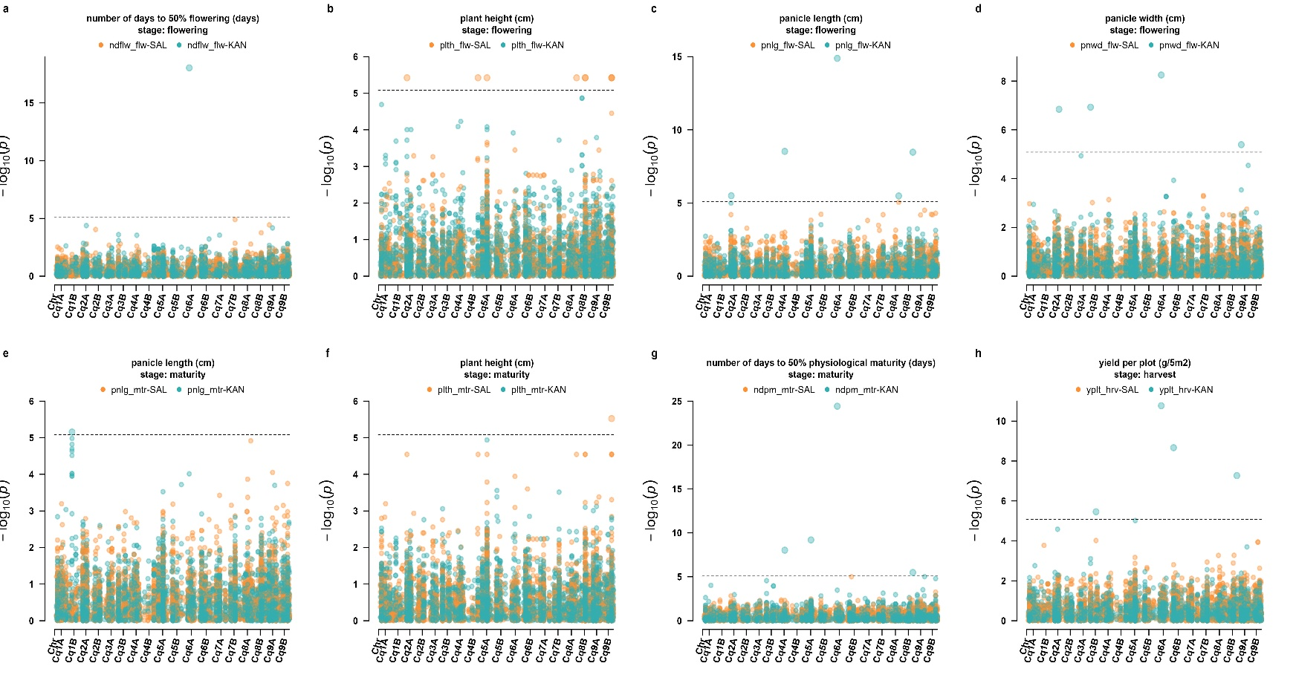
Figure 3: Genome-wide association study for yield-related traits in quinoa (Chenopodium quinoa) in two NAM populations evaluated at two locations in the Peruvian highlands. (a) Number of days to 50% flowering (days, ndflw), (b) Plant height at flowering (cm, plth_flw), (c) Panicle length at flowering (cm, pnlg_flw), (d) Panicle width at flowering (cm, pnwd), (e) Panicle length at maturity (cm, pnlg_mtr ), (f) Plant height at maturity (cm, plth_mtr), (g) Number of days to 50% physiological maturity (days, ndpm_mtr), and (h) Grain yield per plot (g/5m2, yplt_hrv) Orange and green points denote SAL- and KAN-derived NAM populations, respectively (n = 118). The horizontal line indicates the genome-wide significance at Bonferroni threshold (p-value < 0.000008; $α_{Bonferroni}=\frac{m}{α}; m=0.05, α=6054 snps$).

Identification of candidate genes associated with significant SNPs
A total of 38 candidate genes were identified within ±100 kb genomic windows surrounding the significant SNPs detected in the GWAS analysis (Supplementary Table 4). These genes were identified from nine unique significant SNPs and were distributed across seven quinoa chromosomes: Cq2A, Cq3B, Cq4B, Cq6A, Cq8A, Cq8B, and Cq9A. The largest number of candidate genes was identified on chromosome Cq2A (14 genes), followed by Cq8A (10 genes), Cq6A and Cq9A (four genes each), Cq8B (three genes), Cq4B (two genes), and Cq3B (one gene).
Candidate genes were identified for six traits. Panicle length at flowering was associated with the largest number of candidate genes (20), followed by plant height at flowering (13), panicle width at flowering (9), yield per plot (7), number of days to 50% physiological maturity (7), and number of days to 50% flowering (4). Several genes were located within genomic windows surrounding SNPs associated with more than one trait. In particular, SNP_2241 on Cq6A was associated with multiple phenological, architectural, and yield related traits, while SNP_5873 on Cq8B was associated with physiological maturity, panicle length, and yield per plot.
The functional annotations of the candidate genes represented diverse biological processes. For plant height at flowering, the candidate genes included DIR19, DIR7, RPL5, TBL38, and a probable folate-biopterin transporter. Candidate genes associated with panicle length at flowering included genes annotated as a DEAD-box RNA helicase, cytochrome c oxidase assembly protein, PSII maintenance protein, pseudouridine synthase, KIN17-like protein, cytosolic sulfotransferase, dehydrodolichyl diphosphate synthase, choline kinase, and charged multivesicular body protein 7. For phenological traits, candidate genes included acetyl-coenzyme A synthetase (ACS), prohibitin-3 (PHB3), ribulose bisphosphate carboxylase large chain (rbcL), and pre-mRNA splicing factor SR-like 1 (SRL1). Candidate genes identified for yield per plot included ABCG3 and KINB3, which were annotated as an ABC transporter and an SNF1-related protein kinase regulatory subunit, respectively (Supplementary Table 4).

Genomic prediction in NAM population
Genomic prediction performance was evaluated for 12 agronomic and yield related traits in each NAM population. For each trait and population, prediction accuracy and normalized root mean square error (NRMSE) were estimated from 300 independent 60/40 training-validation partitions (Supplementary Table 5; Figure 4). Across traits, mean prediction accuracy was generally higher in KAN than in SAL, with mean accuracies across the 12 traits of approximately 0.38 in KAN and 0.26 in SAL. The differences between populations were statistically significant for most traits based on Welch’s two-sample t-tests, although no significant difference was detected for panicle width × length (P = 0.40).
In the KAN population, the highest mean prediction accuracies were observed for number of days to 50% physiological maturity (0.79), number of days to 50% flowering (0.77), and panicle length at flowering (0.77). Moderate predictive performance was observed for yield per plot (0.51), panicle length at maturity (0.41), and panicle width at flowering (0.38). Accuracy was lower for mean stem diameter (0.08) and panicle width at maturity (−0.11). Prediction accuracy in the SAL population was generally lower than in KAN. The highest mean accuracies in SAL were observed for number of days to 50% physiological maturity (0.46) and plant height at maturity (0.46), followed by panicle length at maturity (0.34), panicle width at maturity (0.31), and panicle length at flowering (0.31). The lowest accuracy was observed for a number of days to 50% flowering (0.24), while mean stem diameter showed a slightly negative value (−0.05).
NRMSE values were generally close to or greater than 1, indicating variable prediction error relative to the phenotypic standard deviation (Supplementary Table 5). In KAN, NRMSE values ranged from 0.78 to 1.03, with the lowest values observed for a number of days to 50% flowering and physiological maturity (0.78) and panicle length at flowering (0.79). In SAL, NRMSE values ranged from 0.98 to 1.02, with the lowest values observed for panicle length at maturity (0.98), panicle width at maturity (0.99), and physiological maturity (0.99). Significant differences in NRMSE between populations were detected for most traits, whereas no evidence of a population difference was observed for mean stem diameter (P = 0.20), panicle length at maturity (P = 0.30), grain yield per plant (P > 0.90), or panicle width × length (P = 0.20).
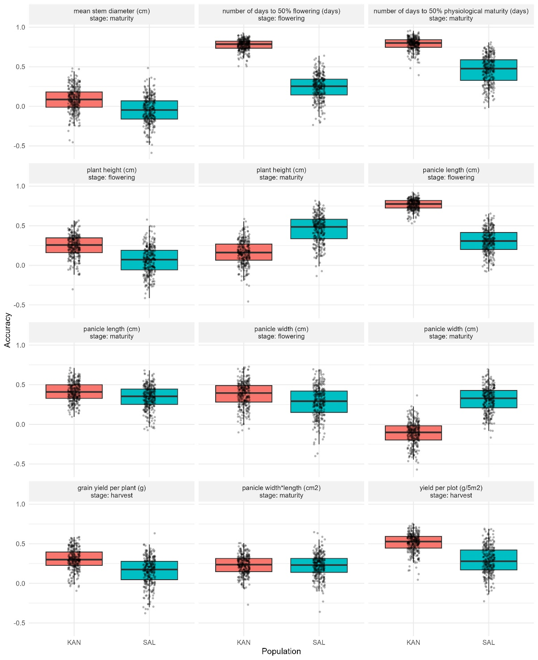
Figure 4: Genomic prediction accuracy for yield-related traits in quinoa (Chenopodium quinoa) across two nested association mapping (NAM) populations. Mean stem diameter (cm), days to 50% flowering (days), days to 50% physiological maturity (days), plant height (cm) at flowering and maturity, panicle length (cm), panicle width (cm) at flowering and maturity, grain yield per plant (g), panicle width × length (cm2) and yield per plot (g/5m2). Training and validation sets were split in a 60/40 proportion with 60 individuals from the KAN population and 65 from the SAL population (n = 118). For each trait, 300 iterations were performed, and boxplots represent the distributions of prediction accuracy.

DISCUSSION
This study presents the first implementation of nested association mapping (NAM) in quinoa, providing a genomic resource to dissect the genetic architecture of yield-related traits in germplasm from the Andean highlands. By combining the two different recurrent parents Salcedo INIA, a widely cultivated improved variety, and Kancolla, a traditional highland landrace, with diverse founder lines from the Peruvian highlands, the NAM populations were designed to include broad allelic variation associated with phenology, plant architecture, and yield components. The integration of multi-environment phenotyping, genome-wide SNP data, and association studies enabled the identification of genomic regions contributing to agronomic trait variation while simultaneously revealing the population structure and genetic diversity underlying this breeding material. Genomic prediction allowed us to evaluate the potential of genomic selection in these structured populations.

Genetic diversity and population structure in NAM population
The assessment of genetic structure and diversity revealed clear differentiation between SAL- and KAN-derived populations, reflecting their divergent breeding histories and adaptation to the environmental conditions of the highland. Salcedo INIA is a high-yielding, disease- and frost-resistant cultivar, while Kancolla is a traditional landrace noted for its stress tolerance and high saponin content [24]. Principal component analysis and ancestry inference consistently separated families according to parental origin, while pairwise FST values confirmed divergence between populations but low differentiation within families (Figure 2). Genetic diversity estimates indicated moderate variability, and consistently negative inbreeding coefficients pointed to a heterozygosity across the populations (Table 1). In the context of the advanced inbreeding generation of the material analyzed (S9), where a high level of homozygosity is expected; however, the residual heterozygosity and negative FIS values reflect the multi-parental origin of the NAM design and the persistence of segregating genomic regions due to recombination among diverse founders.
Patiranage et al. [18] reported low levels of nucleotide diversity (π) in quinoa accessions from highland and lowland populations, with values of 0.000578 and 0.000356, respectively, which is a typical representation of self-pollinated species such as quinoa. These estimates were obtained from high-quality whole-genome resequencing data, which likely provide an accurate representation of the genetic diversity of quinoa than that captured in the present study. In contrast, the present study does not rely on nucleotide diversity estimates but on marker-based diversity using the proportion of polymorphic loci, which reflects allelic variation at the genotyped loci rather than genome-wide sequence diversity. The results obtained in our study showed high proportions of polymorphic loci in the parental lines (Table 1) and moderately reduced in the NAM-derived families, indicating that a considerable fraction of segregating variation was retained across populations (Table 1). KAN-derived crosses tended to exhibit a higher proportion of polymorphic loci values compared to SAL-derived crosses, suggesting a greater contribution or retention of polymorphic segments from the KAN background. Additionally, the relatively narrow range of proportion of polymorphic loci values among crosses indicates a homogeneous distribution of introgressed variation across the NAM population, despite differences in parental origin. This pattern reflects the biparental crossing design and recent recombination events inherent to NAM populations rather than population subdivision.
The high admixture coefficients observed in some KAN- or SAL-derived individuals reflect limited introgression, whereas intermediate coefficients correspond to a greater contribution of alleles from multiple founder parents. Consequently, negative FIS values were detected, indicating an excess of heterozygotes relative to Hardy–Weinberg expectations (Table 1). This pattern likely reflects the biparental crossing design and recent recombination events inherent to NAM populations rather than population subdivision. Additionally, FST estimates revealed differentiation between the SAL- and KAN-derived groups but little divergence within families (Figure 2). In contrast, a study conducted in Colombia that assessed the genetic diversity of quinoa using 27 microsatellite markers across three groups classified according to their geographic origin reported high expected heterozygosity values, ranging from 0.58 to 0.62 [52].

QTL for yield-related traits
The genome-wide association analysis identified 29 significant SNP–trait associations involving 21 unique SNPs and eight agronomic traits (Figure 3). These associations were distributed across phenological, architectural, and yield-related traits, supporting the complex genetic architecture underlying agronomic variation in quinoa. These traits, including flowering time, plant height, panicle morphology, and grain yield, have previously been identified as key targets for genetic improvement due to their relatively high heritability and direct contribution to yield potential [17,24,53,54]. The detection of multiple loci across traits is consistent with the polygenic architecture of yield formation in quinoa, where complex agronomic traits are controlled by numerous loci with small to moderate effects, as reported in previous QTL and GWAS studies [14].
The detected associations presented an uneven distribution of QTL between NAM subpopulations, with 19 associations detected in KAN and 10 in SAL NAM population. Landraces are known to harbor extensive allelic diversity associated with environmental adaptation, which can increase the probability of detecting trait-associated loci in mapping populations [55]. When comparing the genomic positions of the SNPs detected in this study (SupplementaryTable 3) with loci reported in previous quinoa mapping studies (Supplementary Table 6), overlapping chromosomal regions were identified for several phenological and architectural traits. In particular, the significant associations overlapped previously reported regions on Cq4A, Cq6A, Cq8B, Cq2A, and Cq9A, which have been implicated in the regulation of phenology, plant architecture, and yield-related traits in quinoa populations [14,56,57].
For phenological traits such as days to 50% flowering and physiological maturity, significant SNPs detected in this study were located on Cq4A, Cq5A, Cq6A, and Cq8B for flowering and on Cq4A, Cq5A, Cq6A, and Cq8B for physiological maturity. Several of these chromosomes, particularly Cq4A, Cq6A, and Cq8B, also contain regions previously associated with flowering or maturity-related traits, while the association on Cq5A provides an additional genomic signal not represented among the corresponding regions in Supplementary Table 6. Earlier studies have reported QTL controlling flowering time on chromosomes Cq2A, Cq5A, and Cq6A, suggesting that these genomic regions may harbor conserved regulatory elements involved in developmental timing and environmental adaptation [18,57]. The recurrence of associations involving Cq6A and other chromosomes across independent studies supports their potential relevance to phenological variation in quinoa, although the stability and causal nature of these loci require further validation (Supplementary Table 6).
Yield-related traits exhibited fewer significant associations, with four SNP–trait associations detected for yield per plot on Cq3B, Cq6A, Cq6B, and Cq8B. This result is consistent with previous findings indicating that grain yield in quinoa is a highly complex trait influenced by many loci with small effects and strong environmental interactions [57]. The relatively small number of yield SNPs may reflect the polygenic nature of yield and the environmental sensitivity of this trait, which can reduce the power to detect individual loci in mapping populations of limited size. However, the identification of four yield loci provides genomic regions that can be evaluated in independent populations and environments to determine their stability and breeding relevance.
The genomic regions identified in this study were distributed across seven quinoa chromosomes, with the highest concentration of candidate genes on Cq2A and Cq8A. A total of 38 unique candidate genes were identified within the genomic regions surrounding nine significant SNPs associated with six agronomic traits (Supplementary Table 4). For plant height, the region surrounding SNP_202 on Cq2A included DIR19, DIR7, RPL5, and TBL38. Dirigent proteins are involved in the stereoselective coupling of phenoxy radicals and have been associated with lignan and lignin metabolism and cell wall processes [58–60]. Other plant height associated regions contained genes related to cytoskeletal organization, membrane function, DNA replication, and cellular metabolism, including FH13, RTNLB21, MCM5, AHA8, and GDPDL7 on Cq8A .
The multi trait candidate regions were detected around SNP_2241 on Cq6A and SNP_5873 on Cq8B. SNP_2241 was associated with flowering, physiological maturity, panicle length, panicle width, and yield per plot and was located near ACS, PHB3, rbcL, and SRL1. SNP_5873 was associated with physiological maturity, panicle length, and yield per plot and was located near ndhA, ndhE, and ndhG. The chloroplast NDH complex participates in cyclic electron transport and contributes to photosynthetic energy balance and stress acclimation, providing a plausible biological context for the latter association [61]. For panicle traits, additional candidate regions included SNP_555 on Cq2A and SNP_5630 on Cq8A, containing genes involved in RNA metabolism, cellular regulation, G-protein signaling, and copper transport. The Cq9A region surrounding SNP_977 included ABCG3 and KINB3, genes associated with membrane transport and energy signaling; ABC transporters have established roles in plant growth and reproductive development [62].
These findings across independent studies reinforces the genetic basis of yield in quinoa is structured by a set of moderate to large effect regions across populations. These regions could represent strategic targets for marker assisted selection in breeding programs focused on productivity and climatic adaptation.

Genomic prediction in NAM populations
Genomic prediction was implemented in the quinoa NAM population to highlight the breeding potential. The simulations showed prediction accuracies ranged from low (-0.11) to high (0.8) across traits and population, demonstrating their application on quinoa. Accuracy distributions in KAN are consistently centered at higher, positive values for phenological and architectural traits (number of days to 50% flowering, number of days to 50% physiological maturity, and panicle length at maturity), whereas in SAL toward low or negative values and display greater dispersion (Figure 4).
The presence of negative prediction accuracies for some traits, particularly in the SAL population, indicates that the genomic model failed to predict phenotypic variation better than random expectation in those cases. Negative correlations between observed phenotypes and predicted GEBVs can arise when training population size is limited, marker density is insufficient, or when the genetic architecture of the trait is highly complex and influenced by environmental variation [47,63]. In this case, the results of the present study could be explained by the relatively small population size and the moderate marker density derived from low-coverage sequencing, which may limit the ability of the model to capture the underlying genetic signal. Such results do not necessarily invalidate the model but rather highlight limitations in prediction power under the current population structure and dataset size.
The results converge on higher model capacity for phenology and inflorescence architecture – particularly in KAN – and moderate performance for yield traits; SAL shows low accuracies and elevated NRMSEs for most traits, with few exceptions and without significant differences where they occur. In addition to prediction accuracy, model performance was evaluated using the normalized root mean square error (NRMSE), which quantifies the magnitude of prediction error relative to the scale of the observed trait values. Lower NRMSE values indicate greater predictive precision and smaller deviations between predicted and observed phenotypes [46,48]. In KAN, the lowest NRMSE values were observed for days to 50% flowering (0.78), days to physiological maturity (0.78), and panicle length at flowering (0.79), whereas the corresponding values in SAL were 1.02, 0.99, and 0.99, respectively. These findings support prioritizing traits such as number of days to 50% flowering, number of days to 50% physiological maturity, and panicle length at maturity, and indicate the need for targeted strategies – e.g., increased sample size, marker enrichment, or multi-environment models – to improve predictability in SAL population.
In our previous study conducted with the same NAM populations, variance components and broad-sense heritability were estimated [24]. Within this context, traits with high heritability, such as days to maturity (H² = 0.95), days to flowering (H² = 0.91), grain width (H² = 0.94), and plant height at maturity (H² = 0.88), also achieved the highest prediction accuracies (i.e. 0.6–0.9), indicating that a substantial proportion of the phenotypic variance is attributable to genetic effects captured by molecular markers. In contrast, traits with intermediate or low heritability, such as plant height at flowering (H² = 0.45), panicle width at flowering (H² = 0.46), and harvest index (H² = 0.72), exhibited lower prediction accuracies (i.e. 0.1–0.4), reflecting a greater contribution of residual variance and genotype × environment interaction. In particular, traits associated with morphological components at early developmental stages showed higher contributions of error varianceₑ and genotype × location variance, which reduces the stability of genetic effects across environments and consequently limits predictive performance [64]. A particularly relevant case was grain yield, which, despite presenting relatively high heritability (H² = 0.84), showed only moderate prediction accuracy (i.e. 0.3–0.5). This discrepancy can be explained by its considerable interaction component genotype × location variance and residual variance, indicating a complex, likely polygenic genetic architecture.
These differences between populations likely reflect contrasting genetic architectures and trait heritabilities between highland cultivars and traditional landraces backgrounds [24]. Importantly, prediction accuracies reached values of up to 0.79 despite moderate marker density and low sequencing depth, producing outcomes consistent with results in other cereals and legumes [43,45]. The findings confirm that genomic prediction can be implemented in quinoa breeding pipelines to accelerate genetic gain. The integration of genomic prediction under multi-environment trials is particularly relevant, as it allows for the explicit modeling of genotype × environment interactions, which play a key role in determining yield stability across environments [65].
The observed prediction accuracies indicate that genomic prediction can be effectively implemented in quinoa NAM populations, particularly for phenological and architectural traits. The higher predictive performance detected in the KAN population suggests that genetic background and population structure influence model efficiency, highlighting the importance of population-specific training in genomic selection frameworks. Our results demonstrate the practical applicability of genomic selection in quinoa and highlight its potential to enhance selection strategies in Andean germplasm.

Limitations and perspectives
Despite the results, some limitations of the study must be acknowledged. The sequencing depth (~1× coverage) limited marker density. Although genotype imputation can improve low coverage datasets, its accuracy depends on the availability of a suitable reference panel, which is currently unavailable for Peruvian Highlands quinoa [66]. Therefore, we used stringent quality filtering of directly observed SNPs to ensure robust downstream analyses. Future studies using higher sequencing depth or improved reference panels will further enhance mapping resolution [67]. The reduction from 348 sequenced lines to 118 individuals retained for the final genomic analyses further constrained statistical power, particularly for GWAS and genomic prediction. The number of parental lines in this quinoa NAM population is smaller than in classical designs such as the original maize NAM population [68], which included 25 founders crossed to a single reference line. The reduced number of individuals per population could decrease the statistical power for GWAS and genomic prediction analyses. Nevertheless, the smaller population size is offset by the high genetic divergence between parental lines, ensuring allelic diversity for effective QTL detection.
Unlike our previous study [24], which focused on phenotypic characterization and quantitative genetic analyses of these populations, the present work integrates those published phenotypic data with newly generated genome-wide marker information to investigate the genetic architecture of agronomic traits through a NAM framework. The field evaluations were restricted to two highland sites in Puno, which limited the exploration of genotype × environment interactions on inter-Andean valley or coastal ecological regions of Peru [24]. The NAM populations were derived from four different founders and still represent only a fraction of the genetic base available in the Andes. The marked genetic differentiation between KAN and SAL also indicates that the results, particularly genomic prediction accuracy, may be population-specific and should not be assumed to transfer directly across genetic backgrounds. Future research should explore advanced modeling approaches, including deep learning architectures tailored to small datasets, to enhance genomic prediction accuracy [43]. While prediction accuracies were encouraging, they should be interpreted cautiously due to relatively small training population sizes. Larger training sets and integration of advanced modeling approaches such as deep learning may further enhance predictive power [43,63].
Genome-wide LD was evaluated separately for the SAL and KAN NAM subpopulations. Although LD decreased slightly within the shortest physical distances, r2 rapidly reached a low background level and remained nearly constant across larger distances. This pattern is consistent with the advanced recombinant inbred structure of the quinoa NAM populations, in which repeated selfing and accumulated recombination substantially reduce long-range linkage disequilibrium while increasing mapping resolution [69,70]. Therefore, a conventional genome-wide LD decay curve did not provide additional biological information for interpreting the association analyses.

CONCLUSION
This study establishes a nested association mapping (NAM) framework in Chenopodium quinoa and provides insights into the genetic architecture of agronomic traits in Andean germplasm. The genetic differentiation between Salcedo INIA– and Kancolla–derived families, together with the low differentiation among families sharing the same recurrent parent, highlights the contribution of contrasting genetic backgrounds to genomic variation in the NAM populations. Genome-wide association analyses identified 29 significant SNP associations involving 21 unique SNPs across eight agronomic traits, revealing genomic regions associated with phenological, architectural, and yield. The identification of 38 candidate genes around significant loci provides biological hypotheses for the genetic basis of these traits. Genomic prediction showed trait and population performance, with the highest accuracies observed for phenological and selected panicle traits, particularly in the KAN population, whereas yield traits generally presented moderate predictive ability. These results support the use of NAM populations as a complementary framework for dissecting the genetic architecture of quinoa and indicate the potential of integrating GWAS and genomic prediction to improve the efficiency of selection for adaptation and productivity in Andean quinoa breeding programs.

REFERENCES
1. Ali, A. A., Ali, A. H., Nassar, M. A., Elgeilany, S. M. & Ezzat, S. M. Quinoa as a functional crop with emphasis on distribution, nutritional composition, and biological effects. Discov. Food 5, 285 (2025).
2. Hinojosa, L., González, J. A., Barrios-Masias, F. H., Fuentes, F. & Murphy, K. M. Quinoa Abiotic Stress Responses: A Review. Plants 7, 106 (2018).
3. Dehghanian, Z. et al. Quinoa: A Promising Crop for Resolving the Bottleneck of Cultivation in Soils Affected by Multiple Environmental Abiotic Stresses. Plants 13, 2117 (2024).
4. Cocozza, C. et al. Effects of Increasing Salinity Stress and Decreasing Water Availability on Ecophysiological Traits of Quinoa (Chenopodium quinoa Willd.) Grown in a Mediterranean-Type Agroecosystem. J. Agron. Crop Sci. 199, 229–240 (2013).
5. Jacobsen, S.-E., Mujica, A. & Jensen, C. R. The Resistance of Quinoa (Chenopodium quinoaWilld.) to Adverse Abiotic Factors. Food Rev. Int. 19, 99–109 (2003).
6. Nhamo, N. & Talabi, A. O. Pseudocereals as Superfoods: Complementarity with No Competition for Food and Nutrition Security. in Smart Food Industry: The Blockchain for Sustainable Engineering 49–65 (CRC Press, 2024).
7. Serrat, X., Quello, A., Manikan, B., Lino, G. & Nogués, S. Comparative Salt-Stress Responses in Salt-Tolerant (Vikinga) and Salt-Sensitive (Regalona) Quinoa Varieties. Physiological, Anatomical and Biochemical Perspectives. Agronomy 14, 3003 (2024).
8. Yang, A., Akhtar, S. S., Amjad, M., Iqbal, S. & Jacobsen, S.-E. Growth and Physiological Responses of Quinoa to Drought and Temperature Stress. J. Agron. Crop Sci. 202, 445–453 (2016).
9. Alandia, G., Rodriguez, J. P., Jacobsen, S.-E., Bazile, D. & Condori, B. Global expansion of quinoa and challenges for the Andean region. Glob. Food Secur. 26, 100429 (2020).
10. Bazile, D. Global Trends in the Worldwide Expansion of Quinoa Cultivation. in la ValSe-Food 2023 13 (MDPI, 2023). doi:10.3390/blsf2023025013.
11. Afzal, I., Haq, M. Z. U., Ahmed, S., Hirich, A. & Bazile, D. Challenges and Perspectives for Integrating Quinoa into the Agri-Food System. Plants 12, 3361 (2023).
12. Colque-Little, C. et al. Genetic variation for tolerance to the downy mildew pathogen Peronospora variabilis in genetic resources of quinoa (Chenopodium quinoa). BMC Plant Biol. 21, 41 (2021).
13. Fondevilla, S., Calderón-González, Á., Rojas-Panadero, B., Cruz, V. & Matías, J. Genome-wide association study, combined with bulk segregant analysis, identify plant receptors and defense related genes as candidate genes for downy mildew resistance in quinoa. BMC Plant Biol. 24, 594 (2024).
14. Maldonado-Taipe, N., Barbier, F., Schmid, K., Jung, C. & Emrani, N. High-Density Mapping of Quantitative Trait Loci Controlling Agronomically Important Traits in Quinoa (Chenopodium quinoa Willd.). Front. Plant Sci. 13, 916067 (2022).
15. Huang, L. et al. Comparative transcriptomes and WGCNA reveal hub genes for spike germination in different quinoa lines. BMC Genomics 25, 1231 (2024).
16. Li, H. et al. Genome-wide identification of the AAT gene family in quinoa and analysis of its expression pattern under abiotic stresses. BMC Genomics 26, 298 (2025).
17. Lozano-Isla, F., Kienbaum, L., Haussmann, B. I. G. & Schmid, K. A High-Throughput Phenotyping Pipeline for Quinoa (Chenopodium quinoa) Panicles Using Image Analysis With Convolutional Neural Networks. Plant Breed. https://doi.org/10.1111/pbr.13266 (2025) doi:10.1111/pbr.13266.
18. Patiranage, D. S. et al. Genome-wide association study in quinoa reveals selection pattern typical for crops with a short breeding history. eLife 11, e66873 (2022).
19. Maughan, P. J. et al. A genetic linkage map of quinoa (Chenopodium quinoa) based on AFLP, RAPD, and SSR markers. Theor. Appl. Genet. 109, 1188–1195 (2004).
20. Yu, J., Holland, J. B., McMullen, M. D. & Buckler, E. S. Genetic Design and Statistical Power of Nested Association Mapping in Maize. Genetics 178, 539–551 (2008).
21. Chidzanga, C., Mullan, D., Roy, S., Baumann, U. & Garcia, M. Nested association mapping-based GWAS for grain yield and related traits in wheat grown under diverse Australian environments. Theor. Appl. Genet. 135, 4437–4456 (2022).
22. Hu, J. et al. Genetic Properties of a Nested Association Mapping Population Constructed With Semi-Winter and Spring Oilseed Rapes. Front. Plant Sci. 9, 1740 (2018).
23. Kitony, J. K. et al. Development of an Aus-Derived Nested Association Mapping (Aus-NAM) Population in Rice. Plants 10, 1255 (2021).
24. Lozano-Isla, F. et al. Enhancing quinoa cultivation in the Andean highlands of Peru: a breeding strategy for improved yield and early maturity adaptation to climate change using traditional cultivars. Euphytica 219, 26 (2023).
25. Mujica, A., Jacobsen, S. E., Izquierdo, J. & Marathee, J. P. Resultados de la Prueba Americana y Europea de la Quinua. FAO UNA-Puno CIP 51, (2001).
26. Zapana-Yucra, F., Guerra Lima, R. S., Medina Espinoza, W. & Prieto, J. M. Sorption isotherms and physical properties of three quinoa varieties grown at two altitudes. Braz. J. Food Technol. 28, e2024053 (2025).
27. Shams, A. S. Preliminary Evaluation of New Quinoa Genotypes under Sandy Soil Conditions in Egypt. Agric. Sci. 09, 1444–1456 (2018).
28. Maamri, K., Zidane, O. D., Chaabena, A., Fiene, G. & Bazile, D. Adaptation of Some Quinoa Genotypes (Chenopodium quinoa Willd.), Grown in a Saharan Climate in Algeria. Life 12, 1854 (2022).
29. Sosa‐Zuniga, V., Brito, V., Fuentes, F. & Steinfort, U. Phenological growth stages of quinoa (Chenopodium quinoa) based on the BBCH scale. Ann. Appl. Biol. 171, 117–124 (2017).
30. Bioversity International, Fundación para la Promoción e Investigación de Productos Andinos, Instituto Nacional de Innovación Agropecuaria y Forestal, International Fund for Agricultural Development, & Food and Agriculture Organization of the United Nations. Descriptors for Quinoa (Chenopodium Quinoa Willd) and Wild Relatives. (Bioversity International, 2013).
31. Kozak, M. & Piepho, H.-P. What’s normal anyway? Residual plots are more telling than significance tests when checking ANOVA assumptions. J. Agron. Crop Sci. 204, 86–98 (2018).
32. Krueger, F. Trim Galore!: A wrapper around Cutadapt and FastQC to consistently apply adapter and quality trimming to FastQ files, with extra functionality for RRBS data. Babraham Institute (2015).
33. Li, H. & Durbin, R. Fast and accurate long-read alignment with Burrows–Wheeler transform. Bioinformatics 26, 589–595 (2010).
34. Li, H. et al. The Sequence Alignment/Map format and SAMtools. Bioinformatics 25, 2078–2079 (2009).
35. Narasimhan, V. et al. BCFtools/RoH: a hidden Markov model approach for detecting autozygosity from next-generation sequencing data. Bioinformatics 32, 1749–1751 (2016).
36. Hemstrom, W. & Jones, M. snpR: User friendly population genomics for SNP data sets with categorical metadata. Mol. Ecol. Resour. 23, 962–973 (2023).
37. Hemstrom, W., Grummer, J. A., Luikart, G. & Christie, M. R. Next-generation data filtering in the genomics era. Nat. Rev. Genet. 25, 750–767 (2024).
38. Yin, L. et al. rMVP: Memory-Efficient, Visualize-Enhanced, Parallel-Accelerated GWAS Tool. 1.4.5 https://doi.org/10.32614/CRAN.package.rMVP (2019).
39. Liu, X., Huang, M., Fan, B., Buckler, E. S. & Zhang, Z. Iterative Usage of Fixed and Random Effect Models for Powerful and Efficient Genome-Wide Association Studies. PLOS Genet. 12, e1005767 (2016).
40. Holland, J. B. & Piepho, H.-P. Don’t BLUP Twice. G3 Genes Genomes Genet. jkae250 (2024) doi:10.1093/g3journal/jkae250.
41. Jarvis, D. et al. The genome of Chenopodium quinoa. Nature 542, 307–312 (2017).
42. Lawrence, M. et al. Software for Computing and Annotating Genomic Ranges. PLOS Comput. Biol. 9, e1003118 (2013).
43. Montesinos-López, A. et al. Artificial intelligence meets genomic selection: comparing deep learning and GBLUP across diverse plant datasets. Front. Genet. 16, (2025).
44. Endelman, J. B. Ridge Regression and Other Kernels for Genomic Selection with R Package rrBLUP. Plant Genome 4, 250–255 (2011).
45. Meuwissen, T. H. E., Hayes, B. J. & Goddard, M. E. Prediction of Total Genetic Value Using Genome-Wide Dense Marker Maps. Genetics 157, 1819–1829 (2001).
46. Montesinos-López, O. A. et al. Do feature selection methods for selecting environmental covariables enhance genomic prediction accuracy? Front. Genet. 14, (2023).
47. Daetwyler, H. D., Calus, M. P. L., Pong-Wong, R., de los Campos, G. & Hickey, J. M. Genomic Prediction in Animals and Plants: Simulation of Data, Validation, Reporting, and Benchmarking. Genetics 193, 347–365 (2013).
48. Chai, T. & Draxler, R. R. Root mean square error (RMSE) or mean absolute error (MAE)? – Arguments against avoiding RMSE in the literature. Geosci. Model Dev. 7, 1247–1250 (2014).
49. Piepho, H., Möhring, J., Schulz‐Streeck, T. & Ogutu, J. O. A stage‐wise approach for the analysis of multi‐environment trials. Biom. J. 54, 844–860 (2012).
50. Xavier, A., Xu, S., Muir, W. M. & Rainey, K. M. NAM: association studies in multiple populations. Bioinformatics 31, 3862–3864 (2015).
51. Yin, L. et al. rMVP: A Memory-Efficient, Visualization-Enhanced, and Parallel-Accelerated Tool for Genome-Wide Association Study. Genomics Proteomics Bioinformatics 19, 619–628 (2021).
52. Hernández, E. H. M. et al. Genetic diversity of Colombian quinoa (Chenopodium quinoa Willd.): implications for breeding programs. Genet. Resour. Crop Evol. https://doi.org/10.1007/s10722-022-01383-w (2022) doi:10.1007/s10722-022-01383-w.
53. Al-Naggar, A., El-Salam, R., Badran, A. & El-Moghazi, M. Heritability and Interrelationships for Agronomic, Physiological and Yield Traits of Quinoa (Chenopodium quinoa Willd.) under Elevated Water Stress. Arch. Curr. Res. Int. 10, 1–15 (2017).
54. De Santis, G., D’Ambrosio, T., Rinaldi, M. & Rascio, A. Heritabilities of morphological and quality traits and interrelationships with yield in quinoa (Chenopodium quinoa Willd.) genotypes in the Mediterranean environment. J. Cereal Sci. 70, 177–185 (2016).
55. Böndel, K. B. & Schmid, K. J. Quinoa Diversity and Its Implications for Breeding. in The Quinoa Genome (ed. Schmöckel, S. M.) 107–118 (Springer International Publishing, Cham, 2021). doi:10.1007/978-3-030-65237-1_7.
56. Patiranage, D. S. et al. Genome-wide association study in quinoa reveals selection pattern typical for crops with a short breeding history. eLife 11, e66873 (2022).
57. Rahman, H. et al. Mining genomic regions associated with agronomic and biochemical traits in quinoa through GWAS. Sci. Rep. 14, 9205 (2024).
58. Horiguchi, G. et al. Differential contributions of ribosomal protein genes to Arabidopsis thaliana leaf development. Plant J. 65, 724–736 (2011).
59. Paniagua, C. et al. Dirigent proteins in plants: modulating cell wall metabolism during abiotic and biotic stress exposure. J. Exp. Bot. 68, 3287–3301 (2017).
60. Paniagua, C. et al. Dirigent proteins in plants: modulating cell wall metabolism during abiotic and biotic stress exposure. J. Exp. Bot. 68, 3287–3301 (2017).
61. Ma, M., Liu, Y., Bai, C. & Yong, J. W. H. The Significance of Chloroplast NAD(P)H Dehydrogenase Complex and Its Dependent Cyclic Electron Transport in Photosynthesis. Front. Plant Sci. 12, 661863 (2021).
62. Do, T. H. T., Martinoia, E. & Lee, Y. Functions of ABC transporters in plant growth and development. Curr. Opin. Plant Biol. 41, 32–38 (2018).
63. Crossa, J. et al. Genomic Selection in Plant Breeding: Methods, Models, and Perspectives. Trends Plant Sci. 22, 961–975 (2017).
64. Visscher, P. M., Hill, W. G. & Wray, N. R. Heritability in the genomics era — concepts and misconceptions. Nat. Rev. Genet. 9, 255–266 (2008).
65. Buntaran, H. et al. Cross‐validation of stagewise mixed‐model analysis of Swedish variety trials with winter wheat and spring barley. Crop Sci. 60, 2221–2240 (2020).
66. Watowich, M. M. et al. Best practices for genotype imputation from low-coverage sequencing data in natural populations. Mol. Ecol. Resour. 25, e13854 (2025).
67. Varshney, R. K. et al. Resequencing of 429 chickpea accessions from 45 countries provides insights into genome diversity, domestication and agronomic traits. Nat. Genet. 51, 857–864 (2019).
68. McMullen, M. D. et al. Genetic Properties of the Maize Nested Association Mapping Population. Science 325, 737–740 (2009).
69. Buckler, E. S. et al. The Genetic Architecture of Maize Flowering Time. Science 325, 714–718 (2009).
70. Yu, J., Holland, J. B., McMullen, M. D. & Buckler, E. S. Genetic Design and Statistical Power of Nested Association Mapping in Maize. Genetics 178, 539–551 (2008).

