

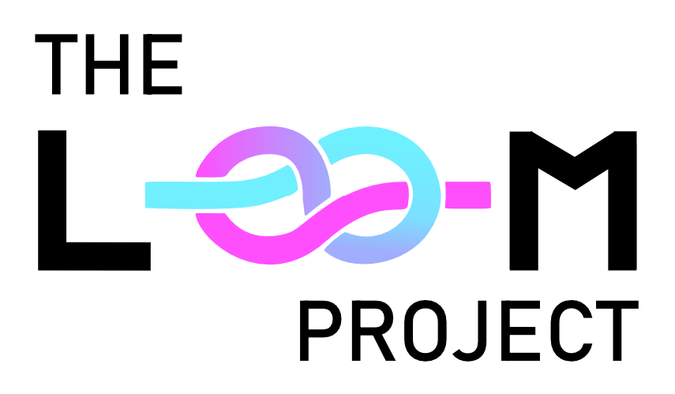

The Loom Project
D1. Scope document

Henrique Ferreira - 1230761
Leonor Gomes - 1222065
22/10/2026 — Version 1.0
Overview of Concept
The Loom Project is a 3D first-person puzzle PC game where players control a government test subject equipped with quantum goggles and parallel-body controlling technology to navigate realities and complete reconnaissance tasks. Directly embodying the Invisible Systems theme, physical movement can only occur while blind to the parallel dimension, forcing players to deduce and master unobservable cause-and-effect relationships between both worlds to progress.

Key features:
Desynchronized Vision & Movement Mechanics: A sensory paradox where players observe and memorize the parallel dimension (Reality B) through quantum goggles while stationary, then remove them to physically navigate in the real world (Reality A) which simultaneously moves them in Reality B while being blind to what is occurring in that parallel dimension.
Autonomous AI NPC Navigation & Dialogue Choices (Advanced Feature): Autonomous NPC behavior powered by Artificial Intelligence (Unity NavMesh & Pathfinding) allowing NPCs to navigate supermarket aisles, visit shelves, and dynamically avoid collisions without running into each other or obstacles, combined with a multiple-choice dialogue system that creates comedic dual-reality contrast.
Cross-Dimensional Collisions & Desynchronization: Spatial puzzles driven by phase-shifted geometry, where moving freely in Reality A can cause the player to scrape against or get blocked by invisible walls present only in Reality B.
Quantum Goggle Time Management & Cooldown: A mechanism introduced in Level 3 that enforces a cooldown period between goggle uses (simulating quantum overload), preventing continuous observation and forcing rapid memorization and precise, time-pressured spatial execution.
A 3-Level Progression System: A structured learning curve transitioning from a tutorial level where everything in the layout is 1:1 from one reality to another to get the player accustomed to using the mechanics, to phase-shifted spatial puzzles, and finally time-pressured cooldown management.

Description
Genre & Target Audience:
The Loom Project is a 3D first-person puzzle and spatial exploration game featuring narrative humor. The target audience includes players who enjoy brain-teasing puzzle mechanics, spatial navigation challenges, and narrative-driven experiences with absurdist humor.
Story & Narrative Context:
Following months of top-secret research into interdimensional travel, government scientists successfully established an observational window into parallel realities under codename "The Loom Project." To interact with these worlds, researchers engineered quantum goggles paired with parallel-body controlling technology, allowing an operator in the real world (Reality A) to control their alternate counterpart in the parallel dimension (Reality B). However, due to a severe neural motor cortex overload, the operator cannot move physically while actively receiving visual feeds from the parallel world. The player controls an unnamed random civilian who was offered some money to be a government test subject sent through a series of test chambers and parallel environments to complete reconnaissance tasks, and gather intelligence across dimensions.
Visual Style & Environment:
The game employs a distinct visual direction that combines accessible 3D Low-Poly modeling with radical aesthetic shifts across parallel dimensions:
- Reality A (Real World — All Levels): A clean, grounded 3D Low-Poly aesthetic representing everyday, mundane environments (a standard testing lab, a normal convenience store, and office spaces).
- Reality B — Level 1 (The Convenience Store): A surreal Photo-Collage & 2D Billboard art style. The 3D environment uses textures made from real-life photographs, while shelf products, environmental props, and NPCs are rendered as flat 2D PNG billboards facing the camera within the 3D space.
- Reality B — Level 2 (Spatial Puzzles): A sleek 3D Low-Poly Sci-Fi aesthetic inspired by futuristic test chambers (reminiscent of Portal 2), featuring clean modular panels, glowing quantum energy conduits, and stark industrial lighting.
- Reality B — Level 3 (Quantum Cooldown & TV Interference): A 1960s black-and-white television aesthetic infused with analog VHS errors, tracking glitches, and TV static noise. The entire parallel reality itself is filled with glitches, which serve as the only sources of color in an otherwise monochrome world. Whenever the quantum goggles overheat and become inaccessible, the screen shifts to a classic retro TV "No Signal" test pattern.

Core Gameplay, Mechanics & Player Actions:
Upon starting the game, the player spawns in a first-person perspective at the entrance of a government testing facility, receiving contextual instructions via environmental audio from government scientists. The player navigates using standard PC controls (WASD for movement, Mouse to look around) and makes its way to grab the equipment for his tasks.
The core gameplay loop revolves around a unique sensory paradox:
- Goggles ON (Observation): Pressing F equips the quantum goggles. The camera view shifts to Reality B, allowing the player to inspect the environment, locate target items or NPCs, and memorize the path. While goggles are equipped, physical movement is completely locked.
- Goggles OFF (Execution): Removing the goggles returns the visual feed to Reality A and unlocks physical movement. As the player walks through Reality A, their body in Reality B moves in exact synchronization, however, the player is completely blind to Reality B during this movement.
- Verification & Correction: The player re-equips the goggles to verify their updated position in Reality B, adjust their heading, or check if they hit an unseen obstacle.
- Dialogue Choices: Pressing E near an interactive NPC in Reality B opens a choice menu. The player choses on of the possible dialogue options to say something to the NPC, while simultaneously, the NPC in Reality A gets confused by what the player is saying generating comedic moments.
3-Level Progression:
- Level 1 — The Convenience Store (Tutorial & 1:1 Geometry): A convenience store setting where the spatial layout is identical (1:1) in both realities. Players learn goggle toggling, object grabbing, and interactive dialogue selection while autonomous AI NPCs roam the store aisles, with the Reality A clerk reacting in confusion as the player seems to be saying nonsensical things while talking to someone in reality B.
- Level 2 — Spatial Puzzles (Phase-Shifted Geometry): Introduces non-matching layouts containing walls, pits, and obstacles present in Reality B that do not exist in Reality A. Scraping against an unseen Reality B wall halts movement in Reality B despite moving freely in Reality A, requiring careful spatial deduction.
- Level 3 — Quantum Cooldown Management (Time Constraints): Set in an environment with time constraints for the tasks and where the goggles suffer from quantum overload, enforcing a mandatory cooldown period between uses. Players must memorize complex paths quickly and execute precise movements under strict time pressure.

Technical Specification
This game’s platform is going to be the PC and it will be strictly a singleplayer experience.
We will be using is the following software:
- Game Engine: Unity Engine (6000.6.5f1)
- Programming Language: C#
- Version Control: Git / GitHub
- Advanced Technical Feature (Autonomous AI Navigation): Implementation of an AI Agent navigation system (Unity NavMesh & Steering Behaviors) enabling NPCs to autonomously wander, visit store shelves, and dynamically avoid collisions with environmental props and other agents.
Hardware Requirements:
- Standard mid-range PC setup capable of executing the Unity Editor and rendering 3D low-poly scenes at a steady 60 FPS.
Concept art
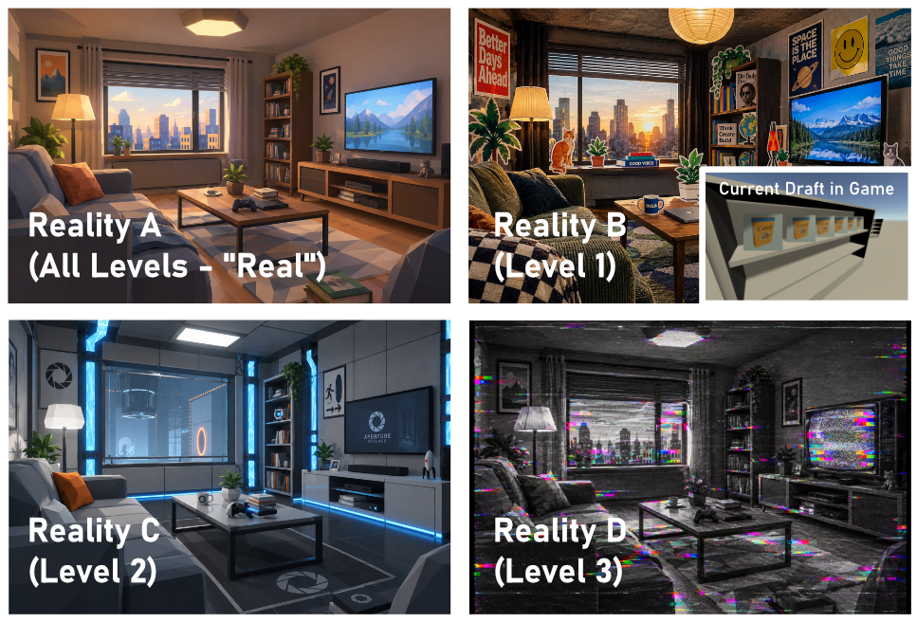
Figure 1 - Examples generated with AI to help visualize the art concept for each reality (with a quick reference to a draft already produced in-game)

Table 1 - Default Keys
Action | Default Key
Move Forward | W
Move Backward | S
Move Left | A
Move Right | D
Sprint | Shift
Crouch | Ctrl
Jump | Space
Grab / Interact | E
Toggle Quantum Goggles | F
Camera Control | Mouse

Flowchart:
Figure 2 - UI Flowchart
Schedule and Deliverables
22/10/2025 D1.1. Scope document (version 1.0)
11/11/2025 D2.1. Game Design Document (version 0.x)
D2.2. First Prototype
07/12/2025 D3.1. Game Design Document (version 1.0)
D3.1. Final prototype

User Stories / Functional and non-functional requirements
First Prototype
- US-1.1 (Goggle Toggle Mechanics): As a player, I want to toggle the quantum goggles using the F key so that I can observe and inspect Reality B.
- US-1.2 (Sensory Movement Lock): As a player, I want my physical movement to be locked while wearing goggles so that I experience the core sensory paradox.
- US-1.3 (Blind Physical Navigation): As a player, I want to physically navigate in Reality A using WASD, Shift (sprint), Ctrl (crouch), and Space (jump) while blind to Reality B.
- US-1.4 (Grabbing & Interaction): As a player, I want to press E to grab objects and interact with NPCs or other stuff.
- US-1.5 (Core UI & Menu Flow): As a player, I want a functional UI menu flow including Main Menu (Play, Settings, Exit), Pause Menu (Esc key), and basic volume sliders.
- US-1.6 (Autonomous AI NPC Navigation & Dialogue Choices): As a player, I want NPCs in Level 1 (Convenience Store) to navigate store aisles autonomously using AI pathfinding without colliding with shelves or other agents, and when I press E near an interactive NPC, I want a dialogue UI to appear allowing me to select from pre-defined response options.
- US-2.5 (Dynamic Key Rebinding System): As a player, I want to rebind all game controls dynamically in the Settings menu using the "Type the New Key" modal interface.
- NFR-1.1 (Performance): The prototype must run at a stable 60 FPS on mid-range PC hardware in Unity 6000.6.5f1.

Final Prototype
- US-2.1 (Full Campaign & Gameplay Duration): As a player, I want to experience 3 complete levels offering at least 10 minutes of effective, continuous gameplay.
- US-2.2 (Phase-Shifted Spatial Puzzles): As a player, I want to encounter phase-shifted geometry in Level 2 where invisible walls, pits, and obstacles in Reality B block or stop physical progress in Reality A.
- US-2.3 (Quantum Cooldown Resource Management): As a player, I want a goggle cooldown system in Level 3 that restricts active observation time (quantum overload), forcing rapid memorization and precise execution under time pressure.
- US-2.5 (Dual-Reality Dialogue Choices Fully Implemented): As a player, I want a fully finished dialogues system that when I select a dialogue choice in Reality B, characters in Reality A overhear my spoken choices out of context for comedic dual-reality narrative reactions.
- NFR-2.1 (Visual Polish & Stability): The game must maintain visual distinction across realities and guarantee zero fatal desynchronization crashes across the 10+ minute session.

References
- Unity Technologies (2026): Unity Engine Manual (Version 6000.6.5f1), 3D Render Pipeline, Input System, and 3D Spatial Audio Attenuation.
- Grand Theft Auto Series (Rockstar Games): Primary conceptual inspiration for ambient AI NPC wandering, autonomous pedestrian pathfinding, and dynamic obstacle avoidance behavior.
- Phineas and Ferb the Movie: Across the 2nd Dimension (2011): Animated film by Disney Television Animation and primary creative inspiration for parallel dimension travel, phase-shifted realities, and distinct visual art styles across dimensions.
- Portal 2 (2011): Video game by Valve Corporation exploring modular test chamber mechanics, environmental narrative, and spatial puzzle design.
- The Stanley Parable (2013): Video game by Galactic Cafe exploring environmental storytelling and absurdist narrative humor.
- WandaVision (2021): Television series by Marvel Studios (specifically Episode 2's 1960s sitcom setting) serving as the primary creative inspiration for Level 3's 1960s black-and-white sitcom visual aesthetic, vintage set styling, and TV glitch/interference mechanics.

