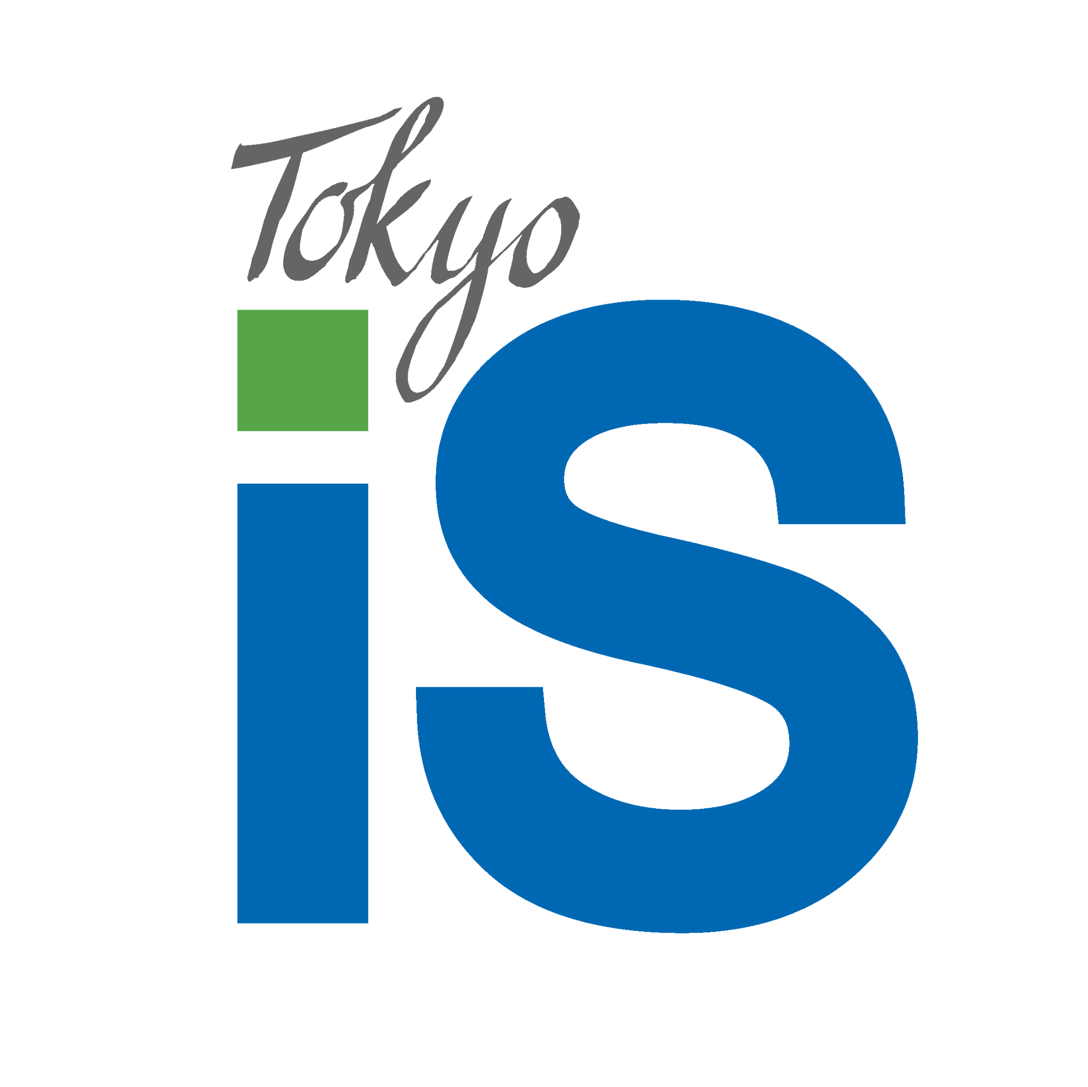
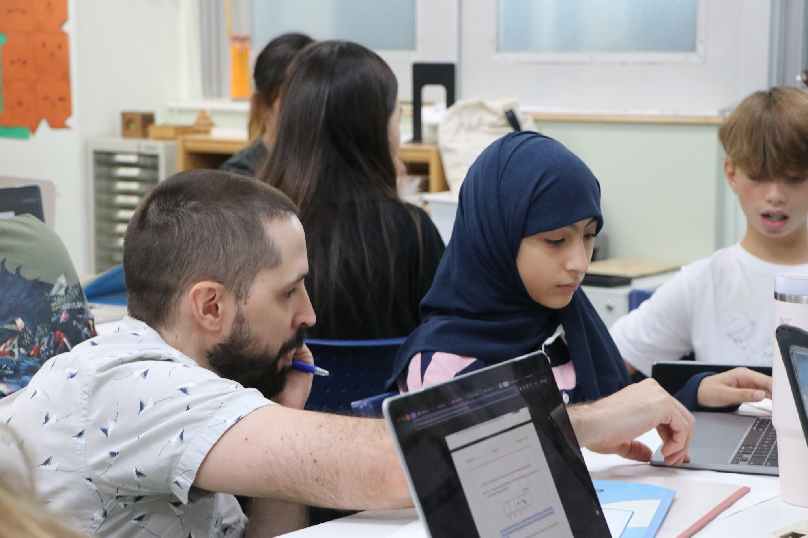
TOKYO

INTERNATIONAL

SCHOOL

Philosophy and Rationale 3
What is Academic Integrity? 3
Key Definitions 3
Roles and Responsibilities 4
Students 4
Teachers 4
Programme Coordinators 4
Parents 5
Digital and Technological Integrity 5
Use of AI Tools 5
Ethical Use of Online Resources 5
Social Media and Academic Dishonesty 5
Supporting Students Involved in Academic Misconduct 6
Consequences of Academic Misconduct 6
Restorative Practices 6
Consequences 7
Review 7
References 8

Philosophy and Rationale
At Tokyo International School (TIS), academic integrity is a core value, aligning with the principles of the International Baccalaureate (IB) Learner Profile and our mission to develop principled, reflective, and responsible global citizens. This policy aligns with IB Programme Standards and Practices, specifically Standard 3.2 (0403-02-0100), which ensures that students understand and demonstrate academic integrity in all assessments and learning experiences. Academic integrity in the Middle Years Programme (MYP) and Diploma Programme (DP) reflects our commitment to honesty, ethical behavior, and fairness in all endeavors within an academic community where we give credit to others’ thinking.
In both the MYP and DP, students are held to high standards of ethical academic conduct, which are essential to their personal growth and to the integrity of their learning experiences. This policy ensures that students, teachers, and parents understand their roles in maintaining a culture of academic honesty throughout these IB programmes.

What is Academic Integrity?
Academic integrity in the MYP and DP means:
- Producing original work that represents a student's own efforts, thoughts, and understanding.
- Acknowledging all sources of information, ideas, and creative works that are not the student's own.
- Upholding IB principles in all assessments.

Key Definitions
- Plagiarism: Using another person’s ideas, words, or work without proper acknowledgment either intentionally or carelessly.
- Duplication of work: Using the same work for different assessment tasks or different subjects.
- Collusion: Allowing someone else to copy your work, sharing information about an assessment to give others an unfair advantage, or working inappropriately with others on individual tasks.
- Cheating: Using unauthorized materials or receiving unauthorized help during assessments.
- Maladministration: School-related actions that compromise the integrity of an assessment, such as providing unauthorized assistance during exams.
- Submitting work obtained by a third party: Submitting work that was entirely or partially produced or edited by a third party is not allowed. Third-party tools in this context are defined as any person, software, application, or service that is not authorised for the assignment by the teacher in the course of academic work.

Roles and Responsibilities

Students
- Submit work that is original and reflects their own ideas and/or learning.
- Properly cite any external sources used, including text, data, images, and ideas. The school teaches and promotes the use of MLA 9 as the referencing guide.
- Avoid academic misconduct, including plagiarism, collusion, cheating, and other forms of misconduct.
- Seek help from teachers if they are unsure whether there is a possibility of academic malpractice.
- Submit substantial work samples or drafts during different stages of the process to prove the authenticity of their work.

Teachers
- Create fair and authentic assessments that encourage individual student responses and avoid opportunities for plagiarism or collusion.
- Inform students about IB assessment guidelines, particularly for MYP Personal Projects, DP Extended Essays, and Internal Assessments, ensuring that students are appropriately supported without receiving too much help.
- Monitor student work for signs of academic misconduct using Turnitin and other plagiarism detecting tools and strategies. .
- Collect work samples or portfolios as a reference for ensuring the authenticity of students’ work over time.
- Explicitly address acceptable levels of outside help (e.g. tutors, friends and family, internet and other resources) and AI use for tasks.

Programme Coordinators
- Oversee all teaching and learning activities to ensure compliance with IB regulations and academic integrity policies.
- Support teachers and the library in developing Academic Integrity skills, and monitoring their alignment with ATL skill development across the programme(s).
- Support teachers in managing academic misconduct cases, providing guidance and consistency in enforcing the policy.
- Ensure that assessments follow IB standards for authenticity and integrity, especially for IB internal assessments.
- Dealing with cases of academic misconduct in compliance with school and International Baccalaureate guidelines.

Parents
- Encourage their children to be honest and responsible in their academic work.
- Reinforce the importance of academic integrity at home and support their children in managing time and workloads.
- Model academic integrity at home.

Digital and Technological Integrity
As digital tools and AI-driven software become more common, students must understand how to use these tools ethically.

Use of AI Tools
- Students may use AI tools, where allowed by the teacher, for brainstorming, summarizing, or language support, but they must clearly cite any content generated by AI. For example:
  - In-text citation: “The model was developed using…” (“Prompt entered in ChatGPT”).
  - Works cited: “Text of prompt” prompt. ChatGPT, Day Month version, OpenAI, Day Month Year, chat.openai.com.
- Submitting AI-generated content as original work, including taking words written by AI, without acknowledgment is a violation of academic integrity. This includes work filtered through tools such as Google Translate, Grammarly Premium, ChatGPT, Google Bard, Quillbot, Wispr Flow, and other AI-powered art tools such as Dall-E.

Ethical Use of Online Resources
- Students should use credible online sources and properly cite all digital content used in their research per their ATL Research and Media Literacy skill development.
- Wikipedia and other non-academic sources may be used as starting points if allowed by the teacher, but should not be relied upon for final submissions.

Social Media and Academic Dishonesty
- Sharing answers or collaborating inappropriately via platforms such as WhatsApp, Discord, or Reddit is prohibited. Students must use these platforms responsibly for discussions and study support, not for academic misconduct.
Prevention of Academic Misconduct
Preventing academic misconduct is a shared responsibility. TIS takes the following measures to educate and support students:
- Research Skills and Citation Workshops: Regular lessons for students on proper research techniques, citation, and time management to avoid plagiarism.
- Subject-Specific Guidance: Teachers provide targeted instruction on how to ethically approach work in each subject area, especially in collaborative projects.
- Teacher Monitoring: Students’ work is regularly monitored for consistency in submissions. The school subscribes to Turnitin as one tool to support monitoring.

Supporting Students Involved in Academic Misconduct
TIS recognizes that academic misconduct can sometimes be unintentional before students have learned proper citation skills or can result from poor time management. When students engage in misconduct:
- Unintentional Misconduct: Students and parents will work with teachers to improve understanding of academic integrity principles through educational workshops and reflection.
- Intentional Misconduct: For serious or repeated offenses, students will face appropriate consequences, including, but not limited to, redoing assessment tasks, restrictions on future assessment tasks, and, in the case of the DP, refusing to sign off on Academic Integrity forms. Counseling and academic support will be provided to address the root causes of the behavior to prevent future misconduct.

Consequences of Academic Misconduct
Given the use of criterion-referenced assessment in the MYP and DP, reducing marks is not an option. Instead, restorative practices are used in conjunction with appropriate consequences based on the severity and intent of the misconduct.
Investigation
- In cases of suspected academic misconduct, the classroom teacher will talk with the student first to assess the situation.
- Following the conversation, the teacher will alert the appropriate coordinator (MYP or DP). Together the coordinator and teacher will determine the appropriate action based on the situation and any history with misconduct.
- The teacher then may have a follow-up conversation with the student or follow-through on the action as appropriate.
- Severe or repeated offences may require coordinator and/or US principal follow-up.

Restorative Practices
- Reflection Assignments: Students may be required to write a reflection on their actions and how they will ensure academic integrity in future tasks.
- Academic Integrity Workshops: Students may attend workshops to improve their understanding of ethical research practices.
- Counseling and Support: If misconduct stems from stress or academic pressure, social-emotional counseling is available to help students manage these challenges.

Consequences
- Redoing the Assessment Task: For both first-time and intentional violations, students may be required to redo the assessment task under exam-like conditions to demonstrate their understanding and effort.
- Academic Integrity Tracking: Teachers will use CPOMs, TIS’s student behavior system, to monitor academic misconduct. Students are expected to learn academic integrity following their first infraction, so any repeated infractions will result in increasingly severe consequences.
- Academic Integrity Probation: For repeated violations, students may be placed on probation, with their work closely monitored for future infractions, or will be given a zero.
- Failure of the Course or Assessment: In severe cases, particularly in the DP, intentional misconduct during major assessments may result in failure of the course or disqualification from the IB Diploma.
In all cases of intentional academic misconduct, parents will be contacted by the school and informed of the investigation and follow-up strategies.
Review
This policy will be reviewed annually to best accommodate changes as the Diploma Programme evolves at TIS and to allow for the inclusion of changes to the MYP and DP.

References
International Baccalaureate Organization. Academic Integrity Policy. International Baccalaureate, March 2023.
International Baccalaureate Organization. Guidance on the Use of Artificial Intelligence Tools. International Baccalaureate, 2023.
International Baccalaureate Organization. IB Programme Standards and Practices. International Baccalaureate, 2020.
OpenAI. ChatGPT. Version 4, OpenAI, 23 February 2023, https://www.openai.com/chatgpt.
Tokyo International School. TIS Metapolicy for Policy Development and Management. TIS, 2024.

For the Extended Essay or some Internal Assessments in the Diploma Programme, students may use referencing system other than MLA 9 that best matches practices in that discipline.

