user guide

COMP4985 Android GPS Project

Krystle Bulalakaw

Oscar Kwan

Gabriel Lee

Eunwon Moon

# Introduction

This document provides instructions on the usage of the Android GPS Project. The application has three necessary components which are required to run in tandem before use:

1. Android client application
2. Java server application
3. Web application

# Android Client Application

## Setup

The application is compatible on any Android device with at least Android 4.0.3 running. To get the app on your device, connect your device to your computer and either

* open the project in Android Studio and run it (an emulator can also be used, but is much slower)
* copy app-release.apk from android-gps/Android/ into the device’s local storage, and install it from the directory it was placed in by double-tapping it.

Ensure that location permissions are allowed in Settings > Apps > GpsTrack > Permissions.

Additionally, ensure that location services are enabled in Settings.

## Usage

* Launch the application.
* On the login page, enter a name and the server IP (52.37.226.120)
* Enter a port number, or leave the default.
* Tap “Start.”

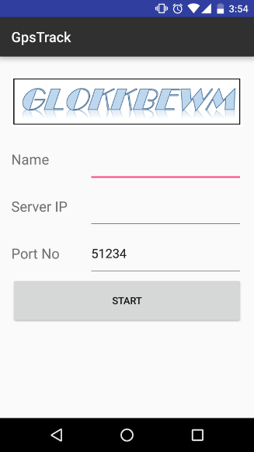

* On the main activity with Google Maps, location tracking will not start until you hit “Start.” There may be markers already set on the map depending if other clients have used the application already.
* The map will centre on your location once it registers, and continually update until you tap “Stop” or when your location has remained stagnant for too long.

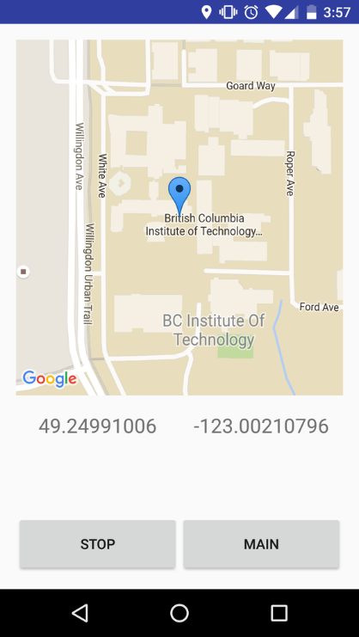

* Tapping “Main” will sign you out and take you back to the login page.

# Java Server

## Setup

On the Linux server device, run the runnable JAR file in Server/lib:

java –jar mysql-connector-java-5.1.38-bin.jar <port>

<port> is optional; if left blank, the default value will be used.

## Usage

No other usage required besides running it for the first time and leaving it on.

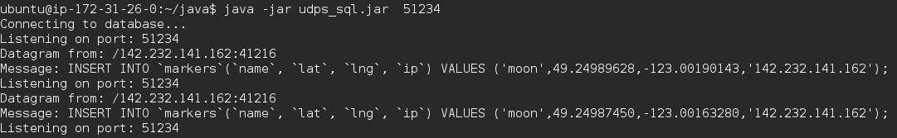

# Web application

## Setup

Open a web browser and enter 52.37.226.120 in the address bar. You will be prompted to a login page where you can enter your credentials if you have previously registered.

If you don’t have an account yet,

* Click “Sign up here”
* Enter a user name, email address, password, and colour for your GPS marker then click “Sign up”
* After being prompted that you successfully registered, click “Sign in here”
* Enter your credentials that you signed up with.

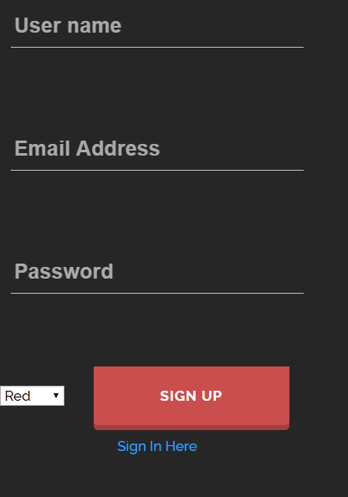

Prompts will be given if any incorrect credentials were entered.

The webpage is not dynamically updated but will show new markers on refresh. Markers are placed onto the map every 15 seconds.

# Usage

* Enter 52.37.226.120 in browser.
* Login with credentials or sign up for a new account.

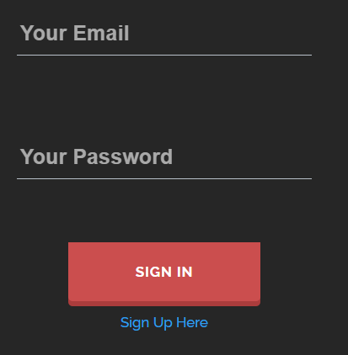

* A google map should be displayed and if there are markers present, they will be displayed on the map.
* By default, the map is zoomed onto BCIT’s coordinates.

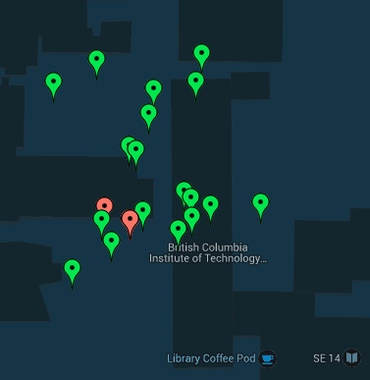

* By clicking Sign Out, you will be directed back to the login page.
* By clicking Info, you will see the list of users that are registered, and all information regarding their GPS tracking (timestamp, name, latitude, longitude, and IP address).

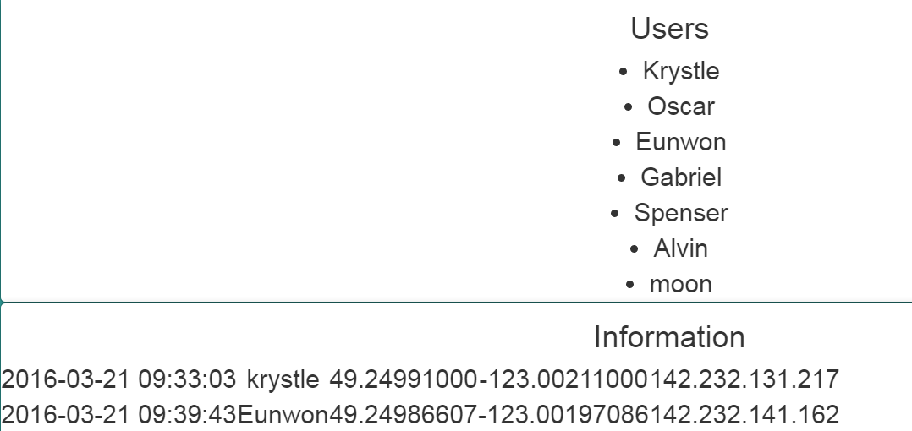

* Your username is displayed on the bottom left.

