|  |  |
| --- | --- |
| NewTULogo-NovareseMed-HORIZONTAL - crop SCHOOL OF COMPUTING AND ITFOUNDATION IN COMPUTINGSeptember 2015 SEMESTER – TEST 2 |  |

**Subject (Code) : Introduction to Multimedia (CSC 30604)**

**Date/ Time : 11 January 2016 / 8:00 am - 10:00 am**

**Instructions to Candidates:**

1. Answer ALL questions.
2. Label the document file starting with “3D” follow by your name. (E.g. 3D-YourName)
3. Submission is in word document (.doc) format with the cover page follow by the print screen of your work and the 3D raw file (.ms3d) format. Don’t forget to attach together your texture file.
4. ZIP both the file as mentioned above before submit.
5. Submit it through TiMES.

**Student Name :** Lim Cheng Qing

**Student ID :** 0324306

10

**Right View**

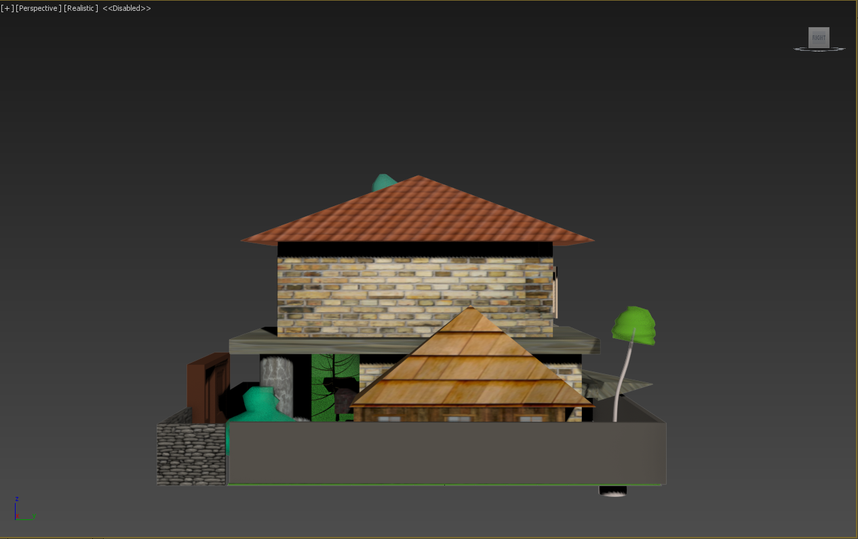

The special design gate surrounding the house consist of two different layer of wall. Both of them is created with “Wall” and they share the same height and width. The first wall with the effect of cement texture and the second wall with the rock effect was edited with “Material Editor”. The two tree which located in front of the car porch and behind it was created using “Fooliage”. The tree in front of the car porch is “Society Garlic” and the tree behind the card porch is “Generic Plant”. The car porch is created with the first step of creating a “Box” then increase its’ length siege by 3, width siege by 4 and height siege by 2. Then create a roof by creating a pyramid and slowly place on top of it. Then the pyramid is materialize with “Wood Texture” and the box is materialized with “Wood Window Structure”. Both effect were used with a tool called “Material Editor”

**Back View**

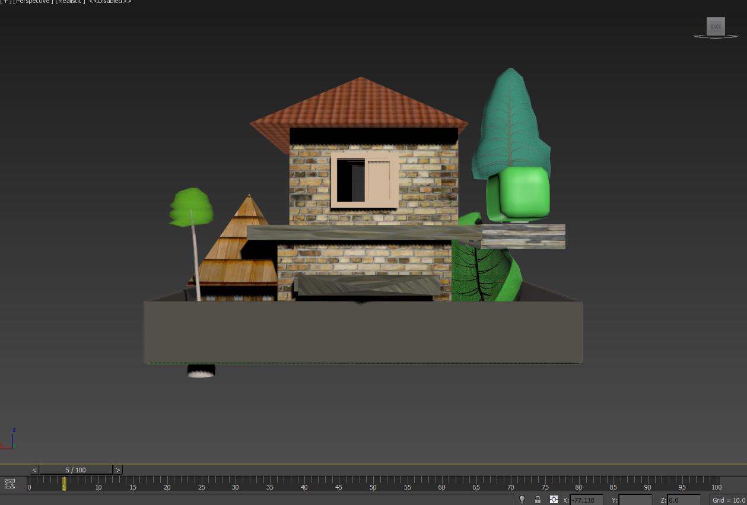

The shade which is located below the second floor is created with “Box” and apply a material effect called “Huge Stone Texture” with the tool name “Material Editor”. The second floor of the house uses a rectangle shape “box” to split the first floor and the second floor of the house. The second floor of the house at the back view consist of a window which created from “Sliding Window”. The window was materialize with the effect of “wood”. Both layer of the house is made from “Wall” and materialize with “Brick Effect”. The purpose why the first floor and second floor of the house is created with “Wall” instead of “Box” is because to ensure that the interior of the house can be design to ensure the further development of the project.

**Left View**

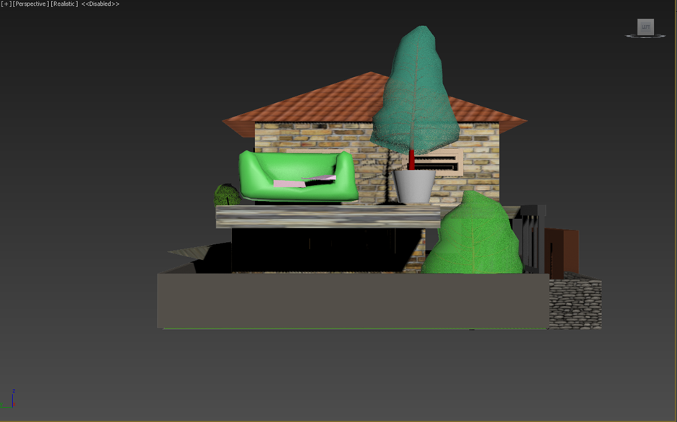

The specially design bench which located on the outside of the second floor and beside the “tree”. The sofa was first created with “Box” then converted to editable poly and was mold with the selection of “Vertex” then uses “Extrude” to increase the particular places of the box to create an animation of the bench. The colour of the bench is green, and it’s materialize with the effect of “Green Leaves”. The pillow on the sofa is create by “Box” and then converted to editable poly and uses “Edge” and “Vertex” to mold to the shape of the pillow. The tree which located next to the sofa is “Scotch Pine”. The three is edited to the suitable height and the pot is created by “Cone”. The post is materialize with the effect of “Cement” with the tool of “Material Editor”. The tree below next to “Scotch Pine” is “Japanese Flowering Cherry, Spring”.

**The Front View**

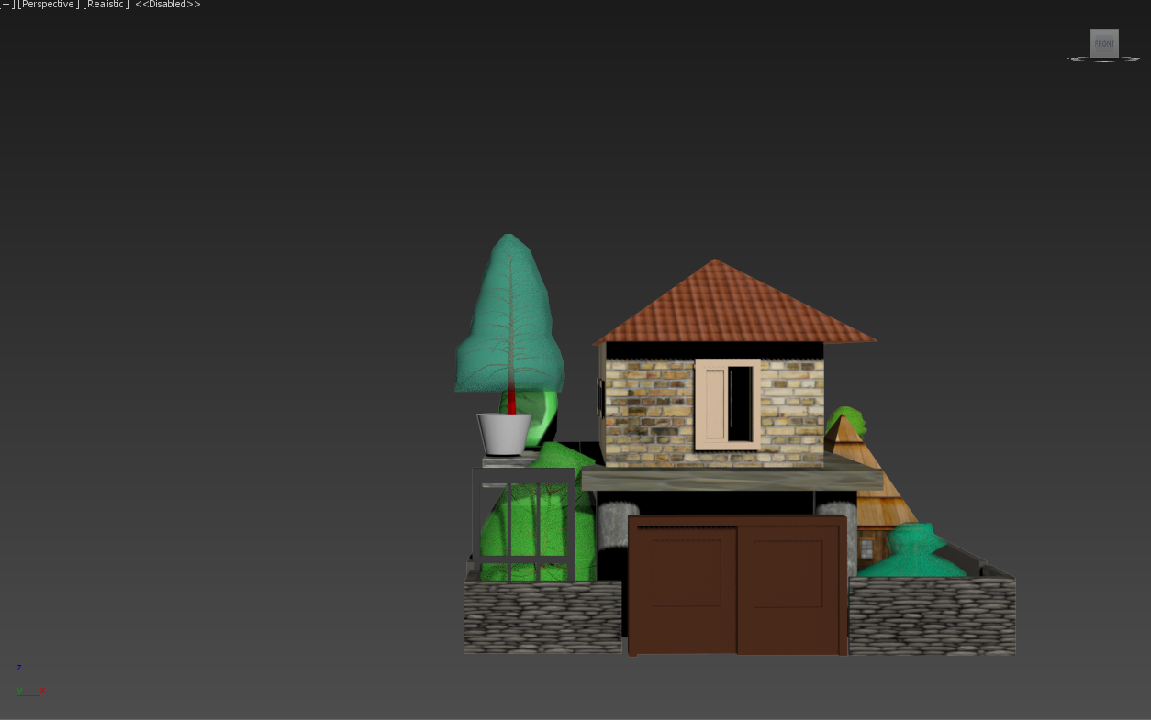

The special design gate is created with “Sliding Door”. It’s materialize with the effect of “Wood 2” by using the “Material Editor”. The front house of the gate is different compare to the one behind and it’s also created by using “Wall” instead of “Box” and the wall is materialize with the effect of “Rock 2” using Material Editor”. There are two reason why the front door of the house is materialize with a stronger looking texture. First is to ensure that the security of the front house is fortified and second it’s also believe by the “Chinese Feng Shui” that the front gate of the house must be fortified to ensure the family is blessed. The “Railing” which located in the right side of the house gate is the second gate to enter the garden of the house. It’s materialize with the effect of “Steel 3” using the “Material Editor”.

**The Top View**

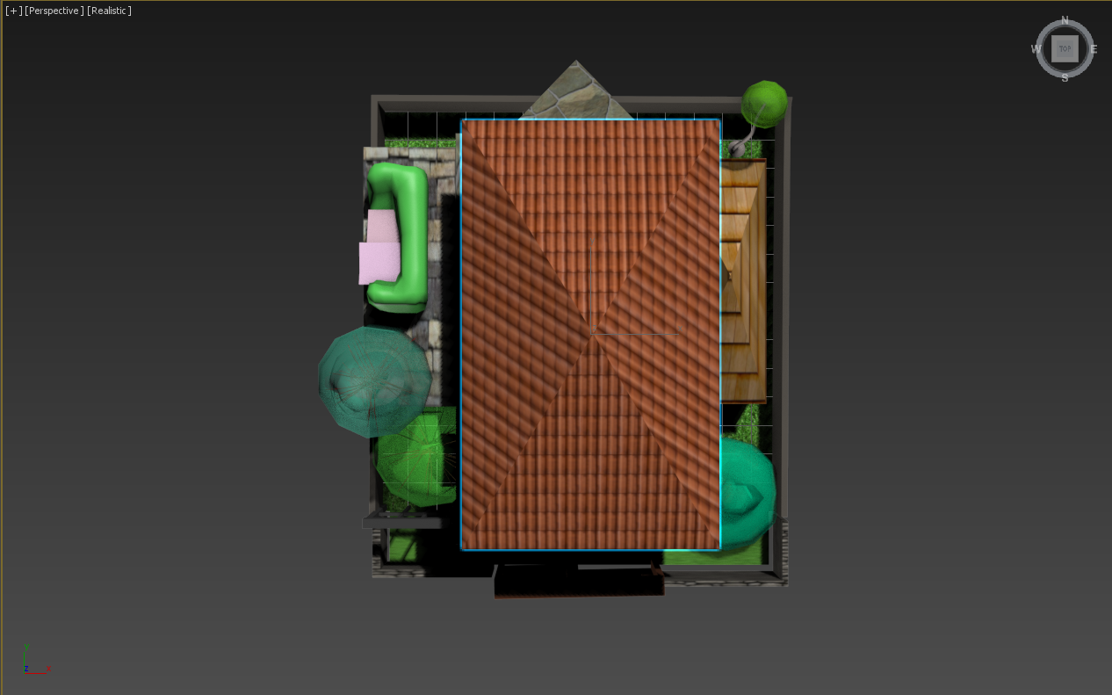

The roof of the house is created by “Pyramid” similar to the roof for the car porch. The roof of the house is materialize with the effect of “Brick Roof 1” using “Material Editor”.