CSE 4334 Assignment 2 Report

Joseph Fitchet
Rodrigo Pleitez

Part 1 Critical Thinking

Challenge A:
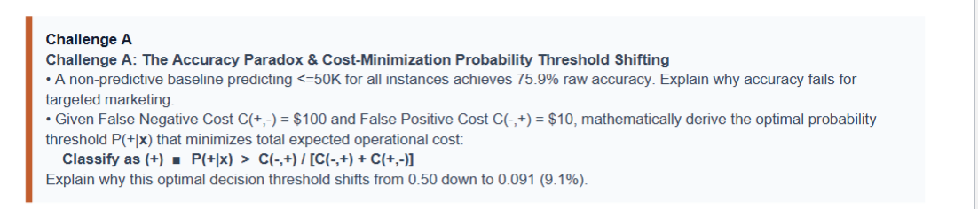
Since the model is non-predictive we can assume that this model then has 759 TN and 241 FN with TP and FP being 0 each. The accuracy fails because the recall is 0%. This model would fail at targeted marketing since it is not able to correctly predict targets that will earn it significant more income.

E[C | y = +] = (1-p)C(-,+)
E[C | y = -] = pC(+,-)
(1-p)C(-,+) < pC(+,-)
C(-,+) - pC(-,+) < pC(+,-)
C(-,+) < pC(+,-) + pC(-,+)
C(-,+) / C(+,-) + C(-,+) < p
10/110 = 0.0909

The optimal decision threshold shifts from 0.5 to 0.0909 because at .5 we are assigning the same cost to the FP and the FN but in this case the false negative is given a bigger priority than the false positive.

Challenge B
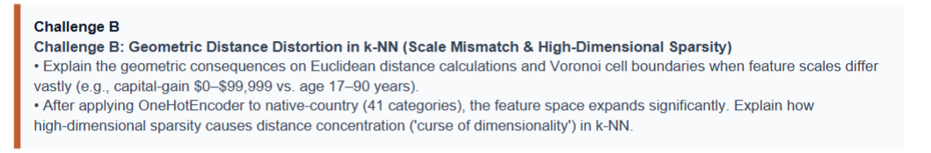

When features scales mismatch like the one shown in the challenge. The feature with a higher cap will take over the other feature. In this case capital-gain will make up a huge portion of the distance computed using these 2 different metrics.

One-hot vectors make features sparse since it adds more features that will be 0. And in high dimensional space feature distance starts to concentrate into similar distances. So the difference between close and common will be weaker.

Challenge C:

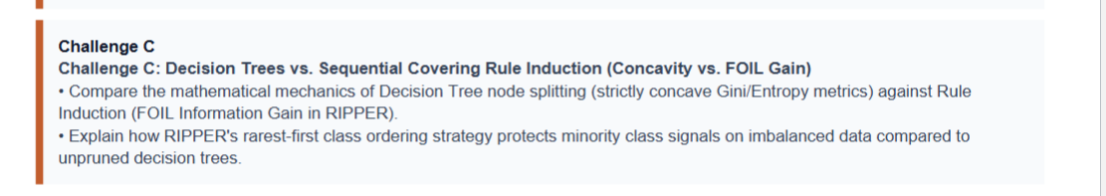

PART 2 AI audit
Rodrigo Pleitez Audit is on file named knn_smote_cost_sweep_conversation.pdf

