**ASSIGNMENT – 2**

SOHAM DAS

IT, UG-2

002311001004

1. SELECT ENAME, MGR, TO_CHAR(HIREDATE, 'DDSPTH MONTH, YYYY')AS DATE_HIRED FROM EMP WHERE (JOB = 'CLERK' OR DEPTNO = 20);

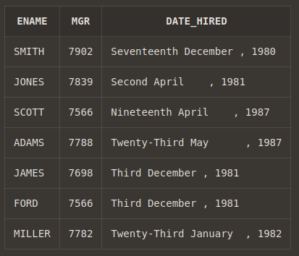

2. SELECT ENAME, SAL AS OLD_SAL, ROUND(1.25*SAL) AS NEW_SAL FROM EMP ;

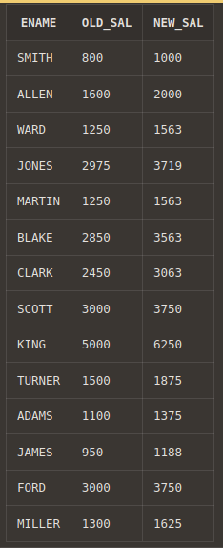

3. SELECT LPAD(ENAME, 10, ' ') AS ENAME, RPAD(SAL,10,' ') AS SALARY FROM EMP ;

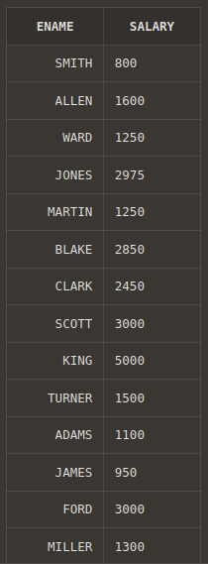

4. SELECT CONCAT(CONCAT(INITCAP(ENAME),'('), CONCAT(INITCAP(JOB),')')) AS ROLL_OF_THE_EMPLOYEE FROM EMP ;

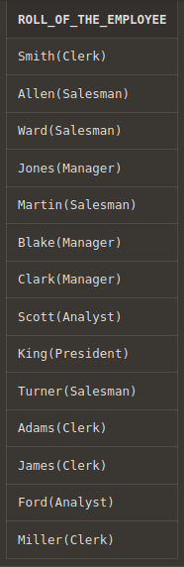

5. SELECT * FROM EMP WHERE UPPER(JOB)= 'CLERK';

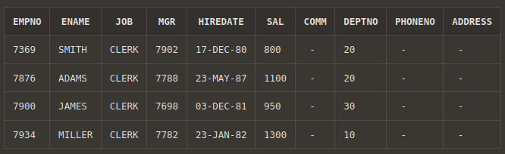

6. SELECT ENAME, HIREDATE, ADD_MONTHS(HIREDATE,12) AS SALARY_REVIEW_DATE FROM EMP ORDER BY SALARY_REVIEW_DATE;

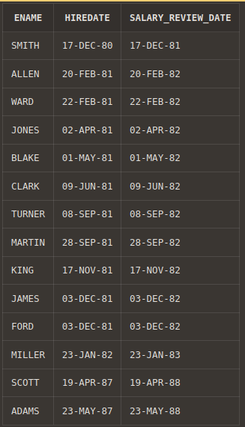

7. SELECT EMPNO, ENAME, JOB, SAL FROM EMP WHERE SAL IN (SELECT MAX(SAL)FROM EMP GROUP BY JOB) ORDER BY SAL DESC;

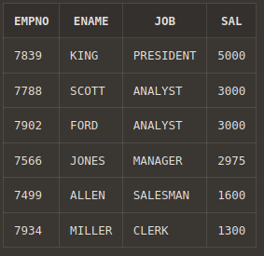

8. SELECT * FROM EMP E WHERE HIREDATE IN (SELECT MAX(HIREDATE) FROM EMP WHERE DEPTNO = E.DEPTNO);

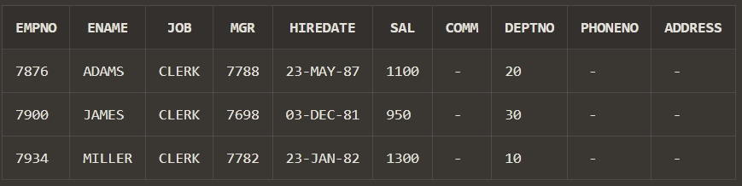

9. SELECT D.DNAME, COUNT(E.EMPNO) FROM EMP E, DEPT D WHERE E.DEPTNO =D.DEPTNO GROUP BY D.DEPTNO, D.DNAME ORDER BY D.DEPTNO;

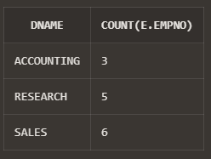

10. SELECT E.EMPNO, E.ENAME, E.SAL, S.GRADE FROM EMP E, SALGRADE S WHERE E.SAL IN(SELECT MAX(SAL) FROM EMP GROUP BY DEPTNO) AND E.SAL BETWEEN S.LOSAL AND S.HISAL ORDER BY E.DEPTNO;

11. SELECT TO_CHAR(HIREDATE, 'YYYY') AS YEAR, COUNT(EMPNO) AS NO_OF_EMPLOYEES FROM EMP GROUP BY TO_CHAR(HIREDATE, 'YYYY') HAVING COUNT(EMPNO)=(SELECT MAX(COUNT(EMPNO)) FROM EMP GROUP BY TO_CHAR(HIREDATE, 'YYYY'));

12. SELECT * FROM(SELECT EMPNO, ENAME,JOB, MGR, HIREDATE,

SAL, COMM, DEPTNO, PHONENO, ADDRESS, ROWNUM RN FROM EMP)

WHERE MOD(RN,2)=1;

13. SELECT EMPNO,ENAME, SAL+NVL(COMM,0) AS TOTAL_SALARY FROM EMP;

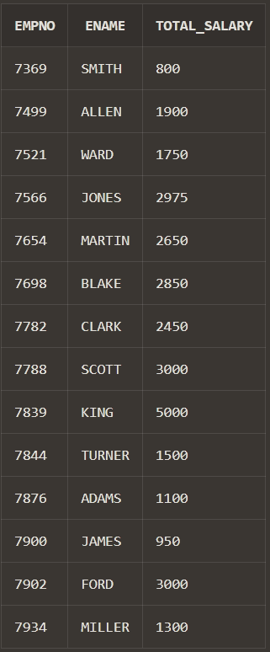

14. SELECT DISTINCT D.DNAME AS DEPARTMENT, E.JOB AS AVAILABLE_JOBS FROM EMP E, DEPT D WHERE D.DEPTNO = E.DEPTNO ;

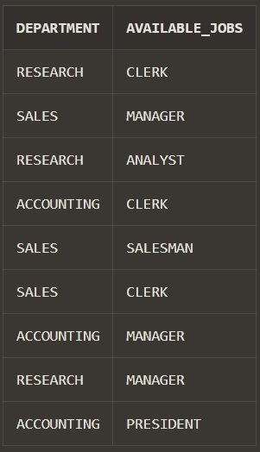

15. SELECT DISTINCT D.DNAME AS DEPARTMENT, E.* FROM EMP E, DEPT D WHERE D.DEPTNO = E.DEPTNO;

