SmartSure Insurance Management System
Project Requirement Document (Microservices)
Angular • ASP.NET Core Microservices (4) • Ocelot API Gateway • SQL Server • EF Core Code-First • JWT

A) Application Overview
SmartSure Insurance Management System is a web-based platform designed to digitize the complete insurance lifecycle. Customers can register, purchase insurance policies, calculate premiums, upload documents, and initiate claims using guided workflows. Admin users manage policy products, verify claim documents, approve or reject claims, and generate operational reports. The application is built using Angular and ASP.NET Core microservices, with Ocelot API Gateway enabling secure and scalable service orchestration.

B) Objective
• Digitize policy purchase and claim settlement processes
• Reduce manual processing using workflow-driven status transitions
• Enforce strong security using JWT and role-based authorization
• Demonstrate enterprise-grade microservices architecture
• Provide reporting and dashboards for operational visibility

C) Roles & Access Control

Roles
Customer (Policy Holder)
• Register/Login
• Buy insurance policies
• View policies and documents
• Initiate and track claims
Admin
• Manage insurance products
• Review and verify claim documents
• Approve or reject claims
• Generate reports and manage users

Security
• Angular Route Guards for /customer/* and /admin/*
• JWT Bearer authentication
• [Authorize(Roles="ADMIN")] on admin APIs
• All requests routed via Ocelot Gateway

D) UI Design Architecture (Angular)

Angular Modules
• CoreModule – layout, interceptors, error handling
• SharedModule – tables, status badges, modals
• AuthModule – login, signup
• CustomerModule – dashboard, policies
• ClaimsModule – claims initiation & tracking
• AdminModule – admin dashboards & approvals
• ReportsModule – charts and exports

UI Design Pattern
Wizard / Stepper Pattern
Used for:
• Buy Insurance Policy
• Initiate Claim
This reduces cognitive load and improves completion rates.

E) Page-by-Page Functional Requirements
(Structure preserved exactly as requested)
- Landing Page
- Signup
- Login
- Customer Dashboard
- Buy Insurance Policy (Wizard)
- Policy Details
- Upload Documents
- Initiate Claim (Wizard)
- Claim Status Tracking
- Admin Dashboard
- Admin Claim Review
- Admin Policy Management
- Admin Reports
- User Management
Each page includes:
• Purpose
• UI Components
• Fields & validations
• API calls (via Gateway)
• Messages
• Navigation rules

F) Status Lifecycle

Policy Lifecycle
Draft → Active → Expired → Cancelled
• Customer: Draft → Active
• Admin: Active → Cancelled

Claim Lifecycle
Draft → Submitted → Under Review → Approved / Rejected → Closed
• Customer: Draft → Submitted
• Admin: Under Review → Approved / Rejected
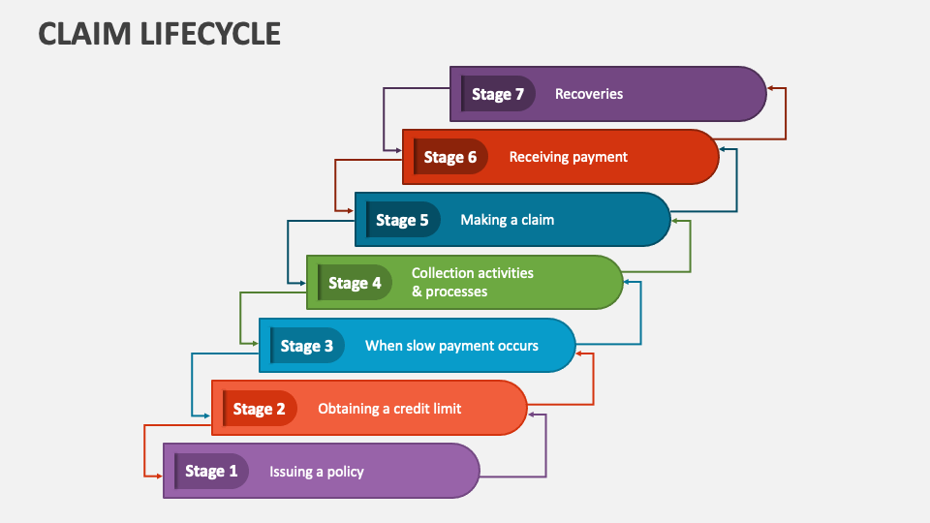
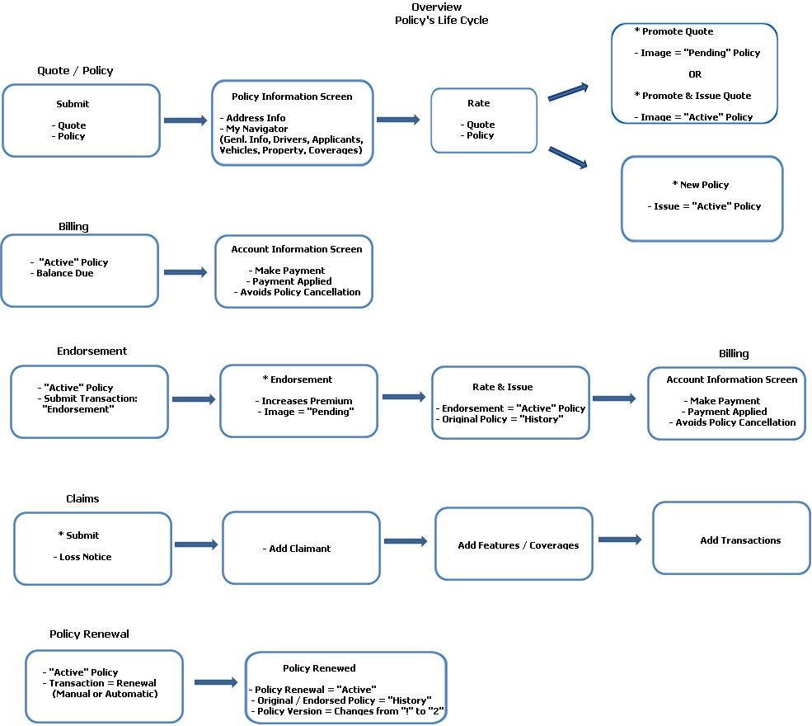

G) Microservices System Architecture

Architecture Overview
Angular UI communicates only with Ocelot API Gateway.
Ocelot routes requests to four independent microservices, each owning its data.
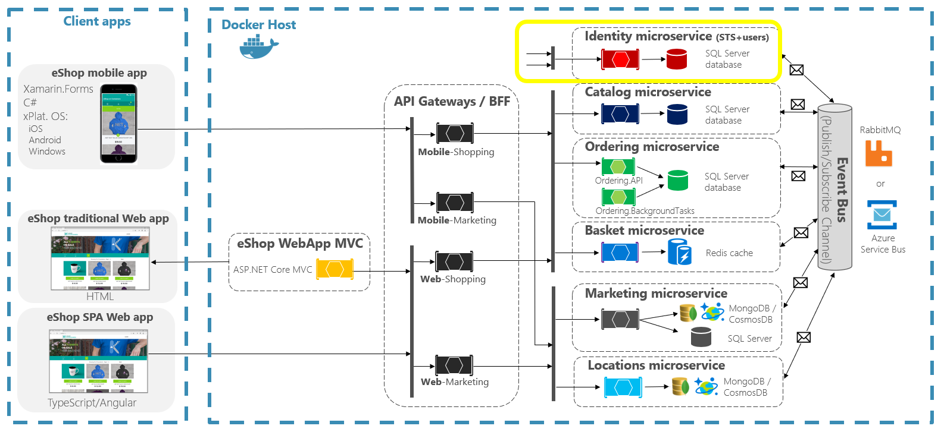
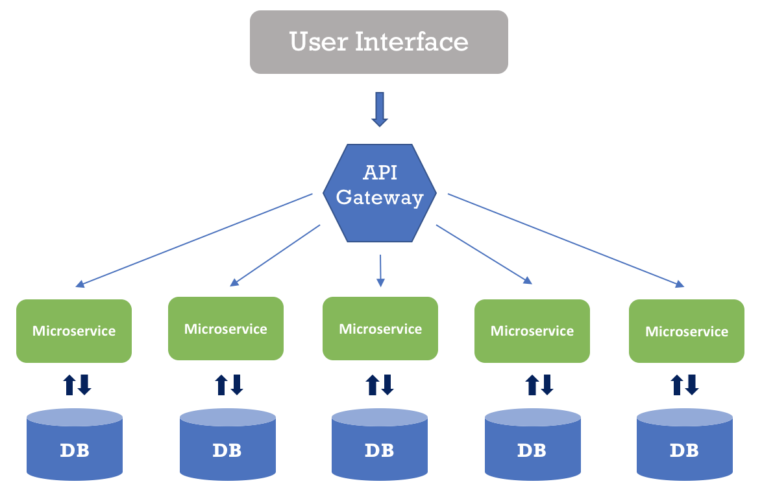

Microservices
- Identity / Auth Service
• Authentication, JWT, roles
- Policy Management Service
• Insurance products, policies, premiums
- Claims Service
• Claims, documents, verification
- Admin / Reporting Service
• Approvals, dashboards, reports

H) Database Design (SQL Server + EF Core Code-First)

Core Entities
• Users
• Policies
• PolicyTypes
• Premiums
• Claims
• ClaimDocuments
• Payments
• Reports
Each microservice maintains its own DbContext and migrations.
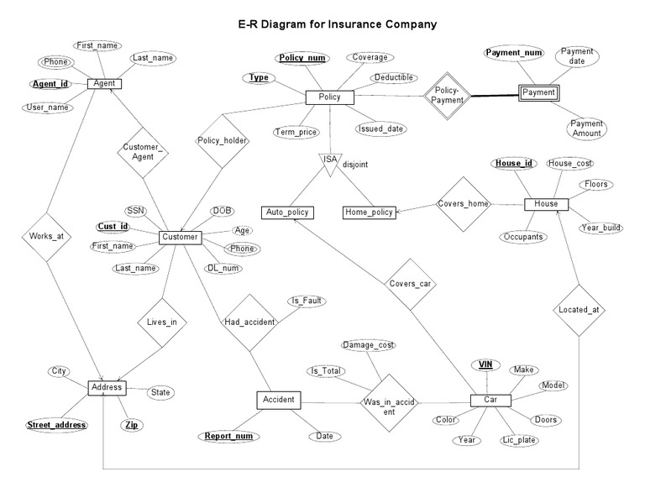

EF Core Code-First Flow
Models → DbContext → Migrations → Update Database → Verify in SSMS

I) REST API Summary

Gateway Routes
• /gateway/auth/*
• /gateway/policies/*
• /gateway/claims/*
• /gateway/admin/*

API Tooling
• Swagger – API documentation
• Postman – testing

J) Software Required
Frontend
• Node.js LTS
• Angular CLI
• VS Code
Backend
• .NET SDK
• Visual Studio 2022
Database
• SQL Server Developer
• SSMS

K) Testing & Quality Plan
Backend (NUnit)
• Service & repository tests
• Coverage ≥ 90%
Frontend (Jasmine/Karma)
• Component tests
• Service & guard tests
Quality
• SonarQube / SonarLint
• dotnet analyzers
• npm audit

L) Student Deliverables
Students must submit:
- Use Case Diagram
- Class Diagram
- Sequence Diagram (Policy Purchase / Claim Flow)
- ER Diagram
- WBS
- Agile Sprint Plan (Azure Boards / Jira / Trello)

M) Test Cases (Sample)
Test Case | Role | Expected Result | Type | Service
Signup | Customer | Account created | Positive | Auth
Login | Customer | JWT issued | Positive | Auth
Buy Policy | Customer | Policy active | Positive | Policy
Initiate Claim | Customer | Claim submitted | Positive | Claims
Approve Claim | Admin | Status approved | Positive | Admin
Unauthorized Access | Customer | 403 blocked | Security | Gateway

N) Deliverables & Evaluation Criteria
Area | Weightage
Microservices & Gateway | 20%
Security (JWT) | 15%
EF Core & DB | 15%
UI & Wireframes | 15%
Testing Coverage | 20%
Planning & Diagrams | 15%

O) Conclusion
This document provides a complete, enterprise-ready blueprint for an Insurance Management System using Angular and ASP.NET Core microservices. It is suitable for corporate training, academic evaluation, and real-world system design.

📲 Screen Design (Wireframes)
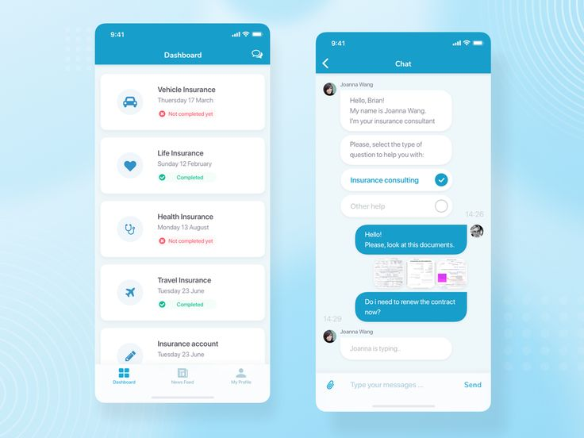
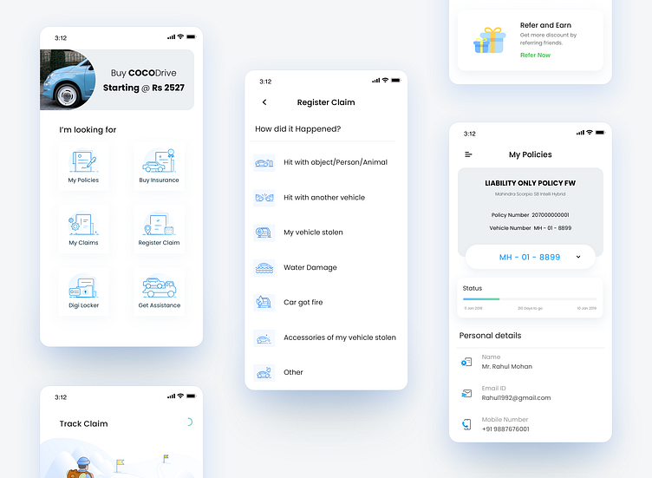
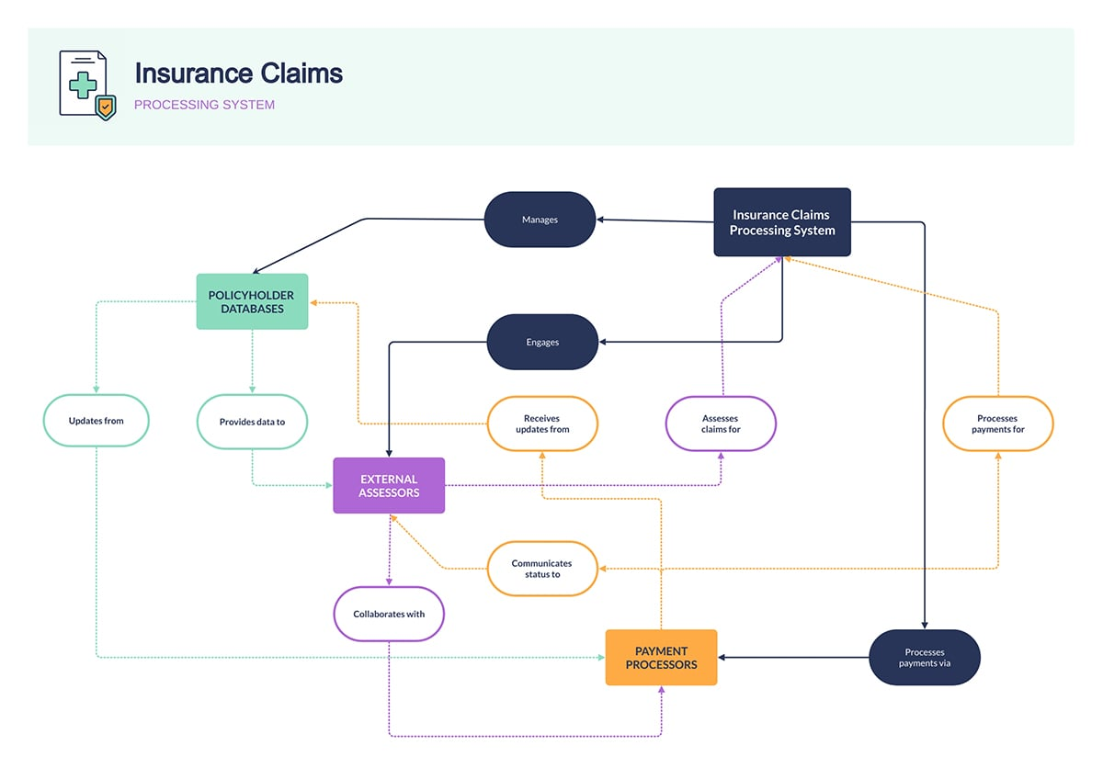
4

