**SQL_CustData**

create table customers (custId int primary key not null,

custName varchar(10), city varchar(10) );

Insert into customers values(1,"Rupa", "Hyderabad"),(2, "Sudha", "Hyderabad"),

(3, "Vinay", "Chennai"),(4, "Sruthi", "Vijayawada"),(5, "Madhu", "Chennai"),(6, "Gita", "Hyderabad");

create table orders (oid int primary key not null, cId int ,

odate date, foreign key (cId) references customers(custId ));

Insert into orders values(22,3,'2018-07-15'),(23,1,'2018-07-16'),(24,1,'2018-07-17'),(25,2,'2018-07-19'),

(26,4,'2018-07-20'),(27,5,'2018-07-20'),(28,5,'2018-07-12');

# 1. Select all the customers who have placed orders.

select customers.custName, customers.custId from customers

inner join orders on customers.custId = orders.cId;

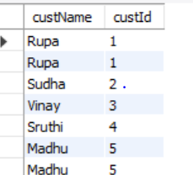

# 2. Display num of orders placed by each customer.

select oId, cId, count(oId) from orders

group by cId;

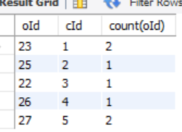

# 3. Select all the customers who have placed more than 1 order

select oId, cId, count(oId) from orders

group by cId

having count(oId) > 1;

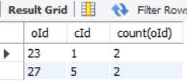

# 4. Select all the customers who did not place any order

select custName, custId from customers

where custId not in (select cId from orders);

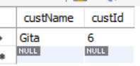

# 5. Display customer names who have made a purchasec on July 20th

select cId, odate from orders

where odate = '2018-07-20';

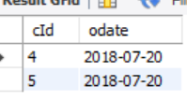

# 6. Select all the customers who made purchases after July 12th and before July 18th

select cId, odate from orders

where odate between '2018-07-12' and '2018-07-18';

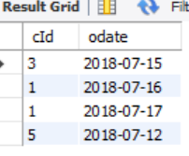

# 7. Select all the customer who did not purchase on these days - 12th and 18th

select cId, odate from orders

where odate='2018-07-12' or odate='2018-07-18';

