**SQL_EmpData**

create table employeeData (empId int primary key not null, firstname varchar(10), lastname varchar(10), salary int, joindate datetime, empRoll varchar(10));

insert into employeeData values

(1, 'Madhuri', 'Sripada', 100000, '19-02-01 09.00.00','HR'),

(2, 'Haritha', 'Verma', 80000, '19-01-10 09.00.00','Admin'),

(3, 'Vimal', 'Rao', 300000, '19-03-10 09.00.00','HR'),

(4, 'Amrita', 'Prasad', 500000, '19-03-10 09.00.00', 'Admin'),

(5, 'Vidhi', 'Agarwal', 500000, '19-02-11 09.00.00','Admin'),

(6, 'Nitya', 'Prasad', 200000, '19-02-11 09.00.00','Account'),

(7, 'Sravan', 'Kumar', 75000, '19-04-20 09.00.00','Account'),

(8, 'Girish', 'Varma', 90000, '19-04-11 09.00.00','Admin');

create table incentivesData (eid int, incentive int, empdate date,foreign key (eId) references employeeData(empId ));

insert into incentivesData values

(1, 8000, '19-06-15'),

(2, 10000, '19-05-11'),

(3, 45000, '19-05-20'),

(1, 9500, '19-06-20'),

(2, 3500, '19-06-11');

create table jobRoles (emId int, empPos varchar(20), joindate datetime);

insert into jobRoles values

(1, 'Manager', '2019-02-01 00:00:00'),

(2,'Executive', '2019-06-01 00:00:00'),

(8,'Executive', '2019-06-01 00:00:00'),

(5,'Manager', '2019-06-01 00:00:00'),

(4,'AstMangr', '2019-06-01 00:00:00'),

(7, 'Executive', '2019-06-01 00:00:00'),

(6,'Team Lead', '2019-06-01 00:00:00'),

(3,'Team Lead', '2019-06-01 00:00:00');

# 1. Display last name as employee_last_name.

select lastname as employee_last_name from employeeData ;

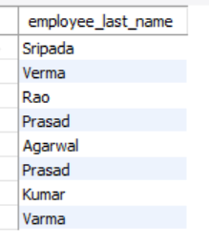

# 2. Display fname and lname as employee_fullname.

select concat(firstname," ", lastname) as employee_fullname from employeeData;

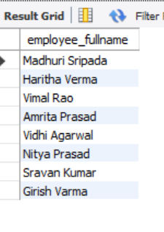

# 3. Display fname, lname in upper case.

select upper(firstname), upper(lastname) from employeeData;

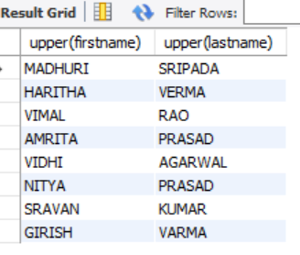

# 4. Display unique dept from emp table

select distinct empRoll from employeeData;

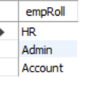

# 5. Display emp fname in asc order.

select firstname from employeeData order by firstname asc;

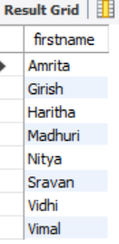

# 6. Print details of employees 'amrita' and 'nitya'.

select * from employeeData where firstname = "Amrita" or firstname = "nitya";

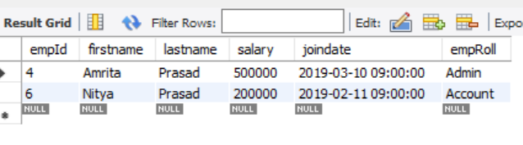

# 7. Details of emps except 'girish' and 'sravan'.

select * from employeeData where firstname not in ("Girish", "Sravan");

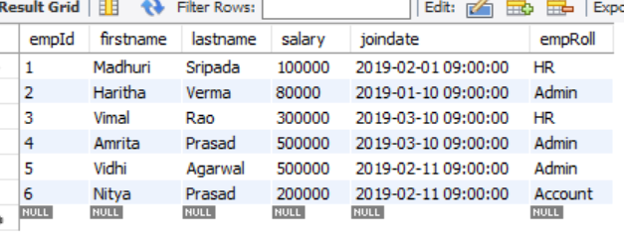

# 8. Display emps from hr dept.

select * from employeeData where empRoll = "HR";

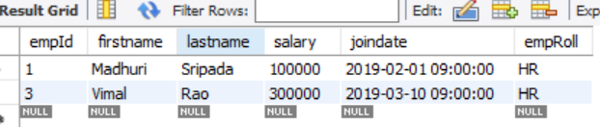

# 9. Details of emps whose name starts with 'A'.

select * from employeeData where firstname like 'A%';

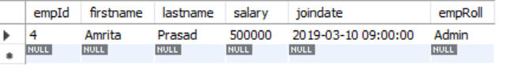

# 10. Details of emps whose name contains 'A'.

select * from employeeData where firstname like '%a%';

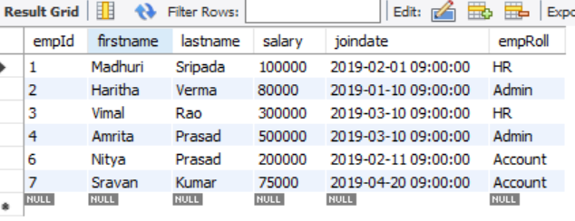

# 11. emp details of salaries who are earning between 2.5 - 5 lacs.

select * from employeeData where salary between 250000 and 500000;

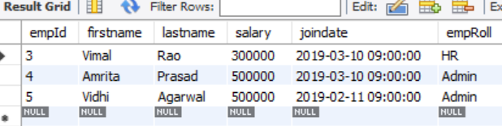

# 12. Write a query to display employee fullname who are earning above 70,000 and below 2 lacs.

select concat(firstname," ", lastname) as fullname, salary from employeeData

where salary > 70000 and salary < 200000;

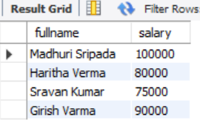

# 13. Write a query to display dept name and number of employees in dept.

select empRoll as deptName, count(empRoll) from employeeData

group by empRoll;

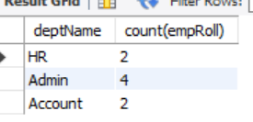

# 14. display employees who are managers.

select employeeData.*, jobRoles.* from employeeData

inner join jobRoles on employeeData.empId = jobRoles.emId

where jobRoles.empPos = "Manager";

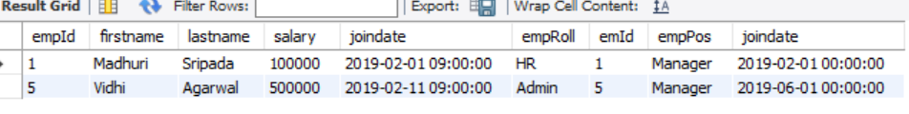

# 15. Print details of employees who got incentives.

select employeeData.*, incentivesData.* from employeeData

inner join incentivesData on employeeData.empId = incentivesData.eId;

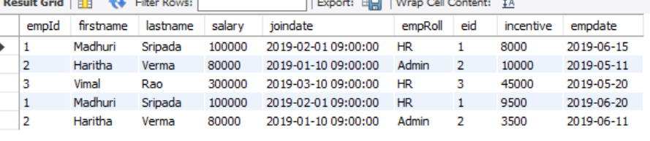

# 16. Display max salary from each dept (department wise max salary).

select max(salary), empRoll from employeeData

group by empRoll;

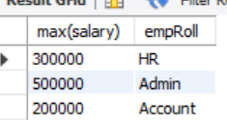

# 17. Print emp name, dept name and bonus amount who got highest bonus.

select employeeData.firstname, employeeData.lastname, employeeData.empRoll, max(incentivesData.incentive) from employeeData inner join incentivesData on employeeData.empId = incentivesData.eId;

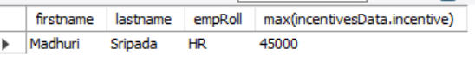

# 18. Display details of emp who is earing max salary

select *, max(salary), empRoll from employeeData;



# 19. Print emp last name , dept , salary of employees who is earing max salary in each department.

select lastname, empRoll, max(salary) from employeeData

group by empRoll;

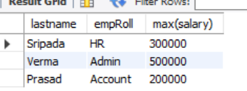

# 20. Print emp details who is earning lowest salary.

select *, min(salary) from employeeData;

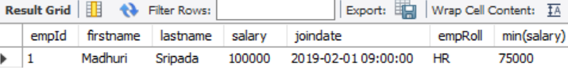

# 21. Print the emp last name, job role and effective date for each employee.

select lastname, empRoll, joindate from employeeData;

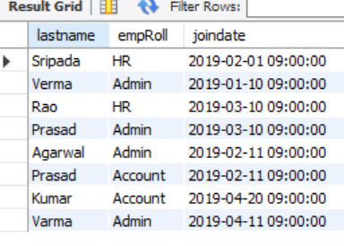

# 22. Print emp lastname.

select lastname from employeeData;

