ITEM 7 – Sobre Análise de Dados

Ponto 1 – Da Análise por Categoria

Script lançado:

SELECT
PRODUCT_CATEGORY_NAME,
COUNT(DISTINCT PRODUCT_ID) AS products_per_category
FROM TB__9CZX8R__OLIST_RAW__PRODUCTS
GROUP BY product_category_name
ORDER BY products_per_category DESC
LIMIT 10;

Resultado:

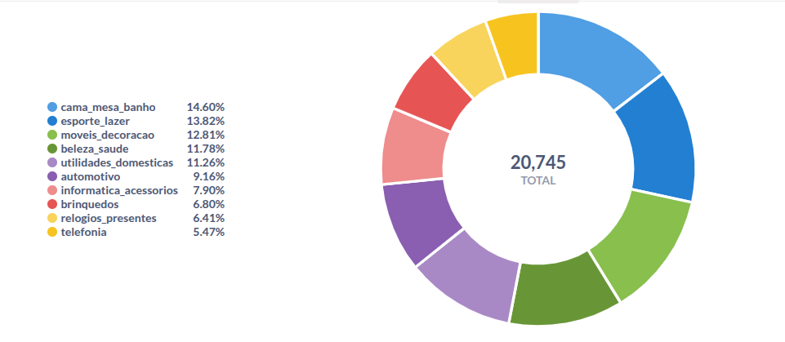
Ponto 2 – Da Análise Série Temporal

Script lançado:

SELECT
DATE_TRUNC('month', ORDER_PURCHASE_TIMESTAMP) AS month,
COUNT(ORDER_ID) AS total_orders
FROM TB__HH17FZ__OLIST_RAW__ORDERS
GROUP BY DATE_TRUNC('month', ORDER_PURCHASE_TIMESTAMP)
ORDER BY month;

Resultado:

