PCB Instruction for Project X
Junzhe Chen, Oli Sharratt, Yuxuan Han

General workflow:
When designing a PCB, the first step would be drawing out a schematic. A schematic is a circuit diagram that shows the electronics components and its connections by its symbol. An example of a schematic looks like the following:
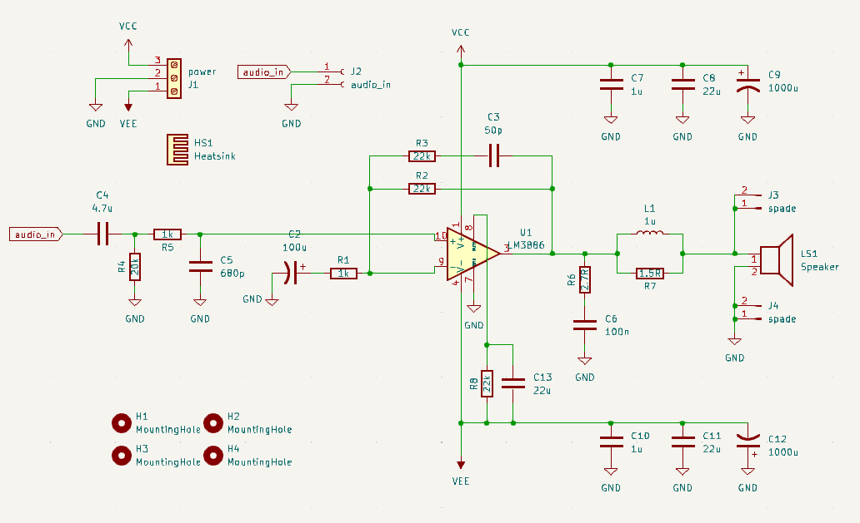
After the schematics, the footprint of components (e.g. resistors, LEDs, battery holders etc). Footprint is the physical contacts between the component and the PCB.
Schematics tells the circuit diagram and connection of the circuit; footprint states the physical component to PCB contacts. After drawing out the schematics and assigning footprints to associated symbols, the next step is to draw the physical board, which brings to the PCB layout
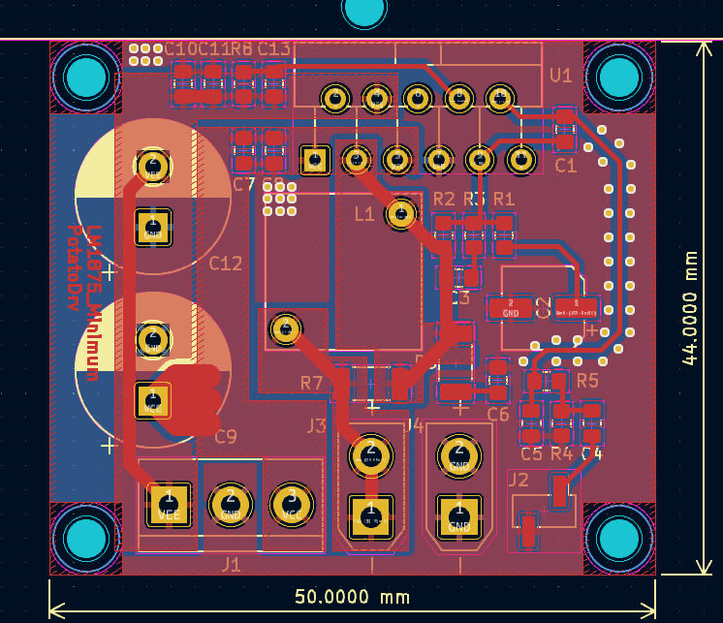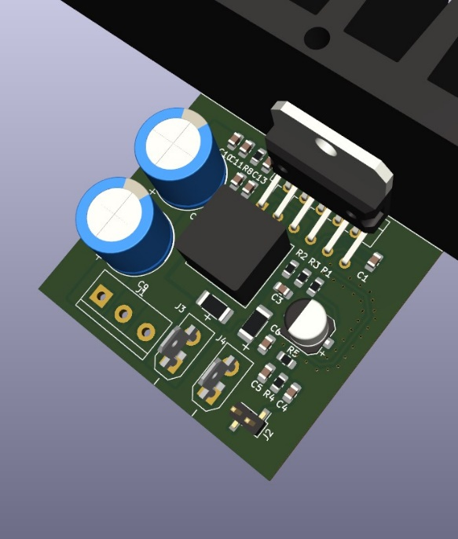
The left figure above shows a PCB design file, the right figure shows the 3D rendered image of the PCB design. The PCB design file contains the footprints of schematic symbols and traces that connects them together. In default KiCAD two-layer design, the top layer is coloured in red, and the bottom layer is coloured in blue. Notice that there is large amount of area covered by copper, that connects the ground or GND of the circuit, which is a commonly used method to minimise the return path impedance.
After finish designing the PCB, it will be sent over to the UCL PCB lab to produce. Usually, it takes one day to produce a double layer PCB. After the PCB is fabricated, the components will be populated and soldered onto the PCB. Then, the test for the PCB can begin.

To begin with:
To begin with, we have drawn part of the important bit of the mood card project: the microcontroller and the sensor. These are placed in the schematics and the layout. Your tasks will be the followings:
- Connect the traces between the microcontroller and the sensor
- Design and layout your own LED circuits
- [advanced] Try to make the footprints of the microcontroller and sensor
Start with KiCAD:
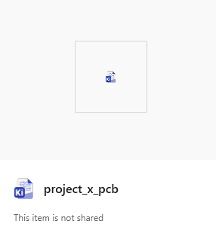
Firstly, open the KiCAD project file with the icon shown in the right. The KiCAD project file contains both the schematic, and the PCB layout files inside the file directory and it will be displayed in the Project Files section shown in the screenshot below:
Schematics and PCB file:
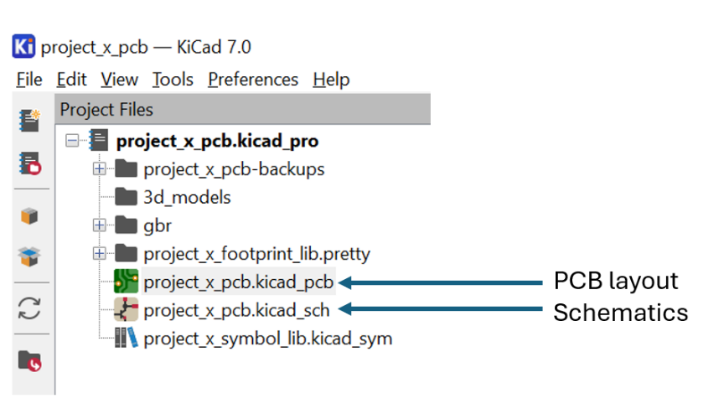
The screenshot on the right displays what will be seen when opening the project file. The most important files are the schematics and the PCB layout, which ends with _sch and _pcb respectively. Try to open the schematics and PCB files by double clicking it, you should be able to see the followings shown below:
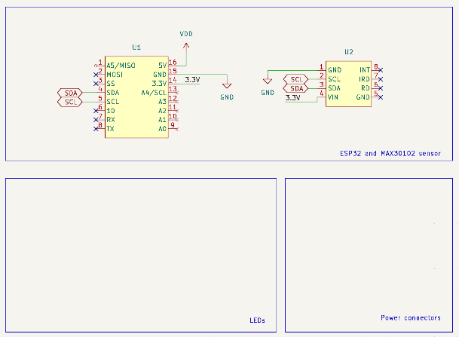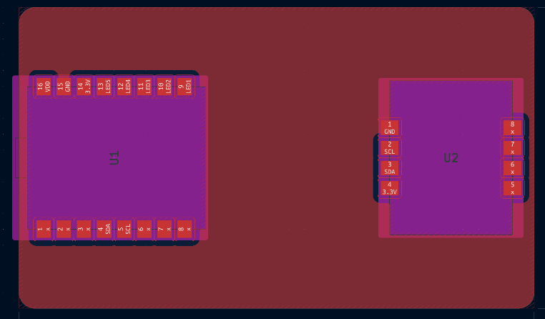
The left figure shows the schematic template, and the right figure shows the PCB in the design template. The microcontroller (U1) and the sensor (U2) has been placed. However, the traces have not been placed yet.
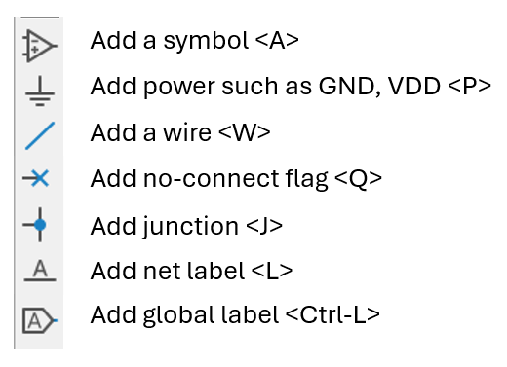
You will need to route the traces between the microcontroller and the sensor, design your LED circuits in schematics and lay it out onto the PCB, as well as adding a battery connector to the PCB to supply power to the microcontroller and the sensor
Start with schematics:
Let’s start the design from schematic, On the right-hand side of the schematic editor, there is a tool bar. You will use the toolbar to edit, add the components and wiring the connections most of the time. The commonly used tools with its shortcut keys are labelled in the diagram on the right:
Add components:
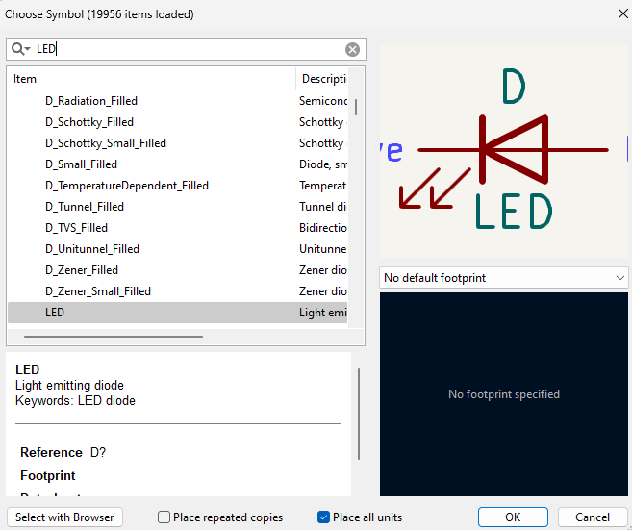
To add a component, click the add components icon or press <A> in the keyboard. The following window on the right will be opened. The components can be found by using the search bar on the top. In this example, we are searching a LED in the symbol library and the LED symbol is shown on the top right. After selecting the symbol you want, press OK and then the symbol can be placed on the schematic.
Task: Please try to place one LED and one resistor in the schematic’s LED region
Connecting the wires:
After placing down the components, we can start connecting them. To connect components together, we can move the cursor close to the unconnected pin (marked with small circle), and a wire will be generated for us to connect. A better method is to use the Add a wire in the toolbar (or press <W> for the shortcut), the connect the symbol with wires.
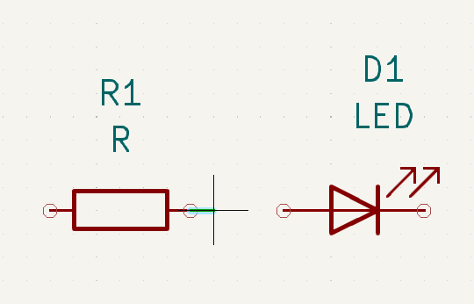
You may notice that the value of resistor is R but not the exact value we want (220). To change this, double click on the R, then the value of the resistor can be modified in the following window:
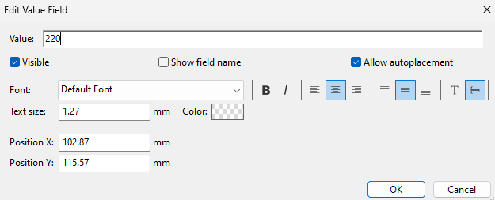
After that, the value of the resistor can be changed.
Connecting with nets:
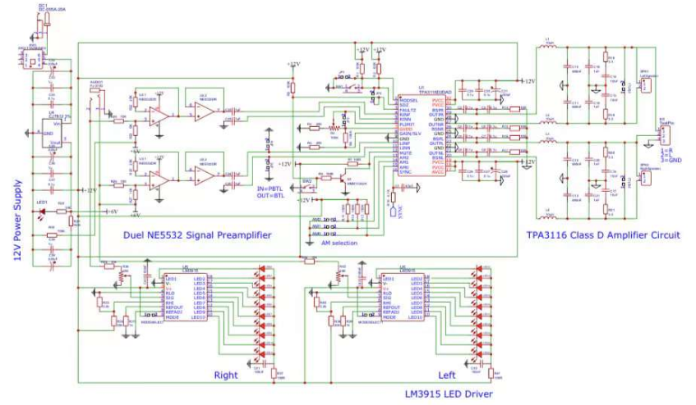
When there are more and more wires present in the schematic, the schematic can be difficult to read. A very bad example is my first ever PCB, which only used the wire connections, and no net connection has been implemented.
Using net connection can greatly simplify the mess of wires connection. Also, the net will have its name in the PCB layout stage, which can sometimes save time during the Design Rule Check, where you know which net connection is wrong.
There are mainly two types of nets, The first type is called as Net Label (shortcut: <L>), as the name suggests, it “labels” a certain net and give it a name. If there are two nets that has the same label, they will be connected together. This can be verified by using the highlight tool
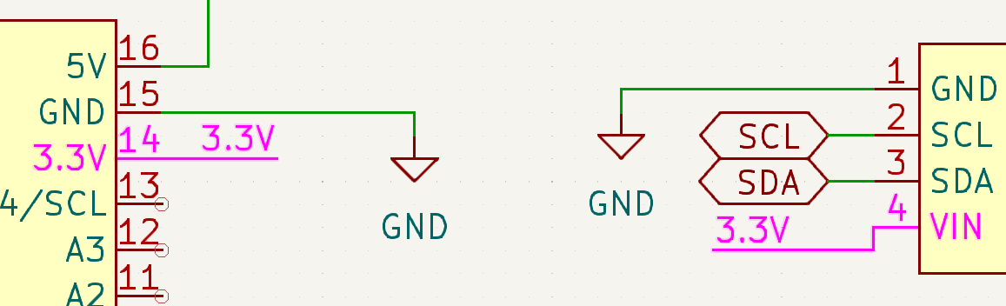
Net label is a very good tool to give certain net a name. However, it doesn’t tell the nets’ characteristics, such as whether it is the input or the output. Also, net label only works on a single sheet. If the design has multiple sheets, the label will not be inherent to the subsequent sheets.
Another type of label in KiCAD is the global label (shortcut: <Ctrl-L>). Global label not only connects the net with same label together, but it also indicates the net’s characteristics. We can configure the label to be the input, the output and more. As the name suggests, global label can be inherent through different schematic sheets.
Task: Please try to connect the LEDs to the microcontroller using global labels.
Assign footprints:
By now we should be able to finish the schematic design, which means the component symbols have been correctly connected using net labels and checked by the volunteers. After that, it is the time to assign the symbols with the corresponding footprints.
To assign the footprints, use the top menu bar and click Tools/Assign Footprints…, or click the follow icon on the top bar
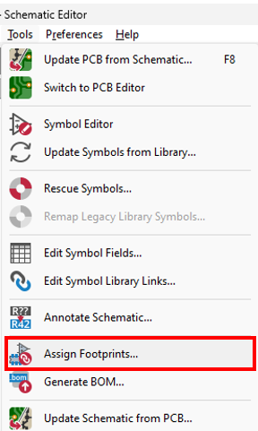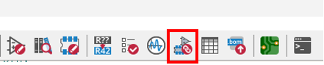
After opening the footprint assignment tool, it will show the following:
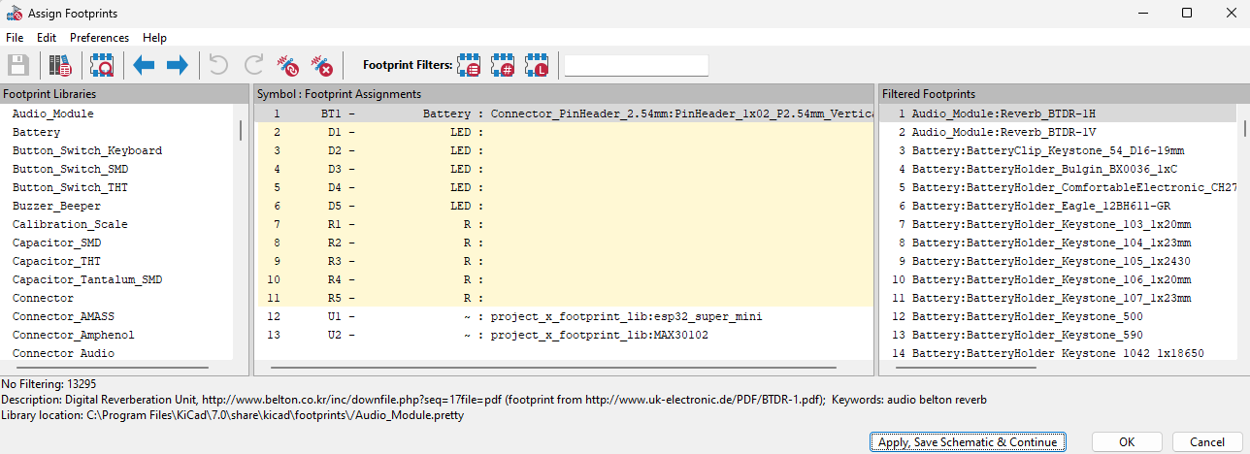
The footprint assignment tool is split into three columns. The left column is the footprint library, the middle one is the symbol in our schematic, the symbols without footprint assigned are highlighted in yellow. The right column shows the filtered footprints. The footprint filter is on the top right side with a search bar.
To find the footprint using the footprint filter, type the name of the footprint in the search bar, and the filtered footprint should be available in the right column, as shown in the figure below.
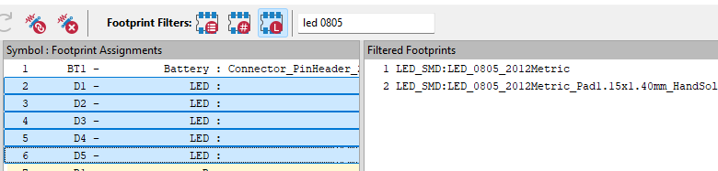
When correct footprints are found, double click on the correct footprint and then the footprint will be assigned to the symbol.
The footprints that will be used for Project X are listed below:
Component | Footprint name | Searc
Resistors | R_0805_Handsolder
LEDs | LED_0805_Handsolder
Batteries | PinHeader_1x02 P2.54mm_Vertical

Task: Assign the footprints to the symbol. After that, ask one volunteer to check

Progress check: please ask one of the volunteers to check if your schematics is correct. If so, you could move onto the PCB design.

----------------------------------
PCB design, a new start
Congratulations to finish your schematic design and get it checked by the volunteers! Now you can move onto the PCB design part.
To start the PCB design, first open the _pcb file and then press the Tools/Update the PCB from schematics on the manu bar, or press <F8> on the keyboard.
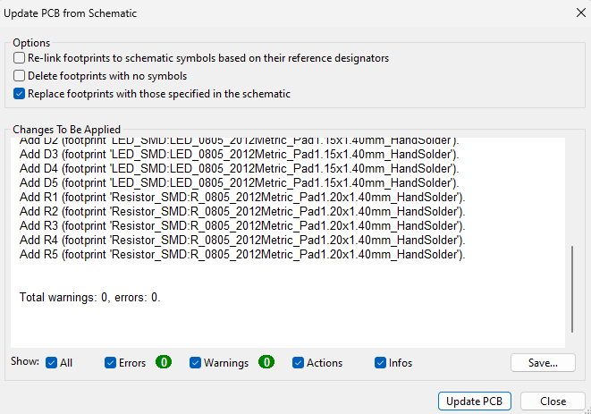
The following window will pop up and if there is no error or warnings, click Update PCB to sync the schematics and the PCB. You should see the added component footprints appears on your mouse cursor shown in the figure below:
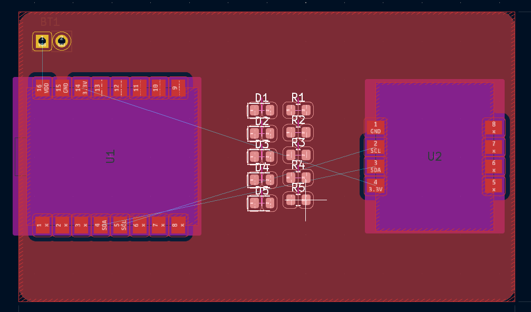
You may notice that there are thin lines connecting from one place to another in the PCB layout, these are ratlines and that indicates the physical connection between different pins.

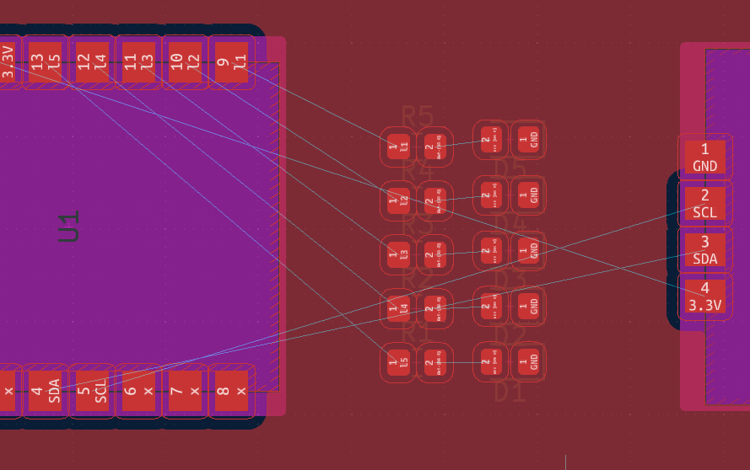
When choosing where to place the components, it is best to look at the ratlines so that the ratline has the least crossing. As ratline indicates the physical connections between the pins, making them to have least crossing will make the trace routing much easier.
Setting up the properties:
After placing the components to the appropriate position, the routing can begin. But before start routing, it is important to set appropriate trace width, clearance and other parameters so that the board can be manufactured from the UCL lab. To do that, click board setup, which is on the top right corner of the PCB editor (screenshot below)
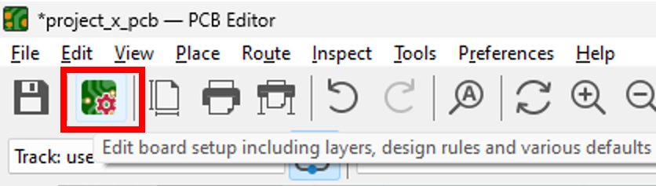
After opening the board setup, go to the constraints page and fill in the following parameters. The Copper section is the most important section for reaching the UCL lab manufacture. Follow the constraints shown above so that the constraints requirements can be met for PCB manufacture.
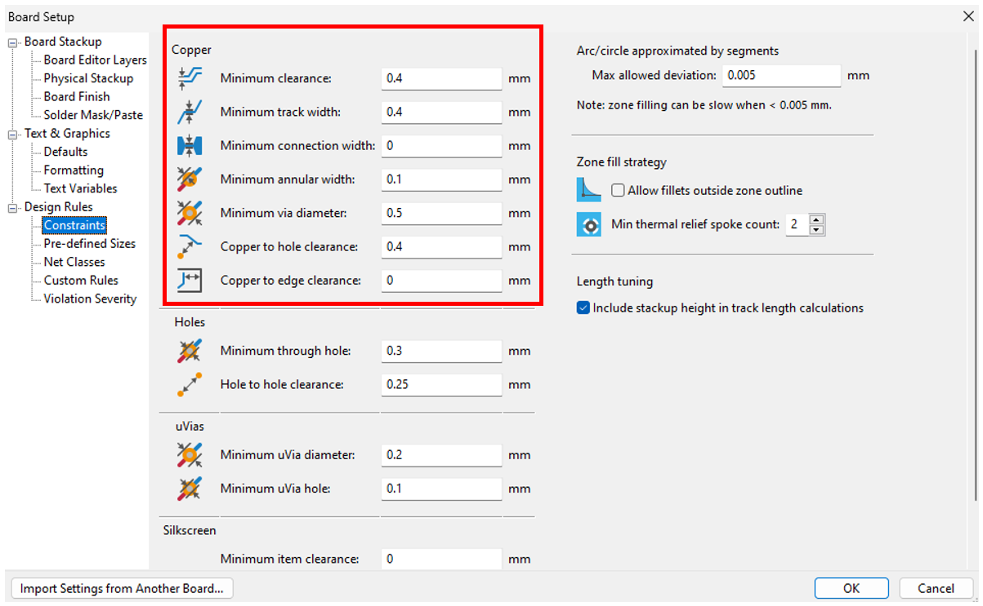
The trace width should also be set for the routing. Go to Pre-defined Sizes (which is just under Constraints, and the Track property should be shown on the left column (see screenshot below). As indicated by the constraints, the track cannot be thinner than 0.4 mm. So, the track width that is larger than 0.4 mm should be added. The track for power node (e.g. VDD, 3.3V) should be set thicker to reduce the track resistance, multiple track width can be set in this case.
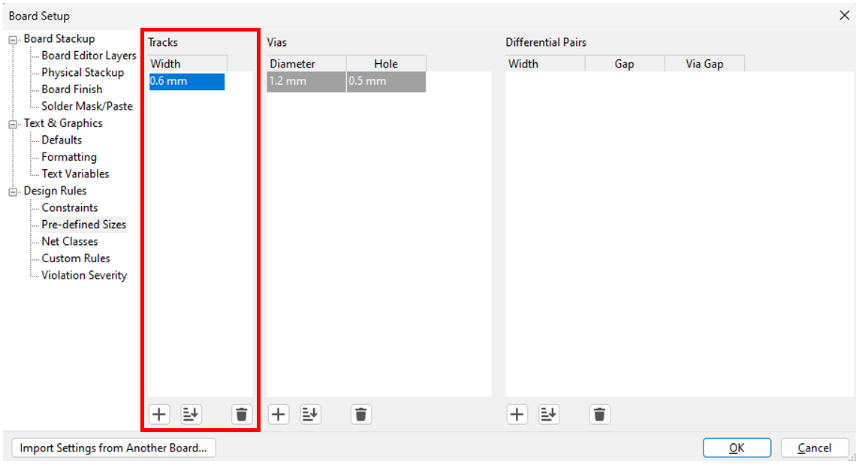
For vias (in the next column), UCL uses specific size vias. The via size should be set as same as the given example (Diameter = 1.2 mm, Hole = 0.5 mm).
Task: Set the constraints and pre-defined sizes and ask one of the volunteers to check
Track routing:
After setting the board setup, it is the time to route the tracks. To route the track in KiCAD, first place the cursor on the pad we want to route, then press the routing key <X> to enter the routing mode. The pads that need to be connected will be highlighted under correct routing setting (shown in the following screenshot)
A copper pour is added for this board, which connects all the ground connection. The When routing tracks, the track goes over the copper pour, thus the reason why you may see two red layers. To resolve that problem, press <B> to rebuild the copper pour, then the copper pour will be updated to leave the space for the track to go through.
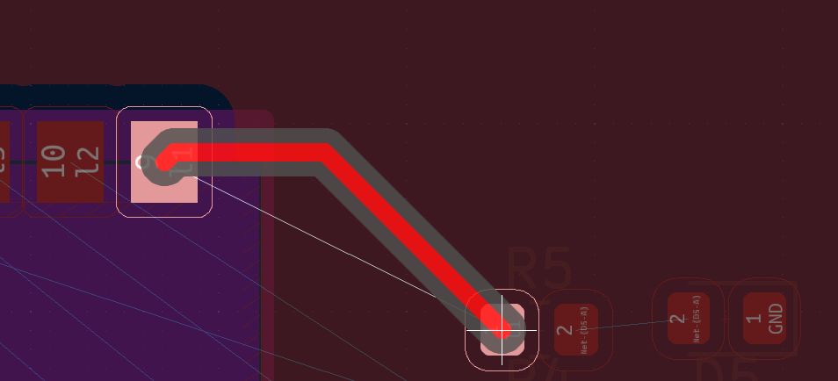
When finished routing, left click to finish the track. Then, press <B> to rebuild the copper pour.
Using vias to switch layer:
Sometimes, it is difficult to route certain tracks that goes across other tracks. In this case, it is good to switch the layer to “bridge” the track over (or under) it.
To connect the top and bottom together, a via is required. Via is a hole that is made right between the bridging tracks, and it connects the top and bottom together by plating the copper across the hole. When placing the track to the desired position, press <V>, then a via will be generated on the cursor. Move the via to the desired place, then click the left mouse button, the via will then be placed.
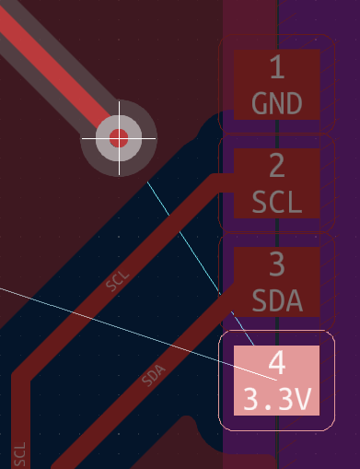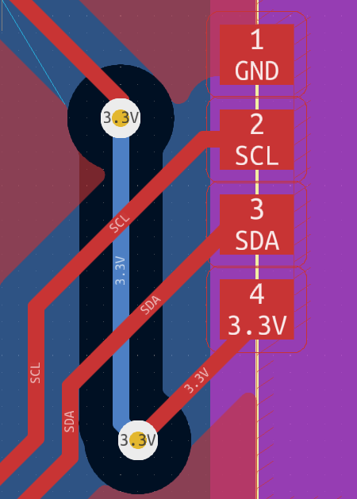
After placing the via, the KiCAD will automatically switch the track to the bottom layer, where the background is showing in blue. Then route the bottom track across the “bridge”, press <V> again, then the track will be completed as shown in the right screenshot above.
Design Rule Check:
After the routing has been completed, it is good practice to check the design rule before sending the design file to be manufactured. The design rule check (DRC) can be found in Inspect/Design Rule Checker in the menu bar shown in the screenshot below:
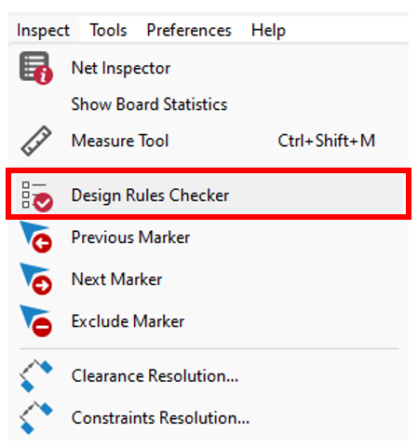 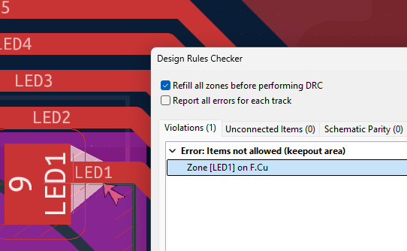If the DRC reports an error, a quick way to locate the error is by double-click the error. Usually, the error will be highlighted as shown above in the right screenshot. It is important to keep the design error-free, so that it maximizes the chance of getting a working board after the board have been fabricated out. The warning can sometimes be ignored.
Progress check: Congratulations to make it till this far! The PCB should be ready and please ask one of the volunteers to check if your board is correct and ready for fabrication!

Misc:
ESP32 C3 super mini related
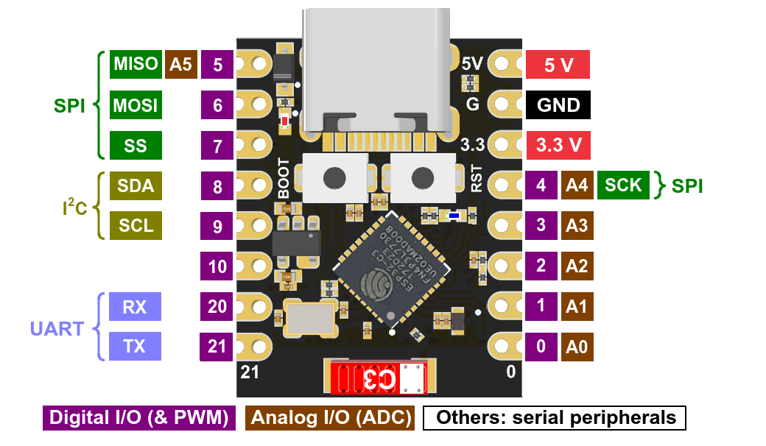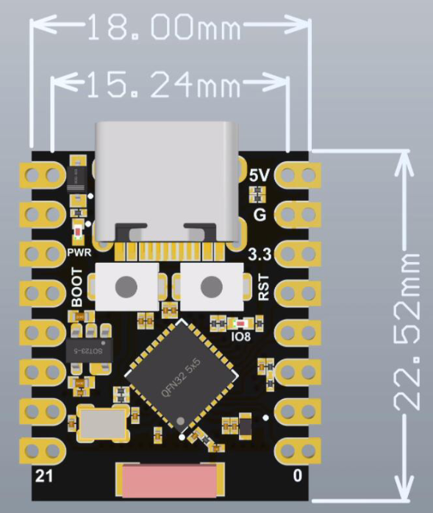
Docs can be found here

MAX30102 related
