**编译原理实践第13次课**

**（基于PLY的Python解析-2）**

1. **利用PLY实现的Python程序的解析**

本次学习的语法是**选择语句**和**循环语句**，需要注意的是本次使用的语法做了一些改进，不是纯粹的python2语法。

需要结合上次课四则运算的解析程序

1. 示例程序位于**example3**/

（2）需要进行解析的文件为**binary_search.py**和**select_sort.py**，分别对应二分查找和选择排序。

（3）需要完成以下内容的解析

* if
* while
* for

（4）解析结果以语法树的形式呈现

1. **编程实现语法制导翻译**
2. 语法树上每个节点有一个属性value保存节点的值
3. 设置一个变量表保存每个变量的值
4. 基于深度优先遍历获取整个语法树的分析结果

在进行翻译条件语句和循环语句时，不能简单的进行深度优先遍历，要对于某些条件节点进行优先翻译

1. **完成实验报告并提交**

一、实验目的

二、实验内容

三、实验步骤和结果

实验结果(文字):

select_sort.py:

======================================================

+ [PROGRAM]

+ [STATEMENTS]

+ [STATEMENTS]

+ [STATEMENTS]

+ [STATEMENTS]

+ [STATEMENT]

+ [ASSIGNMENT]

+ a

+ =

+ [LIST]

+ [

+ [NUMBERS]

+ [NUMBERS]

+ [NUMBERS]

+ [NUMBERS]

+ [NUMBERS]

+ [NUMBER]

+ 1

+ ,

+ 2

+ ,

+ 4

+ ,

+ 3

+ ,

+ 6

+ ,

+ 5

+ ]

+ [STATEMENT]

+ [ASSIGNMENT]

+ n

+ =

+ [LEN]

+ len

+ (

+ a

+ )

+ [STATEMENT]

+ [FOR]

+ [CONDITIONS]

+ [CONDITIONS]

+ [CONDITIONS]

+ [ASSIGNMENT]

+ [ASSIGNMENT]

+ i

+ =

+ 0

+ ;

+ [CONDITION]

+ i

+ <

+ n

+ ;

+ [CONDITION]

+ i

+ +

+ +

+ [STATEMENTS]

+ [STATEMENTS]

+ [STATEMENTS]

+ [STATEMENTS]

+ [STATEMENTS]

+ [STATEMENTS]

+ [STATEMENT]

+ [ASSIGNMENT]

+ max_v

+ =

+ a[i]

+ [STATEMENT]

+ [ASSIGNMENT]

+ i_v

+ =

+ i

+ [STATEMENT]

+ [FOR]

+ [CONDITIONS]

+ [CONDITIONS]

+ [CONDITIONS]

+ [ASSIGNMENT]

+ [ASSIGNMENT]

+ j

+ =

+ i

+ ;

+ [CONDITION]

+ j

+ <

+ n

+ ;

+ [CONDITION]

+ j

+ +

+ +

+ [STATEMENTS]

+ [STATEMENT]

+ [IF]

+ [CONDITION]

+ a[j]

+ >

+ max_v

+ [STATEMENTS]

+ [STATEMENTS]

+ [STATEMENT]

+ [ASSIGNMENT]

+ max_v

+ =

+ a[j]

+ [STATEMENT]

+ [ASSIGNMENT]

+ i_v

+ =

+ j

+ [STATEMENT]

+ [ASSIGNMENT]

+ t

+ =

+ a[i]

+ [STATEMENT]

+ [ASSIGNMENT]

+ a[i]

+ =

+ a[i_v]

+ [STATEMENT]

+ [ASSIGNMENT]

+ a[i_v]

+ =

+ t

+ [STATEMENT]

+ [PRINT]

+ print

+ (

+ [VARIABLE]

+ a

+ )

binary_search.py:

======================================================

+ [PROGRAM]

+ [STATEMENTS]

+ [STATEMENTS]

+ [STATEMENTS]

+ [STATEMENTS]

+ [STATEMENTS]

+ [STATEMENTS]

+ [STATEMENTS]

+ [STATEMENT]

+ [ASSIGNMENT]

+ a

+ =

+ [LIST]

+ [

+ [NUMBERS]

+ [NUMBERS]

+ [NUMBERS]

+ [NUMBERS]

+ [NUMBERS]

+ [NUMBERS]

+ [NUMBERS]

+ [NUMBERS]

+ [NUMBERS]

+ [NUMBER]

+ 1

+ ,

+ 2

+ ,

+ 3

+ ,

+ 4

+ ,

+ 5

+ ,

+ 6

+ ,

+ 7

+ ,

+ 8

+ ,

+ 9

+ ,

+ 10

+ ]

+ [STATEMENT]

+ [ASSIGNMENT]

+ key

+ =

+ 3

+ [STATEMENT]

+ [ASSIGNMENT]

+ n

+ =

+ [LEN]

+ len

+ (

+ a

+ )

+ [STATEMENT]

+ [ASSIGNMENT]

+ begin

+ =

+ 0

+ [STATEMENT]

+ [OPERATION]

+ end

+ =

+ [expr]

+ [expr]

+ [term]

+ [factor]

+ n

+ -

+ [term]

+ [factor]

+ 1

+ [STATEMENT]

+ [WHILE]

+ [CONDITION]

+ begin

+ <

+ =

+ end

+ [STATEMENTS]

+ [STATEMENTS]

+ [STATEMENTS]

+ [STATEMENTS]

+ [STATEMENT]

+ [ASSIGNMENT]

+ mid

+ =

+ (

+ [expr]

+ [expr]

+ [term]

+ [factor]

+ begin

+ +

+ [term]

+ [factor]

+ end

+ )

+ /

+ /

+ 2

+ [STATEMENT]

+ [IF]

+ [CONDITION]

+ a[mid]

+ >

+ key

+ [STATEMENTS]

+ [STATEMENT]

+ [OPERATION]

+ end

+ =

+ [expr]

+ [expr]

+ [term]

+ [factor]

+ mid

+ -

+ [term]

+ [factor]

+ 1

+ [STATEMENT]

+ [ELIF]

+ [CONDITION]

+ a[mid]

+ <

+ key

+ [STATEMENTS]

+ [STATEMENT]

+ [OPERATION]

+ begin

+ =

+ [expr]

+ [expr]

+ [term]

+ [factor]

+ mid

+ +

+ [term]

+ [factor]

+ 1

+ [STATEMENT]

+ [ELSE]

+ else

+ {

+ break

+ }

+ [STATEMENT]

+ [PRINT]

+ print

+ (

+ [VARIABLE]

+ mid

+ )

-------------------------------------

translation:

select_sort.py:

======================================================

['t', 2.0, 4.0, 3.0, 6.0, 5.0]

{'a': ['t', 2.0, 4.0, 3.0, 6.0, 5.0], 'n': 6, 'i': 0.0, 'max_v': 'a[i]', 'i_v': 'i', 'j': 'i', 't': 'a[i]'}

binary_search.py:

======================================================

9.0

{'a': [1.0, 2.0, 3.0, 4.0, 5.0, 6.0, 7.0, 8.0, 9.0, 10.0], 'key': 3.0, 'n': 10, 'begin': 10.0, 'end': 8.0, 'mid': 9.0}

Process finished with exit code 0

实验结果(截图):

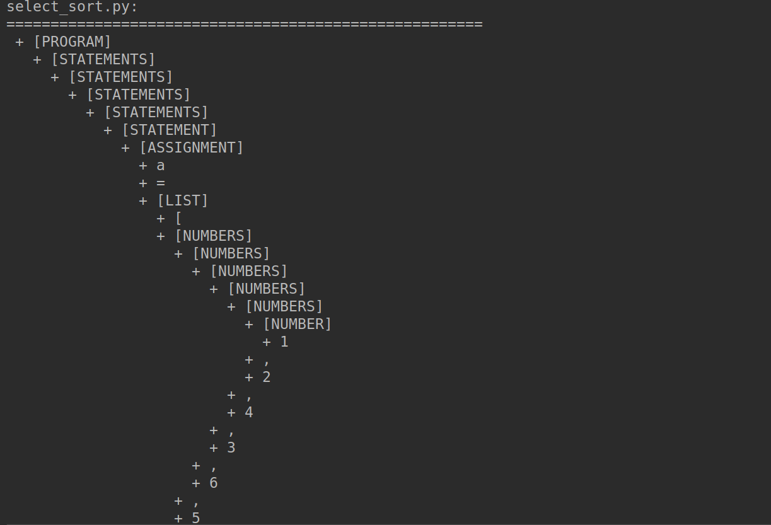

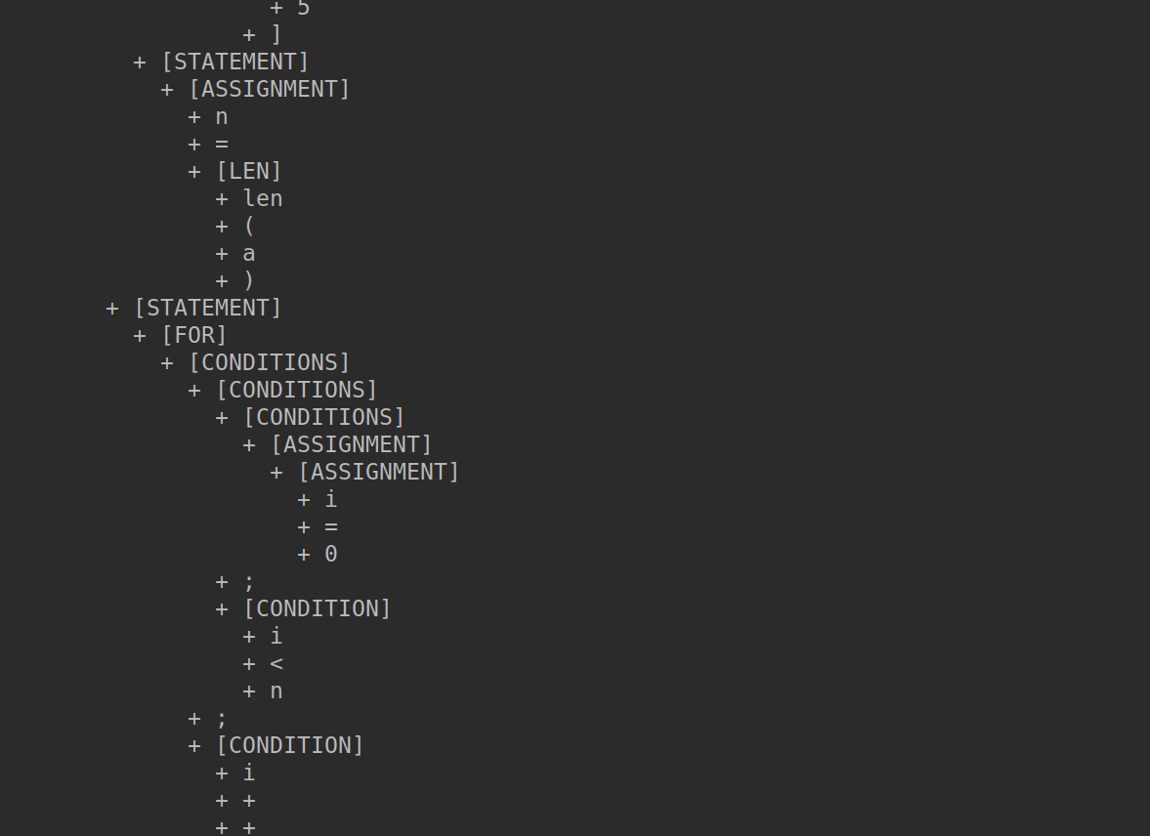

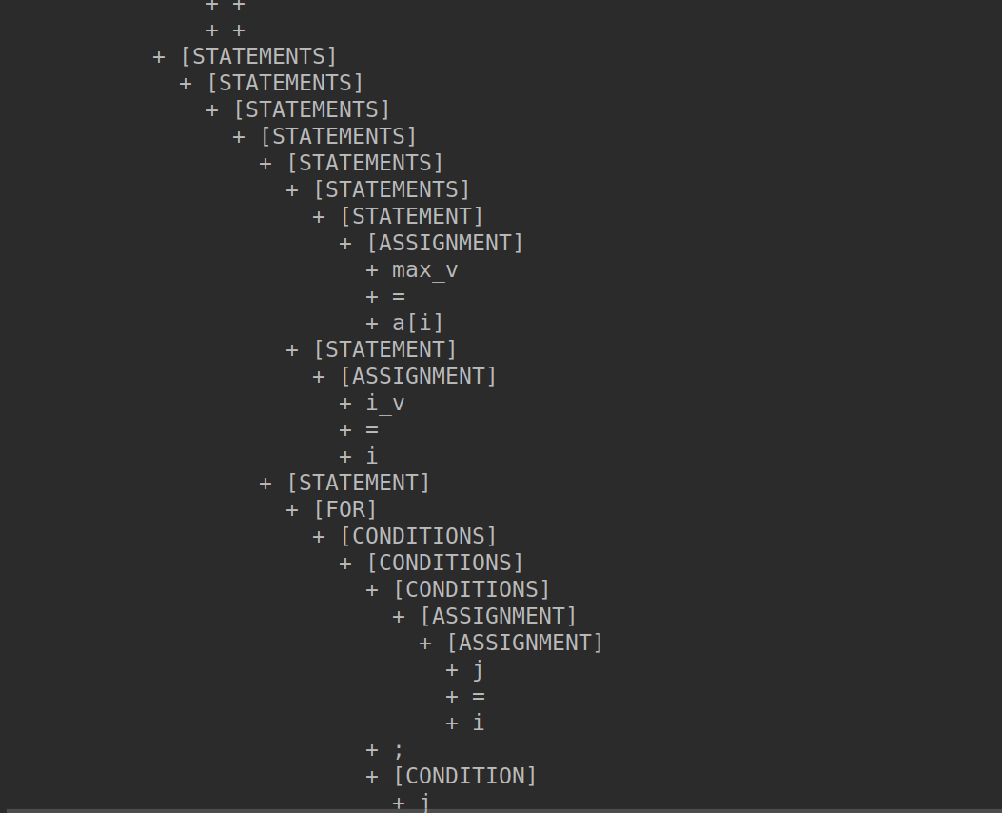

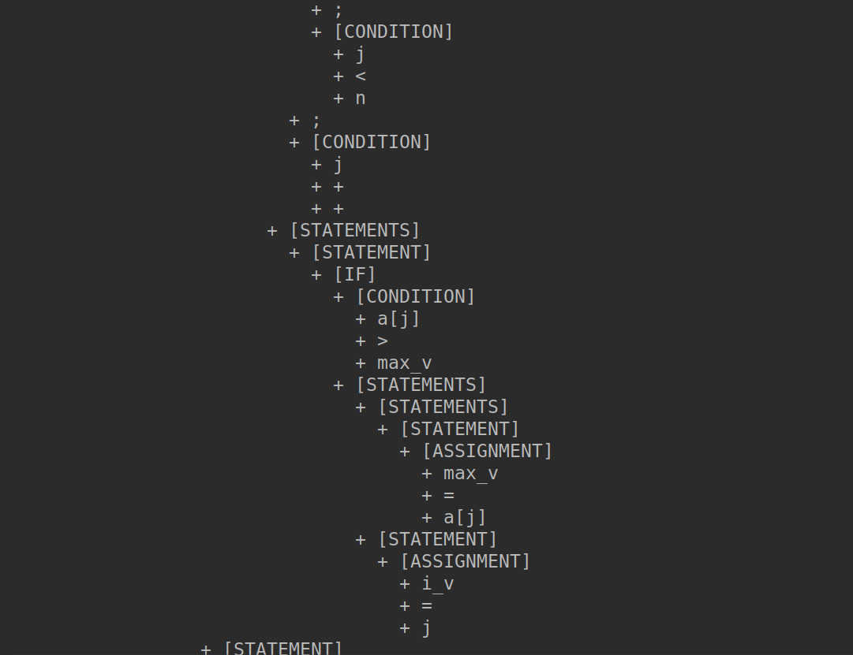

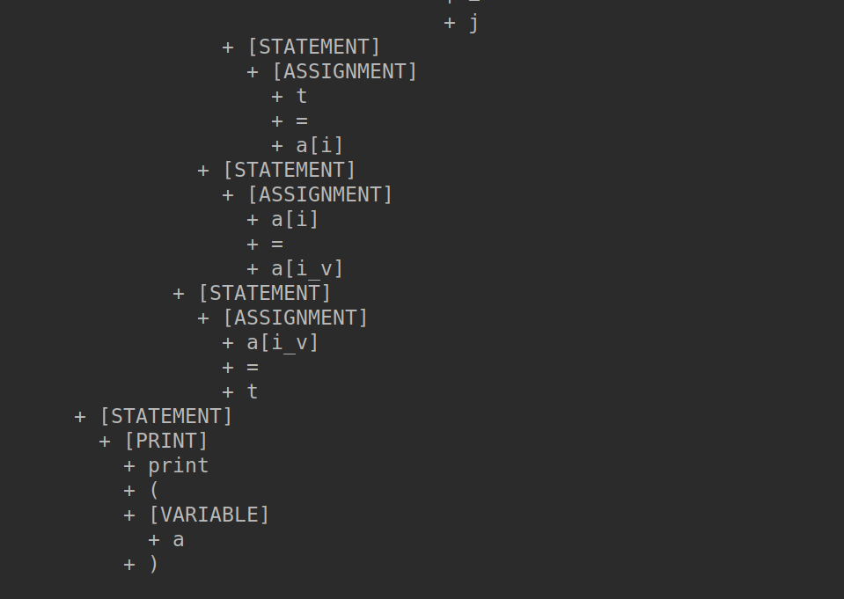

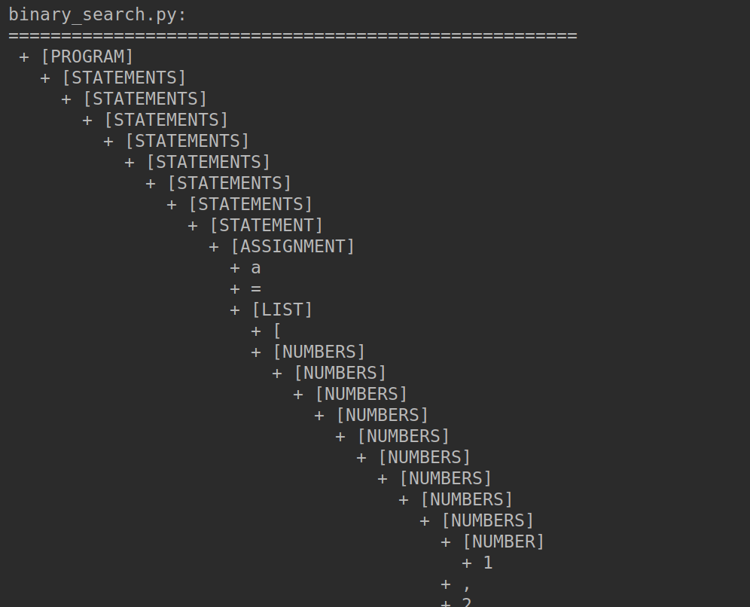

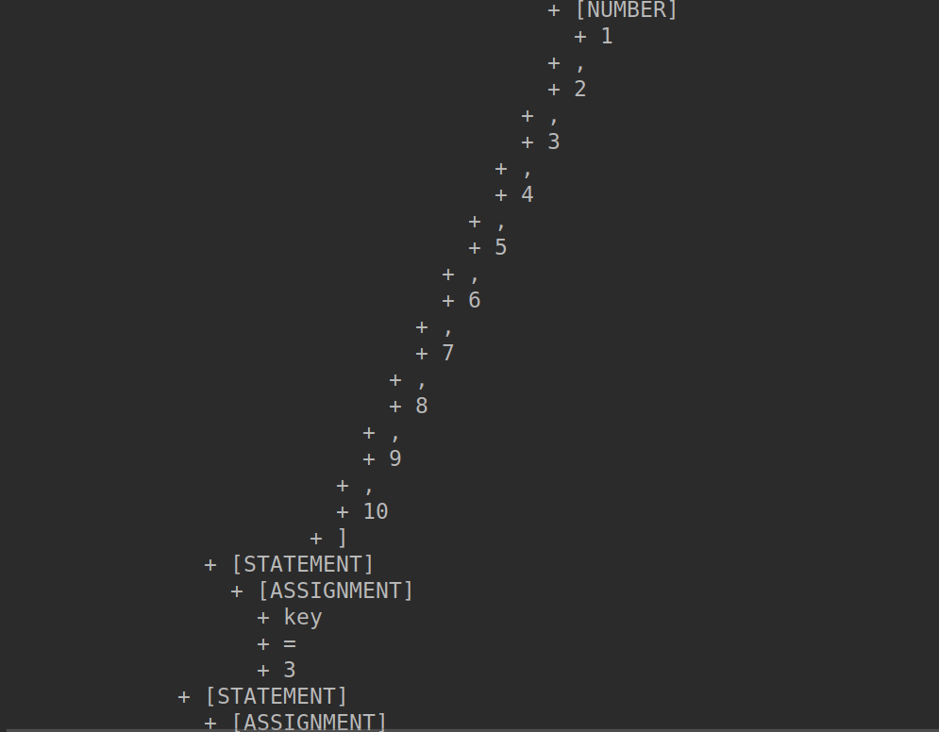

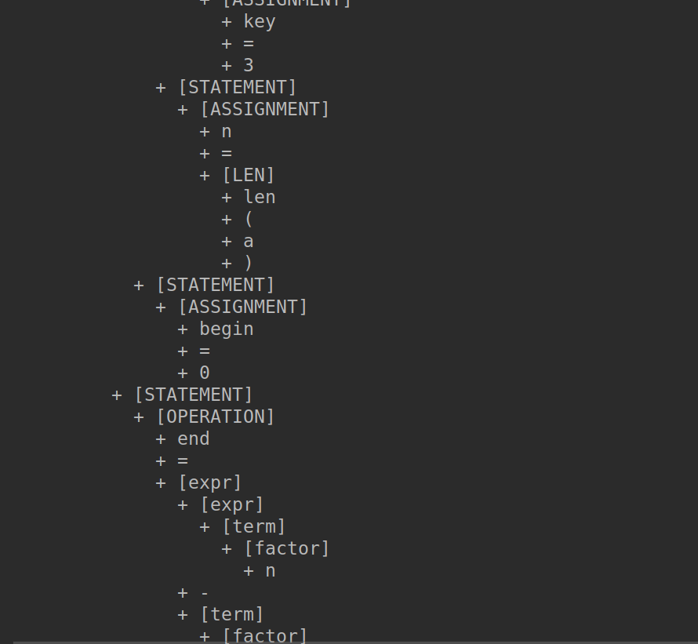

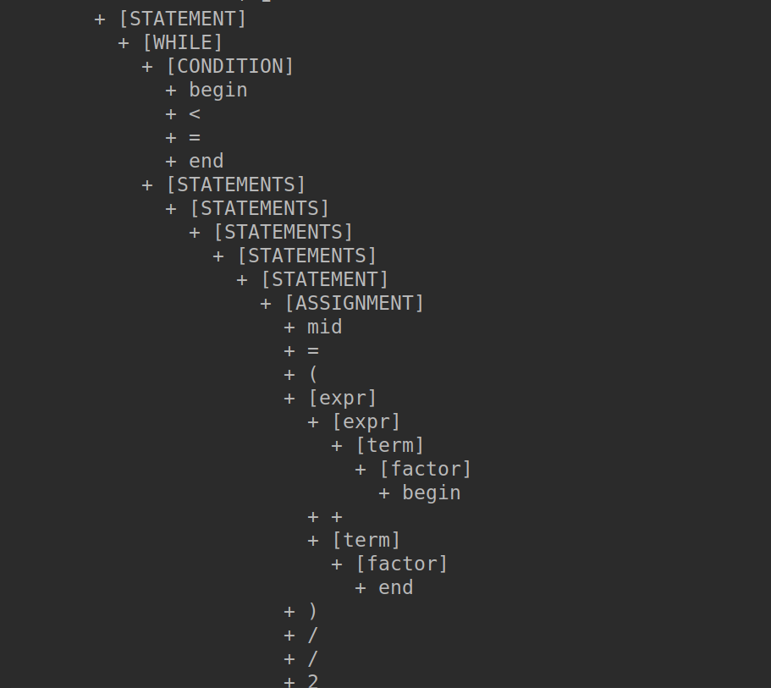

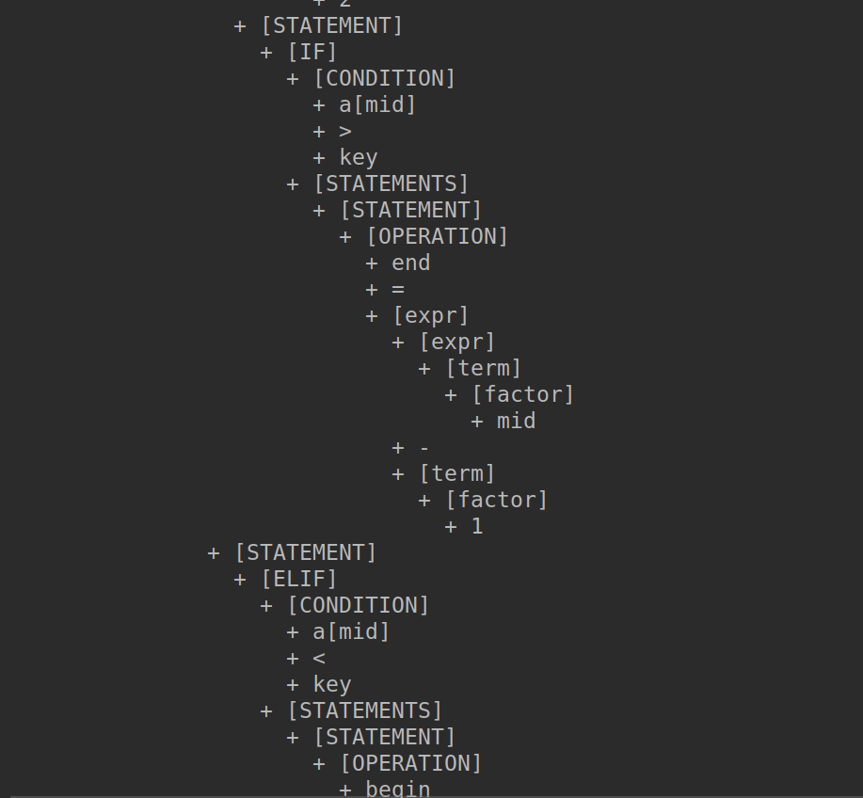

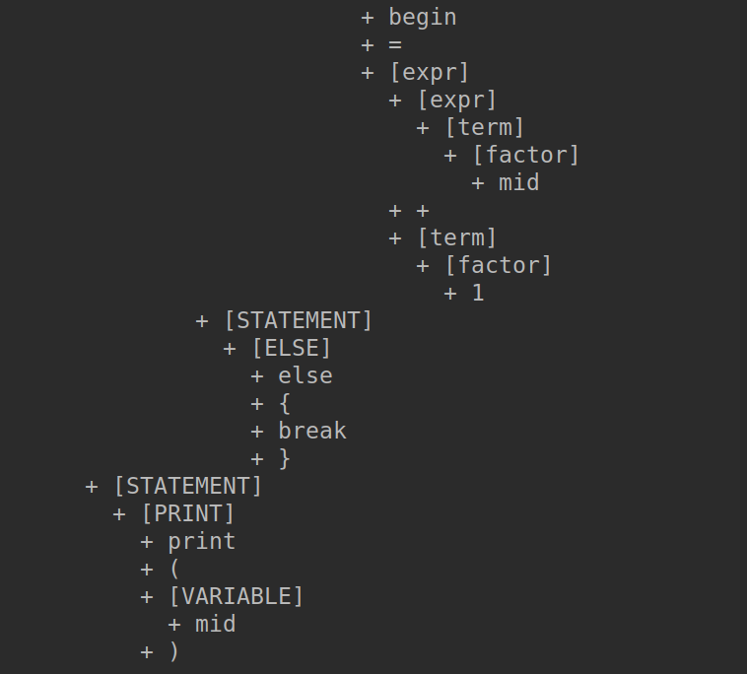

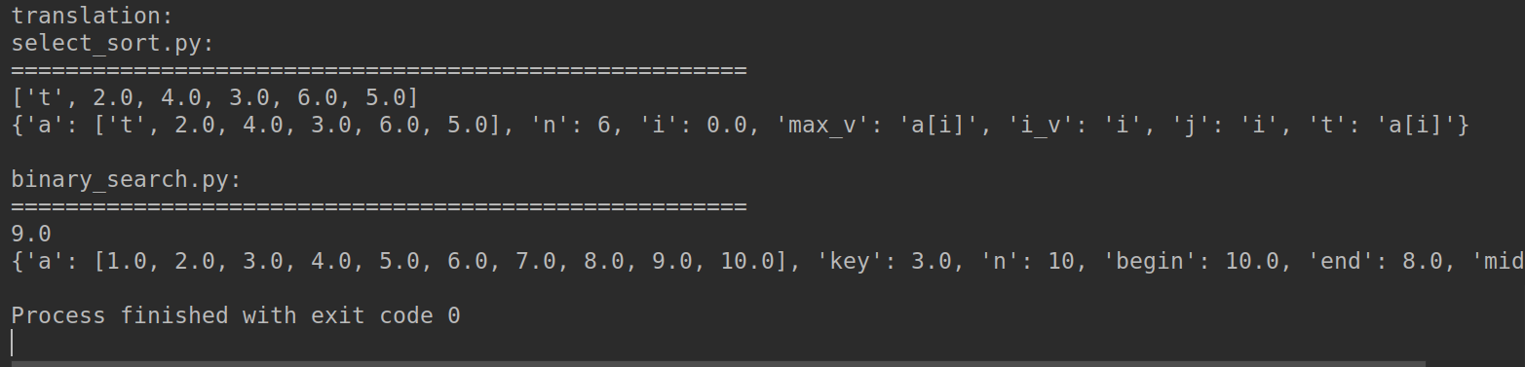

四、实验总结

通过这次实验, 我更加全面的掌握了词法分析,语法分析以及最后的结果的计算和转化.编译原理实践课程让我学到了很多.