Advanced Database Systems
  - Coursework
Fletcher Thomas Moore | SET09107 | 17/03/2020
Contents
Task 1 2
ER Diagram 2
Task 2 3
Redesigned ER Diagrams 3
Critical Discussion - Design 4
Object-Relational 4
Inheritance 4
Types 5
Collections 5
Task 3 6
Task 4 7
Question A 7
Question B 8
Question C 9
Question D 10
Question E 11
Question F 12
Question G 13
Question H 14
Task 5 15
Critical Discussion – Object-Relational and Relational Model 15
Task 6 16

Task 1

ER Diagram
The ER Diagram (Figure 1.1) corresponding to the relation database schema and scenario given in the specification.
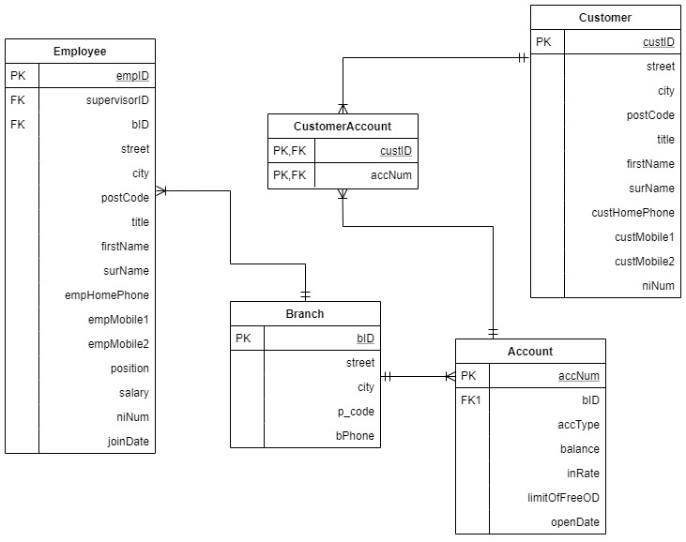

Task 2

Redesigned ER Diagrams
After much thought into the redesign of the database, another two ER diagram were drawn up using draw.io to map out the database types (Figure 2.1) and database tables (Figure 2.2).
Redesigning the database and including Types helps to break down the problem especially when some variables such as Name and Address can be re-used, and inheritance passes variables from one type to another. Name, Phone_Array and Address are needed for People type and the Address type is also used within Branch. Both Customer and Employee inherit from People, carrying the Name, Address, Phone and niNum to each. The same idea happens with Account; CurrentAcc and SavingsAcc inheriting from Account type.
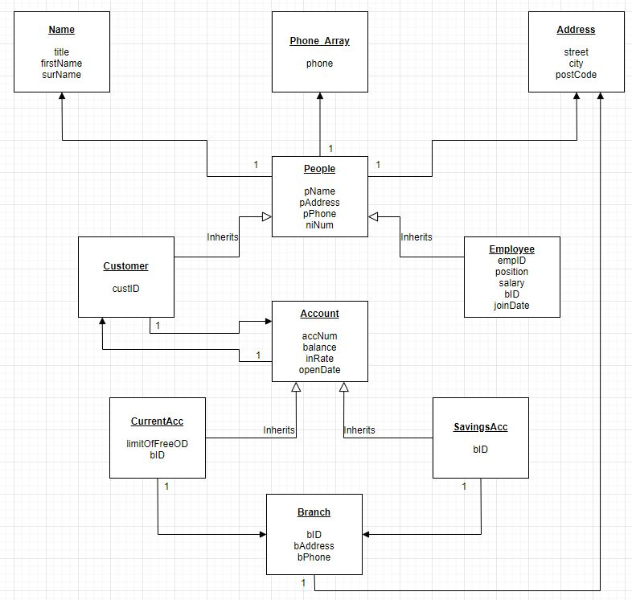

Figure 2.1

With the use of Types, the database had to change slightly in a way that benefits the specification. Some extra tables were added and although it meant some extra work being involved during the data entering, overall, it did aid in easing the use of the system. The three tables that didn’t change were tableBranch, tableEmployee and tableCustomer. In hopes of breaking the problem down, tableAccount was split into tableCurrentAcc and tableSavingsAcc removing the need for accType. This idea was also used for tableCustomerAccount; tableCustAccCurrent and tableCustAccSavings were to be implemented in order to connect the customer to either a Savings or Current account.
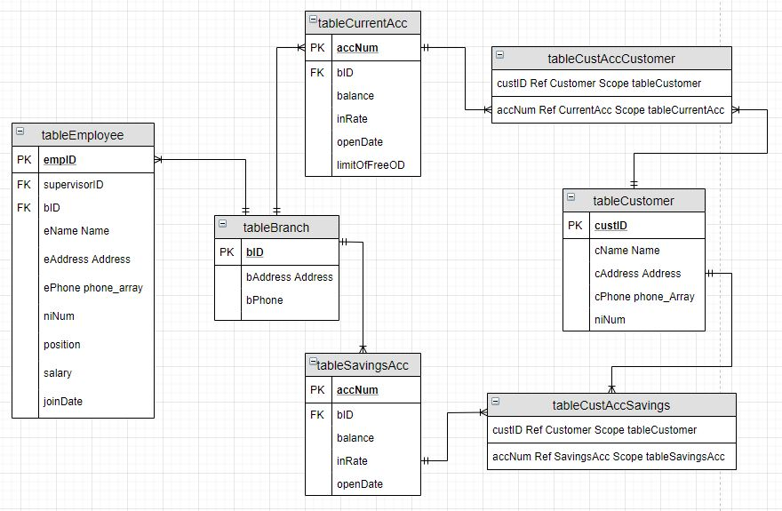

Figure 2.2

Critical Discussion - Design

Object-Relational
The object-relational model contains features and characteristics from both the objected-oriented model and relational model, including constructs to aid working with the additional data types. By using features from the object-oriented model, the object-relational model can also use encapsulation and methods as well as complex objects and inheritance.

Inheritance
Subtypes inherit the attributes from their supertype, very much like what is shown in Figure 2.1. The supertypes contains specific variables and the subtype will inherit those including in extra stated during the creation of the subtype. For example, still following Figure 2.1, Account is the supertype containing the attributes accNum, balance, inRate, and openDate. The subtype is SavingsAcc which inherits all the above attributes as well as the additional variable bID. Account can be used as a supertype many more times, creating numerous different subtypes. This allows previous code to be re-used, saving time re-creating types.

Types
The use of types within the object-relational model condenses the code and keeps the database clean and east to understand. Due to encapsulation being supported, this also means that multiple types will not affect one another. An example would be within Account again. Both SavingsAcc and CurrentAcc contain the attribute balance, but do not affect one another. Types can also be reused again and again, such as Address being used within type People, Customer, Employee and Branch but they do not interfere with one another.

Collections
The object-relational model supports to types of collections; nested tables and varrays. Within the database design used, a varray for the phone numbers was incorporated due to some Customers and Employee’s having up to three numbers. The varray is created like a type, and like multiple types, the numbers for one employee won’t interfere with the numbers for another employee or even a customer. Within the database created for the specification, the varray used could support up to three numbers of a maximum of eleven digits.

Task 3
This is the implementation of the database including the creation of types, tables, and inheritance and the data used to populate the tables. These are within the folder submitted under DBCreating.sql and DBPopulating.sql.

Task 4

Question A
Input
select p.pname.title AS "Title",
p.pname.firstName AS "First Name",
p.pname.surName AS "Surname",
p.paddress.city AS "City"
from tableEmployee p
where lower(p.pname.firstName) like '%st%'
and p.pAddress.city = 'Edinburgh';

Output
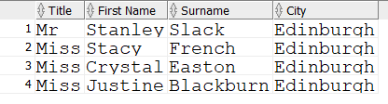

Question B
Input
select b.bID AS "Branch ID",
b.baddress.street AS "Street",
b.baddress.city AS "City",
b.baddress.postCode AS "Postcode",
b.bPhone AS "Branch Number",
count(s.bID) AS "Savings Accounts at Branch"
from tableBranch b Left Join
tableSavingsAcc s on s.bID = b.bID
group by b.bID, b.baddress.street, b.baddress.city, b.baddress.postCode, b.bPhone, s.bID

Output
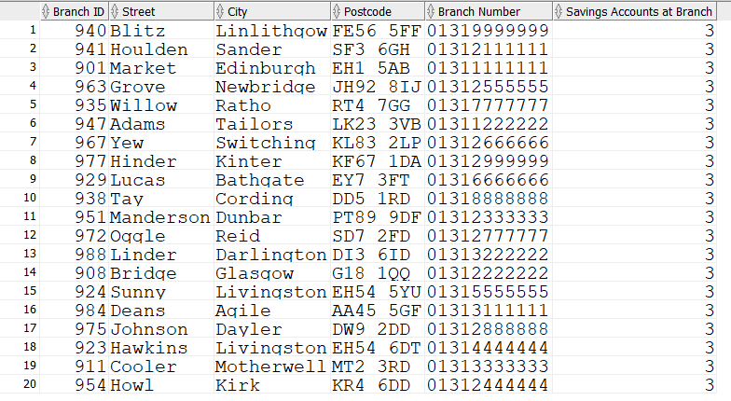

Question C
Input
select s.bID AS "Branch ID",
c.custID AS "Customer ID",
c.cName.title AS "Title",
c.cName.firstName AS "First Name",
c.cName.surName AS "Surname",
a.accNum AS "Account Number",
s.balance AS "Balance"
from
(select s.bID, c.custID, c.cName.title, c.cName.fistName, c.cName.surName, a.accNum, s.balance
from tablesavingsacc s
inner join tablecustaccsavings a on a.accNum = s.accNum
inner join tableCustomer c on c.custID = a.custID
group by s.bID, c.custID, c.cName.title, c.cName.firstName, c.cName.surName, a.accNum, s.balance);

Output

Task 5

Critical Discussion – Object-Relational and Relational Model
Both the object-relational model and relational model have their advantages and disadvantages, but each excel in certain area’s depending on the specification and what is required. Using the object-relational model for this specification, I have run into some of the issues that will be mentioned which is part of the reason I struggled during the query stage of the coursework.
The object-relational model does have numerous advantages, especially regarding extensive amounts of data due to reuse and sharing. Certain attributes and code can be reused and shared by types including through inheritance which reduces time spent on implementing the database but also means that updating and extending the database will be easier with code that can be reused. There is also increased productivity for both the developer and the end user with this model. Due to the object-relational model containing features from both the object-oriented model and the relational model, it should, in theory, work better especially due to being able to use complex data types that are formed using existing datatypes. Like everything though, there are some disadvantages. The complexity is a main one, more so when it comes to querying the data. This is a major problem that I myself ran into. This will be partly to do with how I implemented the database as there are numerous ways this could have been done, some better than others and admittedly my design was not the best as I realized during the more complex queries. Lastly, there is also the increased costs of implementing and using the object-relational design.
Moving on to the relational model, its main advantages is the simplicity and ease of use which some developers and users prefer, and its main concern is the data, not the structure which can improve the performance of the model. The structure can be altered without having to change any applications and it is scalable. Three disadvantages of the relational model include having limits of field lengths which can’t be exceeded, they can become complex with additional data being added and there is a possibility of isolated databases.
Ideally, everyone would prefer simplicity over complexity, but when there are mass amounts of data, very much like the size of data a bank would hold, the object-relational is of greater benefit. However, developers and users need to have a good understanding of this model to be able to use it correctly and utilize the model’s capability.

Task 6
This is where the dropping of tables and types is implemented. This will be within the folder submitted under dropingTypesTables.sql.

