
College of Engineering, Construction and Living Sciences Bachelor of Information Technology
ID511001: Programming 2
Level 5, Credits 15
Practice Skills-Based Assessment

Assessment overview
In this individual practice assessment, you will develop code solutions to a range of problems that cover the key concepts taught in this course.

Learning outcomes
At the successful completion of this course, learners will be able to:
- Build interactive, event-driven GUI applications using pre-built components.
- Declare and implement user-defined classes using encapsulation, inheritance and polymorphism.

Condition of assessment
You will complete this assessment during your learner-managed time. This assessment will need to be completed by TBC.

Pass criteria
This assessment is criterion-referenced (CRA) with a cumulative pass mark of 50% over all assessments in ID511001: Programming 2.

Authenticity

You may bring one double-sided A4 cheat sheet to this assessment. Only Microsoft Word and Visual Studio may be used during the exam. Do not discuss your theory exam answers with students from the other stream. Doing so will result in a mark of zero for this assessment.

Submission
You must submit your assessment via GitHub no later than TBC.

Extensions
Extensions are not applicable for this assessment.

Resubmissions
Resubmissions are not applicable for this assessment.

Resits and reassessments
Resits and reassessments are not applicable for this assessment.

Remember to save your work regularly as you complete this skills-based assessment.

Task one (10 marks):
In the assessment repository, you have been provided with an application called TaskOne. Once you have completed this task, add, commit and push your code to GitHub.
In the Person class:
  - Write a constructor that accepts firstName, lastName and age. (1.5 marks)
  - Write a property for firstName, lastName and age. (1.5 marks)
In the Form1 class:
  - Using the List<Person> people, write a LINQ query that returns a List<Person> where a person’s last name starts with “D”. (2 marks)
  - When button1 is clicked, display the result of the LINQ query from 1.3 in listBox1. (1 mark)
  - Using the List<Person> people, write another LINQ query that returns a List<Person> where a person’s age is between 25 and 50. (2 marks)
  - When button2 is clicked, display the result of the LINQ query from 1.4 in listBox2. (1 mark)
  - When button3 is clicked, clear both listBox1 and listBox2. (1 mark)
Expected output when the application runs:
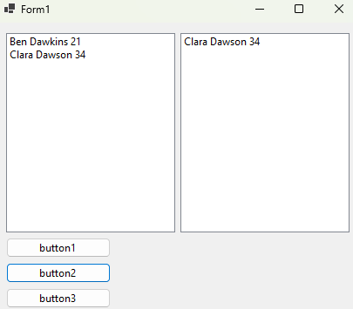

Task two (12 marks):
In the assessment repository, you have been provided with an application called TaskTwo. Once you have completed this task, add, commit and push your code to GitHub.
In the Employee class:
  - Write two fields - name and salary. Note: Use the appropriate access modifier as per the lecture notes. (1 mark)
  - Write an abstract method called Work which returns a string. (1 mark)
  - Write a property for name and salary. (1 mark)
In the Manager class:
  - Write a constructor that inherits from the Employee class. (1 mark)
  - Override the Work method and return “Managing team!”. (1 mark)
In the Developer class:
  - Write a constructor that inherits from the Employee class. (1 mark)
  - Override the Work method and return “Writing code!”. (1 mark)
In the Form1 class:
  - Add two columns to dataGridView1. The first column is name, and the second column is salary. (1 marks)
  - Write a foreach loop that displays the name and salary of each vehicle in the List<Employee> employees in the dataGridView1. (2 marks)
  - Display the number of Employee that have a salary greater than or equal to 50000 in a MessageBox. (2 marks)
Expected output when the application runs:
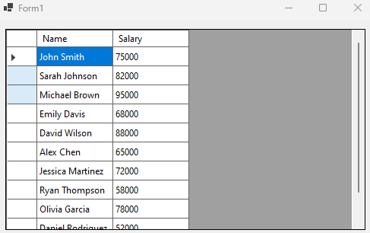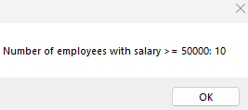

Task three (15 marks):
In the assessment repository, you have been provided with an application called TaskThree. Once you have completed this task, add, commit and push your code to GitHub.
In the Form1 class:
  - When button1 is clicked, generate 15 random square numbers between 1 and 300 using the GenerateRandomSquares method. (3 marks)
  - Categorise the generated square numbers into three groups (6 marks):
- Squares from 1-100
- Squares from 101-200
- Squares from 201-300
  - Display the groups in their appropriate Label controls (3 marks):
- label1 - squares from 1-100
- label2 - squares from 101-200
- label3 - squares from 201-300
  - For each Label control, set the text colour using the ForeColor property to (3 marks):
- label1 - red
- label2 - green
- label3 - blue
Expected output when the application runs:
