**RMIT** University – Introduction to Information Technology.

Assessment 2 – Team Project – Team Profile.

A2-Group#10,

**Team Valour.**

**Team Profile.**

**Personal information:**

**Elisha Rackley**, the *Campaigner* from Team Valour. I consider myself a creative individual with a background in various areas of the Entertainment industry. My goal is to obtain the knowledge that I need to make my imaginations possible. Student Number – S3887249. I bounced around a few customer service jobs before I fell into a job working as tech support for a government agency. I hope to use this job, coupled with an IT degree, to work my way through the ranks while I build up my own company until it can support me enough to focus on my business full time.

**Fletcher Petersen**, The *Logician* from Team Valour. I work in retail selling electronics and I believe that has somewhat sparked my interest in IT. I don't have much experience in IT other than some programming from high school. I play basketball for fun and competitively. Student Number – s3886293. My interest in IT is partly around programming but also the interconnectedness of software and the solutions IT provides for everyday problems.

**Fletcher’s Myer’s-Briggs Test Results**

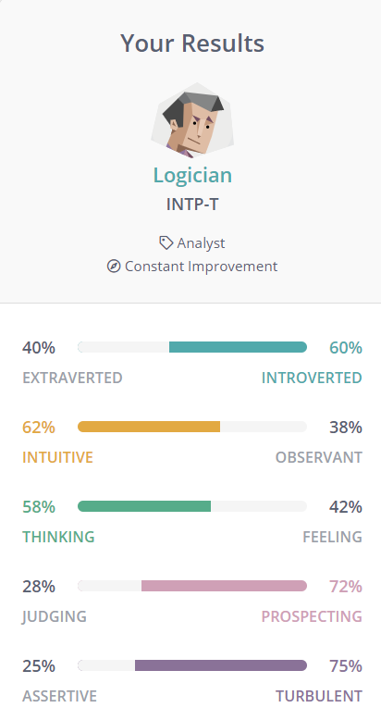

**Fletcher’s Learning Style Test Results**

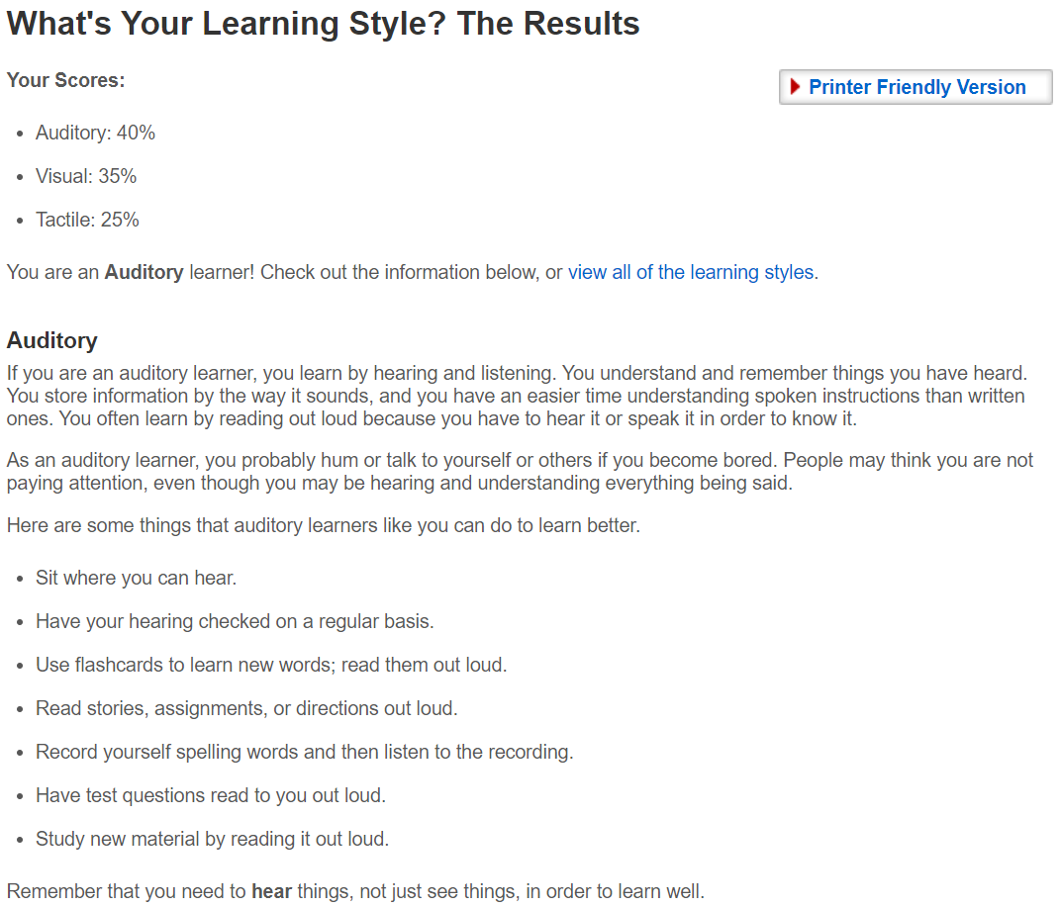

**Fletcher’s Big Five Test Results**

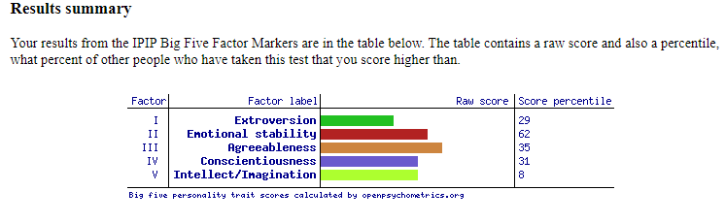

**Glen Whillier,** to enter information and test results.

**Jarrod Petersen**, The *Virtuoso* from Team Valour. My background is in insurance & there is not a great deal to say about me except that I am a rugby union & golf tragic. Student Number – S3806973. My interests are in fair and ethical insurance competition, rugby union, golf and more recently, programming. My motivation to get into IT is purely to skill up and increase my opportunities. I plan on learning programming to assist in development of my own business plan.

**Jarrod’s Myers Briggs Test Results.**

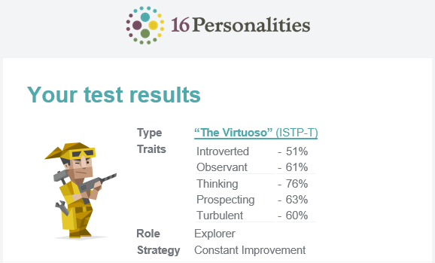

**Jarrod’s Learning Style Test Results.**

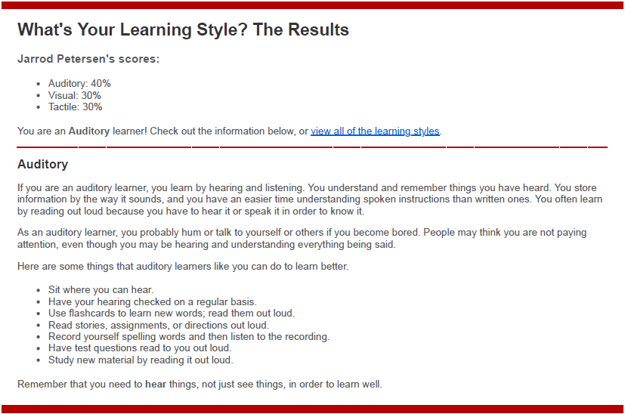

**Jarrod’s Creativity Test Score**

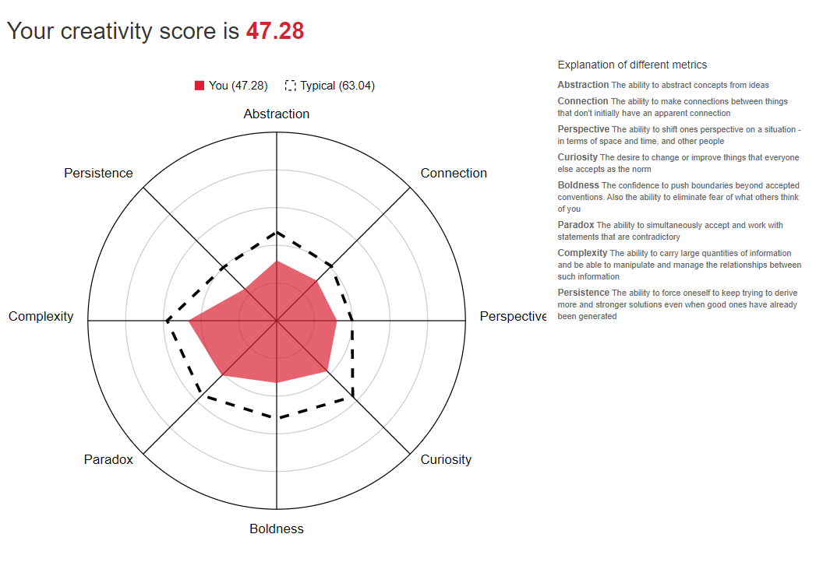

**Keegan Whitfield**, the *Mediator* of Team Valour. Like a cliché geek, I read comic books, watch Japanese anime, play video games, and in my spare time I build plastic Gundam models. Now enrolled at RMIT as student S3885480, will finally achieve my long-sought after bachelor's degree. Especially, as my current IT knowledge consists of a diploma of networking technology from 2016, from a now defunct TAFE.

**Keegan Whitfield’s** **Myers Briggs Test Results.**

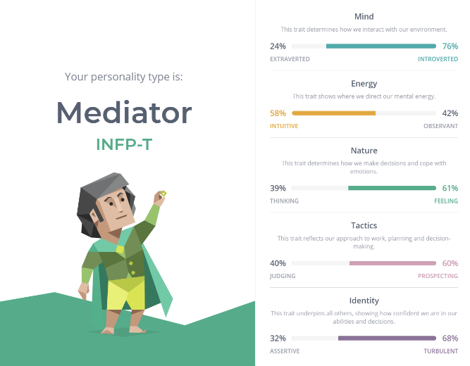

**Keegan Whitfield’s Learning Style Test Results.**

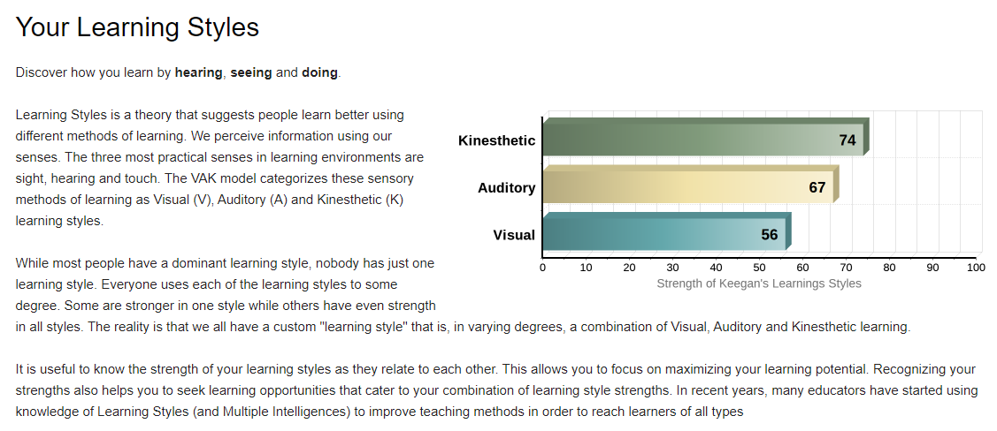

**Keegan Whitfield’s Emotional Intelligence test.**

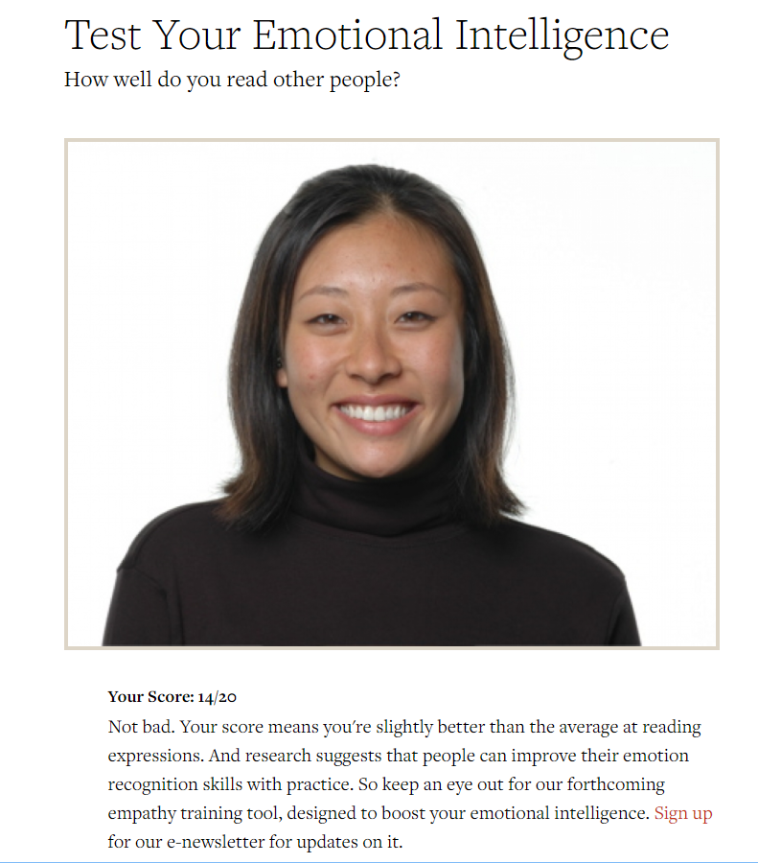

**Mathew Lawton**, the *Protagonist* of Team Valour who went from professional BMX rider and founder/owner of a bicycle manufacturer/distributor to Oil & Gas and Underground Mine site operator to now a loving stay-at-home Dad and RMIT student who dreams of a future as a software developer in Healthcare.  
 Student number - s3887263. Interested in Healthcare, AI, Machine Learning, Space exploration, BMX & Skateboarding culture, being a dad, robotics, IT, Computer science and gaining knowledge about the world around us.

**Mats Myers Briggs Test Results.**

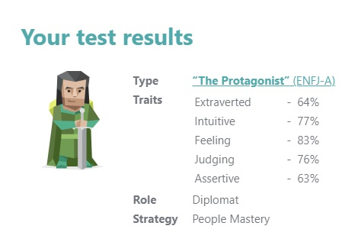

**Mats Learning Style Test Results.**

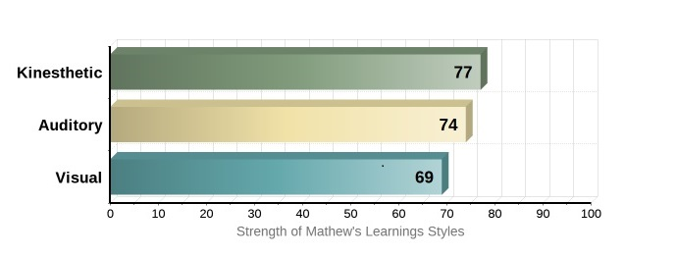

**Mats Non-Verbal Aptitude Test Results.**

