ALUMNI: A WEB AND MOBILE TRACER STUDY
PLATFORM FOR BALIUAG UNIVERSITY

An Undergraduate Capstone Project
Presented to the Faculty of the
College of Information Technology Education
Baliuag University
City of Baliwag, Bulacan

In Partial Fulfillment of the
Requirements for the Degree
BACHELOR OF SCIENCE IN COMPUTER SCIENCE

by
researcher 1
researcher 2

March 2026

Table of Contents
(Right-click and select "Update Field" to refresh page numbers)
CHAPTER I 1
INTRODUCTION 1
The Problem and Its Background 1
Significance of the Study 3
Review of Related Literature and Studies 4
Project Context 7
Statement of the Problem 8
Objectives of the Study 9
General Objective 9
Specific Objectives 9
Scope and Limitations of the Study 9
Definition of Terms 10
Framework of the Study 11
Technical Background 12
Mobile Application 12
Backend Infrastructure 13
AI Integration 13
Data Visualization 13
Security Implementation 14
CHAPTER II 15
METHOD 15
Research Subject 15
Research Instrument 16
Section A: Demographic Profile 16
Section B: Employment Status 16
Section C: Current Employment Details 16
Section D: Skills and Competencies 17
System Development Methodology 17
Planning and Requirements Gathering 17
Analysis and Design 18
Implementation 18
Testing 18
Evaluation 19
Deployment 19
Requirement Specification and Analysis 19
Functional Requirements 19
Non-Functional Requirements 20
Existing System 20
Designing 21
System Architecture 21
Database Design 21
Design Patterns 22
Software Development Tools 22
Development Tools 23
Responsibilities 24
Software Architect 24
Software Developer 24
Quality Assurance 24
Software Trainer 24
Implementation Plan 25
System Requirements 25
Verification, Validation, and Testing 26
Functional Suitability 26
Performance Efficiency 27
Compatibility 27
Interaction Capability 27
Reliability 27
Security 27
Maintainability 28
Flexibility 28
Safety 28
Data Analysis 28
Descriptive Statistics 28
Interpretation Scale 29
Employment Rate Calculation 29
Course Relatedness Analysis 29
Skills Analysis 30
References 31

CHAPTER I

INTRODUCTION

The Problem and Its Background
In the current educational landscape, higher education institutions are expected to produce graduates who are equipped with the knowledge, skills, and competencies required to meet the demands of the labor market (UNESCO, 2021). As industries continue to evolve due to technological advancements and global competition, universities are increasingly required to ensure that their academic programs remain relevant and aligned with workforce needs (International Labour Organization, 2022). One effective way of evaluating this alignment is through a graduate tracer study, which systematically tracks graduates after completing their degree to assess their employment outcomes and career progression (European Commission, 2020).
Graduate tracer studies provide valuable insights into the employability of graduates, including their employment status, job relevance, and the applicability of the skills they acquired during their academic training (Abana et al., 2021). These studies also serve as a feedback mechanism that enables institutions to evaluate the effectiveness of their curriculum and instructional practices (Sarsale et al., 2024).
In the Philippines, the Commission on Higher Education has institutionalized the Graduate Tracer Study as a standard tool for monitoring graduate outcomes and supporting quality assurance in higher education. Universities such as Baliuag University adopt and localize this framework to systematically gather data on their graduates and guide program improvement (Dela Cruz, 2022).
Despite the availability of standardized tracer study frameworks, several challenges are still encountered in their implementation. Many institutions continue to rely on manual or traditional methods of data collection, which often result in low response rates, delayed data processing, and difficulties in organizing and analyzing large volumes of data (Bensi et al., 2024). In addition, recent studies have shown that although graduates are generally employable, issues such as job mismatch, skills gaps, and limited tracking of long-term career development persist (Guzman & Maling, 2026). These challenges create a gap between the availability of tracer study frameworks and the effective utilization of graduate data for institutional decision-making.
With these limitations, there is a need for a more efficient and technology-driven approach to conducting graduate tracer studies. The use of digital systems, particularly mobile and web-based platforms, can improve data collection by providing easier access for respondents and faster processing of responses (Nonyelum, 2020). Moreover, integrating data analytics and automated reporting features can enhance the interpretation of results and support timely and evidence-based decision-making within academic institutions (Sarsale et al., 2024).
In the context of Baliuag University, there is a need to improve the process of tracing graduates from 2019 to 2023 through a more systematic and technology-supported approach that aligns with both the CHED Graduate Tracer Study and the university’s existing tracer practices. While the university offers a wide range of academic programs, there is limited consolidated and digitally managed data regarding the employment outcomes, job relevance, and professional experiences of its graduates. This lack of organized information makes it difficult for administrators and faculty members to effectively assess program outcomes and identify areas for curriculum enhancement (Pallo & Pallo, 2023).
Therefore, this study proposes the development of a graduate tracer system that integrates the CHED Graduate Tracer Study framework with Baliuag University’s tracer process to provide a more efficient, accessible, and data-driven approach to graduate tracking. The proposed system aims to facilitate easier participation among graduates, improve data accuracy, and generate timely reports that can support curriculum development and institutional planning. Through this system, the study seeks to address the existing gaps in tracer study implementation and ensure that the academic programs of Baliuag University remain responsive to current labor market demands (Torrejas & Ordaneza, 2025).

Significance of the Study
This study provides contributions to various stakeholders:
University Administration. The system enables real-time access to organized graduate data for informed decision-making, curriculum enhancement, and accreditation.
Office of Alumni Affairs. The platform improves alumni tracking through centralized and digital record management.
Faculty and Colleges. The findings provide insights into employability trends, curriculum relevance, and skills gaps.
Graduates. The system offers a convenient platform for participation and continued engagement with the university.
Students. The results guide career opportunities and in-demand competencies.
Baliuag University. Overall, the system strengthens institutional data management, quality assurance, and alumni relations.

Review of Related Literature and Studies
Graduate tracer studies are widely utilized by higher education institutions to evaluate the effectiveness of academic programs in preparing students for employment and career development. These studies focus on key indicators such as employment status, job relevance, skills utilization, and alignment between educational preparation and labor market demands, making them essential tools for quality assurance and institutional improvement (Harvey, 2001; Yorke, 2006). In recent years, tracer studies have evolved from simple employment tracking into comprehensive systems that support evidence-based decision-making in higher education.
In the Philippine context, tracer studies are commonly conducted to assess graduate outcomes and inform curriculum enhancement. Several studies highlight the relationship between acquired competencies and employability across different academic disciplines. For instance, Ramel (2025) found that business-related competencies significantly influenced the employability of BSBA graduates, particularly in financial management and marketing roles. Similarly, Abana et al. (2021) reported that pedagogical competencies and licensure preparation contributed to the employment success of education graduates. Cornillez et al. (2021) further emphasized that curriculum alignment with licensure requirements and industry expectations plays a critical role in graduate employability. In the field of information technology, Bensi et al. (2024) identified that technical skills aligned with current industry standards significantly improved employment opportunities among graduates.
Additional local studies reinforce the importance of tracer studies as a basis for curriculum development and institutional planning. Torrejas and Ordaneza (2025) revealed that marketing management graduates benefited from industry exposure and practical training, which enhanced their employability. Likewise, Pallo and Pallo (2023) found that engineering graduates who possessed both technical and soft skills were more likely to achieve higher job level positions. Valdez and Argel (2025) also highlighted that managerial and entrepreneurial competency influenced career progression among cooperative management graduates. Across these studies, common themes such as job relevance, employment rate, and skills applicability consistently emerged, demonstrating that tracer studies provide actionable insights for improving academic programs.
On an international scale, tracer studies serve as standardized mechanisms for evaluating graduate employability and higher education outcomes. The European Commission (2020) introduced a structured framework for graduate tracking, emphasizing the importance of comparable and reliable data across institutions. Similarly, Guzman and Maling (2025) examined graduate employability and career pathways and found that industry alignment and competency development are key determinants of employment outcomes. The International Labour Organization (2022) also reported that monitoring youth employment trends is essential for understanding labor market dynamics and guiding education policies. These studies highlight the global relevance of tracer studies in bridging the gap between education and employment.
With the advancement of technology, the implementation of digital solutions in tracer studies has become increasingly important. Traditional data collection methods often result in low response rates and inefficient data management, prompting the need for more accessible and automated systems. Nonyelum (2020) emphasized that digital platforms improve data collection efficiency and system usability through iterative and user-centered design. Furthermore, Sarsale et al. (2024) noted that integrating data analytics enhances the interpretation of tracer study results, allowing institutions to generate more meaningful insights. These findings suggest that technology plays a crucial role in improving the overall effectiveness of tracer studies.
Moreover, the integration of artificial intelligence in educational systems has opened new opportunities for enhancing user interaction and data processing. According to UNESCO (2021), AI technologies can support personalized user experiences and improve access to educational services. The OECD (2019) also emphasized that digital transformation, including the use of intelligent systems, can strengthen data-driven decision-making in education. These innovations are relevant in the context of tracer studies, as they can facilitate automated responses, improve user engagement, and streamline the overall process of data collection and analysis.
Overall, the reviewed literature demonstrates that graduate tracer studies are essential tools for evaluating program effectiveness, improving curriculum relevance, and ensuring alignment between education and labor market demands. While traditional tracer methods provide valuable insights, they are often limited by inefficiencies in data collection and analysis. The integration of digital technologies and intelligent systems addresses these limitations by enhancing the accessibility, accuracy, and timeliness of data. Therefore, the proposed system builds upon existing tracer study frameworks by incorporating mobile and data-driven solutions to improve the efficiency and effectiveness of graduate tracking processes.

Project Context
The ALUMNI system enhances Baliuag University’s operations in managing alumni data, conducting tracer studies, and analyzing graduate employment outcomes.
Purpose and Description
The project aims to provide a flexible web and mobile-based tracer study system that simplifies data collection, improves alumni engagement, and assists administrators in managing records efficiently. It also provides comprehensive data analytics that generate insights into graduate employability, program relevance, and institutional performance.

Statement of the Problem
This study aims to develop and evaluate a web and mobile-based alumni tracer study system for Baliuag University. Specifically, it seeks to answer the following:
- Tracer Study
- What is the employment status of the graduates?
- How long does it take for graduates to obtain their first job?
- What is the nature of their employment?
- How relevant is their degree program to their current job?
- What skills and competencies are most useful in their employment?
- System Evaluation (ISO/IEC 25010)
- How acceptable is the system in terms of:
- Functional Suitability
- Performance Efficiency
- Compatibility
- Usability
- Reliability
- Security
- Maintainability
- Flexibility
- User Evaluation
How do users evaluate the system using the System Usability Scale (SUS)?

Objectives of the Study

General Objective
To develop and evaluate a web and mobile-based alumni tracer study platform for Baliuag University.

Specific Objectives
Specifically, this study aims to:
1. Determine the employment status of the graduates.
2. Identify the length of time it took the graduates to obtain their first job after graduation.
3. Describe the nature of employment of the graduates in terms of job position and employment status.
4. Assess the relevance of the degree program to the graduates' current occupation.
5. Distinguish the skills and competencies acquired in college that are most applicable to their present work.
6. Evaluate the system quality using ISO 25010.
7. And assess the usability SUS.

Scope and Limitations of the Study
This study traces the employment outcomes and professional experiences of graduates from Baliuag University who completed their degrees between 2019 to 2023. It focuses on key aspects such as employment status, length of time spent securing first employment, nature of current job, relevance of degree to current work, and the skills and competencies that graduates find most applicable to their professional responsibilities.
The respondents of this study are graduates from selected programs offered by the University, including but not limited to business administration and information technology, depending on the availability of respondents who voluntarily completed the online questionnaire through the mobile application.
This research is limited to the information provided by graduates through the tracer study questionnaire. It does not incorporate employer evaluations, salary analysis, longitudinal tracking beyond the point of data collection, or an in-depth study of labor market conditions that may influence employment outcomes. It also does not measure career progression beyond the initial period after graduation.
Furthermore, the generalizability of the findings is limited to the graduates who responded within the data collection period. The results reflect only the experiences and perceptions of respondents who participated in the study and may not represent all graduates from Baliuag University within the covered years.

Definition of Terms
Alumni Tracer Study. A systematic method of collecting information from graduates regarding their employment status, career progression, and the relevance of their education to their current occupation.
BUddy AI Chatbot. An artificial intelligence-powered assistant integrated into the mobile application that provides navigation assistance and responds to user queries about the tracer study.
Cloud Firestore. A NoSQL cloud database used for storing and synchronizing application data in real-time across connected devices.
Course Relatedness Score. A numerical value ranging from 0 to 1 that indicates the degree of alignment between a graduate's degree program and their current employment.
Cross-Platform Development. A software development approach that enables applications to run on multiple operating systems using a single codebase.
Flutter. An open-source UI software development kit created by Google for building cross-platform applications.
Graduate Employability. The ability of graduates to obtain and maintain employment, utilizing the knowledge and skills acquired during their academic training.
Riverpod. A reactive state management library for Flutter applications that provides efficient data handling and dependency injection.

Framework of the Study
This study utilizes the Input-Process-Output (IPO) framework to illustrate the systematic flow of the alumni tracer study system. The framework provides a structured approach to understanding how inputs are transformed through various processes to produce desired outputs.
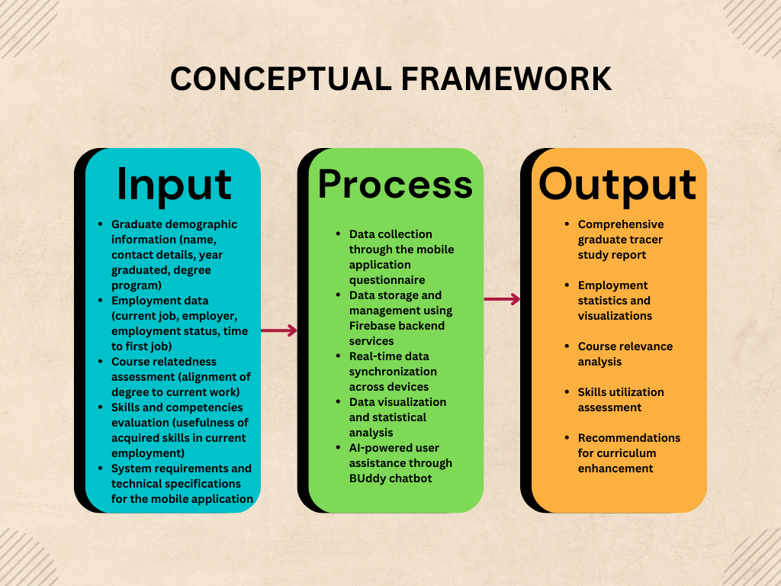
Figure 1. The Conceptual Framework

Technical Background
The BU Alumni Tracer mobile application is built using modern cross-platform development technologies to ensure accessibility, scalability, and maintainability. The system architecture follows a layered approach with clear separation of concerns between the presentation, business logic, and data layers.

Mobile Application
The frontend of the mobile application is developed using Flutter, a cross-platform UI framework by Google that enables deployment on both Android and iOS devices from a single codebase. The Dart programming language is used for application logic, while Material Design 3 provides the UI component system for consistent and modern interface elements.
State management is handled through Flutter Riverpod, which provides reactive state management capabilities, including StreamProvider and StateNotifierProvider for efficient data flow. SharedPreferences is utilized for local persistent storage of user preferences such as theme settings.

Backend Infrastructure
The backend infrastructure leverages Firebase services for reliable and scalable cloud functionality. Firebase Core handles initialization, while Firebase Auth provides secure email/password authentication. Cloud Firestore serves as the real-time NoSQL database for storing graduate data, questionnaire responses, and system logs. Firebase Storage is used for avatar and file storage.

AI Integration
The BUddy AI chatbot is powered by Gemini 2.0 Flash, Google's generative AI model. This integration provides users with intelligent navigation assistance, answers to frequently asked questions, and personalized guidance throughout the tracer study process.

Data Visualization
The application utilizes FL Chart for rendering bar and pie charts that visualize employment statistics, course distribution, and job-field analysis. This enables administrators and stakeholders to quickly grasp key insights from the collected data.

Security Implementation
Security is implemented through Firestore Security Rules that enforce user-based access control. All Firebase connections are encrypted using SSL/TLS protocols. API keys are managed through environment variables to prevent unauthorized access. Parameterized Firestore queries protect against injection attacks.

CHAPTER II

METHODOLOGY
This chapter covers the methods that would be used in designing the system, the architecture pattern applied, the software development cycle that would be used, workflows for the existing and proposed system, and the software technology stack that would be utilized in developing the system. The aforementioned coverage would be detailed and expanded to fully illustrate the overall design of the system. The system would be created from scratch and be flexible to the needs of the intended users.

Research Subject
The respondents of this study are graduates of Baliuag University who completed their degrees between academic years 2019 to 2023. The distribution of respondents would be determined according to the availability of contact information and willingness to participate in the tracer study through the mobile application.
The target population includes graduates from various colleges within the university, including but not limited to:
• College of Business Administration and Accountancy
• College of Education and Human Development
• College of Hospitality Management and Tourism
• College of Information Technology and Education
• College of Liberal Arts and General Education
• College of Nursing and Allied Health Science
Purposive sampling would be employed to ensure representation across different degree programs and graduation years. The minimum target sample size is determined using statistical formulas to ensure adequate power for analysis.

Research Instrument
The study will utilize the standardized Graduate Tracer Study (GTS) questionnaire prescribed by the Commission on Higher Education (CHED) and adapted from Baliuag University’s existing GTS instrument. The questionnaire is divided into several sections:

Section A: Demographic Profile
• Personal information (name, contact details, year graduated)
• Degree program and major
• Additional credentials or certifications obtained

Section B: Employment Status
• Current employment status (employed, self-employed, unemployed, further study)
• Time elapsed between graduation and first employment
• Nature of first employment

Section C: Current Employment Details
• Job position and title
• Employment status (regular, contractual, part-time, freelance)
• Industry or sector of employment
• Course relatedness score (0-1 scale)

Section D: Skills and Competencies
• Rating of skills acquired during college
• Skills most useful in current employment
• Additional skills needed in the workplace

System Development Methodology
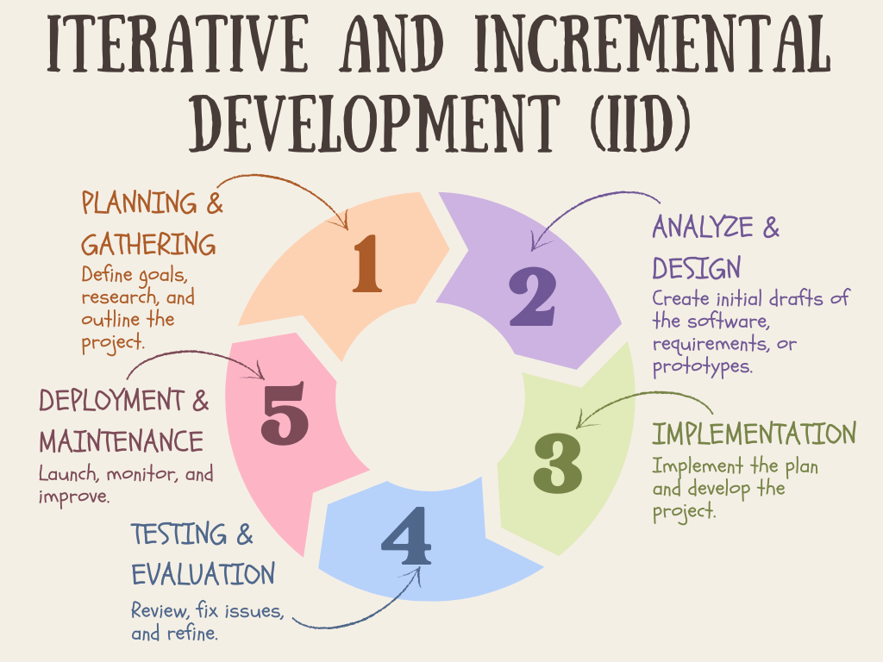
Figure 2. Iterative and Incremental Development Methodology
The Iterative and Incremental Development (IID) methodology would be used as a guide to develop the project. With the project processes being broken down into manageable parts as increments and systematically repeating the cycle for iteration, the project would be flexible enough for requirements or designs to be changed in the course of development (Larman & Basili, 2003; Ibrahim, 2020).
Each phase of the cycle would be used for iteration to improve each deployment of the software. The phases are: Planning and Requirements Gathering, Analysis and Design, Implementation, Testing, Evaluation, and Deployment.

Planning and Requirements Gathering
This phase involves initial discussions with stakeholders, including university administrators, faculty members, and alumni representatives. The requirements for the tracer study system are identified, including functional requirements (questionnaire system, data visualization, AI assistant) and non-functional requirements (security, performance, usability).

Analysis and Design
The system would be designed according to the identified requirements and what is within the limits of the software technology stack. The main functionalities include:
• User Authentication and Account Management
• Dynamic Questionnaire System
• Alumni Directory
• Statistics Dashboard with Data Visualization
• AI Chatbot (BUddy) for User Assistance
• Theme and Preference Management

Implementation
Each functionality would be modular and implemented separately while also being cohesive with others. The implementation follows clean architecture principles with clear separation between presentation, domain, and data layers.

Testing
Each functionality would have its own unit testing, regression, and sanity tests. The overall cohesion of the functionalities would also be tested after all functions are completed. Testing includes functional testing, usability testing, and security testing.

Evaluation
After all tests are completed, the evaluation will then be executed to see its efficiency and validity. Two evaluations would be conducted: a technical evaluation using ISO/IEC 25010 standards and a user evaluation using the System Usability Scale (SUS).

Deployment
The final iteration of the system would then be deployed to the application stores for public access. CI/CD pipelines using GitHub Actions automate the build and release process.

Requirement Specification and Analysis
The final requirement specification and overall analysis for the application would depend on the project's final output. The system proposition is based on initial discussions with stakeholders and would subsequently be refined based on further specifications and feedback.

Functional Requirements
• The system shall allow users to register and authenticate using email and password
• The system shall provide a multi-section questionnaire for data collection
• The system shall display statistics through interactive charts and graphs
• The system shall provide an AI chatbot for user assistance
• The system shall support dark and light mode themes

Non-Functional Requirements
• The system shall respond to user actions within 2 seconds
• The system shall encrypt all data in transit and at rest
• The system shall be available 99.5% of the time
• The system shall comply with data privacy regulations

Existing System
The current process for conducting alumni tracer studies at Baliuag University involves manual distribution of paper-based questionnaires or email surveys. The workflow of the existing system is as follows:
1. The Office of the Registrar provides a list of graduates and their contact information.
2. Questionnaires are prepared in printed form or as email attachments.
3. Surveys are distributed through mail, email, or during alumni events.
4. Completed questionnaires are collected and manually encoded into spreadsheets.
5. Data is processed and analyzed using spreadsheet software.
6. Reports are generated and presented to stakeholders.
The existing system has several limitations:
• Low response rates due to the inconvenience of paper-based or email surveys
• Time-consuming manual data encoding process
• Difficulty in tracking and following up non-respondents
• Limited data visualization capabilities
• No real-time access to collected data

Designing
The mobile application utilizes a layered software architecture pattern that uses three layers: presentation layer, business logic layer, and data layer. The ISO/IEC 25010 software product quality model would be used as a standard for the overall quality of the application.
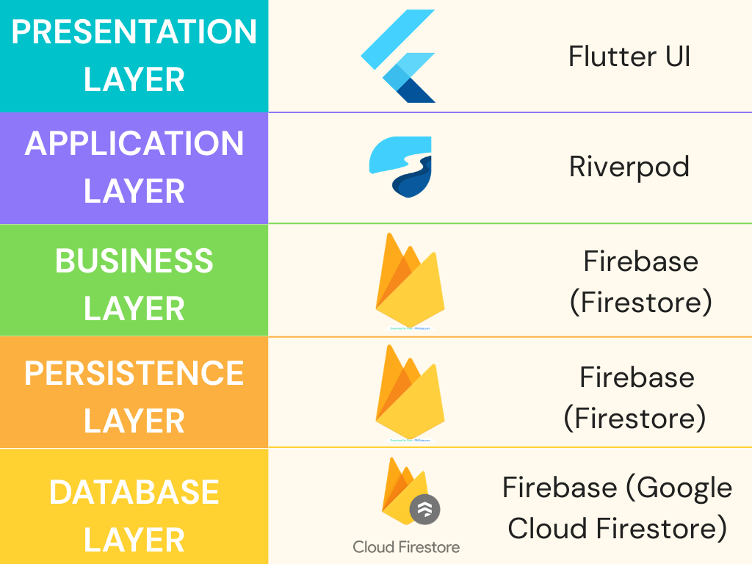
Figure 3. Layered Software Architecture for Mobile App
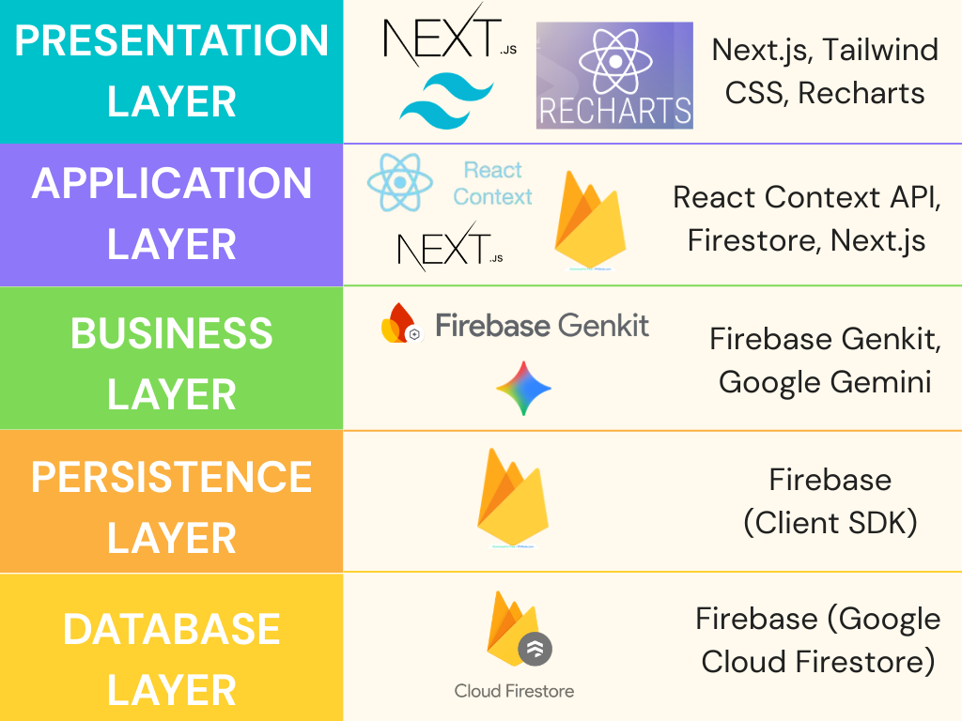
Figure 4. Layered Software Architecture for Web

System Architecture
The architecture follows the Riverpod-based Clean Architecture pattern with MVVM (Model-View-ViewModel) influences. The data flow is as follows:
- Firestore Database -> Services -> Riverpod Providers -> ConsumerWidget UI
Real-time synchronization is achieved using Firestore snapshot streams and a connectivity-aware sync service that gracefully handles both online and offline states.
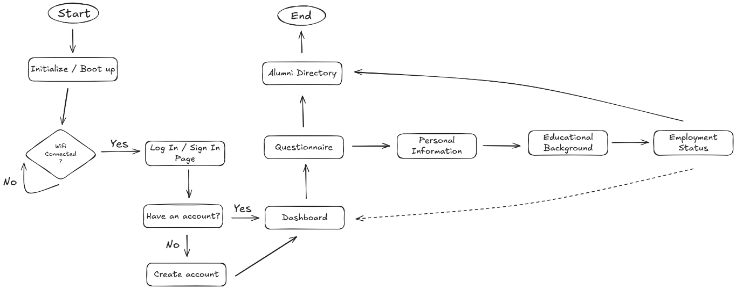
Figure 5. Process Flow Diagram

Database Design
Cloud Firestore uses a hierarchical NoSQL structure with the following main collections:
• alumni - Public-facing profiles for the directory
• users - Private user metadata and authentication details
• questionnaires - Administrative survey definitions
• questionnaireResponses - Subcollection storing individual responses
• logs - Audit trails for system integrity

Design Patterns
The following design patterns are utilized in the system:
• Repository Pattern - Abstracts data access and provides a clean API for data operations
• Provider Pattern - Manages state and dependency injection through Riverpod
• Observer Pattern - Enables reactive UI updates through stream-based data flow
• Factory Pattern - Creates widgets and components dynamically based on configuration

Software Development Tools
The following technology stack was chosen for the development of the mobile application:
Category | Technology | Purpose
Frontend | Flutter | Cross-platform mobile UI framework
 | Dart | Programming language for Flutter
 | Material Design 3 | UI component system
State Management | Flutter Riverpod | Reactive state management
 | SharedPreferences | Local persistent storage
Backend | Firebase Core | Firebase initialization
 | Firebase Auth | Email/password authentication
 | Cloud Firestore | Real-time NoSQL database
 | Firebase Storage | Avatar/file storage
AI/ML | Gemini 2.0 Flash | AI chatbot functionality
Visualization | FL Chart | Bar and pie chart rendering
CI/CD | GitHub Actions | Automated build pipeline
Table 1. Software Development Tools

Development Tools
• Android Studio - Primary IDE for Flutter development
• Git and GitHub - Version control and source code management
• GitHub Actions - CI/CD pipeline for automated builds
• Firebase Console - Backend service management

Responsibilities
In the development of the BU Alumni Tracer mobile application, the researcher is tasked with performing the following roles to ensure the success of the system.

Software Architect
Will create the appropriate technology stacks and orchestrate the overall design of the system based on the needs of the stakeholders.

Software Developer
Will develop the system based on the design and execute the necessary technical decisions for the overall coding aspects.

Quality Assurance
Would do the following tasks to ensure that the system functions and works based on the proposed design: sanity testing, developing test cases, regression testing, and UI touch and feel evaluation.

Software Trainer
The researcher is also responsible for training the users of the proposed system and providing a comprehensive user guide.

Implementation Plan
The following procedure details the overall plan for deployment and implementation of the mobile application:
Strategy | Activity | Persons Involved | Duration
Agreement Discussion | Discuss system use, limitations, and data privacy | Admin, Researcher | 1 Day
Application Deployment | Upload to app stores, configure backend | Researcher | 2 Days
Server Setup | Configure Firebase, AI services, and security rules | Researcher | 2 Days
User Training | Demonstration, manual provision, Q&A | Admin, Researcher | 2 Days
Data Collection | Survey distribution and response gathering | Graduates | 4 Weeks
Analysis & Reporting | Data processing and report generation | Researcher | 1 Week
Table 2. Implementation Plan

System Requirements
The following table shows the minimum requirements for the hardware and software necessary to run the application:
Item | Minimum Requirements
Processor | 1.5 GHz or above, Dual Core
RAM | 3 GB (Android), 2 GB (iOS)
Storage | 100 MB free space
Operating System | Android 8.0+ or iOS 13+
Internet | Required for sync and AI features
Display | 4.7 inches or larger
Table 3. System Requirements

Verification, Validation, and Testing
In compliance with the ISO/IEC 25010 software product quality model, the researcher will conduct comprehensive testing and evaluation of the system. The quality model comprises nine main quality characteristics:

Functional Suitability
Measures the degree to which the system provides functions that satisfy the implied needs of the user. Sub-characteristics include functional completeness, functional correctness, and functional appropriateness.

Performance Efficiency
Measures the software's performance within set time and throughput parameters. Sub-characteristics include time behavior, resource utilization, and capacity.

Compatibility
Measures the software's ability to interact with other software and perform with other systems in the same environment. Sub-characteristics include co-existence and interoperability.

Interaction Capability
Measures the software's capability to interact and complete specified user objectives. Sub-characteristics include learnability, operability, user error protection, and user engagement.

Reliability
Measures the software's ability to perform specified functions under specified conditions over time. Sub-characteristics include faultlessness, availability, fault tolerance, and recoverability.

Security
Measures the software's capability to defend against attacks, protect data, and ensure appropriate user access. Sub-characteristics include confidentiality, integrity, non-repudiation, and authenticity.

Maintainability
Represents the software's ability for efficient and effective modification, improvement, and adaptation. Sub-characteristics include modularity, reusability, analyzability, modifiability, and testability.

Flexibility
Measures the software's adaptability to changes in requirements. Sub-characteristics include adaptability, scalability, and installability.

Safety
Represents the software's ability to avoid harm or endangerment. Sub-characteristics include operational constraint, risk identification, fail-safe, and hazard warning.
In addition to the ISO/IEC 25010 evaluation, the System Usability Scale (SUS) would be used for general end-user evaluation. SUS consists of ten standardized questions measuring both positive and negative perceptions of the system (Bangor et al., 2009; Brooke, 2013).

Data Analysis
The data analysis for the tracer study would be conducted using both descriptive and inferential statistical methods.

Descriptive Statistics
Frequency counts and percentages would be used to describe the distribution of responses for categorical variables such as employment status, job position, and degree program. The weighted arithmetic mean would be used to calculate average ratings for Likert-scale items.

Interpretation Scale
For evaluation using a 5-point Likert scale, the following interpretation would be applied:
Mean Range | Interpretation
4.21 - 5.00 | Very Satisfied / Strongly Agree
3.41 - 4.20 | Satisfied / Agree
2.61 - 3.40 | Neutral
1.81 - 2.60 | Dissatisfied / Disagree
1.00 - 1.80 | Very Dissatisfied / Strongly Disagree
Table 4. Likert-Scale Measurements

Employment Rate Calculation
The employment rate would be calculated using the formula:
Employment Rate = (Number of Employed Graduates / Total Number of Respondents) x 100

Course Relatedness Analysis
The course-relatedness score (0-1 scale) would be analyzed to determine the degree of alignment between graduates' degree programs and their current employment. Mean scores would be calculated for each degree program and compared across different variables.

Skills Analysis
Skills and competencies data would be analyzed to identify the most useful skills in the workplace. Rankings would be generated based on frequency of mention and mean usefulness ratings.

References
Abana, A. S., Ramos, A. B., Gumarang, B. K., Jr., & Tarun, J. Z. (2021). The graduates tracer study: Bachelor of elementary education program. International Journal of Multidisciplinary: Applied Business and Education Research, 2(10), 918–927. https://doi.org/10.11594/ijmaber.02.10.09
Bangor, A., Kortum, P., & Miller, J. (2009). Determining what individual SUS scores mean: Adding an adjective rating scale. Journal of Usability Studies, 4(3), 114–123. https://uxpajournal.org/determining-what-individual-sus-scores-mean/
Bensi, L. P., Bensi, M. E., Alcantara, G. M., & Pula, R. L. (2024). Assessing employment outcomes and curriculum relevance of BSIT graduates batch 2021: A graduate tracer study at Nueva Ecija University of Science and Technology. International Journal of Research and Scientific Innovation, 11(11), 10–21. https://doi.org/10.51244/IJRSI.2024.1111002
Brooke, J. (2013). SUS: A retrospective. Journal of Usability Studies, 8(2), 29–40. https://uxpajournal.org/sus-a-retrospective/
Cantallopez, E. A., & Robles, J. A. A. (2024). Tracer study exploration of BS in criminology and BS in hospitality management graduates of Davao Central College. International Journal of Research and Innovation in Social Science, 8(3). https://doi.org/10.47772/IJRISS.2024.803118S
Cornillez, E. E. C., Jr., Caminoc, S. R. T., Basas, B. R., Militante, B. T., Jr., & Paler, R. R. (2021). Tracer study of teacher education graduates of the Eastern Visayas State University Tanauan Campus, Philippines. European Journal of Education and Pedagogy, 2(3), 186–193. https://doi.org/10.24018/ejedu.2021.2.3.143
Dela Cruz, J. (2022). Tracer study of graduate school graduates of a state higher education institution. International Journal of English and Literature Studies, 11(4), 123–131.
Dela Cruz, J. L. (2022). Tracer study of graduate school graduates of a state higher education institution in the Philippines from 2016 to 2020. International Journal of Education and Literacy Studies, 10(2), 149–154. https://doi.org/10.7575/aiac.ijels.v.10n.2p.149
Enriquez, J. J. A., Muegna, K. J. R., Royo, J. C., Espinosa, D. L., Escandallo, J. C., & Generalao, R. L. (2023). Tracer study on the employability of elementary education graduates from academic year 2019 to 2023. Instructor, 1, Article 8964-0116. https://doi.org/10.36713/epra16751
Escandallo, J. C., Callo, A. M., & Lopez, S. M. (2020). The employment rate and employability status of Bachelor of Science in Office Administration graduates from academic year 2018 to 2019: A tracer study. Journal of Critical Reviews, 7(11), 313–317. https://doi.org/10.36713/epra16000
European Commission. (2020). European graduate tracking initiative: Methodological framework. Publications Office of the European Union. https://op.europa.eu/en/publication-detail/-/publication/6f0c9f74-6a8b-11ea-b735-01aa75ed71a1

Florabel, O. N. (2025). Employability of BSBA graduates: A tracer study of the University of Nueva Caceres class of 2023. GPH-International Journal of Business Management, 8(1), 348–367. https://doi.org/10.5281/zenodo.14651047
Guzman, R. B. D., & Maling, Z. R. (2025). Graduate employability and career pathways: A tracer study of hospitality and tourism management graduates in the Philippines (2015–2021). International Journal of Research and Innovation in Social Science, 9(9), 5816–5824. https://doi.org/10.47772/IJRISS.2025.909000472
International Labour Organization. (2022). Global employment trends for youth 2022. https://www.ilo.org/global/research/global-reports/youth
Nonyelum, O. F. (2020). Iterative and incremental development analysis study of vocational career information systems. International Journal of Software Engineering and Applications, 11(5). https://doi.org/10.5121/ijsea.2020.11502
OECD. (2019). The future of work and education: Tracking graduate outcomes internationally. https://www.oecd.org
Pallo, M. M., & Pallo, M. E. (2023). Job level position and academic competencies: A tracer study of engineering graduates in Biliran Province State University. Innovative Technology and Management Journal, 6. https://doi.org/10.70954/0e6xd626
Ramel, M. (2025). Graduate tracer study on BSBA programs of financial management and marketing management: Basis for curriculum development. Aloysian Interdisciplinary Journal of Social Sciences, Education, and Allied Fields, 1(7), 288–305. https://doi.org/10.5281/zenodo.16870457
Sarsale, M., Garcia, C., & Uy, I. (2024). Dimensions of program relevance towards employment success: Evidence from a graduate tracer study using principal component analysis. Journal of Teaching and Learning for Graduate Employability, 15(1), 205–224. https://doi.org/10.21153/jtlge2024vol15no1art1895
Silongan, M. L., Cerna, C. B., Manlawe, J. S., Espinosa, D. L., Muegna, K. J. R., Escandallo, J. C., & Peñora, R. A. (2024). A tracer study on the secondary education major in Filipino graduates from academic year 2022 to 2023. Instructor, 1. https://doi.org/10.36713/epra16588
Tonita, E. M., Szulakowska, L., Baxter, J., Flannigan, E. L., Narayanan, N. J., & Menard, J. M. (2021). Physics graduate student employment: What we can learn from professional social media. arXiv. https://arxiv.org/abs/2106.04294
Torrejas, I. E., & Ordaneza, E. L. (2025). Tracking the employment status of BSBA marketing management graduates: A tracer study. International Journal of Research and Innovation in Social Science, 9(8). https://doi.org/10.47772/IJRISS.2025.908000014
UNESCO. (2021). Reimagining our futures together: A new social contract for education. https://unesdoc.unesco.org
Valdez, E. J. V., & Argel, H. P. (2025). Graduate tracer study for the Bachelor of Science in Cooperative Management graduates. International Journal of Multidisciplinary Research and Analysis. https://doi.org/10.47191/ijmra/v8-i02-41

