

**Anotium Automation Technologies**

**Bridging the industry technology divide**

Pw: 1k18uaR55HgoFMq67Zcd

User: [info@anotium.co.za](mailto:info@anotium.co.za)

HOME



Welcome

Anotium Automation Technologies provides services for Electrical, Control and Instrumentation Engineering for the industrial sector.

We offer a turn-key solution from the shop floor to the boardroom that includes engineering design, panel manufacture, PLC and SCADA software, installation and commissioning.

Industries where we are active

Water and wastewater

Mining and minerals

Food and Beverages

Power Generation

Pulp and Paper

Focus areas

Automation

Instrumentation

Analytics and Reporting

Production

Solutions

PLC and Network panels manufacture

We design, manufacture, install and commission PLC and MCC Panels. All our panels are manufactured and tested to exacting standards before being shipped off to site for installation and commissioning. Our enclosures are designed to meet the rigorous requirements of the various industries where we are active.

We manufacture panels for:

* The Food industry
* Dusty and Wet environments
* Corrosive environments

We have highly competent and experienced designers and panel builders to meet any of your needs

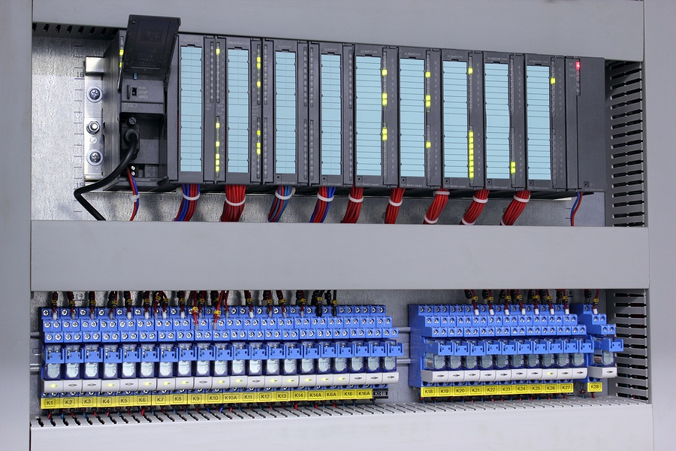

Process Control System Design

**We design and commission Process Control Systems for a wide range of industries.**

Our design philosophy encompasses

* simplicity
* ease of use
* transparency and visibility of information throughout the system
* scalability
* and ease of maintenance

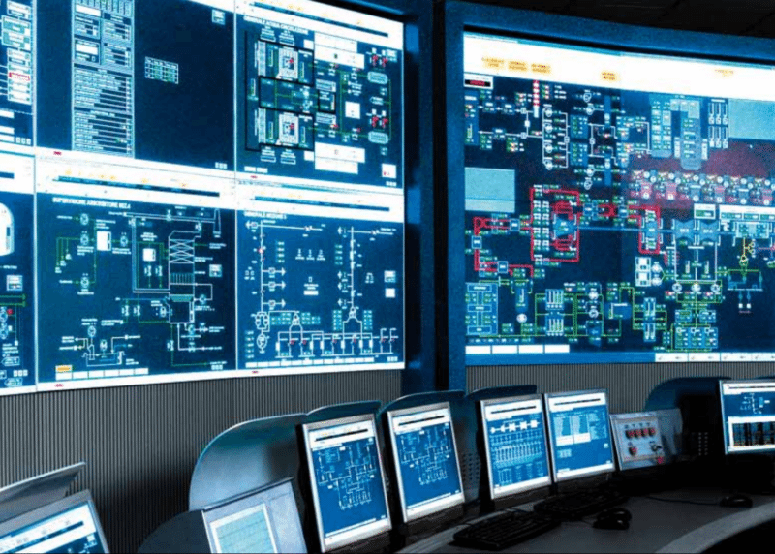

Industrial Networks

Main pic



Side pic



Process Optimisation

Main pic



Sub pic



Industrial Cybersecurity

Main pic



Side pic



IIOT

Main pic



Sub pic



Machine Learning in manufacturing

Mian pic



Side pic



