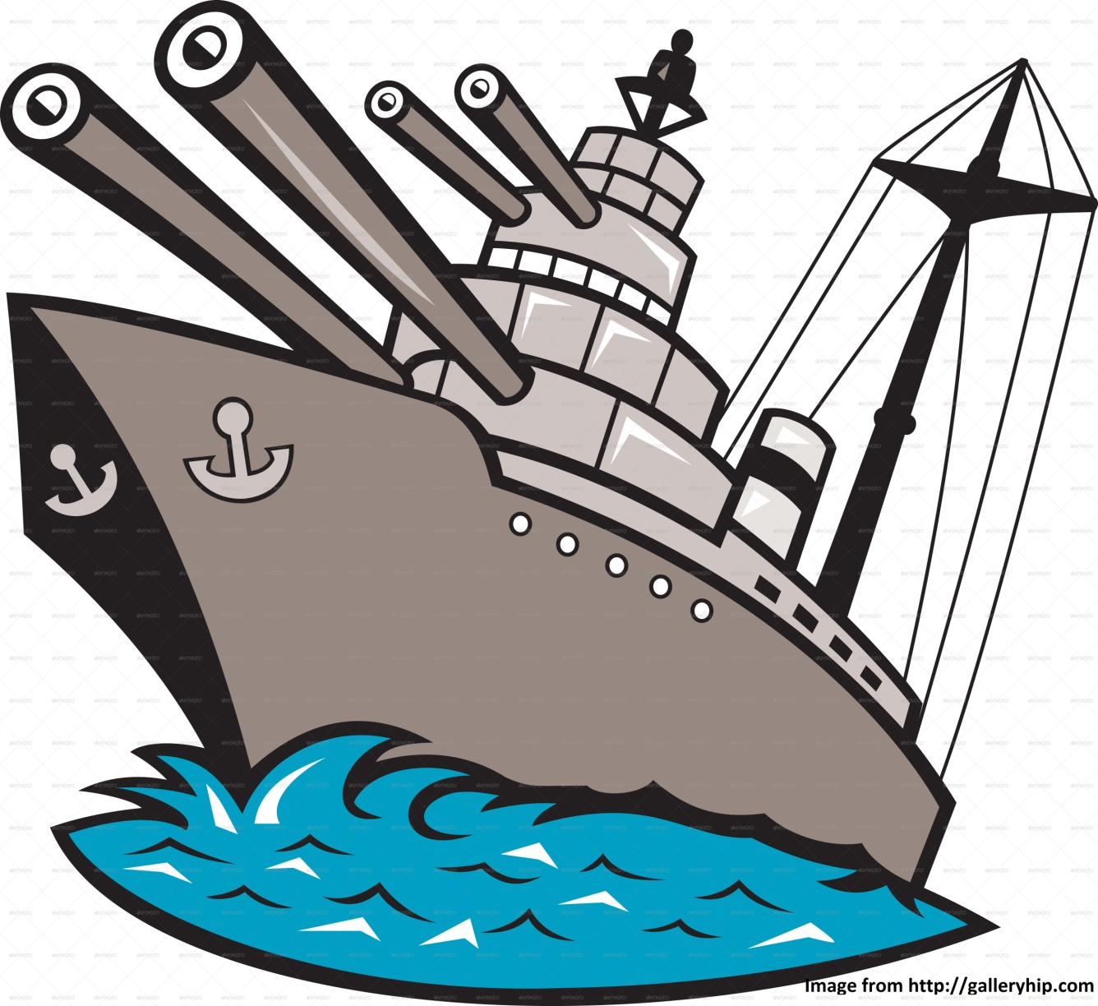

**Authors : Constantin MASSON**

**Jessica FAVIN**

**Anthony CHAFFOT**

Table of contents

Table of contents **.**

Introduction 4

Features 4

Global features 4

Game general features 4

Game modes 5

Player against artificial intelligence 5

2 Player mode 5

LAN 5

Internet 5

Map 6

Choose grid mode 6

Square grid mode 6

Hexagon grid mode 6

Game display 7

Score panel 7

Radar grid 7

Boats grid 7

Chat Room 7

Weapons 8

How to fight 8

How does it work 8

Boats 9

Aircraft carrier 9

Battleship 9

Submarine 9

Cruiser 9

Destroyer 9

How to place boats 9

Subscription 10

User name 10

Password 10

Draft 11

Welcome page 11

Choose game mode page 11

Choose grid mode page 12

Place boats page 12

Game display 13

# Introduction

Battle ship is a game involving 1 or 2 players. Each player must place 5 boats in a grid, then, the battle begin.

Further information could be find here : http://en.wikipedia.org/wiki/Battleship_%28game%29

# Features

## Global features

Operating System supported : Windows and Linux

Game with multiplayer in internet : yes

Internet connection required : no, hors connection mode could be used

Language : English

## Game general features

Window is resizable : No

Window dimension : Not yet determined

Display : Graphics (Color)

Main color theme : Not yet determined

Graphic s theme : Not yet determined, but could be cartoon

multiple graphics theme : Maybe

Sounds : yes

# Game modes

In each mode, when map is started, a new window ask for the grid mode, then, depending of the mode, place boats window will be called or, 'looking for player' window will be called

## Player against artificial intelligence

Login mode : local (offline only)

Victory reward : nothing

Player will fight against AI. There is only one difficulty. User data are from the local file and player can use all his weapons.

## 2 Player mode

Login mode : local (offline only)

Victory reward : nothing

This mode is set for 2 player who want to play with only one computer. You could see this mode as a training. Turn by turn, each player will give a name and place his boats. (These 2 names could be different from the player logged name, there is no ties). Then, the battle could start. Player 1 play first.

Between each turn (and action as boat placement), a black window is displayed (or something else) in order to make a break. Next player has to press a specific key word to start his own action (as space). After finishing it, he will be able to press button 'Next'.

## LAN

Login mode : local (offline only)

Victory reward : yes, victory give some gold (see weapons for more information)

After pressing LAN button, player will be redirect in a 'Looking for games' window. This window display all found games. But all these games are from local network (LAN). If there is one, to get in, select the game and click start button. In the other hand, player also could host a game. Just select 'create game' button, which redirect to grid mode window, then, player has to wait for one another player. After having found him, place boats window will be displayed. (Remind, each player play with remote computer connected with home network).

## Internet

Note : this mode could be hard, we will doing it if we got enough time.

Login mode : remote (online only, internet needed).

Victory reward : yes, victory give some gold (see weapons for more information).

In this mode, all data are saved in a remote server. Player will have a account in this server. (Different than the local one) More documentation will be created if enough time.

# Map

## Choose grid mode

Map is a grid where boats navigate.

Before starting the game (And before starting boat placement), the grid must be selected. Played has 2 choice, square grid and hexagon grid.

The 2 grid are made with 1*1 squares. There are 100 square in a 10*10 grid

Square dimension : To define later

Square grid mode

More commons grid, each position is a square

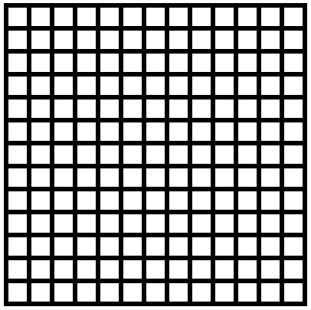

## Hexagon grid mode

Grid is made by hexagon items

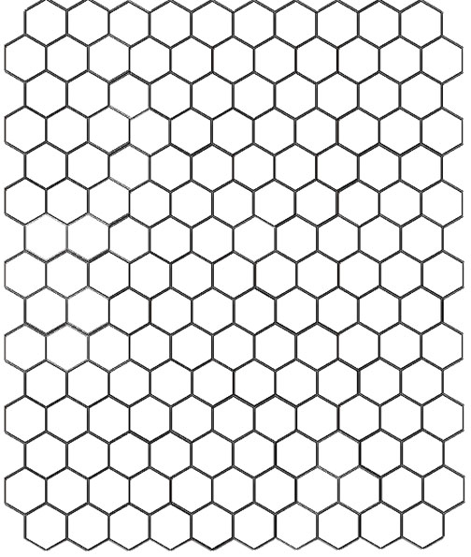

# Game display

4 main components stand on the game window :

## Score panel

Display some date about player and game as

Current player score

Counter enemy remaining boats

Counter enemy killed boats

Counter player remaining boats

Counter player lost boats

Current weapon used

Ammo for this weapon (See weapon section for more information)

## Radar grid

This is the top grid which display the enemy position. Color summarize :

Blue if water, never hit before.

Green if touched boat

Red if shoot at water square

Gray if secure zone (See how to fight for more information)

## Boats grid

This is the bottom grid which display player boats

Display the 5 boats (at the beginning)

Black if a flowing boats.

If a boat is hit, display fire were it was hit.

## Chat Room

Display the chat room.

# Weapons

## How to fight

During his turn, a player as to shoot and try to kill enemy boats. He just have to left click on the radar sector to launch a shoot. The spread explosion zone is displayed by a green color on radar.

Changing weapon is done with mouse wheel. Current weapon is displayed at the left in score panel. In order to have a good feedback, players are able to see enemy mouse cursor on his boats grid. It could be displayed be a gray coloration or something else. (During enemy turn)

## How does it work

Victory give some gold (Depend of game mode) and gold can be trade for some new strong weapons or ammo. But they have limited ammo! And cost lot of gold! At the beginning, there is a default weapon with unlimited shoot, but doing only one square damage.

When player has got enough gold, he could buy one weapon which will be available during a fight

# Boats

There are 5 boats to place. Each one are subdivided by compartment which fill one square

## Aircraft carrier

Size : 5

## Battleship

Size : 4

## Submarine

Size : 3

## Cruiser

Size : 3

## Destroyer

Size : 2

## How to place boats

Boats are placed one by one during the map creation. After choosing the grid type, boats must be placed on the map. Depending of the grid type, they could have different orientations.

* Grid 1 (Square) : horizontal and vertical
* Grid 2 : horizontal, crooked left, crooked right

This action is made by drag n drop. At the beginning, boats are on the reserve room and must be placed. (See draft section for further information). If drop zone is invalided, current boat return in its reserve. when all boats are placed, start button will be clickable.

While start button is not pressed, placed boat can be moved. (Of course, if new position is invalided, it return at the last valid position)

Random : button to create a random position

Valid position : 2 boats can't be stuck, means that a boat is obviously surrounded by water. (But a boat is able to be stuck with map border)

# Subscription

In order to play, user must be logged. It is a local login, means that data are saved in a local file with all information about users (Some file as user.log saved in data directory)

## User name

User name is required

Must be unique

Max size : 20

Min size : 3

Authorized characters : [a-bA-B0-9] (There are no space and special characters, even accent)

## Password

Password is required

Max size : 30

Min size : 6

Authorized characters : [a-bA-B0-9-_] (There are no space and special characters, even accent)

# Draft

This section show some drafts

## Welcome page

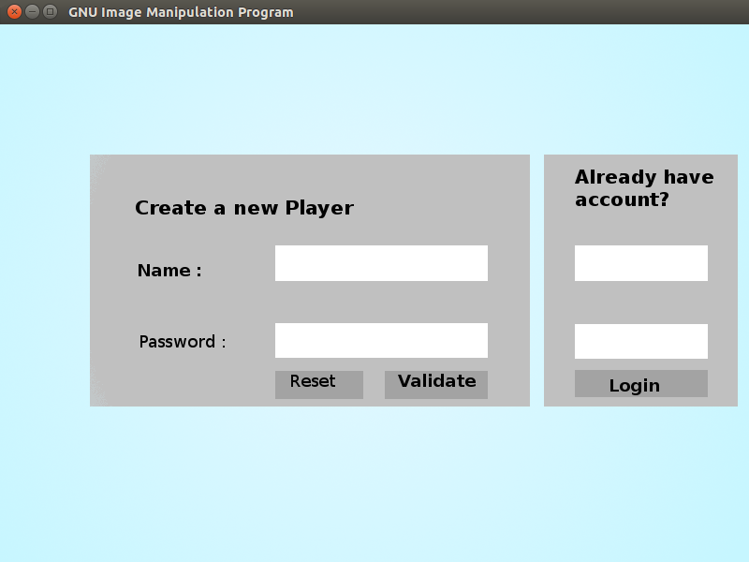

## Choose game mode page

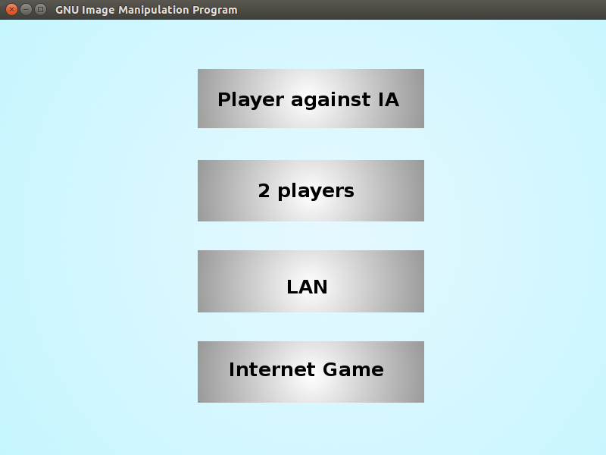

## Choose grid mode page

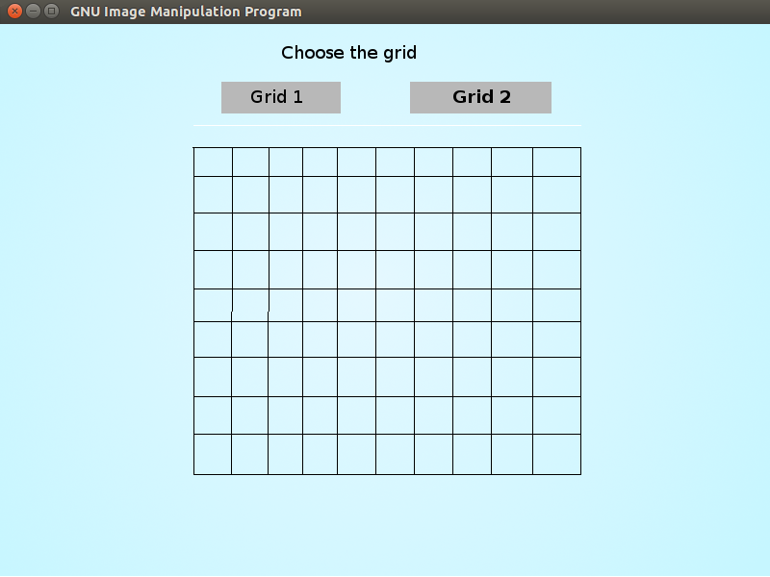

## Place boats page

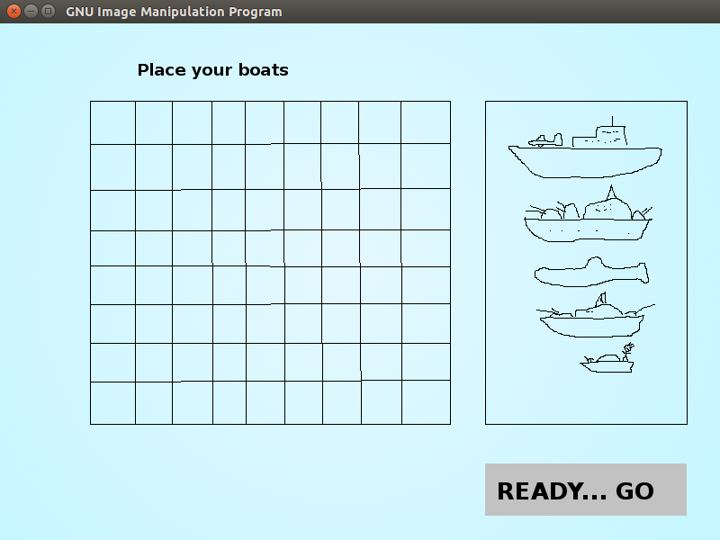

## Game display

