FlexChroma™ Blend Filament Guide
Table of Contents
1. Introduction 1
2. Model Structure 2
3. Mixing Results 3
4. Printing Instructions 4
5. Closing 6

1. Introduction
FlexChroma Blend Filament is a model designed to create intermediate colors by combining two commercially available filaments.
By using this model, you can obtain 35 different colors, including the original two filaments.

Brand Overview
FlexChroma is a brand created not only for people who are unsatisfied with the color options of existing filaments, but also for those whose limited filament collection prevents them from fully expressing their creativity.
Its goal is to expand your freedom in color selection.
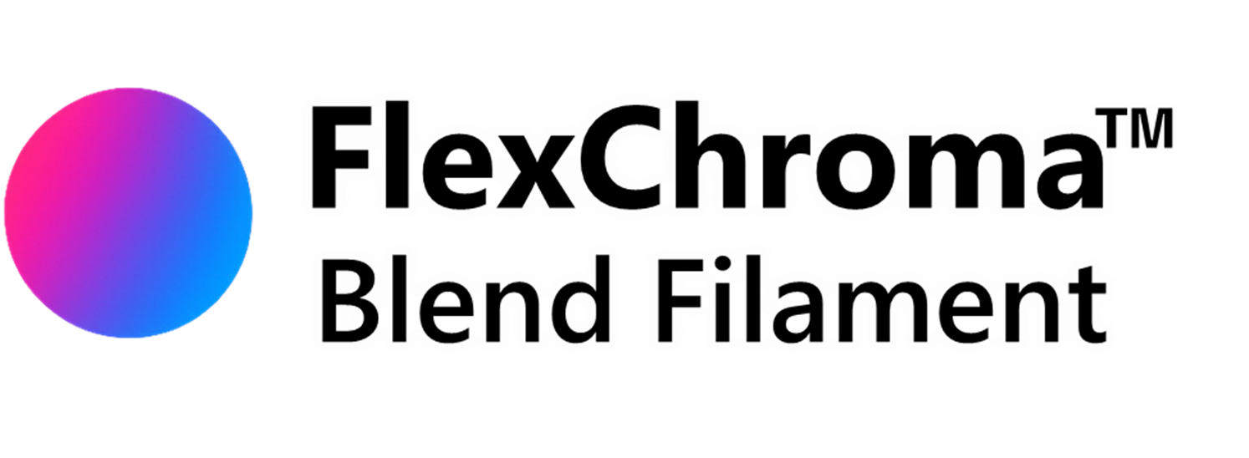

Series Overview
The Blend Filament series is the most fundamental series of FlexChroma.
By combining two filaments at various mixing ratios, you can create a wide range of custom colors.
For users who want even finer control, or for combinations with a large brightness difference, Detail Models are also available.
These cover mixing ratios from 90–99.5%, allowing finer adjustments that Standard Models cannot achieve.

2. Model Structure
This series is divided by size, and each size includes both Standard Models and separate Detail Models.

Mixing Ratios
Mixing ratios are mainly defined by two model types:
- Standard Model: 50–95% in 5% increments (10 models)
- Detail Model: 90, 92.5, 95, 96, 97, 98, 98.5, 99, 99.5% (9 models)
※ The 90%, 95% model is identical in both series.

Although there are 17 mixing ratios, excluding 50%, you can reverse filaments A and B to obtain the opposite ratio.
(Example: Using the 75% model gives A:B = 75:25; reversing filaments results in A:B = 25:75, equivalent to the 25% ratio.)
Standard Models may be split into Standard 1 and Standard 2 to reduce file size.

Sizes
Models starting with “M” are referred to as the “M Family,” and their sizes are compatible with the Bambu Lab P and X series, as well as the A1.
The M2 through M4 models are sized to fit perfectly on major 3D printers other than Bambu Lab.

Models beginning with “S” are referred to as the “S Family” and are sized to be printed on the Bambu Lab A1 mini.
The S4 model is the smallest size and is just large enough to print a 3DBenchy.

Models beginning with “L” are large-scale models compatible with the Bambu Lab H Series. Although no plans have been finalized yet, there is a possibility they will be implemented in the future.

3. Mixing Results
Some filaments produce better color results when layered than others. Generally, filaments with lower brightness tend to produce better color results, while those with higher brightness tend to produce poorer results. Therefore, you’ll need to choose a model based on the specific combination of filaments you plan to use.

You won’t know what the final color will look like until you actually print it. While it’s a good idea to create sample filaments and test them on an S4 model, if time permits, we recommend using the Blend Color Checker to compare the results and verify the colors.

Small lightness difference (CMY)
Combinations such as Cyan, Magenta, and Yellow have small lightness differences and result in final colors that correspond relatively linearly to the mixing ratio.In this case, Standard Models alone will give sufficient results.

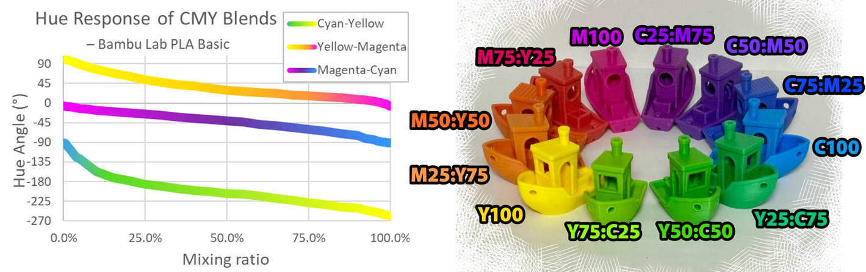

Large lightness difference (White / Black)
When the lightness contrast is large—such as black and white—the darker filament dominates, limiting the expressive range of Standard Models. In these cases, please use the Detail Models.
Because the molten filament has high viscosity and does not fully mix inside the nozzle, blended prints may appear mottled. This is subtle when the brightness contrast is small but becomes noticeable with high-contrast pairs. To create light gray, white + gray is recommended over white + black.

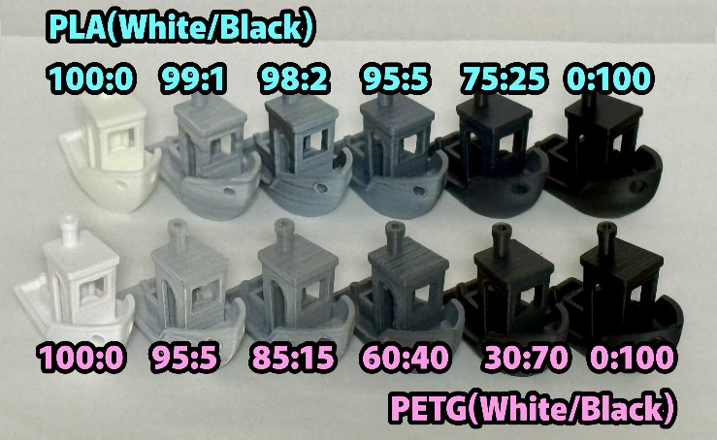
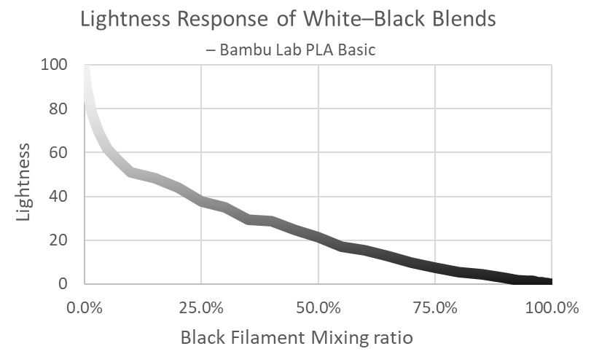

Differences by Material
Looking at the black-and-white results:
- PLA and PETG produce different blending results.
- PLA Basic white is highly translucent, so its influence becomes extremely weak.
- PETG HT white has lower translucency, so its influence becomes stronger compared to PLA Basic.
Blending is affected not only by the base color but also by translucency.
Test printing is recommended.

4．Filaments to Use
We recommend the four colors of Bambu Lab PLA Basic: Cyan, Magenta, Yellow, and White.
With these four colors, you can cover a wide range of basic color expressions.
Black is also useful for expanding your color palette, but because it has such a strong effect, it can easily cause uneven mixing, so caution is required.

Theoretically, the midpoint between two primary colors is the “perceptual midpoint color” defined in an equal-luminance color space (such as LCh). However, in actual filament mixing, due to the absorption characteristics of pigments and the effects of subtractive color mixing, the “material mixing midpoint” shown in the figure below tends to have reduced saturation, resulting in a dull color that differs from the ideal midpoint.
Therefore, to ensure users can reliably achieve the “natural intermediate hue and saturation” they expect, we have added the “recommended bridge filament” shown in the figure.

Cyan, Magenta, and Yellow are evenly spaced on the color wheel and represent an ideal combination; however, a 50% mixture results in a slight drop in saturation. For some users, this may deviate from their vision of a “vivid intermediate color.”
Additionally, Jade White and Black have a large difference in lightness and tend to result in a mottled appearance.

Therefore, for these color ranges, we propose the following bridge colors (filaments):
Cyan–Yellow → Bamboo Green Yellow–Magenta → Orange Magenta–Cyan → Purple Jade White–Black → Gray
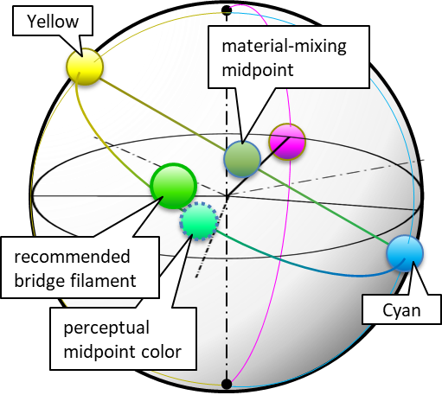
Basic Filament and Bridge Filament
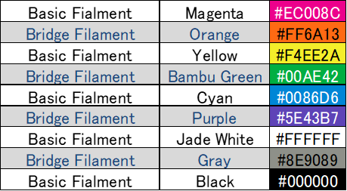

5. Printing Instructions

Printing Workflow
This model is used to create blended filaments.
- Using two commercially available filaments, print Blend Filament (Print #1).
- Using this blended filament, print the model you want to create (Print #2).
With this two-step printing process, you can produce any shape in the color you want.
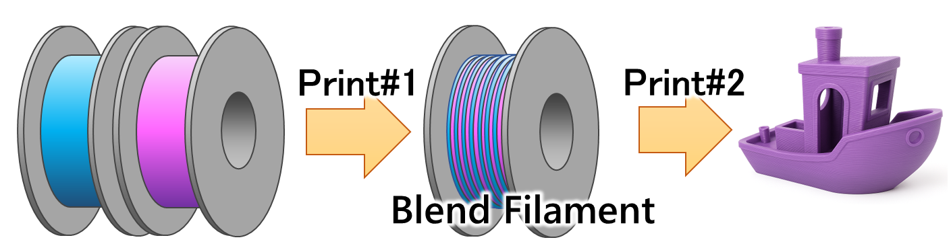

Before Print #1 (Blend Filament)
Required
- AMS required
Frequent switching between two colors is necessary.
Use a printer that supports switching between two or more filaments.
- 0.4 mm nozzle required
A 0.4 mm nozzle is essential due to the combination of a relatively thick first layer and thin layers for maintaining mixing accuracy. 0.4 mm high-flow nozzles are acceptable.
- Degrease the plate and your hands
This model is very sensitive to adhesion. Ensure thorough cleaning.
If adhesion remains difficult, consider using a smaller model size.
Adhesion
Adhesion varies depending on the build plate and filament material. Please refer to the table below.
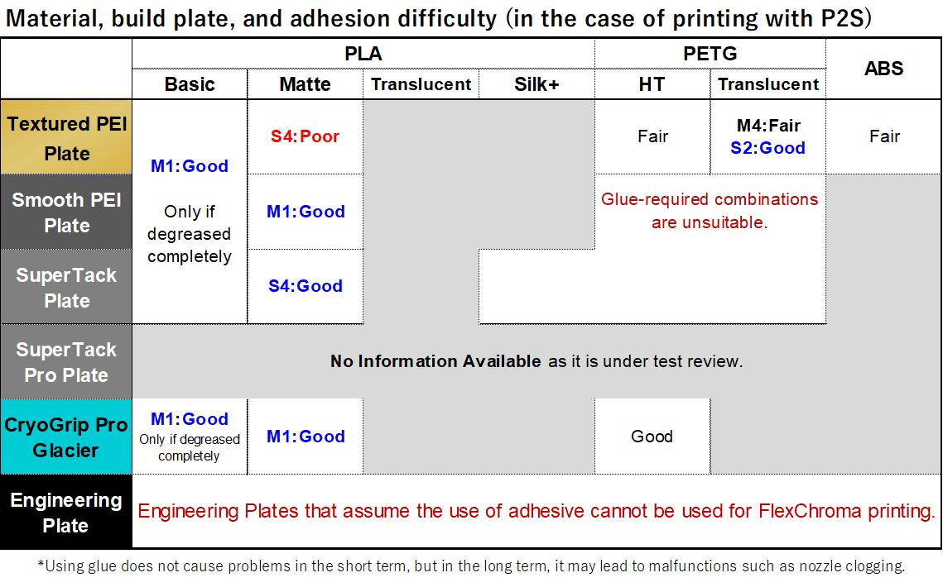
Not Recommended
- Glue
Glue may clog the nozzle during Print #2.
- Mixing different material types
Filaments with different printing temperatures may clog the nozzle during Print #2.
Combinations such as PLA Basic and PLA Matte (same temperature and same material type) may work.
As a general rule, use different colors of the same product from the same manufacturer.
Try other combinations at your own risk.

Before Print #2 (Final Print)
- Remove the brim
Remove the brim before printing.
If you will not print immediately, leave the brim attached.
The engraved markings allow you to check the size and mixing ratio.
- Remove burrs
Rarely, burrs may occur.
Remove them with nippers or a cutter.
Large burrs may cause extrusion issues.
- Nozzle influence in Print #2
Mixing performance varies by nozzle.
Smaller diameters and high-flow nozzles tend to mix better.

6. Closing
Thank you for reading.
We hope that FlexChroma™ expands your creative possibilities.
Print Colors You Imagine.

Revision History
Ver.1.0 2026-03-24 : Initial release
Ver.2.0 2026-06-19 : Corrected color mixing ratios, updated graphs, bridge filament

