=============================

Collection Description (Blend Filament)

=============================

📌 Important Notice / 重要事項
This page includes both English and Japanese descriptions.
このページには 英語と日本語の説明が併記されています。This page includes both English and Japanese descriptions.

🌈 FlexChroma™ — Blend Filament (Collection Overview)

🎨 Introduction
FlexChroma™ Blend Filament is a filament model series designed to combine two commercially available filament colors to create a “mid-tone filament” between them.

🧪 Mixing Ratios & Sizes
Both the Standard and Detail models support a total of 14 mixing ratios.
Because both directions (A→B / B→A) are supported, you can choose from 27 mixing-ratio patterns (1–99%).
- Standard model: 5% increments (50–95%)
- Detail model: 1% increments (95–99%) *95% are the same model
This collection offers three different size models, ranging from the largest size for the Bambu Lab P-series to the smallest just the light size for a 3DBenchy.

🌈 Examples of Color Mixing
🔵🔴🟡 Low brightness-difference combinations (CMY)
For combinations with similar brightness—such as Cyan, Magenta, and Yellow—the final printed color remains relatively linear with the mixing ratio, making the result easier to predict.
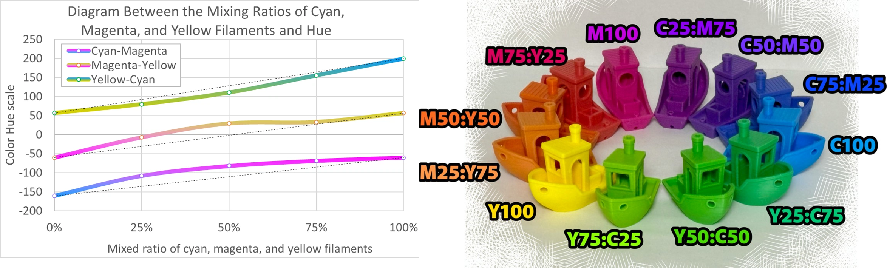
⚪⚫ High brightness-difference combinations (white - black)
Since black has a strong influence, let's try using the Detail model for precise adjustments.
The dominance of black remains the same, but the degree of its influence varies depending on the material.
Also note that combinations with large brightness differences tend to produce mottled or uneven color in the final print.
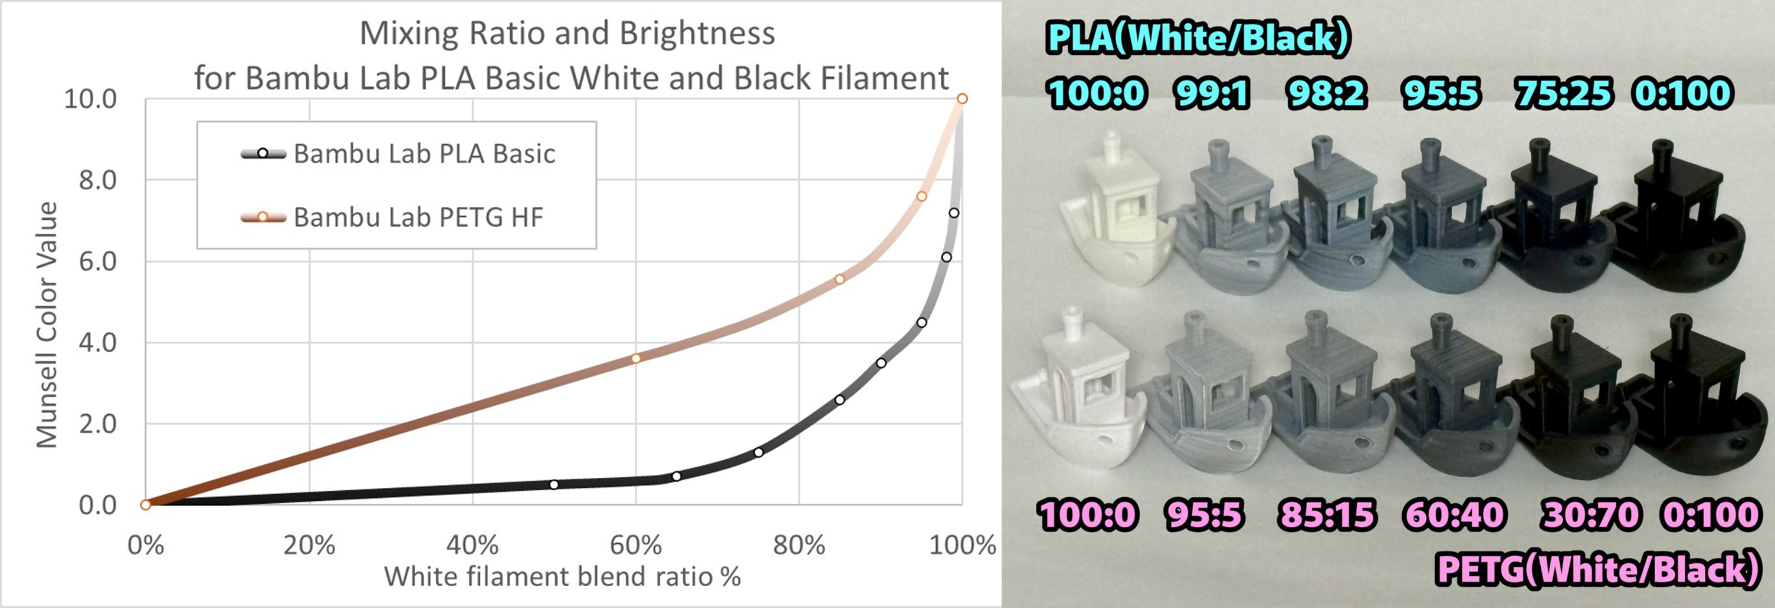

⚠️ Usage Notes

🔧 Workflow
Blend Filament is used in a two-stage process:
Print #1 — Print the Blend Filament model (choose colors)
Print #2 — Print your desired model (choose shape)
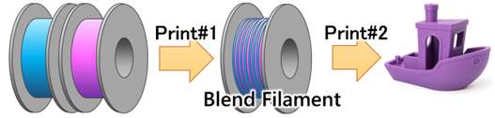

⚠️ Before Print #1 (Blend Filament Model)
- AMS and a 0.4mm nozzle are required
- Textured PEI plate and PLA recommended
- Glue use and mixed-material printing are not recommended
- Thoroughly degrease the build plate
- If adhesion is insufficient, consider reducing the size by one step

⚠️ Before Print #2 (Final Model)
- Remove the brim before printing
- Remove burrs if present
- Mixing performance varies by nozzle type:
0.4mm High-Flow > 0.2mm > 0.4mm

🎨 Closing
Thank you for reading.
More detailed usage notes are included on each individual model page.
We hope this model helps expand your creative possibilities.
Print Any Color You Imagine.

=============================

Model Description (Blend Filament M1)

=============================

📌 Important Notice / 重要事項
This page includes both English and Japanese descriptions.
このページには 英語と日本語の説明が併記されています。
More details on mixing ratios are available on the collection page.
Link to the FlexChroma™ Blend Filament Collection

🌈 Blend Filament — M1 (Largest Model for Bambu Lab P-Series)

🎨 Introduction
This model is the M1-size filament model designed to create “mid-tone filament.”

🧪Size & Mixing Ratios
The M1 size is the largest model designed for the Bambu Lab P-series (256 × 256 mm).
When printed in PLA, the model weighs approximately 72 g.
You can select from 14 mixing ratios within this model.
For details on mixing ratios and precautions, please refer to the collection description:
➡ FlexChroma™ — Blend Filament Collection

⚠️ Usage Notes

🔧 Workflow
Print #1 — Print the Blend Filament model (choose colors)
Print #2 — Print your desired model (choose shape)


⚠️ Before Print #1 (This Model)
• AMS and a 0.4 mm nozzle are required
• Textured PEI plate recommended (other plates may result in slightly reduced height)
• PLA recommended. Adhesion difficulty increases in the order of ABS and PETG.
• Glue not recommended (may cause nozzle clogging during Print #2)
• Mixed materials not recommended (PLA Basic × PLA Matte is acceptable)
• Thoroughly clean oils from the plate and your hands before printing
• If adhesion is poor, consider downsizing the model

⚠️ Before Print #2 (Final Model)
• Remove the brim before printing.
If you do not print immediately, the brim imprint allows you to check the size and mixing ratio.
• Remove any burrs with nippers or a cutter
• Mixing behavior varies slightly by nozzle (better toward the left):
0.4 mm High-Flow > 0.2 mm > 0.4 mm

🎨 Closing
Thank you for reading.
We hope this expands your creative expression.
Print Any Color You Imagine.
For other sizes, visit the FlexChroma™ Blend Filament Collection.

