

Brim Information Guide

1. Introduction
FlexChroma™ models create custom filament by combining commercially available filaments.
Information is displayed on the brim so that the specifications of each printed filament can be identified easily.
This guide explains how to interpret that information.

2. Functions of the Brim
The brim serves two purposes: improving bed adhesion and displaying filament information.
Because the available space on the brim is limited, abbreviations are used to display the filament information.

[Meaning of the Text]
The inside brim identifies the filament series and family (size).
The outside brim displays the specifications selected for that series.
[Meaning of the Colors]
The color of the outside brim indicates the base color.
The color of the inside brim has no specific meaning.
The text in the upper row of the outside brim indicates the second color.
The text color in the lower row indicates the third color when one is used; otherwise, it indicates the second color.
The text color on the inside brim indicates the fourth color when one is used; otherwise, it indicates the second color.
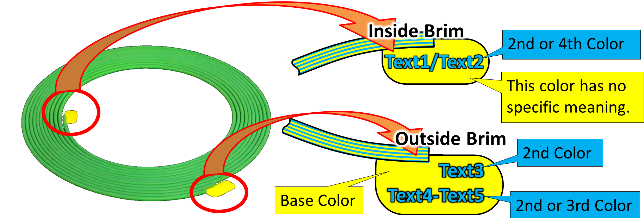

3. Information for Each Series
The previous section explained the basic structure of the brim information. The text displayed on the brim varies by series. The information used for each series is summarized below.

4. Blend Filament
Blend Filament combines two filaments at different mixing ratios to create new colors.
Because its structure is simpler than that of the other series, less information is required and the outside brim contains only one row of text.

[Inside Brim]
The series abbreviation “BL” is followed by “/” and the size name. On early models, the series abbreviation and “/” are omitted.

Example: BL/M4 (indicates a Blend Filament M4 model)

[Outside Brim]
The proportion of the base color is shown
as a percentage.
Example: 75% in blue text on a yellow brim
(indicates a mixing ratio of 75%
yellow and 25% blue)

4-1 Blend Color Checker
[Inside Brim]
The series abbreviation “BL” is followed by “/” and T1 under “Tools.”

Example: BL/T1 (indicates a Blend Color Checker)

[Outside Brim]
There are two types of Blend Filament models: Standard and Detail. The identification details for each are shown in the table below..

5. Gradient Filament
Gradient Filament provides multiple color curves for different color combinations, with models available in different cycle counts. Each model also has a recommended insertion direction.
Because more information is required, the outside brim contains two rows of text.

[Inside Brim]
The series abbreviation “GR” is followed by “/” and the size name. On early models, the series abbreviation and “/” are omitted.
The notation follows the same format as Blend Filament.
Example: GR/S4b (indicates a Gradient Filament S4 Beta model)
[Outside Brim]
The upper row displays “IN→” to indicate the recommended insertion direction. The lower row displays the color-curve abbreviation, followed by “-” and the cycle count.
Example: IN→
Vvd-.5cyc (the arrow indicates the insertion direction, and the lower row indicates a 0.5-cycle gradient using the Vivid color curve)

6. New Series Preview
New Series Preview models provide a preview of an upcoming series.

[Inside Brim]
Only the series abbreviation “Prev” is displayed.
The notation follows the same format as Blend Filament.
Example: Prev (indicates a New Series Preview model)

[Outside Brim]
No fixed notation is defined. The current New Series Preview model was created to suggest Gradient Filament, so “GRD” is displayed.

7. Handling the Brim
The brim is not required when using the filament, so remove it before use.
Because the brim identifies the specifications used to print the filament, we recommend leaving it attached during storage when the filament will not be used immediately.

