City Transport Sim

Content
Analysis 2
The Problem: 2
Current Examples: 2
OpenTTD 2
Mini Motorways 3
User Research: 3
Questions 3
Results 6
Considerations 7
Summary 8
Map Generation: 8
Levels 8
Procedural Generation 8
Procedural Generation Algorithms: 8
Wavefunction Collapse Algorithm 8
Cellular Automata 9
Perlin and Simplex Noise 10
Conclusion 11
Graphics: 11
2D 11
3D 11
Isometric 11
Conclusion 11
Data Structure: 12
Pathfinding: 13
Dijkstra's Algorithm 13
A* Algorithm 14
Objectives: 15
Programming Language: 17
Design 18
Perlin Noise 18
Waveform Collapse 18
Map Generation 18
Cars 18
A* Pathfinding 18
Implementation 19
Testing 20
Evaluation 21
Appendix 22
References: 22

Analysis

The Problem:
Currently there is a gap in the transport simulation game market. This has been a problem for a while since the last big games in 2004 and 2015, with OpenTTD and City Skylines, respectively. Many people enjoy playing a competitive game that does not demand your full attention, which is why many people love small games without a story.

To fix this I am going to develop a game that will fit in this market and could capitalise on the large audience that would play a game in this genre. My aim is to create a single player city transport management game where you are in control of the city's whole transportation and road management/development. The game will be a fun pastime that people can play for any duration of time and should have a good amount of replay-ability.

Current Examples:
Due to the lack of games in this genre, there is not a large number of existing games to research but the ones that do exist will give a useful insight into the needs of the market.

OpenTTD
The game OpenTTD is a business tycoon simulation game where players aim to make money by transporting a variety of products/raw materials to and from various locations using a variety of transport methods, including road, rail, air, and sea. The game was released in 2004 as a successor to the classic Transport Tycoon game from 1994. It was an instant hit for the fans of the transport simulation and city-building games. Over the years, it has been able to hold its audience and has even gained popularity over the recent years.

The centre of the gameplay is its procedural map generation that generates a height map for the land, the industries, and the cities. This allows for a more repayable experience to the user and gives the game a fresh sense. The player has to build and connect cities and industries, transport goods and passengers, and make a profit. It offers a single player mode and a multiplayer browser which allows for many players to connect and play together, enabling competition or cooperation. Players must plan their routes, choose the most efficient transportation methods, and balance their income and expenses to succeed.

Mini Motorways
Mini Motorways is a popular puzzle and strategy game developed by Dinosaur Polo Club that challenges players to design efficient road networks in a city. The game requires a combination of logical thinking and creative problem-solving skills to succeed.

The objective of the game is to connect houses, buildings, and other structures using a variety of road types, including highways and bridges, to prevent traffic congestion and keep the city moving. As the city expands and new structures are added, players must adapt their road network to meet the increasing demand and optimise their routes for more efficient transport.

One of the notable features of Mini Motorways is its minimalist design and calming atmosphere, which creates a relaxing yet immersive gaming experience. Additionally, the game is available on multiple platforms, including PC, Mac, and mobile devices, making it easily accessible to a wide audience.

User Research:
To expand my areas of research I have conducted a brief survey to gather information and complaints about potential users and their thoughts on the current games in the genre. The subjects in my research have been asked a wide range of questions about their gaming habits.

Questions


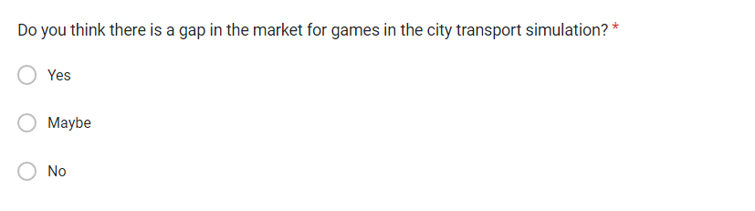
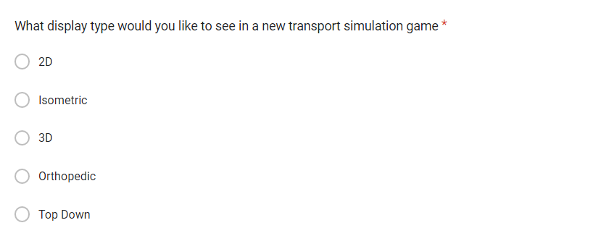
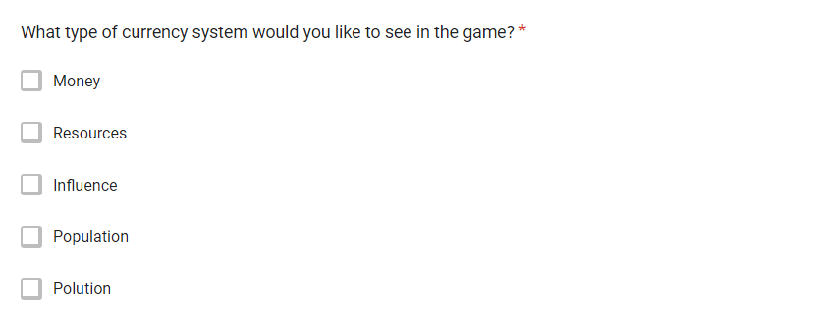


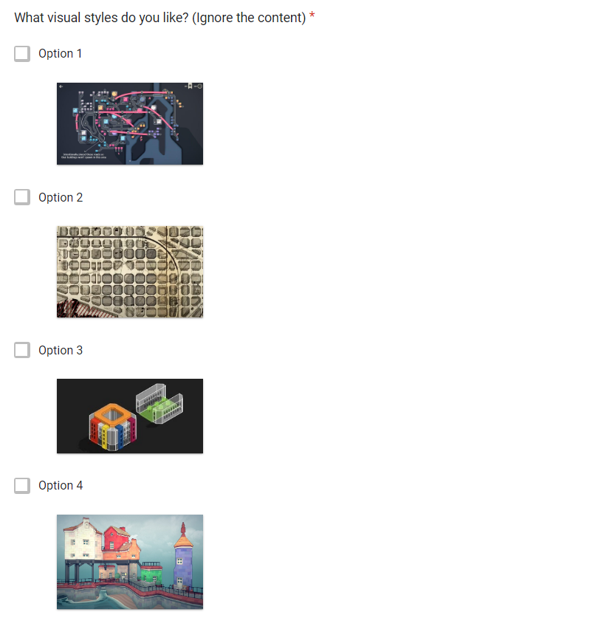

The reasoning for these questions is to gain a better understanding of what people like in current titles in the genre and to find the best combination of attributes to help create the most interesting game possible for the user.

Results
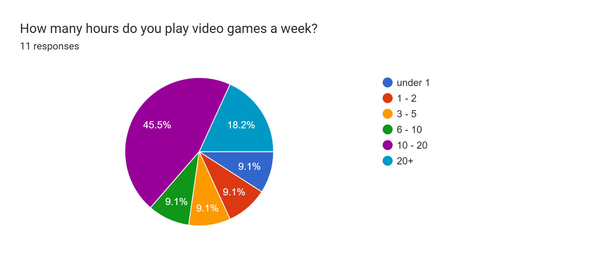
My sample of people have a range of gaming hours a week from under 1 to over 20 hours. From this, I have been able to collect a wide range of opinions from different potential users.
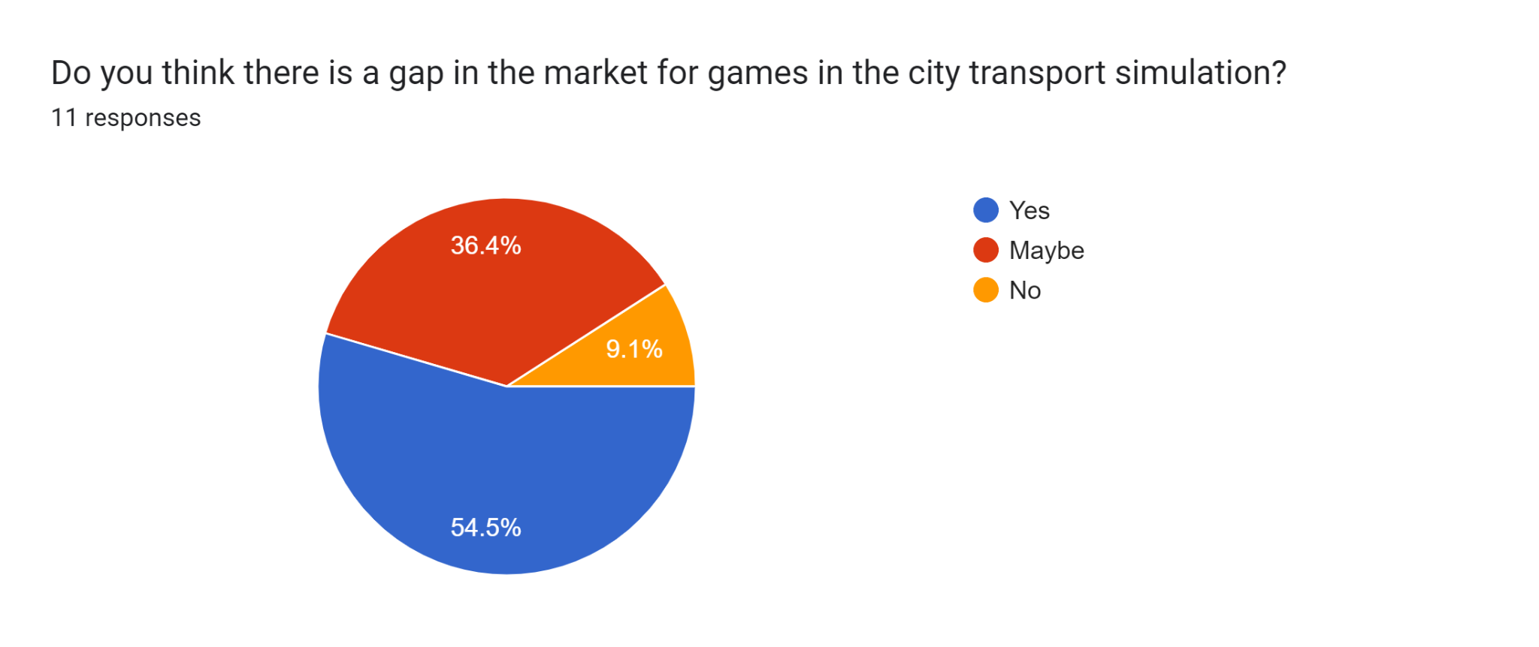
From this you can see that a majority of people agree that there is a gap in the market. This proves that there is potential for a new game to be released and succeed in the space. However, from this data it can also be seen that there is a large group of people that are unaware of the transport simulation genre. This could mean that there is a large group of people that are yet to try a transport simulation game allowing for a potentially large audience for a new game.

Considerations
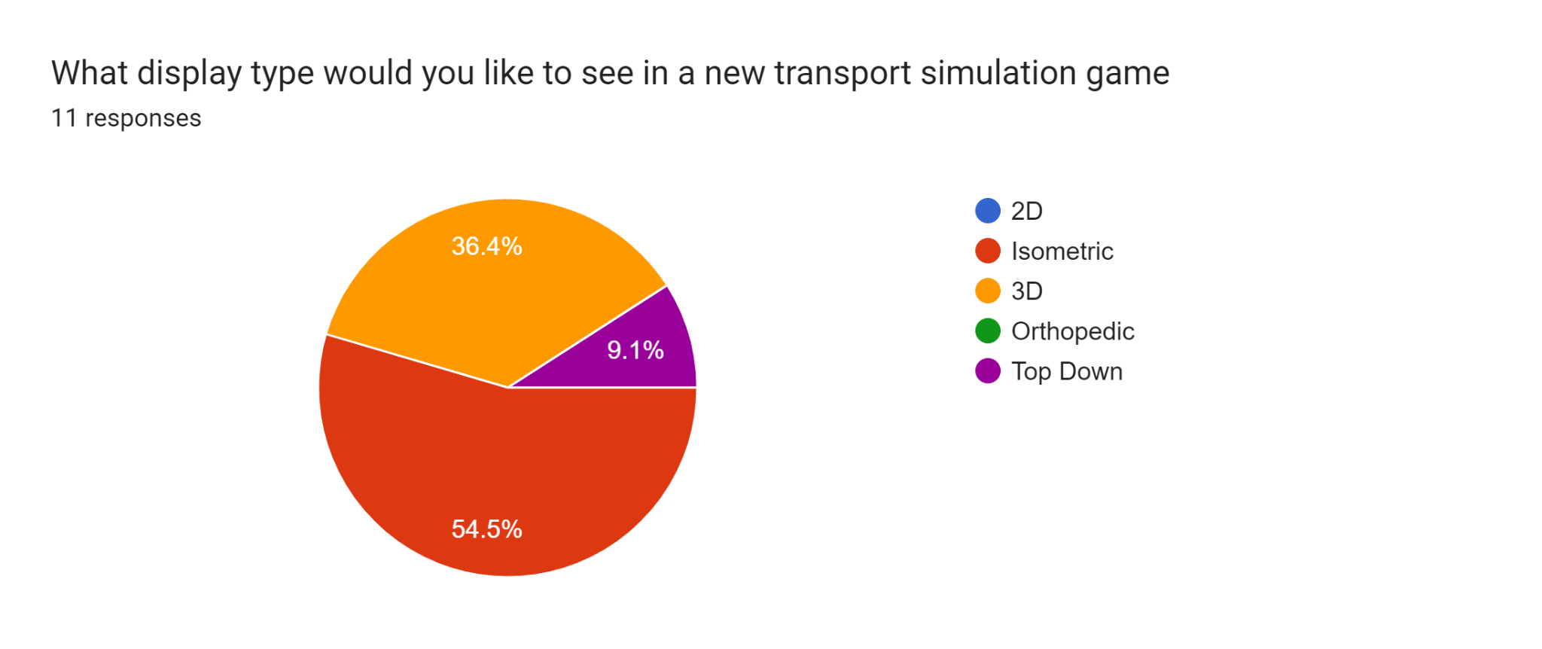From the data collected from potential users, it is clear that most people would like to see a game with either an isometric or 3D graphics style. This was an expected result as many successful games in the genre are using an isometric or 3D style. This style is usually paired with a realistic art design or a completely simplistic modern look. This could be a reason for why this genre of game is able to withhold its audience for so long as it has such a familiar look when the art is made to look as realistic as possible but also when the game art is made to be simplistic as it won't demand too much attention.
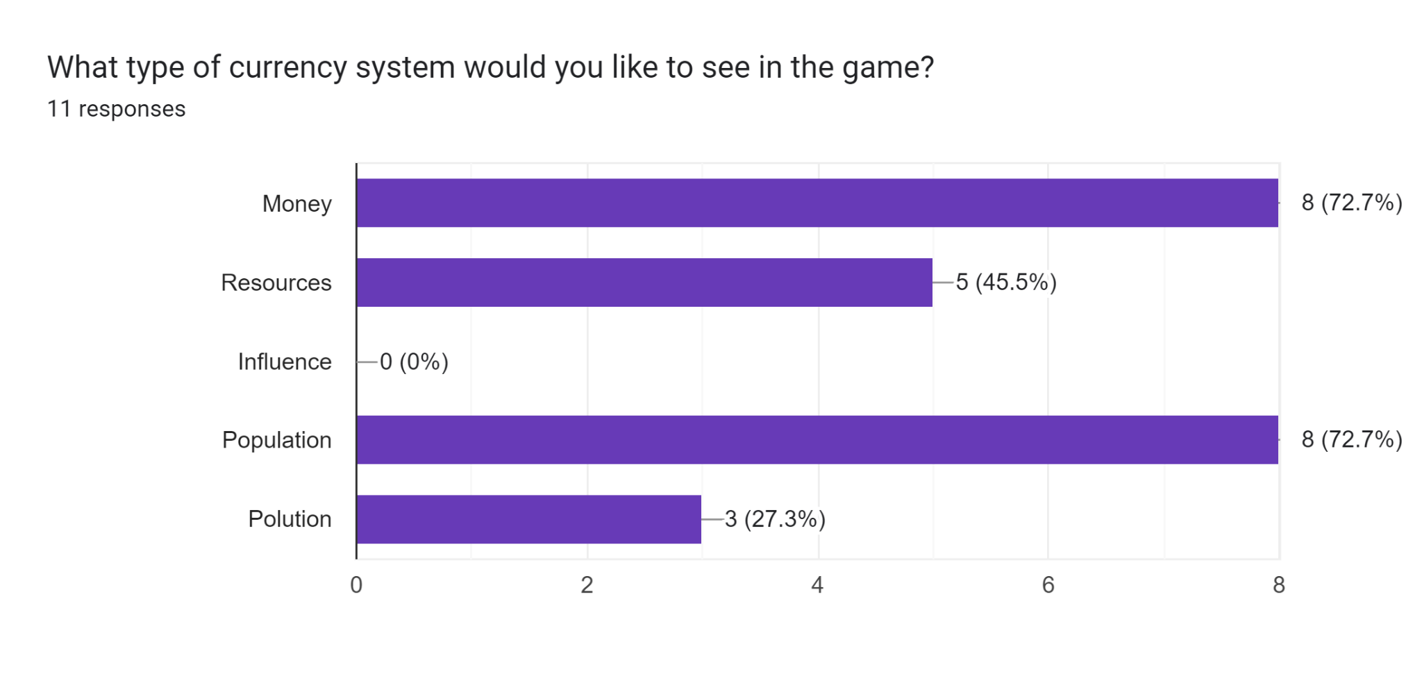
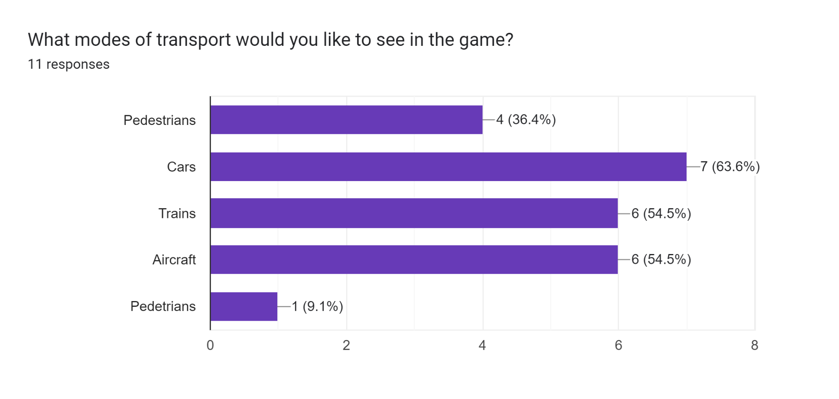
Another question that was asked to the potential users was the type of currency they would want to see in the game. The majority of people stated that they would like to see a traditional monetary currency such as dollars or a specific in-game currency. Aswell as this, users also said that they would want to see population play a part in the progression of the game. This could be implemented as a way to show progression or as a benchmark for a scoring system. Lastly the users were asked about the types of transport that they wanted to see in the game. The most requested forms of transportation were trains and aircraft, with cars also having a large number of votes. This is unexpected as the implementation of trains and aircraft would be distinct and would likely be controlled and managed differently, as trains and cars would have to follow a track or road whereas an aircraft doesn't have to fly in a specified area like a car has to drive on a road.

Summary
The main points to take away from the user research are:
- The majority of potential users believe there is a gap in the market
- Users want an isometric graphics style when playing the game
- Users want to see a currency and population stats implemented into the game
- Users would like to see cars as the main form of transportation in the game

Map Generation:
The base gameplay of the game and the level of progression could be done in a variety of ways including the use of levels or having a procedurally generated map. By using levels, it would remove the need for a map generation algorithm which would help to create a more linear gameplay experience as the maps could be premade to get harder and harder. Aswell as this by hand crafting the maps it would allow for greater complexity and balance as it can be manually tuned until the difficulty is corrected for each level. On the other hand, a procedural map generation algorithm could be developed to generate a random city based on a seed or random conditions. This would improve the replay ability of the game as it would be a completely unique experience than the last. However, when trying to create complex maps using map generation it can be exceedingly difficult to get a map that would meet all the needed criteria and thus would be complicated to create the necessary algorithm. Secondly, the algorithm would have to be well optimised otherwise the long wait and load times to get into a game would bore the user and make them less likely to enjoy the game and play again.

Levels
Levels can be created in many ways and could be used for a variety of purposes. For example, a level can, be used to show progression in a game, like in mini motorways, or to allow for new experience, like in cities skylines. It is important to understand that making a balanced level by hand is a complicated process and can take up a lot of time that could be used for other aspects of the game.

Procedural Generation
Unique map generation can be implemented in many ways, using a variety of algorithms and techniques. They can all be used to create maps based on rules and or random seeds. The algorithms are usually used in computer graphics and in video games to generate their maps or structures. This is used to reduce the workload for designers and to allow for potentially infinite exploration in a game.

Procedural Generation Algorithms:

Wavefunction Collapse Algorithm
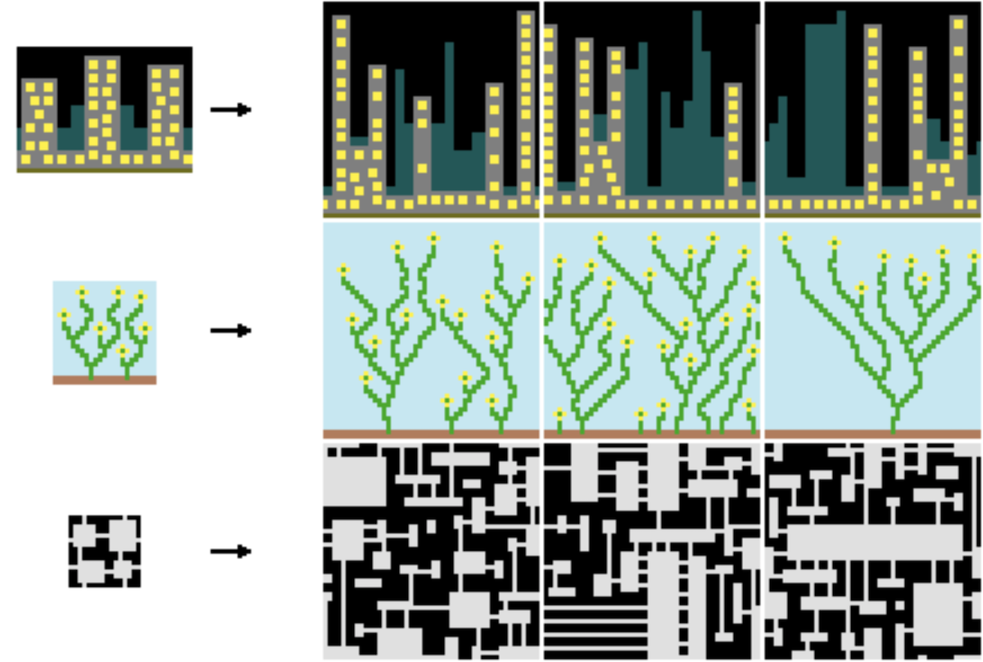
The Wavefunction Collapse algorithm is one of the algorithms that can be used to generate terrain and maps. It is inspired by the phenomenon in quantum physics under the same name. The algorithm starts with a seed map and then expands off the starting template based on adjacency rules and other specified conditions. For example, when creating an adaptation of the waveform collapse algorithm, you would initialise some rules based on an example structure / system. The algorithm can then be fed a starting structure based on a seed or random conditions. The algorithm will then assign all possible states to each segment of the map. It will then give the segment with the least possible states a final state which could be randomly chosen out of the possibilities or chosen based on the seed. The algorithm will do this for all remaining segments until the whole map is complete. This algorithm offers a great amount of randomness and variety which can help to create unique non-repetitive maps. Due to the algorithm choosing each segment based on its neighbours it means that the maps can look very coherent leading to a visually appealing and structurally consistent design.

However, the algorithm can also produce undesirable outcomes as it lacks the understanding of how environments might interact for example how water would flow or the creation of natural topography. This intern creates a struggle that creates a difficulty when trying to generate realistic maps that mimic real world terrain. Secondly, the algorithm requires a large amount of tuning to achieve a desirable algorithm. This can take up a large amount of time and resources that could be used on other areas of a project. Lastly, the algorithm struggles with global coherence on large scale maps as it can lack in overarching structures or connections between regions. To fix this problem the algorithm could be paired with further processing to help to add central features and linking structures.

Cellular Automata
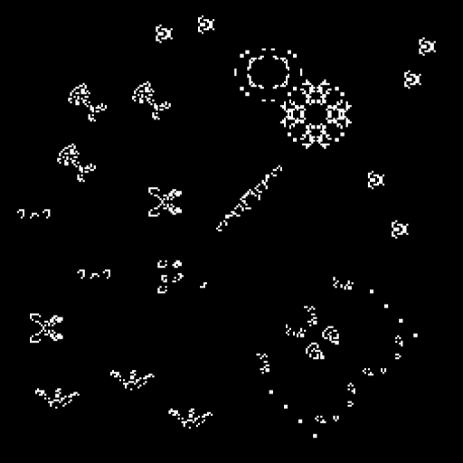
Cellular Automata is an umbrella term that covers algorithms that are usually deployed on 2d or 3d grid structures that uses a small number of simple rules that enable the grids to display complex behaviours and model how different cells can react. There are many versions of Cellular Automata as it can be used with multiple neighbourhoods or single neighbourhoods, this can allow for simulations of reaction species and generate unique and complex ecosystems. The algorithm was first made popular with the introduction of Conway's game of life in 1970 where he used 3 rules to create an environment that compares to real life interactions. As time has gone on many people have adapted these rules to create different interactions and repurposed the algorithm for a variety of applications, such as map generation.

To enable Cellular Automata to be used for map generation it must be configured with a specific set of rules that will create the terrain that is desired. An example of this is the rules: neighbours < 4 -> wall, and neighbours >= 4 -> floor. By tweaking these rules, you can allow different structures to develop. You can also run the algorithm multiple times which allows for a more refined result and gives another parameter that can be tuned to generate the desired result. To start a map generation using Cellular Automata a noise map is usually generated beforehand with a specified noise level. This noise map itself could be manipulated by using non-random noise to generate hot spots in the map generation that could lead to a denser landscape in the at area. Lastly, the map generated by the algorithm can be paired with a height map to allow for a more complex 3d topography that can give the environment a more realistic feel. This however does not remove the issue of uninteresting terrain as the Cellular Automata is usually run with a binary system that enables a cell to be one of 2 states. This could be changed but will remove the simplicity that is the main positive for this algorithm.

Perlin and Simplex Noise
Maps can be created by using just a simple noise function. By generating a smooth grid of fractions, you can generate a height map or terrain guide that could link to resources or areas of interest. These areas can be defined by a range of fractional values. To generate the noise used for this generation, a wide range of algorithms can be used. For example, Perlin and simplex noise algorithms.

Perlin Simplex
Perlin noise is the algorithm created by Ken Perlin in 1983 as a way to make CGI look more realistic. He uses a gradient map that returns a value, usually between -1 and 1, based on values that are inputted into the function. This can be done multiple times with the values multiplied together to generate a more complex noise/environment. This allows for a natural and organic appearance that is visually pleasing. The parameters are also very customizable and allows for a highly precise control for a more desired outcome. The continuous gradient used for the noise allows for a seamless tile grid that will allow for real time generation. Another benefit is the low amount of processing power that is needed to generate the map. However, the simplicity of the algorithm does cause a lack of detail in the outcome and also a struggle for realism as artefacts can sometimes occur that resemble patterns and cause an unrealistic visual. Lastly, the algorithm has no directional bias which prevents the formation of things like rivers and mountain ranges.

Simplex noise is meant to be the replacement for the original Perlin noise, however many still prefer to use the original Perlin noise. This is because Simplex noise is more complicated to implement and is widely considered to have a worse output. Additionally, you also lose a lot of control over the outcome of the algorithm, as well as the possibility for seamless tiling. However, when working with higher dimensions it does offer benefits as it has a lower big O. notation that does not increase the computational requirements when increasing in dimensions. Simplex noise also generates large peaks and troughs of values however has a less smooth transition between values.

Conclusion
After considering the application that the algorithms will be used in, I have decided to use a combination of the wavefunction collapse algorithm combined with Perlin noise to generate the city landscape.

Graphics:

2D
The use of 2D graphics has many implementations, such as top-down games and side scrollers. 2D graphical projection is a way of projection an in-game object onto the screen where there are only 2 directions of movement, usually x and y. A good example of this is the game “Pong” or “Space Invaders.” The basic principle of 2D graphics is that each object has an x and a y coordinate, and they are then rendered onto the screen based on the objects x and y coordinates relative to the screen’s pixels. 2D graphics can also fake depth if objects are rendered in layers one object can be observed as being in front of another.

3D
3D graphics are a revolutionary way of visualising and perceiving digital content such as movies, videogames, or product development. Due to the more realistic nature of 3D graphics, it allows for a user to be immersed in a way that is getting closer and closer to everyday life. The realistic graphics also help to implement real world physics simulations.

Isometric
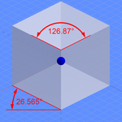
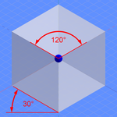
Isometric graphics is a way of displaying a game that has both 2D and 3D implementations. The basic principles of isometric graphics are the parallel projection and angle of the viewpoint which allows for a perfectly angled projection that gives a 3D effect as you can see 3 sides of a cell. The specific angle used in the project can be changed to allow for different visuals styles. The most common angles are 120º and 126.87º. People in the game design industry used the angle 126.87º as it allows for a 1:2 ratio of height to length for the top of the tile. This makes it easier to make art for the graphics. This is extremely important when creating pixel art as it allows for a seamless tile design as the pixels can perfectly fit into the ratio.

Conclusion
After analysing all the possible graphical systems that could be used, I have decided to use an isometric system as it allows for a 2D data structure of the city to be used to generate 3D looking graphics. The isometric system is also a lot simpler to implement than a full 3D system while still having the effect of depth and 3 dimensions. This choice will also allow for an easier design for the art in the game as it can all be based on a single tile reducing the workload when producing the art. Lastly the tiled grid system will allow for an endless map when paired with procedural map generation.

Data Structure:
In the game, there will be a city structure and road network that will have to be stored in a data structure. Below is an example of how the game will look and how it could be represented.
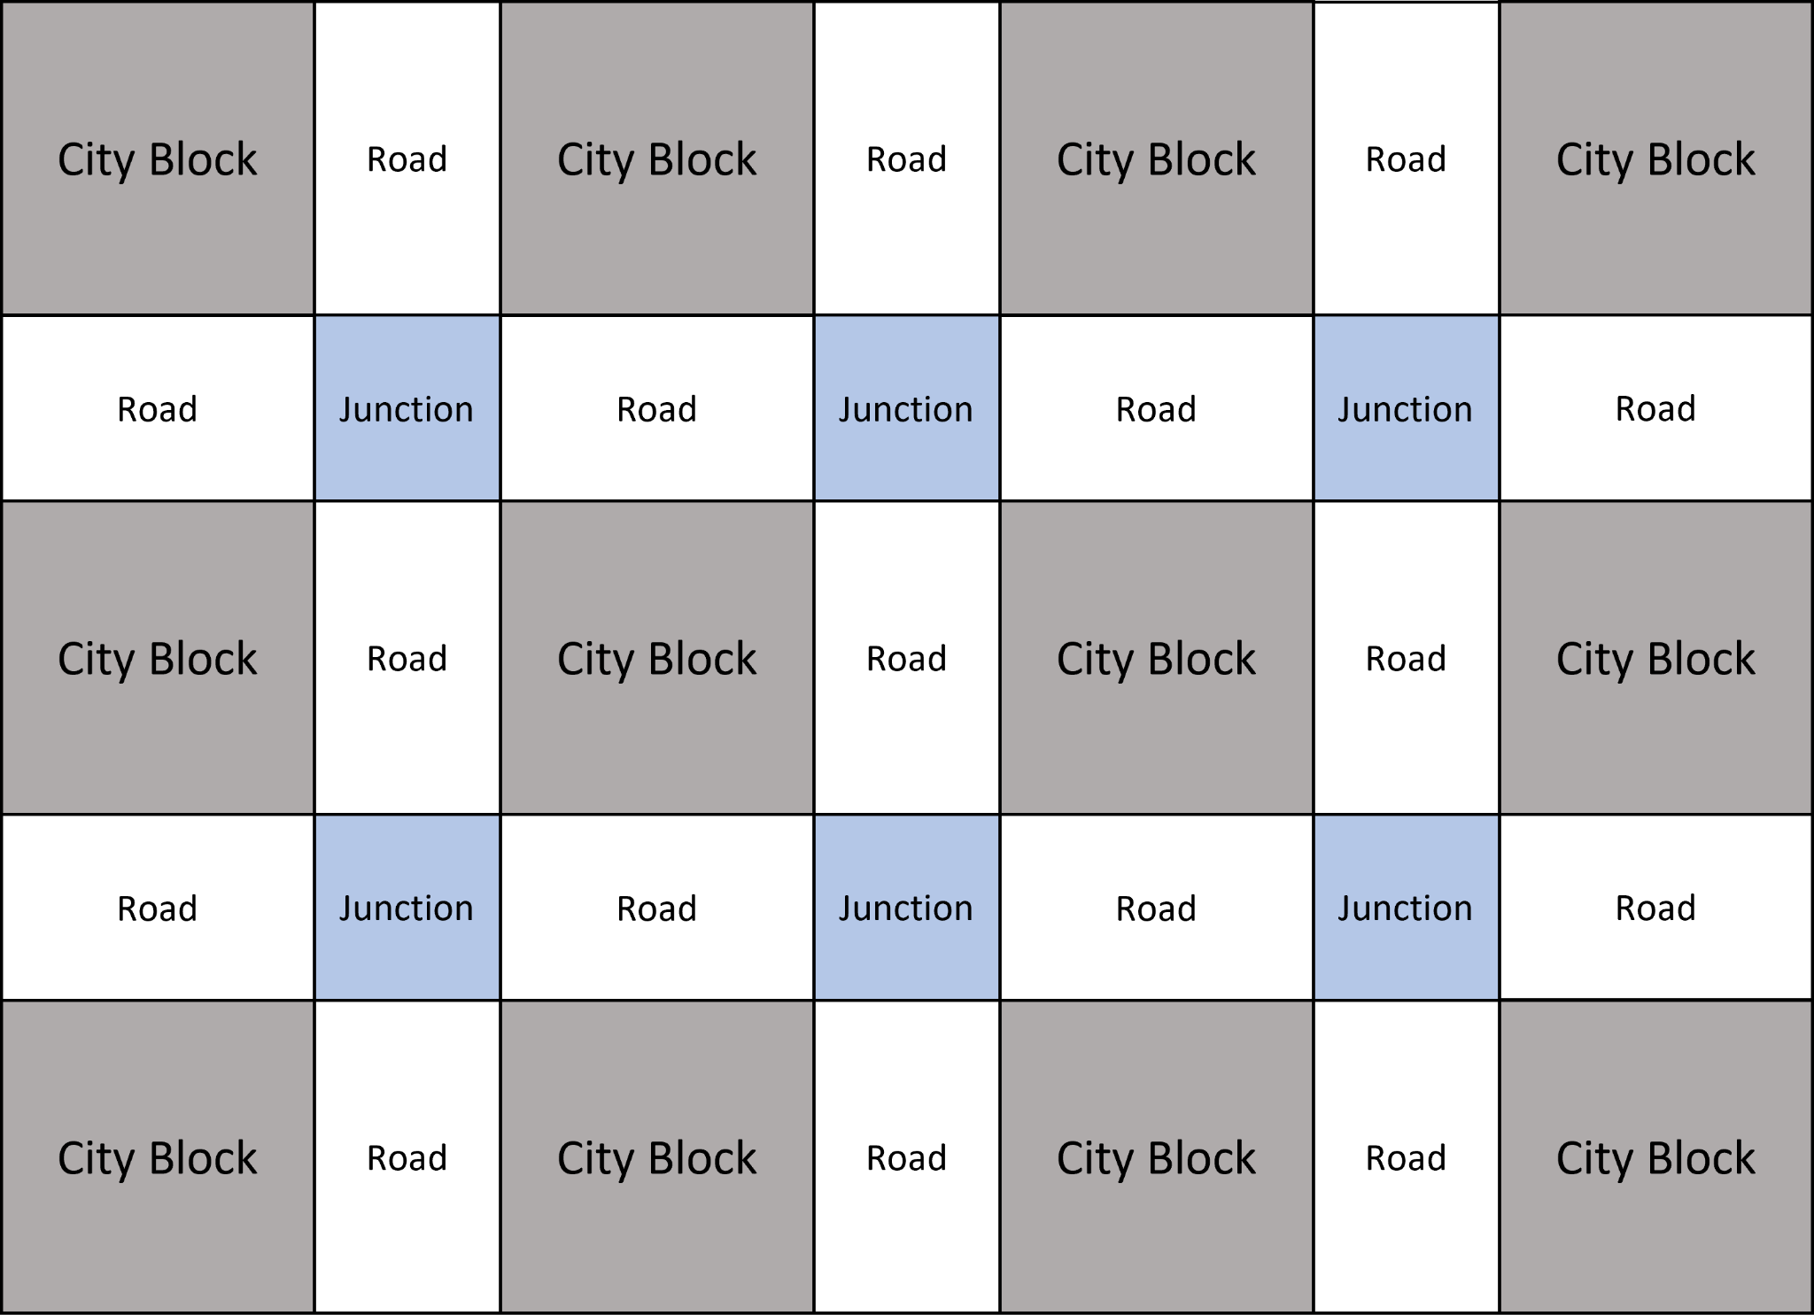
The image above is a rough example of the structure the game will follow. The structure of the city is arranged in a grid pattern and could be represented in many ways. The data could be represented using a single 2D list that just holds all the items in a single grid exactly as seen in the image above. This list could then be accessed using a mod function on the iteration through the list if only a single data type is wanted to be selected. The downside to this approach is that multiple data types will be held in the same list, and this will cause issues when trying to access data.
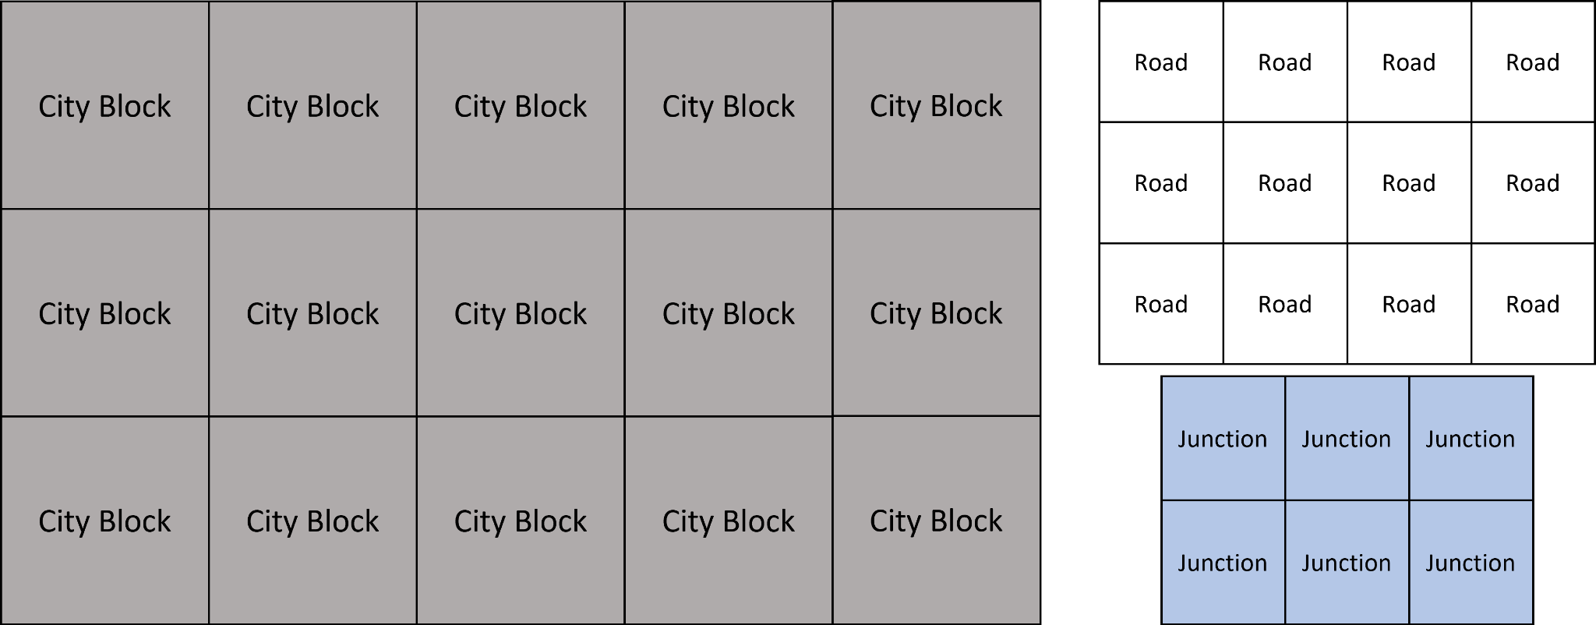
The image above is another way that the data could be stored. It shows 3 lists instead of one where each list holds a single data type. This would allow for easier access for substantial amounts of a single data type and make it easier to iterate through. The downside to this approach is the rules that will need to be used to keep the structure in proportion so that there is the right amount of data in the write place when adding or removing data. This is because it would change the whole structure when data is removed from any of the lists. This would also be an issue with the single list structure but would be easier to manage as you would only need to deal with a single list.
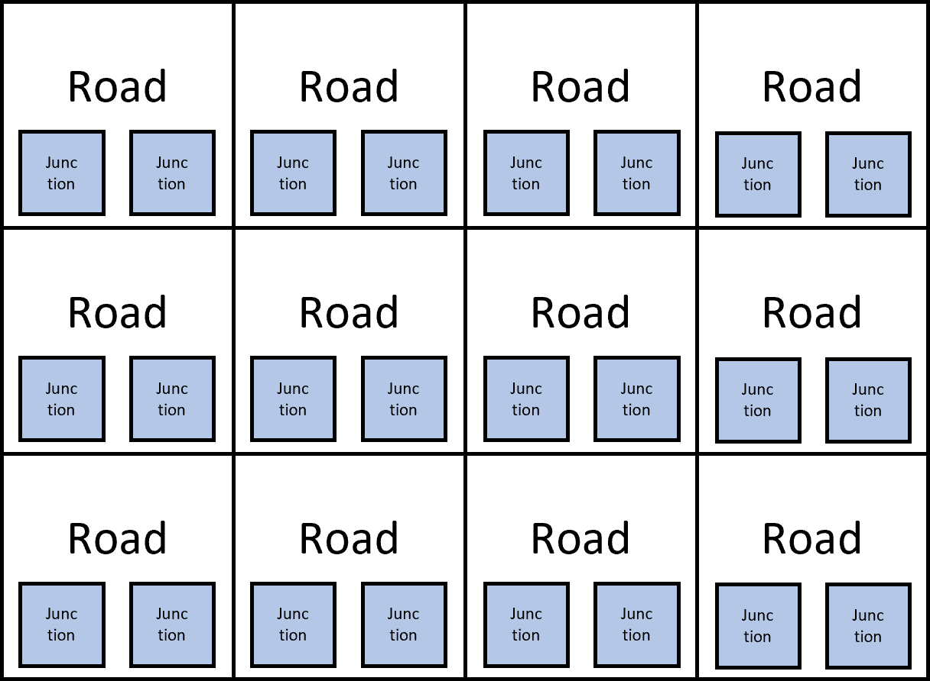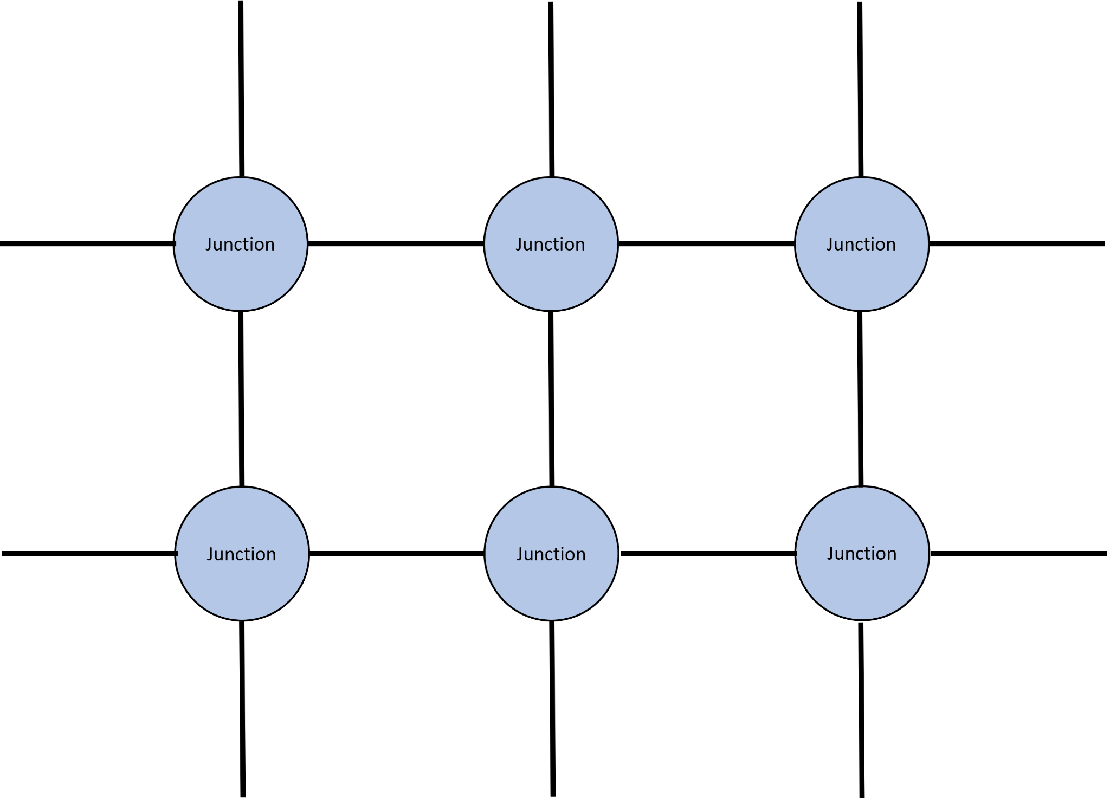
Above are two more ways that the main component of the data can be stored. This is important because this is what will be used in the pathfinding algorithm when it is finding a route through the city.

Pathfinding:
For the cars in the city to be able to get to their destination they will have to use a pathfinding algorithm to find a path to their destination.

Dijkstra's Algorithm
Dijkstra’s algorithm is used to find the shortest path between a starting node and the rest of the nodes in a graph. An example of a graph that could use Dijkstra’s algorithm can be seen below but this doesn't represent all the graphs that could implement this algorithm. This algorithm doesn’t have to be limited to just graphs however it can also be used on grids if the algorithm is adjusted slightly.
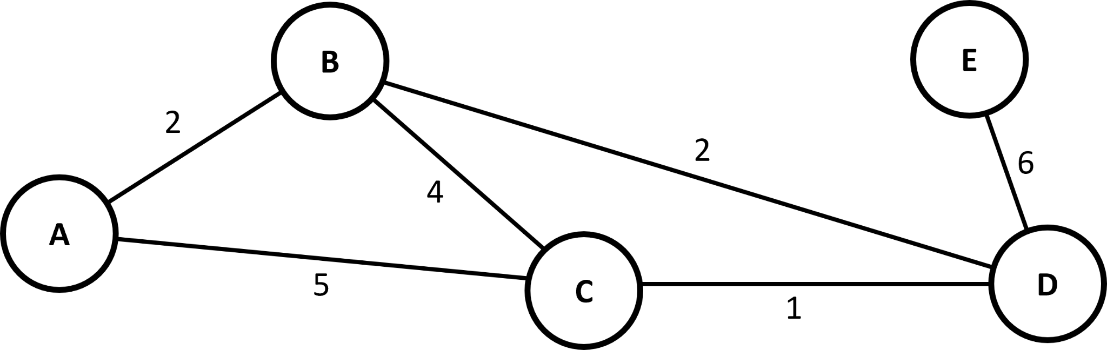
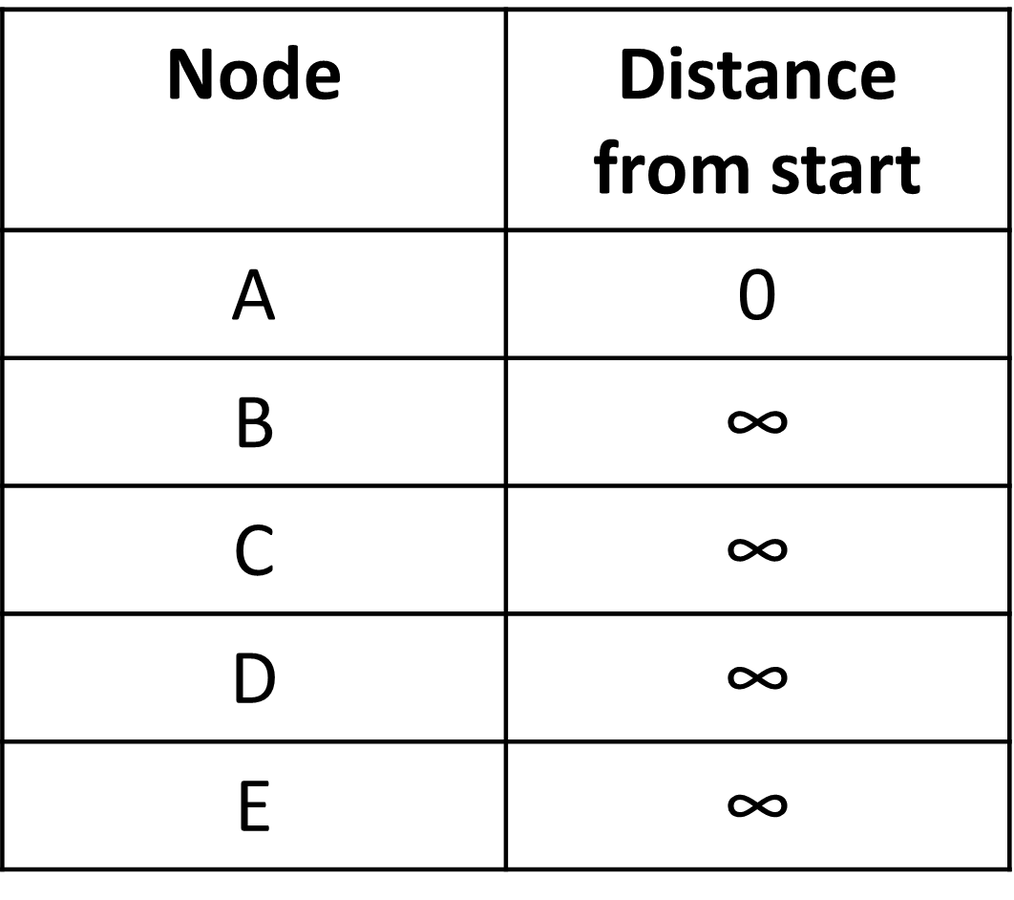
The algorithm does this by looking at all the adjacent nodes to the starting node and determining the distance between them, this distance is then added to the distance list which holds the current shortest distance between the starting node and all other nodes. The distance list starts with all nodes having an infinite distance and the starting node having a distance of 0. After updating all the paths that are visitable, select the closest node to the start based on the current known distances and mark it as visited and add it to the path. After marking a node as visited it is removed from the unvisited node list. Now the nodes adjacent to the selected node are analysed and the distances are updated if a path is found to a node, or a shorter path is found to a node. This is then repeated until all the nodes in the unvisited list are visited. Once this is completed the list storing the distance from the start node will contain the shortest distance to each node in the graph. It is important to note that not all the paths in the graph will be used in one of the final shortest paths as it can sometimes be more efficient to take a path through more nodes even if there is a direct route due to the weights associated with each path.

A* Algorithm
The A* algorithm is an improved version of Dijkstra’s algorithm as it uses the same basic method but introduces heuristics that enable it to find good enough solutions to extraordinarily complex problems. When compared to Dijkstra’s it means that A* is more effective when working with a large graph/grid that needs to be sorted through. It does this by implementing G cost, H cost, and F cost. The G cost is a representation of the distance from the start node, the H cost is the distance from the end node, and the F cost is the G cost + H cost. The F cost is what's used to determine the next node to visit. The algorithm will choose the node with the lowest F cost and visit that node next.

The benefits of the A* algorithm over the Dijkstra's algorithm is that it is not a perfect algorithm, this allows it to work faster than other similar algorithms. This means that the algorithm will not always finds the fastest route which would be beneficial in difficulty and would require a lot more bug fixing and unnecessary efficiency for the problem at hand.

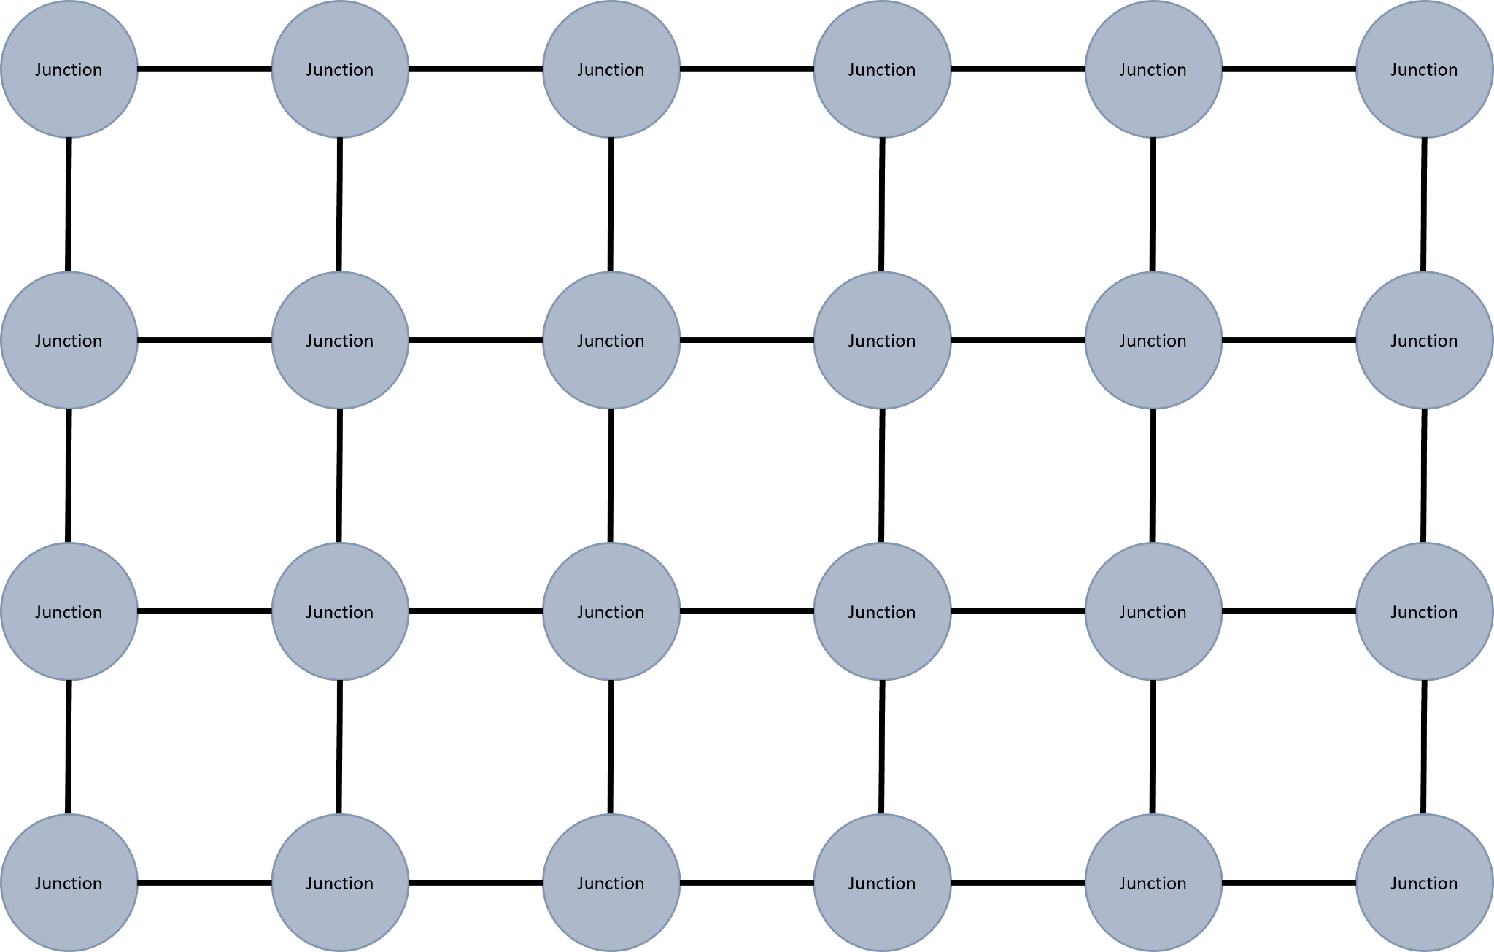

Objectives:
The project's main goal is to create a game where the player manages the junctions in a procedurally generated city. As the game progresses the city will get bigger and the volume of cars on the road will increase.

- Menu screen
  - The player will be able to navigate the menu using intuitive and clearly labelled buttons, ensuring a smooth and user-friendly menu experience
  - The menu must be easy to navigate
    - Have a simple start screen that doesn't overwhelm or confuse the user
    - Have buttons that are easy to identify
      - Buttons have functions that are easy to understand
      - Buttons can be clicked
      - Buttons indicate when the mouse is hovering over them
  - The user must be able to start a new game from the menu
  - The user must be able to continue a previous game
  - The user must be able to view previous saves and see the current population and amount of currency in the save
  - The user must be able to quit the game
- Display
  - The city will be displayed on screen when playing the game.
  - The start menu will be displayed when the user is on the menu screen or when the user has just launched the game
  - The rendering system for the game will render objects in the correct order to ensure that depth and perspective is achieved where necessary
    - Depth based rendering will be achieved by using a layered system
- Gameplay
  - Map will be procedurally generated
    - Maps will be infinitely generated
    - Map generation will provide a varied and diverse city environment
    - Map will be generated using a combination of Perlin noise and the waveform collapse algorithm
      - Terrain will be generated using Perlin noise
      - City blocks will be generated using waveform collapse
    - Map will be based on tiles
      - Each tile will have a state and a type
        - A tile can have a state of empty, in construction or built
        - A tile will have a type that will determine its texture and can be influenced by the neighbouring junction
          - At the corner of each tile there is a junction
      - There will be roads in between each tile
    - Map will expand as the player progresses
  - Player will be able to move around the map
    - Player will be able to navigate the city
  - Player will have a HUD
    - The HUD will display the current population of the city
    - The HUD will display the current amount of money the player has
    - The HUD will have buttons that are clearly identifiable and responsive to user interaction.
      - Buttons can be pressed to select tools to modify the junctions and the roads in the city
      - The buttons will be highlighted when selected
      - The buttons can also be activated with key binds
      - Buttons will clearly show their function
    - There will be a toggle button to switch between isometric and top-down views
  - The game will be able to be saved
    - The game data will be stored in a plaintext file
    - The name of the file will be the name of the save
    - The file will be stored in a folder will the game file
  - Player will be able to pause the game
    - The player can pause the game by pressing the esc key
    - The pause menu will have buttons
      - The player will be able to resume the game
      - The player will be able to leave to menu
      - The player will be able to leave the game
  - There will be cars
    - The cars will drive on the road
    - Cars will be able to navigate a junction
      - Cars will follow the road to their destination
        - The destination will be determined before they leave for their journey
        - Cars will use a path finding algorithm to get a route to their destination
        - Once a car has reached its destination it will wait a random amount of time and then return to its previous location
    - Cars will obey traffic rules
- Programming
  - The programme will be easy to understand
    - Variable, functions, classes are all named sensibly
    - Code is commented to identify the purpose of a block of code
  - Code must be organised
    - The code will be modular and organised into logical units. Modules will encapsulate related functionality, making it easier to understand and modify specific components.
    - Indentation will be used to create clear and concise code
  - Code must be efficient
    - Code chucks that are used more than once are replaced with subroutines
    - Algorithms will be optimised
  - OOP will be implemented where possible
    - Classes will be used to encapsulate distinct types of objects such as vehicles, to help promote code reuse
    - Classes will hold methods that can be called when necessary to perform an action
  - Error handling
    - User input will be sanitised and validated to ensure no errors are thrown
    - Errors will be caught and handled effectively
    - Errors will be displayed suitably to the user

Programming Language:
The Programming language that I am going to use for my project is python. After researching the possible languages that could be used, like C++, Java, and Python, I have concluded that Python would be the best fit to programme the project. I have chosen this language because it is a highly diverse language that has many strengths when it comes to data structures that will help with the development of the city's data structure. As well as this the amount of imports python has will allow for easier solutions to complex problems. The other main choice for a programming language was C++ for its fast speeds and low memory usage when managed properly. However, the development of code in C++ is much more of a complex problem that would require a large amount of time to be spent producing a developing the project.

Design

Map Generation

Cars

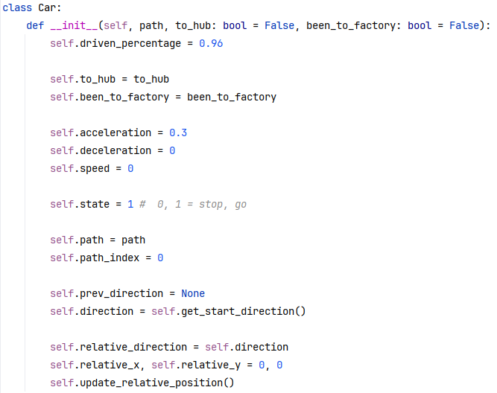

Attribute | Attribute Type | Purpose
driven_percentage | Float | Hold the percentage of the path driven in the current tile
to_hub | Boolean | Holds whether the car is travelling towards the hub or away from it
been_to_factory | Boolean | Hold value based on if the car has been to the factory yet on its current trip
acceleration | Float | Holds the acceleration value of the car
speed | Float | Holds the current speed of the car
state | Boolean | Holds whether the car is current stopped/braking or moving/accelerating
path | List | Holds all the grid positions the car will visit on its path in order
path_index | Integer | Holds the current position in the path
prev_direction | Integer | Holds the previous direction of the car for use in traffic logic
direction | Integer | Holds the direction of the car as it entered the current tile
relative_direction | Integer | Holds the direction the car is currently travelling in
relative_x | Float | Hold the x position as a percentage of the tile the car is currently in
relative_y | Float | Hold the y position as a percentage of the tile the car is currently in

A* Pathfinding
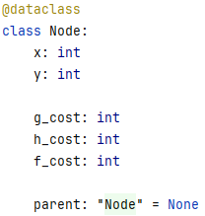
For the pathfinding of the vehicles in the game I decided to use the A Star pathfinding algorithm. I wrote it based around a node being a data class that represents each road tile in the grid.
Attribute | Attribute Type | Purpose
x | Integer | Holds the x position of the node in the graph
y | Integer | Holds the x position of the node in the graph
g_cost | Integer | Holds the g_cost of the node in the graph
h_cost | Integer | Holds the h_cost of the node in the graph
f_cost | Integer | Holds the f_cost of the node in the graph
parent | Node | Hold the parent of the node if it has one. Used to determine the length of the path and to return path once found.

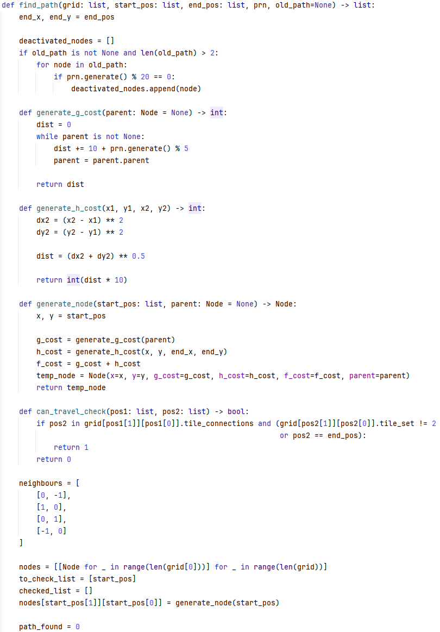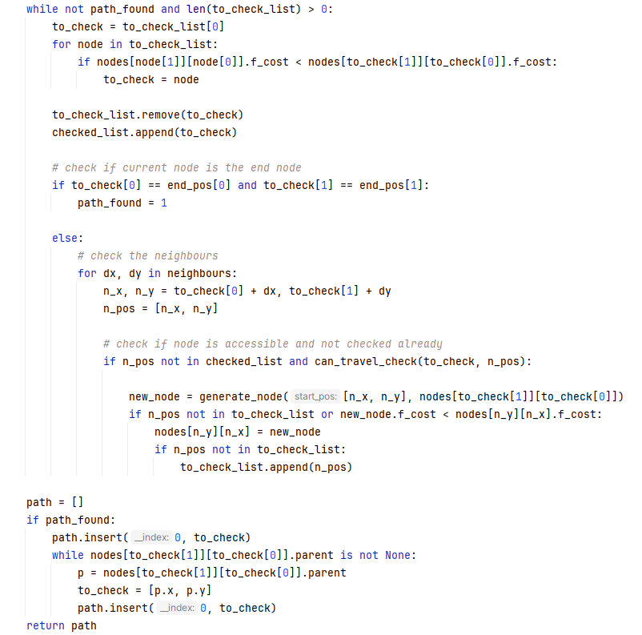

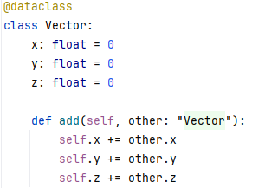
Perlin Noise
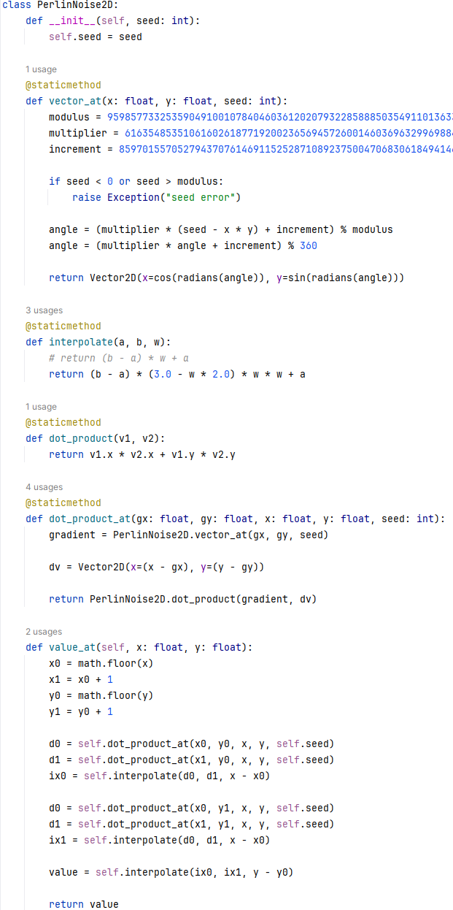
Draw Text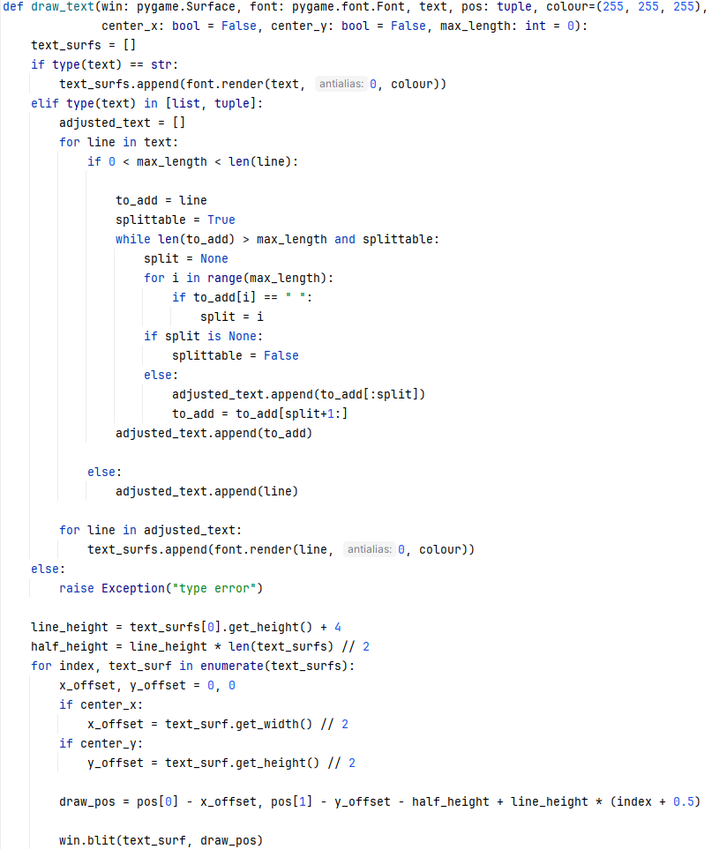

Implementation

Testing

Evaluation

Appendix

References:
- https://store.steampowered.com/app/1536610/OpenTTD/
- https://store.steampowered.com/app/1127500/Mini_Motorways/
- https://brilliant.org/wiki/dijkstras-short-path-finder/
- https://isaaccomputerscience.org/concepts/dsa_search_a_star?examBoard=all&stage=all&topic=pathfinding

