
Association of University Antwerp and University Colleges (AUHA)
Innovation Board
Industrial Research Fund (IOF)
PROOF-OF-CONCEPT PROJECT

IOF-POC-CREATE FINAL REPORT

1. IdentifiCATION of the projecT

1.1. Title of the research proposal

In Dutch: FlexIA – Flexibele Industriële Automatisatie

In English: FlexIA – Flexible Industrial Automation

1.2. Abstract of the project

In Dutch:

Sinds de eerste industriële revolutie heeft industriële automatisering gezorgd voor betere
prestaties, hogere productkwaliteit, betere ergonomie voor werknemers en vele andere
voordelen in verschillende industriële sectoren. In de afgelopen decennia zijn elektronische
systemen op grote schaal geïntroduceerd in industriële automatisering, vaak in de vorm van
programmeerbare logische controllers (PLC's), die bewezen betrouwbaarheid bieden voor
deterministische besturingstaken. Tegenwoordig groeit de vraag naar efficiëntie,
aanpassingsvermogen en intelligente besluitvorming, wat de integratie van geavanceerde
algoritmen stimuleert, zoals kunstmatige intelligentie, computervisie en autonome robotica. De
verschuiving naar deze software-intensieve automatisering brengt belangrijke uitdagingen met
zich mee, waaronder de integratie van geavanceerde algoritmen in bestaande
automatiseringssystemen, beperkte hardware-softwareflexibiliteit en sterke
leveranciersafhankelijkheid.

In de FlexIA-projecten pakken we deze uitdagingen aan door een 'eenmaal ontwikkelen, overal
ontplooien'-paradigma voor software-intensieve industriële automatisering. Het primaire doel
hiervan is het bereiken van echte hardware-softwareflexibiliteit. Dit wordt mogelijk gemaakt door
de ontwikkeling en commercialisering van het FlexIA-framework, een framework voor het
ontwerp, de implementatie en het ontplooien van geavanceerde, software-intensieve
automatisering. In het voorgaande IOF-POC CREATE-project hebben we de technologische
concepten bewezen en feedback verzameld van vijf representatieve bedrijven, wat heeft
geresulteerd in een high-level functielijst die het toekomstige FlexIA-product zal kenmerken.

In het huidige IOF-POC DEVELOP-voorstel streven we naar een voortdurende interactie met
deze (en andere) bedrijven in een Company Interest Group (CIG). Deze CIG zal fungeren als
onze klankbordgroep die de prioriteiten van de FlexIA-ontwikkeling stuurt, waardoor we de TRL
van TRL3 naar TRL5 kunnen verhogen. Bovendien zal het huidige project via pilootprojecten
met de CIG de belangrijkste functies van FlexIA valideren, waardoor de CRL van CRL3 naar
CRL4 wordt verhoogd. In het huidige project zal ook een open-core IP-valorisatiestrategie
worden voorbereid, aangevuld door gelicentieerde uitbreidingen en maatwerk.

In English:

Since the first industrial revolution, industrial automation has enabled improved performance, higher product quality, better worker ergonomics, and other benefits across different industrial sectors. Over the past decades, electronic systems have become widely used in industrial automation, often as Programmable Logic Controllers (PLCs), which provide proven reliability for deterministic control tasks. Today, the growing demand for efficiency, adaptability, and intelligent decision-making is driving the integration of advanced algorithms, such as artificial intelligence, computer vision, and autonomous robotics, into industrial automation systems. This shift towards this software-intensive automation introduces important challenges, including the integration of advanced algorithms into existing automation systems, limited hardware-software flexibility, and strong vendor lock-in.

In the FlexIA projects, we address those challenges by introducing a develop once, deploy anywhere paradigm for software-intensive industrial automation. Its primary objective is to achieve true hardware-software flexibility. This will be facilitated by developing and commercializing the FlexIA framework, an end-to-end automation development framework that unifies design, implementation and deployment of advanced, software-intensive automation. In the preceding IOF-POC CREATE project, we have proven the technological concepts and have gathered feedback from five representative companies, resulting in a high-level feature list characterizing the future FlexIA-product.

In the currently proposed IOF-POC DEVELOP, we aim for a continued interaction with those (and other) companies in a Company Interest Group (CIG). This CIG will be our sounding board steering the priorities of the FlexIA development, allowing us to raise the TRL from TRL3 to TRL5. Additionally, the current project will validate the FlexIA top features on industry-driven demonstrators through pilot projects with the CIG, raising the CRL from CRL3 to CRL4. The current project phase will also investigate and prepare for an open-core IP valorisation strategy, complemented by in-house licensed tool extensions and customization.

1.3. Identification of the promoter/co-promoter
1.3.1 Promoter:
Paul De Meulenaere
Department Electronics-ICT, Cosys-Lab
Nexor consortium
paul.demeulenaere@uantwerpen.be
Tel. +3232651905
Joachim Denil
Department Electronics-ICT, Cosys-Lab
Nexor consortium
joachim.denil@uantwerpen.be
Tel. +3232658901
Hans Vangheluwe
Department of Computer Science, Ansymo
Nexor consortium
hans.vangheluwe@uantwerpen.be
Tel. +3232653291

1.3.2 IOF-Valorisatiemanager
Fatma Bozyigit
Department of Computer Science
Nexor consortium
fatma.bozyigit@uantwerpen.be
Tel. +32495904840

2. Detailed description of technology and valorisation results

  - Project planning & results
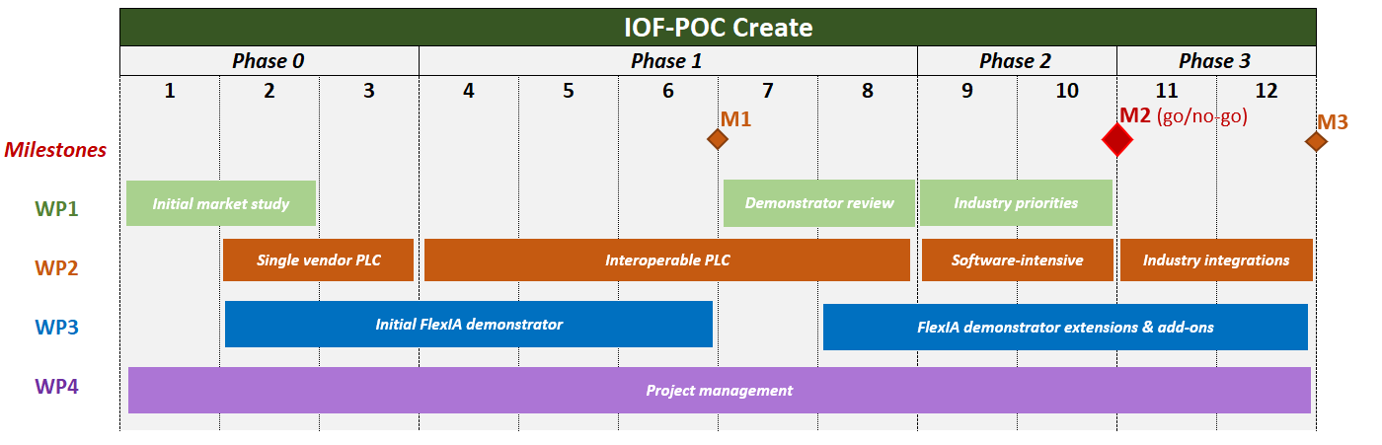
Figure 1 Project planning
The proposed IOF-POC Create phase planning, as outlined in Figure 1, structured the project into four work packages organized in parallel swim lanes with an iterative interaction between WP1–WP3. The approach started with an initial market study (WP1) to align the envisioned techniques with end-user needs, followed by a technology feasibility study and the parallel development of the FlexIA demonstrator (WP3). A second market study was foreseen to review and refine the demonstrator and associated methods, ensuring alignment with industrial requirements. Overall, the project execution closely followed this proposed planning. The work packages and their associated subtasks were carried out as foreseen, and by executing them, the planned results were created. The iterative interaction between market input, technology development, and demonstrator refinement was effectively realized. While the construction of the demonstrator experienced a slight delay, this delay was fully compensated. A functional demonstrator was successfully constructed and used to showcase the core technology building blocks, making the conceptual developments tangible and validating the proposed approach.

Results per Work Package

By executing the defined tasks within each work package, a coherent set of results was created:
- WP1 – Market Study:
  - R1.1 Document describing the market need and technological barriers, market structure, segmentation and size of the market.
  - R1.2: Document describing the IP-protection scheme(s) and freedom to operate.
  - R1.3: Document describing the internal patent search.
- WP2 – Technology Feasibility
  - R2.1: Components of the DMSL and commissioning framework.
  - R2.2: Document describing the feasibility of the DSML and commissioning framework.

- WP3 – Demonstrator construction
  - R3.1: Implemented FlexIA demonstrator using the components developed in WP2 (incremental in 4 phases).

- WP4 – Project management
  - No planned results.

  - WP1 results

    - R1.1 Details on market study & market study results
      - Market identification & segmentation
Within WP1, an initial market identification and segmentation exercise was carried out to ensure alignment of the FlexIA concept with relevant industrial stakeholders. The process started with an extensive desk research phase. During this phase, potentially relevant companies were identified based on their activities in industrial automation. This resulted in a longlist of 58 companies, documented in the Excel file Companies.xlsx. Based on this list, a structured market segmentation was performed. The identified companies were classified according to criteria such as sector, technological focus, system integrator vs. end user profile, and relevance to modeling and commissioning challenges. This segmentation allowed us to prioritize the most promising target groups and tailor our communication strategy accordingly. For each company, an appropriate contact person was selected. In several cases, direct contacts were already available. For other companies, outreach was performed via publicly available contact channels, such as online contact forms on their websites. Each company was approached with a concise pitch presentation (Pitch.pdf) introducing the FlexIA concept and its value proposition.
From the initial list of 58 companies, this outreach resulted in five active leads:
- Cronos4Industry (C4I): part of the broader Cronos Group (over 9,500 employees), acts as an automation and digital transformation consultant, supporting the modernization of traditional warehouses into connected, Industry 4.0–enabled environments through the integration of advanced automation, IT/OT, and digital technologies.
- DEME: A leading company in the offshore industry (e.g., dredging), acting as a system integrator for the development and integration of custom offshore solutions, and integrating both in-house developed and outsourced applications for offshore operations, such as deployment on dredging vessels.
- Vintecc: a high-tech start-up/scale-up supporting Belgian and European companies in the development of advanced automation and robotics applications by combining AI, machine vision, and robust automation infrastructure.
- ABB: ABB is a global leader in the automation industry, delivering custom robotic solutions and automation services that enable companies to design, deploy, and operate industrial automation applications. In Belgium, ABB primarily focuses on the process industry, including sectors such as chemical manufacturing.
- Agidens: Agidens is a Belgian-based industrial automation company with an international presence, including operations in Spain and Mexico. The company designs, builds, and operates turnkey automation solutions, and provides automation services that support customers in developing industrial automation applications, with a strong focus on enabling more efficient, smarter, and safer industrial operations.
With these companies, introduction meetings were scheduled and conducted to activate the market study. These meetings provided valuable input regarding industrial needs, validation of assumptions, and refinement of the proposed FlexIA concepts. All results are documented in: WP1/R1_1_MarketStudy/R1_1_A_Identification_and_segmentation.

      - Market survey
Following the market identification and segmentation phase, an in-depth market study was conducted with the five active lead companies. The objective of this study was twofold:
- To identify their current and future challenges related to industrial automation, and translating them to features of the FlexIA framework
- To gather concrete input for defining a relevant and representative demonstrator case within their application domains.
For each of the active leads, an introduction meeting was organized. These meetings were structured using a predefined checklist (checklist.pdf), which ensured consistency across discussions and enabled systematic comparison of the collected input. It also ensured that the discussions moved beyond high-level interest and focused on concrete operational challenges. It also allowed us to identify common themes across companies, as well as sector-specific needs. Based on these initial meetings, we identified 3 technological aspects or domains, depicted using a venn diagram below.
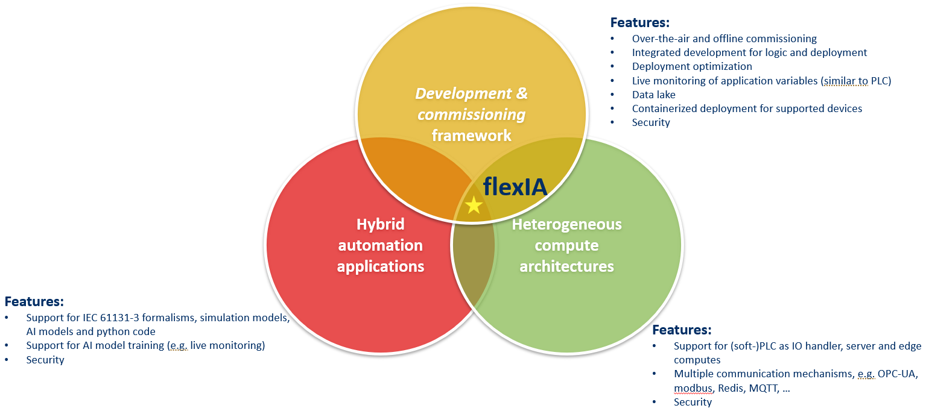
The venn diagram shows 3 main technological aspects and the main features, as discussed with the companies:
- Hybrid automation applications: Emphasis was placed on the need to support the development of modular application components across multiple programming environments and paradigms (e.g., C/C++, Structured Text (ST), and others). Stakeholders highlighted the importance of enabling seamless integration of heterogeneous software components, including AI-based modules, within a unified engineering workflow. Flexibility in combining classical control logic with advanced data-driven components was considered essential.
- Development & commissioning framework: Companies expressed the need for an integrated framework that supports not only application development but also deployment and commissioning on target hardware. Key requirements included streamlined deployment workflows, over-the-air (OTA) update capabilities, integration of deployment aspects within existing development environments, and support for live monitoring and diagnostics. The goal is to reduce engineering effort and improve traceability and maintainability throughout the system lifecycle.
- Heterogeneous compute architectures: Focus on the underlying hardware landscape, including the variety of devices currently used (e.g. PLCs, industrial PCs, edge devices, accelerators) and the ambition to combine these in future architectures. This includes understanding requirements for distributing functionality across heterogeneous compute platforms and ensuring interoperability, scalability, and performance across such mixed infrastructures.

      - Identified challenged & feature matrix
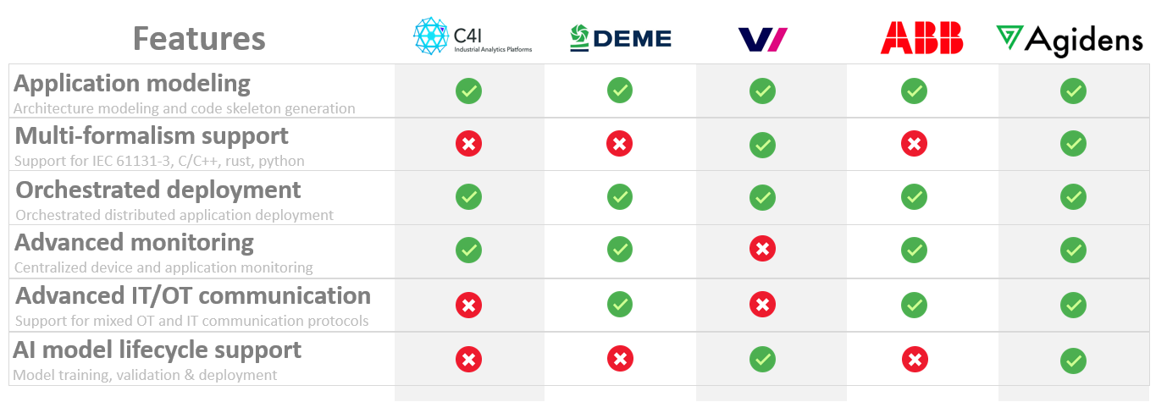
Building on these high-level focus areas, we performed an iterative refinement process to translate them into a structured feature matrix for the FlexIA framework. Starting from the insights gathered during the market study meetings, the identified needs were decomposed into concrete, actionable features across the domains of (I) Modeling aspect of automation applications, (II) Development aspect of automation applications and (III) Deployment aspect of automation applications. These features were clarified, consolidated, and prioritized. This resulted in a structured feature matrix (FeatureMatrix.md) that maps industrial requirements to specific FlexIA capabilities and technology building blocks. The matrix served as a guiding instrument for WP2 - technology feasibility and WP3 - demonstrator construction, ensuring traceability between market needs and implemented functionality.
Across all members, there is a strong consensus on the importance of modeling of the automation application (application modeling), with models serving as central, unifying artifacts throughout the entire development lifecycle. Equally emphasized is the need for properly orchestrated deployment, ensuring that automation applications can be reliably transferred from development to operational environments, scaled across heterogeneous platforms, and maintained over their full lifecycle. Advanced monitoring is the next priority, with 4 out of 5 CIG members emphasizing the need for unified and centralized monitoring of both application behavior and underlying compute hardware. Generic IT/OT communication follows, with 3 out of 5 members indicating the importance of seamless integration between IT protocols (e.g., MQTT) and OT protocols (e.g., OPC UA). AI model lifecycle support is currently a lower priority, with interest expressed by 2 out of 5 members, reflecting a longer-term or exploratory focus.

    - Intellectual property strategy
      - Selected IP model
Within the IOF-POC CREATE, we selected an open core IP-model as the optimal IP-protection scheme for the FlexIA framework. This choice is driven by the fundamental ambition of the FlexIA team to make flexible industrial automation accessible to all automation engineers, while explicitly avoiding renewed forms of vendor lock-in that currently hinder innovation and adoption in the automation domain. The rationale for this decision can be found in the detailed description of the IP model in WP1\R1_2_IPStrategy\R1_2_A_IPModel\IPModel.md

      - Freedom to Operate study
A two-stage freedom-to-operate study, conducted at the start of the project and refined after the feasibility study based on the additional technical knowledge gained, concluded that no blocking intellectual property was identified and that freedom to operate exists at this stage. A more detailed description of the IP Freedom to Operate study in WP1\R1_2_IPStrategy\R1_2_B_FreedomToOperate\ FreedomToOperate.md.

    - Patent search
      - Initial patent search
A patent search was conducted by a Ilse Heyvaert, IP manager at the University of Antwerp, and indicates that the FlexIA approach is patentable. However, the decision on whether to pursue patent protection will be further evaluated during the course of the IOF-POC DEVELOP projects, with a specific focus on assessing the patentability of closed-source plugins and extensions, rather than the open-core components of the FlexIA framework. A more detailed description of the IP Freedom to Operate study in WP1\R1_3_PatentSearch\R1_3_A_InitialPatentSearch\PatentSearch.md

  - WP2 results

    - R2.1 Components of the DMSL and commissioning framework.
      - Overview
Based on the original FlexIA concepts and identified features, the framework was decomposed into four main technology building blocks, each addressing one or more features. This decomposition is illustrated in Figure 2, which provides a conceptual overview of the FlexIA framework. The figure highlights the flex*-prefixed technology building blocks (e.g., flexModeler, flexAgent) and shows how the numbered features are allocated across the framework.
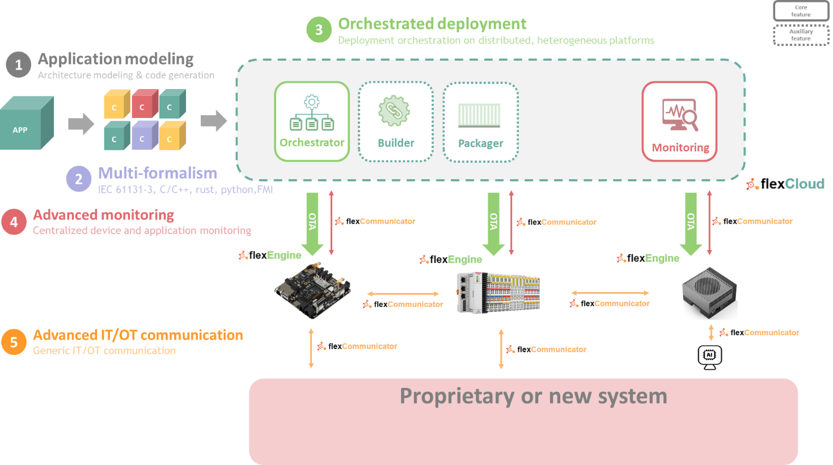
A first technology building block, flexModeler, targets the application modeling environment for the design of industrial automation systems. flexCommunicator complements this by addressing the development environment for application components, enabling advanced monitoring and IT/OT communication, and requiring support for a multi-formalism IDE. The remaining building blocks, flexCloud and flexAgent, focus on the orchestrated deployment environment to automate and orchestrate application deployment across heterogeneous hardware platforms. Within the feasibility study activities of the IOF-POC CREATE phase, a proof-of-concept implementation of each technology building block is developed, focusing primarily on translating the identified conceptual features into actionable feature prototypes. In addition, the key interfaces between the different building blocks were identified, defining how design, implementation, and deployment aspects are linked within the FlexIA framework. A limited subset of these interfaces has also been prototyped, providing initial validation of technology integration. As part of this effort, an Integrated Development Environment (IDE) mock-up for the FlexIA framework was developed to illustrate the envisioned tooling approach and to support technical discussions with the CIG.

      - Modeling aspect of automation applications (flexModeler)

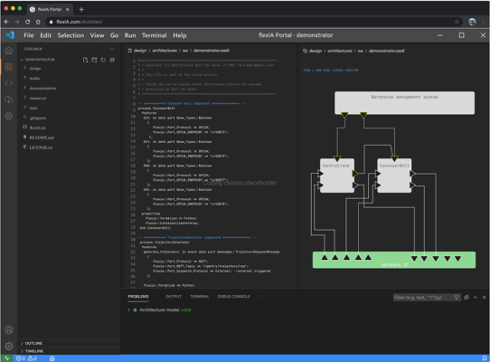
FlexModeler is a modeling environment based on the Architecture Analysis & Design Language (AADL) [1] that supports the architectural design of industrial automation systems across software and hardware boundaries. It currently provides a core modeling language and initial, partial code generation support for a subset of implementation formalisms, including general-purpose languages such as C/C++, Python, and Rust, as well as IEC 61131-3 programming languages and it support a minimal set of platform-independent high-level behavioral modeling patterns, such as state machines, facilitating the portable realization and deployment of automation applications across PLCs, embedded devices, and cloud-based infrastructures. Ongoing and future work aims to further extend the modeling language with relevant automation-specific aspects, such as detailed I/O hardware models, and to broaden and complete the support for implementation formalisms through additional and more comprehensive code generators. Additionally, we want to increase portability by supporting more platform-independent modeling patterns.
Detailed description can be found in WP2\R2_1_TechnologyBuildingBlocks\R2_1_A_TechnologyDescription\flexModeler.md

      - Development aspect of automation applications (flexCommunicator)

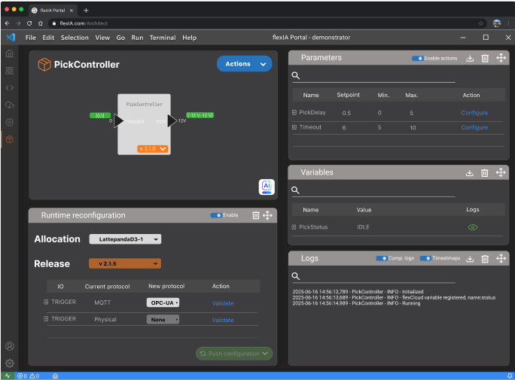
flexCommunicator is a set of client libraries that enables the construction of modular and interoperable software components for industrial automation applications. The libraries are available in multiple formalisms, including Python, C/C++, and Rust, and implement the FlexIA software architecture, inspired by (adaptive) AUTOSAR [2] [3], ROS2 [4] and Autoware [5], providing a uniform set of FlexIA-specific services. Currently, a feature-rich client library is available for Python, while reduced-feature client libraries exist for C/C++ and Rust. The client libraries provide base support for both IT and OT communication protocols, including message-based communication over selected protocols, and offer initial connectivity to the flexCloud, where automated deployment is in place alongside centralized cloud logging for improved observability, online parametrization enabling runtime modification of software component parameters, and status and health monitoring of deployed components. Together, these services significantly simplify diagnostics, commissioning, and lifecycle management. Ongoing and future work focuses on extending the feature set of the C/C++ and Rust client libraries, potentially adding support for additional formalisms, expanding and deepening the support for IT and OT communication protocols, and enhancing flexCloud connectivity. Detailed description can be found in WP2\R2_1_TechnologyBuildingBlocks\R2_1_A_TechnologyDescription\flexCommunicator.md

      - Deployment aspect of automation applications (flexCloud & flexEngine)
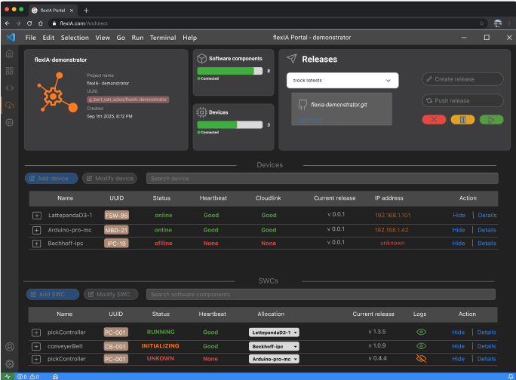
The flexCloud and flexEngine form the core building blocks of the FlexIA deployment ecosystem, providing a unified and automated approach for deploying and operating distributed industrial automation applications. The flexCloud currently provides a base centralized environment for building, packaging, deploying, and managing FlexIA applications composed of flexNodes, software components developed using the flexCommunicator client libraries, across a limited set of supported heterogeneous platforms. A base version of the single-button deployment mechanism is available, enabling automated application rollout and deterministic startup orchestration across distributed compute platforms. Deployment and runtime interaction are facilitated by the flexEngine, a lightweight service running on each target device that connects the platform to the flexCloud and performs basic platform-aware dependency checking and installation, allowing native deployment on compute hardware where container-based solutions, such as Docker, are not viable (e.g., PLC-like devices). Centralized logging in the flexCloud provides initial observability into application behavior and platform-level metrics. Ongoing and future work focuses on extending the cloud environment, improving the robustness and functionality of the single-button deployment mechanism, increasing the range of supported hardware devices, and further advancing dependency checking and resolution. Additional objectives include the integration of comprehensive versioning support for controlled evolution and lifecycle management of flexNodes, as well as the development of robust operational workflows for over-the-air (OTA) updates, enabling safe, reliable, and downtime-free updates for continuously operating 24/7 industrial automation systems.
Detailed description can be found in WP2\R2_1_TechnologyBuildingBlocks\R2_1_A_TechnologyDescription\ flexCloud_flexEngine.md

      - flexIA IDE mock-up
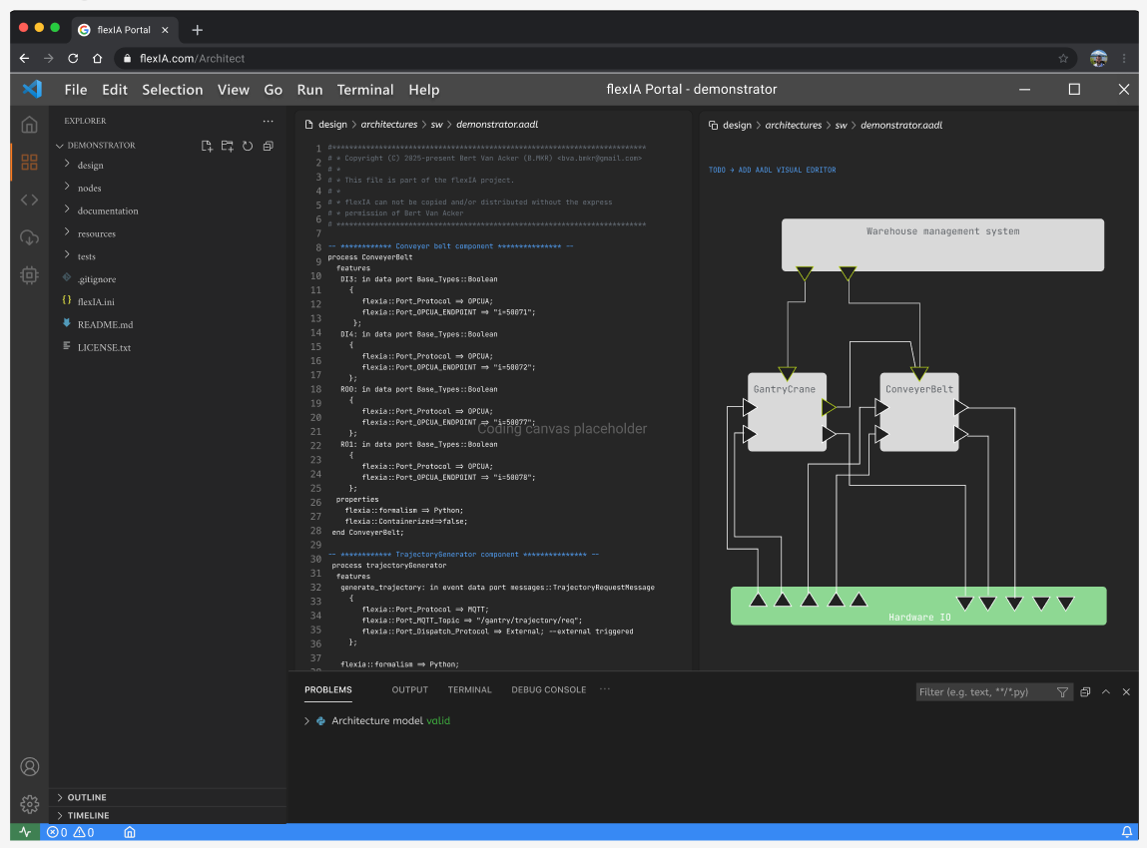
The flexIA IDE mock-up provides a conceptual preview of an integrated flexIA toolchain, envisioned as a plugin for Visual Studio Code. Developed as an interactive prototype in Figma, the mock-up illustrates how different stages of the flexIA workflow can be unified within a single development environment.
It showcases key aspects of the toolchain, including system modeling, automated code generation, implementation support, orchestrated deployment, and integrated device and application monitoring. By combining these capabilities into a cohesive interface, the mock-up demonstrates how developers and engineers can seamlessly move from design-time activities to runtime supervision within one consistent workflow.

The interactive prototype can be explored here: https://www.figma.com/proto/lbrXW1CEBvYZPxkQ7rBeXC/flexIA-cloud-portal-minimal?t=jUyrvbs9IM8cg9Py-0&scaling=min-zoom&content-scaling=fixed&page-id=22%3A1140&node-id=22-1141&starting-point-node-id=22%3A1141

The prototype serves as a tangible vision of a user-centric flexIA development experience, highlighting usability, integration, and end-to-end engineering support.

    - Technology feasibility
      - Developed toolboxes and examples

The feasibility study for the FlexIA toolchain is embedded directly within the repositories of each individual technology building block, FlexModeler, FlexCommunicator, FlexCloud, and FlexAgent, where multiple practical examples and small use cases are provided to test and showcase their capabilities. These examples allow users to explore and validate key features, experiment with workflows, and gain hands-on experience, ensuring that the feasibility of the proposed concepts is continuously demonstrated in a transparent, reproducible, and evolving manner alongside the development of each component. Detailed description can be found in WP2\R2_2_FeasibilityStudy\R2_1_A_TechnologyFeasability\FeasibilityStudy.md.
  - WP3 results

    - R3.1 : Implemented FlexIA demonstrator using the components developed in WP2
      - Overview

We constructed a lab-scale industrial automation demonstrator, relevant to the members of the CIG, which is used to demonstrate the main features of the individual technology building blocks. The lab-scale demonstrator combines a Fischertechnik training factory (industry 4.0), with an automated inbound system consisting of a Fischertechnik Conveyer Belt and a custom-built Gantry Crane. The demonstrator showcases deployment onto a heterogeneous compute architecture, comprising a PLC, a microcontroller and a Single Board Computer(SBC), and incorporates several advanced technologies, most notably the use of digital twins at different abstraction levels. A first digital twin is associated with the Fischertechnik training factory and is realized using a DEVS-based model [6]. This model is continuously synchronized with the execution of the physical machines in the Fischertechnik training factory, enabling both what-if analysis and root-cause analysis in the presence of anomalies. A second digital twin is employed in the trajectory planning of the gantry crane. This twin focuses on the dynamic behavior of the crane and its payload and is used to compute optimized motion trajectories, minimizing load swinging during crane movements. In addition to these model-based components, the demonstrator integrates an advanced reasoning layer in the form of an LLM-based chatbot. This chatbot is connected to the flexCloud, allowing it to reason about the behavior and state of the automation application, using the centralized cloud logging feature. Furthermore, the chatbot can actively interact with the system, e.g. commanding a move operation of the gantry crane. This interaction is enabled through the explicit hardware–software architecture model and the generated communication matrices. Our demonstrator was presented at the Antwerp Innovation Night and attracted significant interest from a wide range of stakeholders, including audiences beyond the automation domain. A detailed description of the demonstrator, the comprising components and the implementation can be found in WP3\R3_1_Demonstrator.

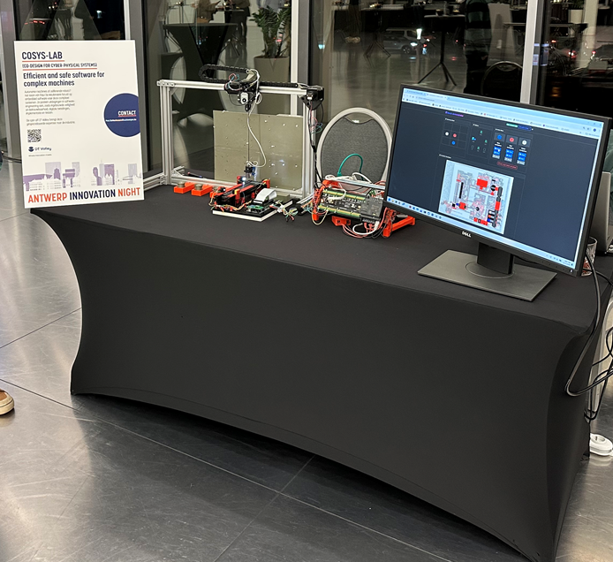

      - Design-time aspect
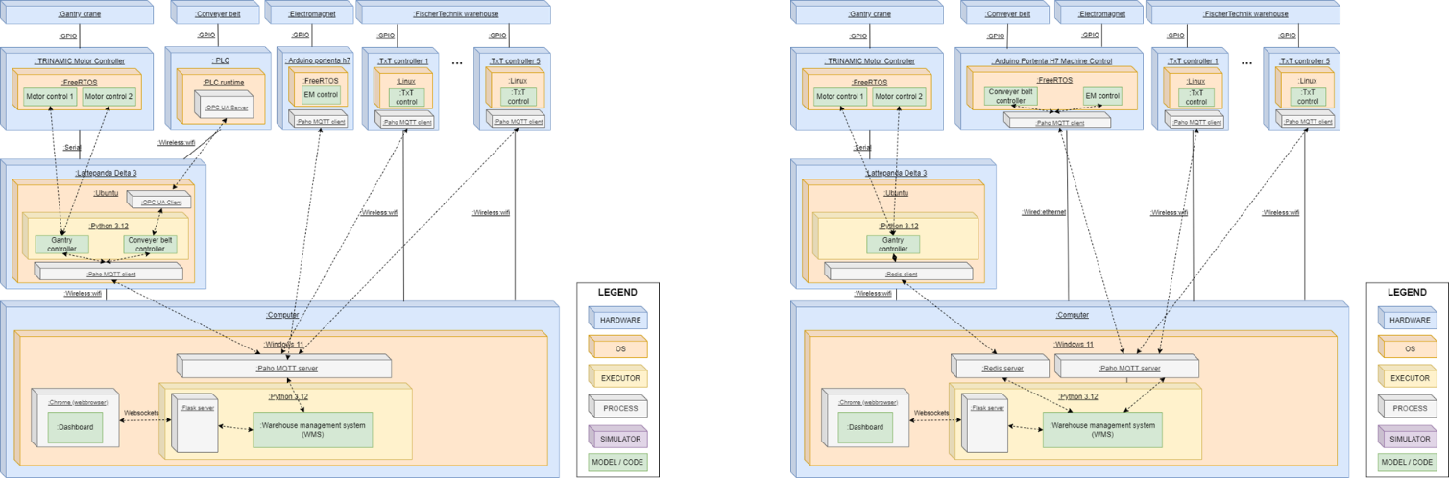

For design time, the demonstrator highlights a model-driven engineering approach for industrial automation systems, centered around the explicit modeling of system architectures using AADL. It demonstrates how system structure, component interactions, and deployment configurations are formally captured and analyzed at design time. A key feature is the AADL2CODE transformation, which automatically generates a flexIA application package along with skeleton code for distributed flexIA software components, supporting multiple implementation formalisms (python, C/C++, ST). This enables a seamless transition from high-level architectural models to executable system artifacts.

The demonstrator further showcases the exploration and comparison of multiple architectural configurations, allowing to evaluate trade-offs and adapt system designs to varying requirements. Finally, it illustrates orchestrated deployment planning and execution, where selected subsets of the flexIA demonstrator are systematically prepared for execution across the targeted heterogeneous platforms.

      - Runtime aspect
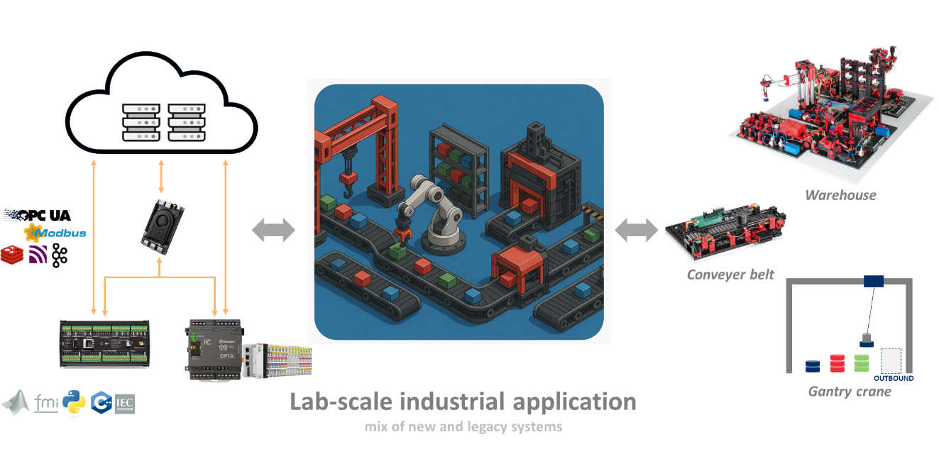
The flexIA runtime demonstrator showcases the execution of an industrial automation application implemented as a set of distributed flexIA software components. It highlights how the flexIA architecture enables modular, composable, and deployable components that collaboratively realize a complete automation workflow across heterogeneous platforms, including single-board computers, microcontrollers, and PLCs. It demonstrates centralized logging, providing a unified view on system behavior and enabling advanced diagnostics and traceability. This logging infrastructure also serves as a foundation for higher-level reasoning, where integrated large language models (LLMs) analyze system logs to support decision-making and dynamically activate interfaces through communication matrices. The demonstrator further illustrates the seamless integration of software-intensive components, such as digital twins and AI modules, within the same distributed application. In addition, advanced monitoring capabilities are showcased, covering application-level aspects (status, parameters, contracts, and requirements) as well as device-level metrics (health and operational status), enabling comprehensive observability of the system at runtime.

      - IOF-POC DEVELOP demonstrator
Within IOF-POC DEVELOP, we will construct one or more integrated demonstrator setups to validate the end-to-end FlexIA automation development framework in industry-relevant environments. In alignment with the CIG, lab-scale demonstrators will be defined and constructed to represent intended use environments and domain-specific operational conditions. While individual demonstrators may address only a subset of aspects, the combined set of demonstrators will validate the FlexIA framework as a whole and cover the following high-level requirements:

REQ 1 - Modeling aspect of automation applications:
- REQ 1.1 Software-intensive system: the demonstrator shall implement a software-intensive automation application, including AI-based components
- REQ 1.2 Legacy system: the demonstrator shall include one or more legacy systems, such as existing operational installations (e.g., warehouse systems)
- REQ 1.3 custom hardware: the demonstrator shall include one or more custom hardware components, such as I/O hardware modules
- REQ 1.4 High-level behavioral modeling patterns: the demonstrator shall showcase one or more high-level behavioral modeling patterns, such as state machines

REQ 2 - Development aspect of automation applications:
- REQ 2.1 Multi-formalism implementation: the demonstrator shall comprise application components implemented in multiple formalisms, including C/C++, Python, and IEC 61131-3.
- REQ 2.2 Application portability: The demonstrator shall showcase the portability of high-level behavioral modeling patterns across application components implemented in different formalisms (e.g., C/C++, Python, and IEC 61131-3)

REQ 3 - Deployment aspect of automation applications:
- REQ 3.1 Heterogeneous & distributed hardware architecture: The demonstrator shall execute an industrial automation application on a heterogeneous and distributed hardware architecture, comprising PLC (or PLC like) devices, microcontrollers, SBCs, and server/cloud-based compute units
- REQ 3.2 Automated deployment: the demonstrator shall showcase automated deployment,
- orchestration, and execution of application components across heterogeneous and distributed platforms.
- REQ 3.3 Centralized monitoring: the demonstrator shall showcase the centralized monitoring of both application components and execution hardware.
- REQ 3.4 Evolution and lifecycle management: the demonstrator shall showcase lifecycle support for application components, including version control, controlled online updates, and rollback mechanisms.
- REQ 3.5 Device portability: the demonstrator shall showcase the portability of high-level behavioral modeling patterns across different execution platforms, such as between PLC-like platforms and SBCs or microcontrollers.

By replicating the intended operational environment with sufficient fidelity, the demonstrators will provide validation proof for all features implemented in the integrated automation solution, supporting progression toward TRL5 and enabling concrete feedback from the CIG to guide further maturation. To increase the feasibility and efficiency of constructing the demonstrators, we will reuse and extend existing demonstrator setups available within the CoSys-Lab research group, for example the demonstrator from the flexIA CREATE phase. In addition, we will explore the use of complementary research infrastructure from other research groups, where appropriate, to further strengthen the realism and scope of the validation. In particular, we will consider leveraging the Smart Mini Factory in Industry 5.0 for Biomedical Applications (SMIFI-5.0-BioApp), an accepted medium infrastructure project by Prof. Dr. Amelie Chevalier and her team, subject to alignment with the demonstrator requirements and availability. The smart mini factory is hosted by Prof. Chevalier, who is also a member of Cosys-lab. Furthermore, we are part of the consortium to build and use the smart mini factory for research.

The SMIFI infrastructure presents an ideal opportunity to validate the results of the FlexIA project because it is a shared research platform used by different research groups, all with different objectives (and applications). This multi-user environment creates the need for reconfiguration and evolution of the software and hardware of the system. This aligns well with the FlexIA “develop once, deploy anywhere” approach. More detailed, SMIFI covers the requirements as follows:
- REQ 1, Modelling aspects: The SMIFI implements a software-intensive automation application that combines industrial robots, AI-based vision systems for quality control and defect detection, and digital twin integration. The factory includes Beckhoff PLCs with fieldbus I/O modules and custom gripper technology, providing custom hardware components. The coordination of transport systems (magnetic levitation, monorail, conveyor), robots, and vision is appropriately modelled with high-level behavioural modelling patterns such as state machines.
- REQ 2, Development aspects: The combination of Beckhoff PLC-based, AI/ML vision components, and low-level device drivers naturally results in a multi-formalism implementation. FlexIA will demonstrate the portability of behavioural models across these formalisms.
- REQ 3, Deployment aspects: he SMIFI runs on a heterogeneous, distributed architecture comprising Beckhoff industrial PLCs, embedded controllers within the robotic systems, and server/cloud infrastructure for digital twins and AI inference. The flexCloud and flexAgent will provide automated deployment and centralised monitoring across this platform mix. The multi-user research context particularly motivates lifecycle management with version control and controlled updates, as different researchers require different application configurations on the shared infrastructure.

Figma mock-up; https://www.figma.com/proto/lbrXW1CEBvYZPxkQ7rBeXC/FlexIA-cloud-portal-minimal?node-id=22-1140&t=xCXUJaFll1MuqKGm-1

