Vintage Engineering Multiblock System

Overview
The multiblock system for VE (Vintage Engineering) provides an immersive crafting mechanic for large machines. After a core block is placed, the multiblock system will guide the player for where to place subsequent blocks with a translucent version of the remaining blocks will go. It is similar to Vintage Story’s multiblock system, but will allow for larger structures than the vanilla multiblock system. Plans are currently supporting 9(x)x9(z)x16(y) sized machines.

Requirements
From a player perspective, the process will be:
- Craft the core block of the desired machine. Internally this is called an incomplete core block, because it is not a complete multiblock yet.
- Place the block while facing the direction desired for the rotation of the machine.
- Upon placing, the block will be surrounded with a single layer of ghosted blocks, showing the location and type of component blocks to place. The type of component blocks depends on the multiblock definition. The multiblock definition can allow any component block type; fences, iron bars, dirt, leaves, metal blocks, etc.. Once the first layer is done, the next is shown and highlighted.
- Once all layers are correctly placed, the core block then swaps the surrounding blocks that built the multiblock with with empty “dummy” blocks, and swaps the incomplete core block with a complete core block. The complete core block has the large final shape of the machine, which extends beyond the normal 1x1x1 block boundary. The complete block is also properly rotated according to how the incomplete core was placed.

The rendering of the ghosted blocks will exist entirely on the client and only one such construction will be supported at the same time per client. If the player places the wrong block, then the block highlight system shows it is the wrong block (which does not z-fight with the wrong block). When the wrong block is broken, the block highlight is replaced with the ghost block again.

The client can right click the core block to show or hide the ghosted blocks, if the client starts another multiblock and the current one is incomplete, its blocks are hidden and the new one is shown. The client can then right click the original and the block placement guide is swapped back. If the players are in a team, the rest of the team can right click the core block to see the block placement guide, even if they did not place the core block.

The multiblock needs to support spanning chunk boundaries. Based on the maximum size supported multiblock size, the multiblock span at most 8 chunks.

The dummy blocks will also need to detect a block break and report that back to the complete core block. On Break, the complete core block will do the following:

- Swap the dummy blocks back to their components blocks.
- Drop any inventory in the complete core block.
- Swap the complete core block back to an incomplete core block.
- Process the block break event at the component block that corresponding to the dummy block that received the block break event.

Core block variants
From a technical perspective, the process is naturally more complex.

A standard block variant naming scheme must be in place to differentiate between the finished and unfinished core blocks.
{machinename}-{incomplete|complete}-{north|east|south|west|[up|down]*}

*=up|down optional and rarely used...
The incomplete and complete blocks should have different BlockEntity objects. The “incomplete” BlockEntity class will contain all of the relevant code to load (from JSON) the multiblock schematic, render the ghost blocks on the current layer, and track the block positions at those locations to update the layer, wrong-block highlights, or complete the structure.

The “complete” BlockEntity class will, essentially, be the operational machine, similar to all of the LV machines. It will also have a callback for all dummy blocks at given X,Y,Z offsets to return their collision/selection boxes (set in JSON), allowing for many shapes of collision/selection without the need for many dummy block variants.

Dummy blocks
All “dummy” blocks point to their core block, so that they can forward events like right click to the core block that runs the entire machine. This dummy block also pulls the collision/selection box from the behavior on the core block to prevent the player from walking through the machine. If a custom collision/selection (CS) box is not defined, the full block size is used.

Dummy blocks must be able to locate the core block in order to forward events to it. The dummy blocks in the base game encode the offset from the dummy block to the core block in the block code. Specifically, the dummy blocks have block codes of the form “multiblock-monolithic-dx-dy-dz”. A problem with this approach is that a new block code must be defined beforehand for every possible dummy offset. The base game limits the size of multiblocks to 5(x)x6(y)x5(z) to limit the number of dummy block types, but that still results in 150 different dummy block types. It is untenable to extend that system to support 9(x)x16(y)x9(z) multiblocks, because that would create a total of 1146 additional dummy blocks.

Instead, each VE dummy block will have a block entity. This allows each placed dummy block to encode an arbitrary offset. This approach has a lower up front RAM cost (fewer dummy block types), but a higher RAM cost per placed dummy block. We estimate that a block entity takes 200 bytes. So a 9x16x9 structure would take 127KiB.
If the RAM becomes a problem, the design can be changed to have multilevel dummy blocks. The existing base game dummy blocks (RAM efficient) would be the level 1 dummy blocks. They would forward interactions to the level 2 dummy blocks, which would the be previously described dummy blocks with a block entity. The level 2 dummy blocks would then forward to the core block. This approach is considered a backup rather than the primary approach due to the additional implementation complexity.

Additionally, only external-facing blocks need to be tracked and created, any ‘internal’ blocks that have no face the player even sees may not even need to exist.

Just like the vanilla multiblock behavior, by default, the dummy block will forward events to the core block as if the core block was interacted with directly. For example, if the dummy block gets a OnBlockInteractStart event, then it will call OnBlockInteractStart on the core block and pass the same arguments. However, this has a limitation. For compatibility with other behaviors installed on the core block, the dummy block must translate the block selection (indicates exactly where the player clicked) so that it looks like the player clicked the core block instead of the dummy block. That prevents the core block from customizing its behavior based on exactly where on the multiblock the player clicked.

Alternatively, if the core block implements special interfaces, then the dummy block will forward the untranslated event to the appropriate interface instead of calling the base Block method. The core block may implement any subset of these interfaces. For base game events, the existing multiblock interfaces can be used:
- IMultiBlockColSelBoxes – customize the collision or selection boxes based on the dummy block location
- IMultiBlockInteract – customize the right click events, middle click events, interaction help, and sounds
- IMultiBlockBlockBreaking – custom handling for block breaking events, such as changing the block breaking decal that is shown, or providing custom block drop handling
- IMultiBlockBlockProperties – customize child block attachment, heat retention, or reading of the general purpose block json attributes

This core block redirection is essential as it will enable the interaction of power delivery (via relays placed in a specific location) and inventory at certain positions. A custom dummy block may be needed to enable these additional features, pointing to the interface at the block position rather than the block position itself. Multiblocks will have specific places that expect power, a relay placed on this dummy block location must be able to communicate with the core power interface directly. Similarly, a pipe or other means of transporting must be able to connect to specific dummy block locations for machine input and output. The “complete” shape, of course, will have obvious indicators showing the expectation of power, transport, etc.

Additional interfaces may need to be included into the Dummy Blocks,
These include:
IBlockEntityContainer (base game) for inventory interactions, Item Pipes look for this interface when determining whether a connection is valid. Chutes, however, look for BlockEntityContainer, not an interface.
IVELiquidInterface (VE) for fluid specific inventory interactions, Fluid Pipes will check for this when determining whether a connection is valid. Also, right clicking the dummy block with a bucket to place/remove a fluid contained (a base game barrel block has 3 different liquid interfaces; ILiquidSource, ILiquidInterface, ILiquidSink).

Add an IElectricalBlockEntity call CanConnect to return whether a connection is possible, this is used by the relay to communicate with the dummy block with additional information on the connection being attempted, including the BlockFacing object (or the larger scoped BlockSelection object).

Dummy block collision and selection boxes
The collision and selection boxes will be defined as properties of the overall vemultiblock behavior on the core block that cover the entire structure. These boxes need to be chopped up into pieces and assigned to the dummy blocks so that each piece does not exceed the boundaries of the dummy block. Each dummy block needs to report the collision and selection boxes that intersect with its block boundaries. The boxes returned by the dummy block may extend beyond the block boundaries, although none of the base game multiblock structures do this (instead they chop up the boxes into pieces that stay within the dummy block bounds).

The base game only supports axis aligned CS boxes (no 45 degree rotated selection boxes). So the multiblock will also only support axis aligned CS boxes.

The complete core multiblock will support up to 7 large CS boxes and the individual single-block CS boxes specific to the dummy block offset location will return their portion of those large CS boxes

Rendering
A 9(x)x9(z)x16(y) test block was placed to verify that the supports shapes extending that far beyond the block boundary. No problems were observed, even as one passed the block on the side. This means it is not necessary for the multiblock behavior to chop up the shape into smaller pieces for the renderer.

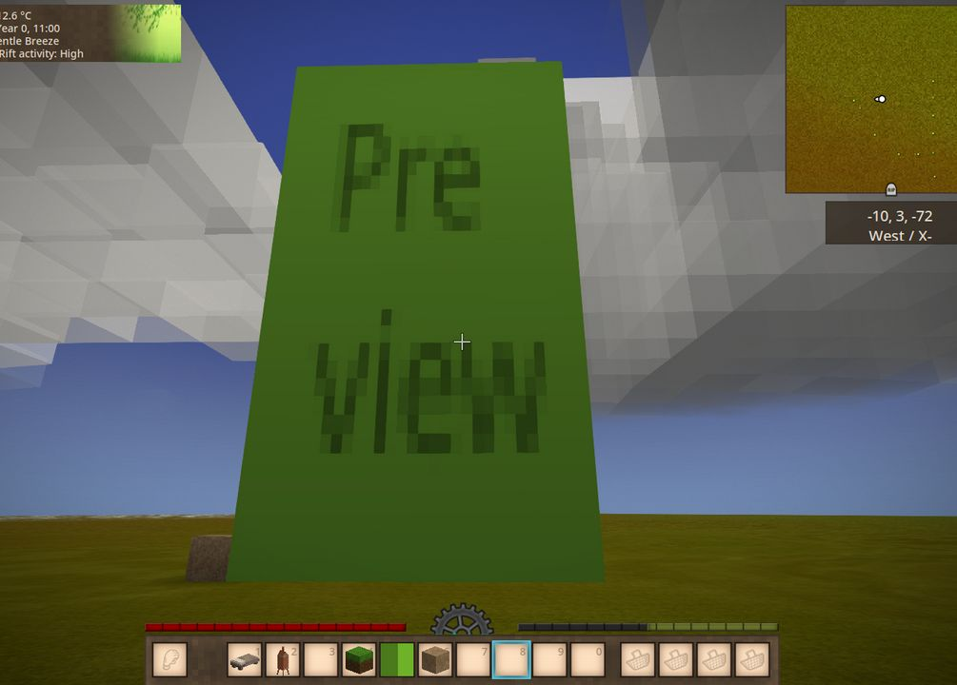

One problem with the large shape is that the renderer does not support texture wrapping within shapes, and there is no way to add support without simulating the wrapping by chopping up the texture into smaller pieces, or by adding custom renderer. So for any large faces, the texture will either need to be very high resolution, or it will get stretched out.

Detecting component block changes around the core
The incomplete core needs to detect changes to the blocks around it in order to:
- Change which layer of ghost blocks is shown when a layer is completed or a block is broken on a previously completed layer
- Show a block highlight when an incorrect block is placed (and hide the ghost block to prevent z-fighting)
- Remove the block highlight when an incorrect block is broken (and thus replaced with air) and show the ghost block
- Swap the incomplete core and component blocks with the complete core and dummy blocks
There are several ways to get these notifications, with no perfect solution

Global events (chosen)
The mod could monitor all block placements and breaks by tapping into the IServerEventAPI.DidPlaceBlock and IServerEventAPI.DidBreakBlock events. The event handler would look at a global list of all the incomplete cores and see if the broken/placed block position belongs to it.
An incomplete core should have awareness of all BlockPos that make up its body, a call like IsApartOf(BlockPos) should be a simple check to see if the position is part of the core, if so, handle.
The downside is to this option is that there would be a very small performance hit. Possibly the event handlers could be unregistered whenever the incomplete cores goes to 0, to remove any performance impact in that case. However, the performance hit would still be linear with regards to the number of active incomplete cores. Possibly the list of incomplete cores could be broken down by the chunk ids that they span. However, that is somewhat complicated to get right (incomplete cores span multiple chunks and multiple cores can be in the same chunk), and there would still be a small performance impact whenever at least one incomplete core is active.

Scan blocks at timed interval (not chosen)
A timer event could be added such that every 100ms the incomplete core block scans all neighboring blocks to see if any have changed. However, scanning up to 1296 blocks per incomplete core adds server latency. Trying to mitigate the latency by decreasing the scan frequency then makes the system less responsive. The response rate is important, because the player needs the ghost blocks to be swapped every time they complete a layer.

Update when the core block is clicked (not chosen)
The base game cementation furnace only updates its block highlights when the core block is shift right clicked. The VE core block could do the same. However, since VE only shows one layer of ghost blocks at a time, it would be tedious for the player to have to click the core block after each layer is completed. This would be especially difficult if the 2nd layer above the core block covers up the core block. The player would need to dig a tunnel under the core block to keep right clicking it at the end of each layer.

Canary decors (not chosen)
The incomplete core could place a special décor block, called a canary décor, at every building block location around it that currently contains an incorrect block. Whenever that incorrect block is broken, it would also break the décor at that location, which would call OnBrokenAsDecor on the canary décor. The décor would then notify the core block.
One problem is that decors are only called when blocks are broken and not when they are placed. So this approach could help with intercepting block break events, but not with block placement events.
A solvable problem is that Block.GetPlacedBlockInfo attaches the primary décor names to the block description. So if the player pointed to one of the incorrect blocks they would see something like “grass block with canary décor”, even though the canary décor is an implementation detail that should never be exposed to the player. Also, placing the canary décor at that location would replace any décor the player already placed there (such a wallpaper). This problem can be solved by avoiding the primary décor indexes and instead using the subindexes. The base game only uses subindexes for the cave paintings. Cave paintings are so rarely used, that likely no player would notice if some of them are lost. The décor subindexes are also not shown in the block info.
The next problem is that decors cannot have block entities. So it would be challenging to find the incomplete core from inside the OnBrokenAsDecor call. The best solution here is to store the offsets of all incomplete cores in the chunk mod data. However, the chunk mod data API is awkward to use, hence why we are avoiding it in the dummy blocks.
The biggest problem with this approach is that the game’s internal logic for handling decors is slow when there are too many decors in a chunk. Specifically, the WorldChunk.BreakAllDecorFast method iterates all decors in the chunk to find the ones at the position of the broken block. If the VEMultiBlock used canary decors, that is up to 9*16*9 = 1296 decors in the chunk that it would need to check.

Monitoring block entities (not chosen)
The lambda mod uses an invisible meta block, called blockmonitor, to watch for block placements and breaks. Any such events it detects are forwarded to the watcher block at a position specified in the block entity associated with the blockmonitor. The blocks have a high replacability so that the player does not notice them if they try to place a different block at their position.

A problem with this approach is that the blockmonitors can only be safely placed on air blocks. Trying to place them on incorrect blocks around the core would end up replacing the incorrect blocks with the blockmonitors. To the player, this would look like the incorrect blocks were replaced with air. Similarly, trying to place the blockmonitor on a component blocks would actually replace the component block with the blockmonitor. So the core block should place the blockmonitors at every position around the core that has air but should have a component block instead.

The lambda mod partially mitigates this by also watching for OnNeighbourBlockChange. This effectively extends the blockmonitor’s range by 1 block in each direction. To effectively use this, the incomplete core block would also place the blockmonitors at the air blocks 1 block away from the component blocks. This still would not catch everything. The player could surround the multiblock with fence blocks, such that they can still select the component blocks behind the fence, but yet there is no room to place a block monitor. Then the player could break a correct component block without the incomplete core block immediately noticing. However, it is unlikely that any player would do this by accident. To prevent players from abusing the system, the incomplete core block would double check all of the component blocks before swapping with a complete core block.

Monitoring OnTesselation calls (not chosen)
With the blockmonitors described above, in addition to listening to OnBlockPlaced, OnBlockRemoved, and OnNeighbourBlockChange, they could also listen to OnTesselation calls. Any block change within the chunk will trigger a OnTesselation call. However, this has 2 downsides:
OnTesselation is only called on the client side, but the server actually needs the data. So the method would need to send a custom network notification to the server.
OnTesselation does not indicate which block changed to trigger the tessellation. So the core block would have to check all of its surrounding blocks.

Creating Multiblocks
Creating the completed multiblock will be much like creating a single block. In VSModelCreator, the modeler creates a model that exceeds the single block highlight the VSModelCreator shows.

First, however, the incomplete single-block sized core is created and textured. This is what the player crafts and places to start the process.

The modeler places the incomplete core block in a test world facing NORTH. They place all required component blocks around the core to define which blocks the multiblock will be made from. Current size limits are 9x9 base and 16 tall. Once all blocks are placed, they select the structure using world edit, then use the built-in World Editor command ‘/we gmc’ to copy the component blocks in JSON format to the clipboard. The json blocks are pasted into the vemultiblock behavior JSON properties of the core block of the machine being defined. To prevent the modeler from having to repeat the above process for all of the other rotations of the core block, the behavior will support rotateX, rotateY, and rotateZ options for the multistructure. Internally the behavior will rotate the multistructure schema. Specifically, the rotateYByType property is expected to be used to transform the NORTH variant into the EAST, SOUTH, and WEST variants.

For multiblock structures with odd x z sizes, the core block will automatically be located in the bottom middle of the structure. However, just like the base game multiblock behavior, vemultiblock structures with an even x or z size, the modeler must specify the location of the core block using the cposition property. Simply placing the core at x/2, z/2 is not good enough, because the center position would change when the structure is rotated.

Modelers are advised to use the shapeByType JSON section to customize the core block shape. The incomplete variants (such as “*-incomplete-north”) should use a shape that stays within the 1x1x1 block bounds (16x16x16 in voxel coordinates) and the large final shape in the complete variant.

The north variant is defined as the default orientation with no rotation. Other directions will need to rotate around the Y axis. This is why when you create the defined component blocks you do so facing north. The rotation values are shown formatted below for the “complete” shape:
"shapeByType": {
"*-complete-north": { "base": "domain:{directory}/{shape-file-without-ext}", "rotateY":0 },
"*-complete-east": { "base": "domain:{directory}/{shape-file-without-ext}", "rotateY":270 },
"*-complete-south": { "base": "domain:{directory}/{shape-file-without-ext}", "rotateY":180 },
"*-complete-west": { "base": "domain:{directory}/{shape-file-without-ext}", "rotateY":90 }
}

The Handbook
The multiblock feature will, of course require some handbook manipulation to provide the player with the information they will need to construct each multiblock.

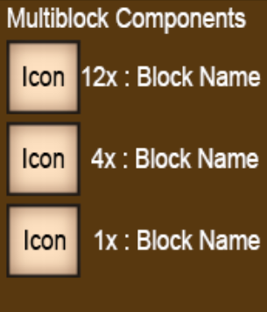
Each craftable incomplete cores’ handbook entry will need to include a list of block types with a count required to build the machine. This information needs to be pulled from the cores multiblock JSON definition at run-time. The core itself shows the build schematic in the world so that is not required to show in the handbook. The list of required components needs to be clear as to what type of block is listed, either showing the icon with the name or just the icon with the name coming up on mouse hover over the icon.

The GUI Icon used for the core block needs to show, at the very least, the final machine (and not the single-block incomplete core). At best, to hopefully prevent any major hits to FPS, a shrunken version of the multiblock could be created in the model editor and used ONLY for the icon, that way the game isn’t trying to render a giant multiblock in a tiny itemslot space.

On extremely large multiblocks that would be impossible to discern at that small scale, a simple icon could be used instead. An example would be for the 16 block tall Oil Refinery an icon of a simple drop of oil could be used for the GUI icon.

The use of a custom icon shape in the GUI is done via the following JSON tag:
shapeInventory: { base: "{domain:path/shape-no-ext}" }

