TripFlag Enterprise System Design, Architecture, & API Reference
  - Confidential & Proprietary - Architecture Division

1. Executive Summary
TripFlag is a highly secure, enterprise-grade data ingestion and auditing platform designed for large-scale logistics and trip telemetry. It normalizes arbitrary file formats (XLSX, CSV, PDF, JPG) using advanced AI-driven Optical Character Recognition (OCR) and applies a rigorous deterministic rule-based flagging engine. The application architecture strictly separates concerns between the Edge-deployed Next.js web frontend, the native Electron desktop wrapper, and the high-performance Neon Serverless PostgreSQL database.

2. System Architecture
The system employs a bifurcated client model. The Web Client (Next.js) is served globally via Vercel's Edge Network, providing standard portal access. The Desktop Client uses Electron to wrap the web application for local execution, enabling deeper OS integration while maintaining a unified codebase. Both clients communicate with the Node.js API Server via secure HTTPS/REST.
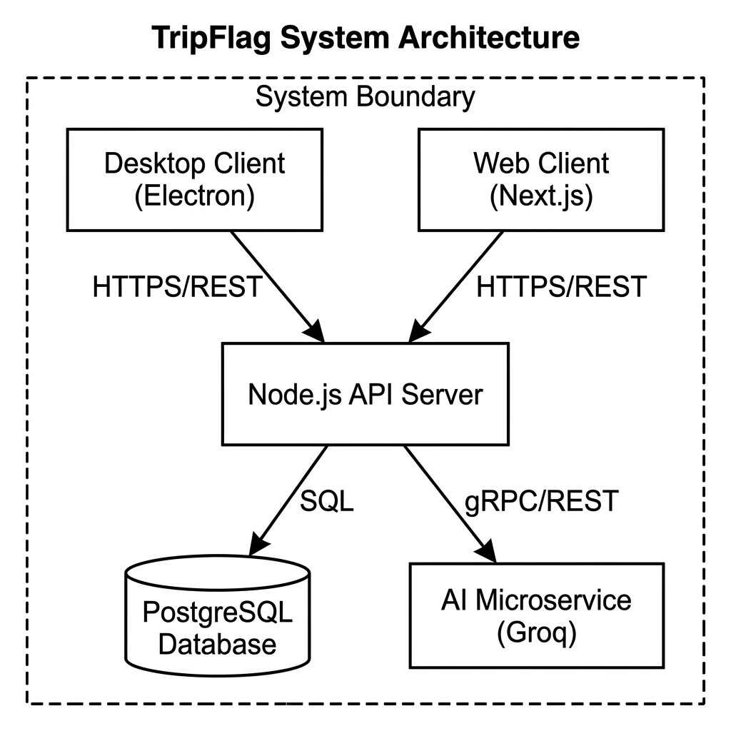
Figure 1: High-Level System Architecture and Data Flow Boundaries.

3. Database Schema & Data Models
The PostgreSQL database (hosted on Neon Serverless) relies on tightly normalized tables. The database leverages native JSONB columns to handle dynamic, unstructured row data extracted from unpredictable uploaded documents, while maintaining strict foreign keys.
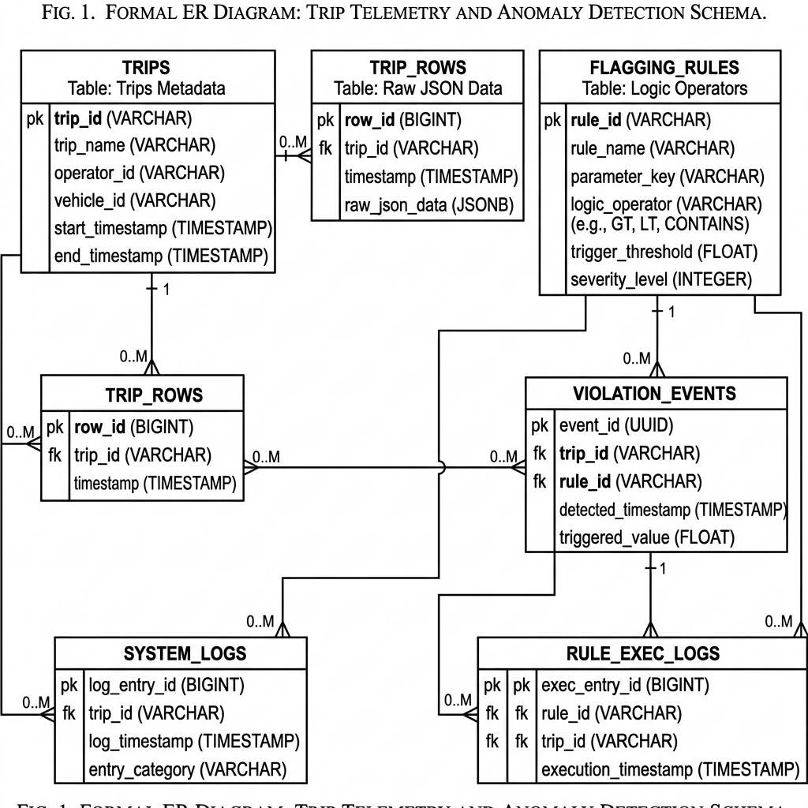
Figure 2: Entity Relationship Diagram (ERD) for Trips, Rows, and Rules.

3.1 trips Table
Stores metadata for every file uploaded.
- id (UUID): Primary Key
- name, original_filename (VARCHAR): User-provided and original file names.
- file_type (VARCHAR): Extension mapping (xlsx, pdf, img).
- column_headers (JSONB): Array of extracted spreadsheet headers.
- total_rows, flagged_rows (INTEGER): Cached counts for O(1) reads.
- status (VARCHAR): 'pending', 'approved', 'rejected'.
- uploaded_at, approved_at (TIMESTAMP): Audit timestamps.

3.2 trip_rows Table
Stores individual row data. Normalizes spreadsheet grids and OCR output into JSONB objects.
- id (UUID): Primary Key
- trip_id (UUID): Foreign Key (trips.id), cascades on delete.
- row_index (INTEGER): Preserves original file row order.
- row_data (JSONB): Key-value pairing of the row data.
- is_flagged (BOOLEAN): High-speed filtering boolean.
- flag_details (JSONB): Array of specific rule violations.

3.3 flagging_rules Table
Maintains the dynamic business logic parameters.
- id (UUID): Primary Key
- field_name (VARCHAR): Exact JSON key to evaluate in row_data.
- operator (VARCHAR): Logic constraint (greater_than, equals, contains, etc.).
- value, value_end (VARCHAR): Threshold values.
- unit (VARCHAR): Human readable metric.
- severity (VARCHAR): 'warning' or 'critical'.
- is_active (BOOLEAN): Soft-delete/toggle state.

4. Comprehensive API Reference
The Node.js API layer is responsible for data sanitation, database transactions, and coordinating with AI microservices. All routes are implemented as Next.js API Routes (Serverless Functions).
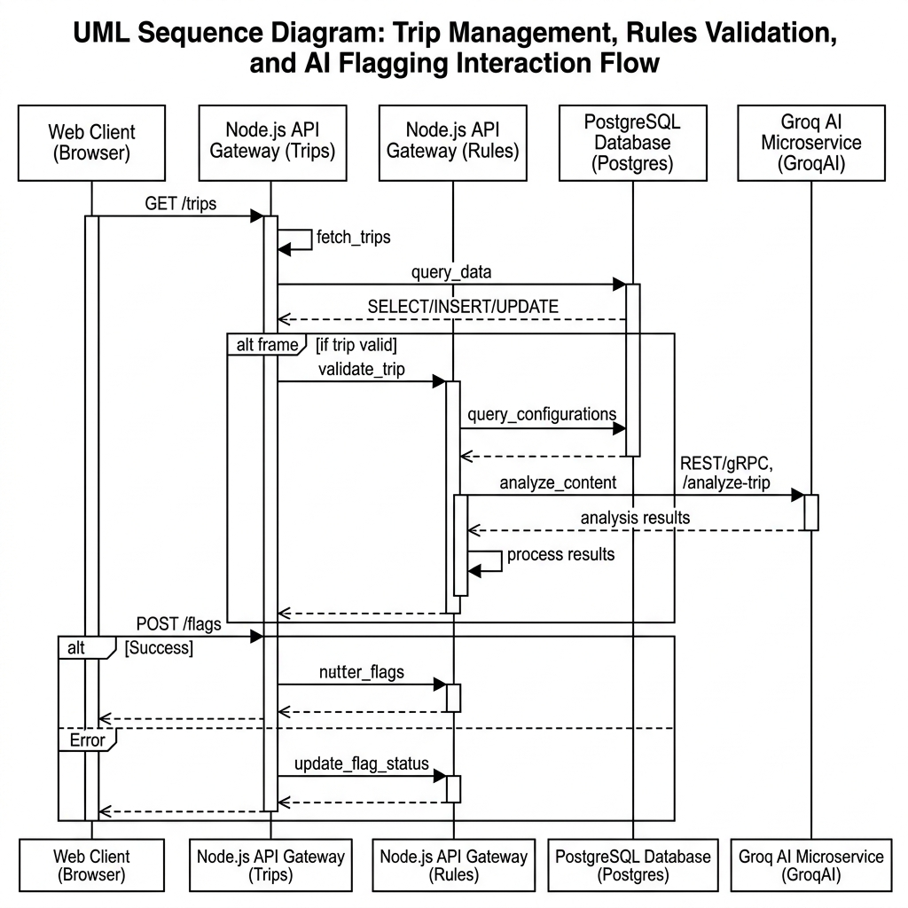
Figure 3: API Sequence Diagram - Interaction Flow.

4.1 Trips API (/api/trips)
GET /api/trips
Description: Fetches all trip metadata, ordered by uploaded_at DESC.
Response: JSON Array of Trip Objects (excluding raw row_data for bandwidth efficiency).
POST /api/trips
Description: Handles core data ingestion payload.
Payload: { name: string, original_filename: string, file_type: string, column_headers: array, rows: array }
Logic:
1. Validates payload existence.
2. Sanitizes JSONB to strip PostgreSQL-incompatible null-bytes (\u0000).
3. Inserts master 'trips' record.
4. Iteratively inserts 'trip_rows' objects.

4.2 Trips Details API (/api/trips/[id])
GET /api/trips/[id]
Description: Fetches a deeply nested trip object, including all associated rows.
Response: { id, name, ..., rows: [ { row_id, row_data, flag_details... } ] }
PATCH /api/trips/[id]
Description: Updates trip status.
Payload: { status: 'approved' | 'rejected', name?: string }
Logic: Updates status and writes to approved_at if status == 'approved'.
DELETE /api/trips/[id]
Description: Permanently deletes a trip. (Cascades to trip_rows).

4.3 Rules API (/api/rules)
GET /api/rules
Description: Fetches all rules ordered by created_at DESC.
POST /api/rules
Description: Creates a new flagging rule.
Payload: { field_name, operator, value, value_end, unit, severity, label, is_active }
PATCH /api/rules
Description: Toggles is_active status of a rule.
Payload: { id, is_active: boolean }
PUT /api/rules
Description: Fully replaces rule thresholds and conditions.
Payload: { id, field_name, operator, value... }
DELETE /api/rules?id=[id]
Description: Deletes a specific rule.

4.4 Flagging Execution API (/api/flag)
POST /api/flag
Description: Executes the deterministic flagging engine on a specific trip.
Payload: { trip_id: string }
Execution Flow:
1. Queries 'trips' to verify existence.
2. Queries all 'trip_rows' for the given trip_id.
3. Queries all 'flagging_rules' where is_active = true.
4. Executes 'runFlagging()' from lib/flagger.js locally in memory.
5. Iteratively UPDATEs trip_rows setting is_flagged = true and injecting flag_details.
6. Calculates total violations and UPDATEs trips.flagged_rows counter.

4.5 AI Integration APIs (/api/analyze-file-structure, /api/parse-pdf, /api/ocr)
These endpoints act as proxies to the Groq Llama-3 AI microservices.
- /api/analyze-file-structure: Sends the first 50 rows of a complex spreadsheet as a markdown table to the LLM to dynamically determine the integer index of the 'Header Row', avoiding strict templating constraints.
- /api/parse-pdf & /api/ocr: Receives base64 image strings or parsed PDF text, prompting the LLM to act as a Tabular Data Extraction Engine. Bypasses traditional zonal OCR by relying on LLM semantic understanding to return strict JSON arrays.

