 Art Document

Document Issue: 1.0 Document Status: Complete
Date Issued: Oct 21 02 Filing Path:
Document Title: Vehicle Rigging
                - Author: Kevin Fink

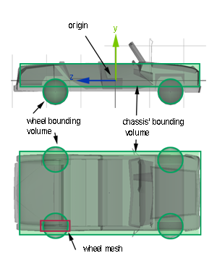
Overview

The Driving engine of the car, Red Brick, performs calculation based on real world units (meters) and thusly the vehicles should be built using the same units. There should only be one Bounding Volume on the chassis. This main Bounding Volume determine the distribution of mass of the vehicle relative to the centre point of the vehicle. Extra Bounding Volumes other than the chassis’ BV will affect the behaviour of the vehicle and potential make the vehicle lop-sided. The chassis’ Bounding Volume should envelop the chassis’ mesh in the x and z plane and can roughly fit the mesh in the y-axis. The wheels meshes, which have their own spherical Bounding Volumes, should ideally be inside the chassis Bounding Volume to avoid unnecessary collision detection between the wheels and other objects in the world. The centre of mass of the vehicle is based on the centre of the chassis, which is at Maya’s origin. The centre of mass can be repositioned in code to tune how the car behaves. The front of the vehicle must be facing the –z direction in Maya.

5 Main Pieces

The Driving Engine requires at least 5 main pieces of geometry. These pieces must have dynamic bounding volumes on them. The 5 required pieces are:

• Chassis – the body of the vehicle, which is the top of the hierarchy and has the skeleton root. The mesh and the Joint must have the same name, (see Diagram A). The pivot of these pieces is located at the centre of the
mesh. The transforms on the Chassis must be frozen.

Diagram A: Chassis Attributes

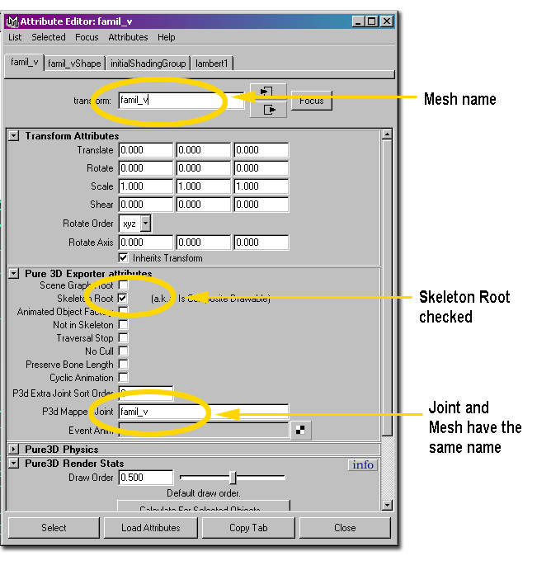
• Wheels (4) – There must be four wheels on a vehicle, which are parented underneath the Chassis in the hierarchy. The wheels must have translations on them. The wheel’s pivot must be at the centre of the mesh. Wheels are named with a single letter prefix “w” and sequenced 0-3, clockwise starting at the back right corner of the car. (See Diagram B)
The Red Brick driving engine must have 4 wheel meshes with Dynamic BV’s on them for the vehicle physics to work properly, but the mesh can be hidden in code for vehicles that don’t visually have wheels.

Diagram B: Wheel Positioning

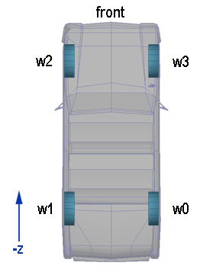

Flapping Joints

The 4 possible flapping joints on the vehicles are as follows and must follow the naming exactly:

- HoodRot
- TrunkRot
- DoorDRot
- DoorPRot

All of these meshes have translations on them but do not have rotations or scaling values. Their centre points are positioned on the mesh where you would expect the object to rotate from. (See Diagram C) Each separate piece gets put under it’s own group node with the meshes name followed by the suffix ”Trans”.
This is necessary to separate the meshes rotations and translations from each other. Hood and Trunk meshes rotate on the x-axis and Door meshes rotate on the y-axis. Each mesh must have a BV set to dynamic.

Diagram C: Flapping Joints and Pivots

