Title Simpsons 2

Platform PS2, Gamecube, XBox
Players 1
Media DVD
Peripheral Memory Card, Steering Wheel (optional)

Territory US/Europe
Voice English, French, Spanish, German, Italian
Text English, French, Spanish, German, Italian

Release 2 Quarter 2003

Audience 8 yrs to 50 yrs
Main Target Simpsons fan
Driving game fans

Quantity 1,200,000 PS2
(Estimated) 600,000 Gamecube World Wide 200,000 XBox

Publisher Fox Interactive
Co-Publisher EA

Developer Radical Entertainment

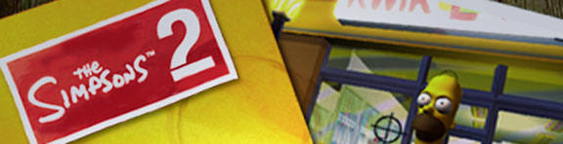
Back of the Box: 3 Hooks and Other Features
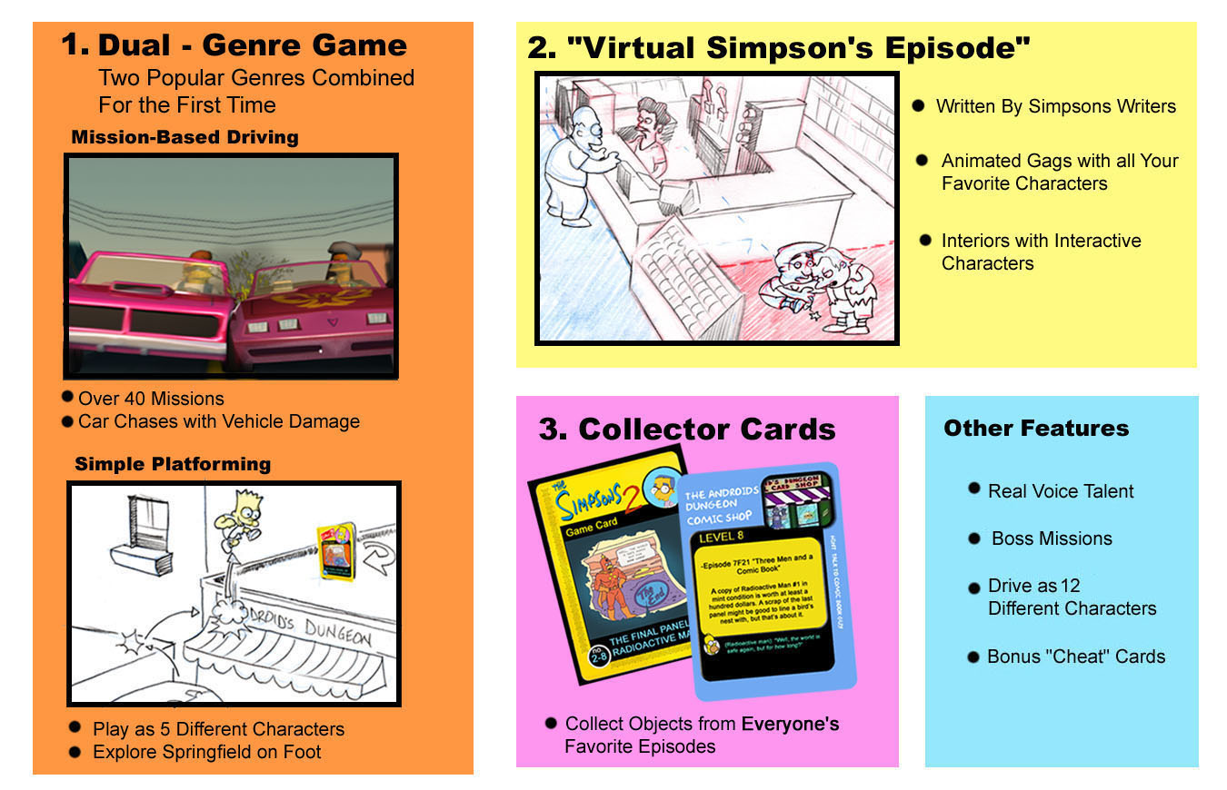

Game Outline

The main menu allows the player to access a single player story mode and view collectibles and unlockables, as well as configure options.

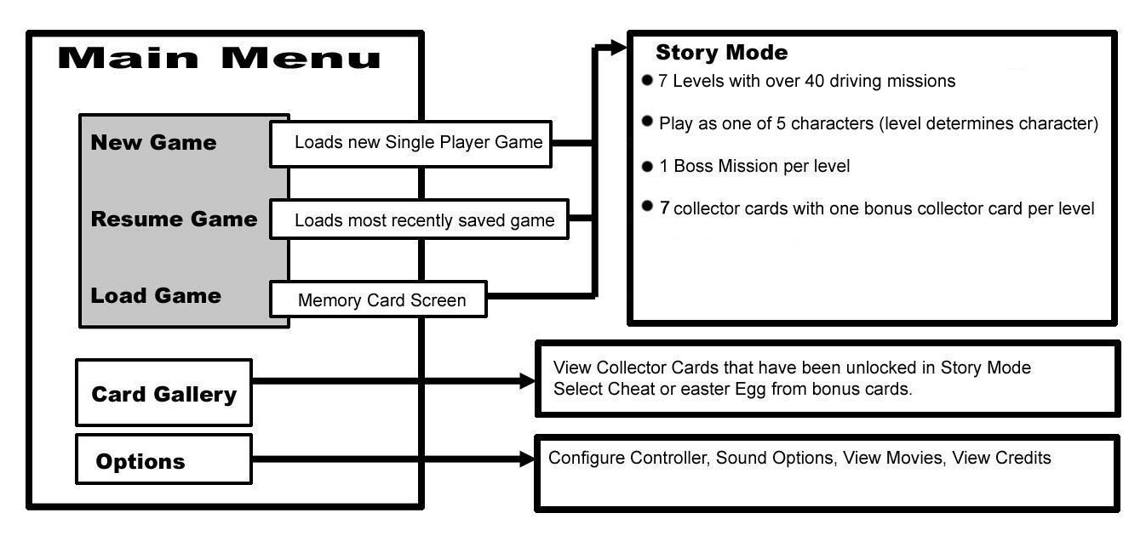
Story Mode

The goal of Story Mode is to find and complete all the driving missions in each level.

In order to do this the player will need to

- Hone their driving skills and learn the advantages and disadvantages of each vehicle type
- Learn to use the level design to outsmart enemy AI
- Strategically use both in car and out of car gameplay to accomplish different mission components.

In addition, the town of Springfield can be explored in between missions, both in car and on foot. This enables the player to engage with the Simpson’s universe and interact with as wide a range of characters as possible, and to do so at their own pace. Episode and character specific collectibles available outside of the missions encourage the player to make use of both styles of gameplay. When the player is not directly engaged in a mission, they are considered to be in “Sunday Drive” Mode.

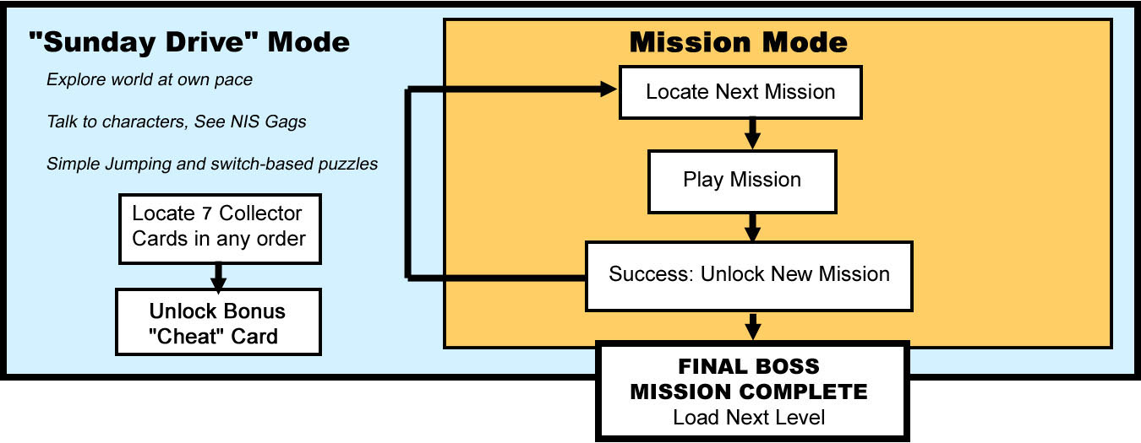

Story Mode: Levels
There are three locations in the game: The Suburbs, Downtown and Seaside. Each level takes place in one of these locations, with different configurations of missions and jumping puzzles. Individual levels may have new unlockable areas and time of day differences. There are 8 missions in each level. When the final mission is complete, the next level loads automatically. A “Newspaper Headline” loading screen helps tie the story from one level and character to the next.
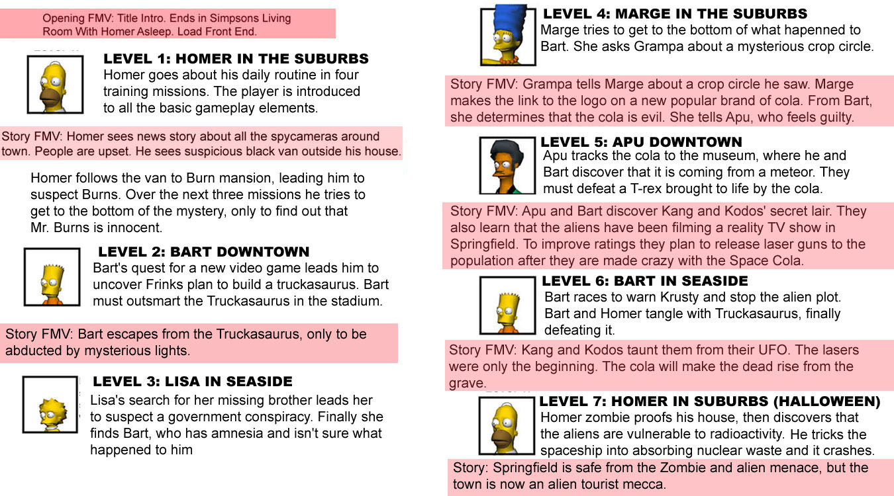
Vehicles.

Each Walkable Character has their own vehicle.

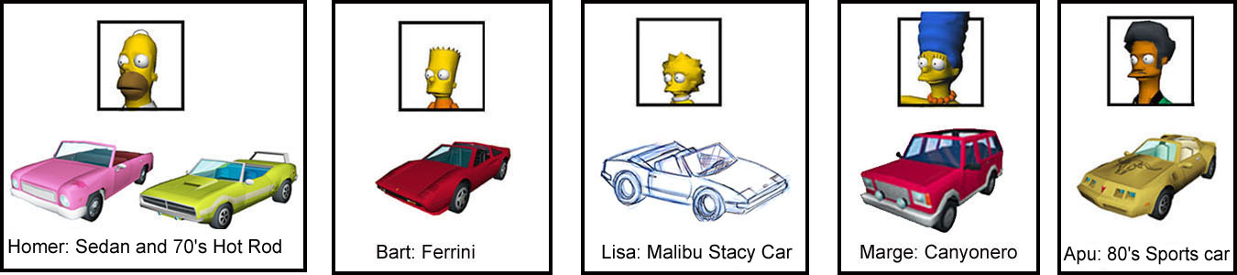

Driveable Characters

Each walkable character can get out of their car and get rides from Driveable Characters. When in that character’s car, the player has control of the vehicle.

Non-Player Controlled Vehicles

AI Vehicles
AI vehicles are used in missions for chase/evade gameplay. There will be five different vehicle shapes, each one must read clearly as an AI vehicle, and stand out from the generic vehicles both by the type and through subtle effects such as shading or glow.

There will be no drivers for these vehicles. Therefore, damage is limited to texture changes only. There are no parts flapping or falling off. When and if these cars are destroyed, there is a mini ‘poof’ explosion and then a texture change and smoke particles.

Chase/Race/Evade Vehicles
- Police cars
- Black Sedans
- Multi-coloured Sedans (“cel phone users”)
- Black Sedan
- Black Limo
- Smithers and Burns White Limo
- Black Surveillance van w/ camera
- Alien Cola delivery truck or van
- Donut Truck
- Generic “Nerd” vehicles
- Armored Truck
- Black Ferrini

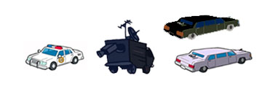

Generic Vehicles
Generic vehicles will provide moving obstacles for both driving and on foot gameplay. Generic vehicles may also be used as props – i.e. parked trucks on streets to allow players to jump onto roofs, etc. There will be at least 10 different vehicle shapes that will populate the Simpsons world. To add variety, each vehicle will be available in several different colors. Some will share the same body type, but use different textures to add variety

Controller Configuration
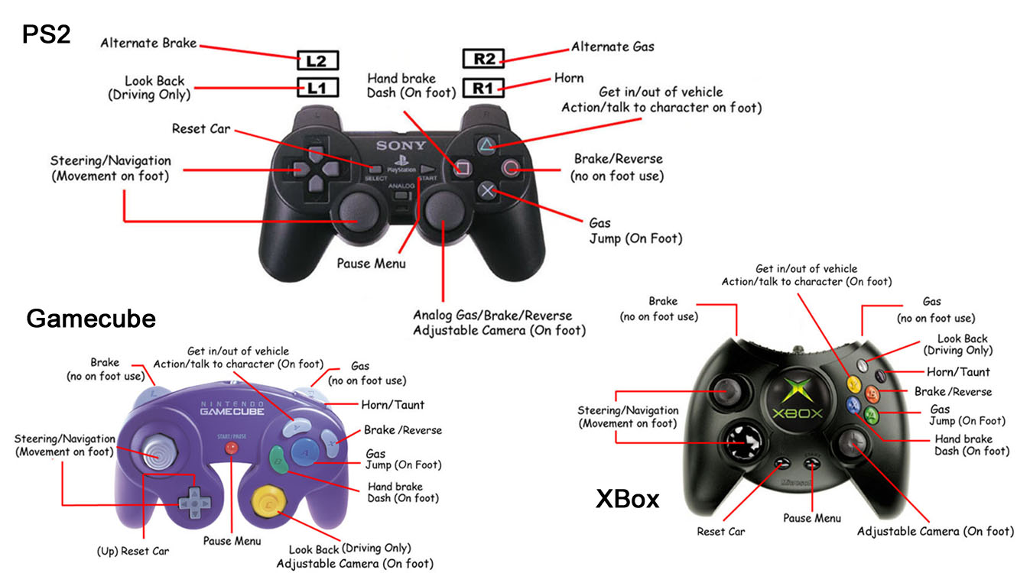

In-Car Gameplay

The in-car gameplay is the core experience of the game, and the most entertaining way to get from A to B (the in car gameplay must be fun without the Simpson’s content). While basic gameplay will be easy for the novice, expert players will be rewarded for learning the strengths of each vehicle.

Navigation

The location of mission goal points (or of the next mission start point if the player is not involved in a current mission) will be displayed on a HUD map showing part of the level.
- If the point is not on the portion of the map that is visible, then it will clearly indicate the direction of the point.
- A full size level map can be accessed through the pause menu at any time if the player wants to better plan his route.
- Hints will also be given through in-game dialogue when there is more than one character in the car.
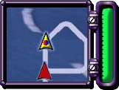

Vehicle Damage

Players must avoid excessive damage to their vehicle, or that vehicle will be damaged out. If the player is in a mission, this will usually result in failure.

Vehicles will also be given a vehicle rating (1 to 10) which will, in turn, determine how many hits it may take.
- No damage meter on the HUD – When a vehicle is two hits away from being damaged out, the engine will start smoking. The next hit – the smoke will increase. The final hit and the vehicle will be incapacitated.
- Vehicles will be divided into four quadrants and each quadrant will have four damage states: undamaged, texture damage, flapping parts (hood, doors, trunk), and finally detachment (the flapping part flies off). This will be strictly a visual element, as damaging out will be determined by overall damage.

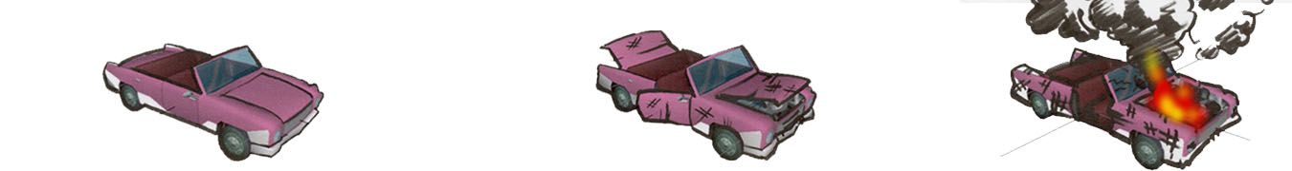
Driving Missions
Missions are linear: the current mission must be completed before the next one is unlocked. When a new mission is unlocked, the player must physically go to the trigger point to trigger it (this will be displayed on the map). Once a mission has been triggered for the first time, it can be started again instantly from any point on the map by accessing the mission select screen from the pause menu. If a player is unsuccessful at completing a mission after 10 tries, they will be given the option to skip to the next one.

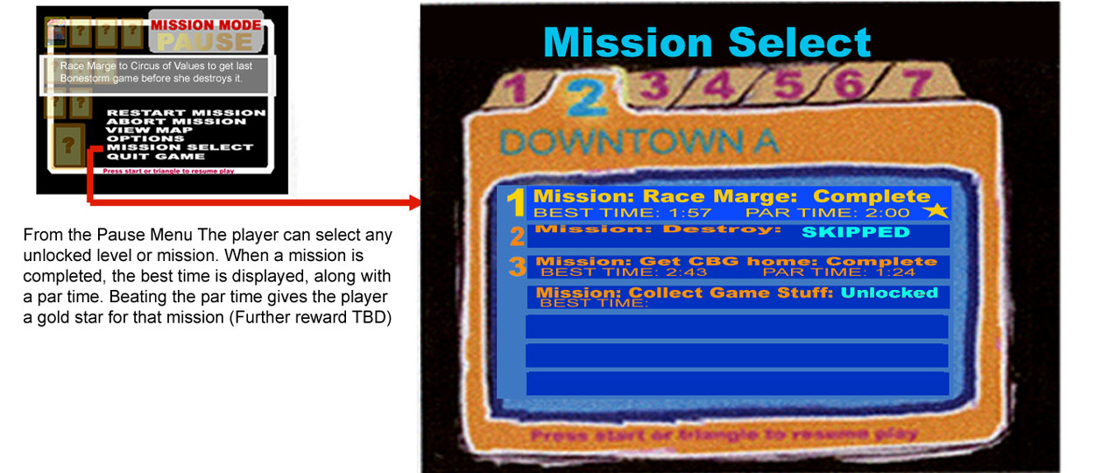

Mission Types
- There are 6 types of missions.
- There should be at least one of each type per level.
- Missions should be between 2 and 4 minutes in length.


Chase – Follow specific vehicle to destination. If you lose sight of it mission failed.
- Note that in Chase missions the player is always doing the chasing.
- Chase mission can have enemy AI vehicles harassing the player to add difficulty, but the goal of this mission type is to keep the vehicle you are chasing in sight.

Chase and Destroy – Pursue specific vehicle and run it off the road. Mission fails if time runs out.
- This mission type doesn’t have a destination point.

Race – Race another vehicle to destination. If other vehicle gets their first, mission failed.

Collect Objects – Collect objects, usually by getting out of car to pick them up. Either collect all the objects within a time limit, or collect all the objects and return them to a pedestrian character within a time limit.
- Objects can be acquired by talking to pedestrians or may be icons in the world

Destroy Objects – Destroy objects by running over them (or, in the case of Power Couplings, getting out of the car and using the action button).
- Destroy all objects within time limit or mission failed
- This is an excellent mission type to add pursuit vehicles to.

Escape – Get to the destination point without getting damaged out.
- This mission type will almost always have a Lose the Tail segment (see below) added on to the end.
- Enemy AI vehicles will always include multiple generic enemies.






Mission Types (Continued)

Combo Missions
Two mission types can be combined, keeping in mind that the presentation for introducing new goals is extremely limited. An example that works very well is Collect with a Lose the Tail segment added on.

“Lose the Tail” Segment- A “lose the Tail” segment can be added to the end of any mission. The player must lose any AI vehicles before he can win the mission (Hitting the destination will not be valid if enemy AI is present). This will always be a very short segment added on at the very end portion of the mission, since the player must be able to lose the tail at any point. If the player can get out of sight of the pursuing vehicle the vehicle will not re-spawn. The player will then be able to win the mission by going to the destination point.

Boss Missions

Each level will end with a “Boss Mission”. In most cases this will simply be a more intense version of the regular mission types. However, there are three Scripted Boss Missions in the game:
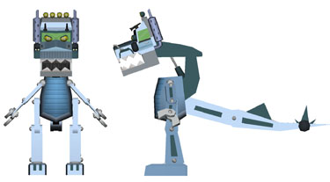
- Bart vs. the Truckasaurus at the end of Level 2
- Apu vs. the T-rex skeleton at the end of Level 5
- Final Showdown between Bart and the Truckasaurus at the end of Level 6

These missions will involve both on foot and in car gameplay against a large scripted boss character.
- They will take place in an enclosed arena.
- Typically the player will start on foot and must get to their vehicle before the Boss catches them.
- There will be obstacles on the way to the vehicle (simple jumping or dodging of obstacles)
- These obstacles are destructible by both the boss and the player vehicle.
- Once in the car, the player must destroy a number of objects while still trying to evade the Boss.
- Destroying the objects will then either enable the player to escape from the arena, or cause a large environmental effect that will take out the Boss character.
- On the last Boss mission, there may be multiple cars required to destroy the Boss (the car will be destroyed by the Truckasaurus before the player can back it out of a narrow alcove – the player must escape on foot while the Truckasaurus eats there car, then get to another vehicle).

On foot gameplay
On foot gameplay is supplemental to the core driving experience. At certain times the player will be required to play on foot. For example:

In order to switch to another vehicle

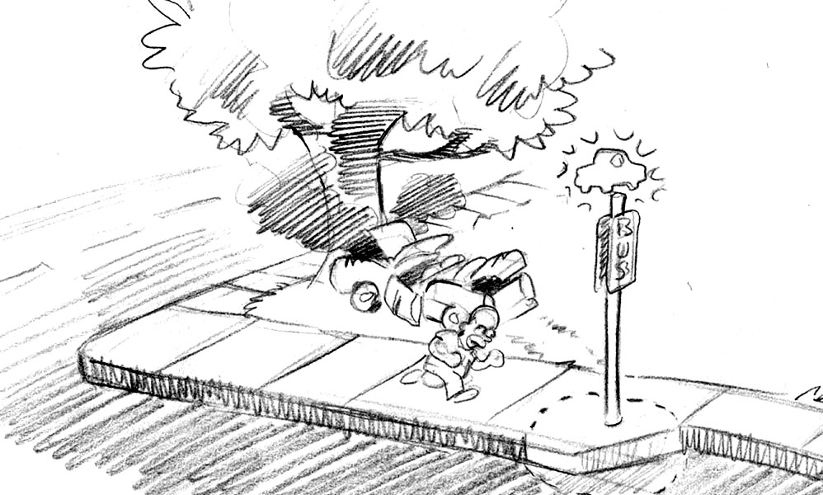
- When Mission requires use of a specific vehicle
- When specific vehicle confers an advantage in completing a specific mission

In order to activate a switch or trigger a specific mission
- Some mission triggers or switches can only be reached by foot (generally through simple jumping and timed obstacle puzzles)
- Some missions may only be triggered by being on foot (talking to a pedestrian, starting on a rooftop or interior location)
- In some cases it may be necessary to get out of the car mid mission in order to trigger a switch. The player must then get back in their vehicle quickly or switch to another vehicle.

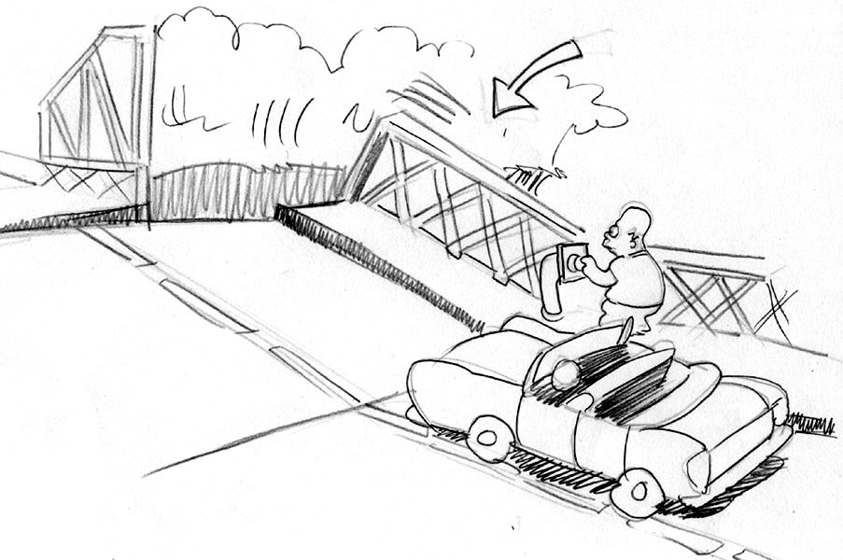
In order to find all the collectibles in the level: Mission based collectibles, Collector Cards, Turbo Power Ups (Food TBD), and surveillance cameras.

- Most collectibles can only be reached on foot
- Collectible Cards are optional: they are collected when the player is in between missions
- Food restores turbo power on foot and gives the player an extra reason to go inside.
- Cameras and power couplings can be destroyed by using the action button.

“Virtual Simpsons Episode” NIS Gags

In order to add to the feeling of playing an actual episode of the Simpsons, NIS gags will be used in all interiors. When the player enters a door from outside, control is briefly taken away in order to accommodate the camera cut. The interior is then loaded along with the NIS gag. There will be some interior specific gags (e.g. ones that happen only in Kwik-e-Mart), and some that can happen in any interior. These will be randomized and each time the player enters the interior they will see a different gag.

Kwik-E Mart Interior
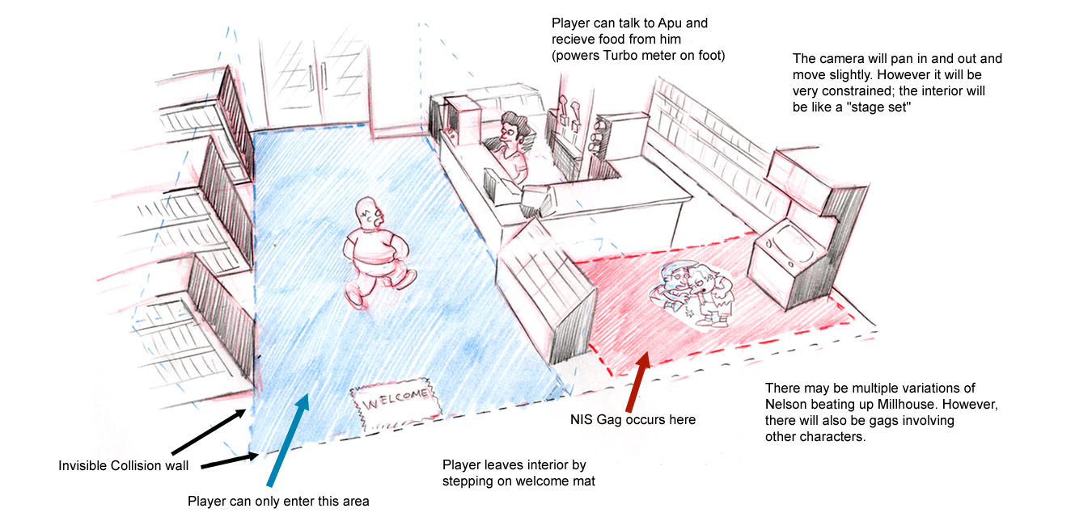

On foot Functionality

The three controls available to the player on foot are Turbo, Jump and Action.

Turbo
- By holding down the Turbo button, the player will run about twice as fast as normal speed.
- While Turbo is engaged, the Turbo Meter slowly drains. The player can’t engage turbo if the meter is empty
- The turbo meter is re-filled by collecting food (e.g. donuts, squishes, etc)
- The turbo can be completely re-charged by going into a generic interior (e.g. Krusty Burger) and getting food from the character behind the counter or from a vending machine.

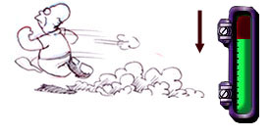

Jump

- Jump will be used for simple platforming and jumping puzzles. As there is no ledge hanging, jump distances will generally be short and penalties light (very little falling to death).
- When combined with the Turbo run, the player can perform a special Turbo-Jump long jump animation to travel extra far.
- The player can jump on special Springboards (e.g. Tires, awnings) to get an extra high bounce and reach otherwise inaccessible areas.
- If the character does fall into a death volume, they will be re-spawned instantly at a nearby point (locater)

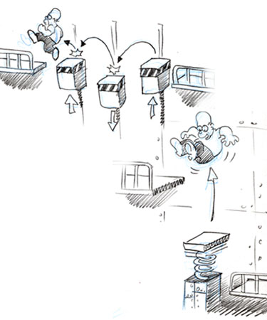

Action

- When in the car and stopped, the action button will get the player out of the car.
- When within range of a vehicle and on foot, the action button will get the player into the car. A button icon will appear over the object or character.
- The Action Button is also used for all On Foot World Interaction (covered on next page).

Action Button: On Foot World Interaction

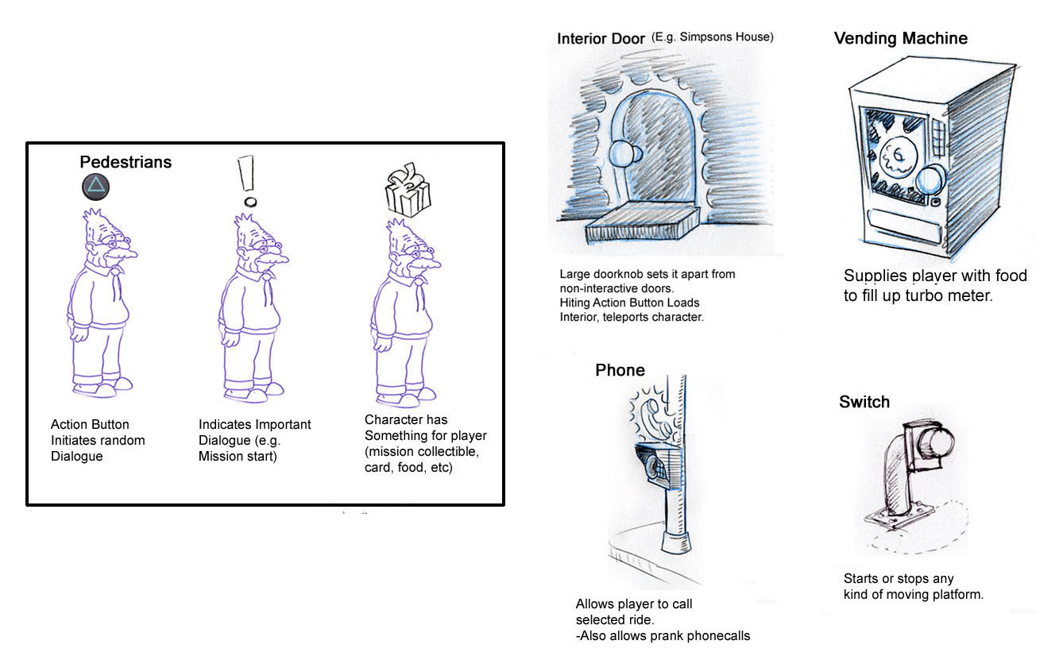
Collectibles

There are a number of different kinds of collectibles: Mission based, Food, Cameras, and Collector cards.

Mission Based collectibles are only loaded into the world when a mission is in play.
- May be collectible on foot, in car, or both.
- 3D modeled object in world. Disappears and is tallied on HUD when collected.
- Examples include Cough syrup to make flaming Moe’s, Firecrackers, Stuff Homer borrowed from Flanders, etc.
Food is present during missions and Sunday drive mode.
- Only collectible on foot.
- Powers Turbo (Sugar?) Meter On foot
- Once collected, re-spawns after a certain amount of time (total number of food collected never tallied)
- If turbo meter is full trigger different dialogue, no affect on gameplay
- Can also be collected from characters (Squeaky voiced teen, Apu) inside interiors (Kwik-E Mart, Krusty Burger) and outside from vending machines.
- Characters will have specific food: Donuts for Homer, Squishees for Bart, Veggie Burgers for Apu, etc.

Cameras (And Power Couplings)
Cameras and power couplings are unique in that they must be destroyed through a press of the action button (triggering a context sensitive animation)
- Power Couplings are a type of mission based collectible.
- Cameras are Sunday drive collectibles: they are always present in the world until destroyed. They don’t re-spawn.
- If the player destroys all the cameras in a level, the map will display where any remaining collector cards are. This enables us to be more devious in hiding collector cards (and makes them more special)
- If the player destroys all the cameras in the game, they may receive some sort of cheat (TBD)
- More alien-looking cameras may appear later in the game.
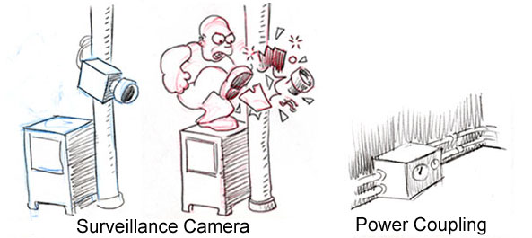

Collector Cards

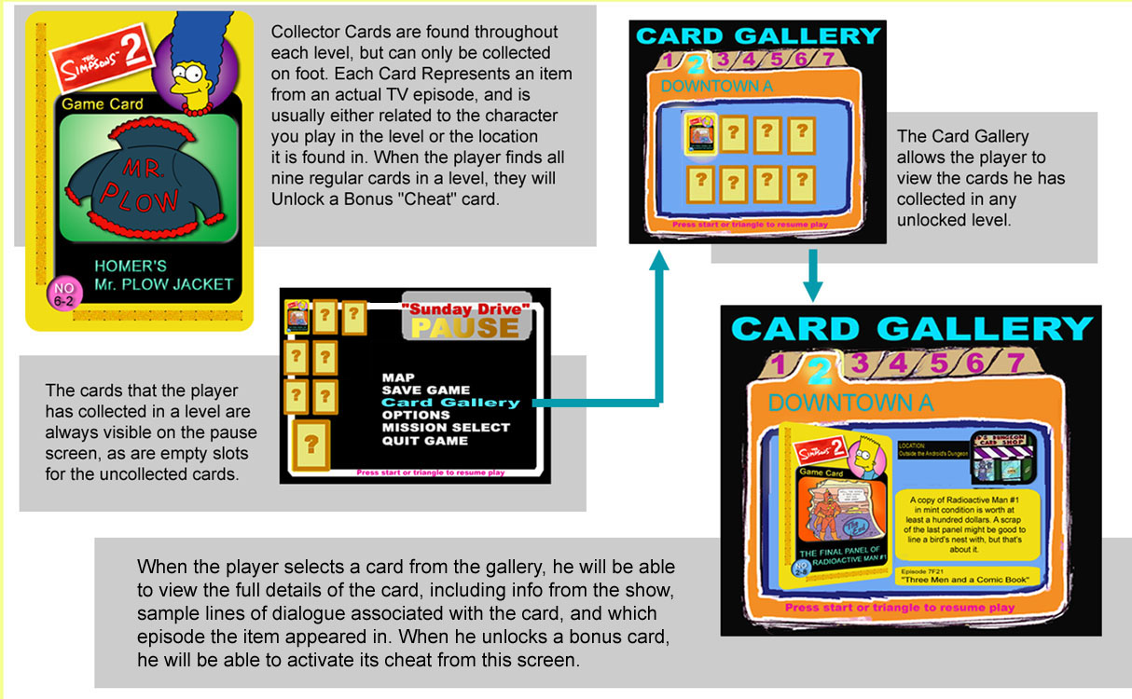

There are 7 Collector cards and 1 bonus card in each level.

Highlights

- Over 40 character-based driving missions in 7 massive levels

- Car chases with vehicle damage

- Play 5 different main characters

- Drive as 12 popular characters

- Simple Jumping and switch-based puzzles

- Interiors with interactive characters

- Animated Ambient Gag animations

- Interact with over 40 characters from the show

- Original dialogue from the Simpson’s voice actors

- Outsmart the Truckasaurus and other bosses

- Find all the authentic Simpson’s collectibles from your favorite episodes! 49 items including Mr. Sparkle, Homer’s Mr. Plow jacket, or a copy of Radioactive man #1

