Technical Design for Loading Manager

Revision History

Issue | Date | Person | Comment
0.1 | March 12, 2002 | Darwin Chau | Created
1.0 | April 14, 2002 | Darwin Chau | Reviewed by team and released

Description

Introduction
The Loading Manager serves as the central access point for retrieving data from the disc.
All game components will make loading requests via the Loading Manager with the exception of streamed data (e.g. music, movies, dialog). The Loading Manager will arbitrate between loading requests to eliminate contention for the disc.

Requirements
- The Loading Manager must support the following types of data:
  - Scrooby data
  - Scripts
  - NISes
  - Driveable vehicles
  - Traffic vehicles
  - Player characters - geometry / textures / animations
  - Non-player characters - geometry / textures / animations
  - Static world objects - geometry / textures / physics volumes
  - Dynamic world objects - geometry / textures / physics volumes
  - Animated world objects - geometry / textures / animations / physics volumes
  - Particle effects
  - Meta data: locators, trigger volumes
  - Meta data: roads, road segments, intersections
  - Meta data: world partition tree / grid, visibility
  - Camera configuration data
  - Sound effects

- The Loading Manager will NOT support loading streamed data (e.g. movies, music, dialog). Components that stream data require direct access to the disc and should not be routed through the Loading Manager.
- The design of the Loading Manager must not preclude the addition of dynamic loading at a later stage. Note: dynamic loading is not required at this time.
- The Loading Manager will support asynchronous mode loading.
- The Loading Manager will operate in a “batch” mode. Multiple load requests can be queued up prior to initiating the load.

References
- All programmers were consulted about the data they needed to load from disc.

Technical Design

Relationships

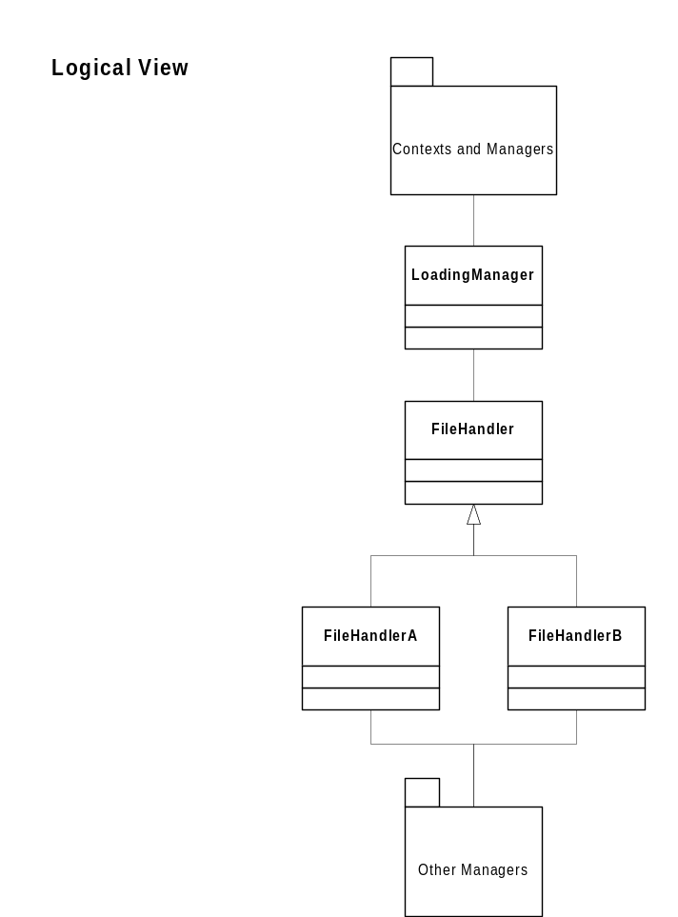

Loading Manager

The Loading Manager is able to provide service to any game component that needs it and the Loading Manager itself is not directly dependant on any other game components. The Loading Manager is able to avoid these dependencies by delegating the work of loading and processing the data to File Handlers.

File Handlers

File Handlers are a collection of utility classes that implement the custom behaviour needed to retrieve and process the various types of data from the disc. File Handlers are derived from an abstract base class and share a common interface.

Interface

The Loading Manager exposes the following public interface:

class LoadingManager : public FileHandler::LoadFileCallback
{
public:

// Static Methods for accessing this singleton.
static LoadingManager* GetInstance();
static void DestroyInstance();

bool AddRequest( FileHandlerEnum handlerType, const char* filename );

struct ProcessRequestsCallback
{
virtual void OnProcessRequestsComplete( void* pUserData ) = 0;
};

bool ProcessRequests( LoadingManager::ProcessRequestsCallback* pCallback,
void* pUserData = NULL );

// Implement FileHandler::LoadFileCallback interface.
virtual void OnLoadFileComplete( void* pUserData );
}

AddRequest

Signature:

bool LoadingManager::AddRequest( FileHandlerEnum handlerType,
const char* filename )
Description:

Clients use this method to submit a loading request. This request is not serviced immediately. The request remains queued until LoadingManager::ProcessRequests() is invoked.

Parameters:

handlerType – an enumeration is used to specify which file handler to use for loading and processing the data (the use of an enumeration keeps the clients of LoadingManager from being dependant on any FileHandler classes.

filename – full qualified path and name of file to load.

Returns:

true - on success
false - request queue is full or loading is in progress

ProcessRequests

Signature:

bool ProcessRequests
(
LoadingManager::ProcessRequestsCallback* pCallback,
void* pUserData = NULL
)

Description:

Start loading queued requests. All loading is done asynchronously so a callback must be provided to notify the client when loading is complete.

Parameters:

pCallback – client supplied callback to invoke when loading is complete.

pUserData – client can optionally provide user data to be passed back through callback.

Returns:

true - on success
false - loading is already in progress

Component Class Diagrams
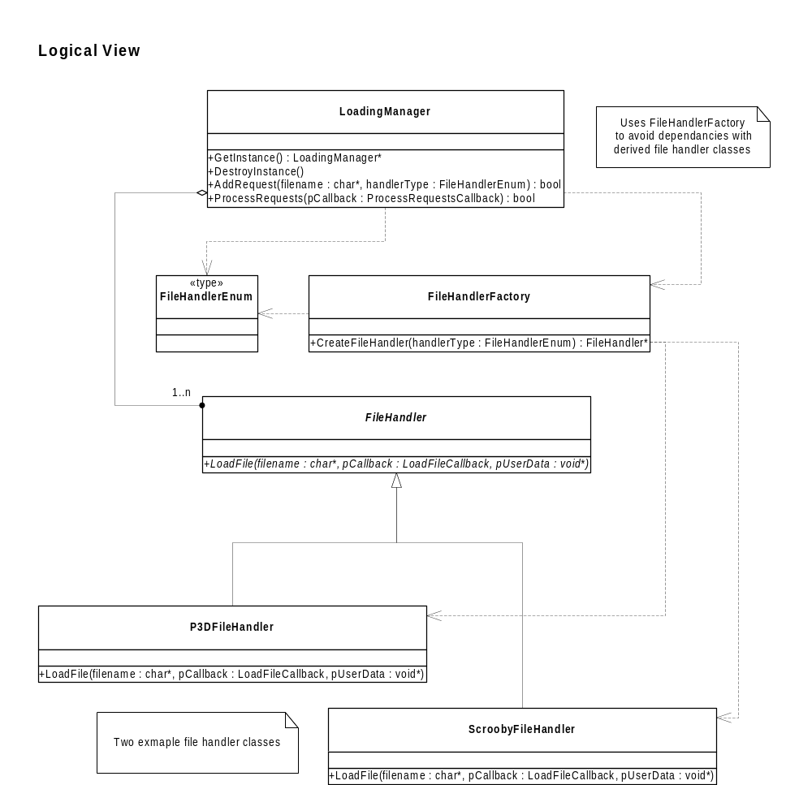

Use Cases
