Technical Design for ScriptManager

Revision History

Issue | Date | Person | Comment
0.1 | April 8, 2002 | Darwin Chau | Created
1.0 | April 12, 2002 | Darwin Chau | Reviewed by team and released

Description

Introduction
A simple scripting system will be integrated with the game to allow functions exposed by other game components to be invoked from a loaded script file or a remote command-line console. This functionality can be used to define mission parameters, tune behaviour at runtime, invoke debugging tools, etc.

Requirements

- The Script Manager will only be able to invoke functions exposed by other game components. The Script Manager will not support control flow, logical expressions or variable declarations.
- Other game components will expose functions by registering them with the Script Manager.
- The Script Manager will handle input in text format (text format script files and console command-line strings). Script files will not be compiled.
- In Debug configurations, the Script Manager will support remote communication using the text console provided by the FTech services.

References

- Talked to Joe and Shawn to get their mission scripting requirements.
- Talk to coders to get their requirements for debugging.
- Talked to Tinman in Mirth about their scripting tools.

Technical Design

Relationships
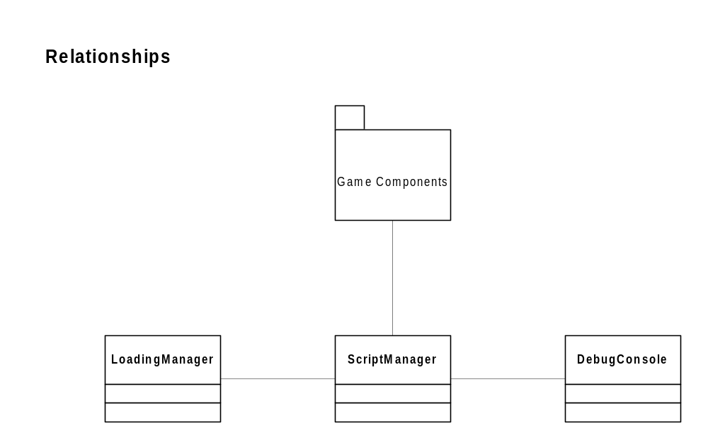

The Script Manager can be used by any game component that wants to expose a function to the scripting system. By registering a function with the Script Manager, a dependency is introduced since the Script Manager is then able to invoke the function at a later time.

The Script Manager uses the Loading Manager to load script files from the disc.

The Script Manager uses the Debug Console to retrieve script commands to execute at runtime.

Interface

The Script Manager exposes the following interface:

class ScriptManager
{
public:

// Static Methods for accessing this singleton.
static ScriptManager* GetInstance();
static void DestroyInstance();

typedef void (*SCRIPT_FUNCTION_PTR)(int argc, char **argv);

bool RegisterFunction( const char* alias,
SCRIPT_FUNCTION_PTR pFunction,
const char* helpString,
int minArgs, int maxArgs );

bool Evaluate( const char* string );
void ExecuteScript( const char* filename );
};

RegisterFunction

Signature:

bool RegisterFunction( const char* alias,
SCRIPT_FUNCTION_PTR pFunction,
int minArgs, int maxArgs,
const char* helpString
);
Description:

Clients use this method to register a function and its alias with the Script Manager. The function can now be invoked from a script file or the console command-line by referring to it using the alias string name.

Parameters:

alias – the string name used to invoke the function from script/command-line

pFunction – pointer to the C-style function the client is registering

minArgs – minimum number of arguments required for the function

maxArgs – maximum number of arguments allowed for the function

helpString – help string to display if number of arguments falls outside min/max.

Returns:

true - on success
false - failure

Evaluate

Signature:

bool Evaluate( const char* string );

Description:

Parses the string and invokes the registered function with the matching alias (if any).

Parameters:

string – contains the alias of the function to invoke and the parameters to pass it

Returns:

true - on success
false - failure

ExecuteScript

Signature:

void ExecuteScript( const char* filename );

Description:

Loads a script file from disc and calls Evaluate() on the contents.

Parameters:

filename – fully qualified path and name of file to load.

Returns:

N/A

Component Class Diagrams

The Script Manager simply consists of the ScriptManager class.

Use Cases

