Technical Design: Simpsons 2 Sound Component

Revision History

Issue | Date | Person | Reason
0.1 | Apr. 7, 2002 | Darren Esau | Initial draft
1.0 | Apr. 7, 2002 | Darren Esau | Reviewed by team and released

Table of Contents

Technical Design: Simpsons 2 Sound Component 1
Revision History 1
Table of Contents 2
1.0 Description 5
1.1 Introduction 5
1.2 Requirements 5
1.3 References 6
2.0 Technical Design 7
2.1 Relationships 7
2.2 Interface 7
2.3 Component Class Diagrams 8
2.3.1 Sound Rendering component 8
2.3.1.1 daSoundRenderingManager 9
2.3.1.2 daSoundResourceManager 9
2.3.1.3 daSoundDynaLoadManager 9
2.3.1.4 daSoundDynaLoadRegion 9
2.3.1.5 daSoundInteractiveMusicManager 10
2.3.1.6 daSoundTuner 10
2.3.1.7 daScriptLoader 10
2.3.2 Sound Resource Management 10
2.3.2.1 daSoundDebugSource 11
2.3.2.2 daSoundResourceDebugSource 12
2.3.2.3 radRefCount 12
2.3.2.4 IRadNameSpace 12
2.3.2.5 IDaSoundResource 12
2.3.2.6 IRadObjectBTree 12
2.3.2.7 daSoundAllocatedResource 12
2.3.3 Sound File Management 12
2.3.3.1 radLinkedClass 13
2.3.3.2 daSoundResourceData 13
2.3.3.3 daSoundFileInstance 14
2.3.3.4 IdaSoundFileInstance 14
2.3.3.5 IRadSoundFileDataSource 14
2.3.3.6 IRadSoundClip 14
2.3.3.7 IRadHalDataSource 14
2.3.4 Sound Tuner 14
2.3.4.1 daSoundTuner_ActiveFadeInfo 14
2.3.4.2 radObject 15
2.3.4.3 IRadSoundFade 15
2.3.4.4 IRadSoundMultiInputKnob 15
2.3.5 Sound Manager component 15
2.3.5.1 SoundManager 16
2.3.5.2 GlobalSoundTuningSettings 17
2.3.5.3 IGlobalSoundTuningSettings 17
2.3.5.4 MissionSoundMonitor 17
2.3.6 Loading System 17
2.3.6.1 EventListener 17
2.3.6.2 SoundLoader 17
2.3.6.3 SoundCluster 17
2.3.6.4 SoundClipCluster 18
2.3.6.5 SoundStreamCluster 18
2.3.7 Ambient Sound 19
2.3.7.1 AmbientSoundPlayer 19
2.3.7.2 SimpsonsSoundPlayer 19
2.3.7.3 AmbientSoundLocationData 20
2.3.7.4 VehiclePosition 20
2.3.8 NIS Sound 20
2.3.8.1 NISSoundPlayer 20
2.3.8.2 NISStateChangeCallback 20
2.3.9 Music System 21
2.3.9.1 MusicPlayer 21
2.3.9.2 PlayList 21
2.3.9.3 IPlayList 22
2.3.10 Avatar Sound System 22
2.3.10.1 AvatarSoundPlayer 22
2.3.10.2 VehicleSoundPlayer 23
2.3.10.3 VehicleSoundInfo 23
2.3.10.4 IVehicleSoundInfo 23
2.3.10.5 WalkerSoundPlayer 23
2.3.11 Sound Effect System 23
2.3.11.1 SoundEffectPlayer 24
2.3.11.2 SoundFXLogic 24
2.3.11.3 SoundFXFrontEndLogic 24
2.3.11.4 SoundFXGameplayLogic 25
2.3.11.5 SoundFXPauseLogic 25
2.3.12 Dialog System 25
2.3.12.1 DialogCoordinator 26
2.3.12.2 SpeechCoordinator 27
2.3.12.3 SelectableDialog 27
2.3.12.3 DialogSelectionGroup 27
2.3.12.4 PlayableDialog 27
2.3.12.5 DialogLine 27
2.3.12.6 Conversation 27
2.3.12.7 DialogPriorityQueue 27
2.3.12.8 ConeOfSilenceTracker 28
2.3.12.9 DeferredConversationList 28
2.4 Use Cases 29
2.4.1 Initialization 29
2.4.1.1 Script Loading 29
2.4.1.2 Loading System Initialization 29
2.4.1.3 Music Player Initialization 30
2.4.1.4 Dialog System Initialization 31
2.4.2 Front End 32
2.4.2.1 Front End Context Initialization 32
2.4.2.2 Menu Selection 32
2.4.3 NIS Sound 33
2.4.3.1 NIS Sound Playback 34
2.4.4 Pause Menu 34
2.4.4.1 Pause Game 34
2.4.5 Gameplay 35
2.4.5.1 Ambient Sound Trigger Volume Entered 35
2.4.5.2 Dialog Event Triggered 36
3.0 Bibliography 38

Description

This document provides a description of the Simpsons game sound component, what it is required to do, and a class-level design description.

Introduction

The sound component is comprised of the classes dedicated to creating sound for the game. This includes:
- Sound made by the car engine
- Dialogue between the drivers, passengers, and pedestrians
- Background music, both in game and front end
- Sound effects, such as collision noises or front-end noises
- Ambient world noises
- NIS sound

Requirements
Internal sound component requirements:
- Must make noises

Sound component interface requirements:

NIS Manager:
- Must provide a function to cue up an NIS sound stream
- Must provide a callback for when the sound stream is loaded and ready to go
- Must provide a callback for when playback is complete

Event Manager:
- Must be able to listen to world events
  - Required for triggering ambient sounds, responding to mission start/completion, changing sound settings when entering/exiting trigger volumes, etc.

Controller components:
- Must be able to signal changes in game state (e.g. lower volume when game is paused)

Camera Manager:
- Must be able to ask the camera for location, orientation and velocity
  - Required for proper playback of positional sounds

Avatar Manager:
- Must provide a reference to the user-controlled objects when asked.

Functionality that Ftech must provide:

RadSound:
- Clip/stream playback
- Basic controls:
  - Volume
  - Pan
  - Pitch
  - Stop playback
  - Looping
- Reverb
- Positional sound capabilities
  - Doppler
  - Volume/pan according to position
- Master volume

RadCore:
- File system for loading/streaming
- System for reading from cement files

RadScript
- Script loader for creating sound resource objects
- Runtime communication system for talking to RadTuner

References
Here’s a list of the guys I annoyed putting this document together.
- Marc Baril: everything sound design
- Tim Hinds: RadSound/hardware capabilities
- Devin: how to find world objects within earshot
- Joe: dialogue and car tuning requirements
- Cary: camera and trigger volume issues
- Greg: getting vehicle data

Technical Design

Relationships

The sound component consists of two sub-components itself: the Sound Manager and the Sound Rendering System. The Sound Manager is the sound code residing in the model layer, and the Sound Rendering System is the code in the View layer. See the software architecture document [1] for more detail on the layers.

The Sound Manager talks to the following components:
- Avatar Manager (get player-controlled walker/vehicle)
- NIS Manager (callback for NIS sound completion)
- Camera Manager (get camera data for positional sound)
- Sound Rendering System (to use lower-level sound playback capabilities)

The Sound Manager is called by the following components:
- Event Manager (provide sound events)
- NIS Manager (play NIS sound)
- Front End/Pause Menu/Game Settings (volume settings)

The Sound Rendering System talks to the following FTT libraries:
- RadSound (sound playback)
- RadScript (script loading/sound object creation)
- RadMusic (if we provide interactive music. Unknown at this point)

The Sound Rendering System is only called by one library. RadScript manipulates published objects to allow the designers to tune sound files.

Interface

The interface for the Sound Manager will look something like this:

class NISSoundPlaybackComplete
{
public:
NISSoundPlaybackComplete();
virtual ~NISSoundPlaybackComplete();

virtual OnNISSoundPlaybackComplete() = 0;
};

class SoundManager : public Manager
{
public:
SoundManager();
~SoundManager();

void Update();
void UpdateOncePerFrame();

bool PlayNISSound( NISIdentifier nisID,
NISSoundPlaybackComplete* playback = NULL );

void SetMusicVolume( SoundVolume volume );
void SetSoundFXVolume( SoundVolume volume );
void SetVoiceVolume( SoundVolume volume );
void SetStereoMode( bool stereoOn );

SoundVolume GetMusicVolume();
SoundVolume GetSoundFXVolume();
SoundVolume GetVoiceVolume();
bool GetStereoMode();
};

With these functions:
- the NIS Manager can start sound playback and be informed of when it completes
- the front end/pause menu can query and set the volumes
- the game settings can be queried and set for memory card loads and saves.

The Sound Rendering Manager does not need to provide an interface to non-sound components. It registers object factories with the RadScript library, which are then used to produce its low-level sound file objects.

Component Class Diagrams

2.3.1 Sound Rendering component

The Sound Rendering component has a high-level structure that looks something like the structure depicted in Figure 1. Note that classes in the Sound Rendering system have a “da” prefix on the class names---this stands for “digital audio”, and is used on classes which have been collected from other Radical projects. Some cleanup and restructuring is needed for the Simpsons project, though, since there’s a lot of dead code and unnecessary interfaces in its original form. This could potentially be replaced by the RadAudio library in development, although it probably won’t be completed in time to be useful for this game.
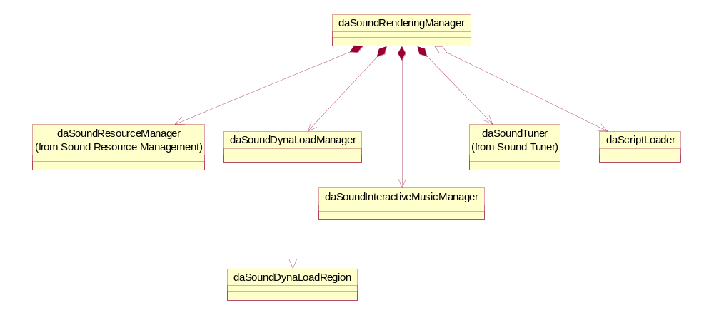
Figure 1- Sound Rendering system (high-level)

daSoundRenderingManager

This class is the first point of contact for the client classes in the Model layer. Its only real responsibility is to hold references to other, lower-level objects, and manage their lifetimes. Pointers to these objects are also passed to outside entities to provide specific interfaces to sound rendering functionality.

daSoundResourceManager

Maintains the list of allocated sound resources. This is discussed further in section 2.3.2.

daSoundDynaLoadManager

Manages the sound regions in console sound memory (SPU (PS2)/ARAM (NGC)/main RAM (Xbox)). The allocated resources ask this guy for a chunk of sound memory when allocation occurs, which then holds the sound data to be played.

daSoundDynaLoadRegion

Represents a chunk of sound memory. Created and handed off by the daSoundDynaLoadManager object. It divides the given sound memory into slots. Each of those slots can be used for a separate sound buffer. This is useful to avoid fragmenting the sound memory, which could potentially place the game in a situation where a clip or stream could not be played because unused contiguous memory of the required size does not exist.

daSoundInteractiveMusicManager

This class isn’t really fleshed out yet, because it’s currently unclear whether we’ll have interactive music at all, since interactive music and externally-composed tunes are apparently mutually exclusive. If we decide not to go with interactive music, this class and its children disappear.

daSoundTuner

Provides a master volume setting, as well as separate volume controls for various sound types (e.g. music, sound effects).

daScriptLoader

Created at boot time by the daSoundManager object, this class is responsible for the initial loading of RadScript files, which will create the inventory of sound resource objects for the game.

Sound Resource Management

This component is responsible for managing the allocation of sound resources at the lowest level. When a sound needs to be played, a resource allocation request is submitted to the daSoundResourceManager object, which delegates the opening of the sound file and preparation for playback.

The classes responsible for tracking sound resources have the structure depicted below in Figure 2.

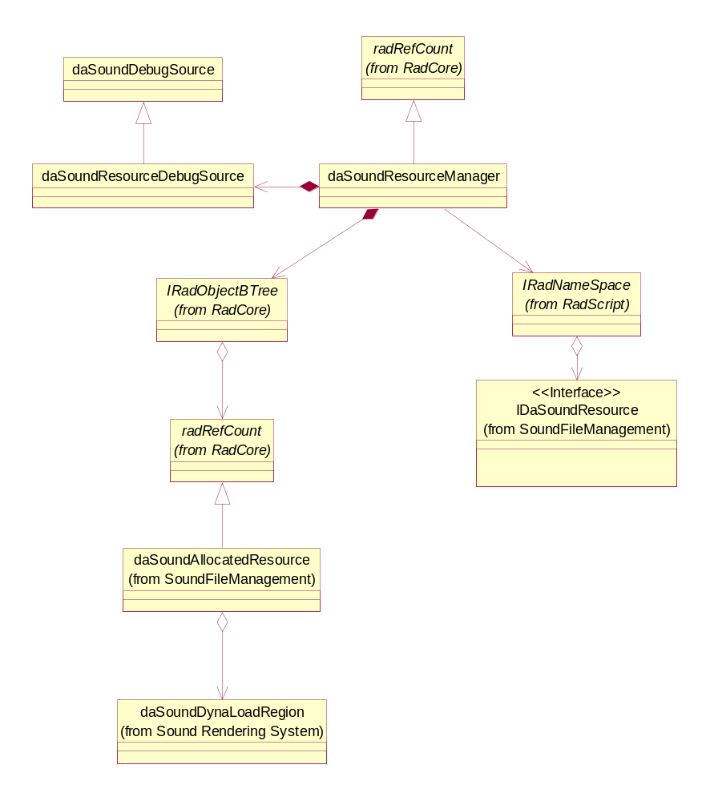
Figure 2 - Sound resource management

daSoundDebugSource

Base class that contains code for communicating with Simpsons debugging facilities. For example, it might talk to a debug menu component to display the list of allocated sound resources during gameplay.

daSoundResourceDebugSource

Subclass of daSoundDebugSource that stores statistics on sound resource allocation submitted to it by the daSoundResourceManager object.

radRefCount

FTT base class for reference counting functionality.

IRadNameSpace

FTT interface class for storing inventories. In this case, this refers to the link that the daSoundResourceManager keeps to the RadSound namespace, where the complete set of available sound resources are stored.

IDaSoundResource

Class for representing sound resources (i.e. individual sound clips/streams). This interface is also used by RadScript for creating the objects with parameters taken from script files and storing them in the RadSound audio namespace. More details on its usage are provided in section 2.3.3.

IRadObjectBTree

FTT base class for storing inherited objects in binary trees.

daSoundAllocatedResource

Takes a daSoundResourceData object, gets the filenames, and makes a bunch of SoundFileInstance objects from it, thus representing the allocated-and-ready-to-play sound. This class also grabs a reference to a memory region that the allocated sound will occupy.

Sound File Management

This component represents the set of sounds and sound files used by the system. The class structure is depicted in Figure 3 below.

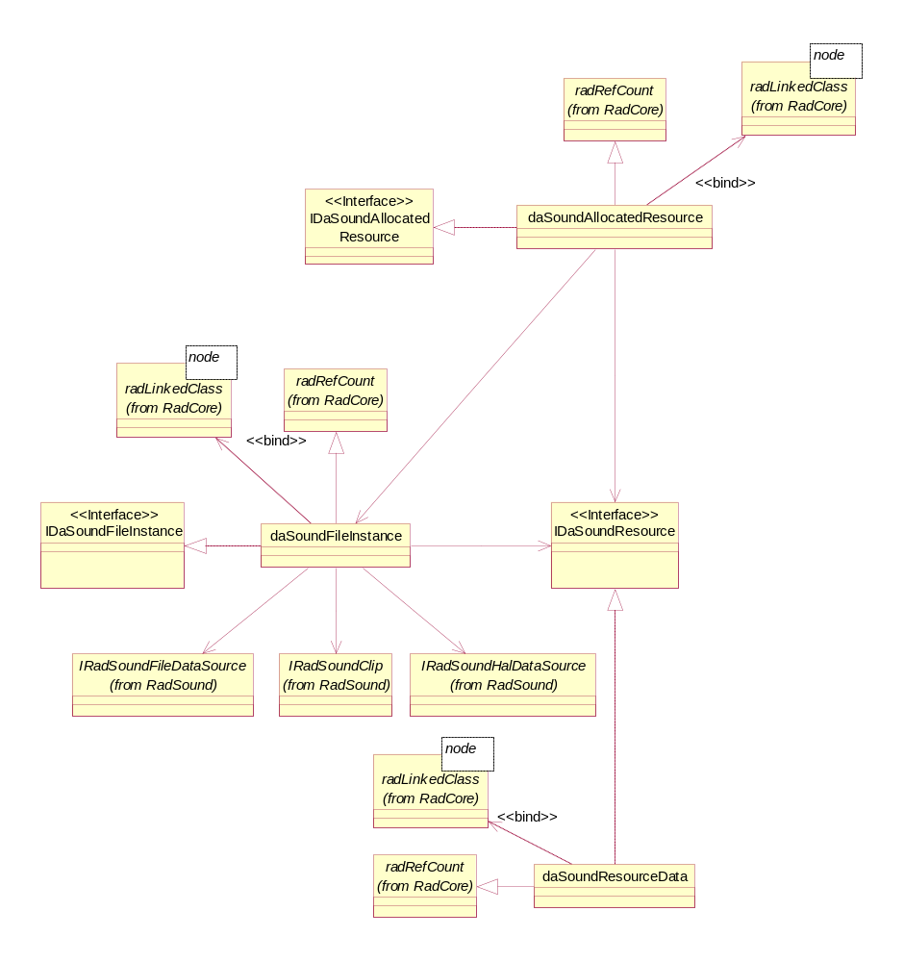
Figure 3 - Sound File Management

radLinkedClass

FTT base class for creating linked lists of objects. Uses C++ templates.

daSoundResourceData

Encapsulates a set of sound files. Contains some attributes associated with these files, like trim range (each file has individual trim, though), pitch range, streaming and looping flags, etc. It implements the IdaSoundResource interface, which is used by RadScript to generate daSoundResourceData objects from scripts.

daSoundFileInstance

Creates a RadSound clip or stream, and associates a daSoundResourceData object (representing a set of sound files) with it.

IdaSoundFileInstance

Interface for the daSoundFileInstance class. If I can be sure that RadScript doesn’t need it, though, I’ll probably remove it from the design.

IRadSoundFileDataSource

FTT class that reads data from a file without buffering.

IRadSoundClip

FTT class that represents playable sound which can be completely loaded into memory.

IRadHalDataSource

FTT class that is used to represent playable sound which is streamed in from CD/DVD.

Sound Tuner

Figure 4 below shows the class structure for the Sound Tuner subcomponent. This component provides the capability for changing sound volumes on groups of related clips and streams.

daSoundTuner_ActiveFadeInfo

Stores information about a fade in progress.

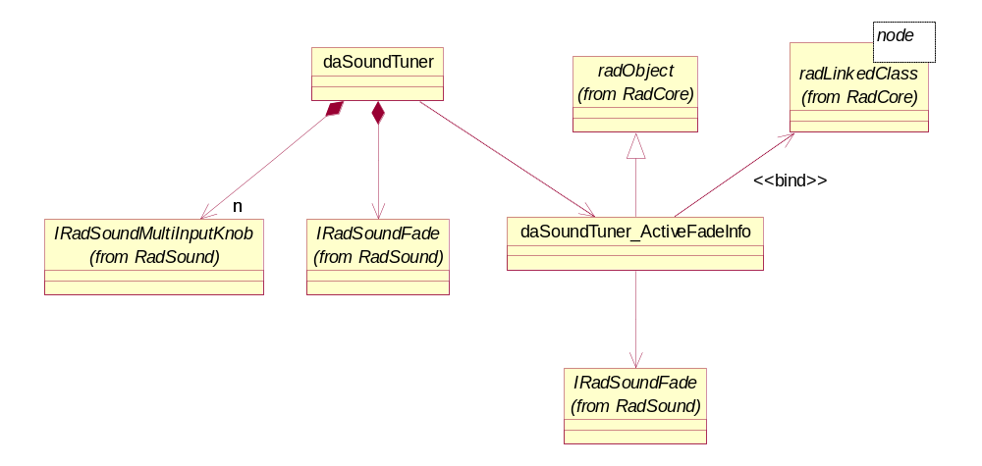
Figure 4 - Sound Tuner

radObject

FTT base class for providing allocation functionality.

IRadSoundFade

RadSound fader class.

IRadSoundMultiInputKnob

RadSound sound knob class that can be connected with other IRadSoundMultiInputKnob objects.

Sound Manager component

The Sound Manager component has a high-level class structure as depicted below in figure 5.

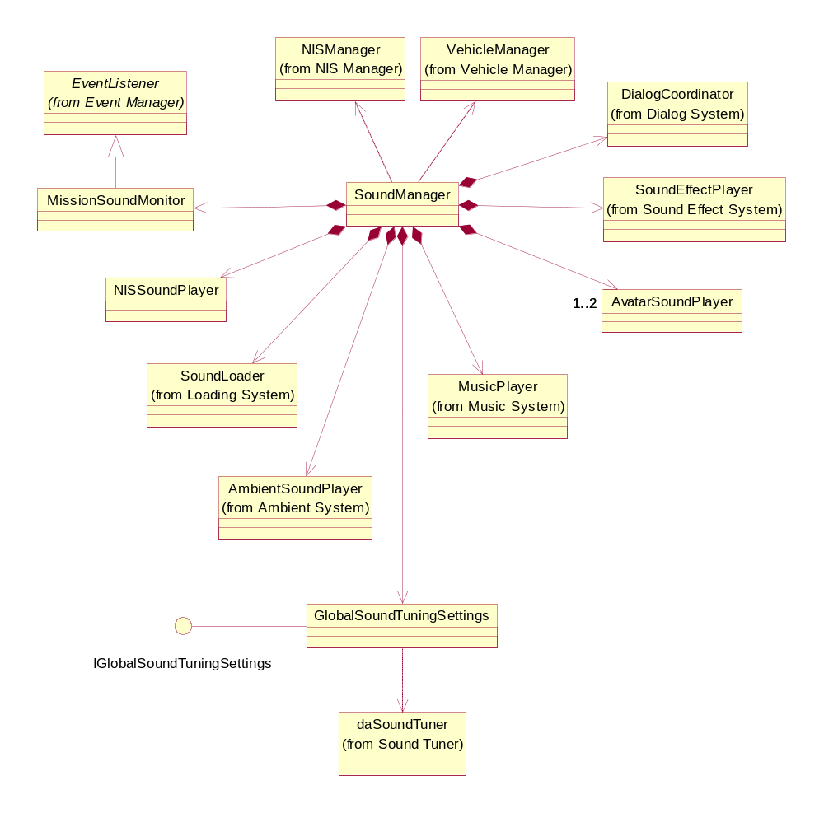
Figure 5 - Sound Manager high-level structure

As the class diagram shows, this component relies on a number of fairly independent subcomponents, each responsible for a particular type of sound. Each will have its own preallocated share of sound resources, such as players and sound memory. The SoundManager class itself handles responsibility for coordination between components, with some assistance from the MissionSoundMonitor object.

SoundManager

Manager interface that the other game components use to interact with sound. Creates and destroys sound subcomponents.

GlobalSoundTuningSettings

Provides master volume settings that can be adjusted by the sound designer. Interacts with the daSoundTuner class in the Sound Rendering system.

IGlobalSoundTuningSettings

Interface class for GlobalSoundTuningSettings. Required to expose the tuning functions for RadTuner.

MissionSoundMonitor

Listens for events generated by the Mission Manager component, and passes directives on to other Sound Manager subcomponents. This may not be a necessary class, though, and will get folded into SoundManager if it isn’t pulling its weight.

The remaining classes depicted above are described in separate sections below.

Loading System

The loading system class structure is depicted in Figure 6 below.

EventListener

Base class inherited by classes that want to provide an interface to the EventManager class that allows them to be informed of the triggering of game events.

SoundLoader

Provides services for allocating sets of sound resources and making them ready for playback. The SoundLoader class keeps ownership of the list of SoundCluster objects, and passes references out to requesting components.

SoundCluster

Encapsulates a set of sound resources to be allocated and loaded into sound memory. The sounds comprising a cluster may be grouped by game state (e.g. front-end sound effects), by level (e.g. Evergreen Terrace ambient sounds), or by mission (e.g. dialog written for a particular mission). This is an abstract base class, since the cluster will behave differently for clips and streams.

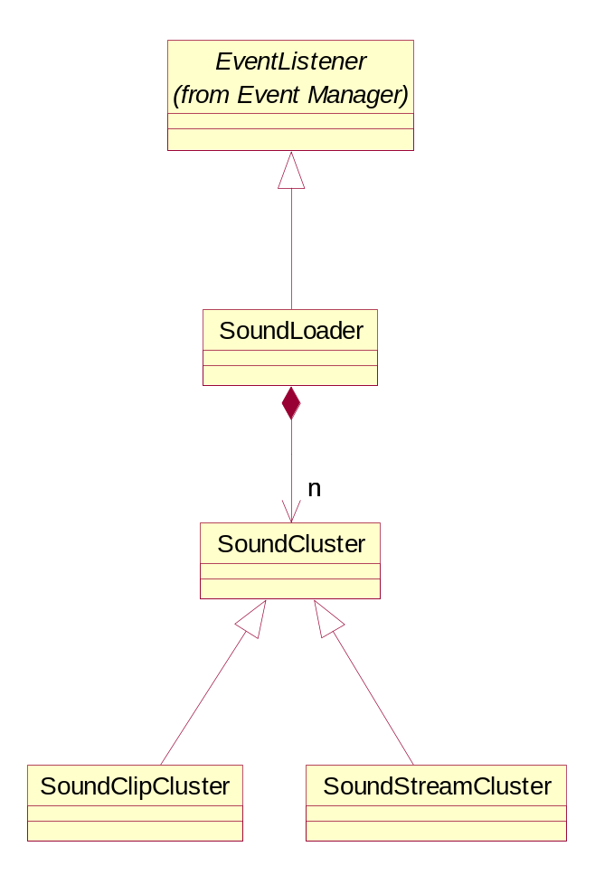
Figure 6 - Loading System

SoundClipCluster

SoundCluster subclass that contains code for dealing with the allocation and loading of clips.

SoundStreamCluster

SoundCluster subclass that contains code for dealing with the allocation and loading of streamed sounds.

Ambient Sound

The ambient sound subcomponent class structure is depicted in Figure x.

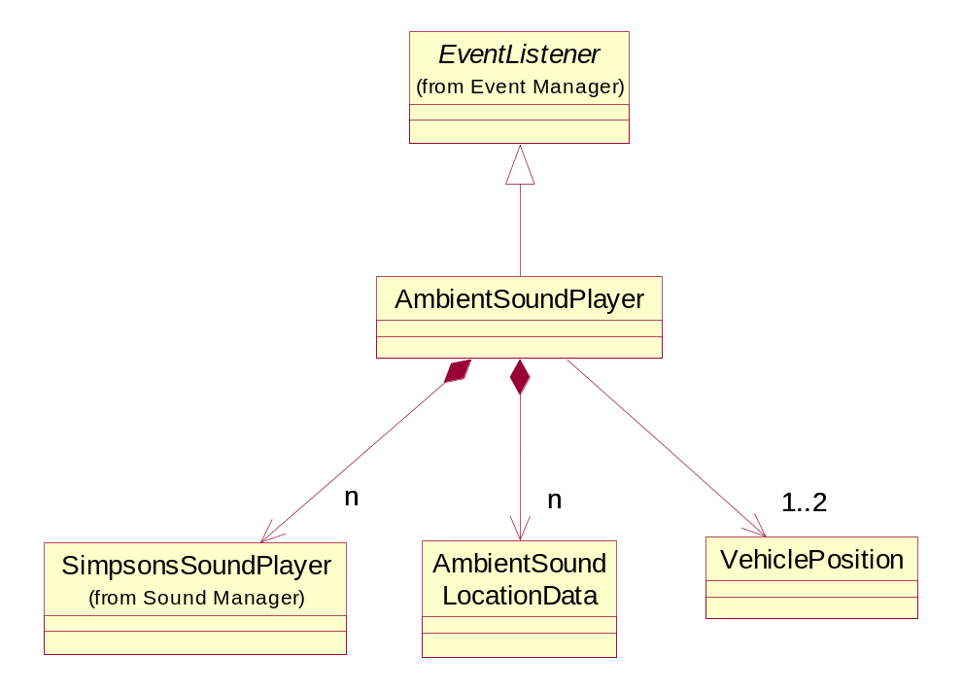
Figure 7 - Ambient Sound

AmbientSoundPlayer

Class responsible for timings of ambient sound playback. Maintains a list of ambient sound sets, determines when the player avatar is within earshot and when the timing is appropriate, and starts playback.

SimpsonsSoundPlayer

Basic sound player class for the Sound Manager component. This class talks to the Sound Rendering Layer and gets sound players, starts the noise, and tracks the number of outstanding players and tries to ensure that we don't overrun our platform voice capabilities. Doing this through one class instead of having each subcomponent talk to the Sound Rendering component directly should save a fair amount of duplicated code.

AmbientSoundLocationData

Contains the location information for a set of ambient sounds meant to be loaded in sound memory at one time. These objects should have a one-to-one relationship with the sound clusters in the sound loader subcomponent. The objects will have links to each other to allow easy navigation between adjacent world zones.

VehiclePosition

Tracks vehicle position from frame to frame. Required for positional sound and proximity detection for ambient sounds and pedestrian/passenger dialog.

NIS Sound

The NIS Sound subcomponent class structure is as follows:

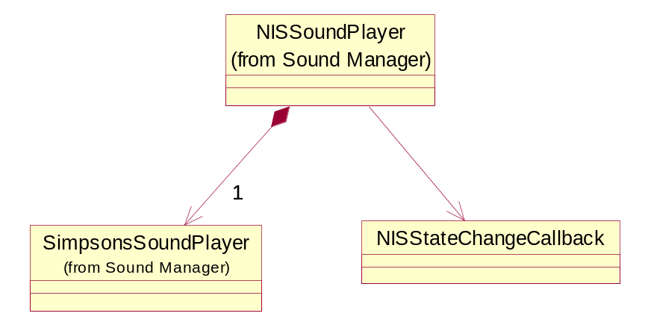
Figure 8 - NIS Sound

NISSoundPlayer

Class responsible for NIS sound playback.

NISStateChangeCallback

Callback interface abstract base class. Used to give the NISSoundPlayer an interface for informing another object of when NIS sound playback is starting and when it is complete.

Music System

See Figure 9 for class structure.
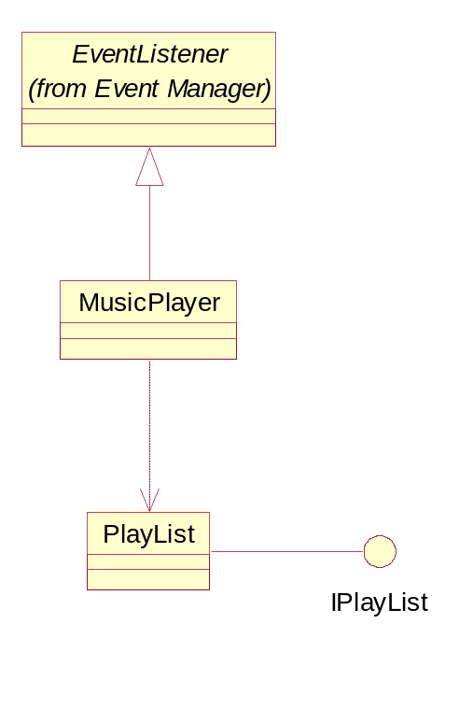
Figure 9 - Music System

MusicPlayer

Responsible for playing background music in the game.

Right now, I've got this as an EventListener subclass on the assumption that this might be expanded to handle interactive music. If not, then the base class may not be needed.

PlayList

List of songs to play. Multiple sets are required since the song set might vary by level or character.

IPlayList

Interface for PlayList class. Required by RadScript.

Avatar Sound System

The class structure is depicted in Figure 10 below:

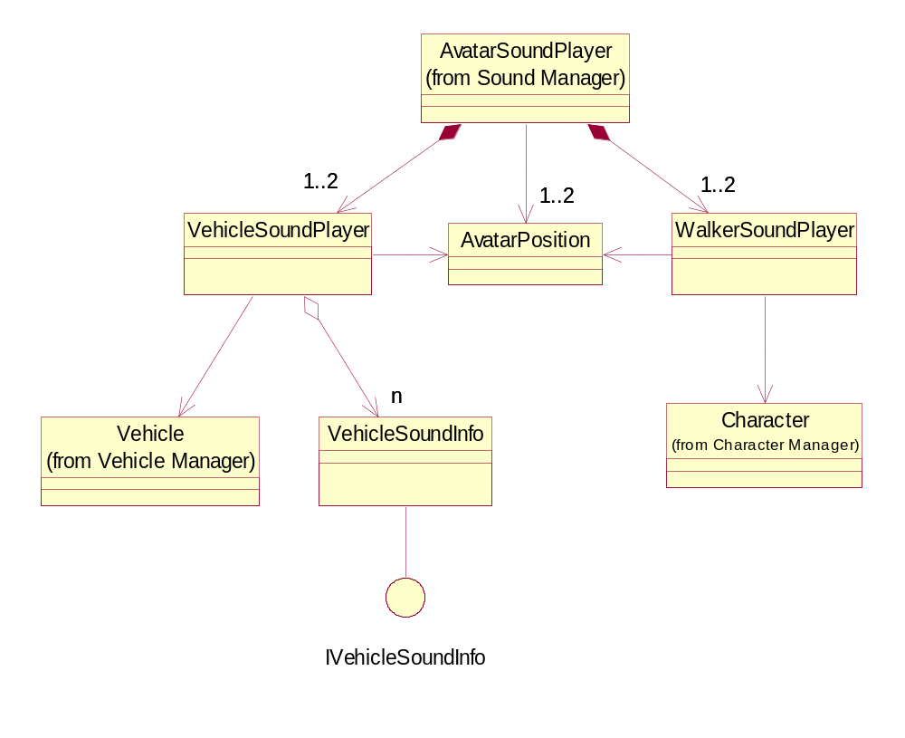
Figure 10 - Car Sound System

AvatarSoundPlayer

Class that plays the sounds associated with the user-controlled entity, be it a vehicle or a character walking around. It contains classes that can play sound for vehicles and walkers, and switches control between them when the player gets in and out of the cars. It also tells the AvatarPosition objects to update themselves with current avatar locations, which other subcomponents use for positional sound and determination of when sound clusters need to be loaded.

VehicleSoundPlayer

Class that keeps the car engine sounds playing. It talks to the Vehicle class taken from the player avatar to monitor engine characteristics, such as RPM. It also keeps a pointer to a VehicleSoundInfo object that owns the vehicle sound tuning characteristics.

VehicleSoundInfo

Vehicle tuning characteristic class. The characteristics are stored in RadScript files, so the objects themselves are created by RadScript and obtained by the VehicleSoundPlayer object when needed.

IVehicleSoundInfo

Interface for the VehicleSoundInfo class. Required by RadScript.

WalkerSoundPlayer

Class that plays sounds associated with the user-controlled character walking around in the game (e.g. footfalls). It talks to the Character class (name subject to change) to get information about the walker.

Sound Effect System

Class structure is depicted in figure 11 below.

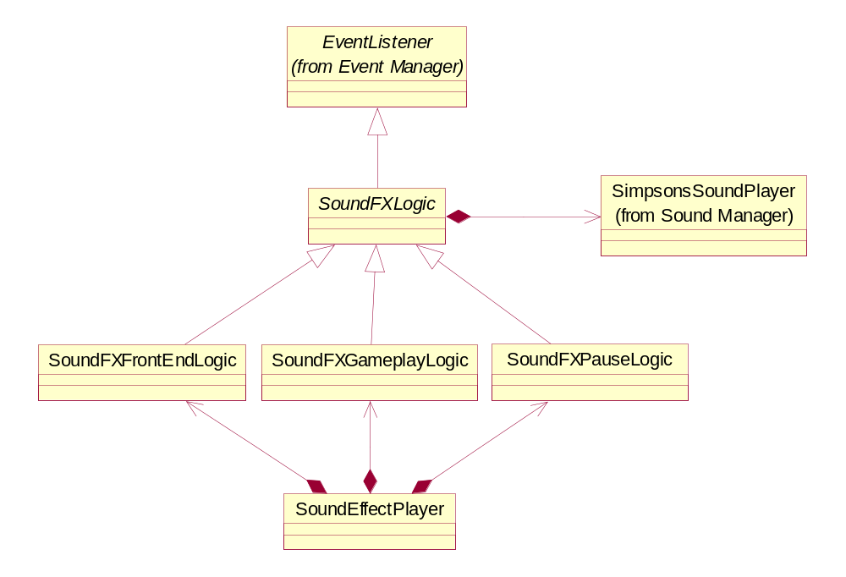
Figure 11 - Sound Effect System

SoundEffectPlayer

This is a fairly light class, since I expect a lot of differentiation in sound effect logic between game modes. It contains a set of logic objects, one of which is used in any given game mode, and is responsible for making the appropriate object active.

SoundFXLogic

Abstract base class for sound effect game mode logic. Contains the basic structure for listening for game events that would trigger sounds (which is why it inherits from EventListener) and for sound playback (which is why it owns SimpsonsSoundPlayer objects).

SoundFXFrontEndLogic

SoundFXLogic subclass with logic specific to front-end sound effects.

SoundFXGameplayLogic

SoundFXLogic subclass with logic specific to gameplay sound effects.

SoundFXPauseLogic

SoundFXLogic subclass with logic specific to pause-menu sound effects.

Dialog System

The class structure for the dialog system is as follows:

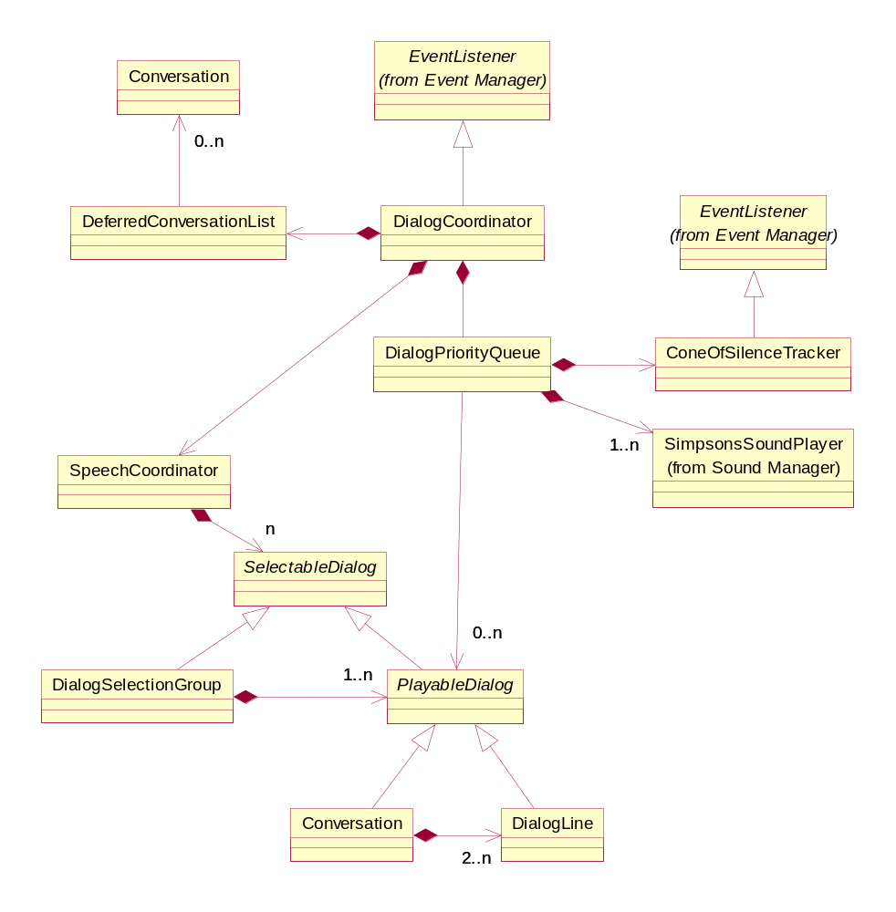
Figure 12 - Dialog System

DialogCoordinator

The main interface class for the dialog system. It listens for game events and cues the appropriate line of dialog. Objects representing lines or sets of lines are obtained from the SpeechCoordinator, and are passed to the DialogPriorityQueue, which determines when playback is ready to begin.

SpeechCoordinator

Maintains the list of dialog lines and conversations. Responsible for assembling the list, and creating the DialogLine and Conversation objects when directed by the game context.

SelectableDialog

Abstract base class for groups of one or more lines of dialog, any of which can be selected randomly in response to a single sound event.

DialogSelectionGroup

Represents a set of dialog lines or conversations that can be randomly selected without affecting gameplay. For example, if Homer had three generic lines for playback whenever he is hit by a car, and all three can be substituted for each other freely, then those lines would be grouped by a DialogSelectionGroup object.

PlayableDialog

Abstract base class for the basic unit of dialog playback. A PlayableDialog object represents a piece of dialog which is to be played without interruption (unless it gets booted by a higher-priority PlayableDialog).

DialogLine

Atomic unit of dialog. A DialogLine object represents a complete line of dialog spoken by a single character.

Conversation

Conversation objects aggregate groups of DialogLine objects which are intended to be played without interruption, like a conversation. Hence the name.

DialogPriorityQueue

Responsible for managing the outstanding dialog playback requests. When the DialogCoordinator needs to play dialog, it hands the PlayableDialog object off, and the DialogPriorityQueue determines if it can be played, or if it should wait until some other dialog completes. When a PlayableDialog is ready for playback, it gets handed to the SimpsonsSoundPlayer.

ConeOfSilenceTracker

The logic component that tries to keep low-priority dialog from playing when higher-priority dialog is forthcoming. I suspect this will be a bit of a grab-bag of heuristics and trigger volumes. For example, we may want to stifle dialog in a timed mission with less than three seconds left, so that we’ll be free to play a mission-ending line without waiting or cutting off the lower-priority line. In an A->B mission, we might put a trigger volume around the destination instead. It depends on what kind of missions we have.

DeferredConversationList

Contains a set of Conversation objects that we might want to give priority in selection at a later point. For example, if we select a particular mission-start conversation from a set of possibilities, it might have a matching mission-end conversation we’d want to play later. That mission-end conversation would be placed in this list, and would be searched for by the DialogCoordinator when the mission-end event is received.

Use Cases

Initialization

The following sequence diagrams explain some of the less trivial sound initialization scenarios.

Script Loading

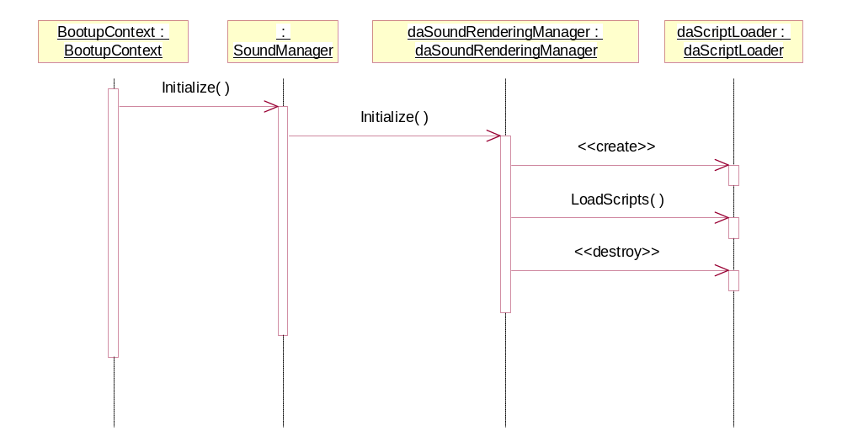

When the bootup context directs the sound to initialize at the start of the game, the sound manager will pass on the directive to the Sound Rendering component. The daSoundRenderingManager then creates a daScriptLoader object, which will load RadScript files to create:
- all of the sound resource objects
- car sound tuning parameter objects
- music playlists
- global sound tuning settings

Loading System Initialization

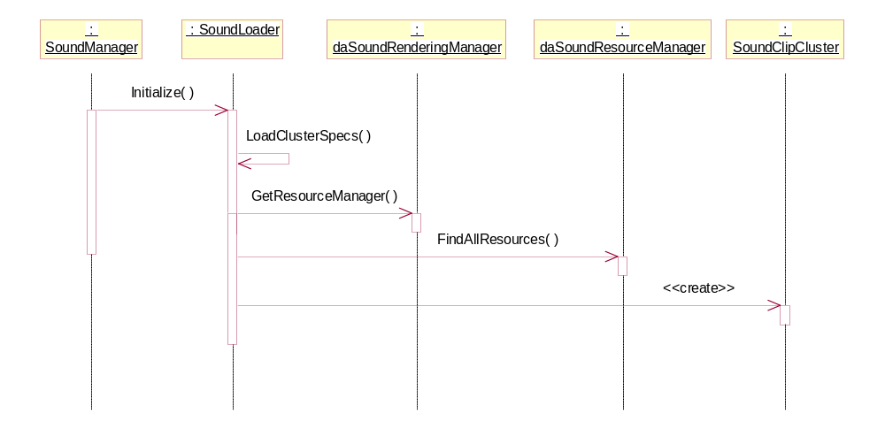

On initialization, the Sound Loader gets the resource manager and searches through the resources, creating clip and stream clusters from them (only clip clusters are shown in the diagram).

Currently, I’m going to assume that the clusters can be formulated strictly based on the naming convention in the sound files. If that proves insufficient, then there may need to be some notion of a cluster specification file that is loaded. That would be done in LoadClusterSpecs() above. Interaction with the Loading Manager is omitted for now, but SoundLoader will need to implement an asynchronous callback as well.

Music Player Initialization

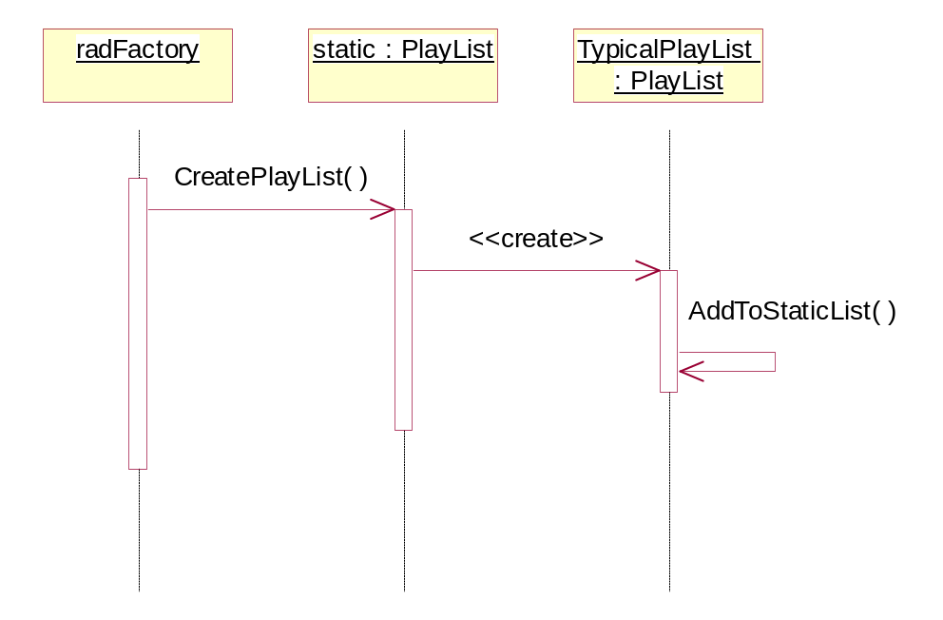

The PlayList objects used by the MusicPlayer object are created using RadScript files. Each created PlayList then adds itself to a static list of PlayLists. The MusicPlayer can then get that static list to find the particular PlayList that it’s interested in later on.

Dialog System Initialization

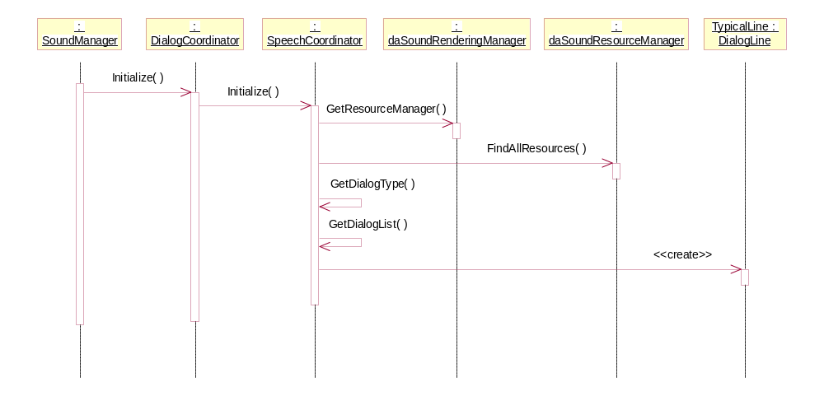

When the DialogCoordinator object is initialized, it passes the message on to the SpeechCoordinator, which looks through all the resources and assembles a list of dialog objects. Each object is a SelectableDialog object, which can be a single line of dialog, a conversation, or a set of single lines and/or conversations. Each SelectableDialog is a set of one or more mutually exclusive dialog playables, one of which is randomly selected when the associated event comes in. The SpeechCoordinator reads through the list of sound resources one line at a time. If it finds a line which matches another line associated with a particular event as a conversation, it assembles a Conversation object. If it adds one to an event and one DialogLine or Conversation object already exists for that event, it groups them together as a DialogSelectionGroup.

The big question right now is how this will perform at runtime. If this matching process adds undue hardship to the startup loading times, the processing could be cut up and run within the front end, or it may have to be moved to an offline process.

Front End

The following sequence diagrams describe scenarios that occur within the front end context.

2.4.2.1 Front End Context Initialization

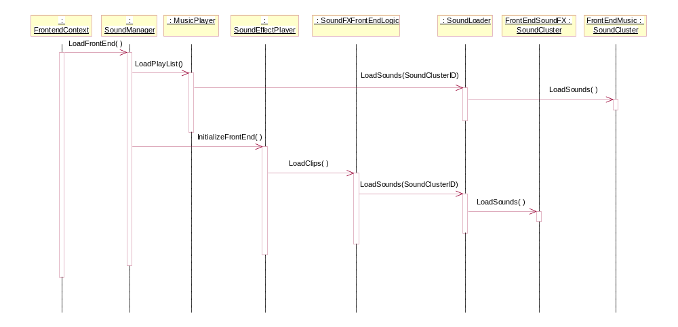

A fairly straightforward scenario. When the front end context begins, the Sound Manager is notified, and passes the context switch on to the MusicPlayer and SoundEffectPlayer. Both of these subcomponents tell the SoundLoader to prepare their streams/clips.

Menu Selection

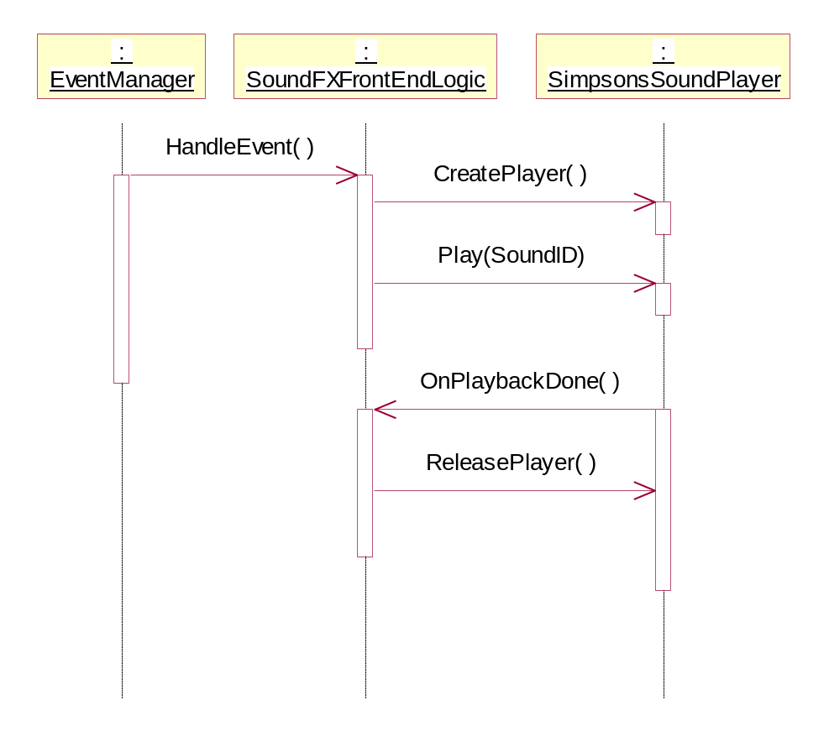

Fairly straightforward. When the user does something in the front end that calls for a sound effect, like a menu selection, the GUI code throws an event. In the sound effect system, the SoundFXFrontEndLogic system will have been activated by the SoundEffectPlayer, so it will be listening for the event, and will call the SimpsonsSoundPlayer to play the sound effect when it occurs. It calls CreatePlayer() to capture the low-level sound player, and Play() to start playing the sound, with an ID to identify which sound to play. Somewhere down the line, the playback completes, and SimpsonsSoundPlayer triggers a callback which allows the SoundFXFrontEndLogic object to release the player.

NIS Sound

NIS Sound Playback
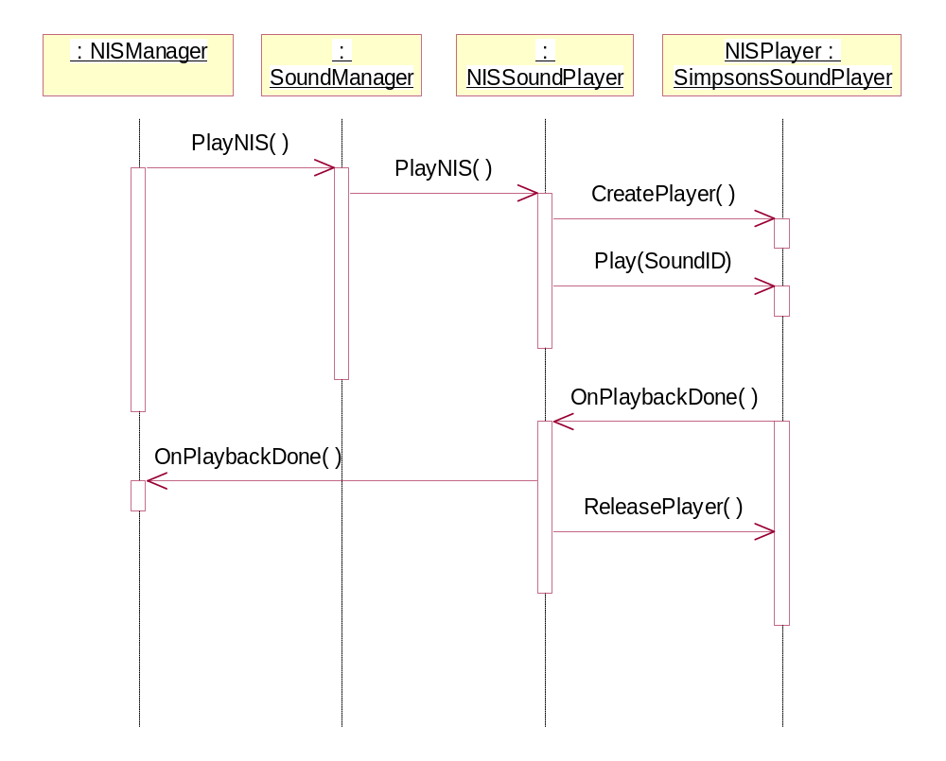

It’s expected right now that the NIS Manager will call the SoundManager object directly. This could easily be changed to an event-based scheme. When the SoundManager gets the call, it signals the NISSoundPlayer to start playing, which it does with another SimpsonsSoundPlayer object. The difference between this and the sound effect example above is that the NISSoundPlayer must notify the NISManager when playback is complete. This will probably be done through an inherited interface made available in soundmanager.hpp.

Pause Menu

Pause Game

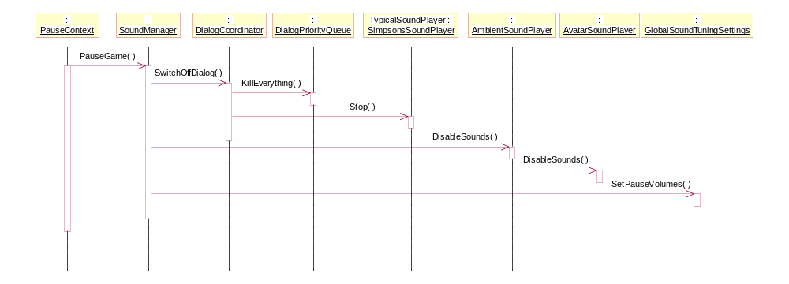

As the diagram above shows, when the pause context becomes active, the dialog currently playing needs to be killed, ambient and avatar sounds need to be turned off, and the global volume settings are turned down to a level suitable for pause mode. When the game is unpaused, ambient and avatar sounds are re-enabled and the regular game volume is reinstated.

Gameplay

Ambient Sound Trigger Volume Entered

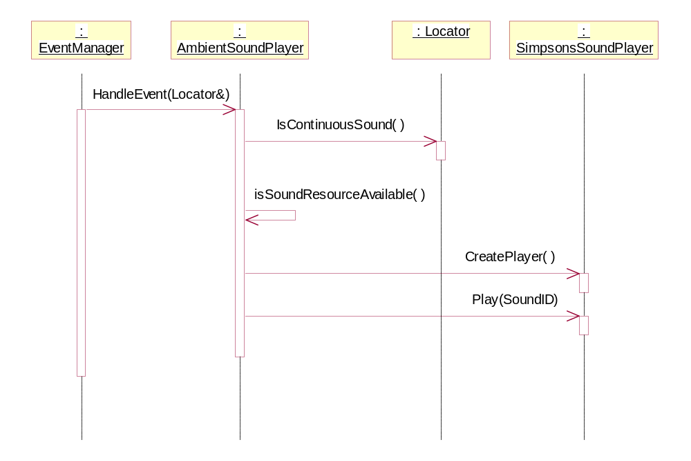
When the avatar enters a trigger volume associated with an ambient sound (represented with a locator), the Trigger Event Manager informs the sound component by sending an event. This event is picked up by the AmbientSoundPlayer object, which first asks the locator if the sound is continuous or a one-shot playback. Assuming that the sound is continuous for this scenario, the AmbientSoundPlayer then ensure that sufficient resources are free to play the sound. I’m assuming for now that we shouldn’t run out, but I may need to implement a queue if this assumption is invalid. After that, the sound is played through a SimpsonsSoundPlayer object. If this had been a one-shot sound, then a callback would be registered to mark the resource as free when playback completes, but for this scenario, that occurs when the trigger volume signals an exit.

Dialog Event Triggered

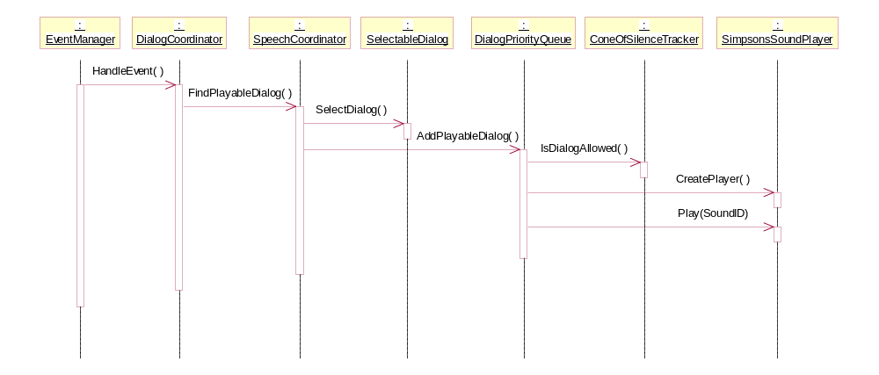

This scenario occurs when the EventManager sends an event which the DialogCoordinator is interested in. It first goes to the SpeechCoordinator to obtain a dialog to play. In this diagram, we assume that this returns a SelectableDialog object, in which case we call on it to return a PlayableDialog which is randomly selected. That object is passed into the DialogPriorityQueue. Assuming that no higher-priority dialog is being played, it first refers to the ConeOfSilenceManager to ensure that we’re not expecting a high-priority line to be played soon. If not, then the dialog is played through a SimpsonsSoundPlayer object.

Bibliography

[1] Software Architecture document, /documents/technical/design/softwarearchitecture.doc in Perforce.

