Revision History
Issue | Date | Person | Reason/Description
0.1 | Feb. 19, 2002 | Darren Esau | Initial draft of document.
0.2 | Mar. 7, 2002 | Darren Esau | Revised after review by Marc Baril
1.0 | Apr. 12, 2002 | Darren Esau | Reviewed by team and released

Table of Contents
1. Introduction 3
1.1 Scope 3
1.2 Goals/Objectives 3
1.3 Audience 3
1.4 References 3

Introduction
This document describes the sound pipeline that we intend to use for the upcoming Simpsons game, based on what we currently know of the sound design. It is intended to describe:
- The build process that converts raw sound files into a format suitable for the runtime sound code
- The tools that perform this conversion
- The tools that allow the sound designer to tune sound settings in the game
- The parameters that will be made available for tuning

Scope
The scope of this document is the sound pipeline as it applies to our game. Any components that can be found in documents elsewhere (or should be found elsewhere) are not described in detail here (e.g. RadTuner).

Goals/Objectives
The goals of this document are to clarify in my own mind what our pipeline requirements are for the game so that we can get everything pipeline going early on in the project, and so that any misconceptions I might have will be clarified right away.

Audience
This document is intended for any sound designers and programmers interested in how to make sounds in our game.

References
N/A

Pipeline Philosophy
As with all pipelines, my ultimate goal is to minimize pain for all participants in the game-development process. I have the following sub-goals in hopes of achieving this:
- The pipeline and sound code should be formed so that the game is stable. Once the game and the sound files are built, nothing should break after startup for a lack of resources. If a particular sound file is missing, it should be handled gracefully. If that doesn’t happen for some reason, then sound should be something you can turn off, so the command-line mute option should always work.
- The pipeline should inconvenience as few people as possible. Toward this end, I’m thinking that the sound build will be separate from the art pipeline and the code compilation process. Fully formed sound files should always exist in the CD directory for the various platforms. Anyone who wants to change the sound in the game is responsible for replacing those files.
- Everything you need to make sound should exist in Perforce---source sound, pipeline and tuning tools, makefiles, etc. Nobody should need to scour T: drive to rebuild sound. Therefore, everyone who needs to build sound should have Perforce access, and everyone who doesn’t care about sound should be given direction on how to change their client view to keep that stuff off their hard drives. This doesn’t require that intermediate pipeline files have to be in Perforce, however, just the minimal set required to do the complete build.
- The build environment should be self-contained, so that nobody should have to set environment variables to make the build work. Anyone who is up-to-date on Perforce should be able to use the same command as anyone else, and it should just go.

Sound File Processing
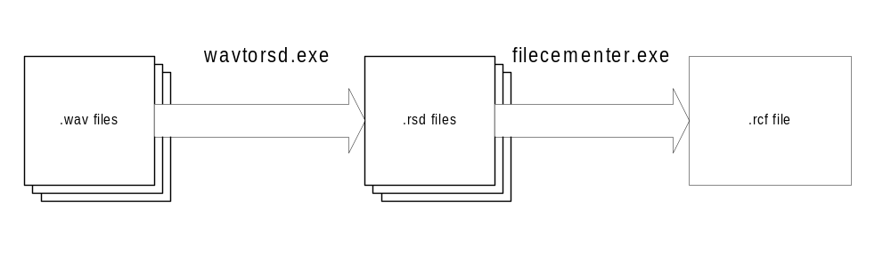The conversion of the raw sound files into a format suitable for the game is depicted below:

wavtorsd
This tool currently exists in radsound/tools/bin, and it converts .wav source files into the .rsd format used by RadSound (Note: this seems to be a header placed on top of whatever format is suitable for the platform in question; VAG for PS2, and some isotope of ADPCM for Xbox and GC. If you look at the binary contents, you might be able to deduce which is which from the text at the beginning of the file.)

filecementer
The file-cementing tool sits in radcore/bin, and it does everything needed to put RadCore cement files together and take them apart again. It’s useful for not cluttering the CD with many many files. Ideally, this should be an optional step for development, to make it easier to replace files on the fly, but it’s required for the production version.

Car Sound Pipeline
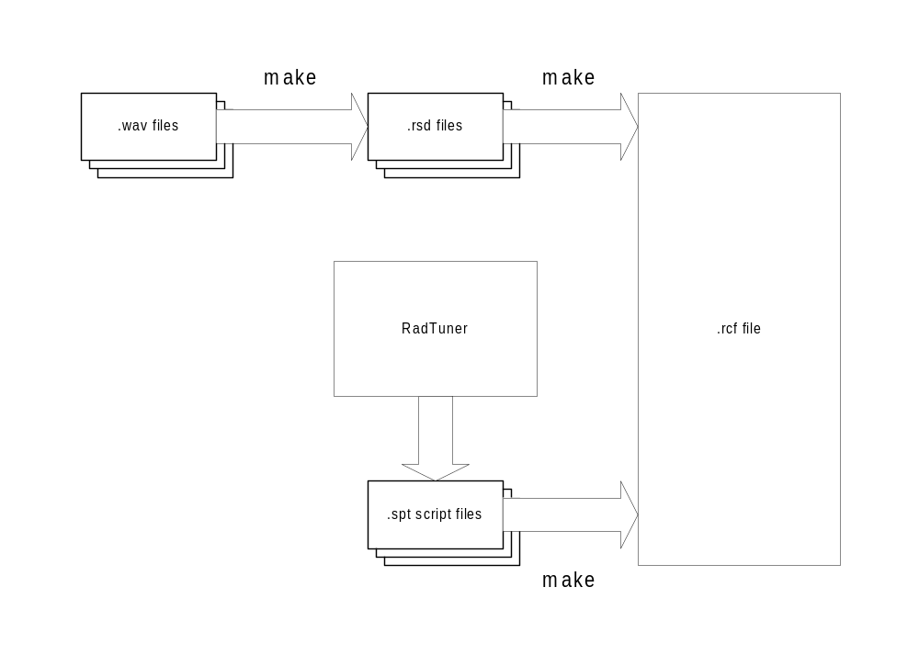The pipeline for the files representing car engine noise is depicted below:

RadTuner
RadTuner is an Ftech program for manipulating RadScript files and adjusting their values in a running game. More details on its workings should be sought outside of this document.
The game will use RadScript to load a script file that will be responsible for creating sound resource objects corresponding to each clip (e.g. Apu’s Firebird engine sound). The designer can use RadTuner to set the name of the clip and the corresponding trim setting. The scripts corresponding to a particular car will be executed when that car is selected in the game.
The script will also direct the creation of a sound object for each car that allows the designer to tune the settings that are global to each car or are game-specific, such as RPM->pitch mappings or maximum volume on skids.

make
By “make”, I mean the Simpsons2 command-line sound build process, which may use any combination of makefiles, batch files, and Perl files to accomplish its terrible goals. The current plan is that it will find all the .wav files in the car sound source directories, and build the piped versions of them in the cd directory if they don’t already exist. If specified in the command line, it could also cement those files together into one .rcf file.

Dialogue Pipeline
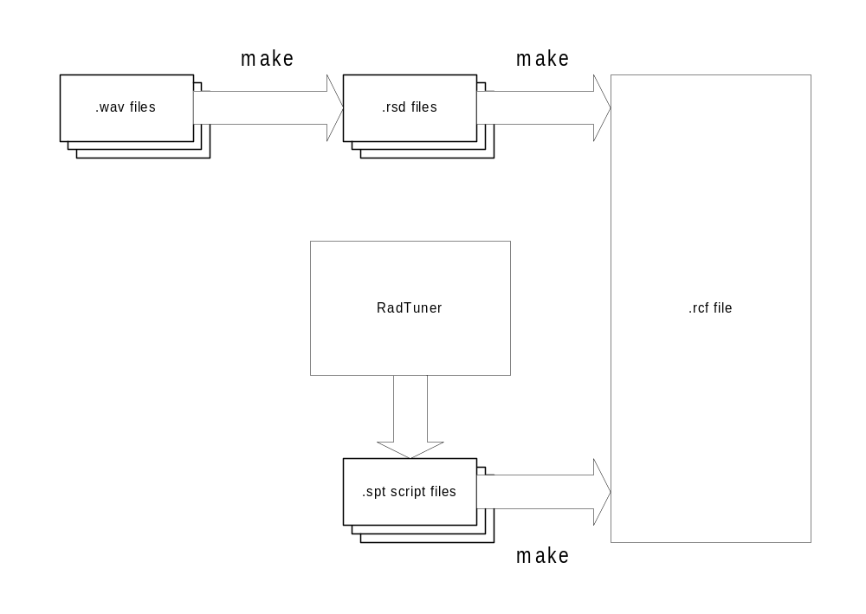The pipeline for the files representing character dialogue is depicted below:

RadTuner
In the dialogue process, RadTuner plays a role similar to that in the car sound pipeline. Each dialogue clip will be represented as a sound resource with associated trim value that can be manipulated with RadTuner. There will also be some global settings available for tuning.

Make
Similar to the car sound process.

Naming Conventions
The names of the sound clip files will be used to associate them with the game events that cause them to be played. For example, a file named Homer_Driver_BigAir_1.rsd might be played in the game when Homer, as a car driver, drove off a cliff, prompting the BigAir event to be triggered. If a second file were added to be chosen randomly in that situation, one would name it Homer_Driver_BigAir_2.rsd, or whatever the designer wanted to put after that last underscore. When necessary, some simple command-line tools should be provided to allow name changes on groups of files. For example, if the name of the BigAir event were changed to Jump, then a tool would find all the files with BigAir in the title and change it to Jump.

Music
<insert diagram here that looks just like the previous two>
The current plan for the music pipeline is to have playlists that are editable as RadTuner scripts. This allows the designer to set up a list of sound files with names and trim settings that can be changed at runtime with RadTuner.

Sound Effects
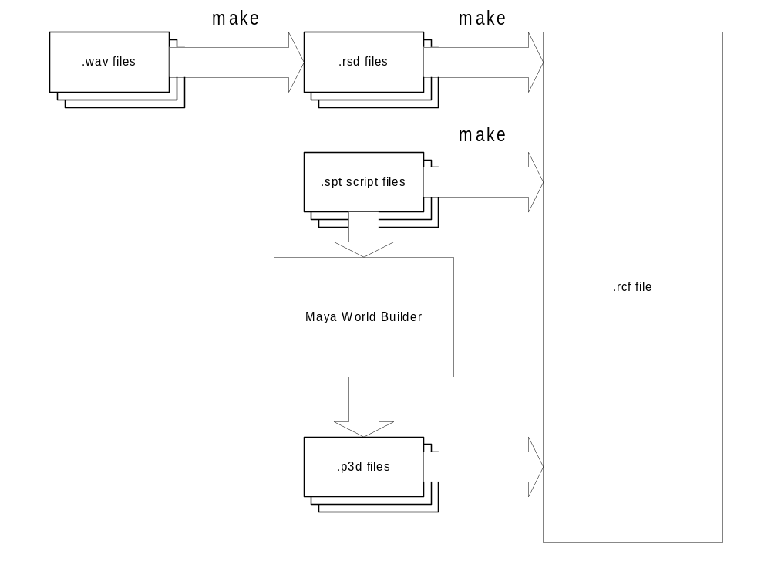The pipeline for sound effects is depicted below:

Maya World Builder
On Simpsons Road Rage, we used Maya for the placement of locators in the game world (e.g. pedestrian start points, traffic waypoints, trigger volumes, etc.) This included the placement of ambient sound sources. On Simpsons 2, the workflow should be similar. The primary change is that we will write some loading code for the World Builder that will parse the RadScript files to create the list of playable sounds available for selection in Maya. After the artists/designers place the sound locators in the game world, World Builder will be used to export that information into .p3d files using custom data chunks that will be read by the sound system. The .p3d files will contain positional data only, and the tuning parameters for those sounds will remain part of the RadScript data for adjustment with RadTuner.
The World Builder may also be used for placement of trigger volumes that affect the way all sound is played in the game. For example, one might use a volume to mark the location of a tunnel, which would cause reverb to be applied to sounds when the car enters that area. This is speculative, though, and needs specification in a detailed sound design.

Tuning Parameters
The following is a list of the tuning parameters made available to the sound designer. This list should change after this document is reviewed and the game/sound design is refined.
Car Sound:
- Per clip (including car engine):
  - Trim
  - Max volume
  - Max speed
  - Min speed
  - Pitch increase
  - Pitch decrease
  - Fade peak speed
  - Looping
- Per car engine:
  - Engine max RPM
  - Engine min RPM
  - Engine “normal” RPM
  - Decay time
  - Delay time
  - Attack time
  - Inside cone angle
  - Outside cone angle
- Global:
  - Master volume
Dialogue:
- Per clip:
  - Trim
- Global:
  - Master volume
Music:
- Per song:
  - Trim
- Global:
  - Master volume
Sound Effects:
- Per clip:
  - Trim
  - Pitch range
  - Delay
- Per positional sound:
  - Min distance
  - Max distance
- Global:
  - Master volume
Global Sound Properties:
- Master volume
- Duck volume
- Fade in/fade out
- Listener settings
  - Doppler
  - Distance
  - Rolloff
- Reverb parameters
  - Depth
  - Mix
  - Reverb type
NOTE: some reverb parameters may be platform-specific.

