Technical Design for the Avatar System
Revision History

Issue | Date | Person | Reason
0.1 | April 7, 2002 | TBJ | Draft
1.0 | April 12, 2002 | TBJ | Reviewed by team and released

Description

Introduction
Handling the game state change between in/out of car is the Avatar systems “raison d’etre”. The Avatar implements two key methods: GetIntoVehicle( int vehicleId ) and GetOutOfVehicle( int vehicleId ).

What follows is a pseudo-code description of GetIntoVehicle():
1. Get a "human" vehicle controller.
2. Init HumanVehicleController with mControllerId.
3. Register new controller with ControllerSystem.
4. Get pointer to Vehicle via VehicleManager using vehicleId.
5. Set Avatar member data mpVehicle to Vehicle pointer from 4.
6. Set Controller for Vehicle.
7. Call Character->SetInCar( true );

The implementation of GetOutOfVehicle is described next:
1. Call Character->SetInCar( false );
2. Set Controller for Vehicle to NULL ( or AI controller )
3. Set Vehicle member data to NULL.
4. Unregister controller with controller system.

It is through these two methods that the game will manage the switch between using the gamepad to control an animated character, and using the gamepad to control a physics simulated vehicle. Updating the “in car” flag in the Character object allows us to give proper context to the control input to the character while in the vehicle. For example, the analog stick would cause character locomotion in the out of car state, will be ignored in the in car state. On the other hand, special inputs, like a taunt command, might be enabled during the in car state.

Requirements

- There will be one and only one Avatar for each human player in a game.
- The Avatar will manage the relationship between the user’s biped character, their vehicle, and their physical controller device.
- The Avatar will manage the state change between “In car” gameplay and “Out of car” gameplay.
- The Avatar will know if the user is in a car or not.
- The Avatar Manager will handle the assignment of physical controllers to Avatars.
- The Avatar Manager will handle the assignment of Characters to Avatars
- The Avatar Manager will be used to initialize all Avatars to a known state at Gameplay start.
- The Avatar Manager will talk to the Event Manager.
  - Handles the GetIn/GetOutof Car event.
  - Dispatches Event to appropriate Avatar.

References

Technical Design

Relationships

Will ask the VehicleManager for a Vehicle pointer given a vehicle Id. Will set the VehicleController for a given vehicleId via the VehicleManager. The VehicleManager will also return a VehicleController object given a vehicleId.

Handles events from the EventManager. The AvatarManager will handle two events: one will signify a game state transition from playing out of car to playing in a car, and the other will signify the opposite transition.

The AvatarManager will query the GameManager for the number of user controlled players. It will also ask the GameManager to report the controllerId associated with a given playerId.

The AvatarManager will ask the CharacterManager for a Character Object given a playerId.

Interface

Avatar Class
class Avatar
{
public:
Avatar();
~Avatar();

void Destroy( void );

int GetControllerId( void ) const;
void SetControllerId ( int id );

const Character* GetCharacter( void ) const;
void SetCharacter( Character* pCharacter );

const Vehicle* GetVehicle( void ) const;
void SetVehicle( Vehicle* pVehicle );

void GetIntoVehicle( int vehicleId );
void GetOutOfVehicle( int vehicleid );

bool IsInCar( void );
private:
//Prevent wasteful constructor creation.
//
Avatar( const Avatar& avatar );
Avatar& operator=( const Avatar& avatar );

// Data.
//
int mControllerId;
Character* mpCharacter;
Vehicle* mpVehicle;
};

Avatar Manager Class
class AvatarManager
{
public:
AvatarManager();
~AvatarManager();

void Init( void );
void EnterGame( void );
void HandleEvent( int id, void* pEventData );

Avatar* GetAvatarForPlayer( int playerId );
Avatar* GetAvatarForCharacter( int characterId );
Avatar* GetAvatarForVehicle( int vehicleId );
private:
Avatar* FindAvatarForCharacter( Character* pCharacter );
//Prevent wasteful constructor creation.
AvatarManager( const AvatarManager& avatarmanager );
AvatarManager& operator=( const AvatarManager& avatarmanager );

// Data.
//
static const int MAX_AVATARS = 4;
Avatar mAvatarArray[ MAX_AVATARS ];
int mNumAvatars;
};

Other
A Character Class that maintains in/out of car state.
void Character::SetInCar( bool inCar );
bool Character::IsInCar( );
Returns the Physical Controller ID to Player ID mapping set up in the front end.
int SettingsManager:::GetControllerIdForPlayer( int playerId )

Returns a Character Object given a character id.
Character* CharacterManager::GetCharacterById( int characterId );

Returns a Character Object given a player id.
Character* CharacterManager::GetCharacterForPlayer( int playerId );

Returns a Vehicle Object given a vehicle id.
Vehicle* VehicleManager::GetVehicleById( int vehicleId );

Registers the physical controller device with the controller system.
void ControllerSystem::RegisterController( int id,
Controller* pController );

Component Class Diagrams

Avatar System
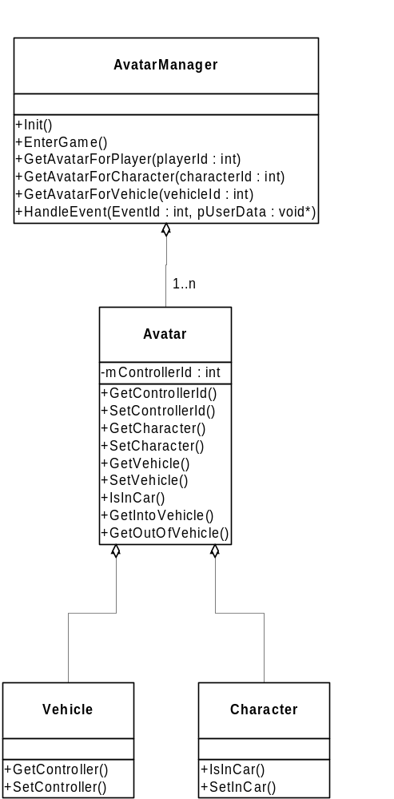

Use Cases

Get out of car
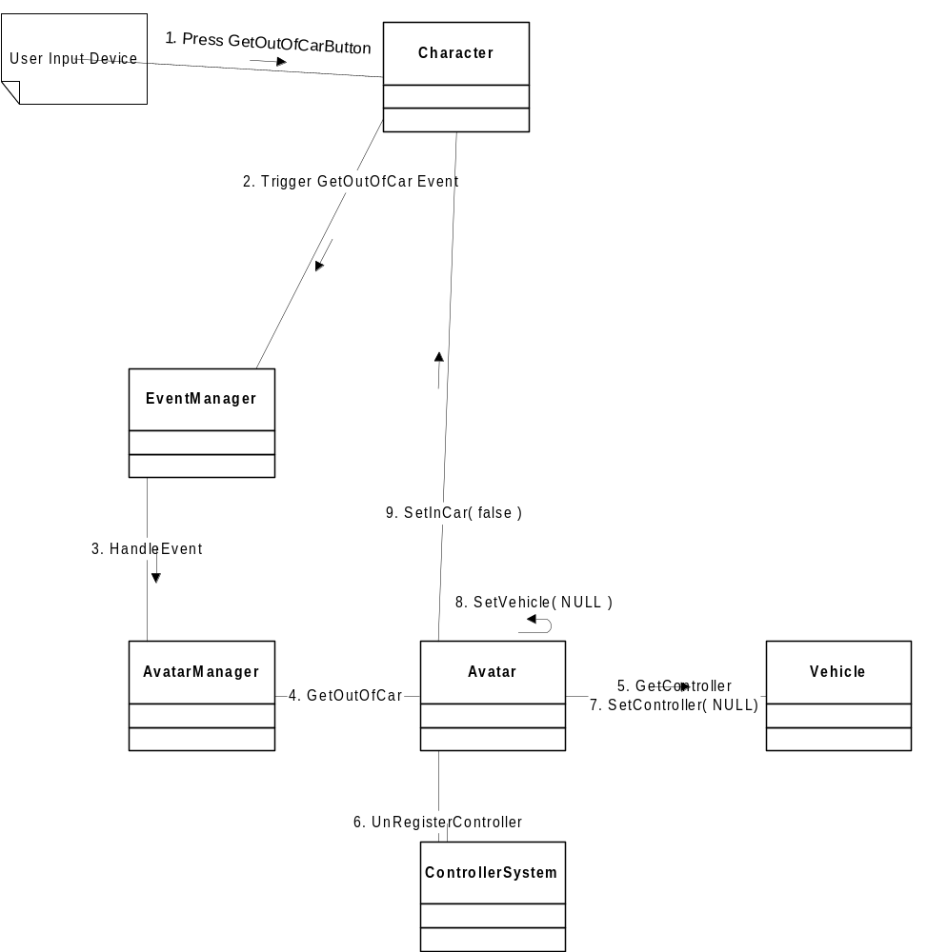

Get into Car
