Technical Design for Character World Objects
Revision History

Issue | Date | Person | Reason
0.1 | April 5, 2002 | TBJ | Draft
1.0 | April 12, 2002 | TBJ | Reviewed by team and released

Description

Introduction
This document includes descriptions of AI- and user-controlled characters. This document will not include detailed descriptions of the AI control driving the characters or objects, but rather the interfaces through which the AI will communicate with the dynamic objects themselves.

Requirements
- Characters must move under user control with a smooth intuitive feel, similar to Mario64.
- Characters shall be able to move over an arbitrary ground mesh with accurate foot placement.
- Characters shall react to physics collisions by simulating a rigid body reaction.
- Characters shall react to physics collisions with collision specific animations.
- Characters shall react to physics collisions with a special fx such as particle systems.
- Characters shall react to physics collisions with dialog and/or sound fx.
- Character movement can be controlled by either user input or AI input.
- Characters accelerate from idle to a full running speed.
- Characters decelerate to idle speed.
- Locomotion animations will smoothly blend and match the locomotion speed of the character.
- Character animations (activating triggers) can be initiated via the user controller or the AI.

References
- Choreographer Technical Design Document, Bryan Brandt
- Talked to Jeff Harkness about Skeleton design for Biped Characters.
- Talked to Jeff Harkness about IK Rigging for foot placement on arbitrary ground mesh.

Technical Design

Relationships

- The Character Update method will be driven by the AI simulation manager.
- The Character will need to talk to the Terrain system for vertical position information for the Character Root and, if necessary, the Character foot positioning.
- The Character will need to be able to notify the Dialog system of collision events and state changes.
- Human controlled characters will need to talk to the Controller system.
- Human controlled Characters will need to query the scene graph to return all “World Objects” within a given proximity.
- The Camera system will need to “look at” the Character.
- The Character will need to talk to the Choreographer system for Locomotion updates.
- The Character will need to talk to the Choreographer system to apply animations to the Character.

Interface

AI Entry Points

All AI objects have a common interface through which they sense and react to their environment. The interface consists of five entry points, and each is called for every AI object being simulated before the next entry point is executed. Not all instances of AI objects necessarily implement each entry point as extensively as others. In general, character actors, especially AI-controlled actors, implement all entry points.

The entry points are as follows:

Sense()
Objects have the opportunity to sample the surrounding world and actor state, as well as their own internal state as defined by the previous simulation frame.

Think()
Objects use their previously acquired sensory data to establish an intention for the forthcoming simulation frame.

Execute()
Objects translate their intentions into actions to be sequenced. For simple objects that only have a few action states, this may mean simply setting a state flag. For complex dynamic objects such as characters, the act of transforming intention to actions will involve querying the action tree for an appropriate action node, given the actor’s current input state, and then sequencing the generated actions from the action node onto the actor’s sequencer.

Simulate()
Objects simulate actions for a frame. No internal physical state is updated. Rather, objects accumulate whatever information they need in order to perform a complete state update later in the Update() entry point.
For example, an object will perform collision detection during the Simulate() entry point, but it will not change its state as a result of a successful collision by sequencing a new action node until the Update() call.

Update()
Objects update their internal state according to the results of the Simulate() call. This will include updating their world space positions, and updating their final joint positions for articulated characters. The actual Update() interface will be spread across multiple calls to ensure proper evaluation of each sub-step of the simulation. Therefore, the first will be UpdateRoot(), which will update each object’s root world position. Next, UpdatePose() will be called, which finalizes the object’s pose and visible state. Finally, UpdateState() is called, which completes the object’s per-frame state, and updates all actions contained in the object’s sequencer (if any).

Characters
Characters, which can be either human or AI controlled, are the most complex dynamic objects simulated in the game. As such, they serve as thorough examples of the dynamic object interface and simulation flow.
Characters are constructed from several disparate parts that work in tandem to produce as output a skinned, fully articulated user- or AI-controlled displayable mesh. The main components of a character are its Intention Controller, its Intention module, the Action Tree, the Sequencer, and the Choreographer. Note that most of these components are fully modular and can be used in other areas of the game.

Intention Controller
The Intention Controller is an abstract interface for specifying high-level character action requests. These requests can include locomotion direction, locomotion velocity, and actions such as attacking or jumping. These action requests have yet to be fully enumerated. Since the Intention Controller interface is abstract, it allows swapping one implementation for another at any time during gameplay, hence allowing us to switch between human or AI control, or even have varying complexity levels of AI for level-of-detail control.
The Intention Controller interface corresponds to the Sense() and Think() entry points of the dynamic object interface.
There will be at least two implementations of the Intention Controller interface, the Human Intention Controller, and the AI Intention Controller.
The Human Intention Controller simply maps input coming from joysticks to character action requests. The actual mapping may be character-dependent. The mapping will be specified in scripts and will be configurable in game to allow user remapping of the button layouts.

Intention controllers are discussed in more detail later in this document. See Section 2.2.3.1.

Intention
The character’s Intention module simply queries whichever Intention Controller is currently active for high-level action requests, and then translates these requests into actual actions to be sequenced on the character’s Sequencer. To do this, it takes the Intention Controller request and uses it to query the Action Tree to retrieve zero or more Action Nodes. It then calls the Action Node(s) sequence method to place the generated actions onto the character’s Sequencer.
The Intention module corresponds to the Execute() entry point of the dynamic object interface.

Action Tree
The Action Tree is a collection of Action Nodes. Each Action Node contains conditions for execution and triggers that fire off timed actions if the node is executed. The Action Tree is specified using a custom scripting language (although this may be abandoned in favour of Lua).
An Action Node’s conditions can include testing such the character’s proximity to world objects or other characters, or the current intention controller locomotion and action requests.
Action Node triggers will usually include timing information and whatever other parameters are available for the specific action to be triggered. Actions can include animation requests, locomotion requests, special effects, changing a character’s collectible stats, or collision testing during animations.
When an Action Node is successfully queried from the Action Tree by the Intention module, it will be “sequenced” onto the Sequencer. Sequencing an Action Node causes it to call each of its action triggers to create new actions that will be placed on the character’s Sequencer. Each of these actions contains timing information made available to the Sequencer that will dictate their lifespan and the point in time they will commence simulating.

Sequencer
The Sequencer is a generic structure for executing timed actions, and overriding a set of currently running actions with a new replacement set.
The Sequencer contains a list of actions and their associated timings. The Sequencer is filled by the Intention module, which uses an Action Node’s sequence method to place actions on the Sequencer. The Sequencer has Simulate() and Update() methods that correspond to the respective entry points in the dynamic object interface.
Actions on the Sequencer usually just make requests to other subsystems during their respective Simulate() calls. These other systems will later do the actual work in the dynamic object’s Update() entry point.

Choreographer
A prime example of one of the subsystems called by actions in the Sequencer is the Choreographer. All animation and locomotion actions simply push requests on the Choreographer per-frame to continue playing an appropriate animation. The actual pose that results from the various animation and locomotion requests is not fully evaluated until the Update() entry point of the character.
The Choreographer is fully described in the Choreographer Technical Design document.

How the characters are controlled.

// An implementation of the abstract IMotionController interface will
// control the movement of the DSGAIObject when the objects is not under
// physics control.
//
struct IMotionController
{
virtual void Sense( float timeins ) = 0;
virtual void Think( float timeins ) = 0;
virtual void Execute( float timeins ) = 0;
virtual void Simulate( float timeins ) = 0;
virtual void Update( float timeins ) = 0;
virtual void GetTransform( rmt::Matrix& out ) const = 0;
};

class Button
{
public:
float GetValue( void ) const;
float GetTimeHeld( void ) const;
private:
float mValue;
float mfTimeHeld;
};

// an aggregation of input data packets that are important to a character.
//
struct ButtonStates
{
// example is a button input that tells the character to play the
// taunt animation,
//
Button mTaunt;

// and so on.
//
};

// The ICharacterIntentionController abstract interface is to be
// implemented for 2 cases:
// 1. the case where the character is user controlled.
// 2. the case where the character is AI controlled.
//
// Note: the implementation is transparent to the
// CharacterMotionController class.
// The class doesn't care whether the transform is updated via the AI
// system or the user input system.
//
struct ICharacterIntentionController
{
virtual void Sense( float timeins ) = 0;
virtual void Think( float timeins ) = 0;
virtual void GetDirection( rmt::Vector& out ) const = 0;
virtual void GetButtons( ButtonStates& buttonStates ) const = 0;
};

// The world object would talk to this class in order to update it's
// internal state.
// This class will talk to the IntentionController.
// It will take the output of the intention controller and transform those
// inputs into character movements and actions (animations).
//
class Character
:
public IMotionController
{
public:
void Sense( float timeins );
void Think( float timeins );
void Execute( float timeins );
void Simulate( float timeins );
void Update( float timeins );
void GetTransform( rmt::Matrix& out ) const;
protected:
private:
float SolveActualDir( float fDesiredDir, float timeins );
float SolveActualSpeed( float fDesiredSpeed, float timeins );

choreo::Puppet* mpPuppet;
ICharacterIntentionController* mpICharacterIntentionController;
};

// A DSGDynamic object exists in the game world and is considered for
// physics collision detection and response (simulation).
//
class DSGDynamic
{
// This class is fully defined elsewhere.
// It is included here just for completeness.
//
private:
sim::SimState* mpSimState;
};

// This class is derived from a DSGDynamic object.
class DSGAIObject
:
public DSGDynamic
{
public:
void Sense( float timeins );
void Think( float timeins );
void Execute( float timeins );
void Simulate( float timeins );
void Update( float timeins );

void SetMotionController( IMotionController* pIMotionController );
const IMotionController* GetMotionController( void ) const;
protected:
private:
IMotionController* mpIMotionController;
};

Explanation
The key to the above class descriptions is the highest level is the ImotionController abstract interface. It is the object that controls the movement of the DSGAIDynamic Object when not under full physics simulation.

Say we have the need for a simple object in the world that moves in a procedurally generated path, an even simpler version of traffic from SRR1. In this case you would create a TrafficMotionController derived from IMotionController. This would be very dumb traffic that ignored all other traffic and other game objects. Since the traffic is very “dumb”, we provide only a blank implementation the Sense(), Think(), Execute() methods of the IMotionController interface. The Simulate() method would largely be implemented by calling updating the SimState object of the parent class. So for our simple “drone” traffic class, we would only need to implement the Update() method which would move the traffic along some path. The parent DSGAIObject would, as long as it is under “AI” control, would then call the IMotionController::GetTransform() method to update it’s world transform.

A more complex object, like a character, would implement it’s behaviour via another object called an “intention controller”. In general terms, an “intention controller” maps input from an abstract source, commonly one of AI or User input, into a representation of intentions that the character must execute. The implementation of an intention controller for a physical input device is fairly straightforward. Implementing an “AI intention controller” is more complex, and is what one would traditionally consider the “brains” of an AI Object. For example, we might want to give our biped characters the ability to dive out of the way of a nearest threat. This intention could be enumerated in an abstract way: “AVOID_THREAT”. For a “human intention controller” we would simply map a button press to the “AVOID_THREAT” intention. The “AI intention controller” however would need to “Sense” (see interface) the world for the nearest “threat” (vehicles). It would then have to “Think” (see interface) to form the intention “AVOID_THREAT”. This intention would be passed to the motion controller where the appropriate actions to avoid a threat would be added to the Sequencer. These actions would include orienting the character in the appropriate direction and scheduling the correct “dive” animation.

An “intention controller” is necessary where you want to be able to transparently transfer control between AI on user input.

Character Motion
It is also via the CharacterMotionController that we will achieve the smooth “Mario64” style feel we desire. CharacterMotionController will implement two methods:

float SolveActualDir( float fDesiredDir, float timeins );
float SolveActualSpeed( float fDesiredSpeed, float timeins );
The first method will provide a means to achieve smooth character rotation. For example, if the character is facing north, and the user input wants to turn him east, the character will turn towards the desired direction ( east ) using damping implemented in the SolveActualDir method. In the diagram below, this concept is illustrated, with the user input event (face east) occurring at time = 0.

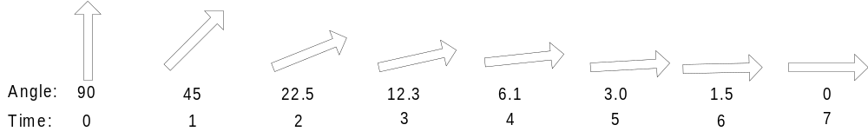

The second method provides smooth acceleration and deceleration of the character. By providing an acceleration function that quickly converges on the desired speed, we retain a smooth responsive feel, without moving the character so abruptly that the motion is visually displeasing.
Component Class Diagrams

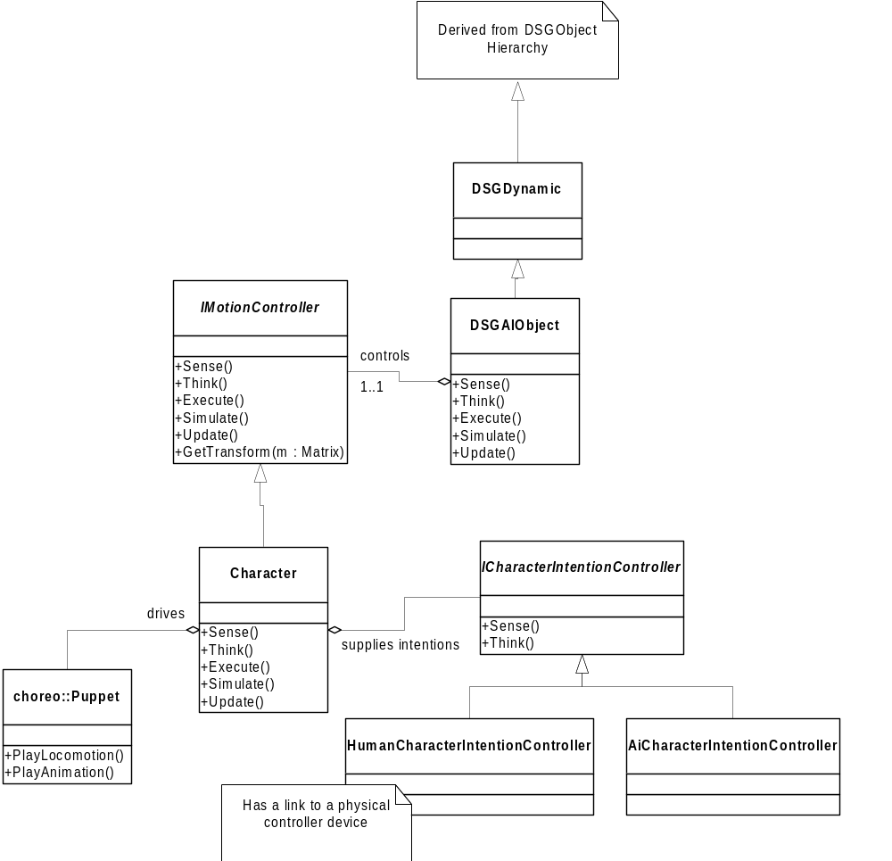

Dynamic Behaviour

What follows is a broad overview of the simulation loop that will be employed to simulate all actors and dynamic objects in the game.

for each actor in actorManager
{
actor->Sense()
{
actor->intentionController->Sense();
}
}

for each actor in actorManager
{
actor->Think()
{
actor->intentionController->Think()
{
if (intentionController->IsHuman())
{
actor->joystickInput->Query();
}

if (intentionController->IsAI())
{
actor->golemAISystem->Query();
}
}
}
}

for each actor in actorManager
{
actor->Execute()
{
actionNode = actionTree->Query(actor)
{
// searches action tree to find action node corresponding
// to current actor state, if any
}

actionNode->Sequence(actor->sequencer)
{
// generates actions that are placed on sequencer,
// possibly overriding previously running actions
}
}
}

for each actor in actorManager
{
actor->Simulate()
{
for each action in actor->sequencer
{
action->Simulate()
{
// example action requests
actor->choreographer->PlayAnimation();
collisionManager->RequestCollisionDetection(actor);
soundManager->PlaySound();
sfxManager->PlayEffect();
}
}
}
}

for each actor in actorManager
{
actor->UpdateRoot()
{
if (actor->HasChoreographer)
{
actor->choreographer->Begin();
actor->choreographer->Advance();
actor->choreographer->UpdateRoot();
}

if (actor->HasPhysics)
{
actor->simState->Update();
}
}
}

actorManager->ResolveActorPositions()
{
// ensures all actors are kept a gameplay-determined intersect distance apart
// includes collision with world geometry
}

for each actor in actorManager
{
actor->UpdatePose()
{
if (actor->HasChoreographer)
{
actor->choreographer->UpdatePose();
actor->choreographer->End();
}
}
}

collisionManager->ResolveRequestedCollisionDetections()
{
// resolves all requested inter-actor collisions
}

for each actor in actorManager
{
actor->UpdateState()
{
for each action in actor->sequencer
action->Update()
{
// each action updates its internal state according
// to simulation results;
// for example, collision action will possibly sequence
// a new action
}
}
}

