Technical Design for Driving Engine
Revision History

Issue | Date | Person | Reason
0.1 | April 5, 2002 | Greg Mayer | first draft started
0.2 | April 11, 2002 | Greg Mayer | first draft done
1.0 | April 12, 2002 | Greg Mayer | Reviewed by team and released

Description

Introduction

This document talks about the requirements and technical design of the driving engine module of Simpsons 2.

The simulation of all the vehicles in the game will be encapsulated in the Vehicle class; this class and it's components will be used to move cars around the world, whether they be full-fledged physics models under user or AI control, or just simple traffic following a path. The module will be set up so that the behaviour of the vehicles can be toggled between traffic and physics. This document will focus on the physics, and just show where the traffic control ties in, and how the interface is flexible enough to handle these two, in addition to any other locomotion models that might come up.

The driving engine module is built on top of the new physics libraries (the sim library) internal to Radical, and uses much of the knowledge and experience gained from the first implementation in the Simpsons Road Rage, though with much new added flexibility and robustness.

Requirements

The driving model for the Simpsons 2 game will be somewhat different than Simpsons Road Rage. It will be far less "cartoony"; vehicles will accelerate in a more realistic manner, and there will be a much greater degree of skill required to drive well. The cars should still be easy to control for a novice, but there will be a lot of depth to differentiate players of different levels, and encourage them to perfect their skill. Driving will still be high-speed and exciting, but the reward of high speed performance has to be earned.

Also, you will not be able to crash through anything with no consequences. Vehicles will accumulate damage, albeit in a much more forgiving manner than real-life, but obstacles will have significant mass, and it will usually be in your best interest to avoid things.

Examples of driving models that cover a range of what we are shooting for are:
Smuggler's Run 2, Project Gotham, Grand Theft Auto 3, Ralli Sport Challenge.

Point Form Requirements

- provide a driving module that gives a fun and exciting driving experience through cool emergent behaviour from the underlying physics model.
- provide a set of parameters with which the designers can create a balanced, yet well-differentiated set of vehicles.
- have capability to switch locomotive control from direct traffic-path following, to full physics.
- interface to rest of world physics system, including chassis and wheel collision with static and dynamic objects, as well as arbitrary wheel-terrain collision over a variety of driving surfaces.
- provide an interface to the character manager so it can fetch information such as acceleration rate and driver/passenger location to update and render the characters in the car effectively.
- provide the required interface for sound to query the vehicle's behaviour, including rpm, gear and skid levels.
- provide an interface for special effects, such as smoke and other particle systems at the wheels, based on the car's behaviour and type of road surface being driven on.
- provide damage states (mostly visual - little performance deterioration) that reflect where and how hard the vehicle was hit.
- provide an interface to the game rendering system to draw the vehicles.
- provide capability to play animations on the vehicle hierarchy, and possibly have special effects such as door and trunk flapping when damaged.
- provide simple and convenient interfaces to things such as speed and position for other game modules such as HUD and Camera.

References

- talked to coders about general architecture fit.
- talked to Trav about traffic and controller issues.
- talked to Devin about Scenegraph interface.
- talked to Martin about many aspects of the new sim library.
- Technical Design for World Physics Manager

Technical Design

Relationships

The vehicle module is integral to the game architecture, as it implements one of the core gameplay mechanics. Most of the interface consists of things calling the vehicle with inputs, and asking it to update itself, or querying it for information. There are only limited cases where the vehicle asks other modules for information.

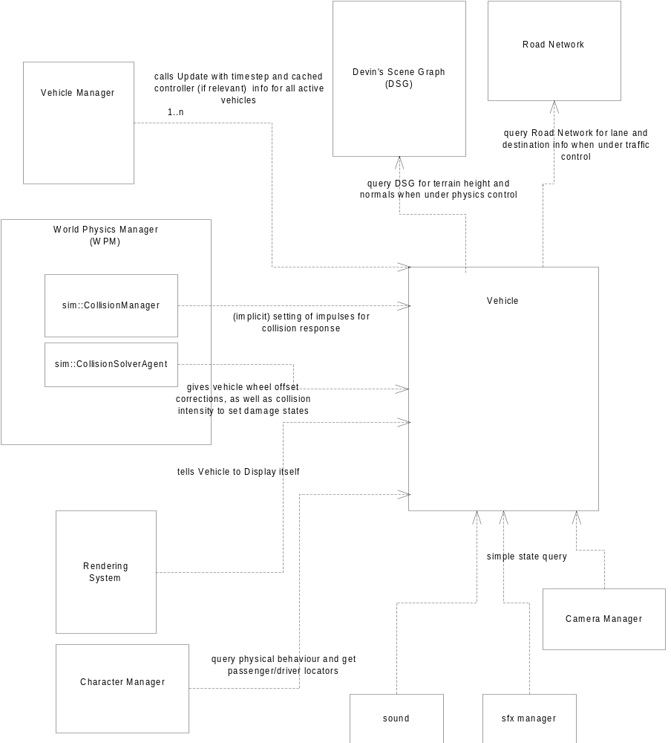

Interface

The following pseudo code gives a logical overview of the updating of a Vehicle, and how this fits into the world physics manager update.

WorldPhysicsManager::Update
for minimum possible number of substeps that still gives a stable simulation:
{
for each active vehicle under physics
vehicleManager->Vehicle[i]->PreCollisionPrep (see section 2.3.1.2.2 PhysicsLoco)

collisionManager->DetectCollisions
collisionSolverAgent:
intercept collisions between wheels and ground and call Vehicle->StoreWheelCorrectionOffset with relevant wheel and value
collisionManager->SolveCollisions
impulses get added to vehicle physics object to prevent interpenetraion with other collision objects
also, info regarding collision intensity and location passed on for setting damage states

vehicleManager:
for each active vehicle:
{
if under physics control:
poll controller for this vehicle and set input values (eg. gas, brake, wheel turn...)

Vehicle[i]->Update
details of internal work in section 2.3.1.2.2 PhysicsLoco
the only external calls required here are:

if under physics control:
query Devin's Scenegraph for terrain height and normal of each wheel

if under traffic control:
query Road Network for lane and destination info
}

}

The other interfaces required are very simple: such things as a Display method when the vehicle is intructred to draw itself, and accessors for physical state like speed, position, heading, etc...

Vehicle Components

The following diagram gives an overview of the Vehicle class.

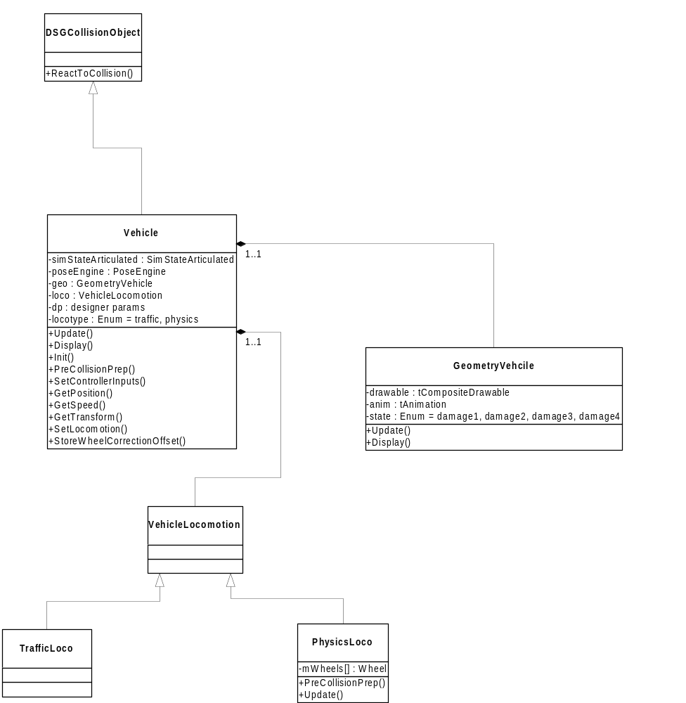

Member Data
SimStateArticulated: this is the sim library class for an articulated 3D rigid body object - both the dynamically simulated object and the collision detection geometry.

PoseEngine: this is a class to own and maintain an efficient transform hierarchy that performs lazy evaluation on joints, and can be modified by AI, physics, and/or animation.

DesignerParams: member data that map to values the designers can tune for the vehicles, such as suspension stiffness, acceleration, top speed, cornering ability etc.

LocoType: an enum to specify whether this vehicle is currently being controlled by traffic AI intelligence, or a physics simulation.

GeometryVehicle
The GeometryVehicle class is used to encapsulate the render geometry (including different meshes for damage states) as well as any animations that may be played on the vehicle (note: these would be for secondary effects like a flywheel of an engine turning - the primary behaviour of the vehicle (banking and lurching) emerges from the suspension and the physics model and does not involve animator work). The update of this class would advance an animation (if any), as well be responsible for swapping meshes for parts of the car that have been damaged through collision.

VehicleLocomotion
The VehicleLocomotion class acts as the base class from which the different (currently only 2) techniques for moving the Vehicles can be derived. The method being used can be toggled on the fly; for example, when traffic cars get hit, we may want to simulate them briefly with full physics. This can be done by simply toggling the VehicleLocomotion pointer in the parent Vehicle class from TrafficLoco to PhysicsLoco. Such a trigger would be called from the ReactToCollision method, which all DSGCollisionObject have, and which gets called from the CollisionSolverAgent.

When the Vehicle is Updated, the call will be propogated to the VehicleLocomotion, which will in-effect modify the worldMatrix of the root of the Pose, as well as other joints such as suspension offsets and rotation values for wheels. Note that the SimStateArticulated uses the Pose to describe it's hierarchy, and the root worldMatrix of the Pose is kept in sync with the transform of the SimStateArticulated.

TrafficLoco
This class will encapsulate the logic for traffic vehicles in the game. They will need to query the road network and make sure that their current heading and velocity are reconciled with their current destination. Their position will likely be modified by direct setting of the transform of the SimStateArticulated; note that it is important to set the transform with the proper time-step parameter as this is used intrenally by the SimStateArticulated to calculate the correct velocity for the simulated object - that way when the car is suddenly toggled to full physics it will behave as we would expect from a car with the apparent velocity it had when under traffic control.

PhysicsLoco
This class encapsulates the guts of the vehicle physics simulation.

The simulation model can be visualized as an articulated rigid body made up of a chassis (which may have multiple sub elements, or just be a simple oriented bounding box - picture a brick) with four wheels attached at defined suspension points. The wheels (represented for the purposes of collision detection by spheres - they work much better than cylinders) are connected to the chassis by a spring-damper system. The springs exert a force proportional to how much they are displaced from rest state, and the dampers exert a force proportional to the speed at which they are being moved-through. The stiffness of the suspension is a designer parameter, and will affect both the visual behaviour of the car, as well as its handling.

The first job of PhysicsLoco is to prepare the vehicle wheels for collision testing with the ground. The PreCollisionPrep call which is exposed through the Vehicle class only has meaning for PhysicsLoco; the call takes the wheels in the vehicle hierarchy and manually moves them to the bottom of their suspension limits. This is to ensure that if the terrain, or any other driveable surface is anywhere within range of the suspension, the wheels will be placed on it. This is a very important step for stability of the driving model, since what we are trying to simulate is a continuous system where the wheels are constanly being pushed down onto the road, and they move along the suspension axis more or less independently, but move in the transverse plane along with the car. Our problem is that we have to simulate this in discrete (albeit small) timesteps. Because of this it would be very easy for the wheels to continually come out of contact with the ground as they are moved along with the chassis, if the chassis were angled even slightly up from pure horizontal. Of course one could attempt to move them down with some spring-relaxing method, but experience has shown this to be unreliable. It should also be taken into account that, even though the Simpsons2 game will have more realistic acceleration than the Simpsons Road Rage, compared to real-life, the Vehicles are for the most part, very powerful, and effects such as that described above get significnatly exaggerated (ie. in the real-world you'd be hard pressed to find a car that can accelerate so hard that it's front wheels lift off the road - in a video game.... much more likley)

Collisions of Vehicle wheels with objects are trapped in the CollisionSolverAgent and the StoreWheelCorrectionOffset is called on the Vehicle, which will use this information in it's Update. Note that some heuristic has to be used for deciding when the wheel is "driving over" something, or when it has "bumped into" something. Typically the orientation of the collision normal with respect to the Vehicle's Up axis will be used. If something is hit very steeply by the wheel, then we probably want to just bounce the Vehicle back with collision impulses, rather than try and "fix" the wheel out of collision manually.

Note that the term wheel is used in two ways in this section: the more important of the two are the four key sub-elements of the vehicle hierarchy noted above, which we manually move to the bottom of their suspension limits for collision detection. The other use of 'wheel', as it appears inside the PhysicsLoco class in the Vehicle Component diagram at the beginning of section 2.3, is simply an internal class that helps encapsulate some of the work that PhysicsLoco has to do.

When the collision detection is done the Vehicle has the cached values for wheel correction offsets. At the beginning of the Update call, there is one more important collision step that must occur. The DSG must be queried for the height and normal of the terrain under each of the wheels - note that this information does not come out of the regular collision detection and callbacks from the CollisionSolverAgent because the terrain we are driving over does not have physics bounding volumes on it that have been submitted to the CollisionManager.

Therefore, this last special step is necessary, and the information returned from the DSG must also be taken into account to correct the wheels positions.

We want to fix the wheels so they are just barely in collision with the ground, or whichever static or dynamic object was the highest thing they were driving over. PhysicsLoco will actually modify the object-space y translation of each of the wheel joints in the hierarchy to effect this change. When this is done, the suspension reaction forces can be calculated based on the displacement of each suspension point, and the speed at which those points are moving on the overall rigid body. These forces are then applied to the rigid body.

The next step is to translate controller input values into forces, also to be applied to the rigid body. This is a complex area that is the focus of much experimentation. One standard technique used to create realism and depth is to cap the amount of locomotive or tractive force a tire can provide based on it's coefficient of friction and the current down force on that tire, which is the opposite of the amount the suspension force is pushing up on the chassis at that point. A further level of complexity is added when you consider the physicsal phenomena that a tire's lateral grip is reduced the more torque that is being applied to it from the driveshaft (thus the fishtailing in powerful rear-wheel-drive cars). This effect in particular needs to be simulated and tuned just right to create realistic effects which are still fun and manageable.

Also note that all these locomotive and breaking forces are applied at the tire contact points, which, in any remotely realistic vehicle, are always below the car's center of gravity, thus they also create an overall torque on the chassis which is what causes all the emergent lurching and banking.

Finally, when all the forces are applied, we simply allow the sim library to update the linear and angular momentum of the rigid body and calculate a new position for us. This new root position, along with the manually settings of values in joints, give us a new Pose which is ready to be rendered.

Also, things such as rpm and wheel rotation angles are actually calculated after since we now know the speed of each wheel and assuming there is not wheel slippage, there is a direct mapping (based on gear and transmission ratio) to an engine rpm value. Of course things like airborne cars and wheel slippage further complicate these calculations.

