Document Issue: 1.0 Document Status: Draft
Date Issued: February 15, 2002
                - Document Title: High-Level Sound Design
                - Author: Darren Esau
                - Keywords: Sound

Revision History
Issue | Date | Person | Reason - include problem #, ECN #, etc.
0.1 | February 15, 2002 | Darren Esau | Initial version of document.
TABLE OF CONTENTS
1. Introduction 3
1.1 Scope 3
1.2 Intended Audience 3
2. Assumptions 4
3. High-Level Architecture 5
4. FTT Libraries 6
5. FTT Manager Layer 7
5.1 Sound File Collection 8
5.2 Sound File Manager 8
5.3 Sound Player 9
5.4 Sound Player Manager 9
5.5 Sound Group 9
5.6 Master Tuner 9
5.7 Loading Manager 9
5.8 Debug Manager 9
6. Simpsons Sound Layer 10
6.1 Car Sound Player 10
6.2 Pedestrian Sound Player 11
6.3 Music Player 11
6.4 Ambient Sound Player 11
6.5 World Sound Player 11
6.6 Proximity Detector 11
6.7 World Event Listener 12
6.8 Sound Effect Player 12
6.9 Dialog Rule Filter 12
6.10 Dialog Sound Player 12
6.11 Game State Manager 12
6.12 Debug Display Manager 12

Introduction
This document provides a high-level description of the sound code architecture for the upcoming Simpsons sequel.

Scope
This document deals primarily with the components specific to the Simpsons game itself, and doesn’t provide detail on the libraries on which it will be based (e.g. RadSound, RadScript).

Intended Audience
This document is intended for programmers, mainly, although anyone else who is interested in our software architecture is more than welcome to read it.

Assumptions
Since the game design is still in somewhat of a state of flux, I’m making the following assumptions regarding the sound requirements for the upcoming sequel:
- Car sound will work in a fashion similar to Simpsons Road Rage (SRR)
- Inter-character dialogue will still exist, of course.
- Front-end sound control (e.g. master volume, FE volume) will be unchanged from SRR.
- Interactive sound will not be a part of the upcoming sequel, because we will be incorporating licensed music. This is only a best guess at this point in time, though. If this changes, there is support in RadMusic for presenting interactive music, but a significant layer of game-specific code will be required.
- Sound effects will be similar to SRR.
- Sounds will be associated with world objects. For example, you might hear a bell when driving by the school, or jet engines when driving by an airport.
- Ambient sounds will be part of the game. For example, on a level like Evergreen Terrace in SRR, you might hear birds at any point within the level.

High-Level Architecture
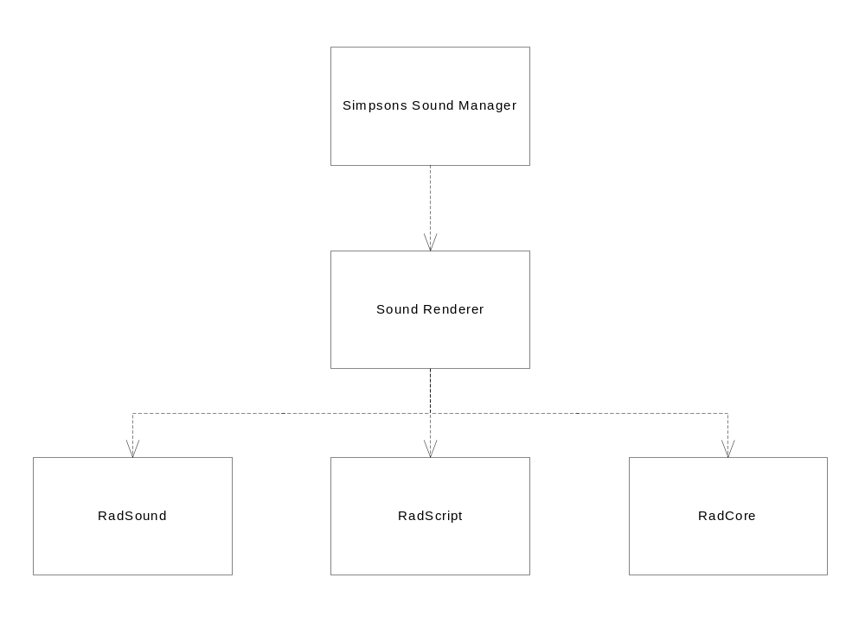At the highest level, the sound component looks something like this:
At the lowest level, we make use of the Foundation Tools & Technology (FTT) libraries that provide sound playback, tuning capabilities, and file access.
Above that is the Sound Renderer layer. This is a collection of classes that don’t provide additional game-specific logic, but assist in collecting and managing FTT functions, and the actual sound file data that are passed to the FTT libraries.
At the top is the Simpsons Sound Manager, which connects the low-level sound code to the game architecture and implements the game-specific sound logic.

FTT Libraries
The FTT libraries are responsible for providing a set of basic services in areas outside of graphics rendering with a console-independent API. The libraries being used by the sound code are:
- RadCore – provides a collection of essential services, such as file access, timers, controller access, debugging services, and memory management. The higher layers will rely on this library for reading sound files and helping to collect sound objects within memory pools.
- RadSound – provides an API for sound file playback. These files can be played as clips, where the entire file is loaded into memory, or they can be streamed off of CD/DVD/HDD. This library also implements a set of playback controls, such as volume, reverb, pitch control, pan, and positional sound support.
- RadScript – provides the backbone of the sound tuning capability. This library allows one to register objects for runtime data changes with a separate tuning tool. This can be used by composers for things like changing volume settings and adding sound files to the event playlists.

More detailed descriptions of the FTT libraries can be found in other documents, so further detail will not be provided here.

Sound Renderer Layer
This layer consists of a set of classes that encapsulate FTT services. By doing so, this layer will:
- Provide a higher level of abstraction than FTT does. For example, the playback details of clip vs. streamed files can be hidden, allowing sounds to be viewed simply as sounds.
- Combine related services between FTT libraries. For example, an object responsible for playing a sound would combine the RadSound functions for volume control with the RadScript functions for tuning that volume setting.
- Manage the allocation of FTT resources. For example, a class will be provided for managing a pool of clip players to avoid memory leakage and fragmentation.

The following diagram shows the components of this layer:

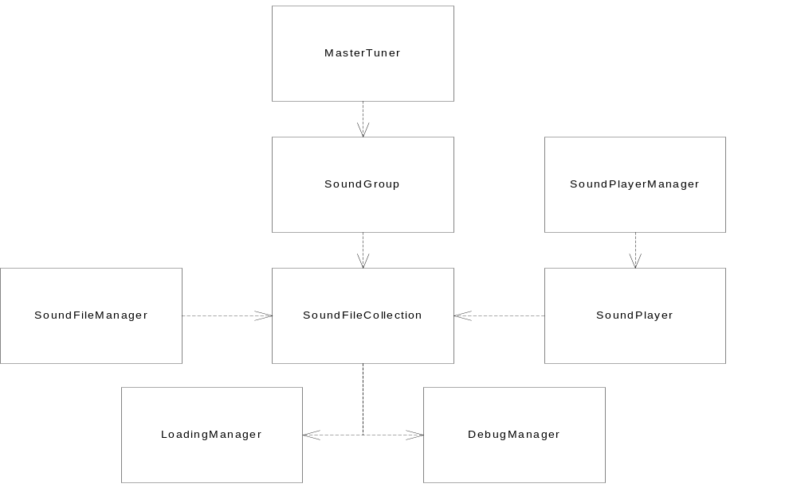Sound File Collection
The basic sound unit. This represents a group of one or more sound files that are played in response to a sound event. If more than one sound file is specified, then a file is chosen at random when playback occurs.
The objects in this component are simply collections of filenames when in their inactive state, as well as attributes particular to those sounds, such as trim settings. When a particular sound is called upon for playback, it is responsible for the creation of RadSound clip and stream objects, and the destruction of those objects when playback is complete.
The name is probably going to change as soon as I come up with a better one.

Sound File Manager
This component manages the responsibilities associated with the entire set of sound files. This will relate mainly to restricting the number of sound files that can be open at any given time, and managing memory pools for RadSound clip and stream objects. It also provides the interface to higher-level objects for finding and acquiring sound files.
This component will also be responsible for dealing with sets of file collections that are appropriate for the player’s current position in the world and game state. If the Sound Manager indicates that a set of clips should be swapped out of memory, this component talks to the individual file collections to make it happen.

Sound Player
This component provides an encapsulation of the RadSound objects that send the sound data to the console hardware. It will interact with the SoundFileCollection component to obtain the sound data from the physical files, and obtain the characteristics associated with playback (e.g. trim).

Sound Player Manager
The Sound Player Manager component tracks a pool of Sound Players, in a manner similar to what the Sound File Manager does for Sound File Collections. It makes sure that we don’t use too much memory or outstrip our ability to play sounds on the console hardware.

Sound Group
This component provides collective attributes for a set of sound files. For example, one requirement is that all of the sound effects have a single volume setting adjustable by the gamer through the front end. The sound effects files could then be referenced from a single sound group object, which would pass the volume setting changes on to the sound files that it collects.

Master Tuner
Provides the global sound attributes (e.g. master volume).

Loading Manager
This component provides services to the Sound File Collection component for the loading of sound data into chunks of memory. It handles the problems dealing with asynchronous loads, to ensure that we manage the integrity of sound data without exceeding resource quotas or leaving file buffers leaking or fragmenting memory.

Debug Manager
This component collects statistics relating to the sound resources that might be useful for debugging. This component only collects statistics; the actual display of debug information is left to the Sound Manager.

Sound Manager
The SSL consists of the components depicted below:
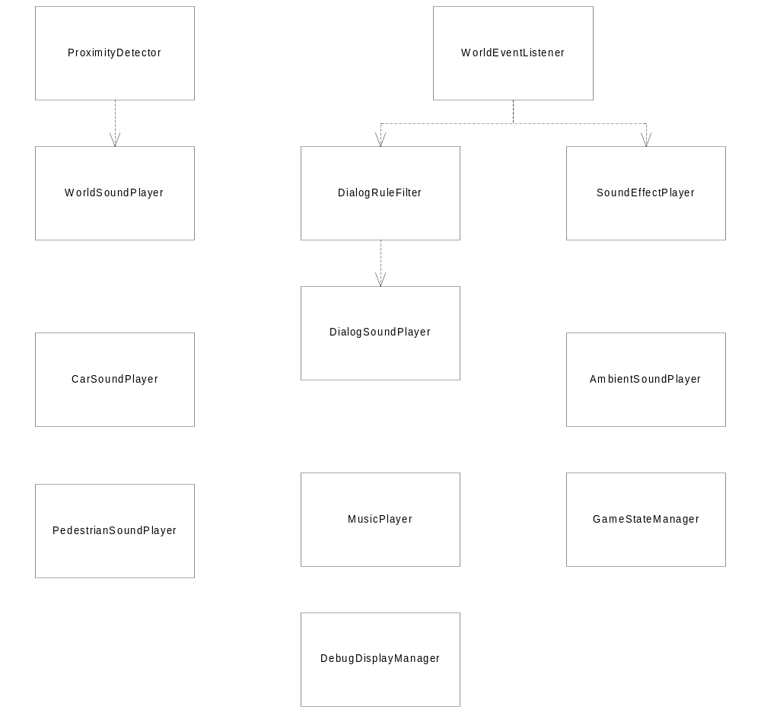These components are described briefly in the following sections.

Car Sound Player
This component encapsulates all of the logic required to have the cars in the game making noise. This includes things like:
- Mapping engine characteristics to volume and pitch
- Selecting a clip matching the car, along with its upgrade and damage characteristics
- Adding in the occasional car sounds like tire squeals and horns when appropriate

Pedestrian Sound Player
The Pedestrian Sound Player manages sounds created by the player character when he’s running around outside of a car. This would include things like footfall sounds, varying depending on the kind of surface that the character is walking/running over.

Music Player
The Music Player component is responsible for keeping the background music going. It stores playlists and does song selection, doing things like fades and volume changes when appropriate (e.g. lowering the volume when the pause menu comes up).

Ambient Sound Player
This component will take care of playing an ambient sound every once in a while. It’ll take care of timing to ensure that the frequency is appropriate, and to choose among a set of sounds appropriate to the level. If the set of ambient sound clips in memory needs to be changed, it tells the Sound Renderer how to do it.

World Sound Player
The World Sound Player records the connections between world objects and the sounds they play. When called upon by the proximity detector, it will play the sounds for those world objects in the appropriate positions in space. It also talks to the Sound Renderer when the set of world sound clips currently occupying memory needs to be changed.

Proximity Detector
This component will monitor the position of the player(s) in the world, notifying the World Sound Player of which sound-producing world objects are within earshot.
Also, it will be responsible for detecting when the player is about to enter or leave an area of the world that will affect which sound clips are loaded. When this occurs, the change is signaled to the World Sound Player to make the appropriate resource changes.

World Event Listener
The World Event Listener monitors the events generated by other game components, such as the physics system, to filter the events that they generate and pass on the ones relevant to the sound system.

Sound Effect Player
This component plays sound effects in response to events passed to it by the World Event Listener. For example, if a car generates an event when it strikes an AI traffic vehicle, this component would translate that into a car crash sound and play it.

Dialog Rule Filter
This component receives events through the World Event Listener, and applies rules to determine whether playback of dialog is appropriate. For example, the player probably will not want dialog with two characters playing at once, or may want to defer speech until another higher-priority sound has played.

Dialog Sound Player
This component does the actual playback of the dialog sound files. It carries the mapping of sound files to characters and combinations of characters.

Game State Manager
The Game State Manager detects high-level changes of game state and makes the appropriate sound changes. For example, when the pause menu comes up, it would be responsible to communicating that a drop in volume is needed to the Music Player.

Debug Display Manager
This component gathers debug information from the FTT Wrapper layer and the other SSL components, and displays it on-screen in the debug menu.

