Technical Design for Road Network Component

Revision History

Issue | Date | Person | Reason
0.1 | March 27, 2002 | TBJ | Initial Draft
1.0 | April 12, 2002 | TBJ | Reviewed by team and released

Description
The Road Network Component is is the set of classes containing the data that makes up the AI representation of Roads, Lanes, Intersections, and possibly sidewalks.

Introduction
The AI in SRR2 (traffic, pedestrian, and enemy) will use the data in the Road Network to make intelligent decisions as they simulate in the game world. The traffic will navigate from road to road, changing lanes as they see fit, navigating through intersections. The pedestrians will navigate along sidewalks, intelligently avoiding other pedestrians, and always remaining on the sidewalk boundaries. The Enemy AI will use the road network to plan Chasing and Evasive strategies. It will also use the information embedded in the road network to stay within road boundaries, and to make routing decisions at intersections.

Requirements
- Each Road will allow for a different traffic density.
- Traffic density will be a tuneable parameter.
- Each Road will allow for a different traffic speed limit.
- Speed limit will be a tuneable parameter.
- Roads will be directional, ie a start and and end.
- A Road will provide lane information (location, heading)
- A Road will have a fixed number of lanes.
- Roads will be connected together with intersections.
- Roads are planar.
- Corollary: Roads will not support banked corners.
- An intersection will provide a list of roads leading out.
- An intersection will provide a list of roads leading in.
- An intersection will connect a maximum of 4 roads (4 in/4 out)
- Each intersection road list (in/out) will be sorted in clockwise order.
- An intersection will have a Traffic Control object.
- A Traffic control object will control the flow of traffic into the intersection.
- A Traffic Control object will have two states: Go, Stop.
- The AI will be able to determine their relative position in the road.
- The AI will be able to determine when it is approaching an intersection.
- The AI will be able to determine when it is approaching a curve in the road.
- The AI will be able to determine the radius of the curve it is driving on.
- The AI will be able to determine the shortest path (list of intersections) between two intersections.
- The RN will NOT have a visual representation.
- The RN will consume a minimal amount of memory.
- The RN will provide information to the AI at a minimal speed cost.

References

- Talked to Joe McGinn about AI requirements for the Road Network.
- Talked to Cary Brisebois about the data representation for the Road Network.
- Talked to Darwin about the adapting the CnavGraph implementation of Dijsktra’s algorithm for from SRR1 for use with the RoadNetwork.

Technical Design

Relationships
AI is dependent on the Road Network for pathfinding. The Enemy AI will request the shortest path from a certain intersection to a specified intersection. The shortest path will be solved using Dijkstra’s algorithm which was used with success in SRR1.

Enemy AI is dependent on the Road Network for autonomous Navigation information. The AI will want to know which road it is on, where it is on the road in relative space. Which intersections, and roads, are connected to that road.

Enemy AI will want to know if it is on a Road, and if it is, where in parameterized terms, it is on the road. For example a car located at a point on the extreme left of the road would return a value of 0.0, extreme right of the road would return a value of 1.0. This test for relative road position must be very efficient, as it will likely be called by the each AI Enemy on every frame.

Traffic AI is dependent on the Road Network for producing positioning and orientation information when travelling along lanes. The algorithm for retrieving lane data must be very efficient, as it will likely be called by the each traffic AI at regular intervals (hopefully not every frame)
The core of the Road Network module, the RoadSegmentData and the RoadSegment Class are completely independent. These two classes can be used without the rest of the classes in the Road Network module. They are simply a memory efficient way to represent the pieces that make up a road. These two objects, along with the Maya tool, and the runtime loader, could possibly make up a module unto themselves.

A class like Road is a container for RoadSegment that contains logic and data for working as a graph edge. It is likely that the AI will want to know about all the objects on a certain Road. The Road Class will likely maintain a list of pointers to “game entities” (Enemy AI) that are on it. This will likely be in addition to the Lane Class maintaining a list of Traffic for each instance of a Lane.

Interface
What follows is an overview and highlights of the actual interfaces that make up the Road Network. If you want to look at the real header files for the true interfaces, they can be found at RADFS1:1675 //depot/game/code/ai/roads/

Class RoadSegmentData
Description:
The basic element of the Road. Contains the actual data for each road segment or piece. This segment is analogous to a Lego block of a certain type. Contains data which uniquely define that piece. At run time, one RoadSegmentData will be created for each unique piece found in the Road Network file. RoadSegmentData are derived from tEntity so they can be stored in the inventory as they are created. One of the key constraint of the RoadSegmentData object is that its corner data points MUST describe a planar surface. All RoadSegmentData objects are constructed with the inside point of their leading edge at 0, 0, 0. This is to ensure that when all RoadSegmentData points will rotate correctly about the origin.

Has Data:
- Geometry Data (4 Vertices, 4 Inward Pointing Edge Normals, 1 Surface Normal)
- Number of Lanes.
Has an interface:
- To access data members.
- To return a lane location and heading based on a 0 to 1 parameterization of the segment and a lane index. For example: GetLaneLocation( 0.5f, 1, &position, &facing ) would return the Lane location, and correctly interpolated heading for Lane 1 at the 50% (0.5f) point in the segment. This data is returned in RoadSegmentData local space.

Class RoadSegment
Description:
Light weight component (memory usage) that is the building block for contructing roads. Contains a reference to a RoadSegmentData. RoadSegementData members (corners, normals, lane location/heading ) are transformed into world space via the object transform matrix when accessed through the RoadSegment interface. By utilizing the RoadSegment interface, game entities can quick determine where they are on a particular road segment. Ie near the left-right edge, near the start, near the end. The RoadSegment data could also be used to calculate the y height at a particular parameterized value, or XZ value.
Has data:
- RoadSegmentData pointer
- Matrix Transform

Has an interface:
- To allow quick parameterization (0-1) of distance into a segment based, lateral distance in a segment, and y “height” information from a 2D world XZ coordinate.
- To access data (corners, edge normals) that has been transformed by the objects transform matrix.
- To access Lane information as in RoadSegmentData, but transformed by the objects transform matrix.

Class Road
Description:
A road is like an “directed edge” in standard graph terminology. A road connects two intersections (nodes). A road has an ordered (begin to end) list of RoadSegments that provide a geometric description of the road. The Road also has a list of Lanes. This list is ordered from left to right. The ordering of the lanes provides an easy mechanism to tell which lanes are next to a traffic vehicle. It also allows us to tell if we are in the “left” lane (index = 0), “right” lane (index = # of lanes –1) or a “straight” lane (all other indexes). This is important when we reach intersection and the AI needs to know what it can do (Turn left, go straight, Turn right).

Has Data:
- Orderered list of RoadSegments
- Source Intersection
- Destination Intersection

Has an interface:
- To return a RoadSegment given an index.
- To return a RoadSegment given a point in world space. NULL if no RoadSegment at point.
- To return a point in world space where the road joins the destination intersection.
- To return a point in world space where the road joins the source intersection.
- To return the source intersection.
- To return the destination intersection.
- To return the Road speed limit.

Class Lane
Description:
The primary job of the Lane object is to maintain an ordered (linked) list of the traffic that is in that lane. The traffic will use that information to quickly determine what cars are in front of it, and how it should set is speed and braking. The Lane object only communicates with the Road and Traffic objects. The Road object talks to its traffic via the Lane object.
Has Data:
- Ordered (linked) list of traffic.
- A pointer to the parent road.

Has an interface:
- To allow adding of traffic
- To allow removal of traffic
- To allow removal of all traffic
- To notify traffic of a traffic control state change.
- To return the distance from an intersection, given a parameterized point on the lane.
- To return the speed limit, based on the Road speed limit.
- To return a truth-value “can I turn left in this lane?”
- To return a truth-value “can I turn right in this lane?”
- To return a truth-value “can I go straight in this lane?”

Class Intersection
Description:
An intersection is like a “node” in standard graph terminology. An intersection is the logical object we use to connect Road (graph edges) together. An intersection does not have a geometric representation at present time. It may be necessary to add some sort of geometry in order to answer the question of “Am I in an intersection?”. Each intersection contains a clockwise ordered list of roads into the intersection, and a similarly ordered list for roads out of the intersection. This ordering is useful because it allows us to easily answer the question “Given the road that I am on, what road will I be on if I turn left/right/straight?”. Intersection is derived from a Pure3D tEntity so we can store it in the inventory at load time. When we load the Road(s), we need to retrieve the Intersection pointer from the inventory and store the pointer in the Road structure.

Has Data:
- Ordered list of Roads In.
- Ordered list of Roads Out.
- A Traffic Control object.

Has an interface:
- To add Roads “in”
- To add Roads “out”
- To return the “left” turn Road based on a given Road.
- To return the “right” turn Road based on a given Road.
- To return the “straight” turn Road based on a given Road.
- To answer the question “Is the intersection clear?”.

Class RoadManager
Description:
The primary responsibility of the RoadManager will be to manage the lifetime of all the objects discussed above. Also, during gameplay the RoadManager will provide an interface that will return a road and a road segment given a point in world space. This operation will be sub optimal if all roads and road segments within a large search space need to be tested. We assume, however, that the Roads and RoadSegments will be stored in some sort of spatial partitioned data structure, minimize excess point in segment tests.

Has Data:
- A list of all the Intersections in the world.
- A list of all the Roads in the world.
- TBD

Has an interface:
- To provide a Road and RoadSegment object given a point in world space. NULL if none.
- TBD

Component Class Diagrams

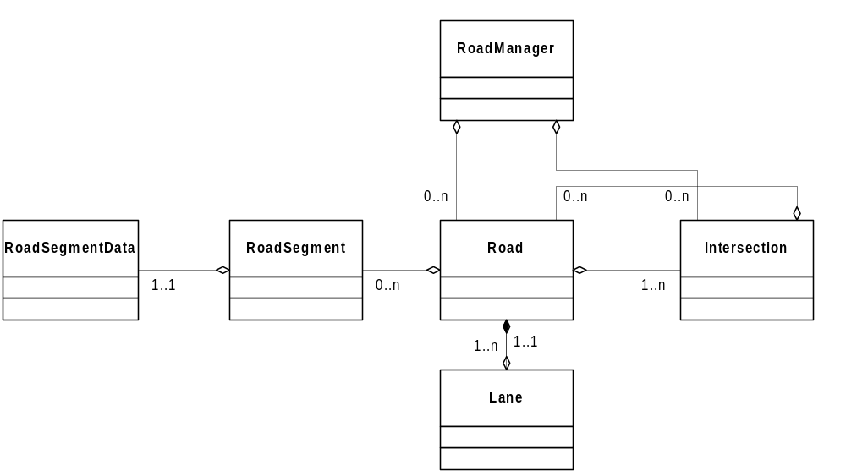

Use Cases

2.4.1 Find Road and RoadSegment given world coordinate.

