Revision History
Issue | Date | Person | Reason - include problem #, ECN #, etc.
0.1 | Feb 11, 2002 | Darwin Chau | Initial draft for internal review.
1.0 | Mar 13, 2002 | James Ceraldi | Second draft
2.0 | Apr. 12, 2002 | Darwin Chau, Greg Mayer, Darren Esau | Updated for new tech design docs

TABLE OF Contents
1. Introduction 4
1.1 Goals 4
1.2 Glossary 4
2. The Static Model 5
2.1 Game Components Overview 5
2.2 Controllers 6
2.2.1 Game Flow Controller 6
2.2.2 Bootup Context 7
2.2.3 Frontend Context 7
2.2.4 Loading Context 7
2.2.5 Gameplay Context 8
2.2.6 Pause Context 8
2.3 Managers 8
2.3.1 Mission Manager 8
2.3.2 Presentation Manager 9
2.3.3 Avatar Manager 10
2.3.4 Camera Manager 10
2.3.5 Character Manager and Characters 10
2.3.6 Controller Manager 11
2.3.7 F/X Manager 12
2.3.8 GUI Manager and GUI Elements 12
2.3.9 Loading Manager 13
2.3.10 Memory Card Manager 13
2.3.11 World Physics Manager 13
2.3.12 Script Manager 14
2.3.13 Sound Manager 14
2.3.14 Trigger Volume Manager 14
2.3.15 Vehicle Manager 15
2.3.16 Devin’s World Scenegraph (DSG) 16
2.4 View 16
2.4.1 Graphics Rendering System and Renderables 16
2.4.2 View Ports 17
2.4.3 Sound Rendering System and Sound Clips 17
3. The Dynamic Model 19
3.1 The Main Game Loop 19
3.1.1 The FTech Dispatcher 19
3.1.2 The Game Flow 20

Introduction
This document provides an overview of the software architecture that the Simpsons 2 project will use. This one architecture will be used for all our target platforms: Playstation 2, Game Cube and XBox. Some software components are currently “generic” to allow for flexibility once the gameplay mechanics and flow are decided on.

Goals
The objective of this document is to describe the major components of the game and how they interact. It also describes how the flow of the events is maintained throughout each of the different game states and the specifics of game state transition activity.

Glossary
FTech Radical Foundation Technology Library/Team
Pure3D Radical 3D Graphics Engine Library/Team
Choreo Radical Character Animation Game Building Block
FMV Full-Motion Video
NIS Non-Interactive Sequence
GUI Graphical User Interface (Frontend / HUD / Pause Menu)
HUD Heads Up Display

The Static Model

Game Components Overview
The software architecture is object-based with objects inhabiting layers of specialization. Objects at the highest layers have the largest knowledge of the application scope. They essentially implement the overall game behaviours at the highest structural level. These objects will delegate responsibility to subservient and increasingly-specialized objects that together will perform the tasks involved in the gameplay. Therefore, these objects are instances of application-independent classes, which in terms of our architecture are found at a lower layer. At the lowest layer are objects and services that are completely application independent; these objects provide interfaces to the computer hardware.
Another key idea is that objects are restricted to hemispheres of control - that is, an object can only directly reference objects that belong to the same layer or to a lower layer in the architecture than itself. Thus, an object at a higher layer can implement its own behaviour by orchestrating the execution of behaviours of other objects that are at or below the layer to which it belongs.
The architecture has three distinct layers of objects:
- The Controller layer includes objects that can reference objects in the model layer, or other controller objects. Controllers set the initial state of the simulation, and then coordinate the execution of the simulation.
- The entities in the Model (manager) layer implement the simulation. The model maintains and modifies the state of the characters and world over time. Entities belonging to components in the model layer can reference other model entities. They cannot however, call ‘up’ to entities in the controller layer. As a rule, model entities must not know about the existence of the controllers (at the higher layer). The intent of this strict top-down approach to referencing objects between layers is to prevent coupling and to create reusable components for any game. Entities in the model layer can reference objects in the layer below it, the View layer.
- At the very bottom of the hierarchy are the View entities. The entities in this layer provide an abstraction (at various levels) to the input and output hardware. View entities do not know about model or controller entities. Model entities will talk to the View entities in order to present themselves for rendering.

In Figure 1 "The GameFlow Component Architecture", the architecture at the component level is laid out. The layers of the architecture are highlighted in the figure by the shaded areas. The components, identified by the boxes, are found in one of these layers.
Following the diagram will be a full description of each component.
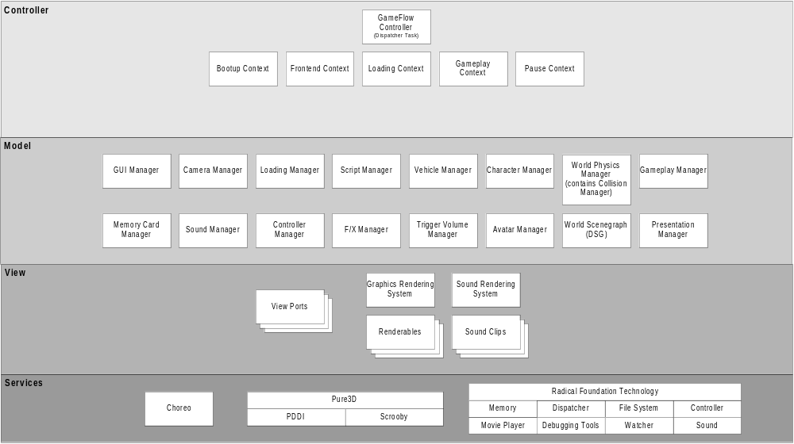
Figure 1 - The Game Flow Component Architecture

Controllers
Controllers are entities that orchestrate the execution of the game. For instance, there are controllers that decide when the simulation should run, and from what initial state. Other controllers decide what to embellish over the simulation to make it into an entertaining game, such as calling up graphic overlays or performing camera cuts. Controllers will call on the managers in the model layer to orchestrate the execution of the game.

Game Flow Controller
The Game Flow Controller orchestrates the overall game execution. It simply controls the switching between “contexts”. Each context represents a game state with distinct functionality and input and output mappings. The GameFlow will run in a given context until that context gives up control, and the GameFlow will switch to run in another context. All contexts are mutually exclusive (the game only runs in one state at a time) but the model is accessible to all contexts. For example, the Frontend Context will store the user selections in the database part of the model that the Game Play Context will later read to initialize the game.
Collaborations:
- Talks to the various contexts (detailed below) to execute the game in the appropriate state.
- Talked to by the various contexts to switch to a different context.
- Talked to by the FTech Dispatcher, who schedules the GameFlow to execute the game in response to time and input events.
Details on the game flow can be found later in this document.

Bootup Context
The Bootup Context is the first active context once the console is powered up. It is called for each GameFlow update when the GameFlow is set to this context.
Collaborations:
- Talks to Loading Manager to display licensing screen and load frontend resources.
- Talks to FMV Manager to stream intro movies.
- Talks to Memory Card Manager to check memory cards.
- Talked to by GameFlow Controller to drive execution of this context.

Frontend Context
The Frontend Context controls the primary user interface for configuring the game.
Collaborations:
- Talks to GUI Manager to manipulate and navigate user interface screens.
- Talks to Memory Card Manager to access persistent storage.
- Talked to by GameFlow Controller to drive execution of this context.

Loading Context
The Loading Context controls the transition between the Frontend and Gameplay and back again. Since large amounts of content will be loaded during this transition, a loading screen will be displayed.
Collaborations:
- Talks to Loading Manager to schedule loading for all required assests.
- Talked to by GameFlow Controller to drive execution of this context.

Gameplay Context
This context represents the gameplay state. In the Gameplay Context, the user has control of their avatar in a live and interactive world.
Collaborations:
- Talks to Character Manager to update all characters’ movements and locations.
- Talks to Vehicle Manager to update all vehicles’ movements and locations.
- Talks to World Physics Manager to apply physics to objects in collision.
- Talks to the Mission Controller to initialize itself. The Mission Controller will handle events from the various other managers in the model.
- Talks to Presentation Controller to initialize itself. The Presentation Controller will handle events from the various other managers in the model.
- Talked to by GameFlow Controller to drive execution of this context.

Pause Context
The Pause Context controls the execution of the Game Flow when the game is suspended and the pause menu is active.
Collaborations:
- Talks to the GUI Manager to manage the control of the pause menu.

Managers
Managers are entities that create, update and destroy the objects comprising the simulation model or presentation model. For client objects, managers are the interface to access and update simulation objects like characters, vehicles and world objects, or presentation objects like overlays. Moreover, a manager will administrate over the lifetimes of these objects, being responsible for their creation and destruction. For instance, the Vehicle Manager will oversee all the player, AI and traffic vehicles that run in the simulation. The Vehicle Manager will be told to create these entities and will do so only when told. It will have an interface to update and access them, and when they are no longer needed, destroy them. The Vehicle Manager will continue to be the access point through which controllers and other managers and their objects access the vehicle.

Mission Manager
The Mission Manager is responsible for overseeing the “rules” of the game. Using scripting, the initial setup, objectives and failure conditions for each mission will be defined. Once the Gameplay Context is executing, the Mission Manager will observe the managers in the model layer for events that impact mission progress.
Collaborations:
- Observes the Character Manager to receive notification when a character changes state. (e.g. a user character is detected by a NPC)
- Observes the Vehicle Manager to receive notification when a vehicle changes state. (e.g. AI vehicle has been disabled)
- Observes the Trigger Volume Manager to receive notification when a volume has been activated. (e.g. user has reached destination)
- Talks to Character Manager to create/kill/place characters.
- Talks to Vehicle Manager to create/kill/place vehicles.
- Talks to Script Manager to run mission scripts.
- Talked to by Gameplay Context at game initialization.

Presentation Manager
A component that controls the execution and timing of overlays, NIS’s, camera cuts, FMVs, and special effects. The Presentation Controller has the role of “director” in managing how the broadcast of the game is presented. It will coordinate the display of popup-overlays, non-interactive sequences, camera cuts, etc. (i.e., whenever some game event warrants an added visual, the Director is involved.) Using scripting, the actions of the Presentation Controller will be bound to events. (e.g. playing an NIS at the completion of mission objectives)
Collaborations:
- Observes the Mission Controller to react to mission progress changes.
- Observes the Character Manager to receive notification for desired events. (e.g. character has picked up object, show overlay)
- Observes the Vehicle Manager to receive notification for desired events. (e.g. vehicle is making big jump, cut to special camera)
- Talks to the NIS Manager to play a given NIS.
- Observes the NIS Manager to receive the end status of an NIS.
- Talks to GUI Manager to control the display of overlays and to receive direction in playing FMVs
- Talks to Camera Manager to control the camera.
- Talks to Script Manager to execute presentation scripts.
Talked to by Gameplay Context at game initialization.

Avatar Manager
An “avatar” is the user’s representation in the game world. The avatar handles the relationship between the user’s biped character, their vehicle, and their physical controller device.
Collaborations:
- Talks to Character and Vehicle Managers to get access to user’s character and vehicle.
- Talks to Controller Manager to route user input to character or vehicle.
- Observes Vehicle Manager to know when a character has entered/exited vehicle.
- Handles events from the Event Manager

Camera Manager
The Camera Manager controls the location of all the cameras for the current view. Cameras are initially set by the Mission Controller. The cameras’ position and targets are then updated when the target character or vehicle changes location or any other game state change.
Collaborations:
- Observes the Character and Vehicle Managers to receive notification when the target characters and/or vehicles change location so that the camera will move in relation.
- Talks to Views to send the active cameras down the rendering pipeline.
- Talked to by Mission Controller to create game camera(s).
- Talked to by Presentation Controller to initiate camera cuts.
Note: When a NIS is active, the NIS have control of it’s own internal cameras.

Character Manager and Characters
A component that manages the characters in the game, where characters are defined as any non-vehicular objects in the world that has state and autonomous control logic. Characters could include humans, animals or even elements in the world that have behaviours. The Character Manager is responsible for managing the character lifetimes and provides an interface to clients for this purpose. The Character Manager will build upon the Choreo system for character animation support.
Collaborations: (Character Manager)
- Notifies all registered observers that are interested in state changes to individual characters when those characters have changed state.
- Talks to Renderables in View to send simulation data updates held in a character objects down the rendering pipeline.
- Talks to FX Manager to trigger special effects related to the interaction of a character and its world (e.g., shadows)
- Talks to Controller Manager to acquire and to release controller devices for a character.
- Talks to the Collision Manager to add characters to the 2D collision test space.
- Talks to World Physics Manager to add characters to the physics simulation if a collision involving the character was detected by the Collision Manager.
- Talked to by the Mission Controller to convey where characters should ‘teleport’ at the start of an event.
Collaborations: (Characters)
- Observes Controller Device objects for human input events. (Player character)
- Observes Collision Manager for involvement in collisions.
- Talks to Script Manager to execute AI script. (NPC)

Controller Manager
The Controller Manager manages Controller objects mapped to the available collection of user input devices (gamepads, steering wheels, etc.). Controller objects will present an interface that abstracts the hardware differences between input devices. Furthermore, the Controller objects can be assigned different key-maps, which provide context-sensitive operation of the controllers. (Context-sensitive operation is required to give the controller transparency when the game flow changes between contexts, e.g. Frontend to Gameplay.)
Collaborations:
- Notifies character and vehicle objects of user input events.
- Notifies the Frontend and Pause Contexts of user input for menu navigation and selection events.
- Talked to by Character Manager to assign a controller to a character.
- Talked to by Vehicle Manager to assign a controller to a vehicle.
- Talked to by various contexts to use appropriate controller mappings.

F/X Manager
The F/X Manager maintains the state of F/X objects. The F/X Manager essentially is a resource registry that arbitrates requests for F/X objects and then manages the lifetimes of those objects. Requests to create an F/X may be rejected based on the current resource limits.
F/X objects include:
- Particle system-based effects such as fire or water spray.
- Vehicle skid marks.
- Shadows.
Collaborations:
- Talks to F/X objects under its management.
- Talks to View to attach/detach and update F/X renderables.
- Talked to by character (Character Manager).
- Talked to by Character, Vehicle and World Managers to create F/X objects.

GUI Manager and GUI Elements
The GUI Manager is responsible for managing the lifetimes for the GUI elements, which are any screens, overlays, pause menu, HUD elements, etc., consisting of visual display objects that communicate session or in-game data to/from the user. The UI Manager is responsible for object creation-deletion and communicating update messages to them.
Collaborations: (GUI Manager)
- Talked to by Frontend Context to create and display initial GUI screen.
- Talked to by Pause Context to create and display pause menu.
- Talked to by Presentation Controller to display/hide HUD elements and overlays.
- Talks to GUI elements to create/destroy them.
- Talks to GUI elements to trigger them to update.
- Talks to View to attach GUI elements to it for rendering.
Collaborations: (GUI Element)
- Observes the Controller Manager for input from a controller.
- Talked to by GUI Manager to get created/destroyed.
- Talked to by GUI Manager to update.

Loading Manager
The Loading Manager serves as the central access point to retrieve the game content from the disk. The Loading Manager will display a loading screen while the Loading Context is active.
Collaborations:
- Talked to by Bootup Context to display license screens and load frontend assets.
- Talked to by Loading Context to display loading screens and load gameplay or frontend assets.
- Notifies Bootup and Loading Contexts when loading is complete.

Memory Card Manager
The Memory Card Manager provides an abstract interface to the various persistent storage options on the different platforms.
Collaborations:
- Talks to FTech File services to save and retrieve persistent data, to and from recording media.
- Talked to by Bootup Context to check for presence of memory cards.
- Talked to by GUI elements (memory card screen) to save and retrieve data.

World Physics Manager
The World Physics Manager performs the physics simulation on characters, vehicles and world objects. Essentially, a character’s skeleton will be deformed by blending the animation transformations with the results of the physics simulation to include all collision forces between that character and the objects with which it collides. The decision to run the physics simulation is made by the Character, Vehicle or World Object Manager - ie. in some cases the objects these managers own will be controlled with AI whereas at other times they will be controlled with physics.
The World Physics Manager also owns the CollisionMangaer, which is the games interface to the low level simulation librarys, which include efficient collision detection routines. It also traps collision events that need to be dealt with specially in the game, and triggers appropriate events.
Collaborations:
- Talks to Devin's Scenegraph (DSG) to get rough world object proximity information.
- Talked to by the Character Manager to enter characters into the physics simulation world and updated them when they are moving with physics - eg. flying through the air.
- Talked to by the Vehicle Manager to enter vehicle into the physics simulation world and update them.
- Talks to CameraManger, telling it to update itself, and gives it points of interest.
- Talks to TrafficManager, propogating updates.
- Talks to Animated Collision Objects telling them to update themselves.

Script Manager
The Script Manager functions as a run-time interpreter for the execution of the Mission and Presentation scripts.
Collaborations:
- Talked to by Mission Controller to load and execute mission scripts.
- Talked to by Presentation Controller to load and execute presentation scripts.

Sound Manager
The Sound Manager is a component that provides a light-weight, device-independent interface for playing sound clips. Clients that require a sound to be played, send a request to the Sound Manager that will create a sound object that gets attached to the View. Since sound resources are limited, the Sound Manager will have to arbitrate requests and may need to drop lower priority items.
Collaborations:
- Talks to View to send setup sound clips for playback using the Sound Rendering System.
- Talked to by the Characters to play sound clips.
- Talked to by the Vehicles to play sound clips.
- Talked to by the World Objects to play sound clips.
- Talked to by the GUI elements to play sound clips.

Trigger Volume Manager
The Trigger Volume Manager is a component that manages the trigger volumes in a given mission. Trigger volumes are geometries that are place in the world by the level designer that are invisible but have collision properties. Associated with the trigger volume are event triggers that are also specified at design-time.
At run-time, a trigger volume will fire off the event triggers whenever the trigger volume geometry is breached by a qualifying character—i.e. any character that has membership in a qualifying set for sending event triggers. Finally, trigger volumes can be either reset so they are active again or active one-time only. Again, this is defined by the level-designer at design time.
Collaborations:
- Notifies World Manager of triggered events.
- Notifies Character Manager of triggered events.
- Notifies Vehicle Manager of triggered events.

Vehicle Manager
A component that manages the vehicles in the game. These include player controlled vehicles, AI controlled vehicles and simplified traffic vehicles. The Vehicle Manager is responsible for managing the vehicle lifetimes and provides an interface to clients for this purpose.
Collaborations: (Vehicle Manager)
- Notifies all registered observers that are interested in state changes to individual vehicles when those vehicles have changed state.
- Talks to Renderables in View to send simulation data updates held in a vehilce objects down the rendering pipeline.
- Talks to FX Manager to trigger special effects related to the interaction of a vehicle and its world (e.g., shadows, skid marks, etc.)
- Talks to Controller Manager to acquire and to release controller devices for a vehicle.
- Talks to Physics Simulation Manager to add vehicles to the physics simulation if a collision involving the vehicle was detected by the Collision Manager.
- Talked to by the Mission Controller to convey where vehicles should ‘teleport’ at the start of an event.
Collaborations: (Vehicles)
- Observes Controller Device objects for human input events. (Player vehicle)
- Observes Collision Manager for involvement in collisions.
- Talks to Script Manager to execute AI script. (Non-Player vehicle)
- Talked to by the Physics Simulation Manager to modify the vehicle pose (e.g. damage state) after running the physics simulation.

Devin’s World Scenegraph (DSG)
The Devin's World Scenegraph is responsible for managing world levels and objects within these levels. The DSG will manage the state of the world and manage the lifetimes of those world objects that have state which are contained in the current world.
Collaborations:
- Notifies all registered observers that are interested in state changes to individual world objects when those objects have changed.
- Observes Trigger Volume Manager to receive notification whenever a qualifying world object penetrates a trigger volume.
- Talks to Renderables in View to send simulation data updates held in a world object down the rendering pipeline.
- Talks to World Physics Manager to register world objects to the collision space.
- Talked to by the Mission Controller to dynamically add or remove world level objects.

View
The View functions as a collection point for any object to be visually and aurally rendered. The View has attached to it objects related to positioning and orienting characters, vehicles, world objects, GUI elements, special effects and sound clips. The game simulation will continually update these attached objects so that when the rendering systems reference them for drawing or playing, they will reflect the current simulation state.
It is because model data can be accessed only through the View, direct coupling between the output (rendering) components and the model is eliminated. Therefore, the model can change without affecting any of the rendering code.

Graphics Rendering System and Renderables
The Graphics Rendering System (GRS) manages the display rendering of the visual game elements, the Renderables, listed below. The GRS is a wrapper that is used to encapsulate all calls to the Pure3D libraries into a single component within the game.
- Characters
- Vehicles
- World and world objects
- Special effects
- GUI elements
- Camera – responsible for targeting, field of view and depth of view of the world.
Collaborations (Graphics Rendering System):
- Talks to Pure3D to perform rendering.
- Talks to Renderables to retrieve display objects for rendering.
Collaborations (Renderables):
- Talked to by model layer components to update simulation state (position and orientation, poses, etc.)
- Talked to by Graphics Rendering System to render to display.

View Ports
A view port represents an instance of the view that must be rendered. Each view port is defined by its attached camera. For example, two view ports are needed for a split screen game where two cameras show different perspectives of the same simulation. The GRS will render any existing view ports.

Sound Rendering System and Sound Clips
The Sound Rendering System performs sound-space load-management and sound rendering functionality. In addition, it provides a system independent, object-oriented interface for creating listeners and sound objects, which can be played, paused, and stopped, etc. These objects can be positioned in 3D space.
The Sound Rendering System will make available the functionality to load and release sound resources to the game client. Sound resources can be both clips and streams, although only clips are loaded in their entirety into sound memory. Sounds like music, dialog or ambient background noise are loaded on demand and streamed off disk. It is really up to the sound designer and programmer to make sure that a sound resource can be quickly loaded and be context sensitive to the scene. For instance, on some mission levels, a sound would be loaded on entry into a room so that sound clips for footsteps will sound sharp and loud (such as when walking on a hard surface in an enclosed space). Continuing further in the mission another sound space may be loaded, (or swapped in place of the existing sound space), that correlated with a change in environment which may be outside in a wide open space where the echo of footsteps would be less prevalent or even non-existent if the ground surface was soft, for instance.
Collaborations:
- Talks to the FTech sound library.
- Talked to by the Sound Manager to trigger level-specific sound space loads.
- Talks to Sound Clips to retrieve sound objects to be rendered.

The Dynamic Model

The Main Game Loop
This section will explain the main game loop architectural components and their dynamic behaviour.
The “while (1)” loop found in many existing game loops has been supplemented with the Radical Foundation Technology Dispatcher. The “run simulation and then render” serialized logic flow has been dropped in favour of simply scheduling these as separate tasks in the Dispatcher. The setup for the game loop is illustrated in the following pseudocode.

START

FTechDispatcherAddTimerTask( GameFlow, 60Hz );
FTechDispatcherAddTimerTask( GraphicsRendering, 60Hz );
FTechDispatcherAddTimerTask( SoundRendering, 60Hz );

while( 1 )
{
// Service FTech
FTechServiceDispatcher();
FTechServiceController();
FTechServiceFilesystem();
}

END

The FTech Dispatcher
The Dispatcher is a mechanism for task scheduling. It is simply a queue in which tasks are placed with an associated timer. These tasks essentially “sleep” until their timer expires at which time they are queued on the Dispatcher to run. Tasks are queued to run in the order in which they were added.
The Game Flow, Graphics Renderer and Sound Renderer are the three scheduled tasks in the game. Note that the execution rate for each task can be configured independently if desired.
The Dispatcher has a non-preemptive task-dispatch system, meaning that a task gives up execution control only when it finishes servicing the event and returns to the Dispatcher. This is shown in the following use-case diagram where the broadened areas on the lines under each task indicate the time during which a task has control of execution. Another feature of the Dispatcher is that it will only service a timer once that has backed-up and ticked multiple times (because another task may have taken a long time). Therefore, each task has to account for a possible delay in their having been dispatched.
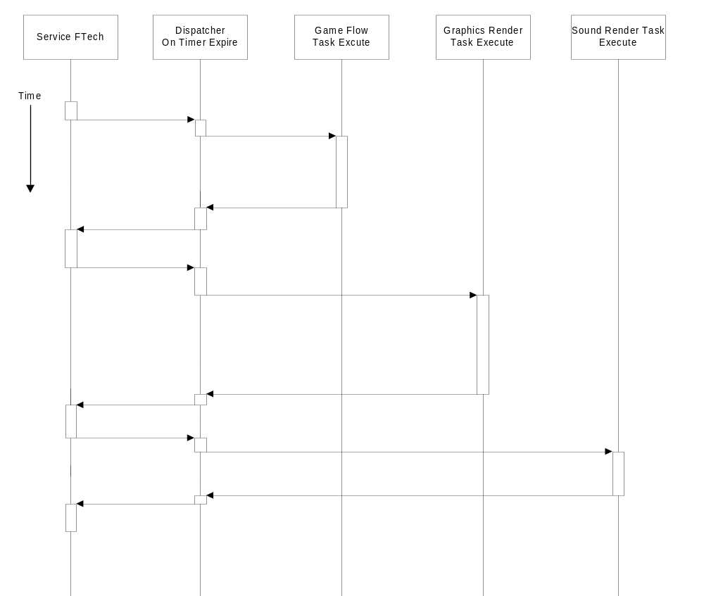

The Game Flow
The GameFlow task is registered at the very top of the program control to be sent by the Dispatcher to execute at regular intervals. It is the brains of the game, executing the AI, menus, etc. The Game Flow task is the thread of execution that controls and maintains the game’s context (i.e. state). A context is a functionally distinct part of the game with input and output mapped according to the current functional grouping. The Game Flow will set the current context and continue to run that context until the context gives up control, and the Game Flow will switch to run in another context. All contexts are mutually exclusive and do not share state.

Known Game Flow execution contexts are:

- Bootup
- Frontend
- Loading
- Gameplay
- Pause

Each of these contexts and their relationships were discussed in Controllers subsection above.
The Game Flow task controls which context gets control. This control logic is hard-coded at the very highest level of the GameFlow state machine. All contexts are mutually exclusive and a context will have control until which time a user or event forces control to return to the GameFlow controller. The transitions between Contexts are illustrated in the figure below:
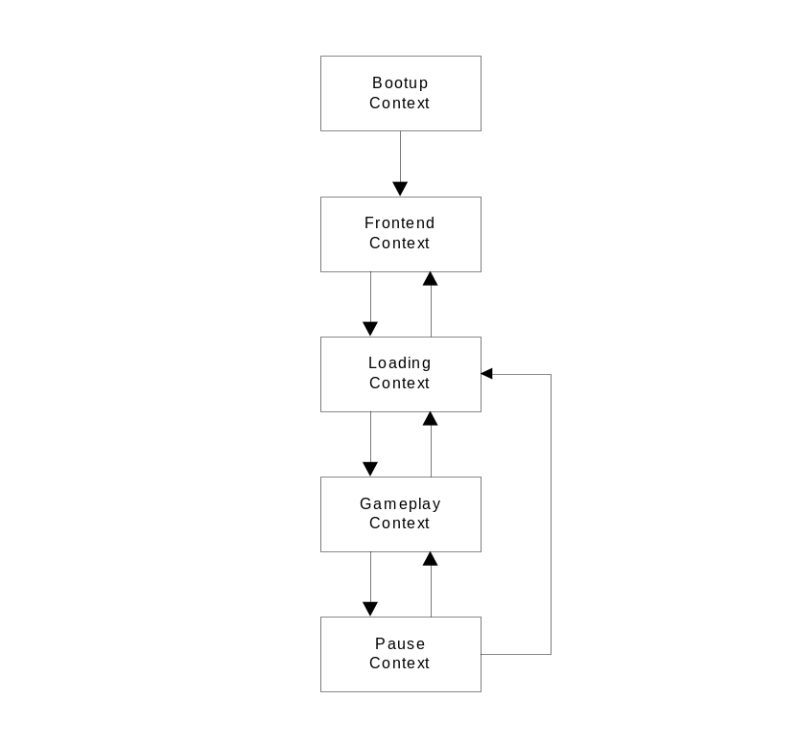

Bootup Context
The Game Flow executes in the Bootup Context on powerup. Once the Bootup Context has completed executing, it transitions to the Frontend Context. The game never returns to the Bootup Context.

Frontend Context
The Frontend Context executes the primary user interface screens. When the user has finished configuring the game options and settings, it transitions to the Loading Context.

Loading Context
The Loading Context is active while required content is being retrieved from persistent storage. This context transitions to the Gameplay Context if it was entered from the Frontend Context. Conversely, this context transitions to the Frontend Context if it was entered from the Gameplay or Pause Contexts.

Game Play Context
The Game Play Context is the GameFlow state that executes the game. This includes the execution of Mission Controller, Presentation Controller, Character Manager/Characters, Vehicle Manager/Vehicles, World Manager, Camera Manager, etc. This context will relinquish control if the user requests a transition to the Pause Context. This context may also transition to the Loading Context at the conclusion of a mission.

Pause Context
The Pause Context manages the operation of the Pause menu screen. In this context, the controller button mappings allow the user to navigate around and execute the functions of the Pause screen. This context will relinquish control back to the Gameplay Context if the user wishes to resume the game. A transition to the Loading Context will be triggered if the user decides to quit the mission.

