Technical Design for Enemy Vehicle AI
Revision History

Issue | Date | Person | Reason
0.1 | April 05, 2002 | TBJ | Initial Draft.
1.0 | April 12, 2002 | TBJ | Reviewed by team and released

Description

Introduction
The goals of the Enemy Vehicle AI in SRR2 are:
- Fun.
- Non-frustrating, the user doesn’t feel that the AI cheats or has skills or abilities that the user does not.
- Non-predictable, the AI should not do the same thing mission after mission.
- Effective strategies, tools, and counter-measures for defeating AI chase vehicles.
- Clear strategies and tools – the user must know what they are supposed to do.
- Visceral payoff for utilizing the strategies – use visuals, sound, controller vibration, camera (position, camera shake, etc.) and physics system (e.g., aftershock of explosion shakes player vehicle).
- Empower the user – e.g., create difficulty by the number of enemies, not by increasing their strength.
- Flexible AI that can be tuned by designers (e.g., location specific AI) but with runtime variables to control AI difficulty and numbers.

Requirements
- AI vehicles will be able to behave as simple traffic vehicles.
- AI vehicles will be able to switch to a fully simulated physics model, equivalent to that of the user controlled character.
- The AI vehicles can be “driven” by an AI controller: there will be no difference between the controller input of an AI vehicle vs. a user-controlled vehicle.
- The AI vehicles will be limited by a “reaction time” to react to game situations. Eg Avoiding traffic.
- The AI vehicles “reaction time” will be designer tuneable.
- The reaction time for AI vehicles can be set by the mission scripter.
- The Vehicle AI will implement many common driving game tactics:
  - Sideswipe
  - Sideswipe a vehicle near the tail, causing a spin out.
  - T-Bone collision.
  - Head-on collision.
  - Rear end collision.
- The Vehicle AI tactics should be implemented in such a way that the user will have effective countermeasures to defeat the AI. Eg Swerving at the right moment.
- AI Vehicle start locations (“spawn points”) will be placed in Maya.
- Start locations will be created on a mission by mission basis.
- AI Vehicles will spawn at start locations only if a given difficulty state is surpassed.
  - For Example: All “spawn points” will be given a difficulty state equal to a scalar value. AI Vehicles will only spawn when the global game difficulty state is greater than this value.
- The difficulty state will increase as chase time accumulates.
- The difficulty state will increase as the user completes or partially completes mission objectives. (eg The more trash cans you destroy (mission objective) the higher the difficulty state.
- The AI vehicles will be spawned into the game world with a specific role to play.
  - AI Vehicles will execute the “Chase AI” role.
  - AI Vehicles will execute the “Evade AI” role.
  - AI Vehicles will execute the “Road block AI” role.
  - AI Vehicles will execute the “Traffic AI” role.
- AI Vehicles will be able to switch between roles in a limited manner.
- There will be “generic” AI vehicles with simple geometry and no visible driver character.
- There will be “boss” AI vehicles with a high detail geometry (similar to the player vehicle) and a fully rendered, skinned, and animated driver character.
- AI vehicles will explode when they crash hard enough to become disabled (cumulate damage exceeds some threshold).
  - a large visible explosion special effect.
  - Explosion sound
  - Camera shake.
  - Controller vibration.
  - Nearby vehicles might will react to force of Aftershock. (see Smuggler’s Run 2)

- AI Vehicles can have visual damage states.
- Escape AI will follow a series of waypoints while “driving” under full physics control.
  - Waypoints can be created offline using the mission scripter (or a Maya Tool?).
  - Paths created offline can have “branching” waypoints that allow the AI to choose an alternate (but still predefined) route a certain points.
  - Waypoints can be created at run time using the Road Network Navigation Graph to create a (shortest) path.
- AI vehicles will signal their intentions to turn left or right.
- Target AI Vehicles will be identified with some sort of 3d decoration.
  - a 3d arrow (GTA3).
  - Glow
  - Damage meter.
- AI vehicles will have a “Car sound” simulation object that will generate Sound fx based on engine RPM, squealing tire Sound fx.
- AI Vehicles will be activated via a trigger volume or proximity test.
- AI Vehicles will be disabled due to cumulative collision impacts.
- Vehicle AI difficulty will be tuneable at run time (The Watcher). Tuning parameters TBD.

References
- Talked to Joe McGinn about the AI Requirements.
- Greg Mayer re: the driving engine module.
- Talked to myself re: the Road Network.
- Talked to Cary Brisebois re: the Road Network.

Technical Design

Relationships

The Vehicle AI makes extensive use of the driving engine module by Greg Mayer. The AI provides input to an instance of a physics vehicle in the same way a user would control a Vehicle with a gamepad. The AI also depends on the PhysicsVehicle to provide information about the physical state of the vehicle. The Ai will need to know how fast the PhysicsVehicle is travelling, if the PhysicsVehicle is sliding, spinning, or air born. It will use this information to control the PhysicsVehicle in much the same way a user would. For example: braking when appropriate, and attempting to control skids through counter steering. This interface is outlined in the next section.

One of the primary concerns of the Vehicle AI is driving about the world realistically. Using the roads, intersections, and shortcuts appropriately. This implies an extensive relationship with the RoadNetwork component. This relationship is one way: the Vehicle AI knows of the RoadNetwork, but the RoadNetwork knows nothing about the vehicles that use it. The Vehicle Ai will use the Road Network to ensure that it stays “on the road”. The RoadSegments, which are the basic building block of the RoadNetwork, provide information about the relative position of an object on the road. Please see the “roadnetworktecherq.doc” document for more information. We will say a vehicle is on a road if the world space coordinate is contained by a road. The Vehicle Ai will maintain a data structure that will contain the current Road, and the current RoadSegment. On a frame by frame basis we will be able to determine where the vehicle is on the RoadSegment. If a Vehicle moves to a new RoadSegment, we will look to the next RoadSegment contained in the current Road, if the vehicle is not on that RoadSegment, we will check the previous RoadSegment (the vehicle could have moved backwards). Failing that, we will test all the RoadSegments in the current Road. If we don’t find a RoadSegment for the vehicle, we will test nearby Roads. Roads and RoadSegments have primitive spherical and axis aligned bounding box primitive so the tests should all be fairly inexpensive. In addition, the Roads and RoadSegments will be culled via the scene graph, so only relevant Roads and RoadSegments will be considered.

The Road Network will also be used by the Vehicle AI for navigation/path following. Paths will consist of Intersection objects. See the Use Case for a more detailed explanation.

If a Vehicle is on a road that is not directly connected to it’s destination intersection, it could potentially plot a path at run time to that intersection. Generally, this will not be the case, as vehicles will be spawned in close proximity to the path that they are supposed to follow.

The Vehicle AI will need to receive messages from the Phsyics Collision Detector. The AI Vehicles will become damaged by Physics collisions. When the cumulative damage exceeds a threshold, the AI Vehicle will be disabled.

Interface
The primary interface for the vehicle AI will be that between the PhysicsVehicle (see driving engine technical design) and the VehicleController. The Vehicle Controller will store state information. The VehicleController will provide an interface for providing this information:
class Vehicle;

// Skeleton class for example.
//
struct IButton
{
virtual float GetValue( void ) const = 0;
virtual float GetHeldTime( void ) const = 0;
};

class VehicleController
:
public tRefCounted
{
public:
VehicleController( Vehicle* pVehicle );
virtual ~VehicleController( void );

virtual void Update( float timeins ) {};

virtual const IButton* GetGas( void ) const = 0;
virtual const IButton* GetBrake( void ) const = 0;
virtual const IButton* GetSteering( void ) const = 0;
virtual const IButton* GetHandBrake( void ) const = 0;
virtual const IButton* GetReverse( void ) const = 0;
virtual const IButton* GetHorn( void ) const = 0;
protected:
Vehicle* GetVehicle( void ) const;
private:
Vehicle* mpVehicle;
};

The Vehicle class will provide an interface which mirrors that of the vehicle controller:

class PhysicsVehicle
{
public:
// Note only relevant input interface is shown.
//
void SetGas( float gas );
void SetBrake( float brake );
void SetSteering( float steering );
void SetHandBrake( float handbrake );
void SetReverse( float reverse );
void SetHorn( float horn );
//
// ...
//
};

The PhysicsVehicle class will also need to provide an interface to expose details about its physical state:

class PhysicsVehicle
{
public:
// Note only relevant output interface is shown.
//
const rmt::Vector& GetFacing( void ) const;
const rmt::Vector& GetPosition( void ) const;
const rmt::Vector& GetVelocityCM( void ) const;
const rmt::Vector& GetAngularVelocity( void ) const;
const rmt::Vector& GetAngularAcceleration( void ) const;

const rmt::Vector& GetWheelFacing( int index ) const;
float GetWheelSlippage( int index ) const;

bool IsAirBorn( void ) const;
//
// ...
//
};

The VehicleController will use the above interface, along with sensory input from it’s “behaviours” to make generate input data (gas, brake, steering) for the PhysicsVehicle.

The RoadManager will provide an external interface that will allow return a road that contains the given point. The RoadManager will talk to the SceneGraph which will return only the Roads that are nearby.

RoadManager::FindRoad( const rmt::Vector& point,
const Road** ppRoad );

The Road Object will return return the RoadSegment the world space point is currently in as well as the lateral position and distance in the RoadSegment.

Road::GetRoadSegmentAtPoint( const rmt::Vector& point,
const IRoadSegment** ppOutRoadSegment,
float& in,
float& lateral,
int hint );

The “hint” parameter is the index of the current RoadSegment.

The RoadSegment will return a lateral position between 0.0 and 1.0 and a distance in between 0.0 and 1.0 given a world space position. Any values returned outside the range 0.0 and 1.0 indicate a point not contained by a RoadSegment.

RoadSegment::CalculateUnitDistIntoRoadSegment( float fPointX,
float fPointZ );
RoadSegment::CalculateUnitHeightInRoadSegment( float fPointX,
float fPointZ );

The TriggerVolume system will throw events that will be received by the VehicleManager Class. The VehicleManager will instantiate Vehicles with the parameters defined by the TriggerVolume event data.

Component Class Diagrams

Vehicle AI
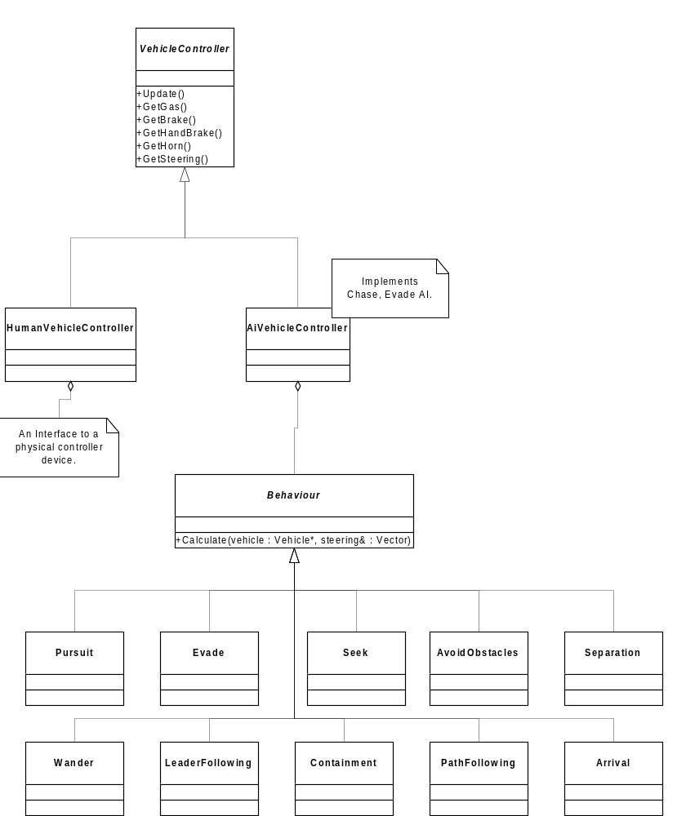

Use Cases

Create an AI Vehicle.
- User vehicle enters a AI Vehicle TriggerVolume.
- TriggerVolume raises a CREATE_AI_VEHICLE event.
  - EventData =
    - Vehicle Spawn Location
    - AI Type = { Chase, Evade, RoadBlock };
    - AI Difficulty State
- EventManager passes the Event to VehicleManager.
- The VehicleManager handles the event.
  - if Game Difficulty State >= AI Difficulty State.
    - Create AI Vehicle of correct AI Type.
    - Place Vehicle in world.
- AI Vehicle will “Chase” target vehicle.

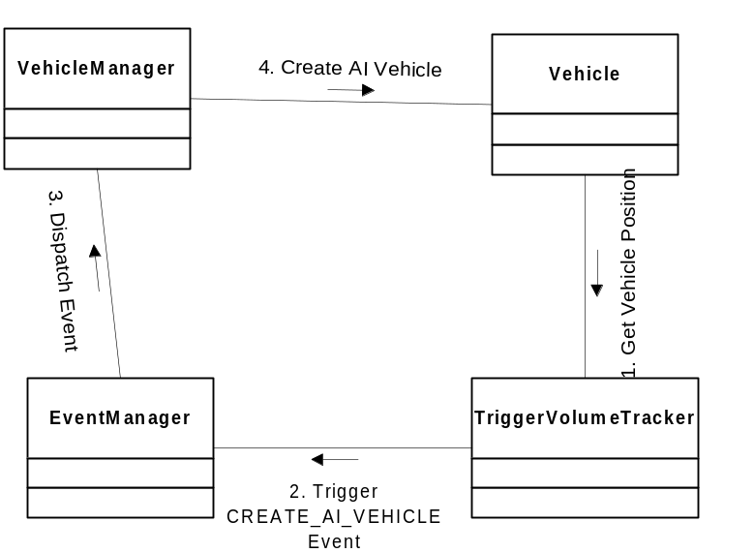

Chase User Vehicle
- VehicleController::Update()
  - Update Behaviours
    - Update StayOnRoad Behaviour
      - Calls Road::GetRoadSegmentAtPoint
      - Returns a steering vector.
    - Update AvoidObstacles Behaviour
      - Calls SceneGraph::GetObjectsInProximity()
      - Returns a steering vector.
    - Update Pursuit Behaviour
      - Returns a steering vector.
  - Evaluate summed steering vector.
    - Generate state for Gas, Brake, Steering based on steering vector.
- VehicleManager::Update()
  - Get VehicleController outputs (gas, brake, steering).
  - Set inputs (gas, brake, steering) for Physics Vehicle.
- Vehicle::Update()
  - Transform inputs (gas, brake, steering) to locomotion forces.
