Technical Design for World Physics Manager
Revision History

Issue | Date | Person | Reason
0.1 | April 5, 2002 | Greg Mayer | start first draft
0.2 | April 10, 2002 | Greg Mayer | first draft done
1.0 | April 12, 2002 | Greg Mayer | Reviewed by team and released

Description

Introduction

The WorldPhysicsManager is the component of the game that is the interface between game objects and the low-level physics/simulation library. It is responsible for the addition and removal of objects from collision detection, as well as propagating Update calls from the calling Context to various Managers. Part of the collision detection process will be trapping special cases to be dealt with by game-specific code, as well as triggering events for sound and special effects. The WorldPhysicsManager (WPM) will also hold the reset-buffers for quick reset of dynamic objects to their initial position.

The main physics update loop will be in the WorldPhysicsManager.

Requirements

- simulated and collision detect between objects in as efficient a manner as possible, without sacrificing simulation quality - ie. visual appearance of behaviour, as well as logical problems like getting stuck inside objects.
- efficiently arbitrate what goes in and out of the collision manager.
- maintain reset buffers for dynamic objects.
- progagate update calls to all relevant managers.
- intercept collisions the game wants to deal with specially.
- trigger sound and special effects in the game, based on collisions.

References

- talked to the coders about things like propagation of calls to various managers, sound triggering, and calling the DSG (Devin's Scene Graph) for world objects in proximity
- Mission Tech Req.doc
- softwarearchitecture.doc
- talked to Martin about usage of the collision manager, solver, collision agents, and collision analyzer.

Technical Design

Relationships

The following diagram gives a high-level overview of some of the major components that the WPM interacts with, as well as some of the important sub-components it contains. The relationship of the WPM to each of the components is described briefly below, and the WPM sub-components are described in more detail in section 2.2.

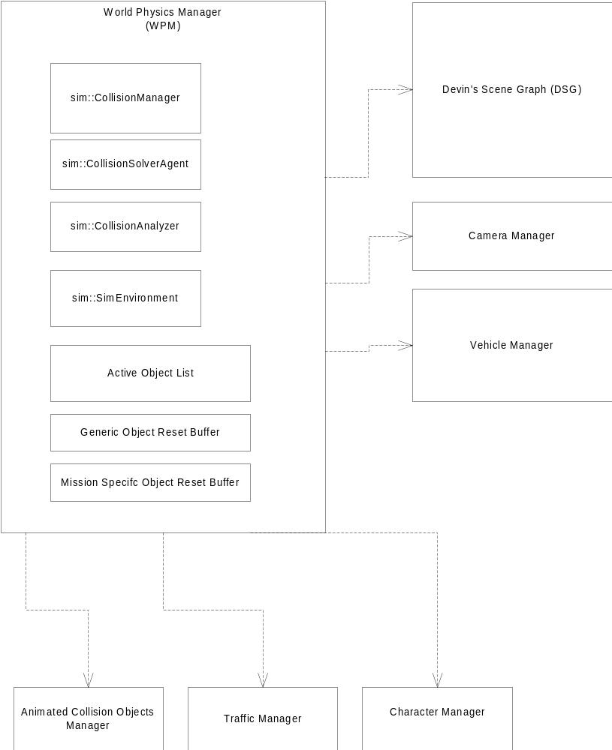

The World Physics Manager has to get world terrain and object information in Devin's Scene Graph, as well as update, in sync, essentially all managers that control moving objects which require precise collision detection against each other.

WPM to Devin's Scene Graph
The World Physics Manager will have to query the DSG every frame to get information on world objects that are in close proximity to the player character, or players car, or chase AI vehicles, or other things of interest. From this list it will have to do more refined tests and make decisions as to what objects (and pairs of objects) should be submitted to the sim::CollisionManager for collision detection.

For objects that are simulating with physics, the DSG will also be queried for terrain collision information - ie. for a given x z world coordinate, what is the y value and the normal of the ground at that point, as well as surface type.

WPM to Vehicle Manager
The WPM will propagate update calls to the Vehicle Manager, so that it can update all it's active vehicles. When active, the player character's vehicle will be in collision detection, and will be the primary point of interest for querying object proximity from the DSG. The other chase AI vehicles will be used in a similar manner, but with lower priority than the users vehicle - ie. the collision detection and simulation around the player's car is more important than an AI car.

WPM to Camera Manager
The camera will likely also be updated from the WPM since it was found last year that the cubic interpolator for it's motion worked best when done in the same number of substeps as the rest of the physics. Furthermore the system to keep the camera from going into buildings and other static objects will likely use the sim::CollisionManager.

WPM to Animated Collision Object Manager
Animated Collision Objects are those objects that have a collision object (simple or articulated) and are moving with AI control, or just animation, and can hit the player vehicle or character or any other dynamic object that might get in the way. For purposes of collision response they have infinite mass, and will never deviate from their path.

It is yet to be determined if we will need a separate manager for Animated Collision Objects, but if we do, it would be updated from the WPM.

WPM to Traffic Manager and Character Manager
For precise collision detection, the traffic and character managers may also be updated from the WPM.

Components of World Physics Manager

Following is a brief description of the key pieces of the WorldPhysicsManager.

note: sim:: indicates a class in the simulation library (or derived from a class in the simulation library)

sim::CollisionManager
This is the CollisionManger from the simulation library. It does efficient collision detection between pairs of objects. Pairing between objects is either done automatically as they are added to the CollisionManager, or in many cases the WPM will submit them with the AutoPair flag false, and then only set up collision pairs between a subset of the present objects.
Minimizing the number of collision pairs at any given time is of critical importance.

sim::CollisionSolverAgent
The sim::CollisionSolverAgent is a class that is allowed to intercept the collision detection results before the collision solver is applied to them, in cases where the game may want to deal with collisions between certain objects specially, rather than just allow the solver to calculate instantaneous changes in velocity that prevent objects from interpenetrating. An example would be the wheels of the players vehicle hitting the ground - in most cases this collision would be handled through special code which simply places the wheels exactly on the terrain. This is also the place where dynamic objects that were at rest and under AI control, would switch to physics control since they have been hit.

sim::CollisionAnalyzer
The sim::CollisionAnalyzer assembles a list of final collision results with additional information about the type of contact between objects, and therefore is the perfect place for triggering sound and special effects events.

sim::SimEnvironment
The sim::SimEnvironment holds some global physics parameters (primarily gravity) that are used by all objects that will ever be controlled by physics simulation in the game.

ActiveObjectList
At any given time there is some subset of the dynamic world objects in a level that we actually want to simulate with physics. The ActiveObjectList maintains and continuously updates which objects these are. A typical entry in the list would be a dynamic object in close proximity to the player's vehicle that has just been collided with by the car and is tumbling along with physics.

Generic and Mission-Specific Object Reset Buffer
The WorldPhysicsManager maintains two lists of objects for the purposes of quick resetting to their intial position. Dynamic objects that may be integral to a mission that go into the Mission-Specific Object Reset Buffer. This buffer must be big enough to hold pointers to, and initial position and orientation of, all dynamic objects that affect a mission outcome. As the objects are struck, they are added to the buffer, so that upon reset of the mission, the buffer can be iterated through and the objects all reset without having to reload any data from a file.

Objects that do not affect the mission outcome go into the Generic Object Reset Buffer. This buffer will have some limited size, and when it fills up, objects that were add first, will get reset, and the newly added objects can take their slot. The size of the buffer can be tuned to balance memory usage and keep visual weirdness to a minimum.

Overview of Main Update Loop

Following is a logical overview of the core of the World Physics Manager:

PreUpdate:

- based on the position of the player-character, or player-character-car, and possibly AI chase vehicles, query the DSG for collision objects in close proximity.
- submit new ones to collisionManager and activeObjectList.
- remove ones that are out of range and/or have come to rest (sample heuristics)
- propogate preupdate call to vehicleManager, and anyone else who cares
- update groundplanes for activeObjectList

Update:

for minimum possible number of substeps that still gives stable simulation:
{
vehicleManager->setupVehiclesforCollision (see driving engine document)
collisionManager->DetectCollisions
intercept results in collisionSolverAgent
deal with vehicle wheels specially
set struck objects from ai/rest to simulation control
add new objects to reset buffer and reset oldest if out of room
collisionManager->SolveCollisions
let collisionAnalyzer peruse results and fire off any events necessary

vehicleManager->Update
cameraManager->Update
activeObjectList->Update

animatedObjectManager->Update
trafficManager->Update
characterManager->Update
}

PostUpdate:

- vehicleManager->postUpdate (if necessary?)

Appendix A - World Object Hierarchy

Here is an overview of the class hierarchy for world objects in the game.

