Document Issue: 0.1 Document Status: Draft
                - Date Issued: 13-Feb-2002 Filing Path: Perforce: RADFS3:1677
                - Document Title: Lightmapping Guide – scaled down version
                - Author: Mike Peredo (mperedo@radical.ca)
                - Keywords: lighting lightmapping lightmap cbv photon corona billboard

Revision History
Issue | Date | Person | Reason - include problem #, ECN #, etc.
0.1 |  | Mike Peredo | Initial draft
0.1b | Feb 1/2002 | Mike Peredo | Scaled down version of full document for limited distribution.
0.1c | Feb 13/2002 | Mike Peredo | Incorporated some changes from Bert and added sample images

Table Of Contents
1. Introduction 3
1.1 Objectives 3
1.2 Intended Audience 3
2. Pre-lighting 4
2.1 CBV lighting 4
2.2 Lightmapping 4
2.3 Photon mapping 4
3. Lightmapping Workflow (work in progress) 6
4. Lightmapping checklists 8
5. Using P3Dlight 9
6. Sample lighting batch file 10
7. Batch files and Mel scripts 11
8. lightmapping FAQ 12

Introduction
This document is a general guide to lighting in the P3D environment. It covers the available tools and concepts and suggests some techniques and workflow for integrating lighting into the game pipeline.

Objectives
This document is intended to be a useful introduction and reference for P3D lighting.

Intended Audience
- Art Directors
- Artists
- Technical Artists

Pre-lighting

CBV lighting
Color By Vertex (CBV) lighting can be used to bake lighting into the vertices. This is a coarse method that can produce artifacts depending on the polygon structure but works well for general lighting mood. It is not practical for detailed cast shadows or shading.
This can be combined with lightmaps to give the appearance of a fully lit model while saving on the cost of runtime rendering.
This can also be used to make objects appear self-illuminated if the lit flag is off and CBV is set to 1. If used for this then the pipeline should take into consideration that certain objects/shaders should not be included in pre-lighting operations. Otherwise these values will be overwritten.

Lightmapping
A lightmap is a layered texture that is (ideally) multiplied with the base texture to produce a variation in shading on the surface. This is basically the same as using a “multiply” layer in Photoshop.
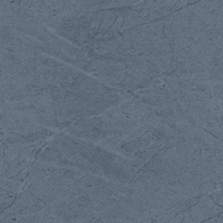
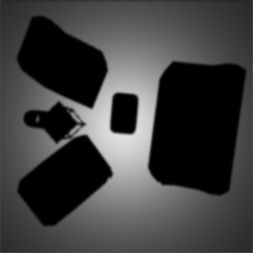
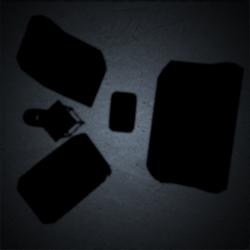

base texture * lightmap = result
Lightmaps should look very close to a Maya render in terms of mimicking cast shadows and shading. Having a separate lightmap allows the flexibility of re-using textures in different pre-lit lighting situations.
Features:
- Easy to use
- Proper representation of Maya lights, including decay, penumbra and dropoff
Limitations:
- Lightmaps are expensive. Lightmaps have a memory cost the same as using an additional texture would.
Recommendations:
- Lightmaps should be used sparingly. The artist should determine where they are most effective. Floors and possibly walls are the best candidates. They can be a great way to “ground” objects by giving them a cast shadow.

Photon mapping
Photon mapping is a method of calculating reflected light based on light photons bouncing around in a scene. Photons emitted from each light source are reflected and absorbed by surfaces that they hit, picking up some of the color from surfaces they bounce off of. The resulting photon map is a 3-Dimensional cloud of photons. When visualized it looks like a bunch of colored specks covering the geometry in the scene.

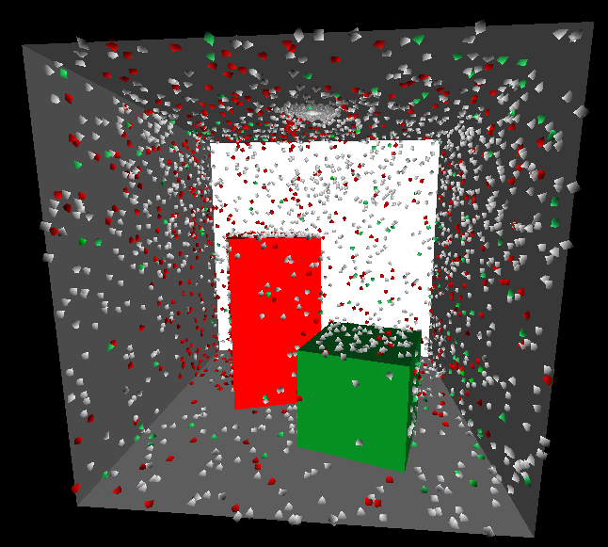

The photon map is then used to generate lightmaps and / or CBV lighting in the scene.
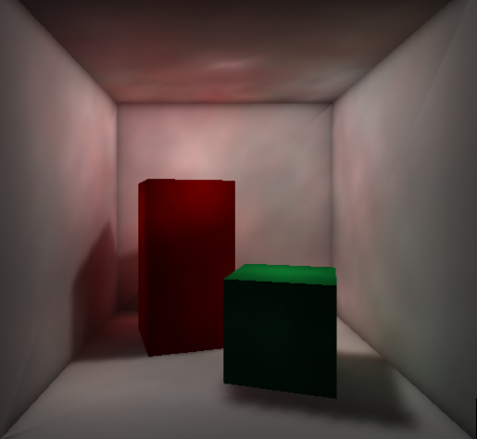

The photon map can take quite a while to calculate. The core calculations are dependant on the arrangement of objects in the scene. As long as these objects don’t move or swap textures some adjusting of the photon map is possible without recalculation.
Features:
- Realistic calculation of reflected light
- Exposure levels can be modified for photon maps without requiring recalculation
- Lightmaps and CBV lighting can be calculated using the photon map
Limitations:
- Difficult to preview in Maya
- More variables to deal with than direct lighting lightmaps
- Require more experimentation and calculation time to achieve desired results
- Large numbers of photons may be required to reduce speckling artifacts
We are currently looking at a few features that would make photon map tweaking much easier for the artist. These features include:
- The ability to add photon maps together (different lights could be calculated and combined afterwards)
- Change intensity of individual photon maps
- Eventually provide an interface for mixing photon maps together

Lightmapping Workflow (work in progress)
- Create model in Maya
- Apply prelit shader to surfaces that will be self illuminated
- ie: light bulbs, headlights, backlit windows
- Place lights
- Turn on shadows on shadow casting lights
- Turn off “casts shadows” on applicable objects (ie: light covers)
- select object, open the attribute editor, turn off “cast shadows” under “render stats”
- Apply CBV color to self illuminated surfaces (with prelit shader above)
- these will be skipped by the P3dlight as they have no “is lit” flag
- Make surfaces to be lit use pure3DsimpleShader
- these will be either CBV lit or lightmapped later using p3dlight
- the “is lit” flag should be on
- Determine surfaces to be lightmapped
- floors make the most sense
- name shaders lm_<name> so they can be found easily
- Turn on the “is lightmapped” flag
- Name surfaces (shapes) to be lightmapped in the following format:
lmap<resolution>_<description>
ie: lmap64_floor01, lmap32_wall
(this makes it easier to run p3dlight on specific groups of objects)
note: renameSelectedShapes.mel may be handy for renaming shapes
- Run p3dunishader
- this will create a unique shader for every object that is lightmapped
usage: p3dunishader myfile.p3d
- Run p3dphotonmap to generate photon maps for specific set of lights (future)
- Combine photon maps together (future)
- Run p3dlight to generate CBV colors
- ie: p3dlight –v –c mylevel.p3d
- Run p3dlight to generate lightmaps
- I usually do this as a separate pass so I can specify objects to lightmap
- ie: p3dlight –v –l –w 64 –t 64 –g lmap64* mylevel.p3d
- see sample light.bat file
- Run p3dlight to remove lights in p3d file
- if you don’t do this it will crash the ps2 with more than 4 lights
- ie: p3dlight –s mylevel.p3d

Lightmapping checklists
Have you done all these things?

Checklist for lightmaps
- Use P3dsimpleshader or P3DlayeredShader
- "is lit" flag must be on (under P3D Material Attributes)
- "is lightmapped" flag must be on (under P3D Texture Attributes)
- export with "de-index meshes" flag on
- run p3dunishader <filename>
- run p3dlight -l -t <rez> -w <rez> <filename>

Checklist for CBV lighting
- Use P3dsimpleshader or P3DlayeredShader
- "is lit" flag must be on (under P3D Material Attributes)
- export with "de-index meshes" flag on
- run p3dlight –v -c <filename>
- or run p3dlight –v –r -c <filename> (to take cast shadows into account)

Using P3Dlight
-r | raycast | use raycasting to determine shadowing (for use with CBV color only)
-h | Help | shows a summary of different flags
-u | unlight | turn off lighting flag on all shaders
-g | geometry | specify the primtive group name to generate lightmap for
-l | lightmap | create light map for geometry
-c | vertex-colored | generate CBV color
-p | photonmap | use direct lighting for first hit (detailed cast shadows) and photon map for reflected light in generating CBV and lightmaps
-E | photonmap only | Use photon map exclusively for generating CBV and lightmaps
-m | merge-grime | merge the grime map of a layered shader with light map (this is not necessary if p3dps2 is run)
-I | intensity-only-light-map | create grayscaled lightmap contain only the intensity of light
-o | output-file name | specify output file name
-w | number | specify the width of each lightmap per plane or per triangle
-t | number | specify the height of each lightmap for per plane or per triangle
-d | Density | specify the sampling density of light map texture (ie: lightmap resolution is based on size of the triangle in world space rather than a fixed resolution as determined by the –w and –t flags)  - texture map rez = size of poly / sampling density  - if sampling density is 1 and maya units across are 100 then rez will be 100 pixels across  - texture map will be fitted into a map that is power of 2 sized (ie: 60 x 100 will fit into 64 x 128)
-s |  | remove-lights (this is generally a good idea. Files with more than a certain number of lights will crash the console)
-b | Cbv+lmap | apply CBV lighting to objects with lightmapped shaders. When a face is lightmapped the CBV color is usually set to full brightness so the lightmap can determine the lighting. This forces lightmapped shaders have
-f | filter | Filter the light map. Gets rid of jaggy edges on cast shadows.

Sample lighting batch file
To run this batch file do the following:
- Open a command prompt window (start -> run -> cmd)
- Change to the directory with your p3d file (ie: cd \temp)
- Run this batch file with your p3d file as the argument (ie: light myfile.p3d)

Light.bat

@rem = this is a generic setup for lighting p3d files with CBV and lightmaps
@rem = it will create lightmaps with resolution determined by the object’s shape name

@rem = requires: p3dunishader.exe, p3dlight.exe
@rem = mike peredo – jan 31 / 2002

@rem – this creates a unique shader for each object that is lightmapped
p3dunishader %1

@rem – this will CBV light all vertices with shaders that have the “is lit” flag checked
@rem – add a “-r” flag to observe shadow casting onto CBV’s (p3dlight -v –r -c %1)
p3dlight -v -c %1

@rem – this will generate 16x16 lightmaps for shapes named lmap16*
p3dlight -v -f -l -t 16 -w 16 -g lmap16* %1

@rem – this will generate 32x32 lightmaps for shapes named lmap32*
p3dlight -v -f -l -t 32 -w 32 -g lmap32* %1

@rem – this will generate 64x64 lightmaps for shapes named lmap64*
p3dlight -v -f -l -t 64 -w 64 -g lmap64* %1

@rem – this will generate 128x128 lightmaps for shapes named lmap128*
p3dlight -v -f -l -t 128 -w 128 -g lmap128* %1

@rem – this removes all lights from the file and turns off all “is lit” flags
p3dlight -s -u %1

Batch files and Mel scripts
These files can be found under T:\Public\Users\mperedo\scripts
light.bat | Template for CBV lighting and lightmapping .p3d files using p3dlight and p3dunishader. (see annotated example)
renameSelectedShapes.mel | Renames shape nodes of selected objects. This is useful for naming a bunch of lightmapped surfaces, billboards or any group of objects that you want to show up individually in the viewer. This will ask you for a base name and then increment a counter so that the shapes will be named “basename1”, “basename2”, etc.
renameSelectedObjects.mel | Similar to the above script but names objects instead. This is a modified version of the renamer.mel script that had a problem renaming objects in multiple groups.
setLightDecay.mel | Sets light decay on selected lights.
setShadowsOn.mel | This can be done in the channel box but this mel script also allows you to set the depth map resolution. The default is 64 because it is mostly for setting shadow casting light flags for p3dlight. I don’t want to bog down my test renders with high res depthmaps.
setShadowsOff.mel | This can also be done in the channel box – I just like having a button ….

lightmapping FAQ

Q: my lights seem to be effecting the scene even though they are in a hidden layer! (maya render)
A:
- this is true. in Maya objects in hidden layers don't render but lights do
- you need to hide the lights themselves

Q: when I run p3dlight it reduces the file size of the p3d file and seems to corrupt it
A:
- there may be two scenegraph roots in the file
- search for Scenegraph in the .p3d file. there should be only one.

Q: p3dlight crashes on a specific object when CBV lighting
A:
- delete history
- check the shader on the object, this will happen when there is no shader assigned
- try running findUnshadedObjects.mel

Q: why are only some of my lights showing up?
A:
- do they have the same shape names?
- you can use renameSelectedShapes.mel

Q: lightmapping strategy: break objects into planes
A:
- lightmapping is more efficient on planes, planes are easier to see and edit in pshop if necessary
- split vertices at edges and separate object
- same shader on object is OK

Q: my lightmaps are wrong! the shadows look wrong and in some places the lightmap seems to be rotated 90 deg.
A:
- make sure you have "de-index" checked and not "tri-strip"

