WORK DISTRIBUTION:
Name | Roles
Ting Tang- 1686923 | Front-End
Hongwei Ding- 1660307 | Front-End
Leon Liang- 1682536 | Back-End/Architecture
Justin Poutoa- 1620107 | Back-End
Ali Javed- 1679215 | Security
Gita Ranmal Modhvadia- 1673767 | Security/Group Leader

OVERVIEW:
Objective & Benefits:
This project aims to develop a secure, cloud-based ride-sharing web application that combines the affordability and predictability of public transport with the flexibility of peer-to-peer ride services. Inspired by New Zealand’s Flex bus service and ride-hailing platforms like Uber, our solution introduces a hybrid transportation model where riders are picked up from any location but dropped off only at designated bus stop zones and vice versa. This approach lowers costs, improves scheduling efficiency, and makes shared rides more sustainable and accessible.
Unlike traditional public transport, which is often limited in availability, our application offers 24/7 peer-to-peer rides to fixed stops, ensuring both affordability and wider coverage.
Built on Amazon Web Services (AWS), the project leverages cloud-native infrastructure to ensure high availability, scalability, and strong security controls. Both drivers and riders will access the service through a shared, responsive web application, reducing platform fragmentation and increasing reach. Security, privacy, and efficiency are prioritized using modern AWS services like EC2, Cognito, DynamoDB, and WAF.
The result is a cost-effective, secure, and scalable transportation alternative designed specifically for the New Zealand context, with potential to scale globally.
Wireframe of Application:
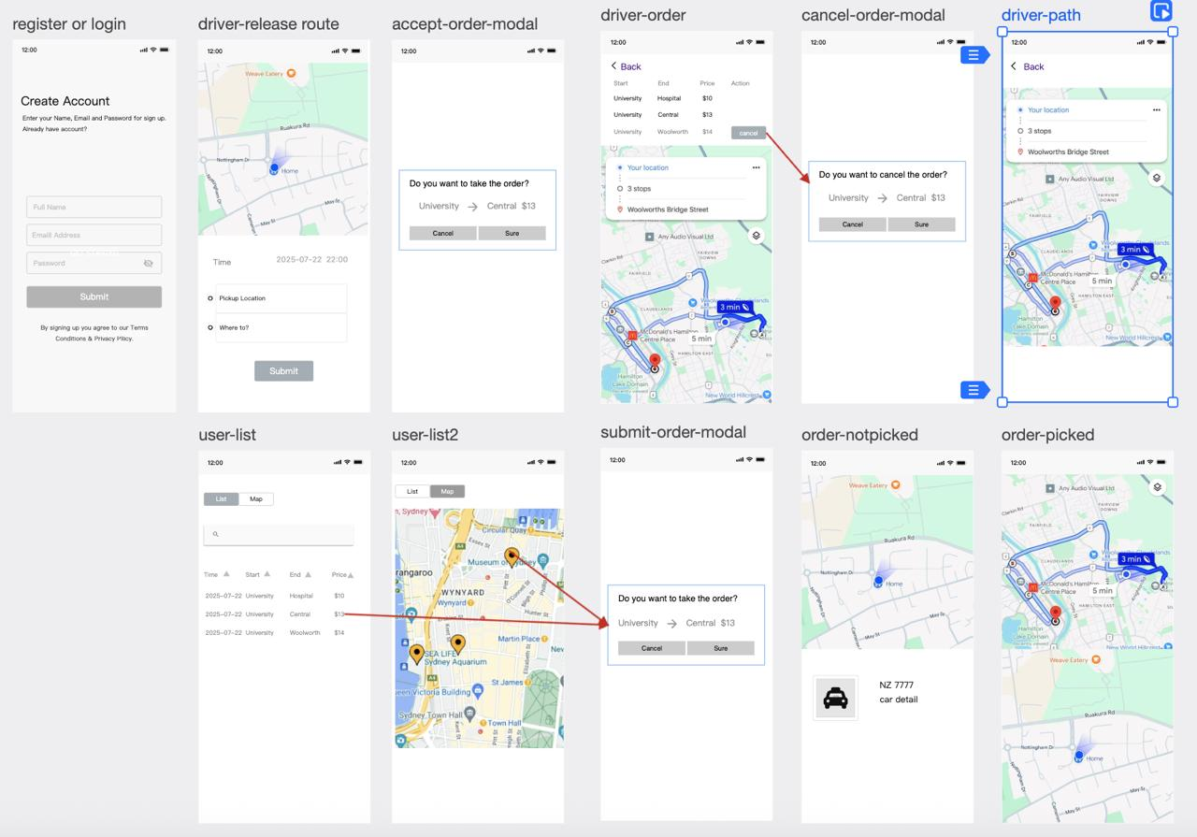
App UI Design by Ting
Backend architecture sketch:
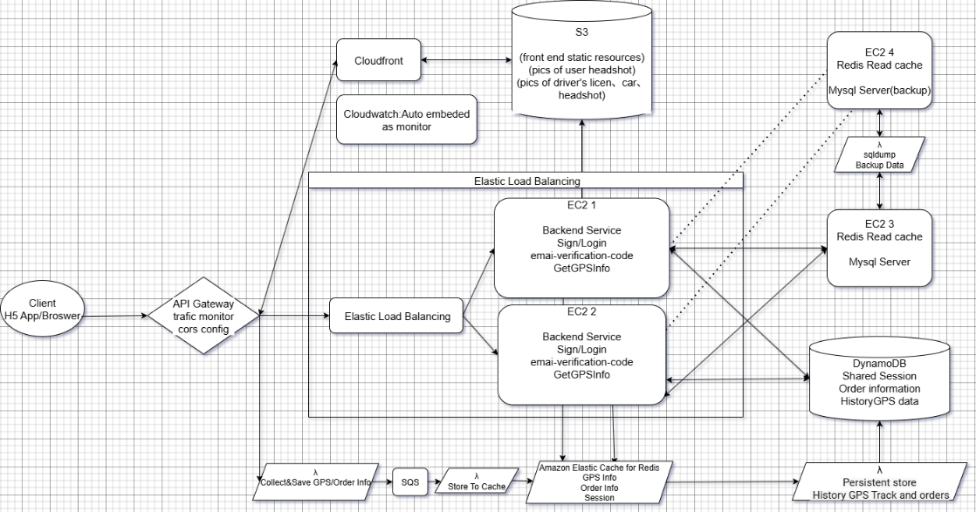
Backend framework drafted by Leon
SERVICES:
- S3: Stores front-end resources and sensitive driver photos, such as images of driver's licenses.
- DynamoDB: Stores order information, historical GPS tracks, and other frequently accessed data.
- EC2 (4):
2 instances for general backend services, including account sign-up, sign-in, email verification, and general data access.
2 instances for hosting MySQL containers.
- Elastic Load Balancing: Distributes traffic evenly between the two backend EC2 instances.
- Amazon ElastiCache for Redis: Serves as a temporary database for reading and writing GPS and order information.
- CloudFront: Accelerates delivery of resources stored in S3.
- Amazon API Gateway: Used for traffic monitoring, CORS configuration, and managing API endpoints.
- WAF Firewall: It protects the application’s web endpoints from common threats (like SQL injection and XSS) by centrally managing, updating, and logging WAF rules across AWS resources.
- AWS Cognitive: It handles user registration, login, and access control at scale providing authentication, token management, and identity federation.
- Inspector: It scans EC2 instances and container images for vulnerabilities and misconfigurations, prioritizes findings with remediation steps for seamless security management.
- SQS: Handles GPS data caching and queuing.
- AWS Secrets Manager: It keeps the app’s passwords and API keys in one secure, encrypted place, automatically rotates them on a schedule, and logs every access, so secrets never have to be hard-coded in code.
- IAM: It will manage users, groups, roles, and permissions, enforce fine-grained, least-privilege access control, and integrate with AWS services for secure resource access.
- AWS CloudWatch: It will collect and store logs and performance metrics from your application and AWS resources, trigger alarms on defined thresholds, and provide dashboards for real-time monitoring and troubleshooting.
BUDGET:

PROBLEM STATEMENT:
- Public transport services like New Zealand’s Flex are affordable but limited, often operating only on specific days and with restricted time windows, leaving many users without accessible or timely transport options during the week.
- Traditional rideshare platforms such as Uber are often too expensive, especially for short or routine trips, and they offer little incentive for ride pooling, making them inaccessible for cost-sensitive users.
- There is currently no hybrid solution that combines the convenience of peer-to-peer rides with the structured efficiency of fixed-route stops, resulting in a gap between public and private transport services particularly in suburban or low-density areas.
- Additionally, buses are not convenient during night time and on some routes, while private cars consume excessive fuel and contribute to air pollution. A system that allows users to spend few time setting routes and share rides with others at a low cost would be beneficial to everyone.

