Website Development
Part 1
Website Project Proposal

Subject: Web Development (WEDE5021)
Full Name: Tshegofatso Maleka
Student Number: ST10509340
Group: 1
Lecturer: Charlotte Nukeri
Date: July 2026

Table of Contents

PROPOSAL 1

LocalHarvest Boxes
“Fresh, local, and delivered weekly — no supermarket middlemen.”

1. Organisation Overview

Name
LocalHarvest Boxes

Brief History
LocalHarvest Boxes is a subscription-based farm-to-door produce delivery business based in Johannesburg, South Africa. The business was founded in 2024 by Tshegofatso Maleka after noticing a gap in the local food market: suburban households wanted access to fresh, locally grown vegetables and artisan products, but had no convenient way to buy directly from small farmers. LocalHarvest Boxes bridges that gap by sourcing weekly produce from small-scale farms and local bakers across Gauteng, assembling customised boxes, and delivering them directly to subscribers’ doors. The business operates from a home base in Johannesburg and currently serves a small subscriber list that continues to grow through word of mouth and social media.

Mission and Vision
- Mission: To make fresh, locally sourced food accessible and convenient for every household, while supporting small South African farmers and producers.
- Vision: A Johannesburg where families eat fresh, local food every week — and where small farms thrive because of it.

Target Audience
- Health-conscious households in suburban Johannesburg (Sandton, Fourways, Bryanston, Midrand) who prioritise fresh produce over supermarket alternatives
- Young professionals and families interested in sustainable, ethical food sourcing
- Eco-conscious consumers wanting to reduce food miles and plastic packaging
- Small local farms and artisan producers looking for a reliable sales channel
- Indoor Micro-Cultivators, craft growers utilizing controlled indoor lights, nutrients, and ventilation systems.

2. Website Goals and Objectives
LocalHarvest Boxes currently relies on WhatsApp and Instagram DMs to manage subscriptions. This is unsustainable as the customer base grows — orders get lost, payment tracking is manual, and there is no professional first impression for new customers who search online. A website would centralise the business, build credibility, and allow new subscribers to sign up without needing to contact anyone directly.

- Drive subscriptions online: Allow customers to browse box options, select a size and frequency, and submit a subscription enquiry directly on the site.
- Showcase farm partners: Feature the local farms and makers behind each box to build trust and tell the story behind the food.
- Build a brand identity: Present LocalHarvest Boxes as a professional, trustworthy business rather than a side hustle run through Instagram.
- KPIs: 30 new subscription enquiries per month within the first two months of launch; 400 unique monthly visitors within 90 days.

3. Current Website Analysis
LocalHarvest Boxes does not have an existing website. The business operates through an Instagram page (@localharvestboxes) with approximately 180 followers, and a WhatsApp broadcast list of current subscribers. There is no way for a new customer who hears about the business to find it on Google, browse the box options, or place an order without first messaging on WhatsApp. Competitors such as The Food Lover's Market and Woolworths Food both have well-established online ordering platforms, while niche competitors like Organic Zone SA have basic but functional websites. LocalHarvest Boxes’ unique selling point is hyperlocal sourcing — but without a website, that story is never told to the right audience.

4. Proposed Website Features and Functionality
- Homepage (index.html): Full-width hero image of a produce box, tagline, subscription call-to-action button, and a “How It Works” section with three simple steps.
- About Us (about.html): The story behind LocalHarvest Boxes, the founder’s background, and a “Meet Our Farms” section featuring partner profiles with photos and brief bios.
- Our Boxes (services.html): Box size options (Small, Medium, Large), what’s typically included each week, pricing per delivery, and optional pantry add-ons. A sample box contents table.
- Subscribe (enquiry.html): Form with fields for name, email, phone number, suburb, preferred box size, delivery frequency (weekly/bi-weekly), and any dietary notes. Client-side validation required.
- Contact (contact.html): Email address, WhatsApp link, Instagram link, pickup point locations with a Google Maps embed, and a general contact form.

5. Design and User Experience
- Typography: Headings in Playfair Display (warm, premium serif); body text in Lato (clean and readable at all sizes).
- Layout: Mobile-first responsive design. Large food photography driving visual appeal. Card-based layout for box options on the services page.
- UX Considerations: Sticky top navigation bar across all pages, large subscribe call-to-action button visible on every page, WhatsApp chat shortcut button in the bottom corner.
Low-fidelity wireframes have been sketched for the homepage (showing hero section, how-it-works, and farm feature strip) and the subscription enquiry page (form layout and validation feedback placement).

Page Wireframes
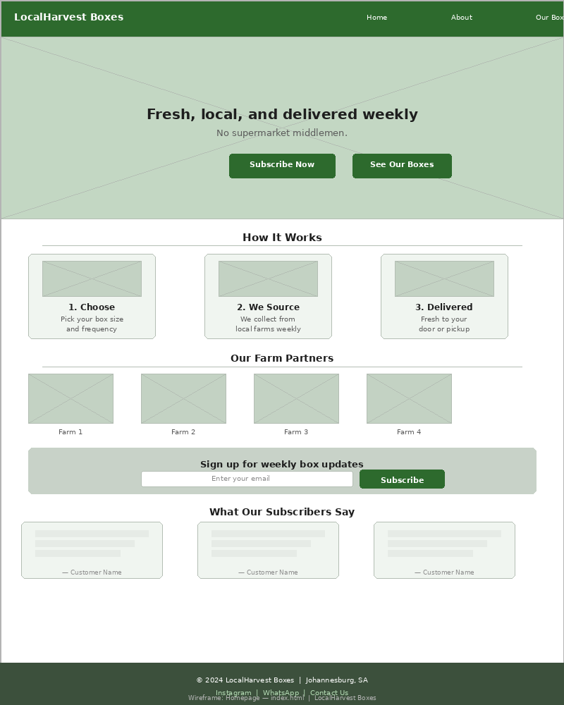
Figure: Low-Fidelity Wireframe — Homepage (index.html)
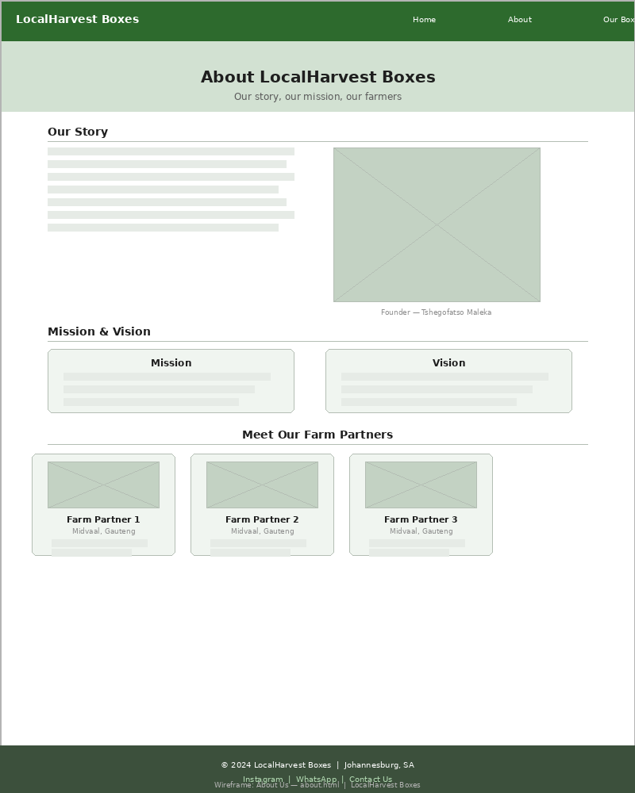
Figure: Low-Fidelity Wireframe — About Us (about.html)
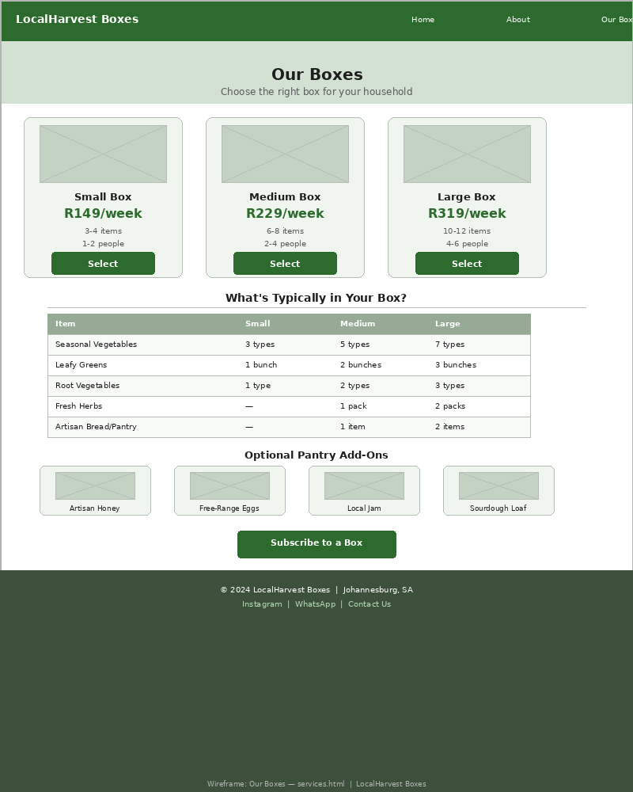
Figure: Low-Fidelity Wireframe — Our Boxes / Services (services.html)
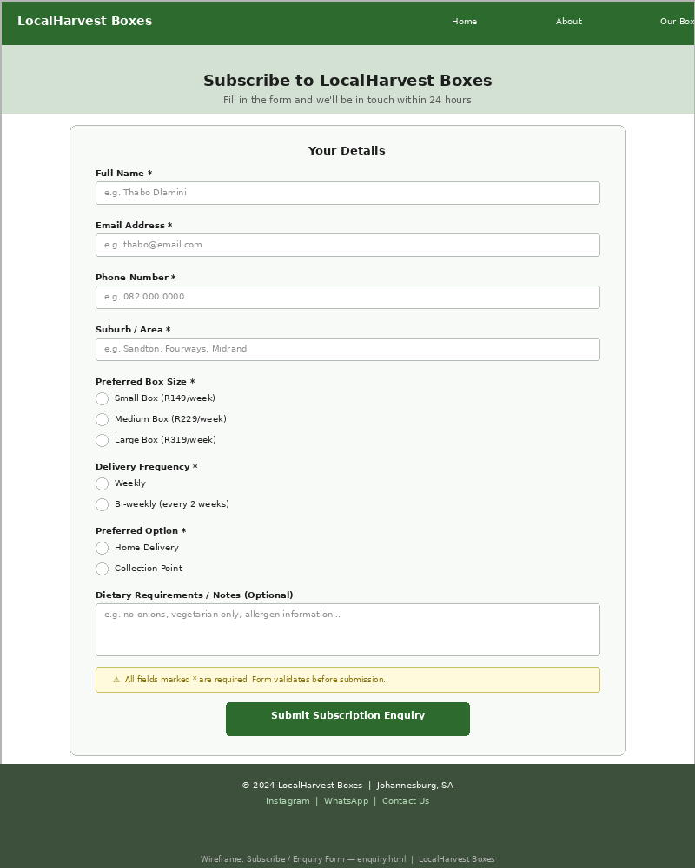
Figure: Low-Fidelity Wireframe — Subscribe / Enquiry (enquiry.html)
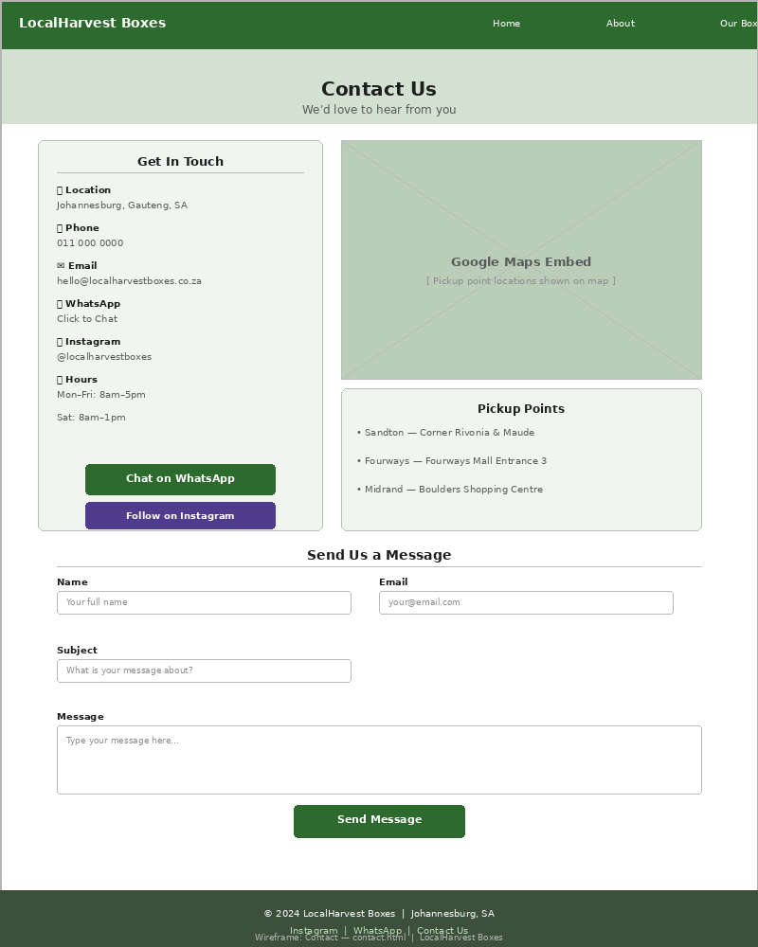
Figure: Low-Fidelity Wireframe — Contact (contact.html)

6. Technical Requirements
- Languages/Technologies: HTML5, CSS3, JavaScript (client-side form validation)
- Version Control: Git with private GitHub repository as required by the brief
- Hosting (Part 1): GitHub Pages — free, appropriate for static HTML/CSS/JS sites
- Domain (future): localharvestboxes.co.za — estimated R149/year via Afrihost
- Tools: Visual Studio Code, GitHub Desktop, Chrome DevTools for testing

7. Timeline and Milestones
- Week 1: Proposal approved; content research begins — farm photos (Pexels/Unsplash), logo concepts, box descriptions written
- Week 2: File and folder structure created; all 5 HTML files created with basic boilerplate
- Week 3: Content integrated into HTML pages; navigation menu linked across all pages
- Week 4: Enquiry form built with client-side validation; Google Maps embed added to contact page
- Week 5: Cross-browser testing (Chrome and Firefox); code comments added; final review
- Week 6: README.md updated; all files committed to GitHub; Part 1 submission

8. Budget
- Domain (localharvestboxes.co.za): R149/year — Afrihost
- Hosting (GitHub Pages): R0 — free for static sites
- Photography (Unsplash/Pexels): R0 — sourced under free commercial licence
- Logo design (Canva free tier): R0
- Development tools (VS Code, Git): R0 — open source
- Total estimated cost for Part 1: R149

9. References
Afrihost, 2024. Domain Name Registration. [Online] Available at: https://www.afrihost.com/site/domains [Accessed 29 July 2026].
GitHub, 2024. GitHub Pages Documentation. [Online] Available at: https://docs.github.com/en/pages [Accessed 29 July 2026].
Google Maps Platform, 2024. Embed a Map. [Online] Available at: https://developers.google.com/maps/documentation/embed [Accessed 29 July 2026].
Pexels, 2024. Free Stock Photos for Commercial Use. [Online] Available at: https://www.pexels.com [Accessed 29 July 2026].
W3Schools, 2024. HTML Forms and Validation. [Online] Available at: https://www.w3schools.com/html/html_forms.asp [Accessed 29 July 2026].

PROPOSAL 2

FixRight Tech Repairs
“Your device, fixed fast — no jargon, no drama.”

1. Organisation Overview

Name
FixRight Tech Repairs

Brief History
FixRight Tech Repairs is a small mobile and laptop repair business based in Johannesburg, South Africa. Founded in 2023, the business specialises in screen replacements, battery swaps, software troubleshooting, and data recovery for smartphones and laptops. The business operates from a small workshop in Randburg and accepts walk-in customers as well as device collection and delivery for clients who cannot come in person. FixRight has built a loyal customer base through affordable pricing and same-day turnaround for most repairs, but relies entirely on word of mouth with no online presence to attract new customers.

Mission and Vision
- Mission: To offer fast, affordable, and honest device repairs to everyday people in Johannesburg — without the corporate markups or confusing technobabble.
- Vision: To be the most trusted independent tech repair shop in Johannesburg, known for transparent pricing and quick turnarounds.

Target Audience
- Students and young professionals with cracked screens or malfunctioning devices who cannot afford manufacturer repair prices
- Small business owners who rely on laptops and phones and need fast, reliable repairs without long waiting times
- Households in Randburg, Northgate, and Roodepoort needing affordable device repairs

2. Website Goals and Objectives
FixRight Tech Repairs has no website and no Google Business listing. Most new customers only find the business through referrals, which limits growth significantly. A website would make the business discoverable through local Google searches, allow customers to understand pricing upfront, and build the credibility needed to compete with larger chain repair shops.

- Improve local discoverability: Appear in Google search results for terms like “phone repair Randburg” and “laptop screen replacement Johannesburg.”
- Display pricing clearly: Publish a transparent pricing page so customers know what to expect before bringing in a device — a key differentiator from competitors who hide prices.
- Generate booking enquiries: Allow customers to submit a repair request form online with device type, problem description, and contact details.
- KPIs: 20 online repair enquiries per month within 60 days of launch; appear on the first page of Google for “phone repair Randburg” within four months.

3. Current Website Analysis
FixRight Tech Repairs has no existing website. There is no Google Business Profile, no social media presence, and no way for a potential customer to find the business online. A quick Google search for “phone repair Randburg” returns three competitors: iStore Randburg, uBreakiFix, and a local shop called QuickFix Mobile. All three have websites. FixRight’s competitive advantage is faster turnaround and lower pricing, but this cannot be communicated to anyone who does not already know the business exists. A website is the most urgent marketing priority.

4. Proposed Website Features and Functionality
- Homepage (index.html): Hero section with tagline and “Get a Quote” call-to-action, a “Why FixRight?” feature strip, and a scrolling customer testimonials section.
- About Us (about.html): Business background, technician profile, workshop photos, and the values behind the business — transparency, speed, and fair pricing.
- Services & Pricing (services.html): Clearly listed repair services with indicative pricing ranges for common repairs (screen replacements, battery replacements, software fixes, data recovery).
- Book a Repair (enquiry.html): Online repair request form with fields for name, contact number, device brand and model, problem description, and preferred drop-off or collection option. Client-side validation required.
- Contact (contact.html): Workshop address with Google Maps embed, phone number, WhatsApp link, operating hours, and a general contact form.

5. Design and User Experience
- Typography: Headings in Roboto Condensed (strong, technical feel); body text in Roboto (clean and modern).
- Layout: Clean and minimal. Services page uses a table layout for pricing clarity. Mobile-first design as most customers will search from their phones.
- UX Considerations: Prominent phone number and WhatsApp button on every page; one-click repair booking; bold pricing displayed without requiring users to contact first.

6. Technical Requirements
- Languages: HTML5, CSS3, JavaScript
- Hosting (Part 1): GitHub Pages
- Domain (future): fixrighttech.co.za — estimated R149/year via Afrihost
- Version Control: Git with private GitHub repository as per brief requirements
- Tools: Visual Studio Code, Chrome DevTools, Firefox for cross-browser testing

7. Timeline and Milestones
- Week 1: Proposal submitted for approval; content research — services list, pricing research, Pexels images of tech repairs sourced
- Week 2: File/folder structure created; all 5 HTML files scaffolded with boilerplate
- Week 3: Content integrated; services and pricing table built in HTML
- Week 4: Repair booking form with client-side validation; Google Maps embed on contact page
- Week 5: Cross-browser testing; comments added to all code; proofreading
- Week 6: README.md finalised; all changes pushed to GitHub; Part 1 submitted

8. Budget
- Domain (fixrighttech.co.za): R149/year — Afrihost
- Hosting (GitHub Pages): R0
- Photography (Pexels): R0 — free commercial licence
- Development tools: R0 — VS Code and Git are free
- Total estimated cost for Part 1: R149

9. References
Afrihost, 2024. Domain Registration. [Online] Available at: https://www.afrihost.com/site/domains [Accessed 29 July 2026].
Google Business Profile, 2024. Get Your Business on Google. [Online] Available at: https://business.google.com [Accessed 29 July 2026].
MDN Web Docs, 2024. Client-side form validation. [Online] Available at: https://developer.mozilla.org/en-US/docs/Learn/Forms/Form_validation [Accessed 29 July 2026].
Pexels, 2024. Free Stock Photos. [Online] Available at: https://www.pexels.com [Accessed 29 July 2026].
W3Schools, 2024. HTML Tables. [Online] Available at: https://www.w3schools.com/html/html_tables.asp [Accessed 29 July 2026].

General References

Duckett, J., 2011. HTML & CSS: Design and Build Web Sites. Indianapolis: John Wiley & Sons.
Google Fonts, 2024. Google Fonts Library. [Online] Available at: https://fonts.google.com [Accessed 29 July 2026].
GitHub, 2024. GitHub Pages – Websites for you and your projects. [Online] Available at: https://pages.github.com [Accessed 29 July 2026].
Mozilla Foundation, 2024. MDN Web Docs – HTML Reference. [Online] Available at: https://developer.mozilla.org/en-US/docs/Web/HTML [Accessed 29 July 2026].
Unsplash, 2024. Free High-Resolution Photos. [Online] Available at: https://unsplash.com [Accessed 29 July 2026].
W3C, 2024. Web Content Accessibility Guidelines (WCAG) 2.1. [Online] Available at: https://www.w3.org/TR/WCAG21/ [Accessed 29 July 2026].
W3Schools, 2024. HTML5 Tutorial. [Online] Available at: https://www.w3schools.com/html/ [Accessed 29 July 2026].

