***Team 7***

**Data and Applications Homework 3**

*Query 1 –*

* select Name From Track where Milliseconds = (select max(Milliseconds) from Track);

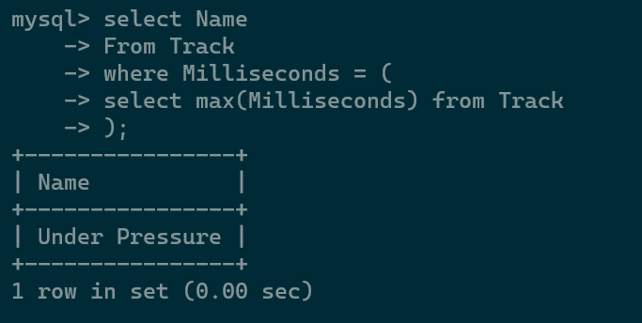

*Query 2 –*

* select count(distinct(lt.trackID)) as num from ListeningTo as lt, Listener as lr where lr.ListenerID = lt.ListenerID and lr.Nationality = 'Indian';

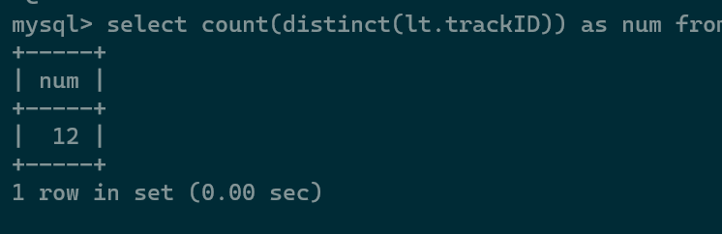

*Query 3 –*

* select Album.Name from Track, Album where Album.AlbumID = Track.AlbumID group by Track.AlbumID having sum(bytes) = ( select max(sum_bytes) from (select sum(bytes) as sum_bytes from Track group by AlbumID) as bytes_table);

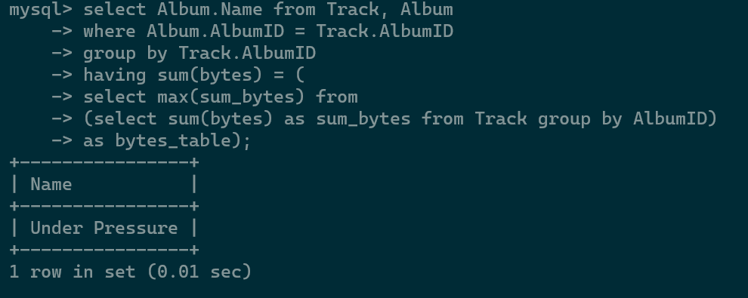

*Query 4 –*

* *select lr.Nationality from ListeningTo as lt, Listener as lr where lt.ListenerID = lr.listenerID group by Nationality order by sum(lt.Milliseconds) limit 1;*

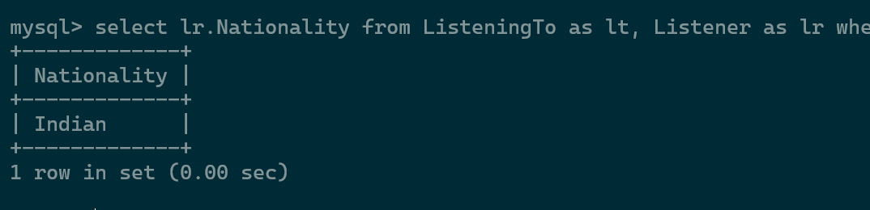

*Query 5 –*

* *SELECT Name FROM Genre WHERE GenreID = (SELECT TT.GenreID FROM (SELECT (GenreID) FROM ListeningTo AS lt, Track AS tr, Listener AS ls WHERE lt.TrackID = tr.TrackID AND ls.ListenerID = lt.ListenerID AND ls.Nationality = 'American') AS TT GROUP BY TT.GenreID ORDER BY count(TT.GenreID) DESC LIMIT 1);*

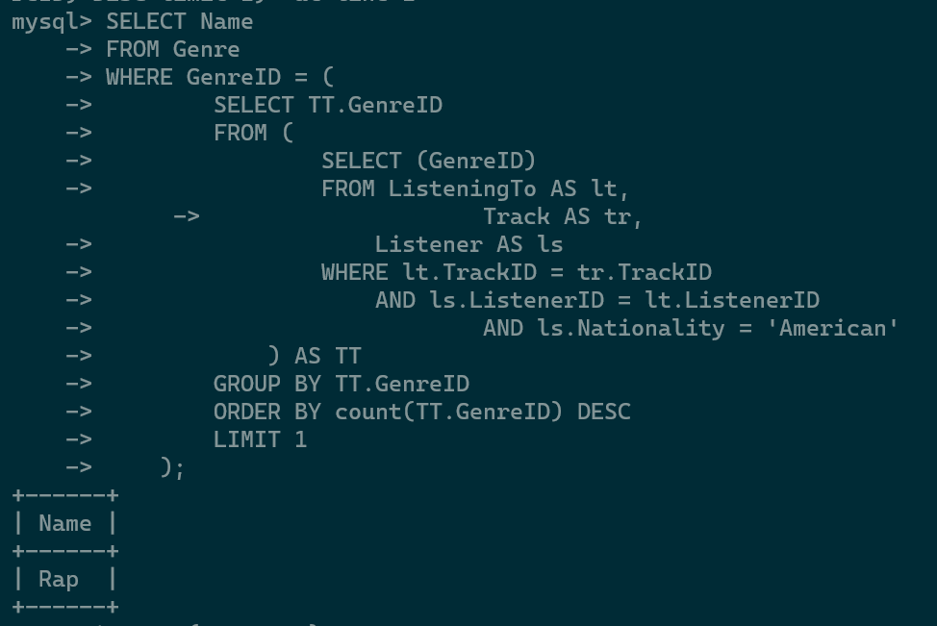

*Query 6 –*

* SELECT Name FROM Artist WHERE ArtistID NOT IN ( SELECT DISTINCT(ArtistID) FROM Track);

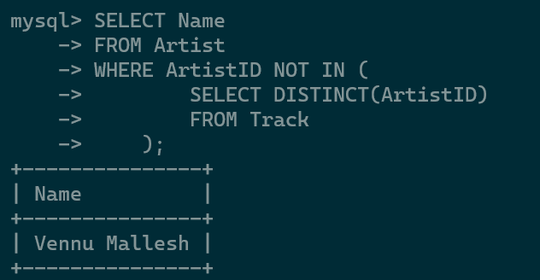

*Query 7 –*

* SELECT Name FROM Artist WHERE ArtistID NOT IN (SELECT DISTINCT(ArtistID) FROM Track WHERE GenreID = (SELECT GenreID FROM Genre WHERE Name = 'Pop'));

