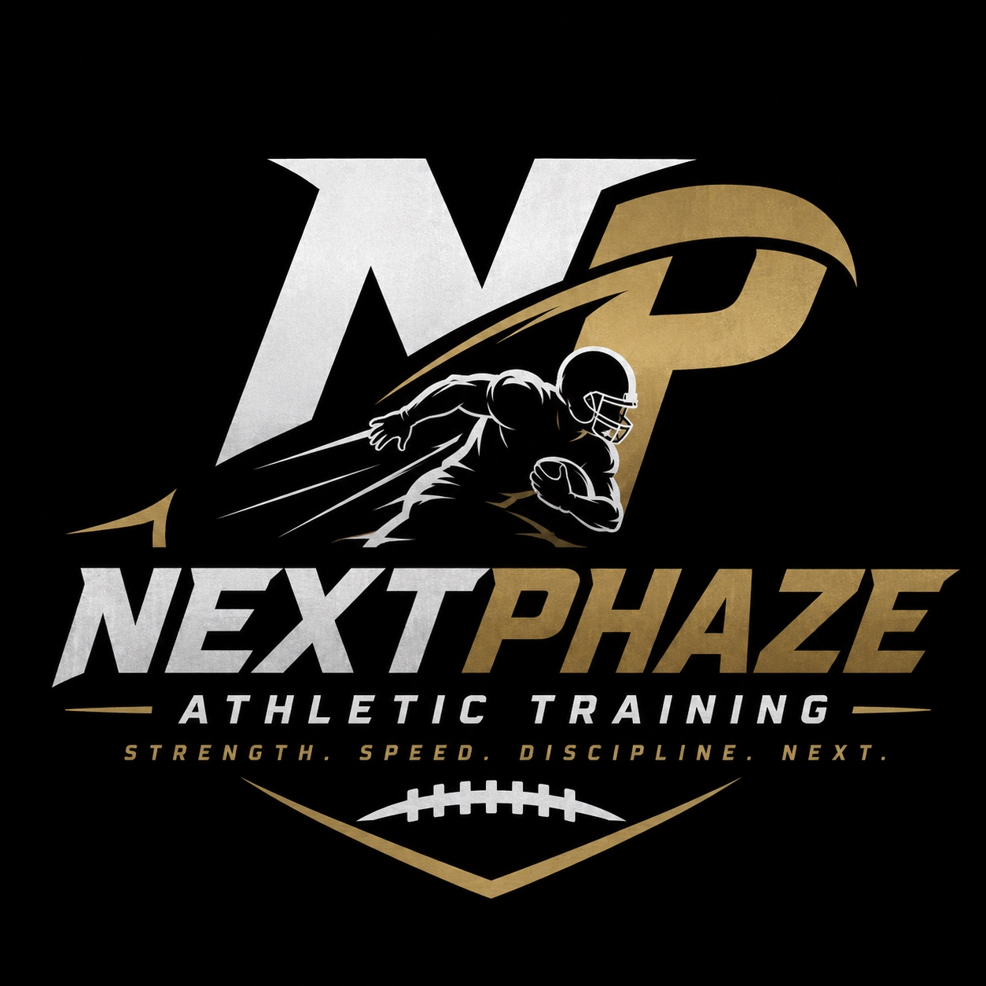
NEXTPHAZE ATHLETIC TRAINING
Strength. Speed. Discipline. Next.
1. Coach Information & Background
- Coach: Carrington Thompson
- Email: carrington.j.Thompson15@gmail.com
- Phone: 810-869-8554
- Former college athlete — Wide Receiver
- AFL experience
- IFL experience
- Previous experience with athletic training and wide receiver-specific training
- Experience coaching athletes in speed, footwork, agility, and overall athletic development
2. Athletic Training Services
Training is designed to help athletes improve their athletic ability, movement, confidence, discipline, and sport-specific performance. Sessions can be customized to the athlete’s age, sport, skill level, and goals.
- Speed development
- Wide receiver training and position-specific development
- Footwork
- Agility and quickness
- Acceleration and change of direction
- Strength and athletic movement
- Sport-specific skill development
- Overall athletic performance and conditioning
3. Sports Served
Training is available for athletes participating in:
- Football
- Basketball
- Soccer
- Baseball
- Track & Field
- Other sports — training is not limited to the sports listed above.
4. Training Options & Pricing
- Group Sessions: $30 per athlete
- Personal One-on-One Sessions: $60 per athlete
- Training plans can be adjusted based on the athlete’s needs and goals.
5. Availability
- Monday–Friday: Flexible hours / Open availability
- Saturday: 9:00 AM–12:00 PM
- Scheduling is based on current availability and confirmed bookings.
6. Online Booking
The website should include an easy-to-use booking option where parents/guardians can select a training session and provide:
- Parent/Guardian Name
- Athlete’s Name
- Athlete’s Age
- Parent/Guardian Contact Information
- Preferred date and time
- Training type: Group or One-on-One
Cancellation Policy: Bookings may be cancelled up to 12 hours before the scheduled session.

Payment Options
Clients should have the option to pay when booking or select Pay in Cash.
Payment options should include:
- Online payment: Debit or credit card
- Pay in Cash: Client can select this option when booking and pay in person at their training session
- The booking system should clearly show whether a session has been paid online or is pending cash payment
- Online payments should be securely processed through the website
- I should be able to view payment/booking status from his business dashboard

private business account/dashboard where I can:
- View a calendar of all upcoming bookings
- See client names, contact information, and booked services
- Receive instant notifications when someone books a session
- Receive notifications when a client cancels or reschedules
- Receive appointment reminders
- Set his availability and block off unavailable dates/times
- Prevent double bookings
- Allow clients to reschedule or cancel according to the cancellation policy
- Keep a record/history of past and upcoming appointments
- Ideally sync the booking calendar with a personal/business Google Calendar
- Manage bookings from a phone as well as a computer

7. Coach & Athletic Experience Photos
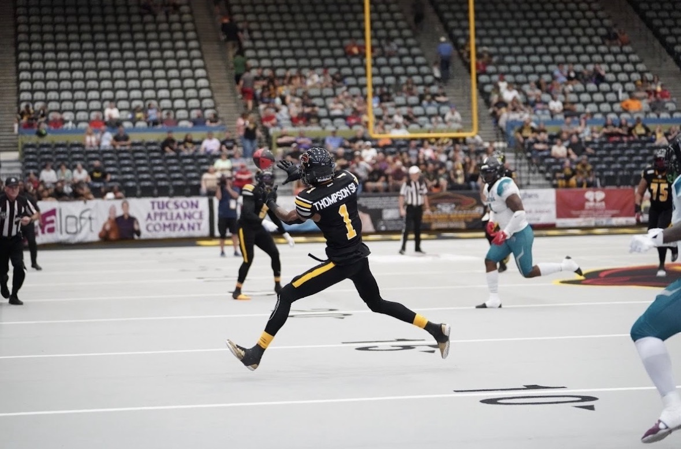
Carrington Thompson — Wide Receiver / AFL Experience
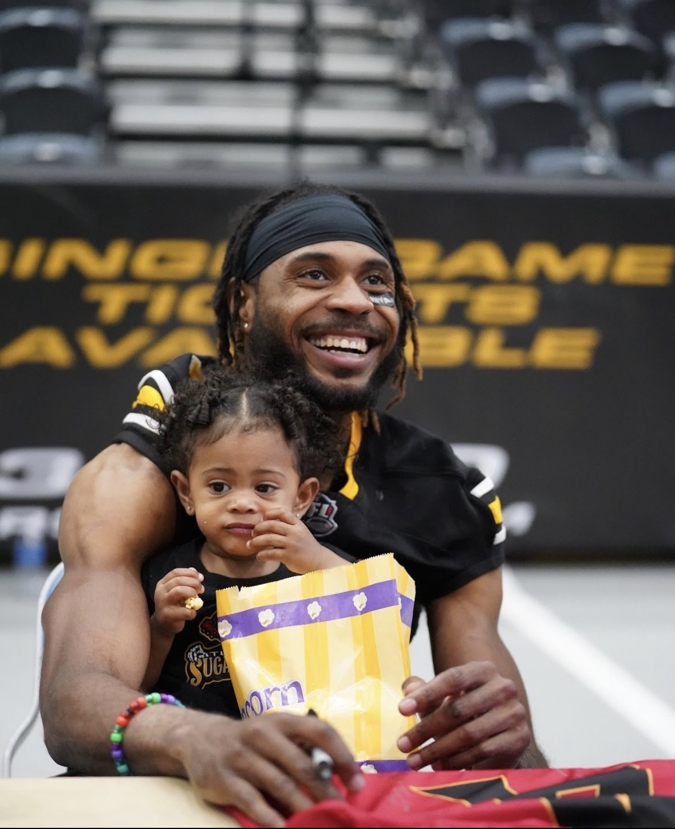
Carrington Thompson — Athletic & Community Experience
8. Suggested Website Sections
- Home — Logo, tagline, action photos, short introduction, and a prominent “Book a Session” button.
- About Coach Carrington — College athlete and wide receiver background, AFL experience, IFL experience, previous athletic training experience, and coaching philosophy.
- Training — Speed, footwork, agility, wide receiver training, conditioning, and sport-specific training.
- Sports — Football, basketball, soccer, baseball, track, and other sports.
- Pricing — Clear group and one-on-one session pricing.
- Schedule / Availability — Current training hours and availability.
- Book a Session — Online booking form with athlete and contact information.
- Cancellation Policy — 12-hour cancellation window.
- Contact — Email and phone number.
9. Suggested Homepage Intro
At NextPhaze Athletic Training, athletes are developed through focused training in speed, footwork, agility, strength, discipline, and sport-specific movement. Led by former college athlete and AFL/IFL wide receiver Carrington Thompson, NextPhaze brings previous athletic training and wide receiver training experience to athletes looking to become faster, more confident, more disciplined, and better prepared for competition.
10. Main Call-to-Action
READY FOR YOUR NEXTPHAZE?
Book your training session today.

